July 30, 2026

Jason R McConnell STUDENT ID: A00133495
520 Yauger Way SW Apt N-204
Olympia, WA 98502

Dear Jason,

Congratulations! I am pleased to offer you acceptance to the Master in Teaching (MIT) Program at The Evergreen State College, starting September 24, 2008. You have been accepted as a candidate seeking an endorsement in Social Studies.

The Admissions Committee in reviewing your Evergreen transcript noted comments from faculty about incomplete work. The Master in Teaching Program is a full time program of sixteen credits per quarter and all credits must be earned or a student will be dismissed from the program. Therefore, you are strongly encouraged to make plans to fully commit adequate time to your graduate studies.

If you have questions about your acceptance, please contact Maggie Foran, the MIT Certification and Advising Officer, at foranm@evergreen.edu or (360) 867-6559.

To hold your place in the MIT class beginning September 2008, you will need to do the following within 30 days of the date of this letter.

- Inform the Office of Admissions, in writing, of your decision to accept or decline this offer of admission at: Admissions Office, The Evergreen State College, Olympia, WA 98505-0002
- Submit a non-refundable $100 tuition deposit along with the enclosed tuition deposit form. Your deposit will be applied toward tuition for Fall Quarter, 2008. If your deposit is not received within 30 days of the date of this letter, this offer of admission expires and your place in the MIT program may be given to another applicant.

Please note you must send an official transcript(s) to the Office of Admissions that documents any coursework you take between the time you applied to the program and the start of the program. This transcript(s) must be received by November 1, 2008.

A required orientation session will be held, tentatively on Saturday, September 20, 9 am – 4 pm, and the program begins September 29, 2008. Over the coming months you will be receiving information about orientation and registration. If you are interested in applying for financial aid and scholarships, you are encouraged to do so as soon as possible. Information about how to apply for financial aid can be found at: http://www.evergreen.edu/mit/finance/financialaid.htm

Again, my sincere and warmest congratulations on your acceptance into the Evergreen MIT program.

Sincerely,
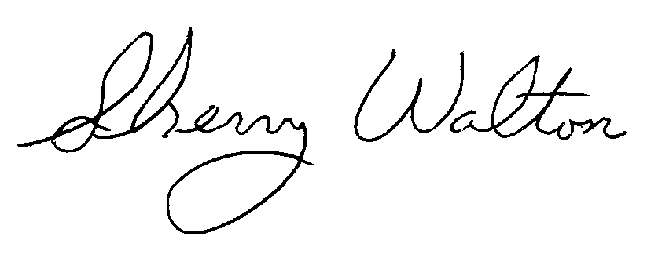
Dr. Sherry Walton, Director
Master in Teaching Program

