July 30, 2026

Shelley L Jobe STUDENT ID: A00101646
7507 66th Ave W
Lakewood, WA 98499

Dear Shelley,

Congratulations! I am pleased to offer you conditional acceptance to the Master in Teaching (MIT) Program at The Evergreen State College, starting September 24, 2007. You have been accepted as a candidate seeking an endorsement in Visual Arts.

This conditional admission is for one quarter, at which time the faculty will re-evaluate whether to recommend you continue in the program or consider transfer to a certification only program based on your performance through program work and participation, as stated in the MIT Student Guidebook to Policies, Procedures and Resources, that demonstrates you have:
* The knowledge and graduate level writing, reading, and critical thinking skills to complete the MIT program successfully
* The interpersonal communication and collaboration skills to support your successful work with children, parents, administrators and colleagues
* The ability to work with and respect gender differences, people of various ages, abilities and talents, ethnicity and race, sexual orientations, religion, etc.

Based on the decision of the admission committee, your admission is also conditional pending completion of the following requirement:

Successful completion of an expository writing course this summer to prepare you for the demands of graduate level writing in MIT. The course should give you additional experience in adequately developing your ideas, and guidance and practice in avoiding errors in conventions (e.g. grammar)

If you have a question about this conditional requirement, please contact Maggie Foran, the MIT Certification and Advising Officer, at foranm@evergreen.edu or (360) 867-6559.

To hold your place in the MIT class beginning September 2007, you will need to do the following within 30 days of the date of this letter.

- Inform the Office of Admissions, in writing, of your decision to accept or decline this offer of admission at: Admissions Office, The Evergreen State College, Olympia, WA 98505-0002
- Submit a non-refundable $100 tuition deposit along with the enclosed tuition deposit form. Your deposit will be applied towards tuition for Fall Quarter, 2007. If your deposit is not received within 30 days of the date of this letter this offer of admission expires and your place in the MIT program may be given to another applicant.

Please note that you complete the writing requirement listed above by September 15, 2007.

Also note, you must send an official transcript(s) to the Office of Admissions that documents any coursework you take between the time you applied to the program and the start of the program. This transcript(s) must be received by November 1, 2007. Finally, if you take course work during summer 2008 to fulfill your requirements, you must send a transcript to the Admissions Office documenting that coursework; that transcript must be received by November 1, 2008.

A required orientation session will be held, tentatively on Saturday, September 15, 9 am – 4 pm, and the program begins September 24, 2007. Over the coming months you will be receiving information about orientation and registration. If you are interested in applying for financial aid and scholarships, you are encouraged to do so as soon as possible. Information about how to apply for financial aid can be found at: http://www.evergreen.edu/mit/finance/financialaid.htm

Again, my sincere and warmest congratulations on your acceptance into the Evergreen MIT program.

Sincerely,
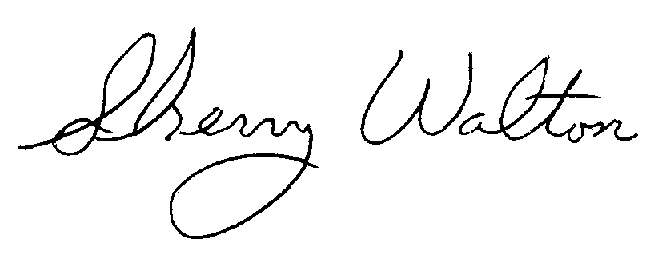
Dr. Sherry Walton, Director
Master in Teaching Program

