July 30, 2026

Jessica Smith Pugsley STUDENT ID: A00110423
25852 SE Tiger Mtn Rd
Issaquah, WA 98027

Dear Jessica,

Congratulations! I am pleased to offer you acceptance to the Master in Teaching (MIT) Program at The Evergreen State College, starting September 24, 2007. You have been accepted as a candidate seeking endorsements in Elementary Education and Middle Level Humanities.

If you have questions about your admittance, please contact Maggie Foran, the MIT Certification and Advising Officer, at foranm@evergreen.edu or (360) 867-6559. You are encouraged to consider strengthening your Pacific Northwest history background.

To hold your place in the MIT class beginning September 2007, you will need to do the following within 30 days of the date of this letter.

- Inform the Office of Admissions, in writing, of your decision to accept or decline this offer of admission at: Admissions Office, The Evergreen State College, Olympia, WA 98505-0002
- Submit a non-refundable $100 tuition deposit along with the enclosed tuition deposit form. Your deposit will be applied towards tuition for Fall Quarter, 2007. If your deposit is not received within 30 days of the date of this letter this offer of admission expires and your place in the MIT program may be given to another applicant.

A required orientation session will be held, tentatively on Saturday, September 15, 9 am – 4 pm, and the program begins September 24, 2007. Over the coming months you will be receiving information about orientation and registration. If you are interested in applying for financial aid and scholarships, you are encouraged to do so as soon as possible. Information about how to apply for financial aid can be found at: http://www.evergreen.edu/mit/finance/financialaid.htm

Again, my sincere and warmest congratulations on your acceptance into the Evergreen MIT program.

Sincerely,
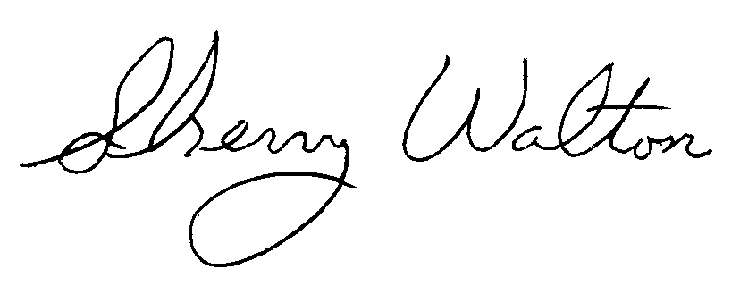
Dr. Sherry Walton, Director
Master in Teaching Program

