July 30, 2026

Craig Patrick Kaumans
815 Seamount Dr
Port Angeles, CA 98363

Dear Craig,

Congratulations! I am pleased to offer you conditional acceptance to the Master in Teaching (MIT) Program at The Evergreen State College, starting September 24, 2007. You have been accepted as a candidate seeking an endorsement in Biology.

Based on the decision of the admission committee, your admission is conditional pending completion of the following requirements:
Documentation of observing a week in science in a public school classroom during regular hours (cannot be in an alternative setting such as outdoor education).

If you questions about this conditional requirement, please contact Maggie Foran, the MIT Certification and Advising Officer, at foranm@evergreen.edu or (360) 867-6559.

The Admissions Committee has noted that much of your academic experience has been as a part time student. They encourage you to recognize this program is full-time at 16 graduate level credits per quarter over six quarters, and to make appropriate arrangements for your full engagement. There are no provisions for a reduced credit load.

To hold your place in the MIT class beginning September 2007, you will need to do the following within 30 days of the date of this letter.

- Inform the Office of Admissions, in writing, of your decision to accept or decline this offer of admission at: Admissions Office, The Evergreen State College, Olympia, WA 98505-0002
- Submit a non-refundable $100 tuition deposit along with the enclosed tuition deposit form. Your deposit will be applied towards tuition for Fall Quarter, 2007. If your deposit is not received within 30 days of the date of this letter this offer of admission expires and your place in the MIT program may be given to another applicant.

Please note that you must complete the requirement listed above by September 15, 2007.

Also note, you must send an official transcript(s) to the Office of Admissions that documents any coursework you take between the time you applied to the program and the start of the program. This transcript(s) must be received by November 1, 2007.

A required orientation session will be held, tentatively on Saturday, September 15, 9 am – 4 pm, and the program begins September 24, 2007. Over the coming months you will be receiving information about orientation and registration. If you are interested in applying for financial aid and scholarships, you are encouraged to do so as soon as possible. Information about how to apply for financial aid can be found at: http://www.evergreen.edu/mit/finance/financialaid.htm

Again, my sincere and warmest congratulations on your acceptance into the Evergreen MIT program.

Sincerely,
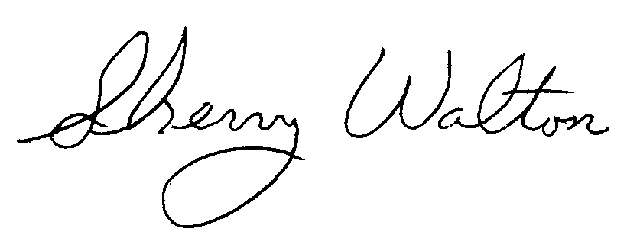
Dr. Sherry Walton, Director
Master in Teaching Program

