<https://www.facebook.com/Evergreen.MiT/photos/a.440501853011.227007.94746153011/10153976781838012/?type=3&theater>



https://www.facebook.com/Evergreen.MiT/photos/a.440501853011.227007.94746153011/10153942988493012/?type=3&theater

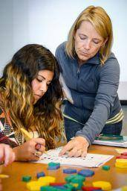

<https://www.facebook.com/Evergreen.MiT/photos/a.440501853011.227007.94746153011/10153831414093012/?type=3&theater>

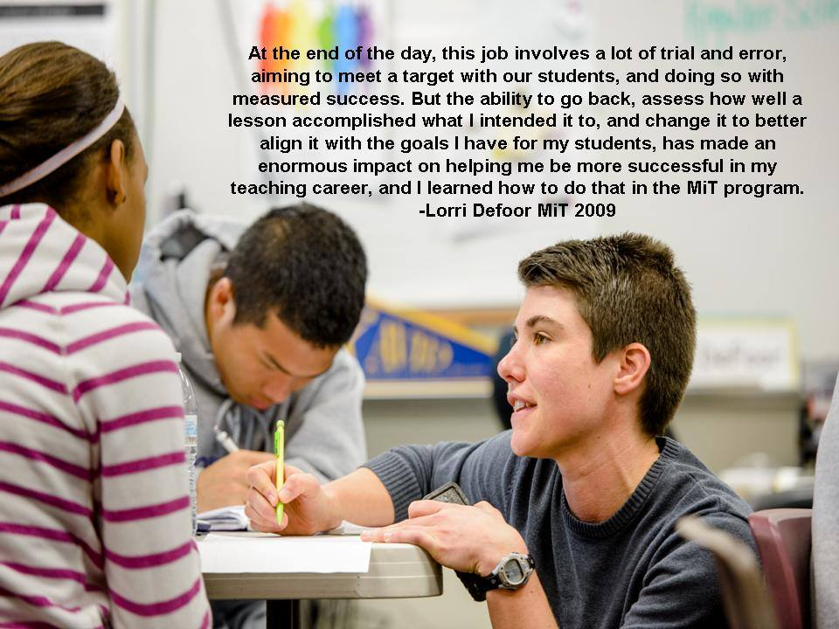

<https://www.facebook.com/Evergreen.MiT/photos/a.440501853011.227007.94746153011/10152793195468012/?type=3&theater>

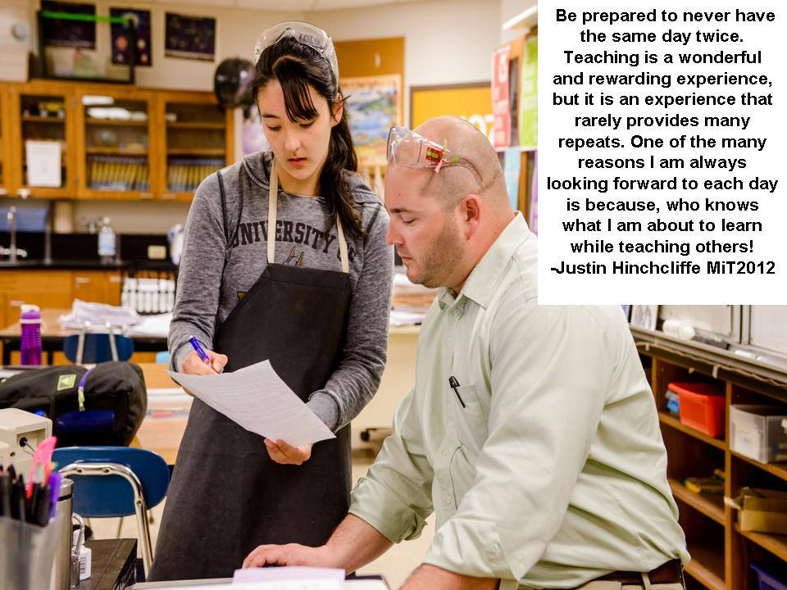

<https://www.facebook.com/Evergreen.MiT/photos/a.10150821178648012.509629.94746153011/10156044200788012/?type=3&theater>

https://www.facebook.com/Evergreen.MiT/photos/a.440501853011.227007.94746153011/10153884410793012/?type=3&theater





<https://www.facebook.com/Evergreen.MiT/photos/a.10150821178648012.509629.94746153011/10156075277478012/?type=3&theater>



<https://www.facebook.com/Evergreen.MiT/photos/a.10150095803503012.310614.94746153011/10152110300728012/?type=3&theater>



<https://www.facebook.com/Evergreen.MiT/photos/a.440501853011.227007.94746153011/10156173875903012/?type=3&theater>





<https://www.facebook.com/Evergreen.MiT/photos/a.440501853011.227007.94746153011/10154569040778012/?type=3&theater>

