Stories of Current MiT Candidates

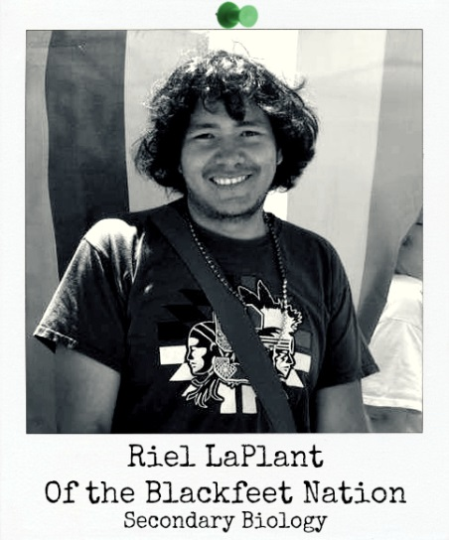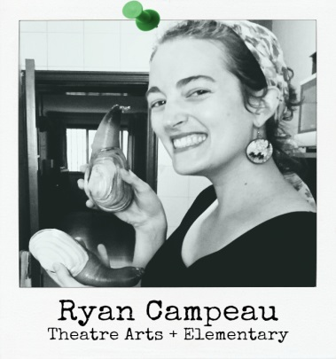

I was born on the Blackfeet Indian reservation in Browning Montana…I would express the plight of my home situation through disengagement with school, running away from home, and a laissez-faire attitude toward my future…Under my grandmother’s patronage I learned my indigenous language, attended ceremonies, developed a love of running, grew as a reader, enhanced my storytelling skills, and fell in love with school. I went from failing every class in middle school to acing every assignment in high school…I was accepted to Stanford University on a full-ride scholarship…Everyone in my community was excited for me and believed that I would …become a doctor and return to the community because that’s what they believed the reservation needed the most…Internally the inaccessibility of medicine and poor medical research history with Native American Populations led me to gravitate away from this field…Eventually I came under the mentorship of Dr. Jennifer Wolf, who helped me think about my community’s needs and the power of education in creating long term systemic change through the empowerment of youth. Under Dr. Wolf I did a Native American honors thesis in education and started to envision creating my own school… After graduating …I moved to work as an AmeriCorps volunteer at Global Connections High School in Sea Tac, WA…I came to a crossroad in deciding how to reach my goal and decided on The Evergreen State College’s Master in Teaching…because most importantly I had seen numerous alumni from Evergreen’s teaching program help students transform their lives on their own terms… the Evergreen MiT program makes social justice a focal point in their curriculum. I think social justice within education is essential for students of color, mine especially, because it teaches them the root causes of dysfunction in the communities. Once students are able to understand the root of their community’s problems, they are better prepared to not only uproot systems of oppression from their own lives, but the lives of others around them…While in the program I noticed a disconnect between my practicum site teachers and urban native youth…and decided on creating a cultural bridge between [them]… I applied for the Billy Mill’s Dreamstarter grant and won $10,000 to make this idea a reality…. I hope to teach for a number of years, acquire a doctorate of education, be involved in national native politics, and eventually start my own schools for native youth. I want my school to be an incubator for social change, like how in my own life, my grandmother was a catalyst for critical thinking.

For as long as I can remember, I said that I would be a teacher or an actor, and throughout high school and college [in Walla Walla, WA] I pursued the theater arts as well as volunteer teaching... While I was studying abroad… I taught English to French students…I found the act of teaching… so rewarding that it became my sole goal after college…I was offered a position in Beijing to work for an innovative education start-up as an arts-based ESL mentor… I recognized my need for a solid foundation in the philosophy and methods of a transformative educator, and so I began to look for teacher preparation programs in Washington State that had a strong foundation in social justice pedagogy. I dreamed of blending theater into my work with elementary and middle school youth in an interdisciplinary way. While I considered completing an online program so that I might live at home to support my family, I knew from prior experiences with online classes that I could gain so much from struggling through ideas with a cohort and professors…After two quarters of the Evergreen Master in Teaching program, I feel more convinced than ever of the rightness of my choice…the program has shown me the importance of recognizing my positionality and that of my students, of learning about their cultural backgrounds, language, community and cultural values in order to serve them. It has made me into a better person as well as teacher in forcing me to consider more deeply my role in society, the privilege that has shaped me, and how I too am complicit in maintaining systems of social injustice…I look forward to a career in which I will serve key [Latinx] communities in my home state through education, the best means for social and personal transformation.

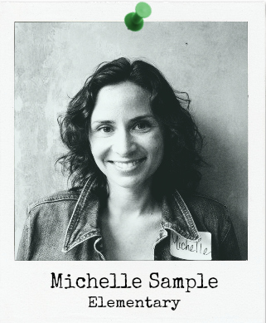

**

I chose Evergreen because I wanted to break the habit of traditional science classrooms and create an environment that inspires science in all disciplines.

Evergreen's interdisciplinary approach along with the critical focus of social justice will help me be the best teacher for every student that I have because everyone deserves to learn.

----James Jarnagin, MiT 2018

James found “the first time I realized about my passion for teaching came about when I tutored geometry in high school for volunteer hours….From the beginning it was always about eliciting the knowledge the individual had and trying to keep it as inquiry-based as possible. It is not the answer that is important, it is the process to get to that answer that is essential to learning. That brief moment of understanding something is why I want to teach…Comprehension leads to confidence, the confidence guides the student to better decisions, and those better decisions improve both the individual and the community around them.” He began his college education studying in a traditional sciences department at Louisiana State University, but finished at Evergreen for its “unique blend of content integration and instruction…engaging with as many viewpoints as possible…This integration of ideas is what helped with my success... The methods used for my learning experience are similar to how I would have wanted to been taught in high school.” James s balanced a grueling workload as a Target store supervisor with his B.S. coursework and AVID tutoring in a local high school prior to entry into MiT. His specific focus “will be for both physics and chemistry, which will allow me to bridge gaps between the two and explain the deeper connections of the mechanics of matter…making those seemingly hard concepts less daunting. ”

In her twenties, Michelle completed a degree in Interior Design at Clover Park Technical College and was eight months pregnant with her daughter at the time. “For several years I wedged and pushed myself for alignment in a male dominated field where women merely decorated the progression. As it turned out, what some consider a tragedy became my fortune as the economic turn of 2008 metaphorically knocked on my door and asked for my keys to the office while handing me my last paycheck..but all of the money that job paid never quite left me fulfilled…Working with children’s wasn’t what I had in mind when suddenly I was thrown into a volunteer position. It didn’t take long for me to realize that paid or not, this was something I would do no matter what…both for myself and the kids. From there, Sallie Mae was happy to see my name show up again and let’s just say that was nearly eight years ago, and since then I’ve inched my way from an Associate’s Degree towards nearing the end of my first year in the MiT program at Evergreen. I offer this glimpse of context to you …it’s unique to anyone who’s never know someone to stick undeterred to a goal as a single mom and a mountain of student loan debt just to be a teacher!” Michelle spent three years as a childcare school site director for the YMCA and gained experience working with school-aged children while finishing her bachelor’s degree. She describes upon completing MiT and taking her first position “Before the day begins, I remind myself why I am there. This classroom will be a safe sanctuary where I will remain vigilant to the harms of bullying, ridicule and racism. All languages and ethnicities are encouraged to be embraced and appreciated. I will strive to build a space for open minded and empathetic thinkers to flourish and grow in wisdom. There will be no empty stomachs or hunger or arguments left unresolved, no insecurities ignored.” She acknowledges “In order to become that teacher I envision, and to endure the challenges ahead as our country faces turbulent times in public education, I need Evergreen’s Master in Teaching program to immerse myself in the social justice framework that I pledge to fight for.”



Kyla “opted out of the popularity game early into my adolescence. My energy was spent in pursual of “nerdy” interests and I enjoyed my lunches in my favorite English teacher’s classroom where a small group of students congregated for discussions of literature and philosophy.” Ten years later after an English degree from UW, experience as a copywriter and writing tutor to teens, and retail manager, she “recognized the common thread of the person I was as a teenager and who I am today: I love to listen to people and find ways to empower them. My energy and creativity skyrocket when there is an opportunity to assist and inspire someone to reach their goals…I had considered being a teacher for many years, because of its mentorship role, but also because it involves work with youth. As a long-time nanny, I’ve loved working with kids—I find their energetic, inquisitive and brutally-honest nature refreshing. I’ve worked with kids who incessantly push boundaries or strictly adhere to the rules; have oodles of confidence or are stifled by their own shyness; struggle or excel in academics; and come from broken or supportive homes. I’ve enjoyed every single kid I’ve worked with—they’re all gems, some just need a little extra support in discovering their worth. It would be an honor to be in a position where I can kelp kids reach their goals through academics, as I feel knowledge is the greatest tool one can have.”

When Kyla lived in Seattle and Los Angeles…she “was befuddled by the social inequality I witnessed.” She began her preparation to apply to certification programs by doing observations in schools. “I entered a classroom, at a school that is known for its low-income community, were 3rd graders were gathered together on the floor. They sat, huddled in front of a poster scripted with bold words. The poster was a transcription of the Civil Rights and the kids read the bill aloud with gust. The verbal declaration of their civil rights is part of their daily routine…the community nature of the classroom and the instructor’s guidance ensured...a community culture of acceptance.” That teacher, Mr. Ryan Reilly [MiT ‘07], “attributes much of his technique to Evergreen. Based on what I’ve seen…I believe Evergreen’s in-depth, two-year program will thoroughly prepare me to step into a classroom and be ready to effectively serve.”

