

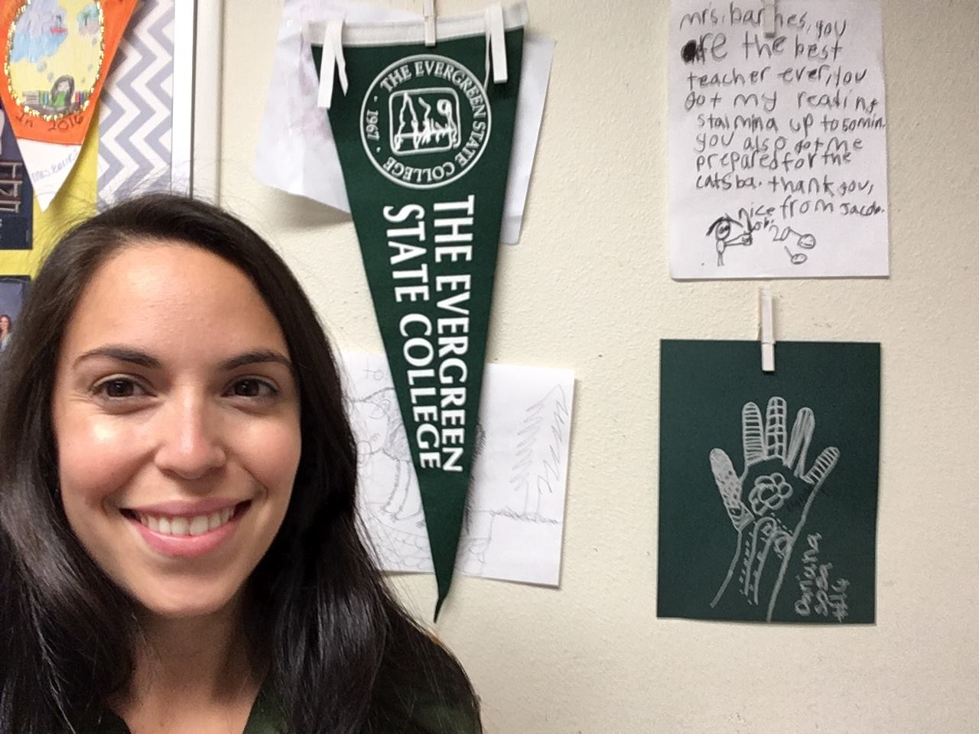

Joanna Tovar Barnes, MiT 2010 and NBCT, teaches third grade at Lydia Hawk Elementary in Lacey, WA.

She teaches because it gives her hope for the future. She trusts that teaching children to be compassionate, thoughtful and critical citizens will make her community a better place. Why did she choose the Master in Teaching Program at Evergreen, "I chose Evergreen because of the focus on social justice and diversity. Equity and access are two of the foundational reasons I chose teaching."