Alumni Voices from the Field

Nate Gibbs-Bowling, MiT ’06, BA ‘04 , Tacoma high school teacher

2014 Milken Family Foundation’s National Educator Award, 2016 Washington State Teacher of the Year.

<https://www.facebook.com/Evergreen.MiT/photos/a.10150821178648012.509629.94746153011/10156075277478012/?type=3&theater> or <https://www.facebook.com/Evergreen.MiT/photos/a.440501853011.227007.94746153011/10156173875903012/?type=3&theater>

“I get to leave my intellectual and cognitive fingerprints on a hundred kids a year, who will be change agents in the community. Poverty and education is a life or death matter. If I am getting kids prepared and competitive for college, then I’m setting them on a trajectory for a better, happier, healthier, longer life.” Read more about Nate’s thoughts on teacihing and eduatinoal equity issues at natebowling.com.

Sarah Bracken, MiT’07, Seattle high school teacher MiT alumni 2014 SB-51

I believe that every student can learn, that their brain can grow in myriad directions, but when they actively work to not lean I feel as though every interaction is like climbing up a steep, muddy hill. I have to remind myself that not learning is a form of persistence in its own way, and if a student with that kind of grit can learn to have a growth mindset instead of a deficit mindset they will be a rock star on day.

Christina Vernon, MiT ’14, Lacey middle school teacher MiT student teachers Lochburn -65 http://www.tacomaweekly.com/news/article/evergreens-master-in-teaching-makes-a-difference-for-area-children

“The program is a win-win for anyone who wants to become a teacher. It was intense, but it definitely helped me become the teacher I am today. MiT prepares you for the realities of teaching.” As a middle school language arts and social studies teacher, she appreciates that her job is to equal the playing field for every one of her 79 students – many of whom come from military families. That’s a challenging job, she said, because no two students are exactly alike. What Vernon loves most about her new life as a teacher are the changes she sees in her students. Her goal is to transform youngsters into critical thinkers who take pride in their own achievements. “I love it because every day is unique. No day is like the other. As a teacher, you make a difference and the kind of difference you make is up to you.”

Julie Grasso Banken, MiT 2015, Puyallup junior high school teacher

"I always knew I had chosen the most rigorous program and believed it would prepare me well for teaching. Today the evidence of the quality of my training is in the fact that my principal has given me a "distinguished" rating. I'm doing a great job teaching and that’s amazing for a first year teacher. I owe it the Master in Teaching Program."  
Julie Grasso Banken, MiT 2015, Puyallup junior high school teacher

Michael Joshua, MiT ’07, BA ’05, Tacoma middle school teacher 2016 MiT Catalog shoot 24

“I love helping kids develop a grittiness with Algebra. I’ve seen academic mind-sets shift and academic trajectories launch. Evergreen gave me a strong learner-centered paradigm, as well as the tools I’ve needed to help all kids grow as learners.”

Justin Hinchcliffe MiT ’12, Lacey high school teacher MiT alumni 20124 SB -127

Be prepared to never have the same day twice. Teaching is a wonderful and rewarding experience, but it is an experience that rarely provides many repeats. One of the many reasons I am always looking forward to each day is because, who knows what I am about to learn while teaching others!”

Joanna Tovar Barnes, MiT ’10 and NBCT, elementary teacher Lacey

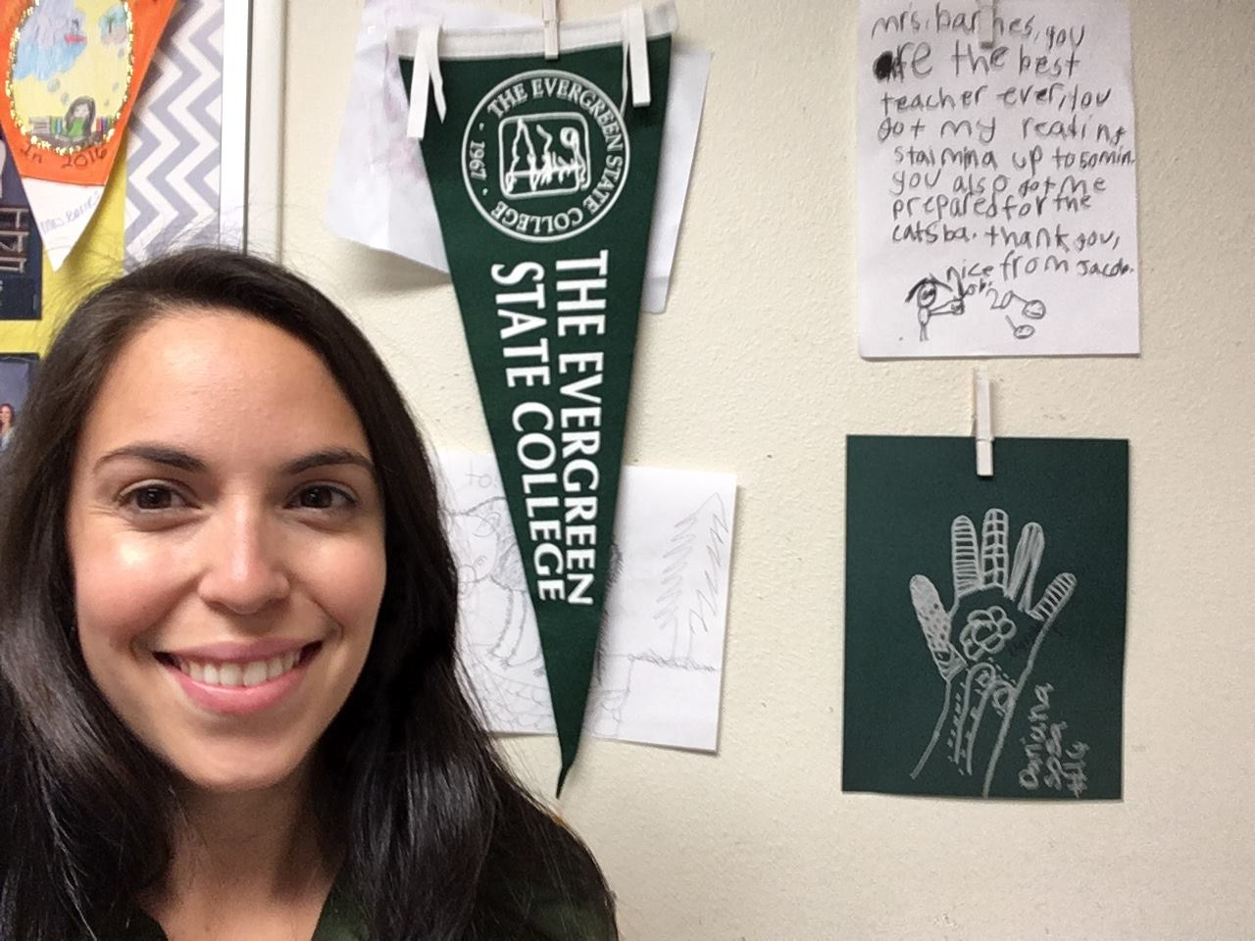

She teaches because it gives her hope for the future. She trusts that teaching children to be compassionate, thoughtful and critical citizens will make her community a better place. Why did she choose the Master in Teaching Program at Evergreen, "I chose Evergreen because of the focus on social justice and diversity. Equity and access are two of the foundational reasons I chose teaching."

More voices on Why Teach? Why Evergreen?

Kids!!! Breaking down boundaries. Watching a child's eyes light up with new ideas. Your heart expanding beyond capacities previously imagined.

Incredible faculty. Social justice / examination of bias-and-privilege. Community. Rigor. Thorough preparedness to enter the rewarding endeavor of teaching! ---Karyn Ainsworth, MiT 2007, Vancouver elementary teacher

I teach to help students recognize that they have an abundance of dreams. --- Stacee Anderson, MiT 2008, Lacey special education high school teacher

Evergreen challenged my personal and professional identity to mold me into a passionate, reflective, empathetic, and FIERCE educator. --- Alaina Hellum-Alexander, MiT 2010, Seattle middle School math teacher

I TEACH in a rural high-poverty school because I LOVE my subject, History, and honestly…if not me? Who? I chose Evergreen because I knew it would teach me courage. A quality I knew I would need in this most challenging (and rewarding) of professions. --- Brent Conklin, MiT 2000, Shelton junior high teacher

I chose Evergreen because I wanted to be focused on the process of becoming a teacher not just the outcomes.--- Dominic Kehoe, MiT 2011, Head of School, Olympia Waldorf School

Diverse learners need qualified individuals in their corner. Evergreen made me that qualified individual. I know how to make a difference because of MiT. ---Beth Chapin, MiT 2015, Shelton elementary teacher

So very few people end up thinking so deeply about teaching and how their personal experiences relate to their practice of teaching. The result makes Evergreen MiT students stand out in a community where the status quo is being merely an adequate educator. The MiT makes it impossible for me to settle for adequacy. --- Amy (Loskota) Mireault, MiT 2004, Upward Bound Program Director, University of Oklahoma