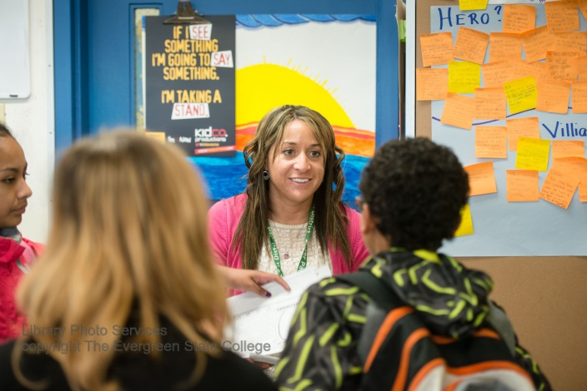



Andrea Benton-Thompson MiT ’15 in her classroom in Tacoma, WA.

**Plant the seeds of Justice –**

**Become a Teacher**

**MIT 2017-2019 the evergreen**

**State college**