MiT 2012-2014 at Tacoma campus

Cohort Theme: Social Justice in the Classroom Requires Your Participation
Students starting MiT in Fall of 2012 will attend classes at Evergreen’s Tacoma campus. . The focus for this cohort will be on successfully educating and serving urban youth and supporting the achievement of all students. During year one in the program classes are expected to be held one night a week and weekends, and one day a week will be spent assisting in public schools. During fall and spring of year two, teacher candidates will student teach five days a week for ten weeks each quarter. In winter, classes will be held evenings/weekends. You are encouraged to contact MiT advisor Maggie Foran sooner rather than later to make sure you are prepared for this exciting opportunity.
If you are applying to MiT for any year other than 2012, you will be on the Olympia campus.

Evergreen's MiT Alumni Make a Difference
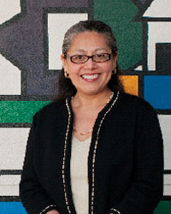
"I became a teacher because I took to heart Evergreen Tacoma’s motto 'Enter to Learn, Depart to Serve.' Evergreen’s MiT program helps you form a true connection with the students you’ll be teaching. Our faculty often reminded us – 'Don’t forget the children!'"
Lupe Jackson MIT '04
Language Arts & Social Studies teacher, Hudtloff Middle School

"I became a teacher to make a difference in the lives of children. I chose Evergreen's MiT program because your values and experiences are shared and respected. It's an exceptional educational experience!"
Command Sergeant Major (ret) Eugene Bradshaw MIT '06
Special Education Teacher, Lochburn Middle School
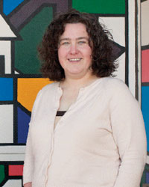
"My students hone their brilliance every day, and I get to be there when it happens. Be there. Be a teacher. Serving other people's children—what an honor!"
Anne Hawkins MIT '99
AVID Program, Jason Lee Middle School

"Wanting my work in life to matter, I chose teaching. Wanting what I already was to matter, I chose MiT at Evergreen."
Kelly Foster MIT '95
Fifth Grade teacher, Park Lodge Elementary

Learn More
If you have questions or would like to set-up an advising appointment, email Lynarra Featherly or call (360) 867-6856. Get started now to apply for the Tacoma 2012 cohort.

