# Brittany Spencer

M.I.T, program, Visual Arts requirement

Artist portfolio

Evergreen State College

March 2013

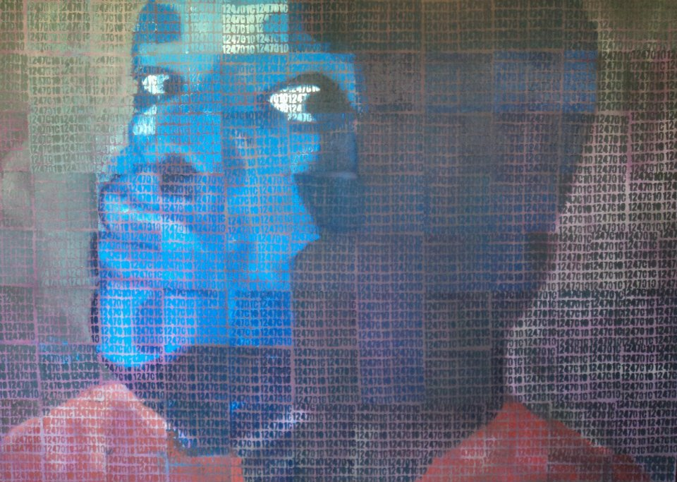

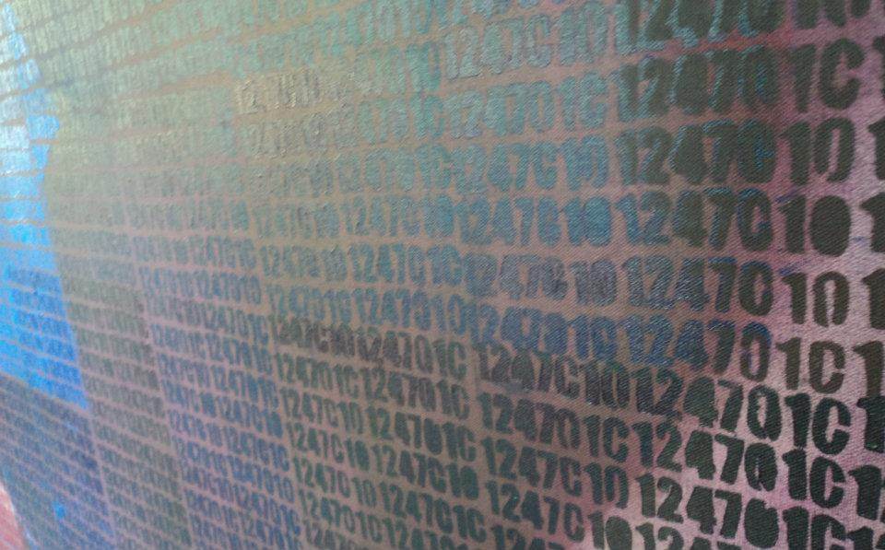

Reflection of “My Name Is”

Throughout the planning conceptualization of “My Name Is” my main focus remained small elements creating larger pictures, metaphorically and realistically. I use my skills and traditional training in oil painting to produce this work. The six and a half foot by 4 and a half foot piece became my life for the three months it took me to create it from the building of the canvas itself to a complete piece. My target audience was adults ranging in ages 20- 50, My hope was in while creating this piece it's size would force people to consider the effects and elements of our criminal justice system. By picking a relative I chose something that was close to home; my brothers’ incarceration fueled my emotion for this piece. It began with him telling me one day his number was now his name sparks my enthusiasm in creating this piece. By using the colors blue and orange I was able to depict what most incarceration uniforms usually consist of. To maintain consistency within the numbers I hand cut a stencil and moved section by section of the painting, completing the entire painting with the same one. Although the message was indirect most were able to figure out what the series of numbers meant and why they were in fact now the character depicted in the pieces' name. When looking at this piece to me it makes me feel closer to my brother. I show it with pride and an example of not only those incarcerated but also the families that love the many that are. Common critique and evaluation vary from person to person. I have been told a variety of things such as some wish the message was more direct but overall I have reserved positive responses.

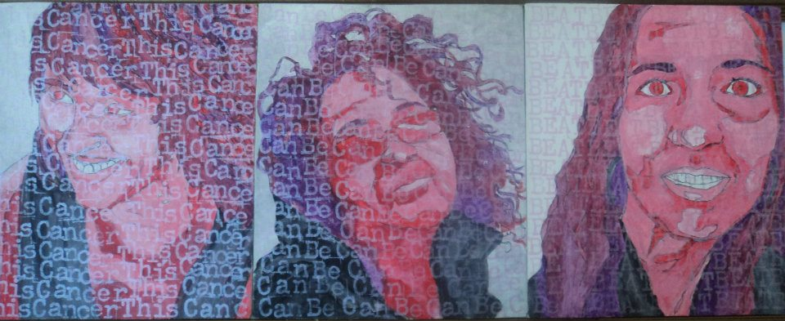

Reflection of “Cancer

Much of the planning in conceptualization that went into the piece “Cancer” rooted from taking part in my mom's journey through breast-cancer. I found that it affects far more women than just my mother and women that were quite close to me. This is why the piece is composed of portraits’ of women that are close to me, my mother, my cousin and a family friend. My intended audience is those who have been affected by cancer. The function for this piece was to recognize the beauty in something that comes from something so ugly like cancer. The use of text serve the purpose as making the viewer look twice these were not just three separate portraits they were one piece united. The ink acrylic piece on the panel was different from many other things and tools I use because the ink for the text was Pearl iridescent. Since acrylics or dry fast drying I had to make decisions that would not conflict with the message I wanted to convey. From this in one position the text that read; “This cancer can be Beat”, looked to not appear at all whereas in another it was as plain as day. The techniques using this piece were similar to one that used before by incorporating many elements to create a “Bigger Picture”. While creating these portraits I chose to stick with the Monochromatic Color scheme to balance the attention between portrait and text. The use of pink was deliberate since it serves as the color that represents breast cancer. The feeling expressed to me though this piece are powerful and motivating common evaluation conveys this feelings as well.

[***The Great Wave off Kanagawa***](http://en.wikipedia.org/wiki/The_Great_Wave_off_Kanagawa)[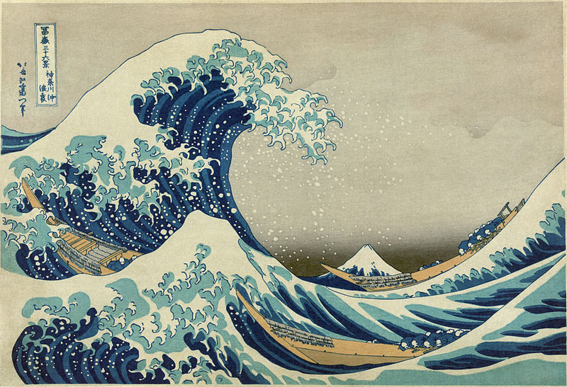](http://upload.wikimedia.org/wikipedia/commons/0/0d/Great_Wave_off_Kanagawa2.jpg)

Reflection of, The Great Wave off Kanagawa by Katsushika Hokusai

This Print produced between 1830-1833 is a color wood block print; it serves as one of the most recognized pieces within Japanese art. Concepts of woodblock printing traditions popular and rooting from Asian traditions; which includes but is not limited to reduction printing, after piece is formed and transferred to a wood block then carved and pressed to create a print. Common evaluations of this piece are that it is a depiction of landscape, history and or myths. My personal fascination with this piece is the art of printmaking. While studying abroad in China I developed a love for not only printmaking traditions but eastern art. My love for history, traditions in which I developed through travel in conjunction with science brought my attention to this piece. Japan is located on the edge of a tectonic plate, which contributes to the earthquakes routine to the island. The fact this picture depicts a large wave swallowing boats shows me how art plays a role in multiple subjects; history, science and how notation of this subject have been made.