Social Media metrics

**All of the Social Media Metrics That Matter**

<http://sproutsocial.com/insights/social-media-metrics-that-matter/?mc_cid=6d3d0b26e7&mc_eid=fa49f02c74>

Tracking SM in Google Analytics

<http://blog.hootsuite.com/tracking-social-media-in-google-analytics/?mc_cid=6d3d0b26e7&mc_eid=fa49f02c74>

Good tips for Twitter

<http://www.convinceandconvert.com/social-media-strategy/social-media-engagement/?mc_cid=91d4e593a3&mc_eid=fa49f02c74>

Benchmarking ideas:

<https://blog.bufferapp.com/social-media-benchmarks?mc_cid=ba4a057a78&mc_eid=fa49f02c74>

email respons ideas

<http://blog.hubspot.com/blog/tabid/6307/bid/33635/12-Automated-Email-Workflows-You-ll-Kick-Yourself-For-Not-Using.aspx?utm_campaign=blog-rss-emails&utm_source=hs_email&utm_medium=email&utm_content=22647015>

more tools:

<http://www.nptechforgood.com/2016/02/28/36-useful-apps-online-tools-for-nonprofits/>

Education FB metrics:

## 5) Nonprofit / Education

Social media is a great channel for marketers in nonprofits and education who need to reach large audiences at scale. Not only does social media allow for direct communication with the audience, which can be especially important for businesses like these, it’s also relatively cheap [compared to other marketing channels](http://www.marketingcharts.com/traditional/b2b-marketers-rank-15-demand-gen-channels-by-cost-per-lead-47657/). Take a look at what we found for interactions per post in the nonprofit / education industry:

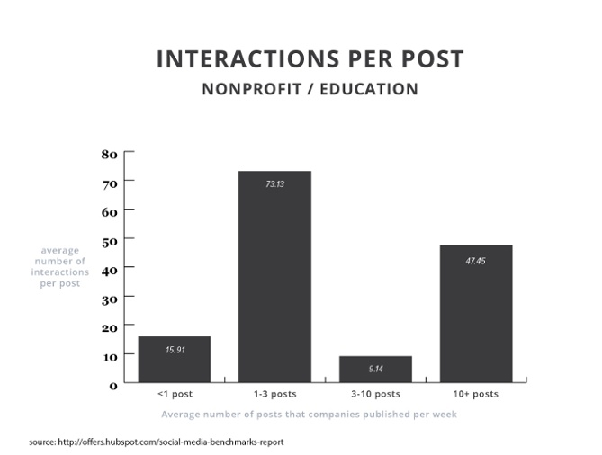

### Key Takeaway

This is one of the more interesting graphs we’ve seen thus far [in our report](http://offers.hubspot.com/social-media-benchmarks-report). There are two sweet spots for this industry when it comes to getting the most interactions per week: companies that post 1-3 times a week, and those that post 10+ times a week. The moral of the story here? Posting as much as you can is worth it, but is not, 2-3 times a week is good.

### How to Apply These Findings

If you’re in the nonprofit / education industry and only posting once a week, try ramping it up to two or three times -- it looks like you’ll be happy with the results. If you want to aim for the 10+ times a week, really take the time to flesh out your [social media editorial calendar](http://offers.hubspot.com/social-media-content-calendar). Can you make Mondays all posts about X? Could you scatter a tips and tricks series throughout every day of the week? Thinking about ways to regulate and repeat some of your content might help you a lot.

Driving people to site through SM

<http://www.convinceandconvert.com/content-marketing/get-more-traffic/?mc_cid=06710f47a2&mc_eid=fa49f02c74>

Best Instagram college accounts:

<http://blog.hubspot.com/marketing/best-college-instagram-accounts?utm_campaign=blog-rss-emails&utm_source=hs_email&utm_medium=email&utm_content=23028859>

choosing hashtags

<http://www.convinceandconvert.com/social-media-strategy/how-to-identify-relevant-hashtags-for-your-business/?mc_cid=6a8d8a66c3&mc_eid=fa49f02c74>

Instagram vs. twitter

<http://sproutsocial.com/insights/twitter-vs-instagram/>

check out Buffer vs. HootSuite:

<http://www.razorsocial.com/the-ultimate-guide-to-bufferapp/?mc_cid=f0ad1bd5dd&mc_eid=fa49f02c74>

best college twitter accounts

<http://blog.hubspot.com/marketing/best-college-twitter-accounts?utm_campaign=blog-rss-emails&utm_source=hs_email&utm_medium=email&utm_content=23845754>

blog formatting

<http://blog.newscred.com/why-formatting-is-the-secret-to-shareable-content-marketing/?mc_cid=72ea98f1fb&mc_eid=fa49f02c74>

getting instagram followers:

<http://www.convinceandconvert.com/social-media-strategy/grow-instagram-following/?mc_cid=43505ceeab&mc_eid=fa49f02c74>

making a web content matrix:

<http://www.convinceandconvert.com/content-marketing/content-library/>

website keyword help (really good):

<http://www.convinceandconvert.com/digital-marketing/does-keyword-optimization-still-matter/?mc_cid=701f30e21a&mc_eid=fa49f02c74>

infographics

<http://www.convinceandconvert.com/content-marketing/build-high-quality-infographics/?mc_cid=a335c3c872&mc_eid=fa49f02c74>

how often to post:

<http://blog.techimpact.org/infographic-2016-nonprofit-communications-trends>