

[Photo credit: Green Roofs for Healthy Cities, http://www.greenroofs.org]

Between September 18th – 20th I attended the Cities Alive conference in Seattle presented by the organization Green Roofs for Healthy Cities. This national conference provided in-depth and expansive breadth around green roofs and walls as a sustainable building solution. I attended this conference to gain a crash course in green roofs while focusing on current policies guiding the implementation of green infrastructure.

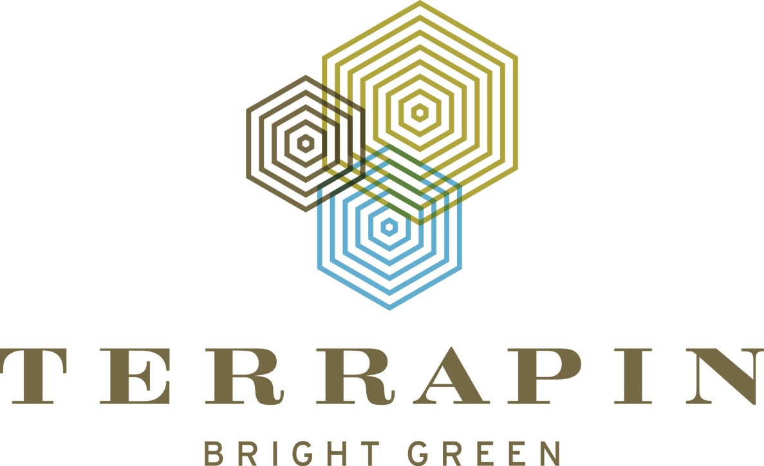

[Photo credit: Terrapin Bright Green: https://www.terrapinbrightgreen.com]

I was able to participate in a Biophilic Design workshop taught by Bill Browning, principal of Terrapin Bright Green. The workshop overviewed the extensive medical research supporting the inclusion of biophilic principles into construction practices. Terrapin Bright Green produced the report 14 Patterns of Biophilic Design (*2014*) and these principles were discussed at length consisting of: *Nature of Space* 1. Visual Connection with Nature, 2. Non-visual Connection with Nature, 3. Non-rhythmic Sensory Stimuli, 4. Thermal and Air-flow Variability, 5. Presence of Water, 6. Dynamic & Diffuse Light, 7. Connection with Natural Systems; *Natural Analogues* 8. Biomorphic Forms & Patterns, 9. Material Connection with Nature, 10. Complexity & Order; *Nature of Space* 11. Prospect, 12. Refuge, 13. Mystery, 14. Risk/Peril (illusion). All of these patterns were understood through the context of human evolutionary processes, which we applied for a green roof design process and critique in the workshop.

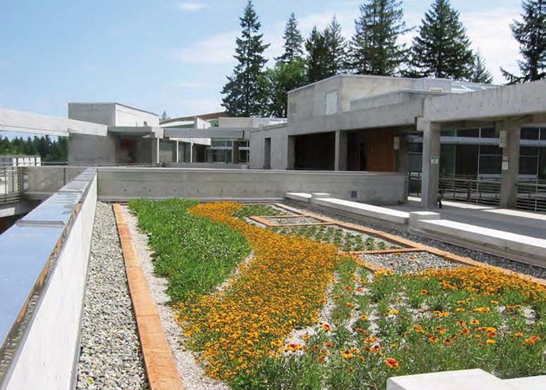

[Photo credit: solaripedia, http://www.solaripedia.com/13/357/4688/seminar_ii_building_veg_roof_flowers.html]

I learned from multiple policy and equity focused presentations throughout the conference. I learned of Portland’s climate adaptation policies requiring green roofs on large downtown building, as well as Seattle’s Green Factor policy requiring green space creation or preservation for all newly constructed buildings. I also learned from a panel discussion on efforts to promote equity through Living Architecture like efforts to establish green walls in the environmental justice communities of South Pak and Georgetown, cities south of Seattle in the Duwamish River Valley, to address the significant local air quality concerns, as well as about King County Green Tools’ efforts in establishing Equity Impact Review processes. Concerns of addressing equity imbalances through certified sustainable building were discussed, and I was shocked to learn that out of Leadership in Energy and Environmental Design’s (LEED) 120-point building rating scale, only 3 points are available for equity design considerations. Even worse, I learned the United States Green Building Council (USGBC) has been very resistant to addressing these concerns.

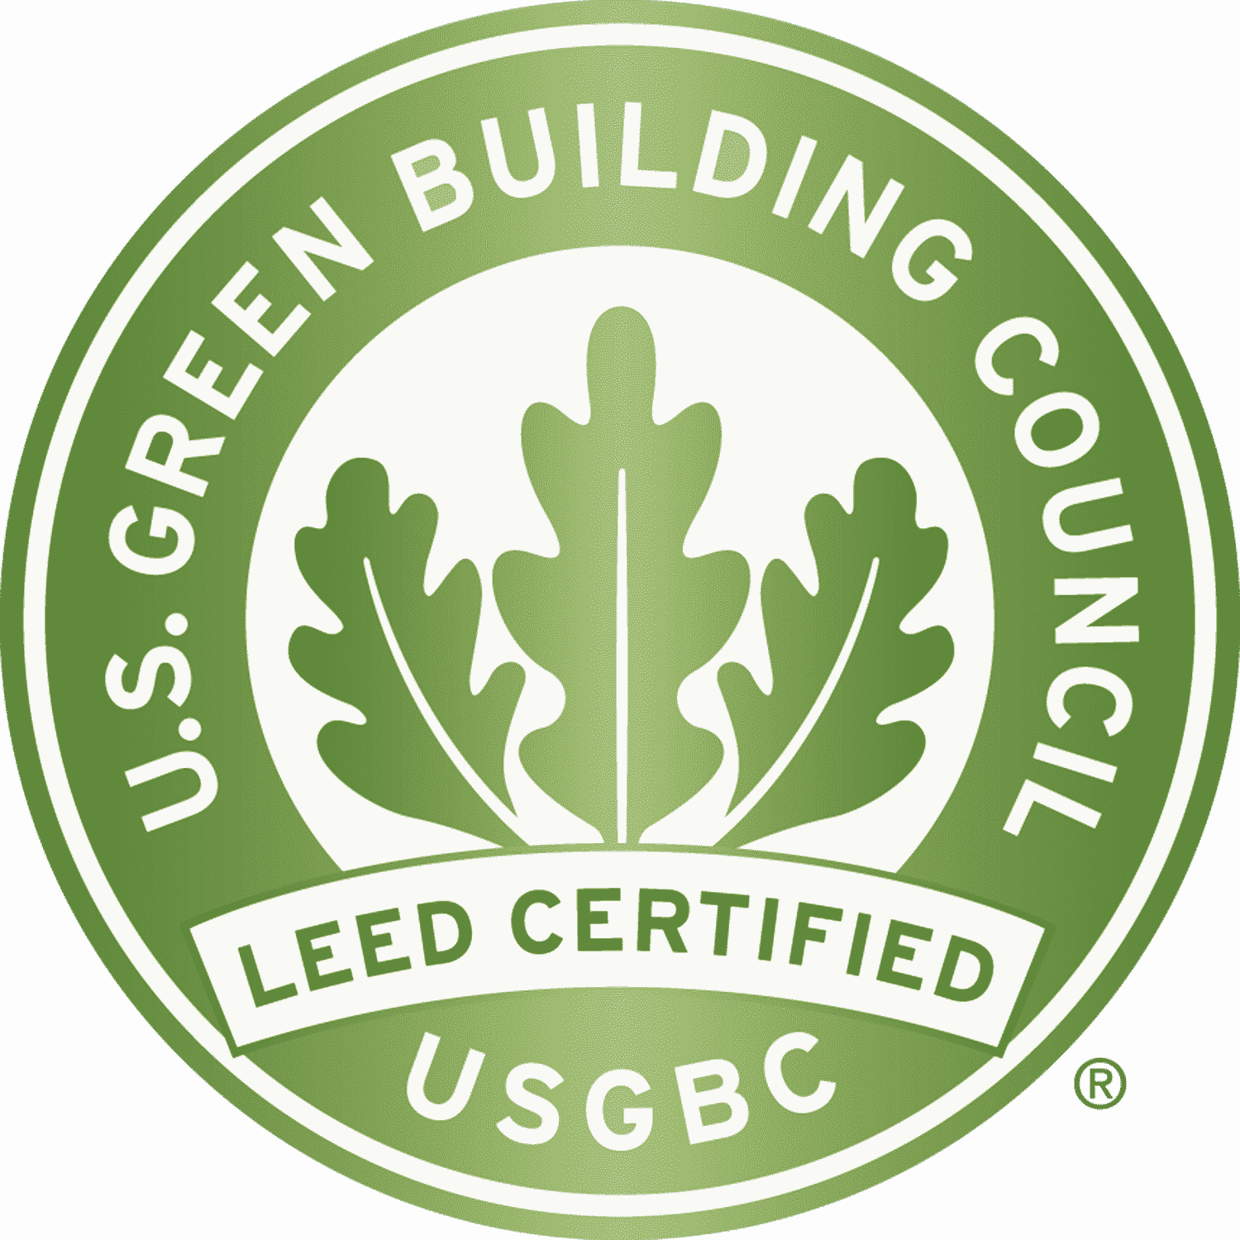

[Photo credit: U.S. Green Building Council, https://new.usgbc.org]

Despite the numerous positives of this experience, I came away from the conference with concerns. This conference did not attract a diverse audience, as most attendees were white middle aged males. This is reflective of architectural and engineering fields overall, as was pointed out through an analysis of demographic data for these fields in the equity panel discussion.

Overall, this conference helped to inform me more on issues to adapt to climate change by including more extended use of green infrastructure. I was excited to learn about King County’s Strategic Equity Plan and meet some dedicated people with King County Green Tools.



[Photo credit: King County Green Tools, http://kingcounty.gov/depts/dnrp/solid-waste/programs/green-building/home-builders-owners.aspx]