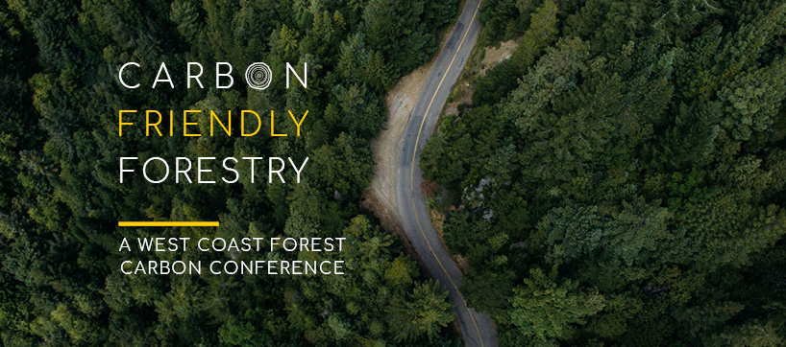

[Photo credit: Washington Environmental Council, https://wecprotects.org/carbon/]

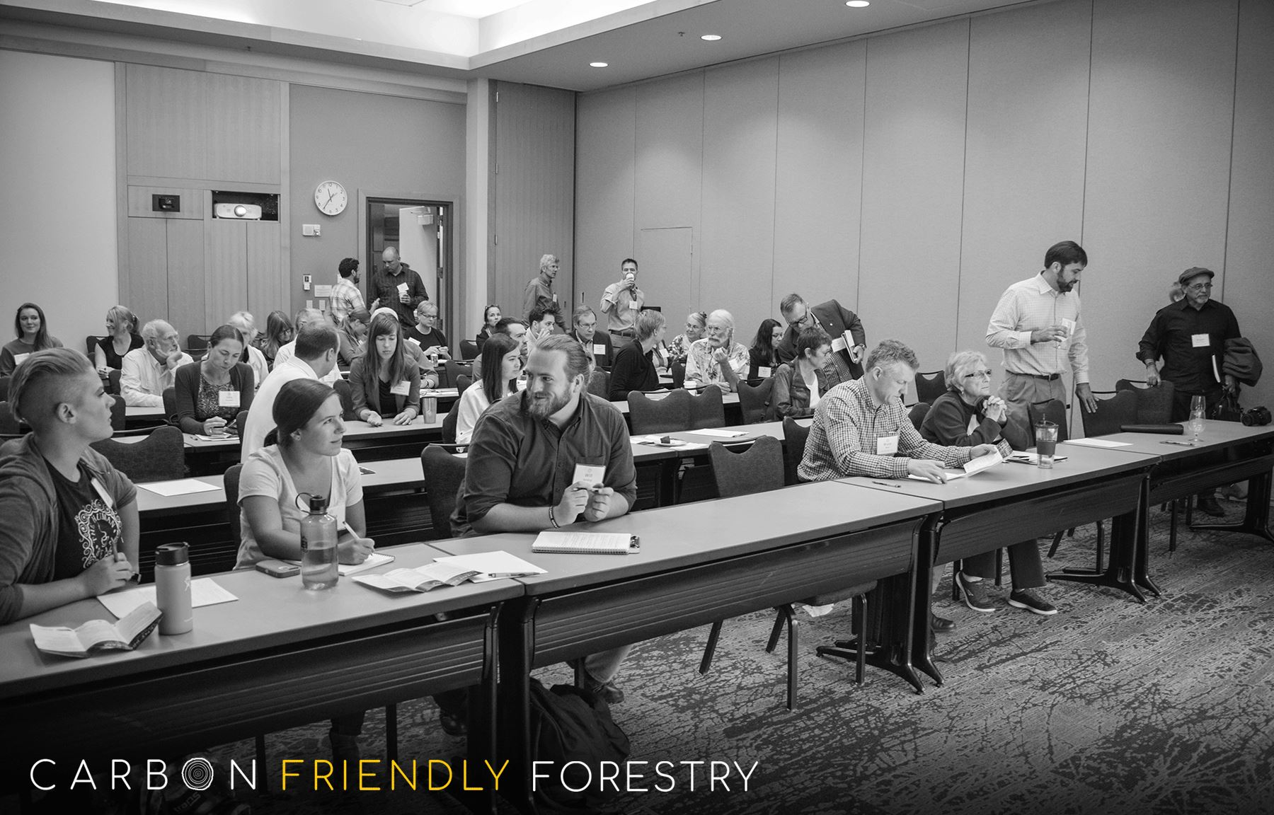I attended the Carbon Friendly Forestry conference at the Cedarbrook Lodge in the Sea-Tac area on Tuesday, September 12th, 2017. Attending was a great experience learning more about Washington Environmental Council’s (WEC) efforts to establish carbon friendly forestry practices by bringing together many interested stakeholders. I attended the event with fellow MES’ers Averi Azar and Katrina Keller (the three of us are pictured below on left side of the front row). It was nice to hear that out of all the colleges contacted to attend the event, Evergreen was the only one to respond and represent with a student presence.

[Photo credit: Washington Environmental Council, https://wecprotects.org/carbon/]

Multiple panel sessions focused the science of carbon sequestration potential of forests, carbon credit markets, and policy options to promote more sustainable forestry practices. It was uplifting to participate in an event like this where the main focus of discussion centered around solutions to address climate change through interdisciplinary concentrations on economic, ecological, social, and political systems. The Commissioner of Public Lands, Hilary Franz, and her policy director spoke on efforts within the state of Washington to make a difference in addressing climate change through more conscious forestry practices.

Many forward-thinking organizations participated in the event and learning about their efforts may have been the highlight of the event for me. I learned about economic drivers resulting in current short-rotation forestry practices and how the developing carbon markets could shift this standard industry practice. I was surprised to learn of the significant impacts of forestry on carbon emissions in the region.

Despite the positives of the event, I had some concerns with the conference. Remarks in the scientific panel indicated resistance to any active management practices in relationship to carbon storage. The flaws with academia were apparent in their distortion from the reality that forests will continue to be vital sources of important resources and there needs to be a greater focus on improving these practices as opposed to resisting them completely. Also, a major concern from this event was the lack of racial, ethnic, and even age diversity as the room was mostly filled with older white people which really limits the effectiveness of events like this. This is an important lesson to come away with to be more effective environmental professional after completing my graduate degree.

On a personal note, I was encouraged to learn about a project I had worked on in the past had inspired small-forest landowners to implement thinning practices to improve forest health with Northwest Natural Resources Group just from pictures of the roundwood structure I worked on constructing as part of an internship as an undergraduate student with ION Eco-Building (pictured below in construction).

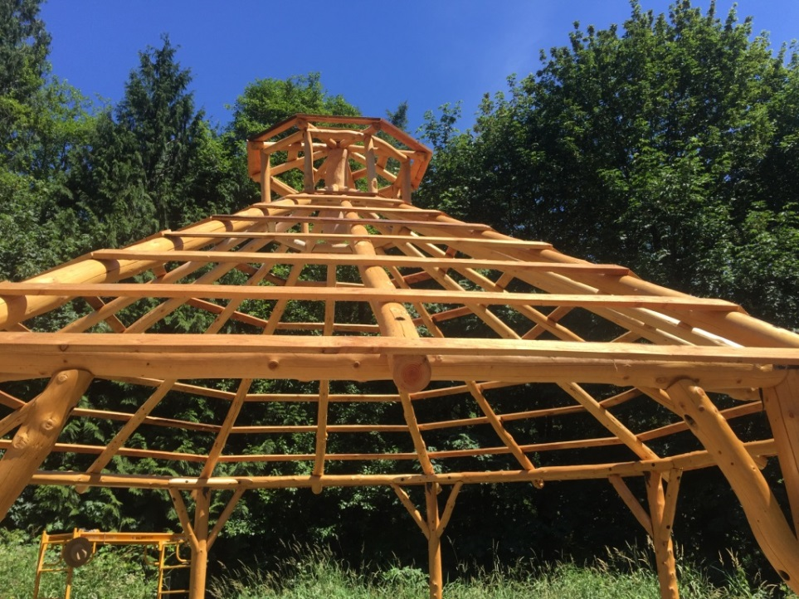

[Photo credit: William Golding personal photograph]

I am thankful to WEC for allowing us to attend the event for free to participate with academic researchers, environmental professionals from the non-profit and for-profit sectors, public officials, green building professionals, product manufacturers, and small forest landowners to learn from a variety of perspectives. (P.S. It was ironic that this forward-thinking conference took place next door to a Northwest Gas Association convention representing two very different ideals.)

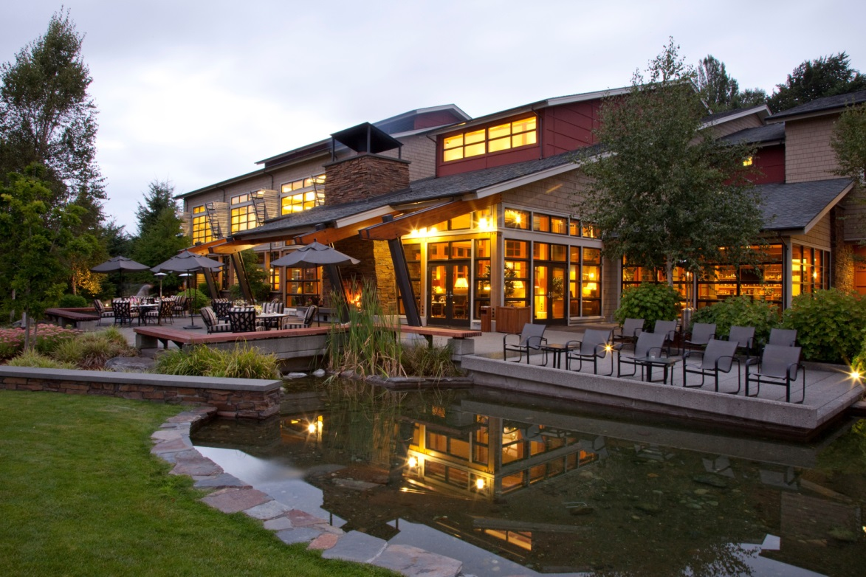

(Cedarbrook Lodge)

[Photo credit: Cedarbrook Lodge, http://www.cedarbrooklodge.com]