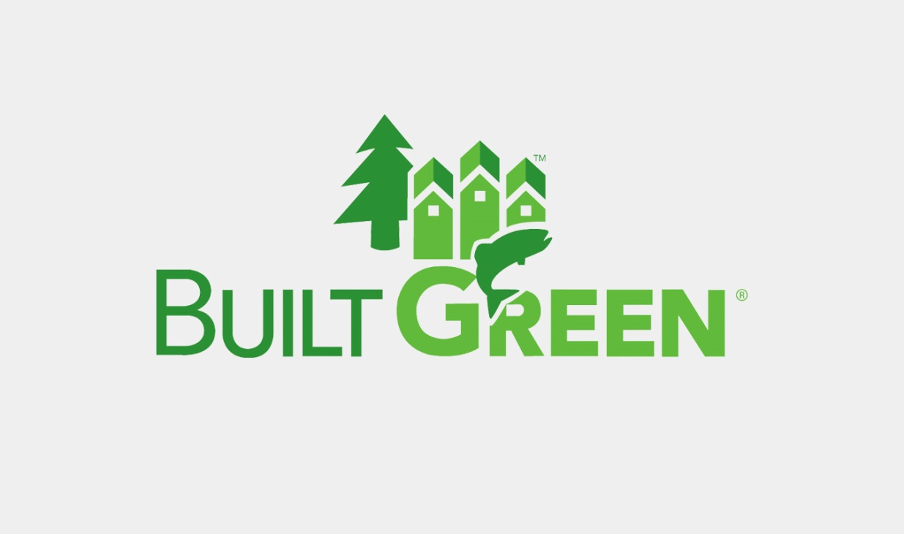[Photo credit: Built Green, http://www.builtgreen.net]

On Thursday, September 14th, I attended the Built Green conference at the University of Washington Bothell and Cascadia College’s shared campus. Built Green is a building certification program in Washington state promoting more sustainable development between the built environment and surrounding ecosystems. This event brought together people from construction fields, financing organizations, real estate agencies, public utilities, construction materials companies, and current/potential public servants. After attending this day-long conference, I came away more informed with current urban development in Seattle and a broader understanding of the challenges facing the Puget Sound region from rapidly increasing population growth.

A major theme of this conference revolved around equity within urban areas. Keynote speaker Alan Durning, founder and president of Sightline Institute, started the day by examining growing concerns of housing equity within Seattle and how multiple factors are resulting in unsustainable living conditions. Alan focused on the shortage of housing options in Seattle driving up prices despite being one of the top five cities for construction worldwide at the moment. Alan focused on the limitations set by single family home zoning throughout the city not allowing for practical in-fill solutions to create more auxiliary dwelling units (ADU) and mother-in-law suites. Teresa Mosqueda, a then prospective and now recently elected Seattle City Council member and Evergreen graduate alumni, added to this understanding by focusing on the historic discriminatory zoning policies of Seattle establishing extensive singe family zoned areas. Both Alan and Teresa participated in a panel discussion with prospective Seattle mayoral candidates Jenny Durkin (recently elected) and Cary Moon.



[Photo credit: Salmon Safe, https://www.salmonsafe.org/getcertified]

Environmental stewardship was also a critical concern for the Puget Sound region’s building and population boom in the face of increasing climate change concerns. I attended a workshop on designing for watershed health by Ellen Southard. Ellen oversees Salmon Safe certifications, a program throughout Pacific salmon country from California to Alaska, working to promote ecological health by reducing stormwater runoff from farms, public parks, and urban development projects. After the presentation, we received a tour of the campus’ wetland restoration project working to restore over a century of human development impacts.

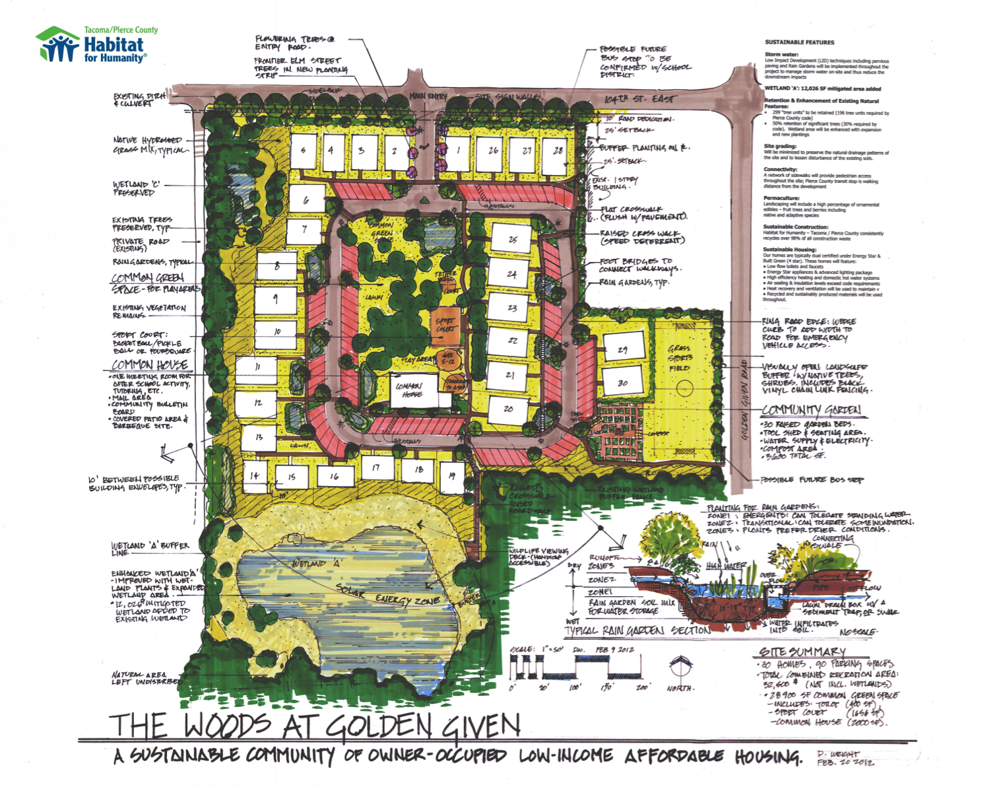

[Photo credit: Tacoma/Pierce County Habitat for Humanity, http://www.tpc-habitat.org]

It was exciting to see a project I had worked on recognized for its innovative design in becoming Salmon Safe certified. The project was a 30-home development by Tacoma/Pierce County Habitat for Humanity, The Woods at Golden Given, that keeps all storm water onsite through exclusive use of pervious pavement on all roads and walkways, extensive rain gardens, and a wetland restoration project in the affordable housing development.

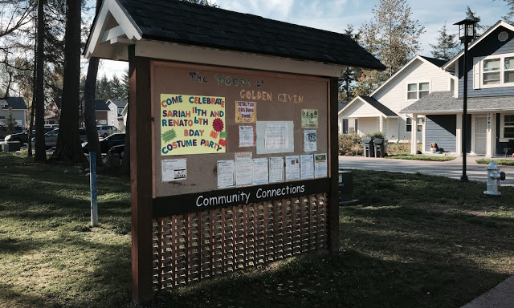

[Photo credit: Tacoma/Pierce County Habitat for Humanity, http://tacomahabitat.blogspot.com/2014/11/2014-building-on-faith-comes-to-close.html]

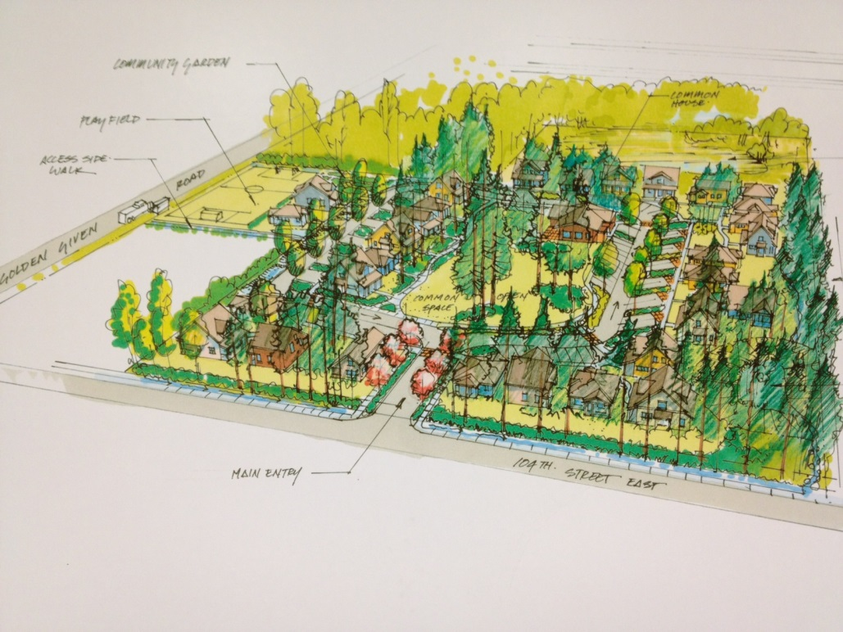

(Aerial rendering of the Woods at Golden Given)

[Photo credit: Tacoma/Pierce County Habitat for Humanity, http://www.tpc-habitat.org]

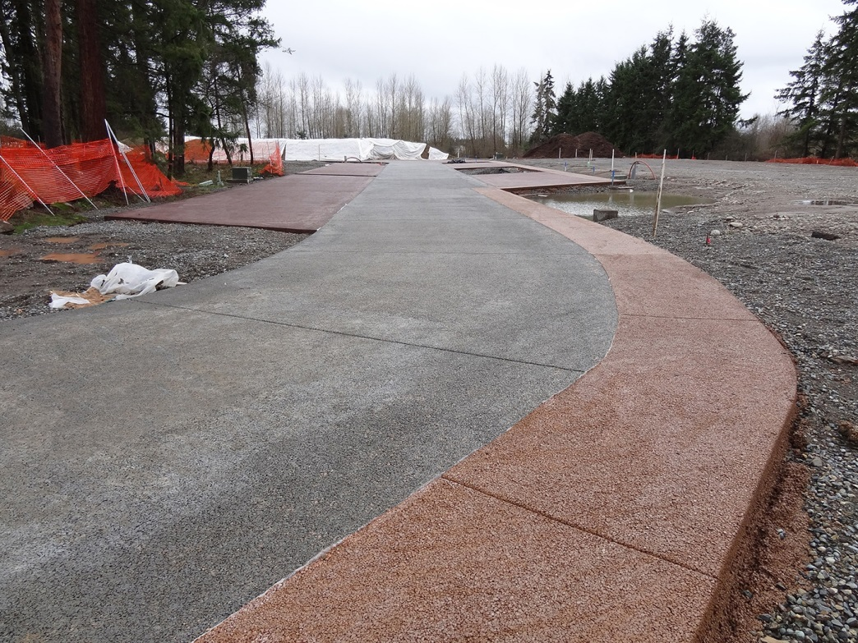

[Photo credit: Architectural Concrete Design, http://acdconcrete.com/commercial/services/pervious-concrete/]

The Built Green conference was a great experience, but there was also room for improvement in general. One concern I had after attending the conference was the lack of diversity in attendees which is reflective of architecture and engineering fields overall. These inequitable trends cannot be addressed unless efforts are made to not only talk about equity, but efforts are made to have more inclusive conferences and networking opportunities creating connections for professional development. This could be accomplished by engaging more schools to get students of color involved to learn about various opportunities.

I am thankful for the opportunity to attend this event and gain some valuable insights, but am also more motivated to continue seeking out solutions for more inclusive and equitable sustainable urban development to ensure more resilient futures. This work is ongoing, but needs to be centered more holistically as builders continue shaping communities.