When I applied for the MES program, I knew I wanted to study environmental education (EE), but whenever someone asked me what EE was before the program started, I honestly did not have a good answer. So! In perfect timing, I signed up for the EE elective with Andrea Martin this fall and the opportunity to learn what EE is all about!

As an optional part of the elective, on October 9-13 2018, we attended the National American Association for Environmental Education (NAAEE) Conference in Spokane, Washington. By we, I mean four students including myself, Shayley Jacobson, Jacob Meyers, and Jesse Dotson. Attending and observing what went on at the conference was a great way to see EE in action and learn about what is happening on-the-ground, outside of the articles and books we read in class.

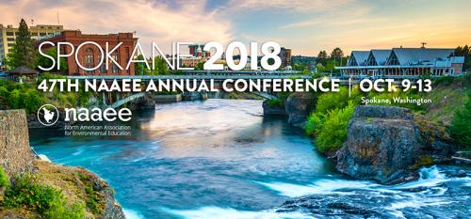

There were over 1,000 people in attendance, mainly EE professionals from a variety of fields. Some worked for government programs, nonprofits, schools, or in research. While there was a good amount of young professionals, we were in no way the majority. But, to highlight youth, NAAEE featured a panel of 6 members from their “EE 30 Under 30.” This is a group of 30 individuals from around the world who are less than 30 years old and are highly impactful environmental educators (pictured below). It was neat to see older attendees as the youth on the panel for advice about the future direction the the EE field.

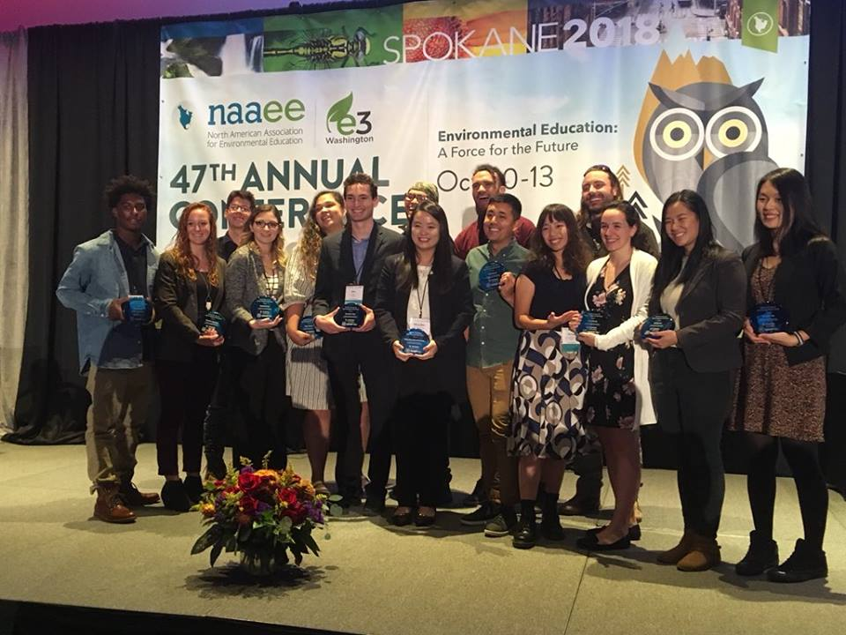

While at the conference, we also got to meet up with Jean McGregor (picture below!), the former EE professor at Evergreen! She has been in the EE field for many years and has watched it grow and evolve, so it was wonderful to be able to hear her reflections about EE and the conference.

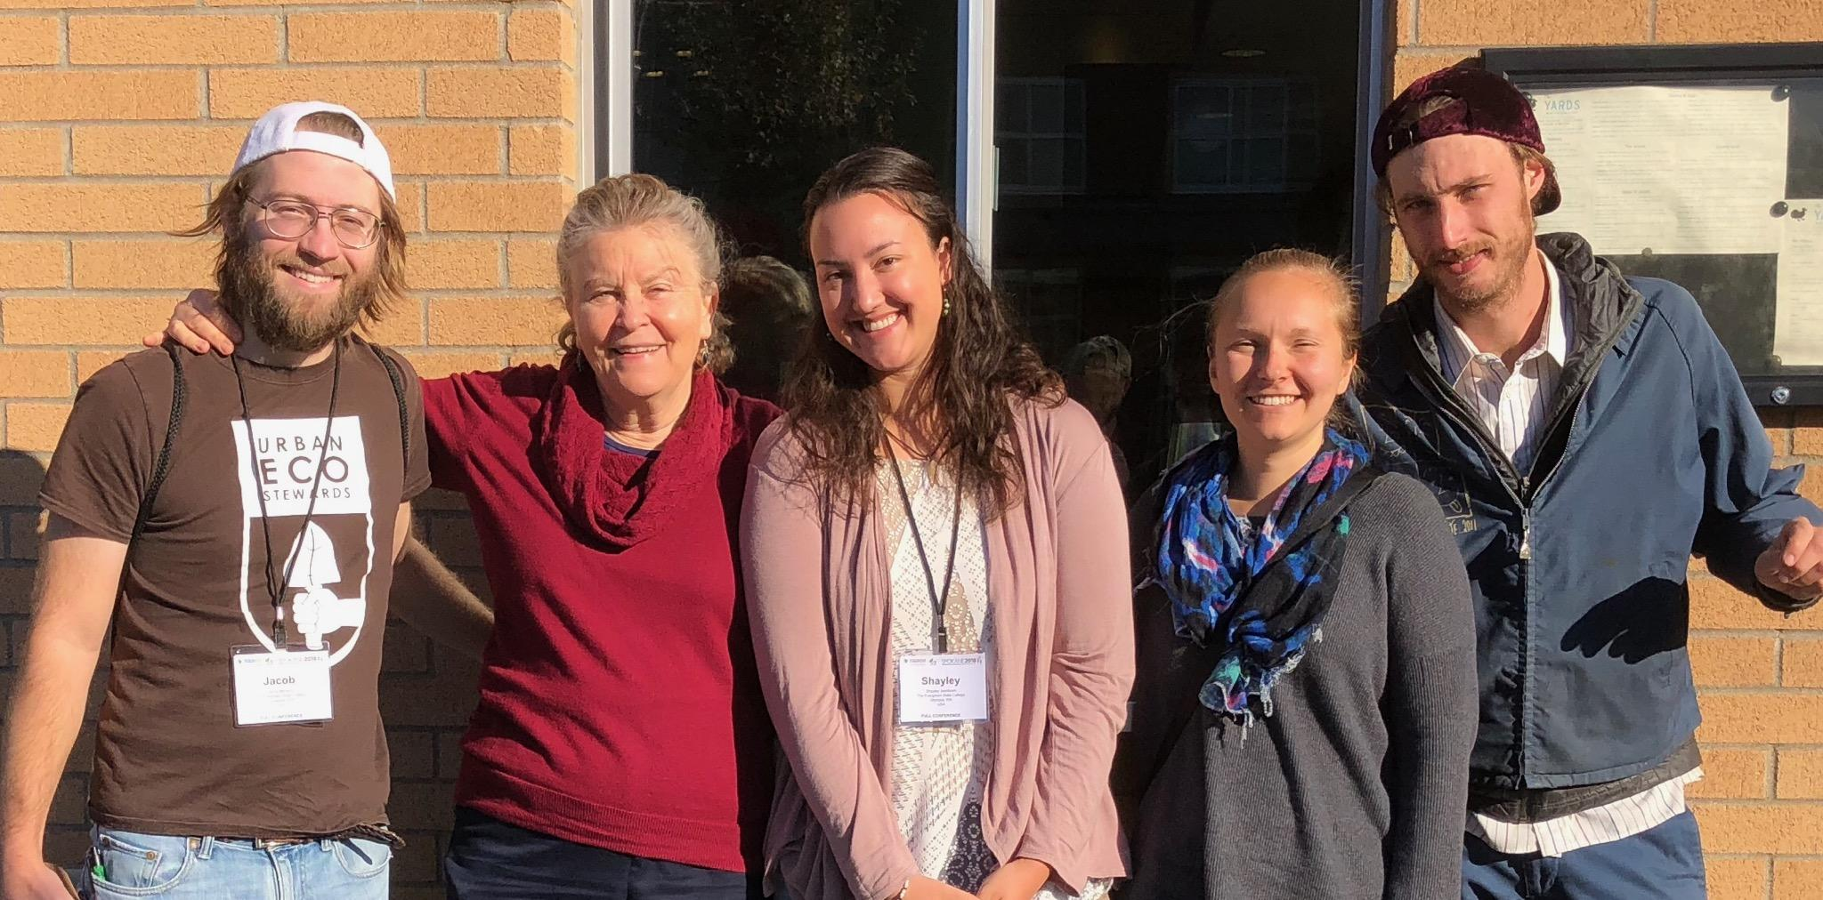

Many of the sessions I attended were interactive. In one, we played a pinball game made from recycled materials, and in another we danced with strips of fabric, weaving them together as we moved around the room. One of my classmates favorite sessions was run by a man who sang his own nature songs; it was a fun change of pace (and we listened to his CD in the car on the drive home). We also got up extra early for a bird watching session one morning (picture below).

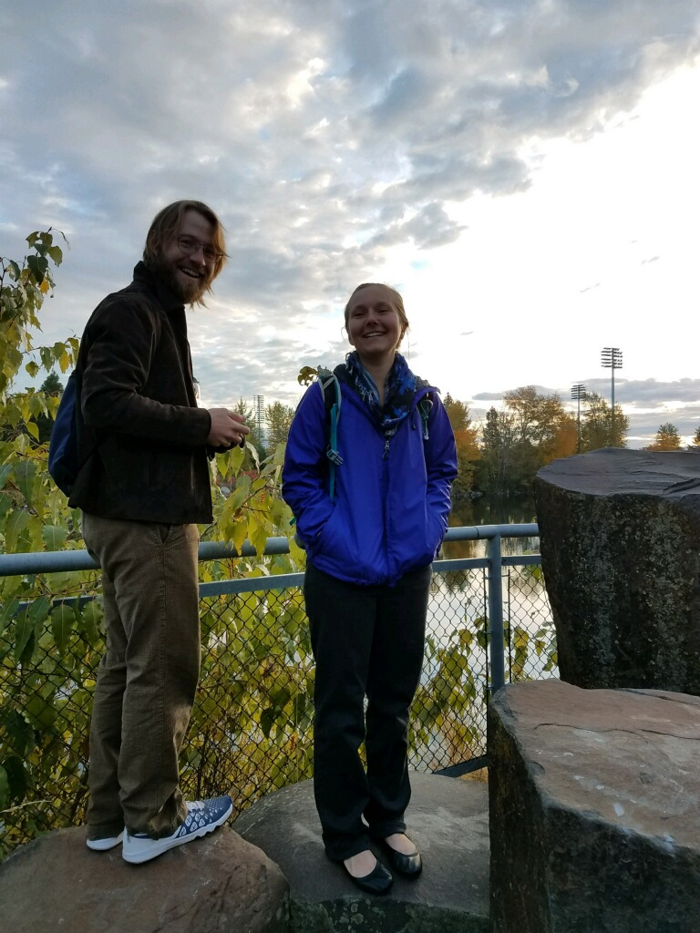

My favorite session was by a branch of the Massachusetts Audubon. They developed a computer program that lets students make zoning decisions about their local community in a virtual world. Different base layers can be added like butterfly habitats or forested areas. They are developing an app of the program that can be used anywhere in the United States using GIS data! While I do not like that technology is a strong focus of our youth, I appreciate that the app combines technology use with learning about the environment and human impact.

Another topic I was glad to see was a focus on social-emotional learning for youth through the use of environmental education. Much of what was discussed dealt with debriefing activities and social-emotional learning models.