PNW Climate Conference Blog 2017

On October 11th, MES students and staff attended the 8th Annual Northwest Climate Conference in Tacoma. From their website (<http://pnwclimateconference.org/>),

“The Northwest Climate Conference annually brings together more than 300 researchers and practitioners from around the region to discuss scientific results, challenges, and solutions related to the impacts of climate on people, natural resources, and infrastructure in the Pacific Northwest.”

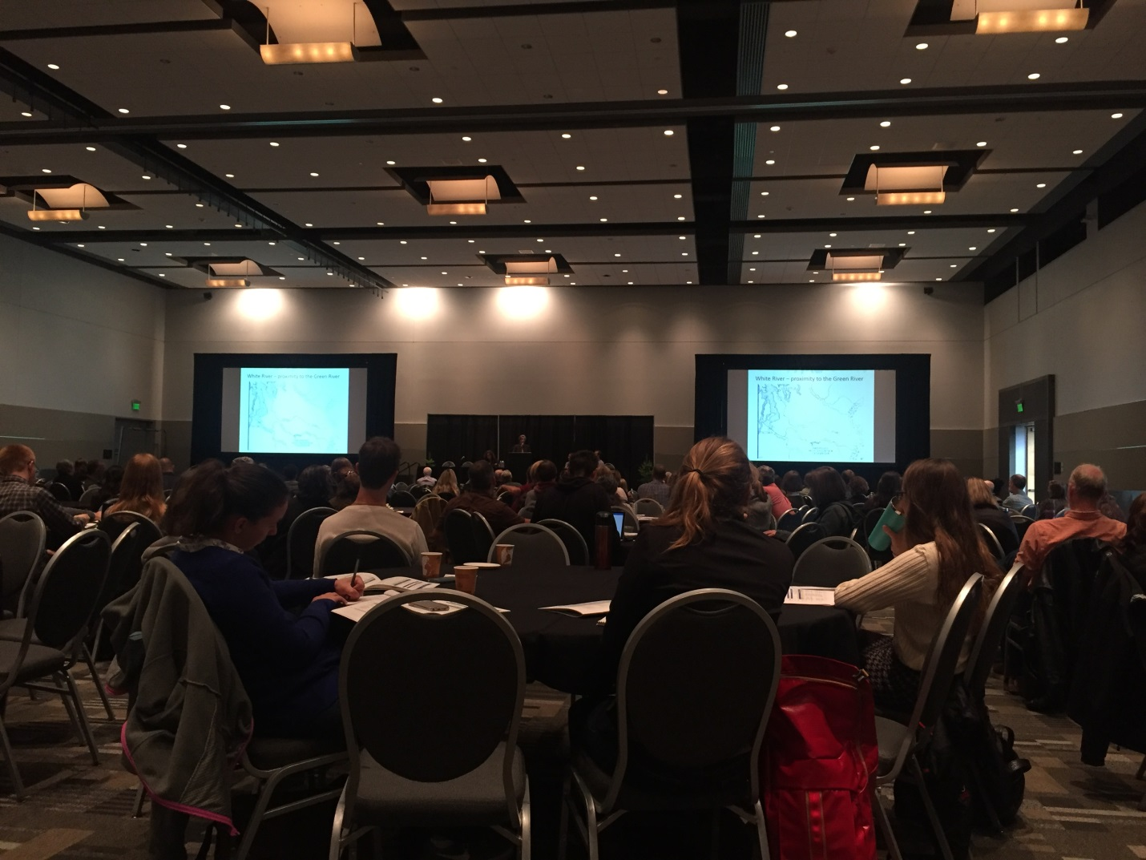

The morning began with a plenary talk and discussion of climate resiliency planning and segued into morning breakout sessions. The breakout included opportunities to attend four different sessions through the late morning. The following tracks were offered: Infrastructure, Pacific Northwest Climate Hydrology, Tribal Communities, and Working Across Boundaries. In the first presentation during the Pacific Northwest Climate Hydrology session, Susan Dickerson-Lange from Natural Systems Design, gave a presentation titled “Stream restoration to buffer climate change impacts on base flows in the Upper Columbia Basin.” Susan described the water storage issues associated with less base flow due to climate change and discussed a potential solution to this issue from a restoration project in Wenatchee. By placing more frequent log jams throughout the length of the river, this restoration style creates obstacles for water flow and widens the stream or river allowing for greater water storage. It is possible that this river restoration technique is more cost effective than reservoirs and more environmentally friendly than dams. Susan concluded that stream restoration may be a more beneficial option to mitigate climate change in the Columbia basin and other watershed systems in the Pacific Northwest because it offers large-scale river and stream restoration opportunities.

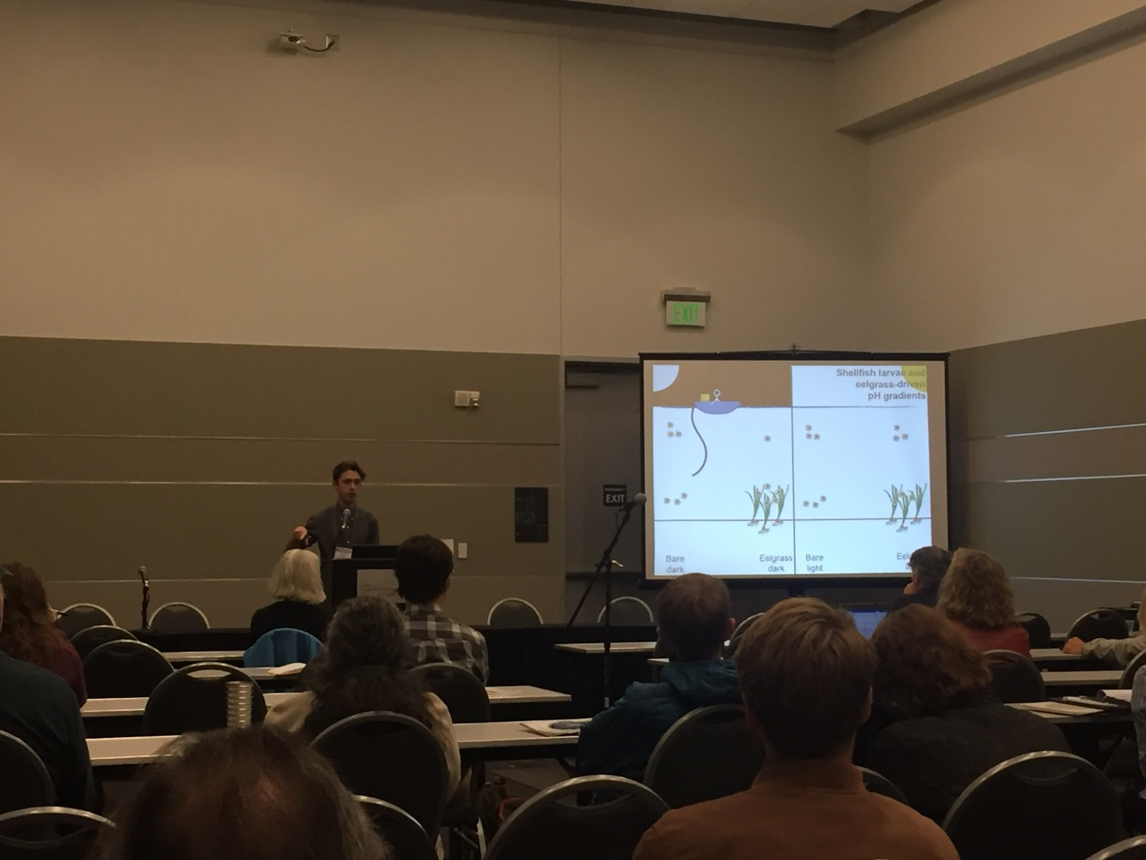

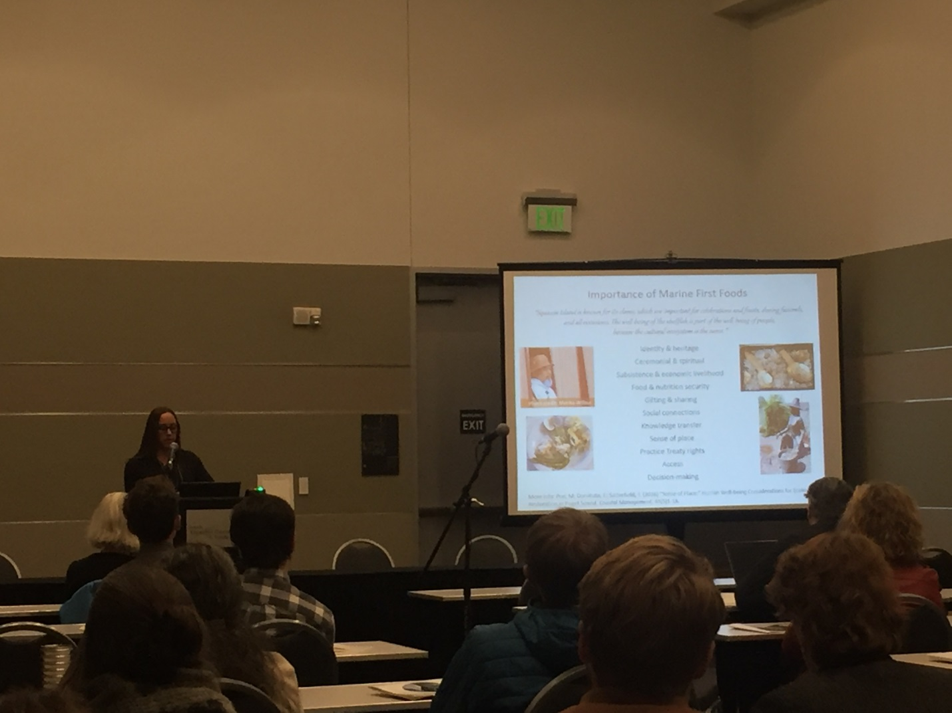

In the afternoon, the conference offered four special sessions: “Coastal & Marine Environments: Multi-disciplinary perspectives of ocean acidification,” “Infrastructure: Storm water and Flooding in King County: Co-producing research to support adaptation,” “Terrestrial & Aquatic Ecosystems: Picking Climate Change Winners and Losers in the PNW Depends on Methodology and Scale,” and Working Across Boundaries: Catalyzing community resilience: bridging science and local action.” During the Coastal & Marine Environments session, four presenters talked about the impacts ocean acidification will have on Washington state, on eelgrass, on policy and management practices and on the socio-cultural dimensions of ocean acidification with the Squaxin Island Tribe. The presenters engaged in a panel discussion with their audience after their talks to discuss, in detail, the implications of their work and the effects ocean acidification will have on marine life and on people. During the discussion, panelists and audience members talked about the negative impacts ocean acidification will have on countries on the front lines of climate change who have limited money and resources. The panelists hoped to bring the knowledge and resources they had developed to mitigate ocean acidification to countries that do not have the knowledge and money. One audience member spoke up questioning this assessment of the ocean acidification dialogue. The knowledge of individuals on the front lines of climate change should not be underestimated just because it doesn’t fit the conventional model of scientific knowledge and climate change solutions. Hopefully it won’t be up to the countries with all the money and resources to find global solutions to mitigate climate change impacts. Ultimately, this would perpetuate the one-size-fits-all climate mitigation model of western science and continue to silence knowledge different from that found in traditional scientific practices. Mitigating the impacts of ocean acidification shouldn’t be a one sided conversation where countries with western science and money tell others how to develop resilience. It should be a mutually beneficial conversation with an equal exchange of knowledge and ideas that meet the unique challenges of individual ecosystems and peoples.