A sneak peek into an MES thesis: Riparian microclimate variability on the Olympic Peninsula

By Katrina Keleher

If you, like me, are interested in forest ecology and forest management, then you have stumbled across the right blog post! For my MES thesis research, I am studying the spatial and temporal variability of riparian microclimate on the Olympic Peninsula of Washington State. I am using three years of microclimate data from Washington State Department of Natural Resources (DNR) along with data I collected this summer to analyze microclimate trends in riparian buffers across ten watersheds.

**Huh? What even is microclimate? A mini-climate?** Exactly!A microclimate is a local set of climatic conditions for a very small area, and it includes variables like moisture, temperature, humidity, wind speed, light, and precipitation. Like many riparian processes, literature has shown that microclimate can be negatively impacted by adjacent timber harvest. It is important to understand how microclimate variables are impacted in these areas since so many riparian processes and organisms depend on them. Not only does microclimate provide suitable conditions for riparian plant growth, but it also maintains in-stream temperatures while providing cool, moist conditions alongside streams which amphibians, small mammals, and invertebrates require. Despite the significant role of microclimate in riparian systems, few studies have characterized microclimate processes as they relate to forest management and ecosystem integrity.

**Okay! Now I know what microclimate is. But tell me more about your study. Where are your data from?** I’m glad you asked! (OK—well, I guess I’m technically the one who asked since I’m writing this in Q&A format, but, ahem, moving on…) The data I am using are from 2014-2016. Of the 50 sample watersheds included in DNR’s *Status and Trends Monitoring of Riparian and Aquatic Habitat in the Olympic Experimental State Forest* project, 10 were randomly selected to be monitored for microclimate. Within each of these 10 sample reaches, microclimate monitoring stations were placed along five randomly chosen 60m transects on either side of the stream. Data loggers were installed at 0, 10, 20, 40, and 60m along each transect and they recorded air temperature and humidity every 2 hours for three years. Two transects within each basin were randomly selected to be included in this analysis, for a total of twenty transects.

**Tell me more about your study area!** My study area is awesome. The DNR-managed [Olympic Experimental State Forest](https://www.dnr.wa.gov/oesf) (OESF) contains over 270,000 acres of state trust forestlands on the Olympic Peninsula. The objective of the OESF is to produce revenue for state trust land beneficiaries (including schools and hospitals) through timber harvesting while maintaining ecological values across the landscape.

**What microclimate variables are you looking at?** I am looking at two microclimate variables: 1) air temperature, and 2) vapor pressure deficit (VPD).

**Vapor pressure what?** Vapor pressure deficit! VPD is the difference between the amount of moisture in the air and the moisture-holding potential the air has when it is saturated. To calculate VPD, you subtract actual vapor pressure (which can be calculated from relative humidity) from saturated vapor pressure (which can be calculated from temperature). Compared to relative humidity, VPD is a much more biologically significant variable to look at since it is independent from temperature. So, VPD it is!

**Got it. So, what else are you looking at? And how are you going to run your analyses?** Excellent questions. Along with my two dependent microclimate variables, I’m looking at a number of discrete predictor variables, including: 1) distance from stream, 2) height above stream, 3) solar radiation, and 4) percent canopy cover. I am creating mixed models with both fixed and random effects in [R](https://www.r-project.org/about.html) to determine a rank of significance for my independent variables. I will be examining the linear relationships between these variables across a number of spatial and temporal scales. I’m particularly interested to see how microclimate gradients are expressed within each transect (i.e. from stream upwards) and what ecological drivers might be influencing these gradients.

**Cool. But, no offense, who really cares about all of these linear relationships?** Besides me (and hopefully after reading this, you!), a lot of people care about this study. The results of this study will contribute to the validation of assumptions about stream influence on microclimate by the State Lands Habitat Conservation plan while providing a baseline for riparian microclimate in second-growth watersheds adjacent to timber harvest activities. Additionally, this study will advance the greater scientific community’s understanding of microclimate and its significance within riparian ecosystems, which could contribute to future designations of riparian management areas. When we manage land, it is important that we understand the complex ecological processes occurring on those lands. The more we understand, the better we can manage for ecological resilience while simultaneously producing revenue.

**Want to learn more?!** I will be presenting my results on April 24 at the 2019 Olympic Experimental State Forest Science Conference at the Rainforest Arts Center in Forks, WA. The conference is free and open to the public, but registration is required. To register, send an email with the words “Yes I will attend” in the subject line to Jessica Huggins at [Jessica.Huggins@dnr.wa.gov](mailto:Jessica.Huggins@dnr.wa.gov) by April 20.

Finally, I would be remiss to not thank my DNR project team: Warren Devine, Richard Bigley, and Teodora Minkova. This project would not be happening without them.

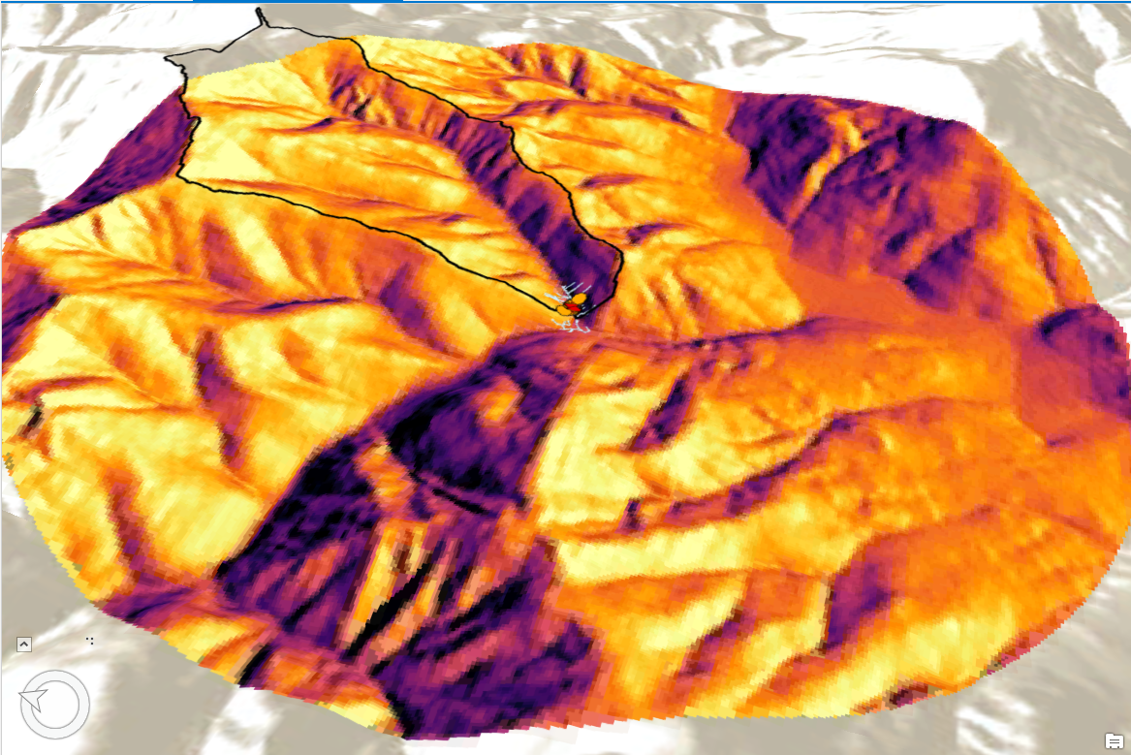

A 3D representation of the solar radiation output raster for one of my ten study basins. The darker colors indicate greater amounts of solar radiation (in WH/m2). Solar radiation was calculated using the Area Solar Radiation tool in ArcMap, and was run for the 15th day of every month (Jan-Dec) for the year of 2015.

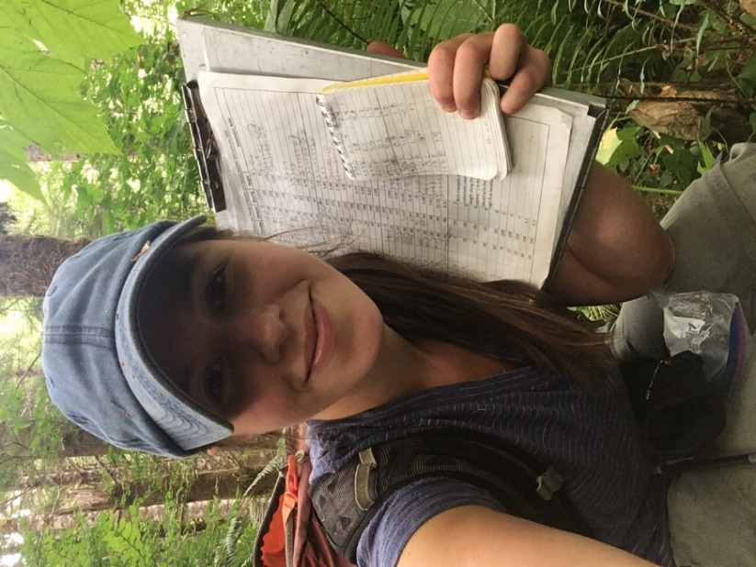

Here I am! Collecting data in the OESF last summer. Yes, those are crumbled leaves on top of my hat. Science isn’t always chic.

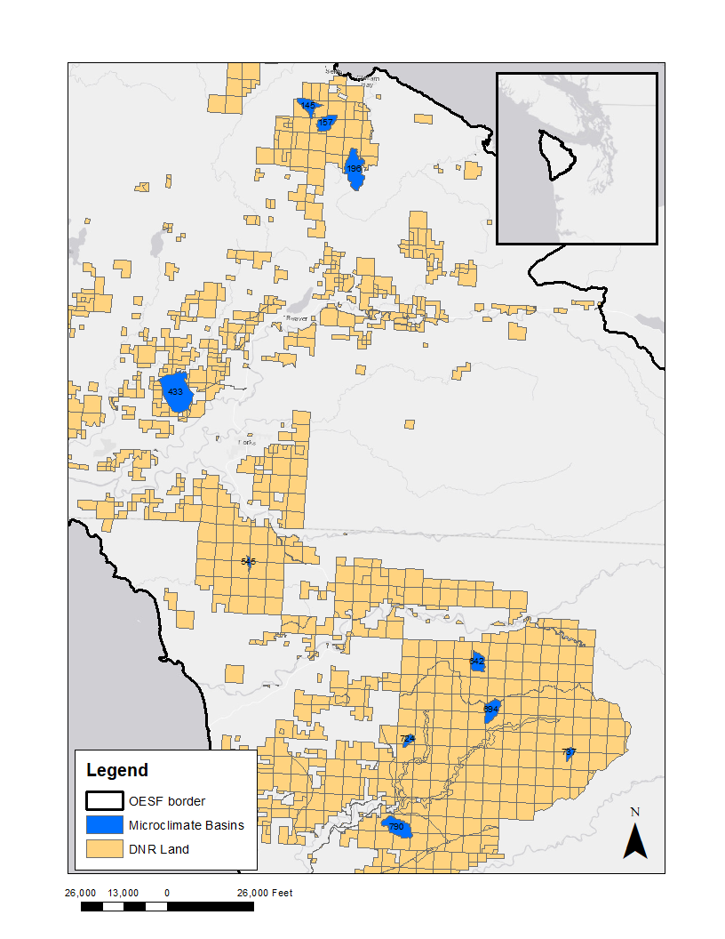

Map of the study area, with the ten microclimate basins characterized in blue.

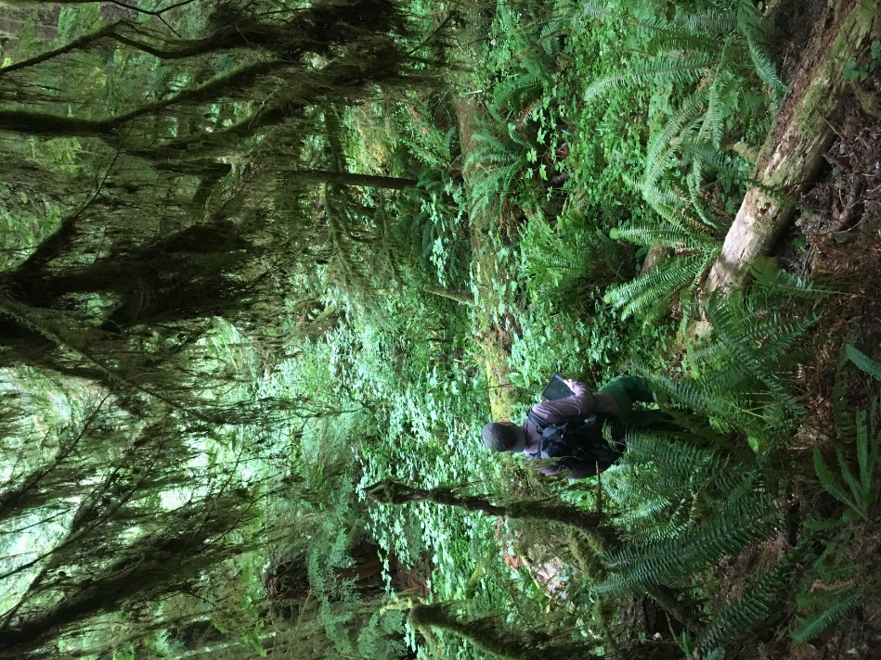

Warren Devine, the Data Management Specialist for the OESF and my DNR mentor, walking down one of our study transects last summer. I’m pretty sure I tripped over a log immediately after taking this photo.

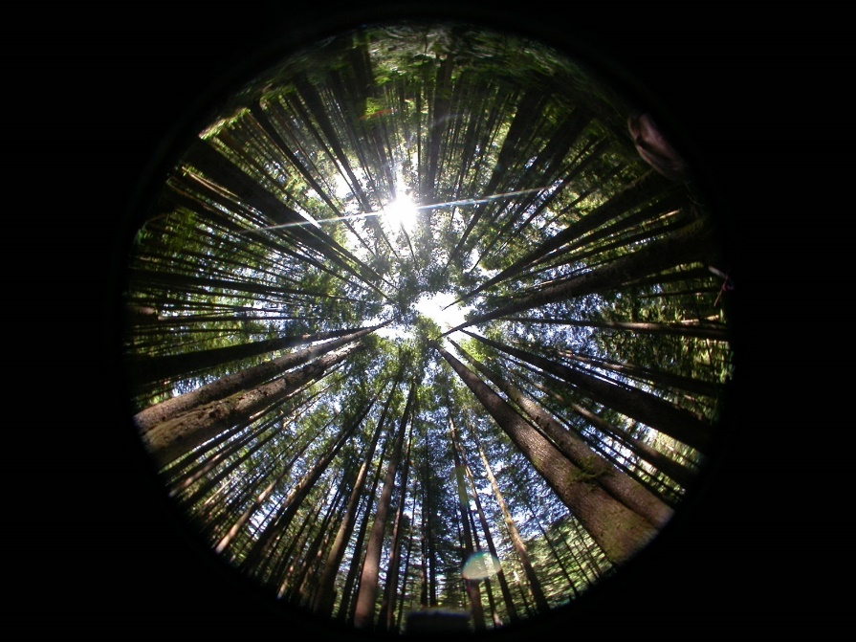

Hemispherical photos from vegetation surveys were captured at each logger along each transect in 2014 by DNR technicians. Percent shade cover was calculated from these photos. Credit: DNR.