MES Blog

FUNGI, MICROSITES, AND FORBS: My second year in the MES

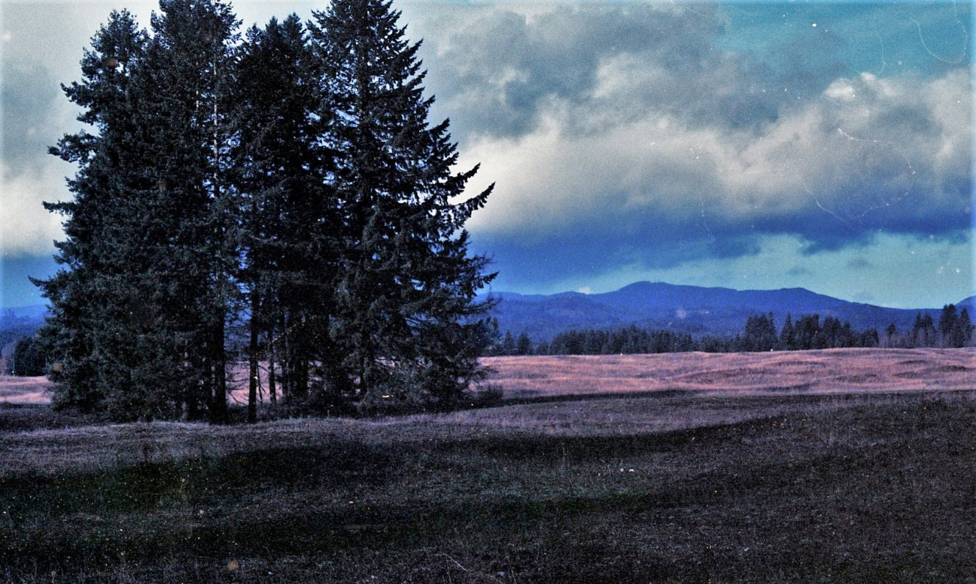

Glacial Heritage, one of my three study sites

Hi, I’m John, lover of the natural world – especially fungi. Here is the story of my second year in the MES, enjoy!

At the conclusion of my first year in the MES program at Evergreen I knew that I wanted to include some aspect of mycorrhizal ecology into my thesis work and research question. I had just completed my candidacy paper on the role of below ground plant-soil feedbacks in plant invasion outcomes and was eager to continue to learn about the incredible fungal mutualists that dominate the soil ecosystem. For those who are unfamiliar with mycorrhizal fungi, the latin name gives some insight: *myco* meaning fungus and *rhiza* meaning roots. Mycorrhizal fungi colonize roots of hosts plants to receive food from the plant. In exchange fungi provide the host with a myriad of benefits including increased disease resistance, increased access to water, and increased uptake of nutrients.

Finding a research question that included a mycorrhizal slant is not too difficult, these symbionts are pretty ubiquitous, approximately 80% of land plants maintain some kind of mycorrhizal connection. I knew from the literature that mycorrhizal fungi would be expected to be present and abundant in some of the prairies that we have in the South Sound. These prairies are stressful environments characterized by low nutrient levels and excessive water drainage. These soil conditions are legacies of glacial retreat approximately 10,000 BP that laid down the gravely glacial till that are found today in the Puget lowland prairies. Colonization by mycorrhizal fungi can be expensive, meaning they require a lot of photosynthetically derived carbon from the plant (upwards of 80%). While expensive to the plant, these fungi are likely important partners in the harsh prairie environment. This all leads me to expect mycorrhizal fungi to be abundant and important to natural maintenance of the South Sound Prairies.

Working with Sarah Hamman, an associate professor in the MES and a restoration ecologist at the Center for Natural Lands Management (CNLM) we identified some priority forb species that have been difficult to restore to some of the land managed by CNLM due to low germination and even lower survival rates. Balsamorhiza deltoidea, Erigeron speciosus, and Gaillardia aristata were identified as priority species due to their status as high-quality nectar sources for pollinators, especially endangered invertebrates such as the Taylors Checkerspot. 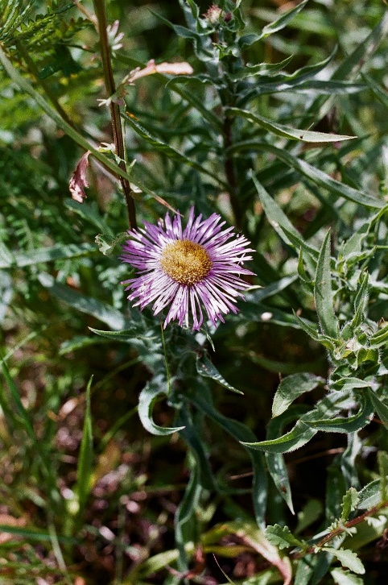

The study I have embarked on is modeled closely on a 2016 paper by Dunwiddie and Martin where the goal was to identify some habitat requirements of a rare and endangered forb, Golden Paintbrush (*Castelejia levisecta*). Out the all the parameters this paper considered, the microsite type was the best predictor of Golden Paintbrush survival. The idea of the microsite comes from the glacial legacy mentioned above. Approximately 11,000 years ago the Vashon Ice sheet reached its southern most extent, right around Olympia. As the climate warmed with the end of the geologically recent younger dryas glaciation, the Vashon Ice sheet which covered the Puget Sound on up into British Columbia began to recede north. At the glacier’s terminus immense amounts of stored sediments began to be expelled as melt intensified. The way that these sediments arranged themselves over the landscape has resulted in a diversity of soil topographies and aspects, which are termed microsites. The most well-known microsite of this region is the Mima mound. These mounds which are found at the Mima Mound Natural Preserve, as well as many other South Sound Prairies. Swales, inter-mounds, slopes, and uplands are all different ways to describe the diversity of microsites found in the Puget lowland prairies. In addition to the topographic diversity that aids in defining microsites, Soil structure also varies between microsites. Mounds are composed of finer deeper Nisqually complex soils while other microsites are often made up of shallower and more gravelly Spanaway type soils.

Erigeron speciosus

Enough about glaciers and soils, lets get back to my research question. Ultimately, we are trying to characterize the habitat characteristics of some of these restoration species. If we know what some of their preferred microsites are then managers and restorationists can make more informed decisions on where and how to reestablish these species – more bang for their buck, and bucks can be tight in the world of restoration ecology! I am looking for correlations between microsite and germination for both Balsamorhiza deltoidea and Gaillardia aristata and am looking for correlations between microsite and survival for Gaillardia aristata and Erigeron speciosus. Survival data comes from species that were seeded and observed for germination by CNLM in 2017 and observed by myself and some technicians for survival in 2018. All the species we looked at are long lived perennials.

Where does the mycorrhizae come into all of this? Questions certainly lead to more questions… If some of these species do indeed show preferences for certain microsites then the question becomes what is the underlying mechanism of that preference? Soil type may differ between microsites, but is that difference biologically significant? Is it differing moisture regimes between these microsites that is causing microsites to select for certain species? Anecdotally microsites seem to be composed of different plant communities. Just by eyeballing these microsites one 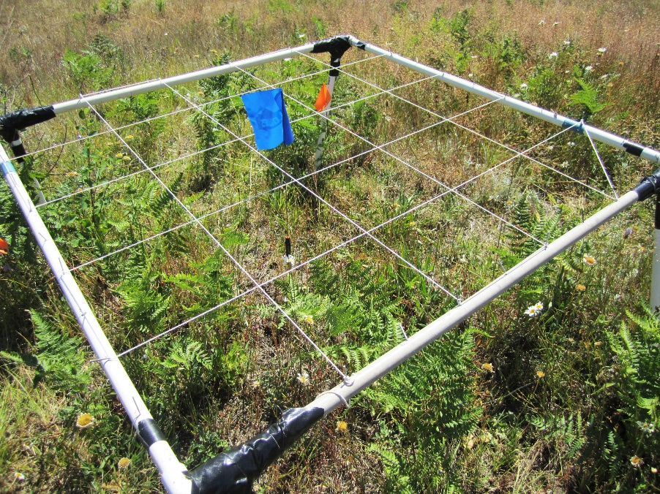can see more vigorous growth on the mounds vs the surrounding inter-mounded areas. Is it the established plant communities associated with microsites that are exerting some kind of control over germination and survival of restoration target species?

A high-tech method for determining functional plant cover: point-intercept method

I am taking the approach of ‘take a little look at everything’ to try and understand what about the microsite may allow them to select for certain plants. In addition to looking at moisture, plant diversity, and soil structure as underlying mechanisms I am very interested if differences in mycorrhizal fungal abundance may play a role in restoration outcomes. To do this I have set up a lab where I take soil samples from the field, extract the phospholipids, blast the phospholipids through a gas chromoatograph, and use the lipid signatures as biomarkers for mycorrhizal fungi. Results are starting to come in and hopeful they will reveal a narrative of what is most important for establishment of some of these rare and important pollinator habitat forbs. Stay tuned for part II!

Me and my chloroform