This past summer I had the opportunity to begin my thesis research at Mount Rainier National Park (MORA) by collecting Cascade red fox and coyote scat samples. My thesis project is looking at the prevalence of endoparasites and viruses within these wild canid species to help aid future conservation measures for the rare Cascade red fox. Scat samples were mostly collected by a team of wildlife surveyors working under my advisor and thesis reader, Tara Chestnut (MORA wildlife ecologist). Tara introduced me to the issues surrounding Cascade red fox and this potential project when I took her Disease Ecology elective during my first year in MES. My interest in the fox project was piqued because it combines my love of disease ecology and wildlife conservation.

On one visit to the mountain, my son Grayson and I joined up with one of the scat survey workers to hike a trail in search of scat. Prior to our hike drove up near Paradise to follow up on a report of a Cascade red fox pup sighting. After walking the road for several minutes, the mama fox appeared on the cliffside and walked across the road. All of sudden, out popped two fox pups—one with a red coat and the other with black coat! What an experience! Check out the video I took of these pups running around and playing. (link: https://www.facebook.com/MountRainierNPS/videos/1612440445492679/)

The beautiful and majestic Mount Rainier

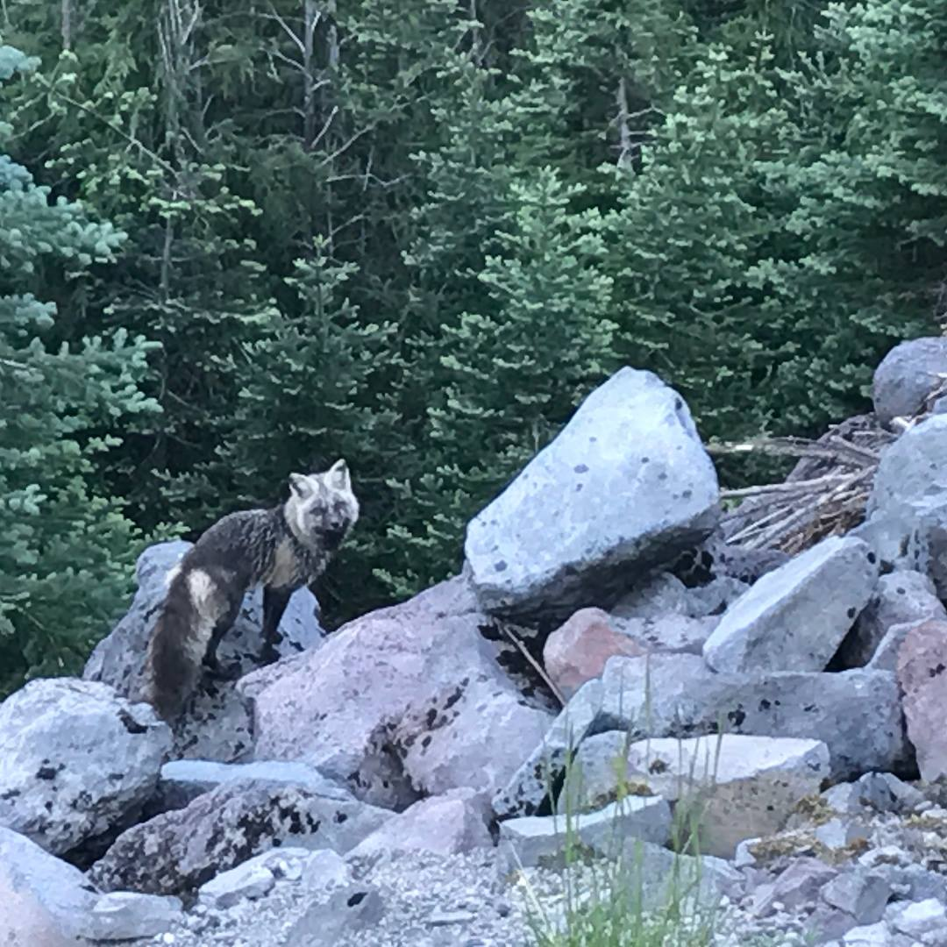

Mama Cascade red fox just outside of Paradise at Mount Rainier National Park.

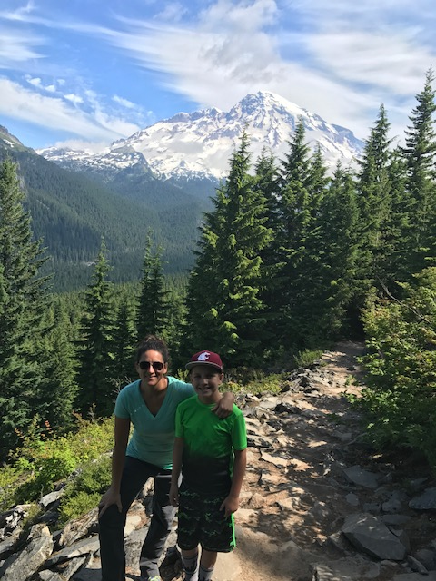

Grayson and I on our hike in search of scat.

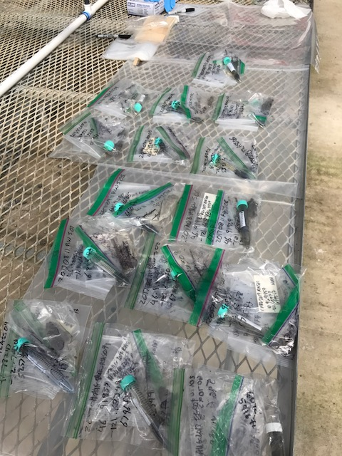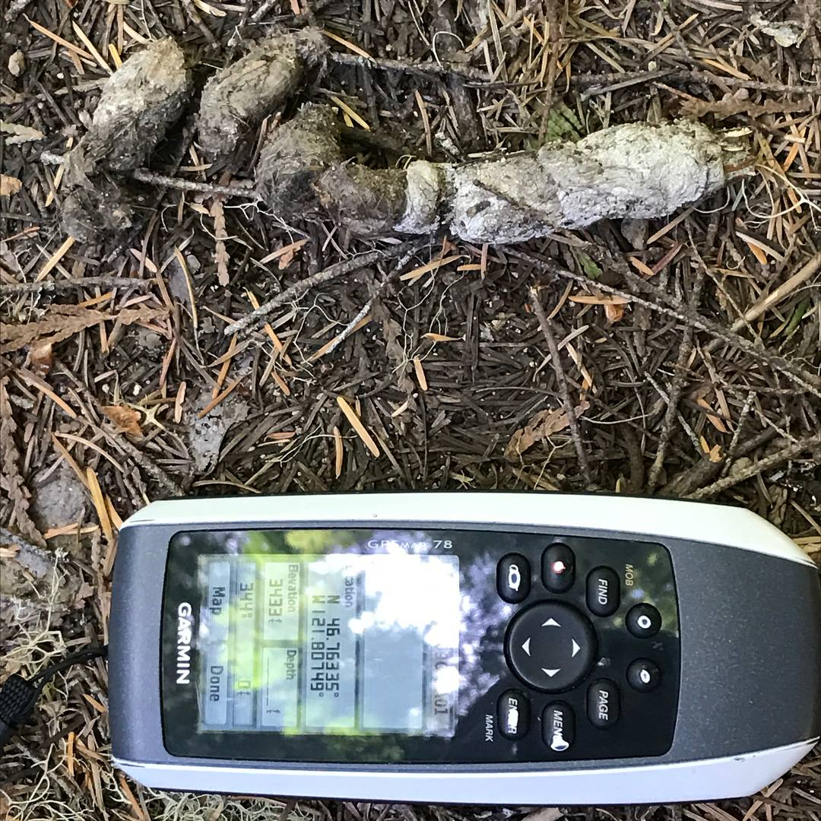

Other visits to MORA were spent separating each scat sample into four bags that I had to label with their coordinates. This was a very time consuming endeavor.

Although we didn’t find any fox scat, I did spot this coyote scat. Each scat is photographed with GPS coordinates to document the location it was found.

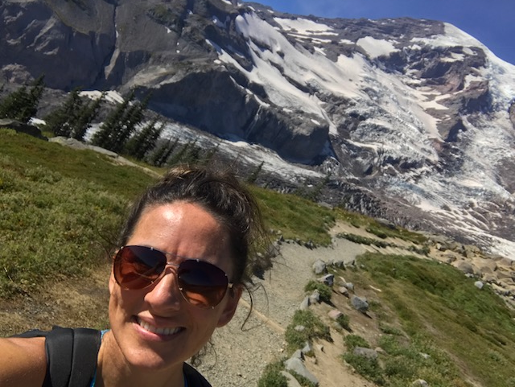

The best part about doing research at Mount Rainier was getting to enjoy the hiking trails!