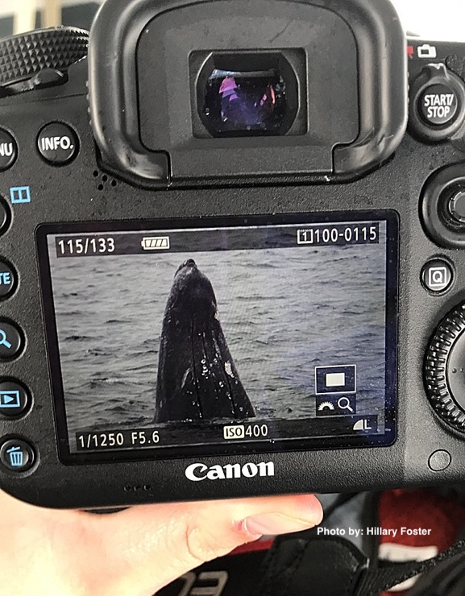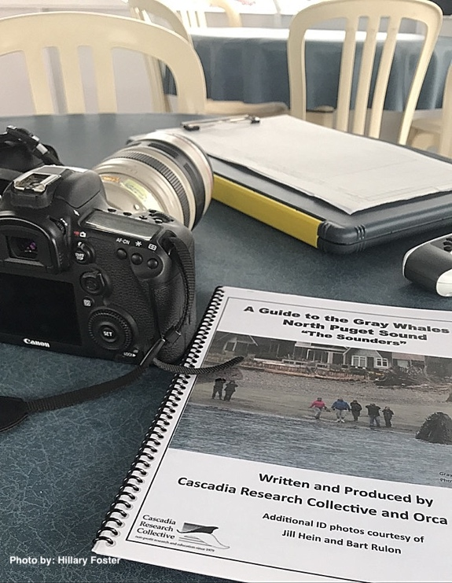During my time in the MES program, I have enrolled in two Individual Learning Contracts (ILCs) – both with Cascadia Research Collective, a non-profit focusing on marine mammal research. ILCs are one example of how Evergreen strives to make your education experience unique and catered to your needs. My first ILC experience was over winter 2018, where I spent the majority of my time researching and collecting preliminary data for a potential master’s thesis project. Topics included researching humpback whale (*Megaptera novaeangliae*) ship strike occurrences in the Salish Sea and coastal waters of Washington State and line transect surveys of marine mammals. As a part of working for Cascadia, I also participated in several whale-watching trips, which are always an incredible experience. Myself and other interns go out on a local whale watching company’s boat (Island Adventures) as Cascadia representatives to collect marine mammal sighting data. We record various information regarding the sightings such as location, their behavior, and number of animals. We also take photo-id shots to track and identify individuals throughout the years. This past winter was focused on a unique group of gray whales (*Eschrichtius robustus*), commonly called North Puget Sound gray whales. This group of whales are comprised of roughly 12 individuals that have been documented coming into the North Puget Sound almost every year since the early 1990’s. They visit between March and May to feed on ghost shrimp. (If you would like even more information on this incredible research visit: <http://www.cascadiaresearch.org/washington-state-north-puget-sound-gray-whale-photo-id-and-feeding-study-cascadia-research-studies>)

Most common equipment used during whale watch trips – clipboard, datasheet, digital camera, GPS, and informational booklet.

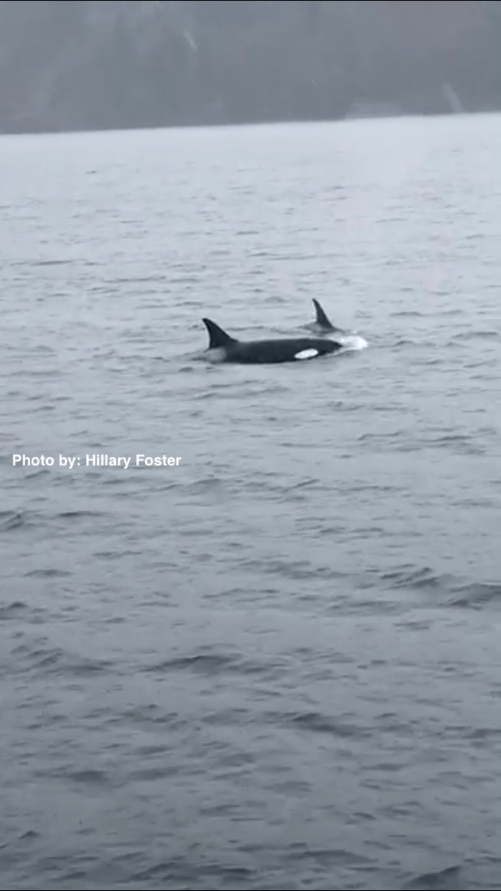It is so exciting to be able to go out and watch these amazing marine mammals feed in the shallows and if lucky, witness a spyhop (when a whale of dolphin visually inspect the environment by holding their head above water)! My most memorable trip was the very first one of the season. We encountered Bigg’s (transient) killer whales (*Orcinus orca*), which was a first for me! It was an exhilarating experience and might have resulted in killer whales taking the humpback’s place atop my favorite cetaceans list!

Bigg’s killer whales spotted near Rose Point, WA. March, 2018.

Gray whale spyhop. Spyhops are when whales poke their heads out of the water to view their surroundings.

At the end of my winter ILC, I was able to nail down a thesis project that will focus on analyzing line transect surveys of marine mammals conducted off the coast of Washington State and Northern Oregon.

Over the summer, my ILC is all about beginning research for my thesis! I am starting to analyze data collected from systematic line-transect surveys for marine mammals off the coast of Washington State and Northern Oregon from 2011 – 2013. I will specifically be looking at counts of humpbacks, their geographic location documented during the surveys, and number of seasons surveyed. I am using the software program Distance to analyze species counts to generate abundance and density estimates. These abundance and density estimates are beneficial for implementing effective conservation management strategies. I also plan on using ArcMap because it offers a variety of tools that can be used to visually explore humpback whale prevalence along the outer coast of Washington State and Northern Oregon. So far, the majority of my time has been spent learning how to use the Distance program. It has been challenging but enjoyable so far! (I know I know – science nerd.) My end goal is to be a co-author on the publication of these findings in a scientific peer-reviewed journal article.

I am very thankful to Cascadia for the amazing opportunity to work with them on my thesis project and for their guidance and patience throughout this whole process. While not all ILCs need to be geared to thesis work, they certainly can be. In my case, it has helped make the whole thesis process a bit more manageable.