My name is Christine Davis and I am a 2nd year graduate student in the Master of Environmental Studies program at The Evergreen State College. During the fall quarter of 2019, MESA contributed partial funding for a Marxan computer software training I attended at the University of Victoria in Victoria, BC.

Marxan, a conservation planning tool that uses an algorithm to run multiple scenarios based on high quality data inputs, will be an integral part of my graduate thesis. Marxan is not just a black box that delivers one answer, but rather it is a tool that provides options for conservation planning based on user supplied data. My thesis will examine riparian areas in Thurston and Pierce County for their habitat quality and potential for new conservation sites and landowner restoration outreach. By using Marxan, I can discuss why and where these areas occur at large spatial scales.

The Marxan software training, led by a nonprofit research group called PacMARA, is an intensive week-long training that gives students hands on experience in Marxan analysis. Students learn by creating the necessary files for running Marxan and how to analyze the algorithm outcomes. The analysis is both spatial in GIS software and in text form within Excel files. If other students are interested in using Marxan for their thesis or other graduate projects, I highly recommend they contact PacMARA to take this training before they commit to using Marxan.

I am grateful to MESA for contributing to my professional development by assisting me with attendance costs for the Marxan training. The training was fortunately, at the perfect time to set me up for success in organizing my graduate thesis plan and to understand the type and amounts of data necessary to run a Marxan analysis.

In addition to attending the Marxan training at UVIC, I rode my bike around the city of Victoria. If you are in Victoria, I highly recommend taking a bicycle to get around, as the city is very bike friendly. I was able to visit the Natural History Museum containing exceptional exhibits on first peoples and the Modern Art Museum that owns some Emily Carr paintings.

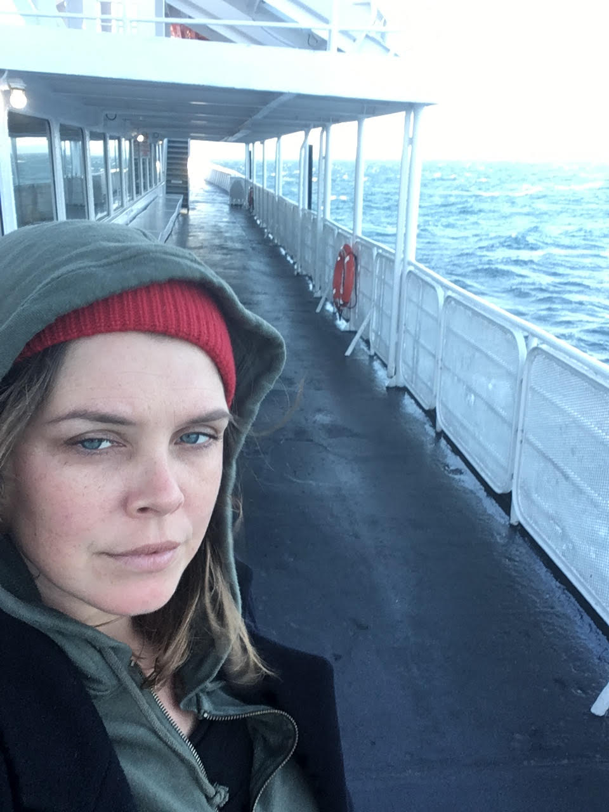

On the ferry from Port Angeles to Victoria, BC for the PacMARA Marxan training.

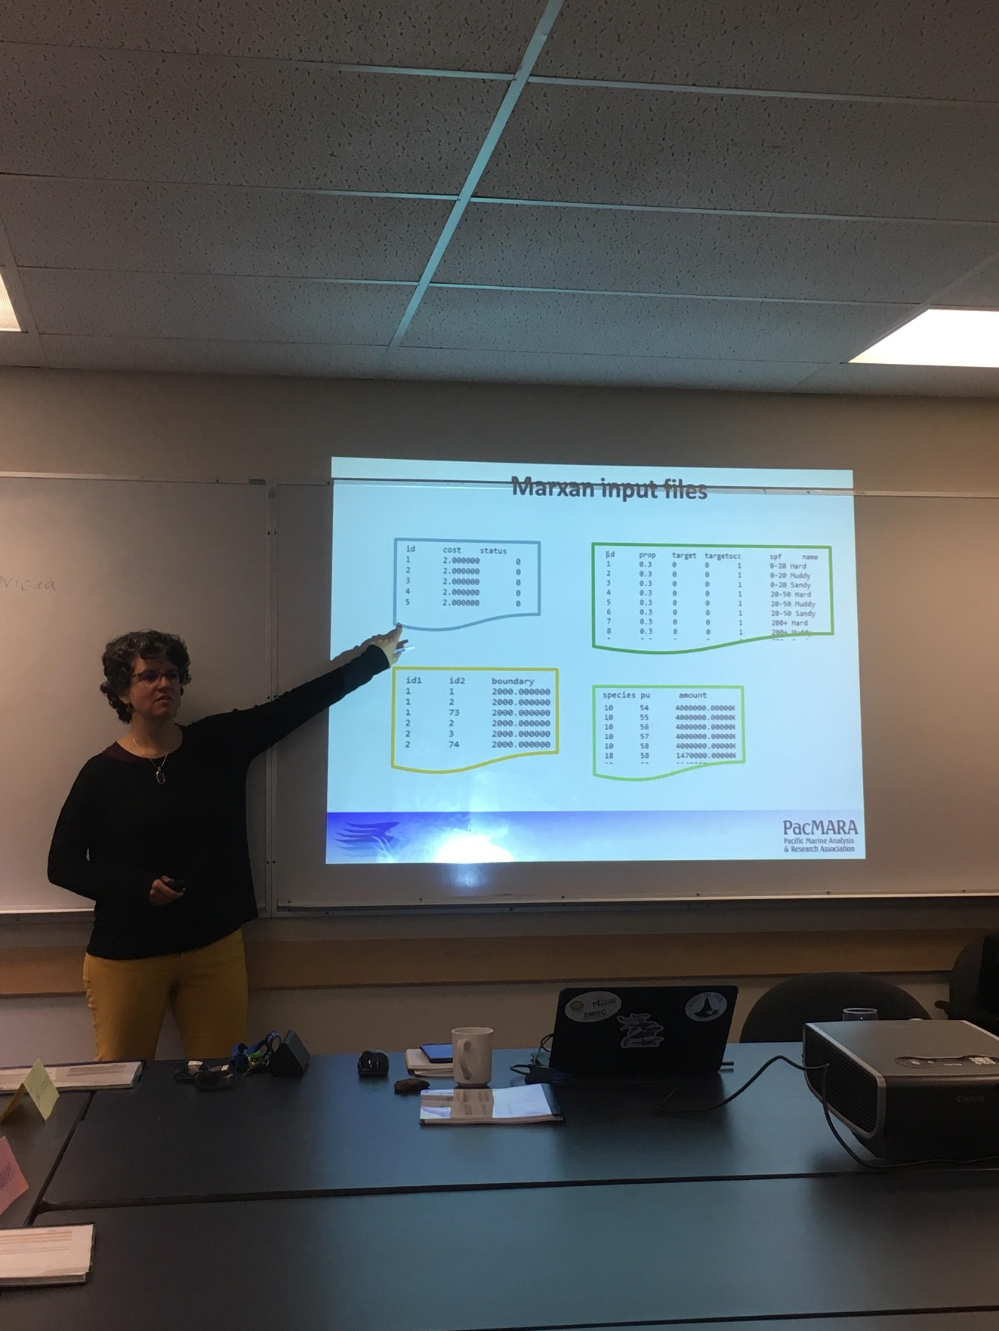

Norma Serra (PacMARA) teaching at the Marxan training course in the basement of UVIC.

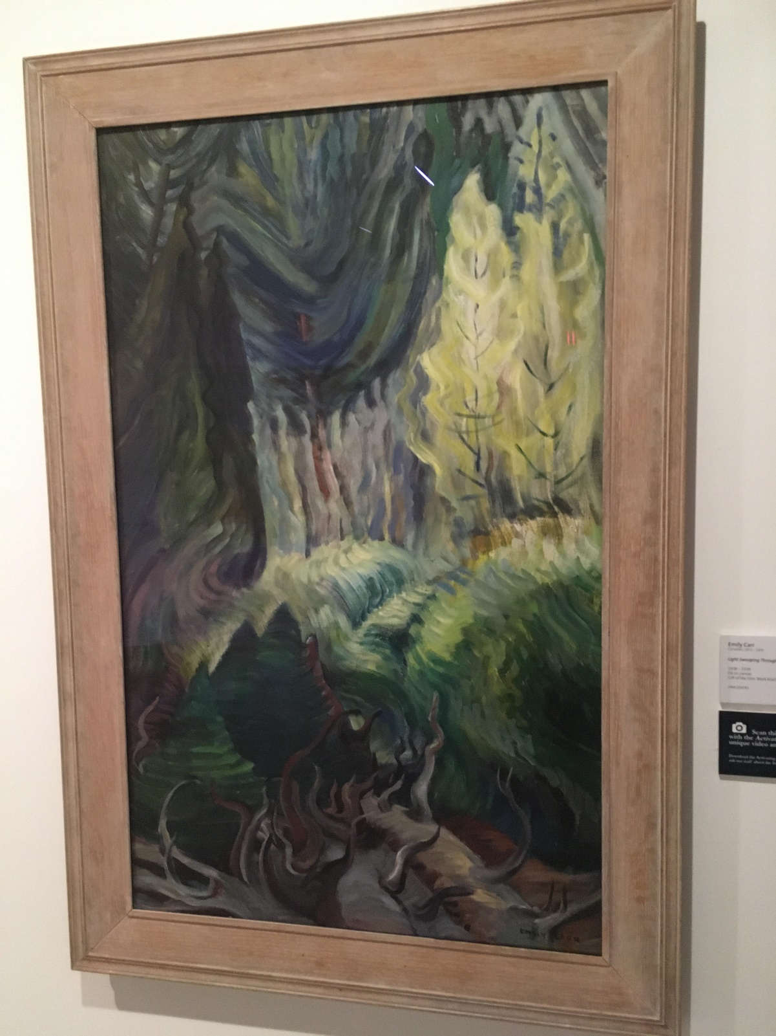

Emily Carr painting at the Victoria Museum of Modern Art.