**The Evergreen State College**

**Graduate Program on the Environment**

### Thesis Prospectus

|  |  |  |  |
| --- | --- | --- | --- |
| **Name** | **Kevin Lester** | **ID Number** | **A00412003** |

**Mailing Address 5930 Harmony ln. SW Olympia Wa. USA 98512**

**Telephone 1-(360)-489-8600**

**Email leskev23@evergreen.edu**

**STUDENT AGREEMENT:**

**SIGNATURE: __________________________________ DATE________________**

**FACULTY READER APPROVAL:**

**SIGNATURE: __________________________________ DATE________________**

**MES DIRECTOR APPROVAL:**

**SIGNATURE: __________________________________ DATE________________**

1. Provide the working title of your thesis.

Abundance, Distribution, and Seasonal Variability of Marine Mammals in the Southwest Puget Sound

1. In 250 words or less, summarize the key background information needed to understand your research problem and question.

Marine mammal abundance and distribution in the South Puget Sound is poorly studied and understood (Pearson, WDFW 2018). Despite the common occurrence of marine mammals in the maze of inlets and channels west of Nisqually Reach, surveys into the populations ended in 1999 (Jeffries, 2003). In order to study the effects of environmental factors, seasonality, and disturbance on behavior, in-water marine mammals must be observed in a reproducible method over time.

The Southwest Puget Sound was chosen as the area of research, cutting off where Case Inlet meets Nisqually Reach for the relative lack of restricted waters and local relevance. In this area of the Sound, four marine mammal species are likely to be detected: harbor seals (very common), California sea lions (uncommon), common dolphins (seasonal), and harbor porpoises (common). Harbor seals will comprise the bulk of the data as they are particularly visible in or out of the water, and abundant enough to provide significant sample sizes.

A gap in the literature exists as there are few regional fine-detail marine mammal counts in the Southwest Puget Sound. Several research groups have looked at the Puget Sound and mapped haul-out hot-spots for pinniped conservation purposes, but none have looked at the Southwest Puget Sound in detail let alone sought linking environmental factors on distribution. If this project is accomplished in a rigorous, replicable, and respectable way, it will be a huge step forward for mapping the South Puget Sound’s ecological make-up.

1. State your research question.

What is the distribution, abundance, and seasonal variability of marine mammals in the Southwest Puget Sound region? How is this distribution affected by environmental factors such as human disturbance and water temperature?

1. Situate your research problem within the relevant literature. What is the theoretical and/or practical framework of your research problem?

In my review of the literature, I have found that researchers are not looking much into the Southwest Puget Sound region and still do most regional counts by helicopter or drone. Aerial surveys may be a quicker and cheaper way of counting seals in a large region because of their swiftness and small crew requirements, but the final numbers from these surveys rely heavily on algorithms to account for seals missed and do not tell a very detailed story of what these creatures are doing (Thompson, 1990). A study in Alaska of harbor seal abundance and distribution found that more seals could be spotted from the ground then by air (Bengston, 2004). I speculate that this is due to the researcher’s greater ability to see harbor seals in the water from their observation point than an aerial vehicle making a quick pass.

The major organizations involved with marine mammal research in the Puget Sound are: Washington Department of Fish and Wildlife (hereafter WDFW), Cascadia Research Collective (hereafter Cascadia), Pacific Mammal Research (hereafter PACMAM), National Oceanic and Atmospheric Administration (hereafter NOAA), and various universities in the area. I have already consulted with researchers from all the above organizations, and read research presented by most of the local universities.

The lack of detailed analysis may be due to the belief that harbor seals in the Puget Sound are at carrying capacity and so common that they are not as interesting of research subjects as orcas or rare fish (Daniel Hull, Nisqually Reach Nature Center, Primary Source). Even so, harbor seal population trends are officially categorized as “unknown” according to the WDFW, leaving me ample room to progress the knowledge of these interesting animals (Pearson, 2018). NOAA releases an annual marine mammal report which includes harbor seals, but there is no distinction made as to where the seals were found and the information is sorely out of date; “However, because the most recent abundance estimate” of harbor seals “is >8 years old, there is no current estimate of abundance.” (Carretta, 2010). What all this discussion indicates that there is an interest in local harbor seal abundance and a clear gap in the current knowledge.

Looking into the habits of pinnipeds requires a more detailed approach than just flying over or shore-based haul-out location counts, we can map out so much more by looking at where the pinnipeds are in the water forging or traveling. The four main methodologies for counting pinnipeds are hydrophone presence studies, aerial haul-out counts, ship-based counting, and on shore haul-out counts. Ship-based research allows for interception of marine mammals while they are out foraging or traveling. For seals in particular this can drastically change the final population estimates;

“Although the timing and methodology of surveys differ considerably between studies, they all share one problem: common seals spend an unknown proportion of their time in the water, even as pups, and these counts can therefore be regarded only as minimum population estimates.” (Thompson, 1990).

Environmental factors are likely to be linked to the prey species as well as the marine mammal. This could be a large confounding variable affecting where marine mammals are found (Pearson, WDFW 2018). Pinnipeds are commonly found in prey trap-points like dams or narrow channels, however they are also very adaptable to finding prey in large bays. Since dams collect salmon trying to spawn, I expect that on the bay side of these barriers there will be a larger number of marine mammals foraging. The first of these installments that come to mind is the connection between Capitol Lake and Budd Inlet in downtown Olympia, where many seals can be seen during the salmon runs feeding in great quantities.

Distribution of marine mammals varies depending on water quality, food availability, and human disruption (NOAA Fisheries, 2019). We already know these variables influence our local marine mammals, however I want to know what affects them in the Puget Sound and to what degree. If it is found in this study that certain marine mammals prefer certain environmental factors, that may be a line of inquiry for future research which could link the habit to prey availability or simply the mammal’s preference.

1. Explain the significance of this research problem. Why is this research important? What are the potential contributions of your work? How might your work advance scholarship?

Researching marine mammals can help define a lot about the health of an ecosystem. Seals have been used as indicator species for pollution, fish population, and disturbance research which may only be relevant in small areas (Hindell, 2013). A comprehensive pinniped survey in the Southwest Puget Sound will reveal fine details about the habits of seals in this region. In conjunction with my research mentor at PACMAM, it will be possible to create a detailed map of the pinniped distribution habits throughout all regions of the Puget Sound with seasonal variability at some point after my research when other groups, or myself, are able to study those regions. A cost effective and replicable strategy would be a major contribution to this type of research. With the impending cull of harbor seals in the Puget Sound in order to protect fish stocks (Hayward, 2005), research into their abundance, distribution, and behavior is particularly relevant.

If it is discovered that marine mammal distribution varies seasonally and geographically, important questions arise as to why. This study opens the door for further ecologically-based research in the area I have called my backyard my entire life. Personally, I am pursuing this research to acclimatize myself for my ultimate goal, becoming a polar researcher. The methods I am using in this study are modeled off of ship-based Antarctic seal surveys, where large aggregations of seals are typically not present calling for a shift in survey techniques and counting seals by water rather than looking for haul-outs by air (Laws, 2009). This survey will use polar methods fit to pinniped research in Washington while working within the marine mammal viewing guidelines.

Typically, seal studies are conducted at low tide and many researchers urge to do so and only count hauled-out seals estimating the rest with calculations (Patterson, 2008). Some meta-analyses have been conducted looking into the effectiveness of this tradition finding significant flaws (Patterson, 2008). I hope that my contribution to marine mammal ecology research will be to prove the effectiveness of a tedious 100% area and count survey over near purely mathematical estimation techniques currently employed to estimate seal population.

1. Summarize your study design. If applicable, identify the key variables in your study. What is their relationship to each other? For example, which variables are you considering as independent (explanatory) and dependent (response)?

The main relationship being looked at in this study is the effect water temperature has on seal distribution. The independent variable is surface water temperature, and the response variable is the local abundance of seals. I hypothesize that seals will prefer cooler waters in the summer and warmer waters in the winter. To do this, average water temperatures will be compared with the number of seals observed using Geographic Information System (hereafter GIS) map analysis. Another independent variable this study will look at is disturbance by recording occurrences of human activity on or near the water and compare that data set as well.

 Other variables to be recorded are waterfront land use, time of day, tidal cycle, water depth, and local weather. To be aware of unique variables, the study will avoid researching on July 4th (fireworks disturbance) or other popular days that may change marine mammals’ behavior and will be conducted three times in each region during each season to avoid anomalous data from skewing the results. Disturbance mapping will be highly useful to conservation interests, and a great deal of effort will be made to record this data. Apparent land-use polygons will be drawn in GIS mobile software along the shoreline of all regions and boat activity will be shown. These will be later compared with the seal observations and other environmental factors in analysis software to see if they are related.

1. Describe the data that will be the foundation of your thesis. Will you use existing data, or gather new data (or both)? Describe the process of acquiring or collecting data.

The survey will consist of recording occurrences and distribution of marine mammals, primarily harbor seals. The intention is to represent the data collected in heat-maps that detail their relative abundance. As an added layer to this inquiry, there will be a creation of the same kind of maps for summer, fall, and winter showing preferred areas by marine mammals in the Southwest Sound over time. This may reveal underlying questions such as the density or seasonal relationship with coastal land use, proximity to certain environmental features, micro-migration patterns, and an overall assessment of population health. Annual marine mammal counts are nothing new; however, these counts are typically done by large government agencies in broad stroke sweeping fashion. This study will be the much-needed fine brush approach to a densely seal-populated region of the state.

Comparison with other data sets will be important post-hoc and may be acquired via communication with WDFW, PACMAM, or Cascadia. As far as I know, there has not been a seasonal variation study in the waters west of Nisqually Reach, but there have been broad stroke studies of abundance in summer (Jefferies, 2003). I have already met with Cindy Elliser at the PACMAM office to complete the survey design, narrow the scope, and go over the techniques vital to the project. After consulting with PACMAM on survey strategies, a study design has emerged that is compatible with future studies they may want to pursue in the North Puget Sound, allowing for an entire Puget Sound density map through the seasons to emerge.

The basis of the study will be data collected on the water. All areas of the Southwest Puget Sound will be divided into routes easily accomplished in the research timeframe. Boat routes are established and repeated three times per season. Observations, transects, and tracks will be recorded in Survey123 software for efficient transfer into ArcGIS for analysis and heat mapping. The research will take place June 19th - July 3rd, August 30th - September 13th, and December 21st - January 4th aboard my 28-foot liveaboard research vessel. By the end of the survey, data-rich material will be in hand that has been pre-digested for use in mapping software. The equipment needed to make this project work and live on the water is already acquired.

Survey123 Selection Tree

Season Specific Survey File

|  |
| --- |
| Time/Date (Auto) |
| LAT/LONG (Auto) |
| Method (Vessel, Zodiac, Other) |

Groups

|  |  |  |  |
| --- | --- | --- | --- |
| Observation | Environmental Data | Disturbance | Waterfront Land-use |

|  |  |  |  |
| --- | --- | --- | --- |
| Species (multi) | Sun/Cloud (multi) | Type (multi) | Type (multi) |
| Count (#) | Air Temp (#) |  |  |
| Water/Hauled (multi) | Water Temp (#) |  |  |
| Travel (multi) | Wind Direction (multi) |  |  |
|  | Beaufort lvl (multi) |  |  |
|  | Tide lvl (multi) |  |  |
|  | Glare (multi) |  |  |
|  | Lunar (multi) |  |  |
|  | Depth (#) |  |  |

SUBMIT

(Offline and Online options)

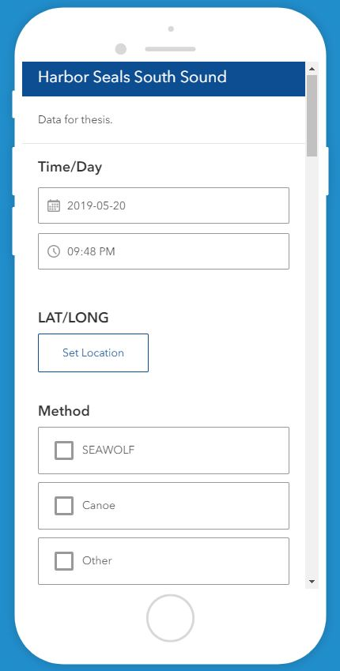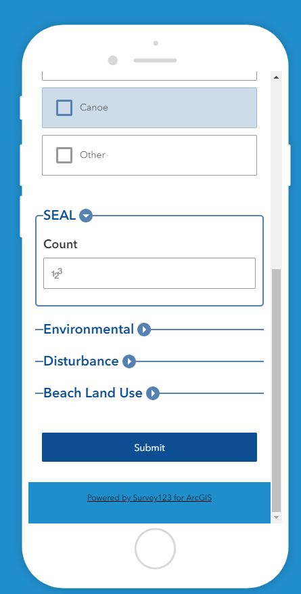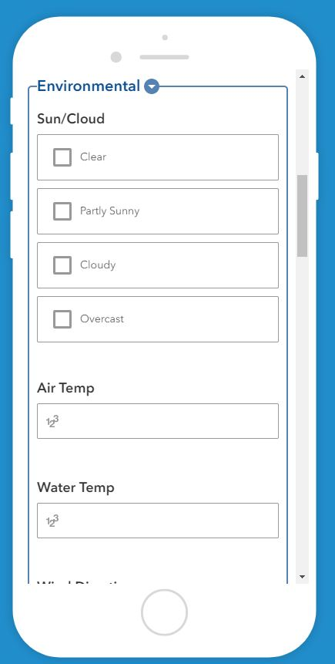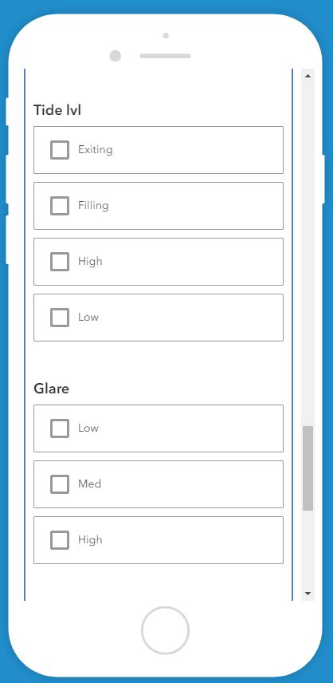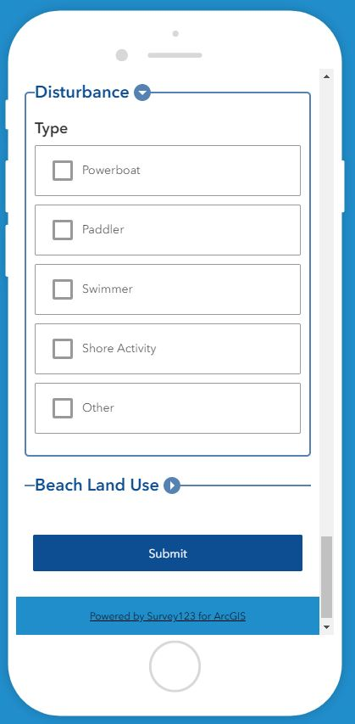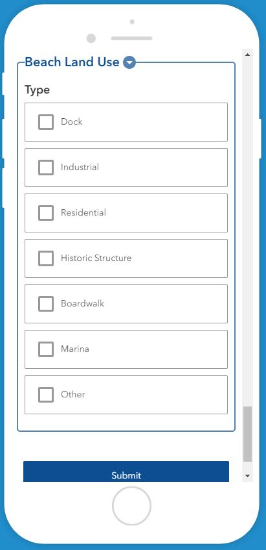

Survey previews provided by Esri Survey123.

Before the study begins, GIS mobile collection maps will be created. This will involve going into Arc GIS desktop software to generate the necessary fields with domains and the various layers used in the web map. Upon completion, maps will be uploaded to Arc GIS Online to be accessible by mobile device. On the water, whether service is available or not, data points will be collected with a couple of quick taps on the device. With WIFI service on land, data will be uploaded into the web map which will store everything for later analysis. Data able to be recorded ahead of time include tides, weather, and moon phase, all of which were requested by PACMAM to include in the study.

A typical research day will be as follows: the survey vessel will be anchored at the relevant starting area, which will be Hope Island State Park or Jerrell Cove State Park depending on the survey area. A scheduled volunteer will arrive and park at the free parking area near the state park. Volunteers will be picked up by dinghy and help in setting up all the necessary equipment while the main vessel engine is warming up and be briefed for the day’s voyage. With the course set on Navionics software, the vessel will move into the survey area. Once in the area, surface water temperature readings will be made using a thermometer, marine mammal sightings will be recorded using mobile GIS software, and human disturbance variables will also be recorded with GIS mobile software. During all excursions, the team will not pursue or harass marine mammals to comply with the Marine Mammal Protection Act viewing guidelines (NOAA Fisheries, 2019). Upon completion of the region, volunteers will be returned to shore and I will complete any further survey work or preparations for the next day. For shallow water areas (tidal or <10ft low tide average areas), a kayak will be deployed to take all of the necessary readings mentioned above.

1. Summarize your methods of data analysis. If applicable, discuss specific techniques that you will use to understand the relationships between variables (e.g., interview coding, cost-benefit analysis, specific statistical analyses, spatial analysis) and the steps and tools (e.g., lab equipment, software) that you will take to complete your analyses.

Upon completion of data collection, the study will yield detailed GIS maps of the individual marine mammal observation points, a map showing the environmental factors, and another map showing disturbance distribution. Using GIS software and Excel spreadsheets, counts of the occurrences of marine mammals in their respective temperature regions will be calculated with respect to proximity to disturbance points and analyze for relationships. I estimate the total number of observations to be in the low-mid thousands of points. PACMAM urged me to include more variables, more recordings, and multiple loops around the survey area to ensure sound and powerful sample results that can later be used in analysis software, perhaps for the first time in the Southwest Puget Sound’s scientific history.

I would also like to investigate how marine mammal observations relate with water depth using the NOAA bathymetry map for GIS, local waterfront land use, and in-water disturbance. Using GIS software, it is possible to visualize and investigate variables that seem to be related to seal observations. Focusing on disturbance, the project will generate a disturbance map of all research regions by season. This can be represented in an additional GIS layer showing points where I observed human activity on the water or adapted from land-use maps.

Although they are not the focus of my study, inevitably the study will come across large haul-out sites. These sites are traditionally used by pinniped researchers to estimate the numbers and distribution of pinnipeds in the entire Puget Sound. For this, researchers have developed special calculation tools like the one in Hayward, 2015. Haul-out counts will be used to compare traditional estimation methods with my own. This survey is designed to be conducted regardless of tides and count marine mammals if they are hauled-out or not, keeping with techniques that are less reliant on haul-outs (Bengtson, 2004).

1. Address the ethical issues raised by your thesis work. Include issues such as risks to anyone involved in the research, as well as specific people or groups that might benefit from or be harmed by your thesis work, perhaps depending on your results. List any specific reviews you must complete first (e.g., Human Subjects Review or Animal Use Protocol Form), and specific permits or permissions you need to obtain before you begin collecting data (e.g. landowner permissions, agency permits).

The study of marine mammals at sea carries with it a whole host of legal concerns and serious inherent risk in the activity of seafaring. To mitigate these risks, I have taken great precautionary steps to mitigate mishaps and planned my research with the appropriate regulatory organizations. In a less direct scope, I am also burdened with the political climate of my time given the current threats posed against harbor seals in particular with the “salmon saving” cull (Hayward, 2005). This raises the ethical question of whether my research may aid in the argument for or against the killings.

My research techniques and practices are designed around the policies of the Marine Mammal Protection Act or MMPA. The MMPA is regulated by the National Oceanic and Atmospheric Administration or NOAA. In the feasibility stage of my research, I attempted to obtain marine mammal surveying permits through the NOAA regional permitting office and was informed that I would not need any as long as I do not breach any of the MMPA viewing guidelines. This primarily means that I must stay a certain distance away from marine mammals (exact measurements vary by species), and do not change their behavior (NOAA, 2019). Essentially, I am no different from the classification of a “pleasure boater” and do not carry any special abilities on the water. Another serious ethical concern arises when considering how my data may be used by recreational groups to pursue and very possibly harass marine mammals I have mapped out. A watermark warning to adhere to MMPA viewing guidelines on my published maps may be necessary to mitigate this risk.

While boating can be inherently dangerous for myself and my crew, the vessel I have supplied (and will captain) is stocked with an overabundance of safety supplies, U.S. Coast Guard approved, and the research schedule is kept loose enough to avoid foul weather. Survey days are always done with a crew who know basic overboard rescue techniques and are supplied with safety equipment for the duration of the voyage. The survey tracks are designed to never encounter shallow water, thus mitigating the risk of running aground or capsizing. If these risk mitigating techniques are adhered to by myself and my crew, my vessel should be one of the safest on the water.

Currently, there is a harbor seal cull in Washington State being carried out by the Washington State Department of Fish and Wildlife who have also said that they do not know the current population of these seals (Pearson, 2018). My research may very well indicate a much higher abundance of seals than previously expected and set forth changes that make the cull more acceptable by regulators. As a person who enjoys seals alive and serving the ecology of South Puget Sound’s waterways, this concerns me. I have already found many more seals than were expected to exist in the region based on 1999 numbers (Carretta, 2010). I realize this may be interpreted as a reason to cull them further. While I will not misrepresent my findings in my research, I will stress the importance of harbor seals in the local environment and propose alternative management techniques that do not include shooting them.

1. Reflect on how your positionality as a researcher could affect your results and how you will account for this in the research process.

A healthy dose of self-awareness has guided my design and data collection conduct from the very beginning. I know that my feelings for seals and other marine mammals fall more on the universal preservation side of the argument rather than the regulatory one. This bias may manifest itself in a few ways throughout my research, but I also believe that the rigid structure of my research design will prevent any interference with the quantitative results.

I am passionate about seals and I wish them the best, however, something as simple as this position can cause problems in Washington State. There is a push in Washington to save the salmon and thus other marine mammal populations by culling seals (Hayward, 2005). My personal position is that it is the industrialized fishing practices of the state that has brought this issue in the first place and that the seals are being blamed because they are an easier target to alleviate political pressure than to tackle a whole industry. It may be that I believe in this position because I have never relied on a steady supply of fish to survive physically, culturally, or economically and thus am biased towards seal preservation. This bias may manifest in my research conclusions if I find more seals than expected and still condemn the practice of culling them or if I chose to only interview seal preservation advocates rather than population managers.

Another point where my bias may seep into the data of my research is through the executive decisions I must make to prevent double counting. In wishing to produce a significant sample size, I am continually tempted to double count a seal even if they may very well be the same seal I just saw. Even with all the preventative measures I take, there are still some grey areas when it comes to counting a seal that pops up. I have thus far not counted “double-count suspect” seals regardless of what the crew believes or reports and have blinded myself to the results of the survey while in that season’s voyage.

The design of this research project should help to eliminate bias in the collection of data, but in the reporting of that data, I may find myself speaking about the seals in an affectionate way. If I or a reviewer finds that I appear to be speaking of seals too far into the preservation side of the argument without adequate backing from the literature, statements made will be amended or provide substantial evidence for my statement. I wish only to represent the data exactly the way it indicates, regardless of my inherent beliefs. My positionality as a conservationist will be taken into serious consideration throughout the project.

1. Provide at least a rough estimate of the costs associated with conducting your research.  Provide details about each budget item so that the breakdown of the final cost is clear.

|  |  |  |  |  |  |
| --- | --- | --- | --- | --- | --- |
| Operational Budget |  |  |  |  |  |
| **Description** | **$** | **Every Season?** | Total | Note |  |
| Fuel (20gal.) x4 | $300 | Yes | $900.00 | Donor paid 3/4 cost. | $233.00 |
| Food | $150 | Yes | $450.00 | Donor provided all food supplies. | $0.00 |
| Propane (heat) | $20 | Yes | $60.00 | Donor refilled tanks. | $0.00 |
| Misc Supplies (estimate) | $50 | No | $50.00 | Thermostat, toilet paper, ect... | $50.00 |
|  |  |  |  |  |  |
|  |  | TOTAL= |  |  | $283.00 |

1. Provide a detailed working outline of your thesis.

**Opening Pages**

* Title Page
* Copyright Page
* Signature Page
* Abstract
* Acknowledgements (donors and volunteers)
* Table of Contents
* Tables List
* Figures List
* Abbreviations

**Chapter 1: Literature Review**

* Title Page
* Literature Review
* Introduction
  + Intro
  + The Subject
  + Limitations of the information
  + Limitations on behavior information
  + Structure of the literature review
* Historical Methods
  + Intro
  + Age of ship-based surveys
  + Aerial surveys
  + Mathematical surveying methods
  + Washington stock reports methods
  + Conclude with issues
* Current Findings
  + Intro
  + Current organizations managing marine mammal stocks
  + Current estimates of population
  + Currently accepted method findings
  + Population projections
  + Conclude with gaps
* Behavior
  + Intro
  + What is known about seal/sea lion behavior
    - Seals vs sea lions
    - Seasonal
      * Pupping
      * Molting
      * Winter
    - Diving
    - Speed
  + How will/must behavior be taken into account
    - Whale/Dolphin behavior
    - Whales
    - Orcas
    - Common dolphin
    - Harbor porpoise
    - How will/must behavior be taken into account
* Challenges
  + Intro
  + Limitations of aerial-based survey methods
    - Math reliant
    - Snapshot only
    - Does not see all seals
  + Limitations of ship-based survey methods
    - Clumping of seals
    - Double counting
    - Traveling seals
    - Restricted areas
  + Possible impactful variables
    - Tides
    - Lunar
    - Time of day
  + Conclusion
* Designing a ship-based Survey
  + Intro
  + Special considerations
  + Legal considerations
  + Important literature that guided design
* Significance
  + Intro
  + Cultural
  + Commercial
    - Recreation
    - Local branding
    - Services
  + Ecological
  + The Cull
  + The Study: A first
  + Conclusion
* Conclusion
* Literature Citations

**Chapter 2: Manuscript**

* Abstract
* Introduction
* Materials and Methods
* Results
* Discussion
* Acknowledgements
* Literature Cited
* Tables
* Figures

**Chapter 3: Broader Relevance to Environmental Studies**

* Title Page
* Abstract
* Introduction
* Materials and Methods
  + Intro to materials
  + Specific materials available and used
    - SEAWOLF
      * Specs
      * Engine
        + Sustainable Cruising Speed (4-6 kn.)
    - Pelican Kayak
      * Sustainable Cruising Speed (3-4 kn.)
  + Challenges and material specific techniques
  + Intro to methodology
  + Fundamental ethical restrictions to methods structure.
  + Actual methods used
    - Deep water
    - Shallow water
* Results
  + Intro to methods
  + Species specific distribution maps separated by season
    - Discussion
  + Disturbance maps
    - Discussion
  + Temperature and environmental variables maps/weather timelines
    - Discussion
  + Land-use maps
    - Discussion
  + Comparison Analysis Maps and Discussion
    - Marine mammals and disturbance factors
    - Marine mammals’ variability by season
    - Marine mammals and environmental factors
  + Abundance Other types of analysis
    - Report Actual observed numbers
      * Averaged by (season total count/laps)
      * Breakdown by region/inlet
    - Estimate variability using traditional haul out count
      * Compare with actual observed
* Discussion
  + Introduction
  + Brief summary
  + Challenges to following through with survey
    - No data areas (industry heavy, restricted, not accessible, etc…)
  + Significance
  + Future research
    - Entire Puget Sound
    - Prey distribution comparisons
* Acknowledgements
* Literature Cited
* Tables
* Figures

**Chapter 4**

* Title Page
* Summary and Discussion
* Conclusions
* Literature Cited

Permissions and Contributions

Bibliography

Appendix

1. Provide a specific work plan and a timeline for each of the major tasks in the work plan. Be as realistic as you can, even though you will probably need to alter this schedule as you complete the tasks. Remember that faculty readers take time to return your drafts and that the final polishing and formatting of your thesis for binding will take longer than you ever imagined.

**Timeline**

May-July: Summer data collection

**Due dates – Mini Prospectus 4/31**

|  |  |  |
| --- | --- | --- |
| Late May | June | Early July |
| Begin summer data collection | Continue summer data collection | Finish summer data collection |

September-October: Fall data collection.

|  |  |
| --- | --- |
| September | October |
| Fall data collection | Begin Analysis Prep |

November: Prep analysis and begin writing

**Due dates – Literature Review 11/24**

|  |  |  |
| --- | --- | --- |
| Early November | Mid-November | Late November |
| Begin writing literature review | Complete literature review draft | Prep for data analysis |

December: Winter data collection

**Due dates – Thesis Poster 12/5**

**Prospectus 12/6**

|  |  |  |
| --- | --- | --- |
| Early December | Mid-December | Late December |
| Finish Analysis Prep | Winter Data Collection | Finish Winter Data Collection |

January: Complete all collection, final analysis, continue writing, peer reviewing

**Due dates – 1/20: MES thesis fund application**

|  |  |  |
| --- | --- | --- |
| Early January | Mid-January | Late January |
| Finish data collection | Distribution analysis, Disturbance map analysis, and create tables. | Write up Chapter 2 draft, and consult peers. |

February: Complete Analysis, finalize draft (writing center then send to reader), create

Presentations

|  |  |  |
| --- | --- | --- |
| February Early | Mid-February | Late February |
| Complete maps and complete “other” analysis techniques, make all presentable | Draft due to writing center and peers | Create presentations |

March: Draft complete, format for binding, perfect presentations (seek conferences)

|  |  |  |
| --- | --- | --- |
| Early March | Mid-March | Late March |
| Complete thesis draft | Format for binding | Perfect presentations |

April: Draft due, finalize formatting

**Due dates – 4/10 Complete Draft of Thesis**

|  |
| --- |
| April |
| Complete and finalize all things thesis related. |

May: Finish and present all

**Due dates –** **5/1** **Request to Present Thesis Research**

**–** **5/18 Presentation**

**–** **5/29 Final Draft of Thesis**

June: Finish

**Due dates –** **6/10** **Submit final print form**

1. Who, beyond your MES faculty reader, will support your thesis? Indicate support both within and outside of Evergreen. Be specific about who they are and in what capacity they will support your thesis. If you are working with an outside agency or expert, be specific about their expectations for your data analysis or publication of results.

Michael Ruth:

Mike is my GIS consultant and professor. Throughout the analysis process, I will be meeting regularly for tips, tricks, and proper procedure in all my GIS needs. All GIS products will be sent to Mike for review and critique. Mike already has helped me create the data collection software and initial stages of analysis.

PACMAM DR, Cindy Elliser:

PACMAM is based in Anacortes, Washington, where I traveled to and met research scientist Dr., Cindy Elliser in a private consultation about my research in April 2019. Cindy and I developed the scope and details of the data collection and continues to be a valuable resource as I progress through the project. I do not have a research agreement with PACMAM, they are purely consultants.

Volunteers:

My project has relied on a steady stream of volunteers to crew the ship while I focus on data collection. For the most part, this purely consists of steering the ship where I direct them to and allow me to take over control during more technical navigation. These volunteers have been family, old friends, and fellow MES students.

1. List the 3-5 most important references you have used to a) identify the specific questions and context of your topic, b) help with issues of research design and analysis, and c) provide a basis for interpretation. For each reference, explain how your project specifically connects to the source by extending, challenging, or responding to the conclusions, methods, or implications.

Bengtson, J., Phillips, A., Mathews, E., & Simpkinds, M. (2004). *Comparing Harbor Seal Survey Methods in Glacial Fjords*. 7.

Note: This study compares aerial and land-based harbor seal counting methods in an Alaskan inlet. This study concludes that aerial counting methods miss a lot of seals, and that other methods are more accurate for this species and space. This study validates my hypothesis that the current purely aerial counting methods are leading to inaccurate population estimates, and that my method of counting seals may lead to a higher, more accurate count.

Calambokidis, John et. al. (1985). *Biology of Puget Sound marine mammals and marine birds: Population health and evidence of pollution effects* (p. 169). NOAA.

Note: This NOAA survey of the Puget Sound contains extremely valuable and rich data about areas in my survey area and marine mammals found there, including counts of harbor seals by haul-out location. The survey also compares land and aerial survey methods to a lesser degree than the previous source. This source gives me a good snapshot of marine mammal abundance in the Southern Puget Sound as of 1984, which was a transitional time for surveying harbor seals from land or sea-based to aerial-based counting.

Carretta, J. V., Oleson, Erin M. (Erin Marie), 1977, Baker, J. D., Weller, David William, 1963-, Lang, A. R., Muto, M. (Marcia), … Brownell, R. L. (2017). U.S. Pacific marine mammal stock assessments, 2016. *U.S. Department of Commerce, National Oceanic and Atmospheric Administration, National Marine Fisheries Service, Southwest Fisheries Science Center*.<https://doi.org/10.7289/v5/tm-swfsc-577>

Note: This source brings harbor seal abundance estimates into modern times (when compared to the previous source). Pages 19 - 23 discusses in detail the estimation of harbor seal “stocks” in Washington’s inland waters. This should be the most recent and modern estimation of harbor seals in the Puget Sound there is. “Stocks” are also mapped out on a graph showing how much the abundance has changed from 1975 - 2000. Most importantly for the validation of my research, there is an explicit and official statement from NOAA on page 20: “No current information on abundance is available to obtain a minimum population estimate for the Washington Inland Waters stock of harbor seals.”

Hayward, J. L., Henson, S. M., Logan, C. J., Parris, C. R., Meyer, M. W., & Dennis, B. (2005). Predicting numbers of hauled-out harbour seals: A mathematical model. *Journal of Applied Ecology*, *42*(1), 108–117.<https://doi.org/10.1111/j.1365-2664.2005.00999.x>

Note: This source shows how harbor seal abundance is estimated using mathematical models, which is the current standard in modeling abundance of harbor seals. There is also discussion of the common pitfalls of seal surveying. Page 113 of the journal discusses how seals are particularly sensitive to heat, which is a major part of my study. The article opens with this profound statement that eerily reminds me of today’s seal cull:

“It was once assumed that commercially important ﬁsh make up signiﬁcant portions of seal diets. As a consequence, prior to the 1970s many seal populations were dramatically reduced by rampant slaughtering. Today, seals and other marine mammals are valued components of marine ecosystems and their numbers are carefully managed.”

Amazing, those who do not learn history are doomed to repeat it.

Jeffries, S., Huber, H., Calambokidis, J., & Laake, J. (2003). Trends and Status of Harbor Seals in Washington State: 1978-1999. *The Journal of Wildlife Management*, *67*(1), 207.<https://doi.org/10.2307/3803076>

Note: This study is cited everywhere because of the hot-spot map on page 208, and because it was the last decent attempt at estimating harbor seal abundance in the Puget Sound. It also has a very rare break down of abundance and projected abundance change over time by region. This estimate shows an abundance of 800-1100 total seals in the Puget Sound south of Everett, which is a gross underestimate according to my preliminary findings. This is perhaps the most important source in my catalogue as it is the most widely reported and most accepted current estimate of Puget Sound harbor seal abundance.

**Bibliography**

Alaska Dept. of Fish and Game. (2019). Harbor Seal Species Profile, Alaska Department of Fish and Game. Retrieved October 16, 2019, from <https://www.adfg.alaska.gov/index.cfm?adfg=harborseal.main>

Alaska NOAA. (2014). *Harbor Seal (Phoca vitulina richardii): Washington Inland Waters Stocks: (Hood Canal, Southern Puget Sound, Washington Northern Inland Waters)*. 6.

Bengtson, J., Phillips, A., Mathews, E., & Simpkinds, M. (2004). *Comparing Harbor Seal Survey Methods in Glacial Fjords*. 7.

Calambokidis, John et. al. (1985). *Biology of Puget Sound marine mammals and marine birds: Population health and evidence of pollution effects* (p. 169). NOAA.

Cammen, K. M., Rasher, D. B., & Steneck, R. S. (2019). Predator recovery, shifting baselines, and the adaptive management challenges they create. *Ecosphere*, *10*(2), e02579. <https://doi.org/10.1002/ecs2.2579>

Carretta, J. V., Forney, K. A., Oleson, E., Martien, K., Muto, M. M., Lowry, M. S., … Hill, M. C. (2010). *U.S. Pacific Marine Mammal Stock Assessments: 2010*. 357.

Carretta, J. V., Oleson, Erin M. (Erin Marie), 1977, Baker, J. D., Weller, David William, 1963-, Lang, A. R., Muto, M. (Marcia), … Brownell, R. L. (2017). U.S. Pacific marine mammal stock assessments, 2016. *U.S. Department of Commerce, National Oceanic and Atmospheric Administration, National Marine Fisheries Service, Southwest Fisheries Science Center*. <https://doi.org/10.7289/v5/tm-swfsc-577>

Cullon, D. L., Jeffries, S. J., & Ross, P. S. (2005). *Persistent organic pollutants in the diet of harbor seals (Phoca vitulina) inhabiting puget sound, washington (USA), and the strait of Georgia, British Columbia (Canada): A food basket approach*. 11.

Essington, Tim et al. (2019). Harbor seals | Encyclopedia of Puget Sound. Retrieved April 23, 2019, from <https://www.eopugetsound.org/articles/harbor-seals>

Fontaine, P.-H. (2007). *Whales and seals: Biology and ecology* (English 3rd ed). Atglen, PA: Schiffer Pub.

Garrett, H. (2019). Welcome to Orca Network. Retrieved June 10, 2019, from Welcome to Orca Network website: <http://www.orcanetwork.org/>

Hayward, J. L., Henson, S. M., Logan, C. J., Parris, C. R., Meyer, M. W., & Dennis, B. (2005). Predicting numbers of hauled-out harbour seals: A mathematical model. *Journal of Applied Ecology*, *42*(1), 108–117. <https://doi.org/10.1111/j.1365-2664.2005.00999.x>

Hindell, M. A., Bradshaw, C. J. A., Harcourt, R. G., & Guinet, C. (2013). *Ecosystem Monitoring: Are Seals a Potential Tool for Monitoring Change in Marine Systems?* 15.

Jeffries, S., Huber, H., Calambokidis, J., & Laake, J. (2003). Trends and Status of Harbor Seals in Washington State: 1978-1999. *The Journal of Wildlife Management*, *67*(1), 207. <https://doi.org/10.2307/3803076>

Kinkhart, E. (2008). *Harbor Seal_ Wildlife Notebook Series—Alaska Department of Fish and Game.pdf*. Alaska Department of Fish and Game.

Kriete, B. (2007). *Orcas in Puget Sound:* <https://doi.org/10.21236/ADA477509>

Lambourn, D. M., Jeffries, S. J., & Huber, H. R. (2009). Observations of Harbor Seals in Southern Puget Sound during 2009. *WDFW Report*, 1–27.

Lance, M., Chang, W., Jeffries, S., Pearson, S., & Acevedo-Gutiérrez, A. (2012). Harbor seal diet in northern Puget Sound: Implications for the recovery of depressed fish stocks. *Marine Ecology Progress Series*, *464*, 257–271. <https://doi.org/10.3354/meps09880>

Laws, R. M., & International Council of Scientific Unions (Eds.). (1993). *Antarctic seals: Research methods and techniques*. New York, NY, USA: Cambridge University Press.

NAMMCO. (2018, September 25). Abundance surveys—Counting seals. Retrieved April 24, 2019, from NAMMCO website: <https://nammco.no/topics/abundance-surveys-counting-seals/>

Newby, T. C. (1973). Changes in the Washington State Harbor Seal Population, 1942-1972. *The Murrelet*, *54*(1), 4. <https://doi.org/10.2307/3535680>

NOAA Alaska Fisheries. (2018, December 4). Harbor Seal Research in Alaska | NOAA Fisheries. Retrieved April 24, 2019, from [/alaska/marine-mammal-protection/harbor-seal-research-alaska](https://doi.org/alaska/marine-mammal-protection/harbor-seal-research-alaska)

NOAA Fisheries. (2018, December 10). Harbor Seal | NOAA Fisheries. Retrieved April 21, 2019, from [/species/harbor-seal](https://doi.org/species/harbor-seal)

NOAA Fisheries. (2019, March 5). Marine Life Viewing Guidelines | NOAA Fisheries. Retrieved April 23, 2019, from [/topic/marine-life-viewing-guidelines](https://doi.org/topic/marine-life-viewing-guidelines)

Patterson, J., & Acevedo-Gutiérrez, A. (2008). Tidal Influence on the Haul-Out Behavior of Harbor Seals (Phoca vitulina) at a Site Available at All Tide Levels. *Northwestern Naturalist*, *89*(1), 17–23. [https://doi.org/10.1898/1051-1733(2008)89[17:TIOTHB]2.0.CO;2](https://doi.org/10.1898/1051-1733(2008)89%5b17:TIOTHB%5d2.0.CO;2)

Pearson, S. F. (WDFW). (2018). *Impact of pinnipeds on Chinook Salmon*. 66.

Purcell, M., Mackey, G., LaHood, E., Huber, H., & Park, L. (2004). Molecular methods for the genetic identiﬁcation of salmonid prey from Paciﬁc harbor seal (Phoca vitulina richardsi) scat. *Fishery Bulletin*, 8.

Ross, P. S., Jeffries, S. J., Yunker, M. B., Addison, R. F., Ikonomou, M. G., & Calambokidis, J. C. (2003). *Harbor Seals (Phoca vitulina) in British Columbia, Canada, and Washington State, USA, Reveal a Combination of Local and Global Polychlorinated Biphenyl, Dioxin, and Furan Signals*. 9.

Scheffer, V. B., & Slipp, J. W. (1944). The Harbor Seal in Washington State. *The American Midland Naturalist*, *32*(2), 373–416. <https://doi.org/10.2307/2421307>

Seal Sitters. (2019). About Harbor Seals. Retrieved October 15, 2019, from <https://www.sealsitters.org/marine_mammals/harbor_seals.html>

Smith, C. E., Sykora-Bodie, S. T., Bloodworth, B., Pack, S. M., Spradlin, T. R., & LeBoeuf, N. R. (2016). Assessment of known impacts of unmanned aerial systems (UAS) on marine mammals: Data gaps and recommendations for researchers in the United States. *Journal of Unmanned Vehicle Systems*, *4*(1), 31–44. <https://doi.org/10.1139/juvs-2015-0017>

Steiger, G. H., Calambokidis, J., Cubbage, J. C., Skilling, D. E., Smith, A. W., & Gribble, D. H. (1989). Mortality of Harbor Seal Pups at Different Sites in the Inland Waters of Washington. *Journal of Wildlife Diseases*, *25*(3), 319–328. <https://doi.org/10.7589/0090-3558-25.3.319>

Stewart, B. S. (1984). Diurnal Hauling Patterns of Harbor Seals at San Miguel Island, California. *J. Wildl. Manage.*, *Vol. 48*(No. 4), 1459–1461.

Thompson, P. M., & Harwood, J. (1990). Methods for Estimating the Population Size of Common Seals, Phoca vitulina. *Journal of Applied Ecology*, *27*(3), 924–938. <https://doi.org/10.2307/2404387>

Watson, J., Joy, R., Tollit, D., Thornton, S. J., & Auger-Méthé, M. (2019). A general framework for estimating the spatio-temporal distribution of a species using multiple data types. *ArXiv:1911.00151 [Stat]*. Retrieved from <http://arxiv.org/abs/1911.00151>

**Supplementary Information**

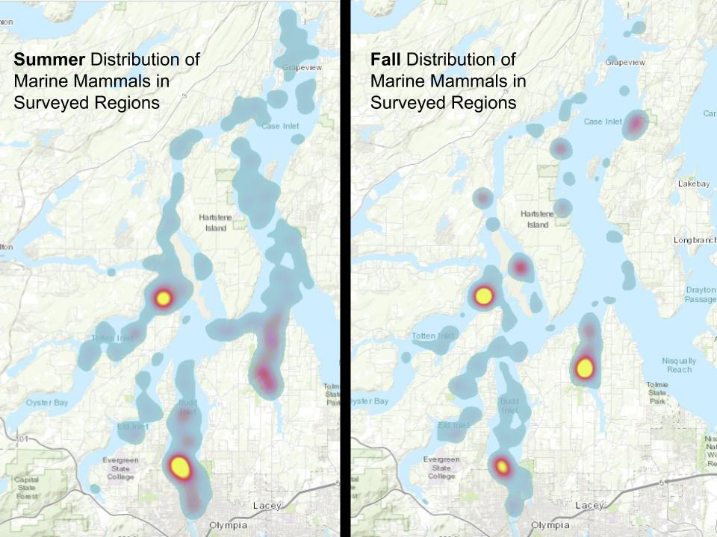

Current results from summer and fall. Note the more condensed distribution in fall as adult harbor seals haul out for most of the day to molt, and the slightly condensed summer distribution as mothers and pups are hauled out. Winter is predicted by the literature to be the most dispersed as all seals hunt and move around most that season.

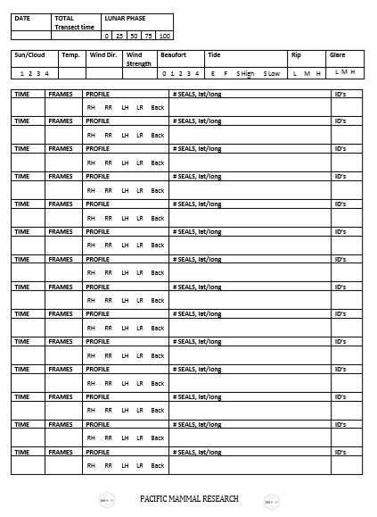

Survey Sheet to be converted into mobile collection software provided by Pacific Mammal Research (PACMAM) Dr. Cindy R. Elliser, 2019.

SUMMER | SOUTHWEST PUGET SOUND MARINE MAMMAL SURVEY

|  |  |  |  |  |
| --- | --- | --- | --- | --- |
| Date/Day | Name | Phone | Email | Survey Region |
| 6/18/19T | Sarah K |  |  | Sailing from Port Orchard. **(12 hrs)** |
| **6/19/19**W | Hayley Barrickman |  |  | Hammersley & South Pickering (7hrs) |
| 6/20/19T | Hayley Barrickman |  |  | East Case |
| 6/21/19F | REST |  |  | REST |
| 6/22/19S | Noelle Lore |  |  | Eld & Budd Inlets (7hrs) |
| 6/23/19S | Kaitlynn Mann |  |  | Oyster Bay,South Pickering |
| **6/24/19**M | Sally |  |  | Henderson, West Case, North Case |
| 6/25/19T | Sally |  |  | North Pickering |
| 6/26/19W | Sally |  |  | North Case, East Case, Henderson |
| 6/27/19T | REST |  |  | REST |
| 6/28/19F | Hayley Barrickman |  |  | Oyster Bay, Eld & Budd, South Pickering |
| **6/29/19**S | Sara Newman |  |  | Henderson, West Case, North Case |
| 6/30/19S | Sara Newman |  |  | Henderson, East Case |
| 7/1/19M | Sally Newman  Sara Newman |  |  | Oyster Bay |
| 7/2/19T | Hayley Barrickman |  |  | Eld & Budd Inlets (7hrs) |
| 7/3/19W | Hayley Barrickman |  |  | West Case, North Case |
| 7/4/19T | Caelin Lee |  |  | Sailing to Port Orchard. **(12 hrs)** |

Example of sign-up sheet being used.

FALL | SOUTHWEST PUGET SOUND MARINE MAMMAL SURVEY

|  |  |  |  |  |
| --- | --- | --- | --- | --- |
| Date | Name | Phone | Email | Region |
| 8/29/19T | Hayley Barrickman |  |  | Sailing from Port Orchard. **(12 hrs)** |
| **8/30/19**F | Claire Olson |  |  | Oyster Bay1, South Pickering1 (5hrs) |
| 8/31/19S | Paul and Hayley |  |  | Eld & Budd1 (5hrs) |
| 9/1/19S | Sara |  |  | Henderson1, West Case1 (7hrs) |
| 9/2/19M | ^^^Same as Above | **************** | STAYING THE NIGHT BEFORE  AT JERRELL COVE STATE PARK | North Pickering1, North Case1, East Case1 (7hrs) |
| 9/3/19T | ------------------------------- | ------------------- | --------------------------------------- | REST |
| **9/4/19**W | Sarah Kowalski |  |  | Oyster Bay2, South Pickering2 (5hrs) |
| 9/5/19T | Hayley |  |  | Eld & Budd2 (5hrs) |
| 9/6/19F | Sally + Sara |  |  | Henderson2, West Case2 (7hrs) |
| 9/7/19S | ^^^Same as Above | **************** | STAYING THE NIGHT BEFORE  AT JERRELL COVE STATE PARK | North Pickering2, North Case2, East Case2 (7hrs) |
| 9/8/19S | Sally | ------------------- | --------------------------------------- | Oyster Bay3, South Pickering3 (5hrs) |
| **9/9/19**M | ------------------------------- | ------------------- | --------------------------------------- | Rest |
| 9/10/19T | Claire Olson |  |  | Eld & Budd3 (5hrs) |
| 9/11/19W | Hayley Barrickman |  |  | Henderson3, West Case3 (7hrs) |
| 9/12/19T | ^^^Same as Above | **************** | STAYING THE NIGHT BEFORE  AT JERRELL COVE STATE PARK | North Pickering3, North Case3, East Case3 (7hrs) |
| 9/15/19S | Sally + Sara |  |  | Sailing to Port Orchard. **(12 hrs)** |

Example of sign-up sheet being used.

WINTER | SOUTHWEST PUGET SOUND MARINE MAMMAL SURVEY

|  |  |  |  |  |
| --- | --- | --- | --- | --- |
| Date | Name | Phone | Email/Note | Region |
| 12/20/19F | Hayley |  | 4:30am Leave -  12:30pm Arrive | Sailing from Port Orchard. **(12 hrs)** |
| **12/21/19**S | Paul, Hayley |  | N/A | Oyster Bay1, South Pickering1 (5hrs) |
| 12/22/19S | Jennifer Welch |  | jrwelch87@gmail.com | Eld & Budd1 (5hrs) |
| 12/23/19M | Sally |  |  | Henderson1, West Case1 (7hrs) |
| 12/24/19T | ^^^Same as Above | **************** | STAYING THE NIGHT BEFORE  AT JERRELL COVE STATE PARK | North Pickering1, North Case1, East Case1 (7hrs) |
| 12/25/19W | ********************** | **************** | Leaving SEAWOLF for a short Christmas morning visit. | REST |
| **12/26/19**T | Hayley |  | N/A | Oyster Bay2, South Pickering2 (5hrs) |
| 12/27/19F | Hayley |  | N/A | Eld & Budd2 (5hrs) |
| 12/28/19S | Angela |  |  | Henderson2, West Case2 (7hrs) |
| 12/29/19S | ^^^Same as Above | **************** | STAYING THE NIGHT BEFORE  AT JERRELL COVE STATE PARK | North Pickering2, North Case2, East Case2 (7hrs) |
| 12/30/19M | ********************** | **************** | ***************************** | REST |
| **12/31/19**T | Claire Olson |  |  | Oyster Bay3, South Pickering3 (5hrs) |
| 1/1/20W | Claire Olson |  |  | Eld & Budd3 (5hrs) |
| 1/2/20T | Sally |  |  | Henderson3, West Case3 (7hrs) |
| 1/3/20F | ^^^Same as Above | **************** | STAYING THE NIGHT BEFORE  AT JERRELL COVE STATE PARK | North Pickering3, North Case3, East Case3 (7hrs) |
| 1/4/20S | Jennifer Welch, Sarah C?, Adrianna |  | 10am Leave   - 8pm Arrive | Sailing to Port Orchard. **(12 hrs)** |

Example of sign-up sheet being used.

Survey123 Selection Tree

Season Specific Survey File

|  |
| --- |
| Time/Date (Auto) |
| LAT/LONG (Auto) |
| Method (Vessel, Zodiac, Other) |

Groups

|  |  |  |  |
| --- | --- | --- | --- |
| Observation | Environmental Data | Disturbance | Waterfront Land-use |

|  |  |  |  |
| --- | --- | --- | --- |
| Species (multi) | Sun/Cloud (multi) | Type (multi) | Type (multi) |
| Count (#) | Air Temp (#) |  |  |
| Water/Hauled (multi) | Water Temp (#) |  |  |
| Travel (multi) | Wind Direction (multi) |  |  |
|  | Beaufort lvl (multi) |  |  |
|  | Tide lvl (multi) |  |  |
|  | Glare (multi) |  |  |
|  | Lunar (multi) |  |  |
|  | Depth (#) |  |  |

SUBMIT

(Offline and Online options)

This is the Survey123 selection tree used to design the app for collecting data.