November 14, 2023

To Whom It May Concern,

This letter is intended to act as official confirmation from the Master of Environmental Studies Program at The Evergreen State College that Emily Gates has been a matriculated student since Fall 2021 and is an enrolled student in our program for the 2023-2024 academic year. Emily has completed all 32 core credits in MES as well as 16/24 elective credits and is still working to complete the 16 thesis credits required for the MES degree. Thesis students often work independently in MES with their faculty thesis reader, and Emily is still focused on completing her research with MES faculty, Erin Martin. Emily Gates’ is expected to meet all degree requirements, including the remaining 8 elective credits, and 16 thesis credits, in Spring 2024, and graduate from the program.

If you have any questions, please contact me at leroyc@evergreen.edu.

Sincerely,
Carri LeRoy

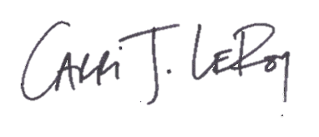
Carri LeRoy, Ph.D.
Director, Master of Environmental Studies Program
leroyc@evergreen.edu

