### Thesis Prospectus 2023-24

**Name: E. David Heydt**  **ID Number: A00400731**

**Email:** [**earlheydt@gmail.com**](mailto:earlheydt@gmail.com)[**heyear27@evergreen.edu**](mailto:heyear27@evergreen.edu)

**Student Final Submission (date): 2/6/2024**

**Faculty Reader Approval (date): 2/7/2024**

**MES Director Approval (date):**

1. Working title of your thesis[1].

Effects of genetic isolation on seed production and viability of golden paintbrush (*Castilleja levisecta*) populations in two south Coast Salish prairies.

1. In 250 words or less, summarize the key background information needed to understand your research problem and question.

Golden paintbrush (*Castilleja levisecta*) was until recently a federally protected species and now in 2023 has been removed from the endangered species list (Federal Register 2021, Federal Register 2023). There are no native populations that rate at “highly viable”, meaning they contain 1000 or more mature plants (Caplow 2004, U.S. Fish and Wildlife Service 2019). Of the native sites that rate midrange for viability none reach the minimum viable population count of ~1000 individuals. The count of the largest native population has decreased by roughly 95% in the last decade (U.S. Fish and Wildlife Service 2019, WADNR data UNPUBLISHED). Certain native populations of *C. levisecta* have been genetically isolated by management which excludes the seeding or planting of individuals with genetics from other populations. When *C. levisecta* plants self-pollinate or mate with close relatives their offspring succumb to inbreeding depression. The fruit set of *C. levisecta* ranged from 0.7% for self-pollinations, 33% for sibling crosses, 71% for within population crosses, and 80% for between population crosses (Kaye and Lawrence 2003). Introducing new, unrelated genetic material into a population of *C. levisecta* has been shown to boost its vigor (Willi et al. 2007, St. Clair et al. 2020).

1. State your research question(s).

Are *C. levisecta* populations in the south Puget Sound prairies becoming terminally inbred due to management driven genetic isolation? Does a population of the rare plant *Castilleja levisecta* that has been genetically isolated due to management decisions suffer reduced seed set and viability?

1. Situate your research problem within the relevant literature. What is the theoretical and/or practical framework of your research problem?

The population counts of mature *C. levisecta* have dramatically decreased at native sites in Washington. (U.S. Fish and Wildlife Service 2019, WADNR data UNPUBLISHED 2023). Certain native populations of *C. levisecta* have been genetically isolated by management that excludes the seeding or planting of individuals with genetics from other populations (WADNR data UNPUBLISHED 2023). Recent research shows that *C. levisecta* produces progressively less seed with progressively more closely related breeding partners (Kaye and Lawrence 2003).

Additional research shows that the introduction of more distantly related breeding partners can increase seed production and population health, a technique called genetic rescue (St. Clair et al. 2020). This genetic rescue technique has been successfully utilized to restore the fitness of rare plants in field experimentation (Willi et al. 2007). Most recently *C. levisecta* has been delisted federally and its conservation future is unclear (Federal Register 2023). The previous findings suggest that this rare plant would be an excellent candidate for genetic rescue as a method to improve fitness via increased seed production and viability, if those are proved to be lacking.

_

1. Explain the significance of this research problem. Why is this research important? What are the potential contributions of your work? How might your work advance scholarship?

This project will improve our understanding of the effects of genetic isolation on seed production and viability in *C. levisecta*.

Demonstrating that seed production and viability on native sites is reduced will hopefully be enough to tie the management strategy to the population issue via the previous research about reduced seed production between close relatives. This in turn will lead to adoption of the recently vindicated genetic rescue technique, prompting a probable rebound in native populations. This research could also lead to a project of genetic analysis for native *C. levisecta* individuals.

If this project does not reveal a reduction in production or viability of the native seed when compared to the introduced seed, then the findings will eliminate low seed production and viability as a reason for population loss on genetically isolated native sites. This will prompt further and varied investigation of the cause for said population loss. In either instance, this methodology could be applied to other rare species on managed lands to examine differences in the count and quality of seed produced. This would be a useful tool for populations of rare plants suffering from climate change or other pressures.

1. Summarize your study design[2]. If applicable, identify the key variables in your study. What is their relationship to each other? For example, which variables are you considering as independent (explanatory) and dependent (response)?

Dependent variable: Seed production/weight/viability

Independent variable: Site genetics management strategy (Foreign genetics introduced vs. foreign genetics excluded.

THIS SAMPLING PLAN IS IDENTICAL TO THE ONE SUBMITTED FOR THE PERMIT. IT IS WRITTEN IN FUTURE TENSE, BUT THE SAMPLING HAS BEEN COMPLETED.

I will collect *Castilleja levisecta* seed from one native population (Rocky Prairie) and one population that has been introduced (Mima Mounds). I will collect 100 samples (randomly selected seed pods from independent plants) from each population if possible. This will allow for the capture of a 0.4 effect size with 0.8 power at a 95% confidence level. Plants with no seed stalks will be excluded. In the event that the reduced population at Rocky Prairie does not have 100 fruiting samples of this rare plant, then the total number of available fruiting samples will be used. 64 samples will allow for the capture of a 0.5 effect size with 0.8 power at a 95% confidence level.

For Mima Mounds the 100 samples will be taken from the eight different seeding units present on the site to ensure a representative mix of genetic material. The number sampled per unit will be a ratio equal to the ratio of said unit’s *C. levisecta* population to Mima Mounds total *C. levisecta* population, rounded to the nearest whole number. This method will ensure a representative sample of a population made of plantings from different years and sources. This method excludes units that would provide less than one sample using the aforementioned ratio. The sampling scheme is detailed below in the figure. A similar sampling scheme has been developed for the six units of Rocky Prairie.

*C. levisecta* sampling counts for each Mima Mounds seeding unit.

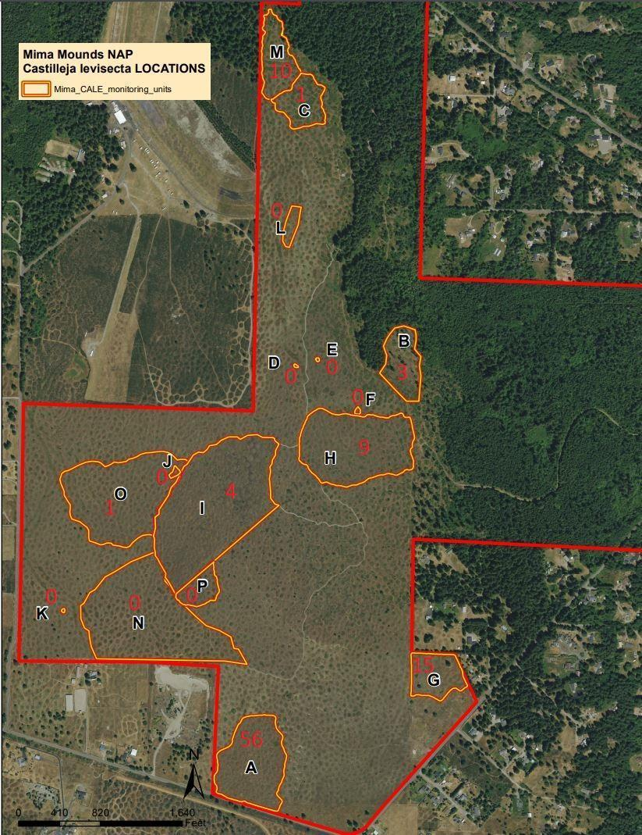

The *C. levisecta* plants are present in low numbers and distributed extremely unevenly in the individual units. This makes randomly distributed points less effective as a sampling tool. ArcGIS Fieldmaps and high visibility flagging will be used to ensure that samples taken within each unit are as evenly distributed as possible. This will include both spatially throughout the unit and also attempting to take an equal number of samples from in-swale and on-mound plants at the Mima Mounds site.

*C. levisecta* fruits mature from late June through July, with capsules beginning to open and disperse seed in August (Evans et al. 1984). Early July is when I plan to sample. For each sample plant I will collect a random seed pod from a random stalk. This will be randomized by using a random number generator in the range of each plant's count of seed stalks, then seed pods on that stalk. I will bag each pod individually and label it with the site of origin. I will record the weight of the seed produced, using a calibrated analytical balance to ensure accuracy. I will record the number of seeds produced by seed pods. After recording seed weight and number, the seeds will be combined from each individual site to form two groups, Mima (foreign genetics introduced) and Rocky (foreign genetics excluded). The results of these analyses will be logged in data sheets like those pictured below.

1. Describe the data that will be the foundation of your thesis. Will you use existing data, or gather new data (or both)? Describe the process of acquiring or collecting data[3].

This will be new data.

Seed viability data will be generated at the site scale. Individual seed pods, plants, and sampling units will provide too little seed to reach the minimum amount required to run through viability testing. This table shows seed viability results by site, with total seed count, total number of seed pods, and total seed weight included.

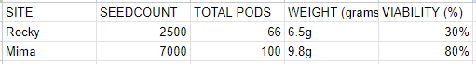

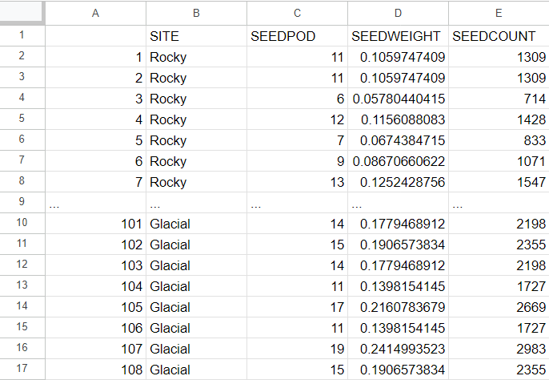

The adjacent table shows an example of seed count and weight data for this study. The sheet includes the sample number, site name, total seed weight, and total seed count. Ideally this master data sheet will contain 200 entry rows, one for each sample.

1. Summarize your methods of data analysis. If applicable, discuss any specific techniques, tests, or approaches that you will use to answer your research question.

Using Rcode and RStudio, the seed count and seed weight data will first be analyzed to determine if the use of parametric or non-parametric statistical tests are needed. Summary statistics will be reported for the data. If the data are normally distributed, parametric testing will lead to a two tailed t-test. If the test returns a statistically significant result indicated by a p-value of less than 0.05, then I will run a one-tailed t-test to determine if the seed set of the native population at Rocky Prairie is significantly lower than the seed set in the introduced population at Mima Mounds. If the data are not normally distributed then various data transformations will be attempted to achieve normality. If normality cannot be achieved then non-parametric testing will lead to a Mann-Whitney U-Test.

I will use the sampled seed to run viability tests for germination rate of each site's samples. The WADNR Natural Areas lead ecologist will assist in selecting a suitable lab. These germination rates will be reported in the final document in both figures and discussion. There will likely only be enough seed to run one viability test for seed from each site, so I will not have sufficient data to run any statistical analyses on seed viability data.

1. Address the ethical issues[4] raised by your thesis work. Include issues such as risks to anyone involved in the research, as well as specific people or groups that might benefit from or be harmed by your thesis work, perhaps depending on your results. List any specific reviews you must complete first (e.g., Human Subjects Review or Animal Use Protocol Form).

There are no ethical issues raised by this work or my involvement with it.

1. List specific research permits[5] or permissions you need to obtain before you begin collecting data (e.g. landowner permissions, agency permits).

DNR research sampling permits for *C. levisecta* at Rocky prairie and Mima mounds sites ACQUIRED

1. Reflect on how your positionality as a researcher could affect your results and how you will account for this in the research process[6].

My position allows me to subconsciously bias my samples by plant selection and pod selection per plant. To reduce the possibility of this occurring I will use gps tracking to disperse my sampling as evenly as possible within units. I will also use random number generators to select my samples rather than blind grabbing.

1. Provide at least a rough estimate of the costs associated with conducting your research, if any.  Provide details about each budget item so that the breakdown of the final cost is clear.

$86 per viability test x2 = $172 plus tax and transit.

Tetrazolium (TZ) A quick biochemical viability test which determines the number of live seeds based on dehydrogenase activity in seeds. It indicates the percentage of viable (live) and non-viable seeds in any sample regardless of its dormancy level. The test can be performed in 24-48 hours. *ISTA Accredited Test

1. Provide a detailed working outline of your thesis.

INTRODUCTION

Relevant background

* Conservation history
* Conservation associations

Current happenings

* Delisting
* Implications
* Population decline

Figure 1 Monitoring data for abundance of C. levisecta flowering plants 2004 - 2020.

Figure 2. Native C. levisecta site abundance range wide 2004-2017.

Quality of populations

* Viability ratings
* Rocky prairie decline

Rocky specific

* Rocky pop history
* Rocky pop current totals

Reasons for pop decline

* Seed set
* Self-incompatibility (rates)
* Rocky isolation

Delisting

* Good and bad
* Native pops vs introduced
* Study and justification
* Use for management

Why I chose the topic

* Site stewardship
* Delisting
* Data driven
* Inquiry and research question

Wrap-up

* Study proposition
* Viability test
* Locations and permissions

LITERATURE REVIEW

Introduction The topic of focus for this literature review is the recently delisted, and formerly endangered prairie plant Castilleja levisecta.

* Specifically, the requirements for sustainable management of the native *C. levisecta* populations.
* Examination of several decades of *C. leviseca* management has revealed a clear depiction of past and current states of recovery.

Literature on NeedsThe requirements for the healthy establishment and sustainable management of *C. levisecta* Populations are similar to those of other plants, with several key differences.

* High quality habitat of the appropriate type is one of the most important requirements for the health of this species.
* The presence of the proper host plants is a key factor for the sustainability of a *C. levisecta* population.
* The number of individuals in each population is also very important.
* When *C. levisecta* plants self pollinate or mate with close relatives their offspring may show negative effects related to inbreeding depression, while the opposite is possible if individuals that are distantly related reproduce (Kaye, T. N., & Lawrence, B. 2003).
* *C. levisecta* is an insect pollinated plant and requires insects to thrive (ECOS 2003).

Literature on Threats*C. levisecta* faces many threats to its continued survival.

* Herbivory is a common challenge plants face.
* Invasive species are a more major cause for concern in *C. levisecta* management.
* Habitat destruction is the main problem *C. levisecta* is facing.
* Hybridization with other *Castilleja* species is an additional pressure on the survival of the species.
* On the opposite end of the scale from hybridization we have the problem of inbreeding.

Literature on ManagementThe various needs and threats for the sustained existence of *C. levisecta* are met or rebuffed by the management techniques, methods, and policies used by the conservation community surrounding it.

* *C. levisecta* is an important plant in Western Washington restoration.
* The physical, on the ground management of *C. levisecta* habitat is incredibly important to the species.
* The securing of C. levisecta populations is being done primarily through a system of preserves and natural areas (Caplow 2004).

SummaryAfter in depth review of available research it is clear that the requirements for sustainable management of the native *C. levisecta* populations requires many things for sustained health.

* My hypothesis is that native Western Washington populations of Castilleja levisecta require cross-breeding between their few remaining isolated sites to sustain viable future populations.
* It is clear from the literature that *C. levisecta* needs to have genetically heterogeneous reproductive partners located within flight distance of its insect pollinators if it is to produce a healthy seed set.

METHODS

First Paragraph

* Collect seed from native population (Rocky Prairie) and introduced (Mima)
* Each population sampled 100 times (Mima), 66 (Rocky)
* Capture of a 0.4 effect size with 0.8 power at a 95% confidence level.
* Plants with no seed stalks excluded.

Second Paragraph

* Mima Mounds samples taken from eight different seeding units.
* Number sampled per unit equal in ratio to percent of total.
* Excludes units that would provide less than one sample

Figure 3. C. levisecta sampling counts for each Mima Mounds seeding unit.

Third Paragraph

* ArcGIS Fieldmaps and high visibility flagging to ensure evenly distributed samples.
* Equal number of samples from in-swale and on-mound plants at the Mima Mounds site.

Fourth Paragraph

* Early July sampling.
* Collected a random seed pod from a random stalk.
* Randomized by random number generator.
* Bagged each pod individually and labeled it.
* Record the weight of the seed produced, using a calibrated analytical balance
* Record the number of seeds produced by seed pods.

Fifth Paragraph

* Rcode and RStudio to determine if the use of parametric or non-parametric. Summary statistics will be reported for the data.
* Tests used
* Viability testing

RESULTS

* Summary stats
* Seed count
* Seed weight
* Seed viability

DISCUSSION

* Implications of findings

CONCLUSION

* Future management
* Further study

1. Provide a specific work plan and a timeline for each of the major tasks in the work plan. Be as realistic and specific as you can at this point, including the deadlines for Spring quarter.

Sampling: Summer 2023 COMPLETE

Literature review rough draft: November 16th 2023 COMPLETE

Lab access: November 2023 IN PROGRESS

Poster: November 21st COMPLETE

Sample processing: January 2024 NOT STARTED

Statistical analysis: January 2024 NOT STARTED

Final signed prospectus: December 15th 2023 IN PROGRESS

Background (Introduction?) rough draft: January 2024 IN PROGRESS

Methods rough draft: January 2024 COMPLETE

Samples sent to OSU seedlab: January 2024 NOT STARTED

Results rough draft: February 2024 NOT STARTED

Discussion rough draft February 2024 NOT STARTED

Concussions rough draft February 2024 NOT STARTED

Literature review final draft: Week 5 Winter 2023 IN PROGRESS

Complete draft of Results/Discussion for peer: Week 1 Spring 2023 NOT STARTED

Complete draft of Results/Discussion for reader: Week 2 Spring 2023 NOT STARTED

Conclusion for peer review: Week 3 Spring 2023 NOT STARTED

Conclusion for reader review: Week 4 Spring 2023 NOT STARTED

Request to Present Thesis Research: Spring 2023 NOT STARTED

Thesis Presentations: Week 8 Spring 2023 NOT STARTED

Final Draft of Thesis: Week 9 Spring 2023 NOT STARTED

1. Who (if anyone), beyond your MES thesis reader, will support your thesis (in or outside of Evergreen)? Be specific about who they are and in what capacity they will support your thesis. If you are working with an outside agency or expert, be specific about their expectations for your data analysis or publication of results.

DNR Natural Areas ecologist David Wilderman helped me develop a sampling plan, file permits, and identify labs for send-out viability testing. Dr. Sarah Hamman supported me in the role of thesis-reader.

1. Provide the 5 most important references you have used to identify the specific questions and context of your topic, help with issues of research design and analysis, and/or provide a basis for interpretation. Annotate these references with notes on how they relate to/will be helpful for your thesis. For any other sources cited in your prospectus in other answers, provide a complete bibliographic citation here as well.

Ingvarsson, P. K. (2001). Restoration of genetic variation lost – the genetic rescue hypothesis. *Trends in Ecology & Evolution*, *16*(2), 62–63.<https://doi.org/10.1016/S0169-5347(00)02065-6>

This paper establishes the concept of “genetic rescue”. Genetic rescue is the management tactic of introducing exotic genetics to a population of a species as a way of increasing the fitness/vigor of the individual members and the population as a whole. It fights inbreeding depression.

Kaye, T. N., & Lawrence, B. (2003). *Fitness effects of inbreeding and outbreeding on golden paintbrush (Castilleja levisecta): Implications for recovery and reintroduction*.

This study quantifies the effects of inbreeding and outbreeding on golden paintbrush. It specifically details the percentage change in seed production across a scale of reproductive pairings. It shows that inbreeding of golden paintbrush leads to a massive reduction in seed production. I hypothesize that this is happening to native populations.

St. Clair, A. B., Dunwiddie, P. W., Fant, J. B., Kaye, T. N., & Kramer, A. T. (2020). Mixing source populations increases genetic diversity of restored rare plant populations. *Restoration Ecology*, *28*(3), 583–593.<https://doi.org/10.1111/rec.13131>

This experiment demonstrates that the genetic diversity of golden paintbrush can be increased by introducing exotic genetics. Genetic diversity in golden paintbrush leads to increased seed production. This is proof positive that the genetic rescue method can be applied as a management technique to golden paintbrush. This is the preferred management action if my hypothesis is correct.

Willi, Y., Kleunen, M. van, Dietrich, S., & Fischer, M. (2007). Genetic rescue persists beyond first-generation outbreeding in small populations of a rare plant. *Proceedings of the Royal Society B: Biological Sciences*, *274*(1623), 2357–2364.<https://doi.org/10.1098/rspb.2007.0768>

This study confirms that genetic rescue as a management tactic can be effective for multiple generations. This solidifies the long term effectiveness of the technique, demonstrating its applicability to this situation should my hypothesis be confirmed.

U.S. Fish and Wildlife Service. 2019. Species Biological Report for golden paintbrush (Castilleja levisecta). Version 1.0. Washington Fish and Wildlife Office, Lacey, Washington. 81 pp.

This data shows the dramatic and dangerous decline in native golden paintbrush population counts. It is important for highlighting the distinct difference in how native and introduced populations have been progressing under the current management direction. This shows how bad a problem we have at these legacy sites.

1. You are not locked into this title; we want you to identify the main point or topic of your thesis.
2. You might discuss a selection of case studies, sampling methods, experimental design, and/or specific hypotheses you will test. You should also address any specialized knowledge or skills that are necessary to complete the research.
3. If you are planning to use existing data, explain the specific source, contact information, arrangement with collaborating agencies, and expectations about use of data and final products of your research. If you are planning to gather new data, describe specific methods, time, place, and equipment that will be required.
4. If you’re not sure where to start, consult a ‘Code of Ethics’ or other similar document from an academic society in an applicable field of study.
5. If you are collecting ANY samples or data, even observational data, on public lands (city, county, state and/or federal) it is your responsibility to find out the permit requirements BEFORE you collect data. Conducting research with tribal members/on tribal lands will have different and additional requirements.
6. Your *positionality as a researcher* refers to the fact that one’s “…beliefs, values systems, and moral stances are as fundamentally present and inseparable from the research process as [one]’s physical, virtual, or metaphorical presence when facilitating, participating and/or leading the research project…” (The Weingarten Blog 2017).