RENEWABLE HEATING ON U.S. COLLEGE CAMPUSES:

ASSESSING VIABILITY USING PLACE-BASED FACTORS

by

Emma C. Wright

A Thesis

Submitted in partial fulfillment

Of the requirements for the degree

Master of Environmental Studies

The Evergreen State College

June 2024

©2024 by Emma C. Wright. All rights reserved.

This Thesis for the Master of Environmental Studies Degree

by

Emma C. Wright

has been approved for

The Evergreen State College

by

_______________________________

Kathleen Saul, Ph.D.

Member of Faculty

_______________________________

Date

ABSTRACT

Renewable Heating on U.S. College Campuses: Assessing Viability Using Place-Based Factors

Emma C. Wright

Replacing fossil fuels with renewable energy is an essential step in eliminating greenhouse gas emissions and mitigating climate change. However, when renewable energy systems are imposed on places in a way that does not work with their unique characteristics, they may perpetuate environmental injustices and cause more harm than they address. In this thesis, I sought to build a connection between place-based factors and their influence on the criteria that ultimately determine the prospective viability of different renewable heating systems for a place. I studied three forms of renewable heating — air-source heat pumps, ground-source heat pumps, and geothermal direct heating — across the spatial extent of the contiguous United States, and for implementation on college campuses specifically. For this spatial extent, I gathered data on four place-based factors: average annual heating degree-days, commercial natural gas prices, financial-incentive policies, and electricity from renewable sources. I classified each factor’s data into five categories scored from 0 to 4, which respectively indicated the lowest and highest levels of viability for a renewable heating system that would be implemented under that category of the factor. I then overlaid these factor layers using ArcGIS Pro to produce overall viability mapsfor each studied form of renewable heating. These viability maps were color-coded to indicate areas of lowest and highest overall viability as of 2024 for each form of renewable heating, according to the four place-based factors included in this thesis. In addition to providing information on the current relative viabilities of air-source heat pumps, ground-source heat pumps, and geothermal direct heating for college campuses in the United States, the model used in this thesis holds potential for further extension through incorporating additional place-based factors, studying additional forms of renewable heating or renewable energy, and/or covering other geographical areas.

Table of Contents

List of Figures vi

List of Tables vii

Acknowledgements viii

Introduction 1

Fitting Solutions to Place 2

Scope of Research 3

District Heating 4

Research Questions 5

Literature Review 6

Overview 6

Forms of Renewable Heating 6

Solar Thermal 7

Biomass Heating 9

Geothermal Direct Heating 11

Heat Pumps 12

Waste Heat 19

Criteria 20

Costs 22

Emissions 23

Land Impacts 24

Efficiency 25

Social Criteria 26

Place-Based Factors 26

Temperature and Humidity 26

Fossil Fuel Prices 29

Policies and Incentives 30

Renewable Electricity Availability 33

Renewable Heating Case-Studies 33

Cornell University 34

West Virginia University 36

University of Illinois, Urbana-Champaign 37

Ball State University 38

Methods 40

Overview 40

Place-Based Factors 40

Heating Degree-Days 41

Commercial Natural Gas Prices 43

Financial Incentives 44

Renewable Electricity Availability 46

Viability Mapping 49

Results 52

Place-Based Factor Component Maps 52

Heating Degree-Days 52

Commercial Natural Gas Prices 53

Financial Incentives 55

Renewable Electricity Availability 61

Viability Maps 62

Air-Source Heat Pumps 62

Ground-Source Heat Pumps 64

Geothermal Direct Heating 66

Discussion 69

Overview 69

Current Renewable Heating Viability 69

Air-Source Heat Pumps 69

Ground-Source Heat Pumps 70

Geothermal Direct Heating 71

Re-Visiting Case-Study Colleges 72

Limitations, Omissions, and Recommendations 74

Limitations 74

Omissions 76

Recommendations for Further Research 76

Conclusion 78

References 79

List of Figures

**Figure 1**. Factors, Criteria, and Viability 31

**Figure 2.** Annual Heating Degree-Days 55

**Figure 3.** Average Commercial Natural Gas Prices 57

**Figure 4.** Incentives for Air-Source Heat Pumps 59

**Figure 5.** Incentives for Ground-Source Heat Pumps 61

**Figure 6.** Incentives for Geothermal Direct Heating 62

**Figure 7.** Renewable Electricity Availability 64

**Figure 8.** Viability of Air-Source Heat Pumps 66

**Figure 9.** Viability of Ground-Source Heat Pumps 68

**Figure 10.** Viability of Geothermal Direct Heating 70

**Figure 11.** Case-Study Colleges and Geothermal Direct Heating Viability 75

List of Tables

Table 1. 32

Table 2. 44

Table 3 46

Table 4 48

Table 5 50

Table 6 52

Table 7 53

Acknowledgements

First and foremost, I wish to give all the gratitude in the world (and then some more) to Dr. Kathleen Saul for her mentorship, guidance, and accompaniment throughout the twisting and turning utter rollercoaster of a journey that has been this thesis. Thank you for always believing in me, through the high points equally as the low, and for helping me remember how to believe in myself in the times when I almost forgot how to. Thank you for being my mentor, my friend, my confidant, my accomplice.

I am forever indebted to the Evergreen Master of Environmental Studies Program and everyone in it for giving me an almost endless level of support over the last two years. Thank you to Carri LeRoy; Kevin Francis; Erin Martin; John Withey; John Kirkpatrick; Shangrila Joshi; and everyone else along the way. Thank you to Mike Ruth for mentoring me from the ground up in the art of GIS and helping me grow into a proficient and confident practitioner with your unmatched enthusiasm for my work. Thank you to Averi Azar for all your help along the way, all the way from when I first applied to Evergreen up to the very end of this thesis process. Thank you to all my classmates and peers who persevered through the core curriculum and electives alike with me, who reviewed, critiqued, and gave feedback to my work, who believed in me when I fell upon hard times and championed me when I rose back up from them alike. Thank you, all of you, for letting Evergreen be a place I can call home.

Thank you to Scott Morgan, my mentor of a year and a half with the Evergreen Office of Sustainability, for guiding me through the vast world of building decarbonization and helping me grow my confidence to step fully into it. I don’t know if I would have even landed on this thesis topic if not for working with you. A big, big, big thank you to Michael Joseph with the Center for Climate Action and Sustainability for your mentorship, friendship, being a truly awesome human being, and basically everything. Thank you to Anthony Levenda, Joni Upman, Kayla Mahnke-Hargett, and my fellow members of the 2023-2024 Evergreen Clean Energy Committee. Your support and companionship have meant more to me than I can possibly say.

Thank you to my family, both near and far, both born and chosen. Thank you to Mom, Dad, and Sonja for accepting me and loving me for exactly who I am — I feel so blessed and fortunate to have you all in my life. Thank you to all the folk I have found in Olympia, those who have brought me into their community and given me the foundation to lay down my roots in this place. You know who you are.

Last but most certainly not least, thank you to Terra for everything under the stars, and then some. Thank you for being a shining beacon of light and love in my life. Thank you for being you.

*~ Hekate Soteira, Hekate Enodia, Hekate Trimorphos, I thank you. ~*

Introduction

Climate change and its destructive effects have worsened by the year. In 2022, disasters directly linked to climate change caused multiple thousands of deaths and cost an estimated 300–400 billion U.S. dollars in damages worldwide (Masters, 2023). According to the 2023 report by the Intergovernmental Panel on Climate Change (IPCC), to avoid the most irreversible and catastrophic effects of climate change that will become increasingly likely if global temperatures exceed 1.5 degrees Celsius of total warming, all net emissions of atmospheric greenhouse gases must completely cease within the next three decades, which requires a significant and continuous reduction of global emissions every year (Intergovernmental Panel on Climate Change, 2023). The International Energy Agency reported that approximately 44 percent of global greenhouse gas emissions in 2021, or nearly half, came from the combustion of fossil fuels such as coal, oil, and natural gas for the purpose of energy production **(International Energy Agency, 2023LETTER; https://www.iea.org/data-and-statistics/data-tools/greenhouse-gas-emissions-from-energy-data-explorer)**. It is therefore imperative to replace these means of energy production with renewable systems, in order to achieve the necessary greenhouse gas emissions reductions indicated by the Intergovernmental Panel on Climate Change (2023).

However, sustainability often encompasses more than just the reduction of greenhouse gas emissions. For instance, the United Nations lists 17 distinct goals as part of its Sustainable Development Goals, of which renewable energy encompasses only one small part — other goals cover such additional aspects as well-being, equity, and social justice (United Nations, n.d.). To be fully sustainable, renewable energy solutions cannot only reduce greenhouse gas emissions but rather must also embody and represent these additional principles, as otherwise they merely replace one problem with another.

Unfortunately, when they are improperly planned, renewable energy solutions may infringe upon other aspects of sustainability and ultimately cause more harm than good. As an example, a proposed energy storage facility to be built in southern Washington state would strengthen the supply of local renewable wind power **(Goldendale Energy Storage LLC, [https://goldendaleenergystorage.com/benefits.html])**, but is slated to be constructed on land used by indigenous peoples of the Yakama Nation for important traditional food and resource gathering (Yakama Nation Fisheries, 2024). Although this energy storage facility would increase local renewable energy production and create new renewable energy jobs in the area **(Goldendale, [https://goldendaleenergystorage.com/benefits.html])**, it also risks disrupting or destroying a way of life that has sustained local peoplefor many thousands of years(Yakama Nation Fisheries, 2024). When considering the full breadth of the United Nations Sustainable Development Goals (United Nations, n.d.), the true sustainability of renewable energy-related projects like the proposed Goldendale energy storage facility may be called into question.

Fitting Solutions to Place

Despite issues such as those mentioned above, greenhouse gas emissions must be reduced; taking no action is not an option. Solutions must therefore be created that both curtail global emissions *and* simultaneously honor the other United Nations Sustainable Development Goals (United Nations, n.d.). The issue of how to accomplish these simultaneous and potentially conflicting goals forms the central question of this thesis.

*Fitting solutions to place* is the proposed answer to this question. In this thesis, this espouses the idea that solutions should be developed that fit to the places they are implemented, and made to work best with a place’s characteristics, rather than attempting to universally apply “one-size-fits-all" solutions everywhere. According to Pierotti and Wildcat (2000), Johnson et al. (2016), and Cajete (2020), while this concept is novel in and often clashes with the established Western scientific method,within Indigenous science it forms an essential backbone of worldview that guides all subsequent actions taken. Nelson (2014) and Cajete (2020) highlighted how working with places comprises a central part of environmental sustainability within an Indigenous science context, through a robust knowledge of how ecological systems operate at both local and broader scales. Although this concept remains relatively rare within the Western scientific paradigm (Johnson et al., 2016), its principles have occasionally appeared in practice — for example, Hester (2010) documented many personal examples of successful environmental urban-renewal projects that worked heavily with local communities to provide solutions fit to their respective places. This suggests that even within current systems, the concept of fitting solutions to place may already be close to present.

According to Nelson (2014) and Whyte et al. (2016), as Indigenous science becomes more integrated into established scientific method and policy, its principles such as those of working with place will become more widely familiar concepts. Because of this and because of the existing applications of these principles such as demonstrated by Hester (2010), the concept of fitting solutions to place forms the central paradigm of this thesis research.

Scope of Research

While fitting solutions to place is a broad and abstract concept, in this thesis it is applied to the specific field of renewable energy and its implementation. However, renewable energy is itself a broad field that can be divided into major sub-categories of renewable *electricity* and *heating*, respectively(United States Department of Energy, n.d.). To narrow the conceptual scope of my thesis work to within a manageable degree, I have chosen to focus on renewable heating only in my research. I furthermore narrowed the spatial scope of this thesis study to cover only the extent of the contiguous United States; in other words, the “lower 48” states plus the District of Columbia. While this decision was made out of necessity to limit the spatial bounds of the thesis research to a manageable size, it does not imply the comparative importance of the study area relative to any other place — rather, in this thesis research I demonstrate a model that can ideally be applied to any other study area, with appropriate modifications where necessary.

District Heating

While not synonymous with renewable energy, *district energy* is a related and highly intertwined concept that refers to the distribution of energy to multiple consumers across a network of built infrastructure (Mahmoud et al., 2020). Within district energy, *district heating* encompasses specifically this network-distribution of thermal energy, or heat (Jodeiri et al., 2022). Although most renewable heating systems can function as individual units, they are often integrated into district heating systems due to the greater efficiency and cost-saving it can bring(Werner, 2017; Jodeiri et al., 2022). For this reason, the primary research conducted in this thesis focuses on the viability of renewable heating systems within the framework of an assumed existing district heating network.

According to Han et al. (2021), at the time of their writing district heating in the United States remains very sparse and is generally limited to small, self-contained environments such as college campuses and hospitals. Owing to these circumstances, this thesis focuses specifically on college campuses within the contiguous United States for studying the viability of renewable heating. While Han et al. (2021) advocated for the continuing expansion of district heating infrastructure in the United States, I have made renewable heating — rather than district heating — the specific focus of this thesis. Although the expansion of district heating infrastructure in the United States remains an important topic for study and research, it is set aside here to instead focus on implementing renewable heating systems where this infrastructure already exists.

Research Questions

The mission of this thesis is to apply the core ethos of fitting solutions to place to the main topicof implementing renewable heating on U.S. college campuses. I seek to build a general model for determining the viability of different renewable heating forms for a college campus, based on factors that affect this viability and that may vary from place to place. Therefore, I ask the following research questions:

1. What criteria components comprise the *viability* of a form of renewable heating, and what *place-based factors* increase or decrease this viability?
2. What is the spatial distribution of viability for the prospective implementation of three formsof renewable heating — air-source heat pumps, ground-source heat pumps, and geothermal direct heating — on college campuses across the contiguous United States, according to these place-based factors?

Literature Review

Overview

To better understand the current status of renewable heating developments in the United States, common forms of renewable heating will be reviewed with attention given to their strengths, weaknesses, and other unique and/or relevant characteristics. I will also indicate which forms of renewable heating I am including or excluding from further analysis in the main research component of this thesis. Once current common forms of renewable heating have been established, I will next seek to build a working definition of “viability” for use in this thesis, which will be accomplished by reviewing existing studies on the forms of renewable heating I have chosen to cover and noting common criteria metrics used for their evaluation. I will then cover factors that studies have found to positively or negatively affect renewable heating viability, according to the metrics previously noted. Finally, I will review some of the current case-studies of renewable heating on U.S. college campuses, spanning from completed projects to those still in planning. In each of these case-studies, connections will be drawn to the concepts of factors, criteria, and renewable heating viability as they appear in these real-world scenarios.

Forms of Renewable Heating

For this thesis, renewable heating is defined as any system that produces thermal energy (heat) through non-fossil-fuel-consuming means. It also includes systems that provide thermal energy using electrical power, with the assumption that the electricity was itself produced through renewable means. Common forms of renewable heating will be outlined below, with descriptions given of each form’s main strengths, weaknesses, and considerations necessary to achieve their most optimal implementation. Finally, select renewable heating forms will be chosen for inclusion in the main body of this thesis research, according to a combination of active interest among U.S. college campuses, availability of data on influential factors, and this author’s discretion.

Solar Thermal

While solar photovoltaic panels (solar PV) are a common form of renewable electricity production, solar is also used for the direct production of thermal energy through *solar thermal* technology (Kalogirou, 2004). Solar thermal exists in a variety of designs, but generally uses *solar collectors* to capture thermal energy from the Sun and in turn heatwater or a circulatory heating fluid (Kalogirou, 2004; Tian & Zhao, 2013). While solar thermal can be implemented on an individual-building scale (Buker & Riffat, 2015), according to Jodeiri et al. (2022) it is also commonly integrated into district heating systems, with two key factors enabling this integration being progressively lowered heat-distribution temperatures within district heating systems and the advent of *thermal energy storage*. Thermal energy storage is not itself a form of renewable heating, but rather stores excess heat produced during times of over-production, enabling it to be saved for times of higher heat demand (Tian & Zhao, 2013; Sarbu & Sebarchievici, 2018). In this way, thermal energy storage is therefore closely related both to renewable heating and to district heating.

Tschopp et al. (2020) showcased that when it is combined with sufficiently large thermal energy storage systems, solar thermal can function successfully even in high-latitude, temperate regions such as Denmark, Germany, and Austria. All the case-studies covered by these authors included integrated thermal energy storage systems; every covered case-study system included thermal energy storage for daily heat production, while their case-study in Denmark additionally included seasonal thermal energy storage that accumulated heat over the summer season for use in the winter. According to these authors, local economic factors such as financial incentives and heat/electricity pricesproved equally important as sunlight availability for the effectiveness of the studied solar thermal systems. Although many of the solar thermal systems included in the authors’ study used boilers (including some fueled by fossil fuels) for supplemental heat production during the winter season, their study nevertheless demonstrates both the potential and the necessary considerations of solar thermal in regions that might otherwise not be thought of for its implementation.

As with solar PV, a weakness of solar thermal is its dependence on the availability of sunlight for maximum functionality, which is often limited by season and weather (Tester et al., 2021a; Jodeiri et al., 2022). This issue is however further compounded for solar thermal, because its provided services — hot air and water — typically exist in highest demand during the same periods where sunlight is least available, such as the winter season in temperate climates (Tester et al., 2021a). According to Tian and Zhao (2013), solar thermal is often most effective when coupled with thermal energy storage; in the United States, Tester et al. (2021a) doubted the ability of solar thermal to serve as a large-scale renewable heating solution, due to the high cost of building sufficient levels of this thermal energy storage as well as the aforementioned mis-match between sunlight availability and periods of highest heat demand.

Solar thermal is not included among the forms of renewable heating studied further in this thesis. However, it may nevertheless hold potential for applications in renewable heating on U.S. college campuses when it is combined with thermal energy storage and supplemented by other forms of heat production, as demonstrated by Tschopp et al. (2020).

Biomass Heating

Biomass heating encompasses the combustion of plants, animal waste products, and other “non-fossil-fuel" organic matterfor heat production (Vallios et al., 2009). It typically uses boilers similar to those run on fossil fuels, and in some cases it can directly replace fossil fuels with biomass as the boiler fuel (Ericsson & Werner, 2016; Jodeiri et al., 2022). Like most other forms of renewable heating, biomass heating has been heavily integrated into district heating systems (Ericsson & Werner, 2016; Jodeiri et al., 2022). More uniquely, biomass heating has been studied extensively for use in rural areas, owing to advantageous factors such as its often-easier implementation in these areas compared to other forms of renewable heating (Hendricks et al., 2016; Soltero et al., 2018c; Yan et al., 2019). While the suitability of biomass heating for rural areas varies from place to place according to factors such as resource availabilityand competitive pricing (Hendricks et al., 2016; Soltero et al., 2018b; Jodeiri et al., 2022), this nevertheless showcases the principles of fitting solutions to place.

Assuming that it incorporates the replenishment of an equal or greater amount of carbon than it uses (i.e., it does not involve the novel clearing of habitat), biomass heating qualifies as a renewable form of heating (Neri et al., 2016). However, due to inefficiencies inherent to the combustion process,biomass heating consumes more resources than other forms of renewable heating and requires significant amounts of fuel to operate on a large scale, which can lead to environmental issues such as habitat destruction and/or degradation (Tester et al., 2021a). Furthermore, when not used locally to where it is produced, biomass heating can incur major energy and pollution costs from fuel transportation due to a lack of easy portability methods (Ericsson & Werner, 2016; Neri et al., 2016; Jodeiri et al., 2022). Because biomass heating typically uses a traditional combustion process, it also tends to emit more pollutants than other forms of renewable heating, which can lower local air quality and harm human health (Neri et al., 2016; Jodeiri et al., 2022). While these drawbacks have not prevented the continued use of and research into biomass heating, they remain important for consideration in any prospective implementation scenario.

Despite these drawbacks, case-studies such as by Akhtari et al. (2014) have shown the potential for biomass heating to effectively replace fossil fuels. According to Jodeiri et al. (2022), biomass heating may hold potential as a supplementary heating source in systems headed by other, more efficient forms of renewable heating. This is corroborated by existing case-studies and proposed projects where biomass heating is used or recommended for use in “backup boilers” to support other renewable heating systems in meeting a full heating demand load (e.g. Kassem et al., 2020; Tschopp et al., 2020). To address the combustion inefficiencies inherent to biomass heating, authors such as Sartor et al. (2014) and Furubayashi and Nakata (2021) have studied the use of biomass for *combined heat and power,* in which the biomass fuelis combusted primarily for electricity generation and the remaining “unused” thermal energy is then recovered for heating use. These examples demonstrate that despite the aforementioned weaknesses of biomass heating, it is possible to play to its strengths and work around some of these weaknesses to various extents.

While biomass heating is not covered further in this thesis research, it holds potential as a supplemental renewable heating role in some cases. Due to its use of combustion, biomass heating arguably resembles fossil-fuel heating closer than other forms of renewable heating; while this brings weaknesses such as a lower thermal energy output for the resources required, it may conversely also allow biomass heating to fill a niche in the renewable heating paradigm due to the semi-unique characteristics of its “boiler nature” among forms of renewable heating.

Geothermal Direct Heating

Geothermal energy, the latent thermal energy within the Earth’s crust, is commonly used as a source of renewable electricity in geothermal power plants (Tester et al., 2021a). Less common but emerging in interest is the direct use of geothermal energy for heating purposes, referred to as geothermal direct use or geothermal direct heating (Beckers et al., 2021; Tester et al., 2021a). While this form of renewable heating is ubiquitous in countries such as Iceland, it remains sparse in the United States outside of sparse, isolated cases such as hot spring resorts (Snyder et al., 2017; Kolker et al., 2021).

Despite the current limited use of geothermal direct heating in the United States, Tester et al. (2021a) argued that it holds a greater potential for widespread national implementation than other renewable heating systems such as solar thermal and biomass heating. The authors reached this conclusion through a combination of the large untapped geothermal potential across the contiguous United States according to their cited research (e.g. Blackwell et al., 2007), and their perceived lack of a better large-scale alternative for renewable heating in the United States. Similarly, Goetzl et al. (2023) expressed optimism in geothermal direct heating as a viable renewable heating form to further incorporate worldwide, including in the United States. They based this primarily on the potential to integrate geothermal direct heating with other systems such as thermal energy storage and heat pumps, as well as highlighting the large amount of active research in the field.

Like other forms of renewable heating, geothermal direct heating has its weaknesses; according to Jodeiri et al. (2022), these include high construction costs (both in money and time) relative to other forms of renewable heating, potential negative environmental impacts from their construction and operation, and a high susceptibility to lowered operational efficiency resulting from design problems. Because of the often high construction costs, geothermal direct heating is also vulnerable to external factors such as competing fossil fuel prices and policy support (or lack thereof) that can sway its viability of implementation seemingly on a whim (Thorsteinsson & Tester, 2010; Kolker et al., 2021). While all forms of renewable heating rely on local policies and financial incentives to varying degrees (Jodeiri et al., 2022), geothermal direct heating depends especially strongly on this support to enable further research into its implementation(Thorsteinsson & Tester, 2010; Tester et al., 2021a).

Due to the emerging body of research on geothermal direct heating in the United States, including multiple active case-studies of its potential implementation on college campuses that will be highlighted later in this literature review, geothermal direct heating will be included for further study in the main portion of this thesis research.

Heat Pumps

While the previous forms of renewable heating produce or extract their own thermal energy, heat pumps instead use electrical power to *move* existing thermal energy “against the gradient” that it would normally flow, concentrating it in desired spaces such as buildings (Gaur et al., 2021). This is accomplished by using a typically closed-loop system of refrigerants, which absorb thermal energy from an external ambient source and cycle it into the desired spacethrough deliberately-timedevaporation and condensation (Z. Wang et al., 2021). Many heat pumps are capable of operation for either heating or cooling purposes, depending on current external environmental conditions (Gaur et al., 2021; Z. Wang et al., 2021). Although renewable cooling is outside the scope of this thesis, this additional flexibility may prove advantageous for the future implementation of heat pumps as climate change continues to warm global temperatures (Gaur et al., 2021).

According to Jodeiri et al. (2022), the primary current role of heat pumps in district heating systems is to increase the temperature of distributed thermal energy before it reaches its end-user. As distribution temperatures in district heating systems have continuously lowered, the niche value of heat pumps at this end step has increased (Jodeiri et al., 2022; Sarbu et al., 2022; Gjoka et al., 2023). Heat pumps may also be coupled with thermal energy storage systems, which can increase their reliability by providing a back-up source of heat(Ermel et al., 2022). Alongside these developments in district heating, heat pumps have also been studied for their use outside of district heating systems, such as for individual residential heating (Carroll et al., 2020; Chesser et al., 2021). This plethora of studies and applications suggests a high diversity in scenarios where air-source heat pumps may be viable and worth studying.

Compared to other forms of renewable heating, heat pumps generally enjoy an advantage in efficiency — due to how they operate and the laws of thermodynamics, heat pumps can provide equal amounts of heating using comparatively fewer resources when operating under ideal conditions (Gaur et al., 2021; Z. Wang et al., 2021). Their lack of dependence on specific fuels also makes heat pumps more versatile in where they can be constructed, as they generally require access only to electricity and the appropriate external physical medium to operate (Gaur et al., 2021). This high degree of flexibility combined with generally good efficiency makes heat pumps akin to a “jack of all trades” among forms of renewable heating.

Heat pumps’ dependence on electricity presents weaknesses, however, as their consumption may strain and potentially over-burden local electricity supply (Gaur et al., 2021; Tester et al., 2021a). Furthermore, if the electricity used to power a heat pump comes from fossil fuels or other non-renewable sources, the “renewability” of the entire heat pump system comes into question (Greening & Azapagic, 2012). Like other forms of renewable heating, heat pumps are subject to external market factors and may lose viability for implementation when fossil fuels are comparatively cheaper than electricity (Doak et al., 2022). Other concerns with heat pumps include their use of refrigerants, many types of which produce additional greenhouse gas emissions, harm the ozone layer, or cause other polluting effects when they leak (Greening & Azapagic, 2012; Staffell et al., 2012; Gaur et al., 2021); and a lack of widespread familiarity when compared to other, more recognisable forms of renewable energy (Nyborg & Røpke, 2015; Gaur et al., 2021). These concerns show that while heat pumps hold unique advantages compared to other forms of renewable heating, they are not a one-size-fits-all solution and their pros and cons must be weighed against those of other forms of renewable heating in any implementation scenario.

While heat pumps share some general characteristics, they differ in many ways according to their *type*, which is categorised by the external physical medium (air, water, or ground) from which they draw thermal energy (Gaur et al., 2021; Z. Wang et al., 2021). These different types of heat pumps are described next, along with more specific strengths, weaknesses, and considerations for the effective operation of each.

Air-Source Heat Pumps

Air-source heat pumps encompass those that use the surrounding, ambient air as the external medium with which they exchange thermal energy (Gaur et al., 2021; Z. Wang et al., 2021). While air-source heat pumps vary in size and capacity, they are typically smaller than other types of heat pumps and often operate as separate units on individual buildings (Staffell et al., 2012). Generally, air-source heat pumps require less space and fewer specificities for where they can be constructed than other types of heat pumps, which combined with a typically lower cost offers them a high degree of flexibility even by the standards of an already-flexible renewable heating form(Staffell et al., 2012; Z. Wang et al., 2021).

However, their inherent “exposure to the elements” leaves air-source heat pumps highly susceptible to changes in external environmental conditions; in particular, they run the risk of frosting in cold weather, which can severely lower the efficiency of the system or even disable it entirely (Staffell et al., 2012; Z. Wang et al., 2021). Even when they avoid frosting, air-source heat pumps tend to drop significantly in efficiency when ambient temperatures are low (Safa et al., 2015; Y. Zhang et al., 2017). Due to this, air-source heat pumps may perform worse than other heat pump types over the entire heating season and accrue higher expenses in the long run (De Swardt & Meyer, 2001; Safa et al., 2015). These drawbacks balance the previous advantages of air-source heat pumps against other types.

Air-source heat pumps have appeared as potential options in the decarbonisation plans of some U.S. college campuses, such as Foothill College in California (Hansen, 2023). However, compared to other types of heat pumps, air-source heat pumps appear to be recommended more frequently for use in tandem with other renewable heating infrastructure, such as with Western Washington University in Bellingham, Washington (Säzän Group & Integral Group, 2022); or deemed a less viable option than other forms of renewable heating, such as by the University of Washington in Seattle (University of Washington, 2023). Nevertheless, air-source heat pumps are included for further study in this thesis, due to many of the key factors affecting their viability such as temperature data and renewable electricity availability being among the factors gathered and used in this research.

Ground-Source Heat Pumps

Ground-source heat pumps use below-ground soil as the physical medium from which they draw and exchange thermal energy (Gaur et al., 2021; Z. Wang et al., 2021). The term “ground-source heat pump” overlaps and is sometimes used synonymously with “geothermal heat pump” (Gaur et al., 2021), which may cause confusion with geothermal direct heating in the latter case. For clarity in this thesis, “ground-source heat pump” is consistently used as the term that encompasses the mechanisms described in this sub-section, while “geothermal” always refers to geothermal direct heating when used. The term “geothermal heat pump” is avoided in this thesis, except when referencing sources that use it or a related term.

Compared to air-source heat pumps, ground-source heat pumps typically offer a higher reliability and efficiency, being less susceptible to adverse weather conditions due to the comparative thermal stability of the below-ground over ambient air (De Swardt & Meyer, 2001; Staffell et al., 2012). Even under fairly stable weather conditions, ground-source heat pumps typically exhibit greater efficiency than air-source heat pumps, due to the thermal properties of ground-soil making heat exchange more thermodynamically favourable (Staffell et al., 2012); this advantage is especially pronounced in climates that experience significant seasonal temperature variations (Sarbu & Sebarchievici, 2014; Z. Wang et al., 2021). This efficiency may lead to a lower cost over the heat pump’s operational lifetime (Paiho et al., 2017). In general, ground-source heat pumps tend to hold small to moderate advantages over air-source heat pumps in many of the latter’s areas of weakness, while still reaping many of the same benefits heat pumps enjoy over other forms of renewable heating.

Besides sharing the weaknesses inherent to all heat pump types, ground-source heat pumps present higher construction costs and increased space requirements compared to air-source heat pumps (Z. Wang et al., 2021). Constructing a ground-source heat pump system requires a large ground “footprint” that may not be available in all cases, and risks causing environmental problems through surface habitat destruction and/or groundwater contamination (Saner et al., 2010; Gaur et al., 2021). Although ground-source heat pumps typically exhibit much better resilience against low temperatures than air-source heat pumps, their efficiency has nevertheless been observed to drop over their operational lifetimes in cases where the system over-draws thermal energy from its surroundings, which can cause a gradual and long-term lowering of ground temperatures around the system (Staffell et al., 2012; Safa et al., 2015). Furthermore, ground-source heat pumps depend on large differences between surface and below-ground temperatures for their best performance, which makes them less optimal in climates that tend to lack these temperature differences (Lu et al., 2017; Gao et al., 2021). Despite holding many comparative strengths over air-source heat pumps, ground-source heat pumps may therefore not be the most viable renewable heating form in every implementation scenario.

Besides implementations already established on campuses such as Ball State University in Indiana (Im et al., 2016), the University of Illinois, Urbana-Champaign (Nifong, 2022; Sheppard, 2022), and Carleton College in Minnesota (Janzer, 2021; Jossi, 2022), ground-source heat pumps have attracted study for decarbonisation by other U.S. colleges such as the University of Dayton in Ohio (Shea et al., 2020) and the University of Illinois, Chicago (Reddy et al., 2020). Owing to the current interest and active implementations, ground-source heat pumps are included as the third and final studied renewable heating form in this thesis, alongside air-source heat pumps and geothermal direct heating.

Water-Source Heat Pumps

Besides air-source and ground-source heat pumps, water-source heat pumps use surface water bodies or groundwater as their external physical medium (Z. Wang et al., 2021). A major inherent advantage to water-source heat pumps comes from the high specific heat capacity of water, which due to its temperature-moderating effect grants them a typically higher operational efficiency than other types of heat pumps (Chen et al., 2006; Sarbu & Sebarchievici, 2014; Schibuola & Scarpa, 2016). In the long term, this increased efficiency can save money and lead to lower resource consumption than other types of heat pumps (Schibuola & Scarpa, 2016; Gaur et al., 2021). Additionally, Greening and Azapagic (2012) found in a study of heat pumps’ negative environmental impacts that water-source heat pumps had on average a smaller total impact than both air-source and ground-source heat pumps.

Water-source heat pumps are limited mainly by their required access to a usable water body, which limits where they can be implemented more than other types of heat pumps (Gaur et al., 2021; Z. Wang et al., 2021). They also typically carry higher initial construction costs than air-source heat pumps, though these may balance out with returns from higher efficiency over their operational life (Z. Wang et al., 2021). Despite the lower overall environmental impacts observed by Greening and Azapagic (2012), water-source heat pumps still carry risks of environmental harm from their construction and operation, especially when considering the often high vulnerability of aquatic ecosystems (Z. Ren et al., 2024). As with all forms of renewable heating, water-source heat pumps are not a universal solution, and their successful and sustainable use in a given scenario will depend both on their appropriateness for the circumstances of a placeand on how they compare to other renewable heating options.

College campuses in the United States that have researched or implemented water-source heat pumps for heating and/or coolinginclude Cornell University, which features an active “lake-source cooling” system in the adjacent Cayuga Lake (Beckers et al., 2020; Tester et al., 2023), and the University of Washington in Seattle, which has considered implementing a water-source heat pump within the neighbouring Lake Washington to meet part of its campus heating and cooling needs (University of Washington, 2023). While water-source heat pumps are not included among the studied forms of renewable heating in this research, their potential for use by U.S. college campuses exists as demonstrated by the above examples.

Waste Heat

An emergent form of renewable heating, the recovery of “waste” heat for use in district heating systems has attracted recent study for its potential as a novel method of decarbonisation (H. Lund et al., 2021; Jodeiri et al., 2022; Gjoka et al., 2023). As distribution temperatures within district heating systems have progressively lowered with the advent of new distribution-infrastructure technology, integrating left-over heat from sources such as industrial manufacturing and combined heat and power has become thermodynamically feasible (Jodeiri et al., 2022; Gjoka et al., 2023). According to Ziemele et al. (2018) and Lagoeiro et al. (2020), integrating waste heat into district heating systems can significantly reduce both the greenhouse gas emissions and generated waste of cities and district heating systems. Due to the comparatively low temperatures of recovered waste heat to those typically demanded, the expansion of waste-heat recovery in district heating systems has also integrated heavily with that of heat pumps (Lagoeiro et al., 2020; Jodeiri et al., 2022).

Making effective use of waste heat for renewable heating requires a heavily developed district heating system, and thus its implementation is typically restricted to places where this infrastructure already exists (H. Lund et al., 2021; Jodeiri et al., 2022; Gjoka et al., 2023). It is difficult for waste heat to serve as the primary source of renewable heating in a system, due both to its nature as a “source of opportunity” dependent on the existence of pre-existing infrastructure and its low temperatures compared to other renewable heat sources (Jodeiri et al., 2022). According to Jodeiri et al. (2022), while waste heat holds significant potential as a supplemental heating source in district heating systems, the degree of its role in a given system depends heavily on the existing local circumstances.

District heating infrastructure remains largely un-developed in the United States (Han et al., 2021), which may limit its current extent of potential waste heat implementation due to the aforementioned dependency of waste heat systems on this infrastructure (Jodeiri et al., 2022). However, as many of the current district heating networks in the United States exist within college campuses (Han et al., 2021), waste heat recovery may hold potential viability there. Usage of recovered waste heat on U.S. college campuses has been proposed by Lukawski et al. (2013) for torrefied biomass generation at Cornell University, and by the University of Washington as a part of its campus decarbonisation plan (University of Washington, 2023). While these examples showcase emergent interest by some U.S. college campuses in waste-heat recovery, it is not included among the forms of renewable heating studied further in this thesis.

Criteria

This overview of common forms of renewable heating has revealed strengths, weaknesses, and considerations for the most effective implementation of each. In a real-world scenario, these intersecting factors may make determining the “best” form of renewable heating for a given situation a complex and difficult process. Without consistent metrics by which to compare different forms of renewable heating, making a clearly informed decision may not be feasible due to the difficulties of weighing different forms’ strengths and weaknesses against each other (Kumar et al., 2017).

Multi-Criteria Decision Analysis (MCDA) is a broad term that encompasses numerous different frameworks intended to address these complex decision-making scenarios by creating consistent and comparable metrics of evaluation for all possible solutions in a given scenario(J. Wang et al., 2009; Kumar et al., 2017). Due to its flexible nature, MCDA has been commonly applied to decision-making in numerous fields, including renewable energy (J. Wang et al., 2009). According to J. Wang et al. (2009) and Kumar et al. (2017), while specific MCDA frameworks vary in their structure, they generally involve the evaluation of multiple potential solutions for implementation — referred to as “Alternatives” — against multiple variables known as “Criteria” whose outputs are pre-set as the rubric by which the most optimal Alternative can be determined. These Criteria will be the focus of the following sections, which will cover some of these most common variables that appear in current renewable heating MCDA studies. (While the terms “Alternatives” and “Criteria” are normally not capitalized, for the remainder of this thesis they are intentionally written with capitalization as a means to draw attention to them specifically as the terms referenced here.)

Each Criterion covered here will be analysed with two purposes in mind: 1) to show how they each shape the overall viability of renewable heating systems, therefore giving them importance for consideration; and 2) to examine when and why they have been included or excluded from different MCDA studies, according to considerations such as the priorities of the study and other, potentially overlapping Criteria also included. Rather than serving as an exhaustive list of all renewable heating MCDA studies, the following sections are intended to highlight a small number of examples for each Criterion, showing the forms in which they may be potentially included in a study. This will in turn provide a connection between place-based factors, which will be covered in the next section, and their ultimate influence on viability of renewable heating systems as a whole.

Costs

Nearly all reviewed renewable heating studies included at least one Criterion relating to the minimization of project costs. According to J. Wang et al. (2009), two of the most common Criteria appearing in renewable energy MCDA dealt respectively with the minimization of up-front (i.e., project construction) and running (on-going) costs. (Although these authors’ review focused on renewable energy as a whole rather than renewable heating specifically, many of the Criteria they listed overlap with those appearing in the renewable heating studies examined in this section.) Studies using both these Criteria included those by H. Ren et al. (2009), who studied solutions for residential heating and energy in Japan; Kontu et al. (2015), who evaluated residential renewable heating options in Finland; and Yang et al. (2018) and Wen et al. (2023), both of whom studied residential renewable heating in Denmark. In other studies, effectively similar Criteria were included under different names; Yan et al. (2019) included a “net present cost” Criterion similar to that of investment cost in their evaluation of heating solutions in rural Canada, in addition to a Criterion for running cost. In general, the widespread use of these two Criteria across different renewable heating MCDA studies shows a high emphasis placed on cost minimization, both at the project implementation stage and thereafter.

Levelized Cost of Heat

Kirppu et al. (2018) included an up-front cost Criterion, but notone for running cost, in their study of renewable heating options for a municipal system in Helsinki, Finland. However, these authors included a Criterion in their study for the *levelized cost of heat*, which they defined as the total expenses required per unit of heat produced by each studied Alternative. Consequently, these authors’ study can be considered to still indirectly incorporate running costs among its Criteria. Levelized cost of heat has furthermore appeared in geothermal direct heating case studies such as by Reber et al. (2014) and Beckers et al. (2020), as one of the metrics by which they evaluated the financial viability of potential geothermal systems compared to other forms of heating. These uses suggest a degree of interchangeability between levelized cost of heat and running cost Criteria in different renewable heating studies, examining related variables but from slightly different perspectives depending on specific situational context.

Emissions

Although the goal of renewable energy is to reduce greenhouse gas emissions, many systems still produce some emissions in actuality; whether from their own inherent emissions in systems such as biomass, drawing from fossil-fuel-produced electricity in the case of heat pumps, or other emissions from their manufacture and/or construction (Greening & Azapagic, 2012; Amponsah et al., 2014; Jodeiri et al., 2022). According to J. Wang et al. (2009), the amount of carbon dioxide and other greenhouse gas emissions produced by a renewable energy system forms one of the most widespread Criteria used in renewable energy MCDA studies. Many of the reviewed studies, such as those by H. Ren et al. (2009), Kirppu et al. (2018), Yang et al. (2018), and Wen et al. (2023), included this as a Criterion either in the form of emissions produced or as the reduction in emissions compared to present systems. Although this Criterion was nearly universal among reviewed renewable heating studies, it remains possible that some excluding it may exist; nevertheless, the observed ubiquity of greenhouse gas emissions as a Criterion in these studies implies that the ultimate goal of reducing emissions remains at the forefront of most studies’ emphases.

In addition to greenhouse gas emissions, many renewable heating studies have also included Criteria for the reduction of other common pollutant emissions; those described by J. Wang et al. (2009) included nitrogen oxides, sulfur oxides, and miscellaneous particulate matters. According to J. Wang et al. (2009), these other pollutants carry negative impacts on human and/or environmental health, making their minimisation important even for those that lack direct impacts to climate change. Studies such as those by Kirppu et al. (2018), Yan et al. (2019), and Wen et al. (2023) included Criteria for these other pollutant emissions, as did Grujić et al. (2014) in their evaluation of municipal renewable heating options in Belgrade, Serbia. However, Criteria for these other emissions did not appear in other studies such as those by H. Ren et al. (2009) and Yang et al. (2018), while Kontu et al. (2015) included only particulate-matter emissions in their study (in addition to carbon dioxide emissions). This suggests that emissions other than carbon dioxide and its associated greenhouse gases may be a lower priority for inclusion in some studies, though their considered importance nevertheless is evident from their appearing fairly frequently in studies as their own Criteria.

Land Impacts

Aside from greenhouse gas and other emissions, J. Wang et al. (2009) listed the negative environmental impacts to land resulting from infrastructure construction, referred to by the authors as “land use”, as an important Criterion for renewable energy systems. Kontu et al. (2015) and Kirppu et al. (2018) both included a Criterion for land impacts in their analyses, with Kirppu et al. (2018) citing the issue of space availability in their study location of Helsinki as a major reason for inclusion. However, this Criterion otherwise seldom appeared in the reviewed literature. As more attention is raised about the environmental injustices presented by some renewable energy projects such as the proposed energy-storage project in Goldendale, Washington (Yakama Nation Fisheries, 2024), it remains to be seen whether this Criterion will appear more frequently in MCDA studies as a result.

Efficiency

J. Wang et al. (2009) defined the *efficiency* of a renewable energy system as the amount of energy produced per unit of consumed fuel or other resources. According to these authors, this Criterion has appeared often in renewable energy MCDA studies, and they considered it to be a highly important metric of evaluation due to a higher efficiency implying both lower costs and fewer operational greenhouse gas emissions. Despite this, it rarely appeared in the reviewed renewable heating MCDA studies: Wen et al. (2023) were among the few to include it as its own Criterion, with which the authors measured the thermal energy produced by each Alternative per unit of fuel input. However, according to J. Wang et al. (2009), the overall efficiency of a renewable energy system influences its costs and potential greenhouse gas emissions, as systems with lower efficiencies consume more resources to produce an equivalent output; therefore, renewable heating studies that included cost and/or emissions Criteria could be considered to indirectly account for some impacts of efficiency on overall viability, even if they did not include a Criterion for efficiency itself.

Social Criteria

J. Wang et al. (2009) defined “social” Criteria as encompassing both quantitative metrics such as jobs created by a renewable energy system, and qualitative Criteria such as its popular acceptance and understanding. Although these authors considered these Criteria important to evaluate, relatively few reviewed renewable heating studies included them. Among those that did, Kontu et al. (2015) included a Criterion for *popularity*, which they evaluated quantitatively as the degree to which each Alternative was already present in Finland where their study took place; while Yan et al. (2019) included three Criteria marked as “social”, one being a qualitative measurement of the degree to which each Alternative would necessitate changes to existing ways of life among its recipients in rural Canada. According to J. Wang et al. (2009), including fewer Criteria when possible is often best to minimise the overall complexity of the decision-making; therefore, some studies may have culled social Criteria for the purpose of simplifying their analyses.

Place-Based Factors

Temperature and Humidity

The ambient temperature and humidity in a place are examples of environmental conditions, which are brought up for review as place-based factors due to studies documenting their effects on the performance of some renewable heating systems (Safa et al., 2015; You et al., 2016; Y. Zhang et al., 2017). As these values typically constantly change, average measurements over periods of time may be useful to provide informative data, such as those by the National Oceanic and Atmospheric Administration in the United States (<https://www.noaa.gov/>). The effects of climate change are projected to significantly alter average temperatures and humidities across the world over time (Intergovernmental Panel on Climate Change, 2023); therefore, considering temporal as well as spatial context may be particularly important for data gathered on these factors.

Air-Source Heat Pumps

The negative impact of low ambient temperatures on air-source heat pump performance has been noted in reviews by Staffell et al. (2012), Z. Wang et al. (2021), and Sarbu et al. (2022). In a study of air-source heat pumps in three different cities in Italy, Madonna and Bazzocchi (2013) observed lower efficienciesover the course of the heating season in the cities with colder overall climates. Similarly, Safa et al. (2015) found that the efficiency of air-source heat pumps dropped heavily under cold temperatures (e.g., below 0 degrees Celsius) in both in-field studies and model simulations performed in Canada; while Y. Zhang (2017) also observed lowered efficiency in negative degree-Celsius temperatures from a field study in Harbin, China. This reduction of efficiency in cold settings occurs because air-source heat pumps withdraw thermal energy from the surrounding air when operating for heating purposes, and when the available ambient thermal energy is already low it becomes increasingly thermodynamically expensive to withdraw further heat (Z. Wang et al., 2021).

Frosting is recognized as a major threat to air-source heat pumps operating under cold and humid conditions (Staffell et al., 2012; Z. Wang et al., 2021). Under these conditions, condensation can quickly turn to frost as the heat pump continuously withdraws thermal energy from its surroundings, severely lowering efficiency and in the worst case causing the system to fail (Pu et al., 2021; Z. Wang et al., 2021). While many air-source heat pumps contain built-in defrosting mechanisms, doing so takes time away from their ability to provide heating and may further lower their efficiency (Staffell et al., 2012; Liu et al., 2017). To address this, studies have explored novel technologies for increasing air-source heat pumps’ resiliency to frosting (Y. Zhang et al., 2018), and increasing the efficiency of defrosting when it is necessary to run (Jiang et al., 2013). Other authors such as Guoyuan et al. (2003) and Bertsch and Groll (2008) have run field trials of air-source heat pumps modified with alternate refrigerant systems and have reported favorable results, even in cold weather conditions. Despite these innovations, the general relationship nevertheless holds between low temperatures, high humidity, and reduced air-source heat pump efficiency.

Ground-Source Heat Pumps

While ground-source heat pumps usually exhibit better resilience to cold conditions as compared to air-source heat pumps, their efficiency may nevertheless also drop when temperatures are low (Staffell et al., 2012; Safa et al., 2015). This typically occurs when the immediately surrounding ground from which the heat pump withdraws thermal energy lowers in temperature, which can occur during extended cold periods where ground-source heat pumps risk withdrawing thermal energy faster than it can be replenished (You et al., 2016). While ground-soil typically holds a much larger stock of accessible thermal energy than ambient air, it remains a finite source that risks depletion when it is over-drawn from, and consequently ground-source heat pump efficiency tends to decrease with lower external temperatures (Safa et al., 2015; You et al., 2016). Compared to air-source heat pumps, the effect of humidity on ground-source heat pump performance is less well documented, and the concern of frosting seldom appears in ground-source heat pump studies. However, according to W. Zhang and Wei (2012), ground-source heat pumps used for cooling purposes may suffer adverse performance effects in regions that are both hot and humid, due to an increased difficulty in providing effective coolingunder these conditions.

Ground-source heat pumps’ relationship with climate and temperature is further complicated by seasonality; according to Gao et al. (2021) and Z. Wang et al. (2021), ground-source heat pumps often exhibit their highest overall efficiencies in climates where temperature highs and lows vary widely between seasons, due to the resultingly more pronounced difference between above-ground and below-ground temperatures. In their study on ground-source heat pump performance in China, Gao et al. (2021) found that they exhibited the highest efficiencies in climate regions that experienced major temperature swings in both summer and winter, rather than just one. However, Liu et al. (2015) showed that ground-source heat pumps in China are widely used even in colder climate regions without hot summers, which they attributed to those regions of high use being major population areas. The latter authors’ findings suggest that urbanization and population density are also influential place-based factors for ground-source heat pumps that may sometimes work in opposite directions as climate and seasonality. The implication is that rather than being a simple, one-dimensional relationship, the effect of temperature on ground-source heat pump efficiency also depends on the local climate of a region and its seasonal temperature trends.

Fossil Fuel Prices

The prices of fossil fuels such as coal, oil, and natural gas in a place may influence the viability of renewable heating systems due to economic competition (Werner, 2017; Jodeiri et al., 2022); therefore, they are reviewed as a place-based factor. According to Staffell et al. (2012) and Z. Wang et al. (2021), both air-source heat pumps and ground-source heat pumps typically cost more overall than fossil fuel systems; however, according to these authors and Gaur et al. (2021), heat pumps have nevertheless received fairly high levels of implementation in recent years.

Geothermal Direct Heating

According to Thorsteinsson and Tester (2010), Snyder et al. (2017), and Kolker et al. (2021), low fossil fuel prices in the United States have severely dampened the development of new geothermal direct heating systems, especially when compared to Europe where geothermal development has been higher and fossil fuels have historically been more expensive. While low fossil fuel prices often negatively impact renewable heating overall, geothermal direct heating has been found to be especially susceptible due to its inherently high financial and material barriers (Jodeiri et al., 2022). Thorsteinsson and Tester (2010) and Kolker et al. (2021) both observed that the largest upswings of geothermal direct heating development in the United States have generally occurred immediately following nation-wide increases in fossil fuel prices. Their findings suggest a major direct relationship between fossil fuel prices and geothermal direct heating viability.

Policies and Incentives

Different place-based factors that have been found to influence the viability of the three forms of renewable heating chosen for study (air-source heat pumps, ground-source heat pumps, and geothermal direct heating) have been summarised in **(Table 1)**. More detailed explanations of each factor and its observed effects according to field studies will be reviewed below. Importantly, this list is not exhaustive and depends on the current extent of studies in the existing literature, which will continue to develop and progress with time. The factors presented in this section and their indicated effects on the studied forms of renewable heating are intended as a starting point from which further research can build.

**Figure 1**. Factors, Criteria, and Viability

*Factors, Criteria, and Viability*

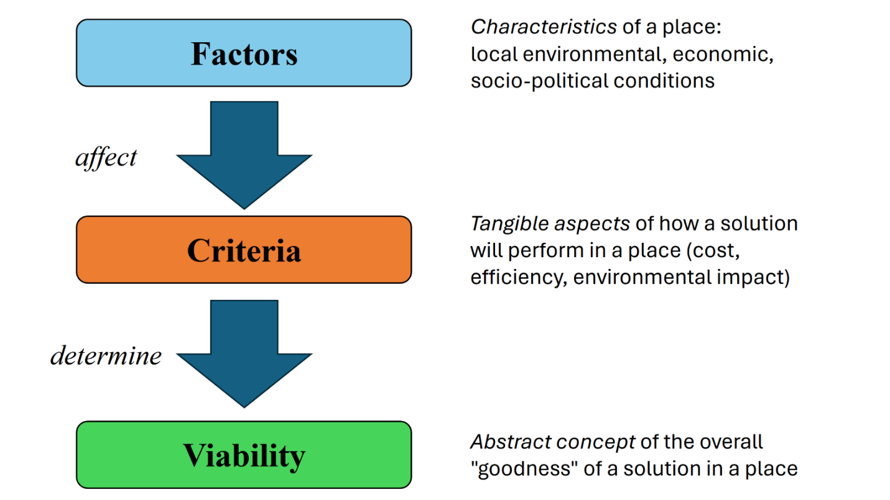*Note.*Flow-chart defining the terms *factors, criteria,* and *viability* as they are used in this thesis, indicating how they relate to one another.

Table .

|  |  |  |  |
| --- | --- | --- | --- |
| **Factor** | **Effects**  **(Air-Source Heat Pumps)** | **Effects**  **(Ground-Source Heat Pumps)** | **Effects**  **(Geothermal Direct Heating)** |
| Temperature | Low temperatures majorly decrease efficiency (Madonna & Bazzocchi, 2013; Safa et al., 2015; Y. Zhang et al., 2017) | Prolonged low temperatures can decrease efficiency (Safa et al., 2015; You et al., 2016) | Uncertain |
| Humidity | High humidity and low temperatures can lower efficiency through frosting (Staffell et al., 2012; Z. Wang et al., 2021) | High humidity and high temperatures can make cooling less efficient (W. Zhang & Wei, 2012)    Frosting effect uncertain | Uncertain |
| Fossil Fuel Prices | May benefit from more expensive fossil fuel prices relative to electricity   (Staffell et al., 2012; Z. Wang et al., 2021) | May benefit from more expensive fossil fuel prices relative to electricity   (Staffell et al., 2012; Z. Wang et al., 2021) | Low fossil fuel prices may disincentivizegeothermal direct heating development (Thorsteinsson & Tester, 2010; Snyder et al., 2017; Kolker et al., 2021) |
| Policies and Incentives | Supportive incentives may make development more favorable   (Staffell et al., 2012; Gaur et al., 2021) | Supportive incentives may make development more favorable  (Staffell et al., 2012; Gaur et al., 2021) | Supportive incentives may make development more favorable (Thorsteinsson & Tester, 2010; Reber et al., 2014; Kolker et al., 2021) |

*Note.*Summarisation of covered place-based factors and their general, broad-scale effects on the viability of development for air-source heat pumps, ground-source heat pumps, and geothermal direct heating according to reviewed sources.

Air-Source Heat Pumps

According to Staffell et al. (2012), while air-source heat pumps are already a commonly implemented form of renewable heating, favorable policies and incentives could benefit them even further by increasing their accessibility and competitiveness with fossil fuel heating systems. While air-source heat pumps are comparatively cheaper up-front than other types of heat pumps, they typically have higher running costs and may therefore benefit from incentives that reduce these latter expenses(Staffell et al., 2012; Z. Wang et al., 2021). In a simulation study in the United Kingdom, Cabrol and Rowley (2012) found that with enough financial support from tariffs that subsidized running costs, air-source heat pumps could achieve lower costs even than fossil fuel-based heating systems. Although support from financial incentives will likely not change the negative effects of cold temperatures and frosting on air-source heat pumps, they may help make air-source heat pumps more viable where weather conditions are more favorable for their implementation (Z. Wang et al., 2021).

Ground-Source Heat Pumps

Similarly to air-source heat pumps, ground-source heat pumps benefit from policies and incentives that make them cheaper to implement (Staffell et al., 2012; Liu et al., 2015). Because ground-source heat pumps typically cost much more than air-source heat pumps to construct, incentives for up-front costs may prove especially useful (Staffell et al., 2012; Z. Wang et al., 2021); though according to Staffell et al. (2012), ground-source heat pumps also benefit from incentives that can reduce their running costs compared to fossil fuel-based heating systems. According to Liu et al. (2015), especially in the United States ground-source heat pump development has been hampered by a relative lack of support through incentives. However, there have nevertheless been recent large and successful projects in the United States that have benefited from the support of financial incentives, such as a fully installed system at Ball State University that received some federal grant funding (Im et al., 2016). Furthermore, according to Nifong (2022), newer measures such as the Inflation Reduction Act provide opportunities to cover large portions of up-front costs and will therefore likely spur further development of renewable heating systems in the United States. These examples showcase the supportive power of policies and incentives especially for the up-front costs of ground-source heat pumps.

Geothermal Direct Heating

The presence of supportive financial policies and/or incentives for geothermal direct heating has been noted as an important factor by authors such as Thorsteinsson and Tester (2010), Reber et al. (2014), and Kolker et al. (2021). Due to its high construction costs and susceptibility to competing fossil fuels, geothermal direct heating is often especially dependent on external financial support for encouraging its development (Snyder et al., 2017; Jodeiri et al., 2022). Reber et al. (2014) and Tester et al. (2021a) found that incentives supporting geothermal direct heating often reduced its levelized cost of heat, in turn raising its viability; furthermore, J. Lund and Toth (2021) attributed a decline since 2000 in new geothermal direct heating developments in the United States to a decrease in supportive policies and incentives, while Kolker et al. (2021) similarly considered the lack of current support in the United States as compared to much of Europe a major factor in the former’s comparatively sparse geothermal direct heating presence. These findings all suggest a strong, positive relationship of geothermal direct heating viability in a place with the level of support it receives from policies and incentives.

Renewable Electricity Availability

According to Gaur et al. (2021), the availability of renewably generated electricity in electrical supply influences the sustainability of heat pumps, as they will indirectly contribute to greenhouse gas emissions and climate change if they are powered by electricity generated from fossil fuels. Under these circumstances and when Criteria for greenhouse gas emissions are incorporated into decision-making processes, the viability of heat pumps may decrease. According to Averfalk et al. (2017) and Jarre et al. (2018), heat pumps may offer especially promising levels ofsustainability compared to other forms of heating when they operate under renewable electricity; but conversely, according to Tester et al. (2021a), the lack of renewably generated electricity supply in a place could spur the most optimal renewable heating solutions for those places away from heat pumps and towards other forms less dependent on electricity supply, such as geothermal direct heating. Renewable electricity availability therefore may constitute an influential place-based factor to the viability of both air-source heat pumps and ground-source heat pumps.

Renewable Heating Case-Studies

Current examples of renewable heating implementations on college campuses within the United States are limited at the time of this thesis. However, those that exist may serve as worthwhile “case-study” examples of their circumstances, challenges encountered, and devised solutions. This section will review a small number of U.S. colleges that have either heavily researched or already implemented on-campus renewable heating systems, drawing back to the principles of fitting solutions to place in each instance. Through this, the previously outlined concepts of place-based factors and viability will be highlighted through real-life examples.

Cornell University

Cornell University (Cornell) in Ithaca, New York has actively researched the potential of a geothermal direct heating system to meet its campus heating needs for over a decade (Lukawski et al., 2013; Beckers et al., 2020; Tester et al., 2023). As of 2023, the project remains in its research phase (Tester et al., 2023); however, Cornell has made major progress in areas such as economic cost-modelling (Beckers et al., 2015; Beckers et al., 2020)and local geologic assessment (Gustafson et al., 2020; Fulcher et al., 2023; Fulton et al., 2024). The plethora of available research and the uniqueness of Cornell’s research into geothermal direct heating as a college campus in the United States provide excellent opportunity for a case-study of the college’s unique circumstances and other factors at play.

The local climate of Cornell is overall cold and is known for its long heating season (Beckers et al., 2020; Kassem et al., 2020). This, combined with other relevant place-based factors such as the campus’s northern latitude, has limited Cornell’s potential options for renewable heating by rendering several forms (such as solar thermal and heat pumps) largely non-viable (Beckers et al., 2020; Tester et al. 2021a). These constraints on other forms of renewable heating have spurred the college’s strong research into geothermal direct heating as potentially its most viable option (Beckers et al., 2020; Tester et al., 2023). Additionally, according to Tester et al. (2023), the college’s district heating system currently consists of a combination of steam and hot-water distribution, which would need to be converted entirely to the latter as a component of their intended geothermal direct heating system. However, per Beckers et al. (2015) and Tester et al. (2019), Cornell already plans to entirely replace its steam heat-distribution with hot water as a step in decarbonisation, which integrates into its current geothermal direct heating research.

Beckers et al. (2015) and Kassem et al. (2020) have proposed supplementing the planned geothermal direct heating system with biomass boilers to help the college meet adequate heating demand during times of highest need. According to these authors, plentiful sources of fuel for these boilers exist on local campus farms, in forms such as agricultural plant waste and/or processed manure from cows. Tester et al. (2023) supported this avenue as a viable means of supplementing the geothermal direct heating system, with the additional proposal to integrate a thermal energy storage system. Combined with existing on-campus renewable infrastructure, such as a “lake-source cooling” system that provides renewable chilled air and water(Beckers et al., 2020; Tester et al., 2023), these proposals demonstrate principles of fitting solutions to place through their focus on working with existing local circumstances.

Although their proposed geothermal direct heating system remains in the research phase, with it Cornell has showcased the techniques of fitting solutions to place through their embodiment of solutions that work with local existing place-based factors. However, circumstances such as the availability of funds, material resources, and people-power should be borne in mind, as different colleges will possess these to different extents. That Cornell already possesses a district heating system consisting partially of hot-water distribution, rather than fully steam (Tester et al., 2023), also provides them an advantage many other colleges in the United States do not currently have. These caveats are brought to light not to de-value any of the work or research done by Cornell, but rather to highlight how circumstances differ from college to college, and to show that some place-based factors such as internal college infrastructure may not be readily apparent despite their importance. While the unique circumstances and local place-based factors of every college campus in the United States will differ from those of Cornell, at a more abstract level Cornell has demonstrated principles of fitting solutions to place that may be taken and embodied by other colleges according to their own places and circumstances.

West Virginia University

West Virginia University (WVU), located in Morgantown, West Virginia, has researched the potential of implementing a geothermal direct heating system on its campus to replace its current source of thermal energy from external coal boilers (Garapati et al., 2019; Garapati et al., 2020). In a study of geothermal heat flow throughout the contiguous United States, Blackwell et al. (2007) identified isolated “hot spots” in the eastern states that they believed held potential for supporting geothermal systems. From further work centered in West Virginia, these researchers identified regions of high heat flow that included WVU’s location in Morgantown (Blackwell et al., 2010, as cited in He & Anderson, 2012). Building off these authors’ research, Smith (2019) evaluated local geothermal potential at WVU and found it likely favourable, while He and Anderson (2012) modelled the levelised cost of heat of a geothermal direct heating system with hot-water distribution for the college. Culminating these studies, Garapati et al. (2019, 2020) further modelled a potential geothermal direct heating system for the WVU campus that would be supplemented by heat pumps to fully meet the college’s heating needs.

However, according to Alonge (2019) and Garapati et al. (2019, 2020), implementing a geothermal direct heating system in full would require converting the college’s heat-distribution system (currently in the form of steam) to hot water, which these authors deemed to not be economically viable. To address this, Garapati et al. (2019, 2020) have proposed an alternative “hybrid” model that would retain the steam heat-distribution system, consisting of natural gas boilers and heat pumps in addition to the geothermal direct heating installation. Further analysis by Garapati and Hause (2021) re-iterated these findings and confirmed the college’s current focus on pursuing a hybrid system with natural gas boilers.

The research into geothermal direct heating by WVU highlights both campus infrastructure and local economic factors as important place-based factors in a real-life renewable heating scenario. While a full conversion of the campus heating system to hot-water distribution would have been most optimal for integrating a full geothermal direct heating system (Garapati & Hause, 2021), the issue of incompatible existing campus infrastructure (Alonge, 2019) and the comparatively higher viability of a natural-gas hybrid system (Garapati et al., 2020) demonstrate that in a real-world scenario, compromise sometimes occurs and may be the most viable of possible options. Garapati and Hause (2021) expressed optimism that the hybrid system could fully replace WVU’s dependence on coal for heating; if it is ultimately implemented, this system may offer a case-study of replacing coal with natural gas and its long-term implications for the college.

University of Illinois, Urbana-Champaign

Like Cornell University and West Virginia University, the University of Illinois at Urbana-Champaign (UI-UC) has researched geothermal direct heating, specifically for use in heating on-campus agricultural facilities (Stumpf et al., 2018; Stumpf et al., 2020). The college has conducted studies on the geologic feasibility (Lin et al., 2020; Stumpf et al., 2020), potential environmental impacts (Thomas et al., 2020), and economic implications(Lin et al., 2020; Stumpf et al., 2020)of implementing a geothermal direct heating system on its campus; all studies have reported generally favourable findings. Stumpf et al. (2020) predicted geothermal energy would play a crucial role in the decarbonisation strategy of UI-UC for heating and electricity alike, as they expected other forms of renewable energy would prove insufficient for meeting the college’s decarbonisation targets. According to Lin et al. (2020), the proposed geothermal direct heating system would both be economically feasible and environmentally beneficial. Since 2020, however, emergent progress on geothermal direct heating at UI-UC has been unclear; Jello et al. (2022) studied the re-use of defunct fossil-fuel exploration wells in the local region for thermal energy storage, but other new studies relating to the college were not apparent at the time of this writing.

Separately from the above geothermal direct heating system, UI-UC has also built and commissioned a "geothermal exchange” system, similar to a ground-source heat pump system, for heating and cooling one of its campus buildings (Nifong, 2022; Sheppard, 2022). This project built off an evaluation by Stumpf et al. (2021) that found the proposed system to be economically feasible and to offer a long lifespan over which it would significantly reduce campus greenhouse gas emissions. Although this system covers only one building on the campus, its proponents within UI-UC have expressed optimism that further systems hold potential to be implemented as the college continues its progress towards full decarbonisation (Nifong, 2022).

Ball State University

Beginning in 2009, Ball State University (Ball State) in Muncie, Indiana overhauled its heating system of coal-fired boilers, replacing them with a major ground-source heat pump installation intended to provide both renewable heating and cooling to its campus (Im et al., 2016; Indiana University, n.d.). Notably, Ball State has fully completed this project, allowing for evaluations of its actual performance (Im et al., 2016; Indiana University, n.d.). Working for the Oak Ridge National Laboratory and partnering with the United States Department of Energy, Im et al. (2016) assessed the performance of Ball State’s ground-source heat pump system over a one-year period and documented their observations of the project’s strengths and shortcomings. The authors found that while the system operated well overall, it exhibited some inefficiencies due to occasional over-production of heating or cooling, which they deemed a consequence of its design. Furthermore, due to the system being powered by electricity from local utilities, its exact degree of renewability depends on the degree to which the electricity is produced from renewable sources(Indiana University, n.d.).

Despite the above issues, Ball State’s successful completion and operation of its campus ground-source heat pump system provides a worthwhile case-study for future college-campus implementations. The analysis provided by Im et al. (2016) may prove especially helpful in improving the optimality of future ground-source heat pump system designs.

Methods

Overview

Based on the findings of the literature review, three forms of renewable heating were chosen for further viability analysis in this thesis — air-source heat pumps, ground-source heat pumps, and geothermal direct heating. For each of these chosen forms, a color-coded map referred to as a *viability map* was constructed by overlaying multiple *factor layers*, each of which contained data on one place-based factor across the extent of the contiguous United States. While the analysis of all three forms of renewable heating used the same number of factor layers (four) in the construction of their respective viability maps, factors were given different weights in each analysis to best reflect the disproportionate influences on each respective renewable heating form’s viability.

Place-Based Factors

The place-based factors chosen for use in this thesis research were selected to meet the following two conditions: 1) being clearly and strongly influential (either positively or negatively) to the viability of at least one, and ideally all three studied renewable heating forms; and 2) having spatial data accessible in consistent quality and granularity across the full extent of the contiguous United States. Though these two conditions greatly limited the selection of place-based factors available for inclusion in these analyses, I attempted to include factors that spanned a wide breadth of categories, from physical/environmental to socio-economic. Ultimately, I selected four place-based factors for use in this thesis research: heating degree-days, commercial natural gas prices, financial incentives for the studied renewable heating forms, and percent electricity from renewable sources.

After gathering the spatial data and formatting them appropriately, I scored each place-based factor on a five-point scale, ranging from 0 to 4 inclusive. The lowest scores on these *factor score* scales universally represented the areas deemed to carry the least amount of viability for each renewable heating form, based on what was learned in the literature review. Other than the financial incentives place-based factor, which had a separate factor layer assembled for the respective financial incentives available for each of the three renewable heating forms, the factor layers were otherwise scored identically for each renewable heating form — in other words, areas of respective low and high viability on each place-based factor layer were assumed to carry the same low or high viability for all three renewable heating forms. However, to represent the unequal levels of influence that different factors had on each form, weightings were used during the main viability analysis to differentiate the factors in each case.

Heating Degree-Days

According to the National Weather Service Climate Prediction Center (2005), heating degree-days are calculated as annual summations of the differences below 65 degrees Fahrenheit of all mean daily temperatures throughout the year, therefore serving as a general metric for the “coldness” of a region with higher values corresponding to colder climates. Due to the general detrimental effects of cold temperatures on the operational efficiency of both air-source heat pumps (Madonna & Bazzocchi, 2013; Y. Zhang et al., 2017) and ground-source heat pumps (Safa et al., 2015), heating degree-days across the contiguous United States were included as a place-based factor in the viability analysis of the chosen renewable heating forms.

The data for heating degree-days across the contiguous United States was obtained from the National Centers for Environmental Information (NCEI), a part of the U.S. National Oceanic and Atmospheric Administration (NOAA). Historical data of annual heating degree-day averages from 1981–2010, and the latitude/longitude coordinates of reporting weather stations necessary for their spatial mapping, came from the NCEI Climate Data Online (CDO) portal (<https://www.ncei.noaa.gov/cdo-web/>). I assembled the factor layer in ArcGIS Pro, Version 3.2.0, using the “XY Table to Point” function to generate a feature layer of points for each weather station containing heating degree-day data and turning these points into tessellated polygons with “Create Thiessen Polygons”. This layer was then divided into five manually set classes **(Table 2)**, based on the heating degree-day values which ran from fewer than 3000 to over 7500. Because colder temperatures have been foundto be detrimental to both types of heat pumps (Madonna & Bazzocchi, 2013; Safa et al., 2015), areas with the coldest climates (represented by the highest values of heating degree-days) were given the lowest scores on the “factor score” scale.

Table .

|  |  |
| --- | --- |
| **Heating Degree-Days** | **Score** |
| More than 7500 | 0 |
| 6001 to 7500 | 1 |
| 4501 to 6000 | 2 |
| 3001 to 4500 | 3 |
| 3000 or fewer | 4 |

*Note.*Classifications and scores of the heating degree-days place-based factor layer. The highest values of heating degree-days represent the coldest overall climates, and are scored with the lowest values on a five-point scale running from 0 to 4 inclusive. The cut-offs between classes were manually chosen for the dual purposes of representing approximately equal portions of data and transitioning between classes at easily understandable locations.

Commercial Natural Gas Prices

The United States Energy Administration (EIA) keeps data about historic natural gas prices on a state-by-state level (<https://www.eia.gov/>). To best represent the prices most applicable to college entities, average prices specifically for commercial consumers were used for this place-based factor. Data was obtained from the EIA database (<https://www.eia.gov/dnav/ng/ng_pri_sum_a_EPG0_PCS_DMcf_m.htm>) on commercial natural gas prices for the 48 contiguous United States and the District of Columbia, with the average annual prices over the 5-year period of 2018 to 2022 selected and averaged to account for inevitable price fluctuations between years. To translate state-by-state natural gas prices into factor scores on the 5-point scale, I compared prices to the 2018–2022 nation-wide average commercial natural gas price of $8.60 per thousand cubic feet (United States Energy Information Administration, 2024b). Because cheap fossil fuels were found to be largely detrimental to the development and implementation of geothermal direct heating (Thorsteinsson & Tester, 2010; Kolker et al., 2021), this factor was scored to reflect the highest viability in the most expensive natural gas prices for all three forms of renewable heating, with an especially high weighting for geothermal direct heating. Therefore, states bearing cheaper average commercial natural gas prices compared to the $8.60 per thousand cubic feet national average scored fewer points, while those with the most expensive prices scored the maximum possible points for this factor layer **(Table 3)**.

Table

|  |  |  |
| --- | --- | --- |
| **State/District Commercial Natural Gas 2018–2022 Average (per 1000 ft3)** | **Comparison to U.S. 2018–2022 Average** | **Score** |
| $7.60 or less | –$1.00 or cheaper | 0 |
| $7.61 to $8.60 | $0.00 to –$1.00 | 1 |
| $8.61 to $9.60 | +$0.01 to $1.00 | 2 |
| $9.61 to $10.60 | +$1.01 to +$2.00 | 3 |
| $10.61 or greater | +$2.01 or more expensive | 4 |

*Note.*Classifications and scores of the commercial natural gas prices factor layer, based on 2018–2022 5-year averages. Comparisons to the U.S. 5-year average over the same period were used as reference points for the breaks between classes, which occurred in one-dollar increments.

Financial Incentives

Because the support of financial incentives was indicated as a key driver of further development for all three studied forms of renewable heating (Reber et al, 2014; Gaur et al., 2021; Lund et al., 2021), I deemed this a priority factor for inclusion. To construct the necessary spatial data, information on currently active financial incentives for each renewable heating form was sourced from the Database of State Incentives for Renewables and Efficiency (DSIRE), a repository of information related to renewable energy in the United States run by North Carolina State University (https://www.dsireusa.org/). I recorded extant financial incentive policies for each of air-source heat pumps, ground-source heat pumps, and geothermal direct heating in each of the 48 contiguous United States and the District of Columbia. Federal-level financial incentives were excluded, due to their theoretical uniform applicability across all places within the spatial extent of this research.

Unlike the other three place-based factor layers, a separate financial incentives layer was created and scored for each of the three renewable heating forms. For each renewable heating form, the spatial distribution of its extant incentives was translated into a five-point factor score using the following rubric **(Table 4)**. Each state (and the District of Columbia) was first given between 0 to 2 points, based on the number of extant state- or district-wide incentives it possessed. A state having at least two separate financial-incentive policies (i.e., multiple incentives) received 2 points, while a state with one policy received 1 point and a state without any relevant incentives across its entire extent received 0 points. After this, financial incentives at the local level — i.e., incentives covering municipalities, counties, utility provider territories, or any other “smaller-than-state level” spatial extent — were evaluated and summed. Again, between 0 to 2 possible points were assigned to every location, based on the number of *local* financial incentives present: places with multiple overlapping local incentives scored 2 points, places with one local incentive 1 point, and places with no local incentives 0 points. When combined with the state-wide incentives scores, this resulted in a total factor score of 0 to 4 at every location in the contiguous United States, scored separately for each of the three renewable heating forms. The highest possible score could only be achieved in a location possessing a robust multitude of financial incentives for a particular renewable heating form at both the state *and* the local levels.

Scoring and mapping the local financial incentives proved to be a particular challenge, due to the difficulty of finding an appropriate spatial layer to represent the coverage extent of every possible local incentive. To avoid having to hunt for layer data in an inconsistent and unreliable fashion, I obtained a reference feature layer from Esri Data & Maps (<https://www.esri.com/arcgis-blog/products/product/mapping/esri-data-maps/>) consisting of county subdivisions within the 48 contiguous United States. The county subdivisions were then manually edited to assign the appropriate local factor scores to each subdivision, according to how many local financial incentives covered its territory. Spatial information on the coverage territories of utility districts tied to local incentives was sourced from Find Energy LLC, a private firm that gathers and provides openly accessible information on U.S. utility providers and their coverage territories (https://findenergy.com/). The level of granularity achieved by working with U.S. county subdivisions was deemed acceptable for these factor layers, being fine enough to show the spatial nuances of local financial incentive distributions while also not being unnecessarily complex in detail.

Table

|  |  |  |  |  |
| --- | --- | --- | --- | --- |
| **Number of State- or District-wide Incentives** | **Points Earned (out of 2 possible at state-wide level)** |  | **Number of Local Incentives** | **Points Earned (out of 2 possible at local level)** |
| 0 | 0 |  | 0 | 0 |
| 1 | 1 |  | 1 | 1 |
| 2 or more | 2 |  | 2 or more | 2 |

*Note.* Rubric of scoring for the financial incentives place-based factor layer. A maximum of 2 points were possible to earn for any given location at the statewide and local levels each, combining for a total factor score ranging from 0 to 4 much like previous place-based factors.

Renewable Electricity Availability

While “viability” holds many meanings as already covered in this thesis, all three previous three place-based factors have related to it primarily through ease of implementation, and/or ease of operation. However, in a sustainable world, viability must also encompass the lowest possible level of negative environmental impact. It is for this reason that the fourth and final place-based factor included in this thesis research is of the availability of renewably sourced electricity in primary utility districts throughout the contiguous United States. Because both air-source heat pumps and ground-source heat pumps are electrically powered devices, they should only be considered as “clean” as the source of the electricity from which they are powered; this is corroborated by Lund et al. (2021) and Jodeiri et al. (2022). I also included availability of renewable electricity as a factor for geothermal direct heating, due to the possibility of back-up generators or other powered systems also being present within an installation.

To construct this factor layer, data on primary energy providers in the United States, their coverage territories, and the source make-up of their generated electricity was obtained from Find Energy LLC. Wholesale utilities that purchased their electricity from other providers were excluded from consideration, due to the uncertainties in knowing the exact origin of their purchased electricity. Places were given a score between 0 to 4 in this factor, based on the percentage of renewable electricity in local supply **(Table 5)**. As before, the cut-offs between scores were chosen manually; here, they are meant to emphasise places that have access to even a small amount of renewably sourced electricity, while showing “forgiveness” towards places close to, but not quite reaching, 100 percent renewable electricity.

In this factor layer, I defined “renewable electricity” as electricity sourced from solar, wind, and/or recovered landfill gas. Hydroelectric power, however, was intentionally excluded from this definition. This decision reflected a strong statement on the many environmental drawbacks of hydroelectric dams, including detrimental impacts to local landscapes and wildlife, greenhouse gas emissions resulting from their construction, and the inundation of once-vegetated areas (United States Energy Information Administration, 2022a). Reflecting these detrimental impacts, some state legislatures — such as that of Washington — exclude hydropower from their current definitions of renewable energy (Wash. RCW 19.405.020, 2023). It must be acknowledged that environmental drawbacks such as habitat degradation and greenhouse gas emissions from construction are also present in solar and wind energy (United States Energy Information Administration, 2022b; United States Energy Information Administration, 2024a). However, for the purposes of this thesis research, the line is drawn at hydroelectric power to reflect the intention and desire to prioritise solar, wind, and recovered landfill gas over hydroelectric power in future U.S. renewable energy development. While none of these forms of energy are perfect, the latter three are judged by the author to be more easily capable of integration into this thesis central paradigm of fitting solutions to place, relative to hydroelectric power.

Table

|  |  |
| --- | --- |
| **Percent Renewably Sourced Electricity (solar, wind, landfill gas)** | **Score** |
| Less than 10 percent | 0 |
| 10 to up to 30 percent | 1 |
| 30 to up to 50 percent | 2 |
| 50 to up to 70 percent | 3 |
| 70 percent or more | 4 |

*Note.*Factor score classification breakdown for percent electricity sourced from solar, wind, and recovered landfill gas in a given location.

Viability Mapping

To create the “overall viability” layer for each of the three studied renewable heating forms, a Raster Weighted Overlay (RWO) function was performed in ArcGIS Pro using the four obtained factor layers for each form — heating degree-days, commercial natural gas prices, financial incentives, and renewable electricity availability. Because this function allowed for the unequal weightings of different factor layers, the four place-based factors were given different weightings in each case that best reflected their levels of influence on each renewable heating form’s viability **(Table 6)**. This allowed the highest priorities in analysis to be given to the factors most commonly mentioned in the relevant literature.

For geothermal direct heating, the heaviest weightings were given to the commercial natural gas prices and financial incentives place-based factors, due to the frequency that both factors appeared in the literature (Thorsteinsson & Tester, 2010; Kolker et al., 2021; Tester et al., 2021a). While heating degree-days and percent renewable electricity were deemed comparatively less important, they may nevertheless be influential and were thusly included in the analysis at smaller weightings. Conversely, the factor weightings for air-source heat pumps and ground-source heat pumps emphasised these latter two factors, again due to their importance to these forms of heating according to reviewed literature (Madonna & Bazzocchi, 2013; Safa et al., 2015; Jodeiri et al., 2022). While the factors were weighted very similarly between air-source heat pumps and ground-source heat pumps, some minor adjustments were made, mainly in the form of a comparative slight reduction in the heating degree-days factor weighting for ground-source heat pumps (though it remains highly weighted). This adjustment was made to reflect the slightly less acute but nevertheless reasonably strong effect of prolonged cold temperatures on ground-source heat pump efficiency over time (Safa et al., 2015).

Table

|  |  |  |  |
| --- | --- | --- | --- |
| **Place-Based Factor** | **Weighting**  **(Air-Source**   **Heat Pumps)** | **Weighting**  **(Ground-Source**   **Heat Pumps)** | **Weighting**  **(Geothermal**   **Direct Heating)** |
| Heating Degree-Days | .34 | .3 | .1 |
| Commercial Natural Gas Prices | .1 | .1 | .4 |
| Financial Incentives | .22 | .25 | .4 |
| Percent Renewably Sourced Electricity | .34 | .35 | .1 |
| **Total Sum** | **1.0** | **1.0** | **1.0** |

*Note.*Relative weightings of place-based factors used for the Raster Weighted Overlay viability analyses of each renewable heating form. Weightings are expressed as decimal proportions out of 1, with higher values indicating heavier weightings given to more proportionately influential factors. All factor weightings for each renewable heating form sum to exactly 1.

After performing the Raster Weighted Overlay calculations, I prepared the final viability maps for each renewable heating form using a standardised colour scheme format **(Table 7)**. The final possible viability scores after analysis ranged from 0 to 4, inclusive and with decimals possible. To translate this range of scores into a more intuitive format, equal ranges of possible scores were converted into whole numbers spanning from 1 to 5 inclusive, respectively representing the lowest and highest possible viability scores. These five scores were then colour-coded using a consistent system of “coolest” (dark blue) to “warmest” (bright red) colours, with the latter intended to draw visual attention to the areas of highest overall viability akin to a heat map.

Table

*Rounded Viability Score Ranges and Colors*

|  |  |  |
| --- | --- | --- |
| **Final Viability Score Range** | **Rounded Value** | **Colour** |
| 0.0–0.8 | 1 |  |
| 0.8–1.6 | 2 |  |
| 1.6–2.4 | 3 |  |
| 2.4–3.2 | 4 |  |
| 3.2–4.0 | 5 |  |

*Note.* This table lists the range categories of possible final viability scores after all performed calculations, and their translated whole-number values on a 1-to-5 scale. The corresponding colors for each rounded score are used consistently in all subsequent figures produced in this thesis research.

Results

Place-Based Factor Component Maps

Heating Degree-Days

The distribution of average annual heating degree-days in the contiguous United States **(Fig. 1)** followed patterns to be expected from general national geography. The highest values of more than 7500 heating degree-days in an average year — indicating the coldest overall climates — occurred in northern inland latitudes and through the Rocky Mountains. The lowest values and the warmest climates, meanwhile, occurred in the southeast and Gulf Coast, as well as in southern Arizona and California. Gradients between the distribution categories used in factor scoring largely followed latitudinal lines in the central and eastern portions of the United States, but exhibited much more varied behaviour from the Rocky Mountains westward, due to the mountainous topography.

**Figure 2.** Annual Heating Degree-Days

*Annual Heating Degree-Days*

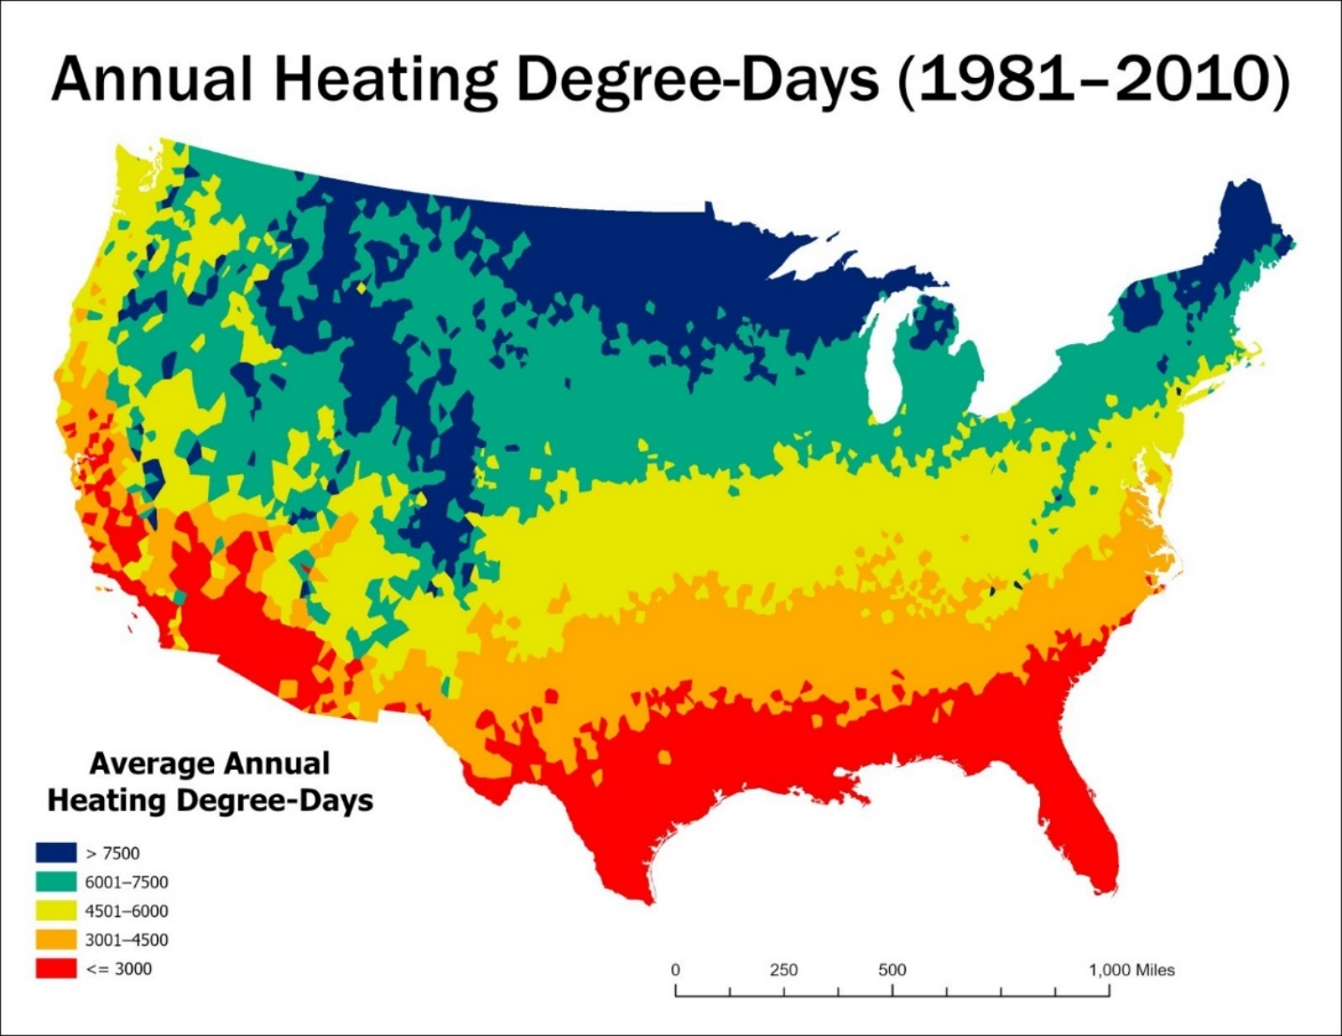

*Note.*Map of annual heating degree-days, measured as the total summation of daily low degrees below 65o Fahrenheit over the span of one year across the contiguous United States, averaged over the years 1981–2010; data sourced from the National Centers for Environmental Information (<https://www.ncei.noaa.gov/>). Dark blue regions indicate areas with the highest number of annual heating degree-days and therefore the coldest climates.

Commercial Natural Gas Prices

Average state-wide commercial natural gas prices from 2018 to 2022 **(Fig. 2)** varied and often contrasted between neighbouring states, but did follow general trends when viewed at a national level. The cheapest average prices occurred in states distributed from the Rocky Mountains and the inland southwest, through the Midwest to the northern Appalachians, as well as New York and Vermont. States with the most expensive natural gas prices included those in New England (except Vermont) and the Mid-Atlantic, many southeastern states, and California. Many possible factors relating to potential influences of natural gas prices, such as local economies and availability of competing fossil fuels (e.g., coal, fuel oil) were beyond the scope of research in this thesis; however, they are acknowledged here as additional likely influential factors, both in influencing patterns of natural gas prices as well as potentially affecting other studied factors such as renewable electricity availability.

**Figure 3.** Average Commercial Natural Gas Prices

*Average Commercial Natural Gas Prices*

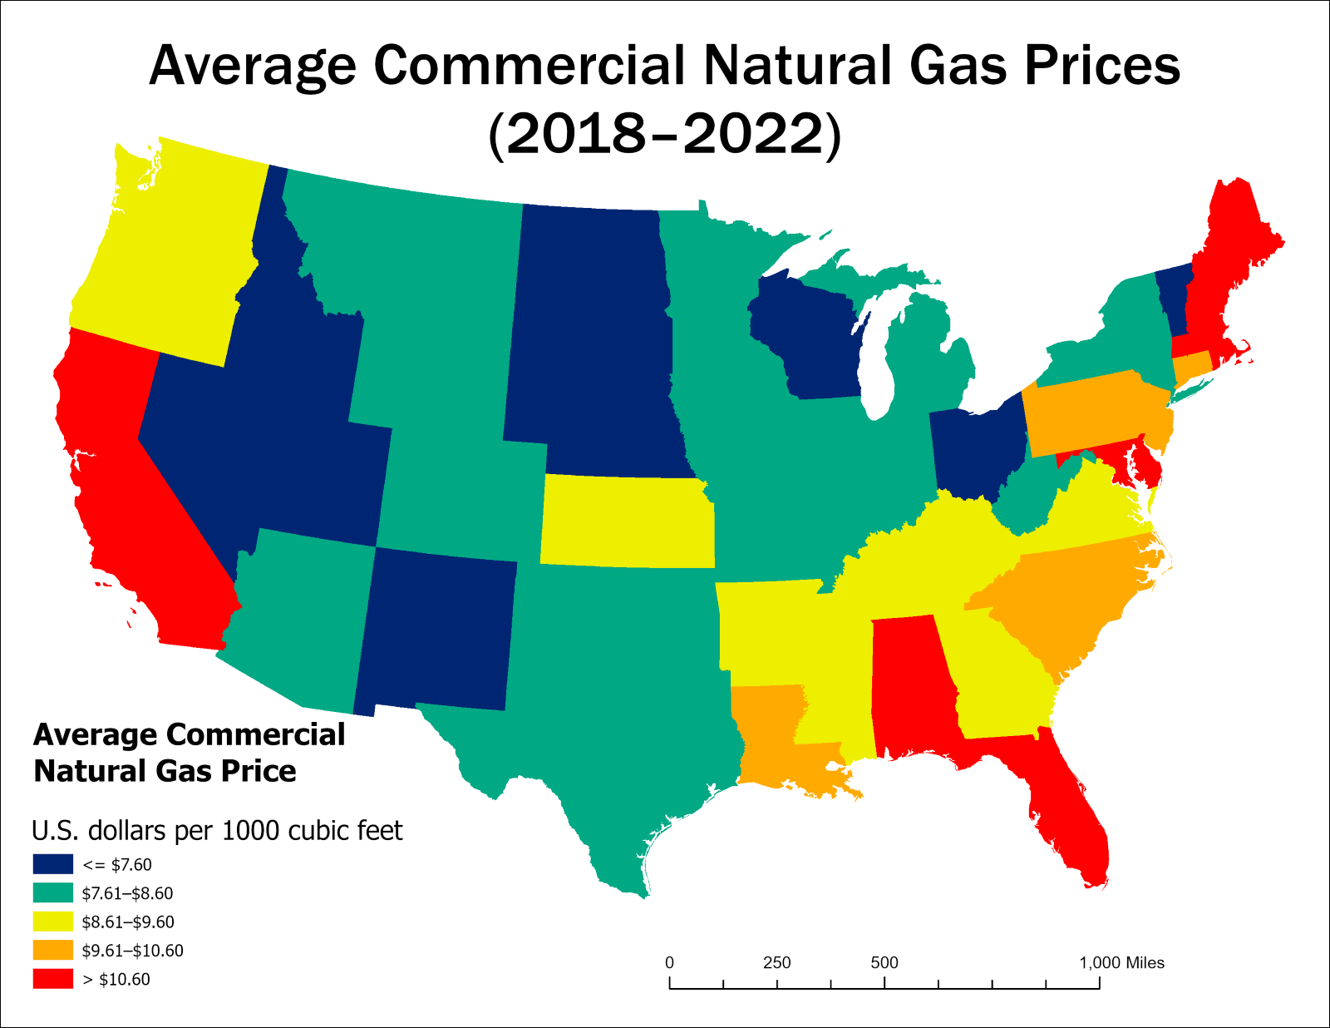

*Note.* Average commercial natural gas prices from 2018–2022 in U.S. dollars per thousand cubic feet. States with more expensive prices than the 2018–2022 U.S. average of $8.60 (United States Energy Information Administration, 2024) are colored in yellow, orange, or red, while states with cheaper prices are colored in teal or blue. Data sourced from the United States Energy Information Administration (<https://www.eia.gov/>).

Financial Incentives

Air-Source Heat Pumps

The map of financial incentives for air-source heat pumps **(Fig. 3)** exhibited a “patchwork” distribution in many locations, due to many states having at least one incentive active at a “lower-than-state" level. Furthermore, many of these incentives were tied to utility districts whose coverage territories frequently exhibited discontinuous, spotty distributions. Some states such as Minnesota and Wisconsin had many utility district-level or county-level incentives for air-source heat pumps, but no state-wide incentives; because of the rubric used for scoring, these states could not achieve a score higher than 2 for this factor anywhere within their boundaries, no matter how many incentives may have overlapped in some places.

The sole region to achieve a maximum score for air-source heat pump financial incentives occurred in southeastern Pennsylvania, encompassing Philadelphia and the surrounding Delaware Valley metropolitan region. In addition to Pennsylvania exhibiting multiple active financial incentives at the state-wide level, the Delaware Valley region fell under the coverage territory of PECO Energy Company (Find Energy LLC, 2024b), a utility company that had multiple extant incentives for air-source heat pumps as of 2024 according to the Database of State Incentives for Renewables and Efficiency (<https://www.dsireusa.org/>). This combination of multiple incentives at both the state-wide and local levels resulted in the maximum possible factor score in this region.

Contrarily, states such as Florida, West Virginia, Ohio, Iowa, and South Dakota had few financial incentives for air-source heat pumps within their boundaries, or lacked them entirely. Many additional states, especially those in the western half of the contiguous United States, lacked incentives over large portions of their areas. Overall, the availability of financial incentives for air-source heat pumps trended slightly toward the eastern half of the contiguous nation.

**Figure 4.** Incentives for Air-Source Heat Pumps

*Incentives for Air-Source Heat Pumps*

.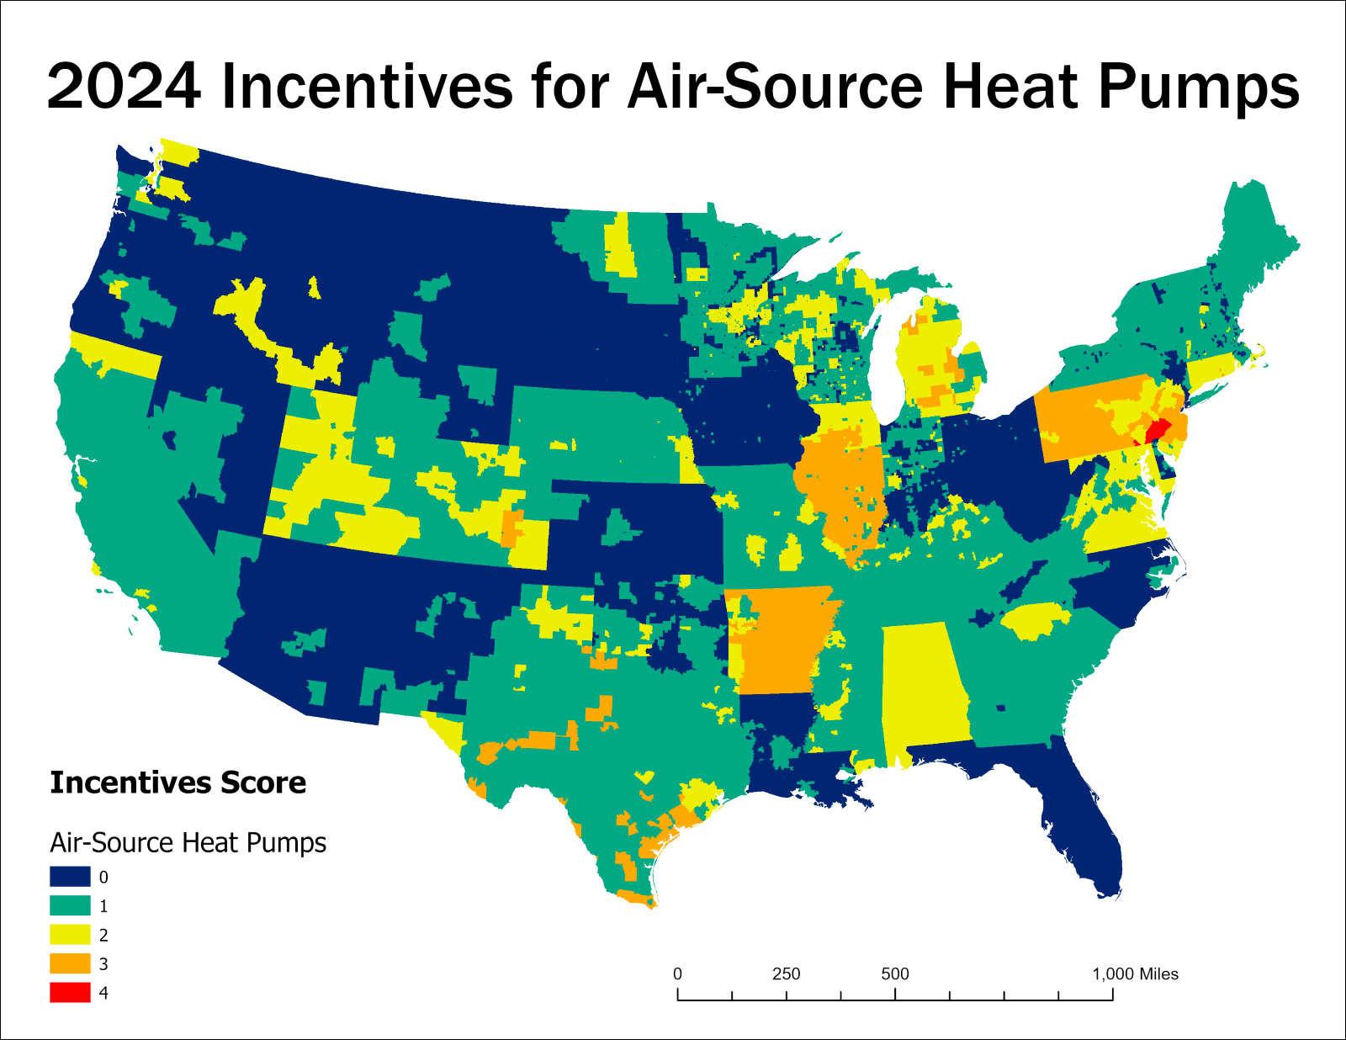

*Note.*Distribution of financial incentives for air-source heat pumps at state and local levels as of 2024. The maximum score of 4 points appears in locations covered by more than one incentive at both the state and local levels. Data sourced from the Database of State Incentives for Renewables and Efficiency (<https://www.dsireusa.org/>).

Ground-Source Heat Pumps

Compared to air-source heat pumps, the distribution of financial incentives for ground-source heat pumps exhibited less of a “patchwork” tendency and adhered more strongly to state borders in many areas **(Fig. 4)**. This was largely caused by the comparatively fewer incentives for ground-source heat pumps at a “lower-than-state" level. Ground-source heat pump financial incentives were more concentrated than those for air-source heat pumps, with the highest-scoring areas for the former mostly limited to a small number of states such as Colorado, Illinois, Pennsylvania, Virginia, and New Hampshire.

Ground-source heat pumps achieved the highest possible financial incentives score in multiple distinct regions, contrasting with the single Philadelphia/Delaware Valley region for air-source heat pumps. In addition to this same region, ground-source heat pumps also scored maximum possible points in parts of rural southeastern Colorado and central-northern Illinois, in both cases due to the overlap of multiple incentive-carrying electrical districts or other utility providers.

More than 15 states offered no financial incentives for ground-source heat pumps at any level within their territories, and multiple others carried only one state-wide incentive, and/or isolated local incentives. Due to the spatial distribution of the states offering state-wide incentives, relatively few large regions were entirely devoid of ground-source heat pump incentives. However, the Southwest (including nearly all of California), the Pacific Northwest, and most of the Southeast stood out in having some of the largest areas that lacked incentives.

**Figure 5.** Incentives for Ground-Source Heat Pumps

*Incentives for Ground-Source Heat Pumps*

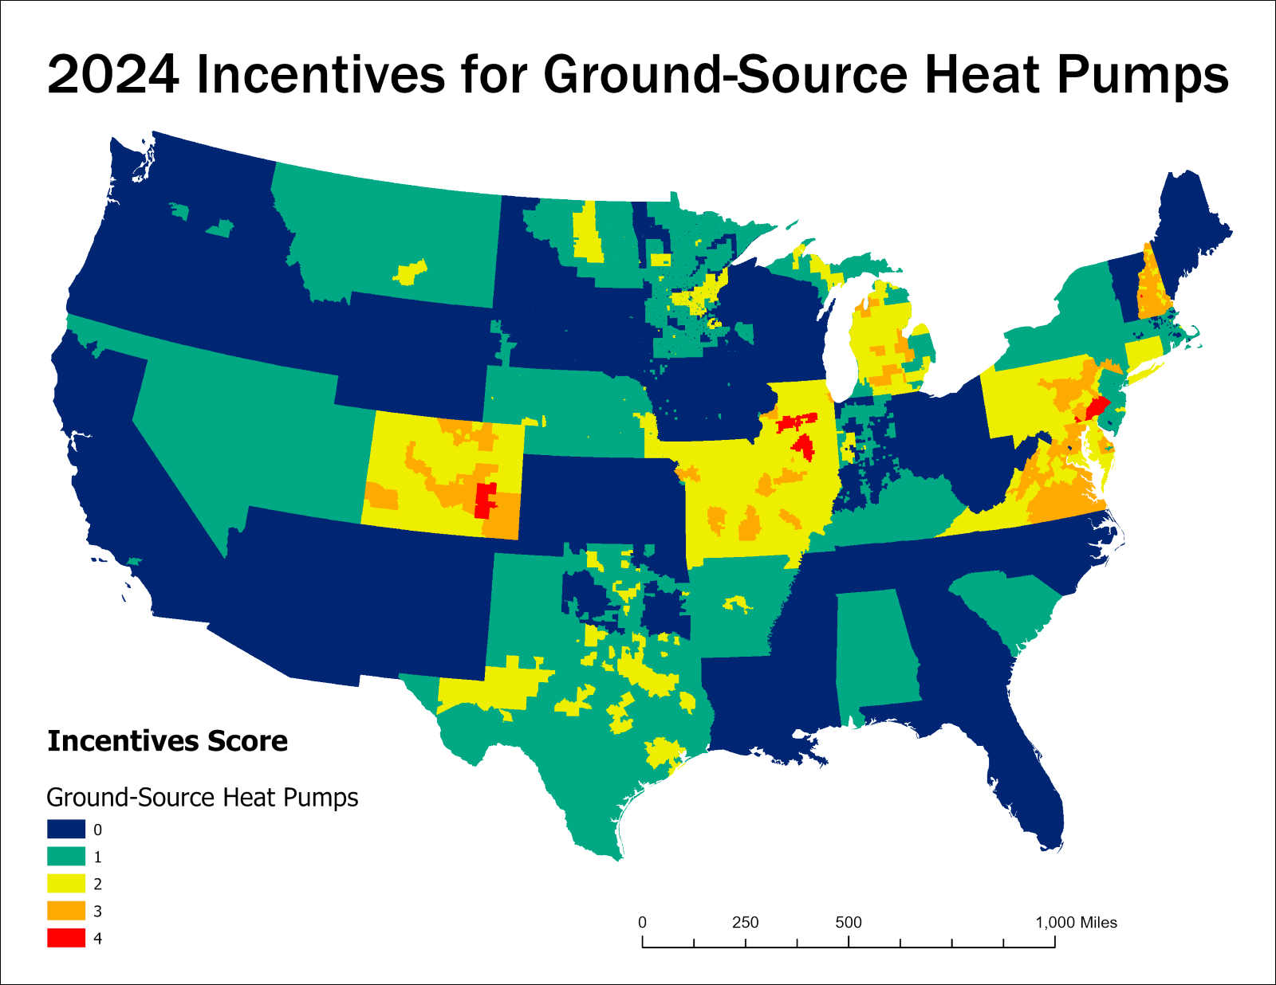

*Note.*Distribution of financial incentives scores for ground-source heat pumps at state and local levels as of 2024. The maximum score of 4 points appears in locations covered by more than one incentive at both the state and local levels. Data sourced from the Database of State Incentives for Renewables and Efficiency (<https://www.dsireusa.org/>).

Geothermal Direct Heating

Geothermal direct heating had the fewest extant financial incentives in the contiguous United States as of 2024 **(Fig. 5)**. Only Pennsylvania offered multiple state-level incentives for geothermal direct heating, and fewer than 10 states offered any. Meanwhile, only Michigan, Illinois, and Minnesota carried any incentives at the lower-than-state level. As a result, only one-quarter of the 48 covered states scored higher than 0 in any portion of their territory. Using the same scoring range of 0 to 4, no location anywhere in the contiguous United States achieved a score for geothermal direct heating incentives higher than 2.

**Figure 6.** Incentives for Geothermal Direct Heating

*Incentives for Geothermal Direct Heating*

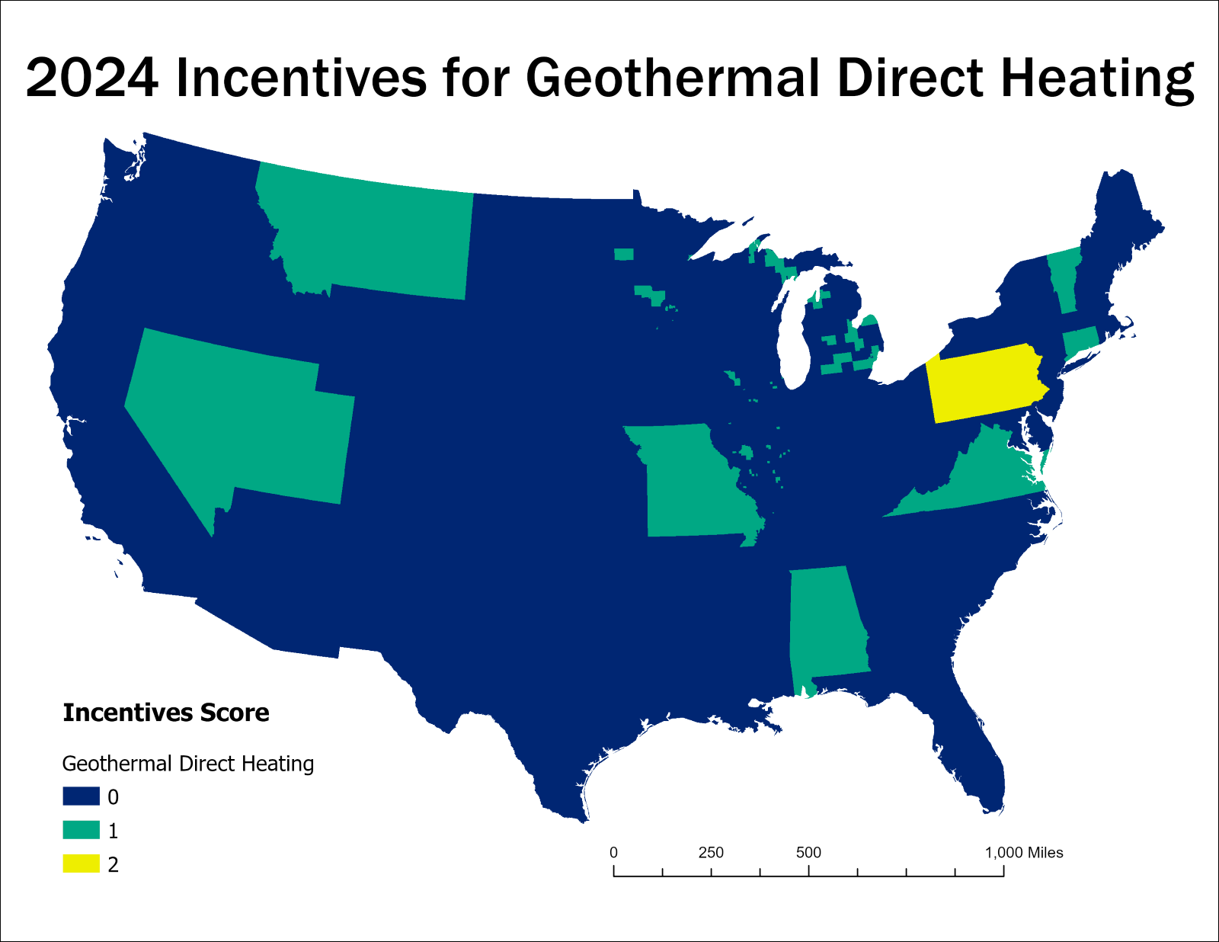

*Note.* Distribution of financial incentives scores for geothermal direct heating at state and local levels as of 2024. Data sourced from the Database of State Incentives for Renewables and Efficiency (<https://www.dsireusa.org/>).

Renewable Electricity Availability

The percentage of renewable electricity in local supply exhibited a distribution that largely conformed to state boundaries **(Fig. 6)**. A large portion of the area that scored in the highest designated category of renewable energy (70 percent or more) fell under the service territory of IGS Energy, a primary energy supplier whose service territory covered nearly all of Massachusetts, Pennsylvania, Ohio, and Illinois and large areas of Texas, and which sourced 100 percent of its electricity from solar (Find Energy LLC, 2024a). This was a relatively unique case among the primary energy suppliers covered in this study, as most others covered only portions of a state or of neighbouring states according to their coverage information provided by Find Energy LLC (https://findenergy.com/). Despite IGS Energy serving fewer customers than other energy suppliers in most states as reported by Find Energy LLC (2024a), I included and scored IGS Energy in the entirety of its indicated commercial service territory.

Outside of isolated metropolitan areas such as Atlanta and Nashville, the entire region spanning from the Southeast to the Appalachians lacked a substantial percentage of renewable energy supply. Smaller but still major areas of absence included the majority of South Dakota through Kansas, and the western half of New Mexico extending through Arizona and most of California. It is important to remember that hydroelectric power was excluded from the definition of renewable energy used in this research — as a result, regions that use hydroelectric power extensively will score low on this factor if they do not also make use of other renewable sources such as solar and wind.

**Figure 7.** Renewable Electricity Availability

*Renewable Electricity Availability*

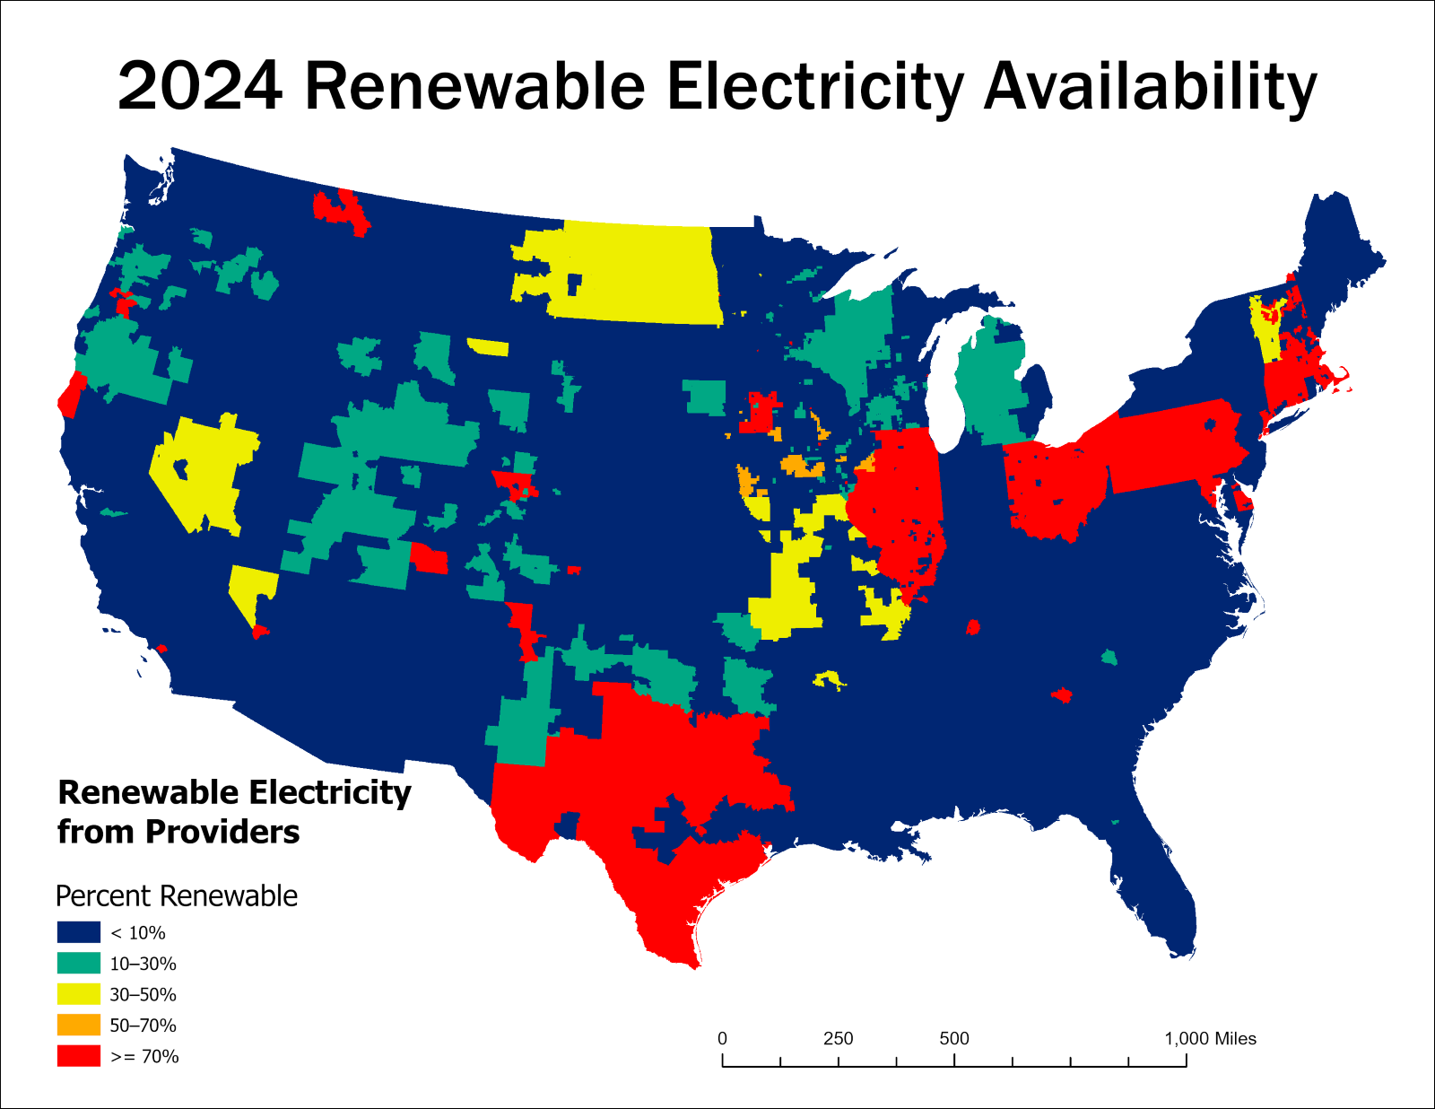

*Note.*Percent renewably sourced electricity in local supply throughout the contiguous United States as of 2024, including solar, wind, and landfill gas but excluding hydroelectric power. Data sourced from Find Energy LLC (<https://findenergy.com/>).

Viability Maps

Air-Source Heat Pumps

Areas of highest viability for air-source heat pumps within the study region occurred in the Philadelphia/Delaware Valley region of southeastern Pennsylvania, very small portions of Maryland and southern California, and scattered areas across southern Texas including the Houston metropolitan region. With the highest weightings for air-source heat pumps viability given to the factors of temperature (lowest heating degree-days) and presence of renewably sourced electricity, the areas indicating highest overall viability reflected high scores in both these factors. An overall trend of higher viability scores across the southern United States, as well as along coastal regions, is evident when compared to the inland and northern regions. Nevertheless, in some areas (particularly in the Great Lakes and Mid-Atlantic regions) the borders between states are clearly visible as transitions between different levels of overall viability. In states such as Illinois and Pennsylvania, one or more financial incentives for air-source heat pumps at the state level combined with both a broad reach of lower-level incentives and a wide extent of renewable electricity availability to produce high overall viability in most of the state area.

Areas of lowest overall air-source heat pump viability generally overlapped with those bearing the highest average annual heating-degree days, indicating the coldest climates. However, even some cold-climate locations achieved moderate to high viability scores when in the presence of local renewably sourced electricity and/or financial incentives; examples of this occurred in parts of Colorado, northern Montana, and New Hampshire. Especially in the northeastern states, low-viability regions often occurred as “pockets” surrounded by areas of higher viability. Two examples of this occurred with West Virginia and most of New York. Due to the especially pronounced state-by-state viability differences in the northeastern states, this is likely caused primarily by differences between neighbouring states in their state-level air-source heat pump financial incentives.

**Figure 8.** Viability of Air-Source Heat Pumps

*Viability of Air-Source Heat Pumps*

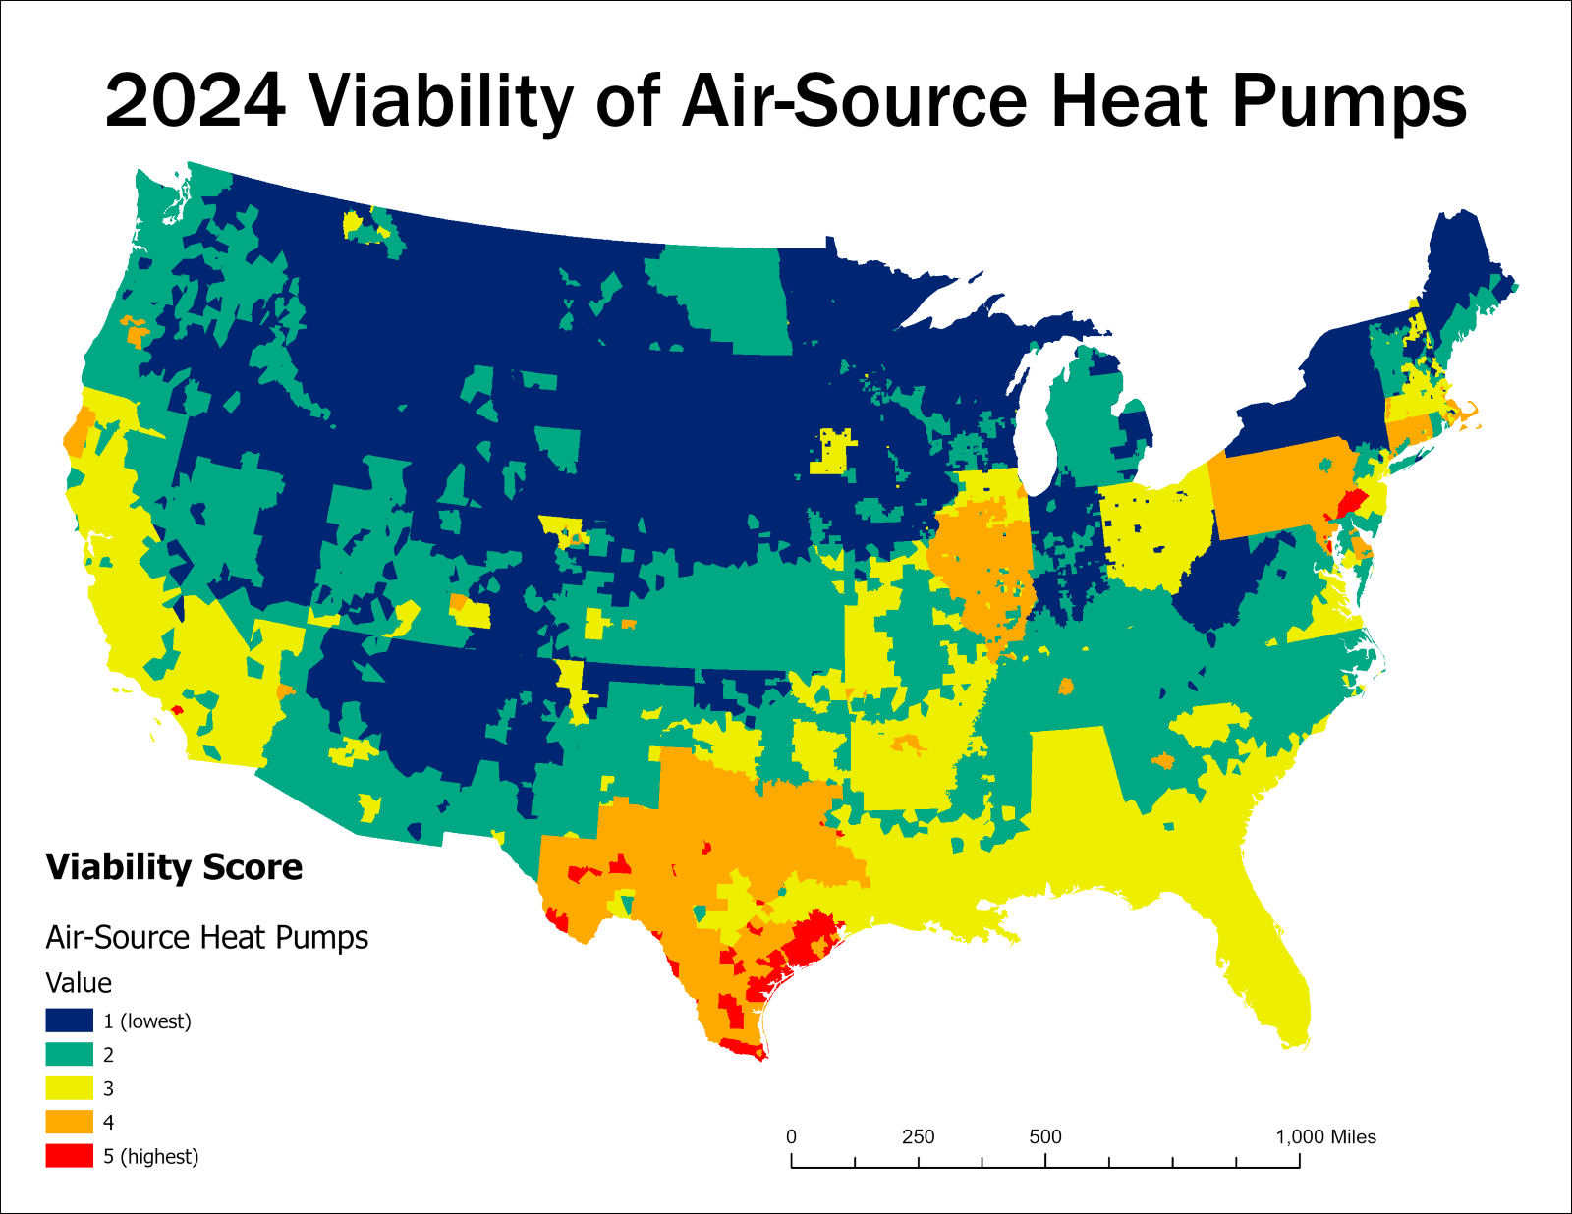

*Note.*Final viability map for air-source heat pumps in the contiguous United States as of 2024. Red and orange colors indicate areas of highest overall viability, while dark blue indicates lowest viability.

Ground-Source Heat Pumps

Ground-source heat pumps exhibited a viability distribution generally similar to that of air-source heat pumps, though with comparatively fewer areas of higher viability overall. Many areas that exhibited varied levels of viability for air-source heat pumps appeared comparatively “muted” for ground-source heat pumps, especially in the South. This was likely influenced by the distribution of ground-source heat pumps financial incentives being largely similar to those for air-source heat pumps, but slightly lesser in number overall. In some areas (particularly within Texas and New Hampshire), the viability of ground-source heat pumps also exhibited major, rigid jumps between lower and higher viability, likely owing to the “Renewables” factor carrying the single highest weighting for ground-source heat pumps analysis. This also resulted in large overlaps between the coverage territories of majority-renewable electricity suppliers, such as IGS Energy, and high ground-source heat pump viability scores.

Although the heating degree-days factor was also weighted heavily for ground-source heat pumps viability, it had a much less pronounced overall presence in the final viability map compared to for air-source heat pumps. This was especially evident when comparing parts of the “Deep South” region (Arkansas, Louisiana, Mississippi, Georgia, and the northern half of Alabama) to their appearances in the air-source heat pumps viability map. However, some regions such as the southern halves of Alabama and South Carolina still exhibited “jumps” between levels of scored viability, suggesting that these regions may have fallen within “cutoff points” between adjacent levels of the final viability score.

**Figure 9.** Viability of Ground-Source Heat Pumps

*Viability of Ground-Source Heat Pumps*

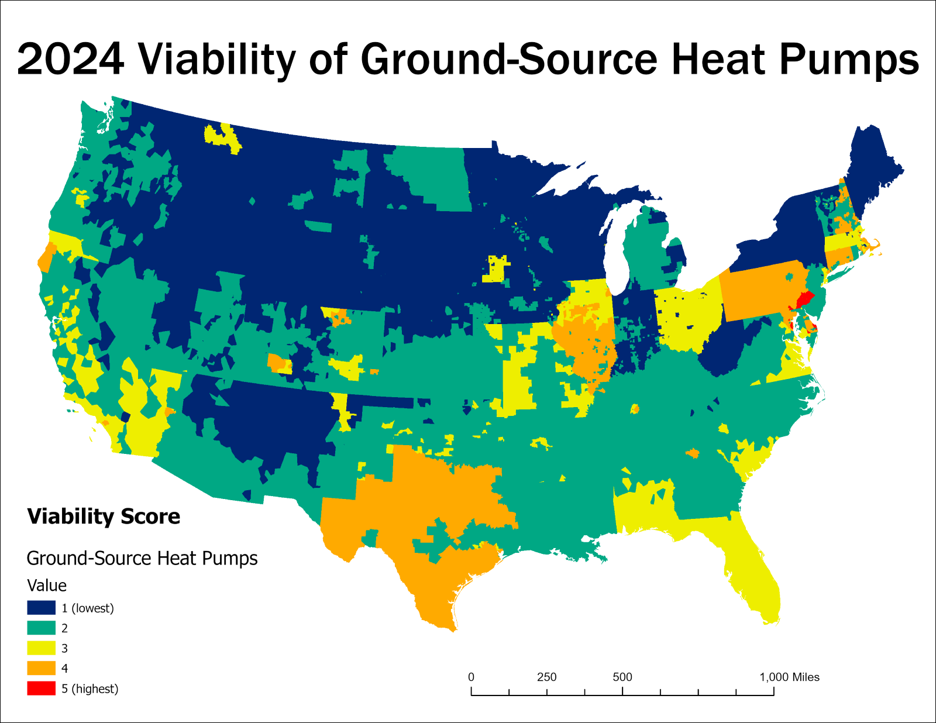

*Note.*Final viability map for ground-source heat pumps in the contiguous United States as of 2024. Red and orange colors indicate areas of highest overall viability, while dark blue indicates lowest viability.

Geothermal Direct Heating

The overall viability of geothermal direct heating also closely followed the borders of the U.S. states in many places **(Fig. 9)**. This was largely due to the proportionately heavy weightings given to the factors of commercial natural gas prices and financial incentives, both of which entirely or nearly entirely followed state boundaries. Although the factors for heating degree-days and percent renewable electricity were weighted minimally for geothermal direct use, their effects were still visible in some places such as in parts of the southern-latitude states.

No places within the contiguous United States achieved the maximum possible viability score for geothermal direct use, largely due to the small number of extant financial incentives. Additionally, many states that did possess an active financial incentive for geothermal direct use conversely had cheap state-wide natural gas prices and scored low in the commercial natural gas factor layer, such as Nevada, Utah, Montana, and Missouri. In the final viability map for geothermal direct use, the states with the highest overall viability nearly fully coincided with those bearing the most expensive natural gas prices.

**Figure 10.** Viability of Geothermal Direct Heating

*Viability of Geothermal Direct Heating*

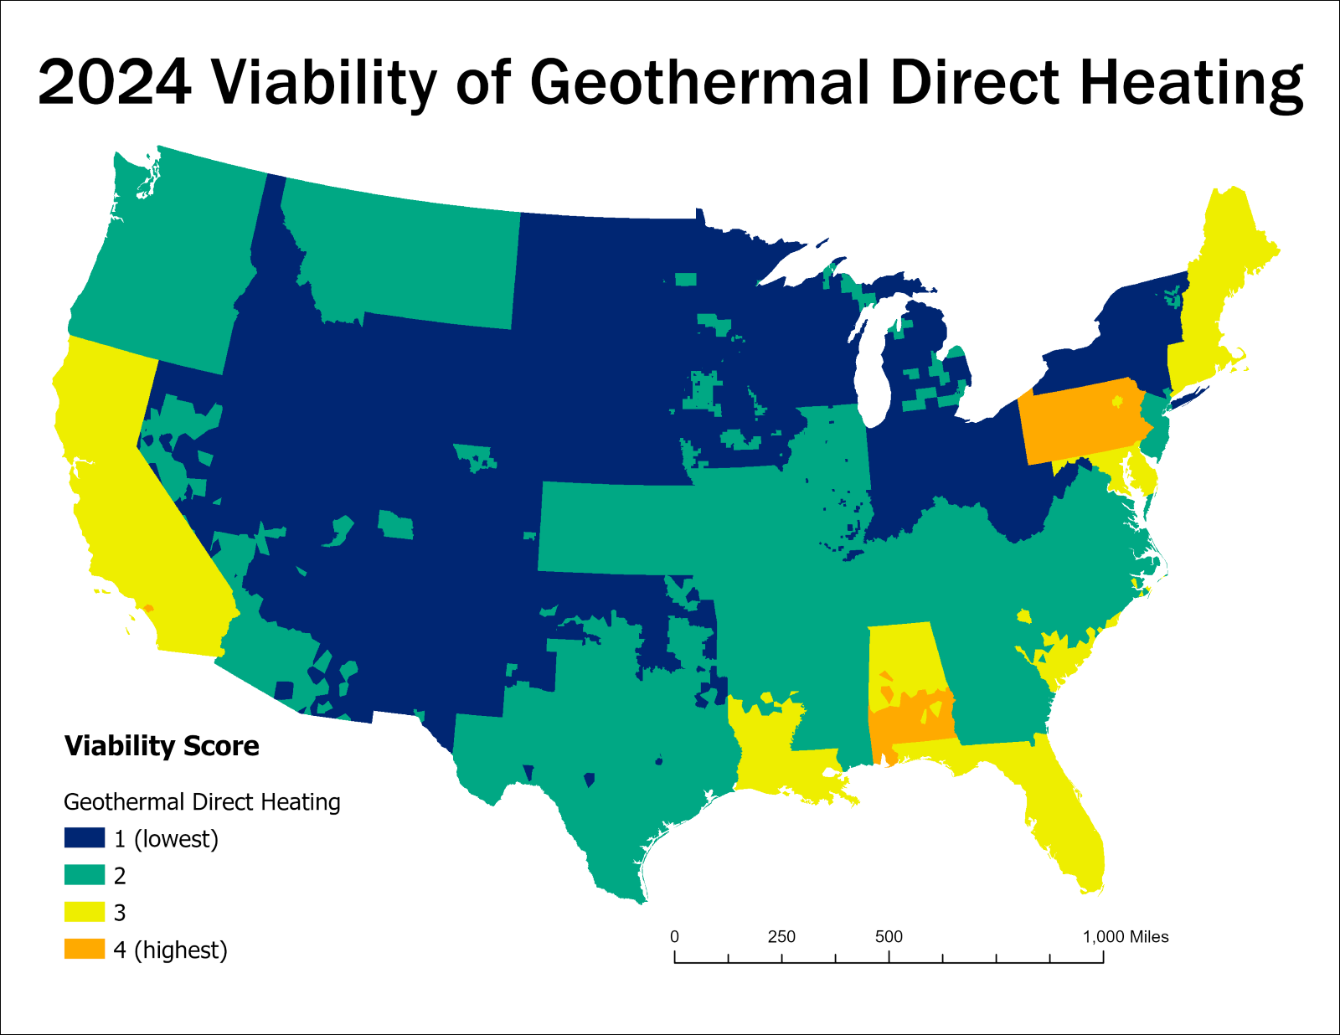

*Note.*Final viability map for geothermal direct heating in the contiguous United States as of 2024. Orange color indicates areas of highest overall viability, while dark blue indicates lowest viability.

Discussion

Overview

These viability maps ultimately serve as a spatial representation of the chain of influence that runs from place-based factors through Criteria to determine the overall viability of each form of renewable heating. The influence of these place-based factors in the final viability maps is perhaps most evident through the shapes and patterns of different score distributions on each map, which frequently adhere to the shapes of states, counties, or other noticeable outlines. Although these viability maps each include only four factors out of many others that may hold influence, they nevertheless serve a useful purpose for analysis by comparing their findings with those of other extant research, including the research conducted by the case-study colleges highlighted earlier. I will therefore first interpret these viability maps further by examining the score trends in relation to the place-based factors used in their construction, drawing back to existing research where applicable. After this, I will re-visit the “case-study” U.S. college campuses and compare their respective progresses to the findings indicated by these viability maps, followed finally by a discussion of potential future extensions and improvements to the model of analysis used in this thesis research.

Current Renewable Heating Viability

Air-Source Heat Pumps

Overall, air-source heat pumps exhibited the comparatively highest levels of viability across the contiguous United States among the studied renewable heating forms. The most influential cause for this was the comparatively large and well-distributed number of air-source heat pump financial incentives across most states. While climate “coldness” factored heavily into the viability scoring for air-source heat pumps, even northern-latitude states with greater average annual heating degree-days, such as Pennsylvania and Connecticut, still achieved high overall viability scores for air-source heat pumps due to possessing these financial incentives, in tandem with broad coverages of renewably sourced electricity within their boundaries. Many southeastern states also achieved relatively high air-source heat pump viability scores, influenced by the low annual heating degree-days in the regional climate. In these warmer regions, the actual demand for heating would be lower than in a comparatively colder climate, which could reduce the overall need for heating. However, due to their general small size and flexibility, *air-source heat pumps may serve as an optimal form of renewable heating in slightly warmer climates, especially those that also require some cooling*, as corroborated by Staffell et al. (2012) and Sarbu et al. (2022).

Ground-Source Heat Pumps

In nearly all locations across the contiguous United States, ground-source heat pumps generally scored only equally to air-source heat pumps at best, or else lower. Due to the place-based factors being weighted very similarly in both instances, scoring comparatively higher in a location generally required the presence of more financial incentives for ground-source heat pumps than for air-source heat pumps, which was rare. The implication is that by the factors covered in this research, air-source heat pumps appeared the marginally (i.e., comparatively) more viable choice than ground-source heat pumps in nearly all places. However, reality is of course more complex, and this “hard-and-fast" interpretation is unlikely to be true in every actual instance. The interpretation here should not be that air-source heat pumps outweighed ground-source heat pumps in nearly all instances; but rather, that given the four studied factors (and acknowledging the existence of others not included in this research), *ground-source heat pumps comparatively lacked the support of financial incentives* that could otherwise make them more viable across much of the contiguous United States. Especially in colder climates where ground-source heat pumps will likely out-perform air-source heat pumps in efficiency and resilience(Staffell et al., 2012; Sarbu et al., 2022), gaining further incentive support in these places could boost their viability more easily and with less compensatory effort than for air-source heat pumps in the same areas.

Geothermal Direct Heating

Compared to both air-source heat pumps and ground-source heat pumps, geothermal direct heating clearly lacked the same level of support in the form of financial incentives across the contiguous United States, as of this assessment in early 2024. With this factor unable to provide support beyond a small number of states, it was largely left to natural gas prices (which will inevitably continue to fluctuate) to dictate where geothermal direct heating implementation could be most viable. Although prices for other fossil fuels such as coal and fuel oil were not included in this study, their fluctuations would likely have a similarly strong command. While it is impossible to say for certain what could “tame” the powerful hold of these fossil fuels on geothermal direct heating viability, *implementing more financial incentives in states and localities across the United States would almost certainly comprise a portion of that solution.*

In their assessment of U.S. geothermal potential, Blackwell and Richards (2004) mapped geothermal heat flow throughout the contiguous United States. They found areas of highest heat flow, implying highest geothermal viability, in the region spanning from the Rocky Mountains to the Cascades, down through New Mexico, Arizona, and inland southern California. Conversely, the geothermal potential according to the factors examined in this research returned very low in this same region. It is unfortunate that the regions of the contiguous United States found by Blackwell and Richards (2004) to carry the highest viability for geothermal implementation in the form of heat flow also currently have little to no support from local financial incentives. Of the three renewable heating forms covered in this thesis research, it is therefore arguable that *geothermal direct heating will require the most support from policymakers and advocates to increase its future viability throughout the contiguous United States*.

Re-Visiting Case-Study Colleges

All four case-study U.S. colleges covered earlier in this thesis matched to locations that scored low in overall viability on the produced maps for their respective forms of renewable heating. For geothermal direct heating, regions of moderate to high viability were already scarce, and Cornell University, West Virginia University, and the University of Illinois, Urbana-Champaign fell within its lowest two ranks of scoring **(Fig. 9, 10)**. Similarly for Ball State University, no place within the state of Indiana scored higher than the second-lowest rank for ground-source heat pump viability, as seen in **(Fig. 10)**. The lack of financial incentives at state or local levels in the locations of these case-study colleges was a common theme acknowledged by many researchers on these projects — for example, Tester et al. (2020) acknowledged the widespread lack of current financial incentives in the United States for renewable heating in general, compared to those for renewable electricity. In lieu of localised funding opportunities, some case-study colleges made connections at the federal level: West Virginia University partnered with the United States Department of Energy to fund their geothermal direct heating research (Garapati et al., 2019). Similarly, Im et al. (2016) reported receiving federal-level funding from the American Recovery and Reinvestment Act that was active at the time of the Ball State University ground-source heat pump system implementation, but they did not mention the application of any state- or local-level grants or incentives for this project.

**Figure 11.** Case-Study Colleges and Geothermal Direct Heating Viability

*Case-Study Colleges and Geothermal Direct Heating Viability*

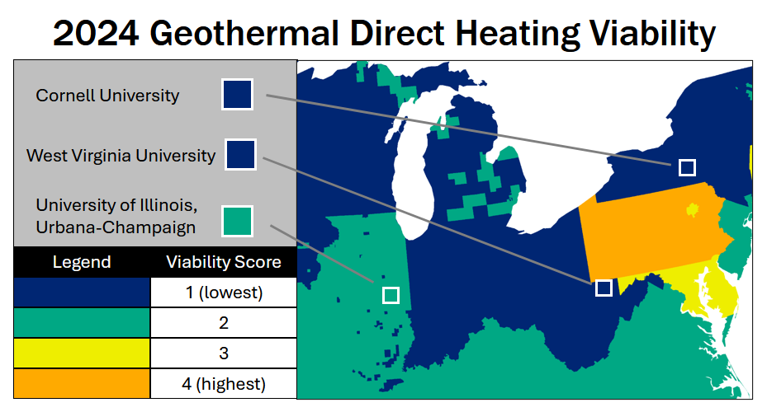

*Note.* This figure approximates the geographical locations of the three U.S. college campuses studying geothermal direct heating that were covered in this thesis — Cornell University, West Virginia University, and the University of Illinois, Urbana-Champaign — above the final viability map for geothermal direct heating produced in this thesis research.

It should therefore be apparent that the story does not end with the viability maps produced in this thesis research, given that these colleges have nevertheless already implemented or made major progress towards implementing their respective forms of renewable heating, regardless of the actual viability of doing so in their respective places. For instance, the work performed by West Virginia University to research and model their proposed geothermal direct heating campus system should be commended as a major step of progress in breaking away from their local place’s centuries-old legacy of fossil fuels, even if they ultimately implement their system in the natural gas hybrid form proposed by Garapati et al. (2020). Likewise, Ball State University’s ability to fully implement and commission a ground-source heat pump system for both heating and cooling should be commended, even with some mistakes and lessons learned in the course of implementation as described by Im et al. (2016). Ultimately, *it is unwise and even potentially harmful to discourage any development or research of a form of renewable heating in a place just because it scored low in viability there.* All the factors included in this research will inevitably change with time and may soon exhibit entirely new patterns. Furthermore, the factors in this research comprise but a few pieces of the greater puzzle of place-based factors influential to renewable heating, which could be theoretically endless. The additional inclusion of even one or two additional factors not in this study would likely change the overall viability maps, potentially in major ways. This research is best considered as the beginning of a new story, rather than the end of one.

Limitations, Omissions, and Recommendations

Limitations

Even in “distant” observational research as was conducted for this thesis, the researcher is necessarily a part of and an influence on the research. Limitations and compromises exist and must be acknowledged in such aspects as the classification of viability scores and the illustrative methodology of displaying their final results.

Because all factors in this analysis were scored in 5 classes (which was itself an arbitrary decision made for visualisation purposes), cut-offs inevitably occurred between different score classes in the final viability maps. Some locations may have displayed apparent “jumps” between score classes despite only a small difference in score; and conversely, other locations may have masked differences in score within the same class. This is an inevitable product of using a rigid score-classification system, but its potential to create artifacts in the data maps must be acknowledged. The cut-off points between different classes were themselves all either chosen manually or otherwise the product of a manually-designed classification method (in the case of the financial incentives factors). In reality, factors such as natural gas prices, renewable electricity availability, and heating degree-days rarely if ever exhibit rigid jumps in their characteristics at any precise location, rather existing on a continuum. Nevertheless, the classed methodology of viability scoring was chosen for this research with the belief that its benefits in clarity of understanding and interpretation would far outweigh the aforementioned limitations.

Despite best efforts to match the place-based factors’ weightings to their relative influences on each form of renewable heating viability according to the reviewed literature, the exact weighting amounts used in these analyses nevertheless carry a degree of arbitrary decision-making in their exact finalised amounts. For example, while studies on geothermal direct heating consistently showed the high influence of factors such as fossil-fuel prices and financial incentives on its viability (Thorsteinsson & Tester, 2010; Snyder et al., 2017; Kolker et al., 2021), determining the exact “mathematical” degree to which these factors are more important than heating degree-days or renewable electricity was well beyond the scope of this thesis. It is also possible that these weightings are not static and may themselves change from place to place, potentially themselves influenced by variations in place-based factors. While this cannot be known for certain under the scope of work conducted in this thesis, it is mentioned here as a potentially worthwhile subject of further study in future viability analyses.

Omissions

While the four place-based factors chosen for this thesis research almost undoubtedly influence the viability of the studied forms of renewable heating, they are nevertheless far from the only influential factors, nor is it possible to rule out finer nuances or complexities in the relationships between the studied factors and viabilities. While it may never be possible to fully comprehend all possible missed factors and influences, several factors that were excluded from this research are readily apparent. These may include: other climate-related factors such as humidity, precipitation, freezing weather, and seasonal trends; other socio-economic factors such as prices of coal, oil, or other fossil fuels; and geological factors that could especially affect ground-source heat pump and geothermal direct heating viability. These factors were generally excluded due to the difficulty or inability to obtain a data-layer spanning the contiguous United States that would be compatible with this research analysis. However, their potential to serve as additional factor layers in future viability studies is always present and depends only on the existence of sufficient data formatted into the appropriate form for analysis.

Recommendations for Further Research

It is important to re-iterate that none of the place-based factors used for this thesis research are static or unchanging, as few if any are. Commercial natural gas prices will inevitably continue to change, as will the existence of active financial-incentive policies. Even the heating degree-day data used in this research will soon become obsolete as climate change continues to increase average temperatures throughout the United States as with elsewhere. Through this inevitability, however, comes the opportunity to incorporate a time-element into this form of viability mapping, which opens the door to its potential use for future viability modelling under predicted or projected scenarios. For example, a new factor layer could be created for the projected changes in heating degree-days across the contiguous United States at a specified year and under a specified level of global temperature warming. This new factor layer could then be overlayed with the other existing layers to project how viability of these renewable heating forms would potentially change under this global warming scenario, when all other factors remain held constant. Similar projections could likewise be made for fossil-fuel price fluctuations, projected growth of renewably sourced electricity available on the market, and the potential growth and/or decline of renewable heating financial incentives at state and local levels. In all cases, it is perhaps most important of all to develop streamlined workflows of data-processing, which in many cases requires the “de-siloing” of various separate departments that may not have existing lines of communication despite working towards a shared goal.

The framework used in this thesis research — of gathering spatial data relating to place-based factors and overlaying them to calculate overall viability — is a flexible method of analysis that has the potential to be extended to many applications including and beyond renewable heating. In addition to closely related forms of “solution-fitting”, e.g. determining the most viable form of renewable electricity or renewable cooling for a local system, this framework can theoretically be extended to applications in other fields such as habitat restoration, urban planning, and social services. In all these instances, it is important foremost to consider the unique aspects and characteristics of the most important place-based factors that exist in the paradigms of each different “solution world”. Characteristics of place should always serve as the ultimate guide from which all subsequent solutions stem.

Conclusion

Climate change presents arguably the greatest challenge to humanity of all time, because it encompasses many multifaceted challenges not always apparent at first glance. When looking below the surface, even apparently satisfactory renewable solutions often show themselves to perpetuate environmental and social injustices in actuality, as seen in cases such as the proposed Goldendale, Washington project (Flatt, 2022; Yakama Nation Fisheries, 2024). Only through fully incorporating the idea of fitting solutions to place can a full, just transition to global sustainability be achieved.

Within the paradigm of renewable heating, this ethos necessitates a robust understanding of the most influential Criteria for different renewable heating forms, and how different place-based factors both positively and negatively affect these Criteria and in turn shape viability. Although the renewable heating forms, Criteria, and place-based factors covered in this thesis research comprise only a part of the full picture, it is hoped that the general methodology used in this research will be drawn from and used in more viability studies that embody the spirit of fitting solutions to place, for renewable heating and other sustainable endeavors alike. Through doing so, we may form the beginning of a new story; one of learning from places and fitting our solutions to these places, so as to overcome the ubiquitous nemesis of climate change and all its encompassing harms in a truly just manner.

References

Akhtari, S., Sowlati, T., & Day, K. (2014). The effects of variations in supply accessibility and amount on the economics of using regional forest biomass for generating district heat. *Energy, 67,* 631–640. [https://doi.org/10.1016/j.energy.2014.01.092](https://nam02.safelinks.protection.outlook.com/?url=https%3A%2F%2Fdoi.org%2F10.1016%2Fj.energy.2014.01.092&data=05%7C02%7CAveri.A.Azar%40evergreen.edu%7C393afd206163481b589008dc9244b3d7%7C22adcff7c06f49a68f2050711c40ddaa%7C0%7C0%7C638546070996449096%7CUnknown%7CTWFpbGZsb3d8eyJWIjoiMC4wLjAwMDAiLCJQIjoiV2luMzIiLCJBTiI6Ik1haWwiLCJXVCI6Mn0%3D%7C0%7C%7C%7C&sdata=pqjTz7Wva36Ndas5tDUCoqZhFG31ROPts6e3uO%2FWt1M%3D&reserved=0)

Alonge, O. B. (2019). *Design of geothermal district heating and cooling system for the West Virginia University* [Master’s thesis, West Virginia University]. The Research Repository @ WVU. [https://doi.org/10.33915/etd.7397](https://nam02.safelinks.protection.outlook.com/?url=https%3A%2F%2Fdoi.org%2F10.33915%2Fetd.7397&data=05%7C02%7CAveri.A.Azar%40evergreen.edu%7C393afd206163481b589008dc9244b3d7%7C22adcff7c06f49a68f2050711c40ddaa%7C0%7C0%7C638546070996463184%7CUnknown%7CTWFpbGZsb3d8eyJWIjoiMC4wLjAwMDAiLCJQIjoiV2luMzIiLCJBTiI6Ik1haWwiLCJXVCI6Mn0%3D%7C0%7C%7C%7C&sdata=FcyapSDKxAAaUOzWT2gYbzZHLJTqso1fuWAwju%2B9x38%3D&reserved=0)

Amponsah, N. Y., Troldborg, M., Kington, B., Aalders, I., & Hough, R. L. (2014). Greenhouse gas emissions from renewable energy sources: A review of lifecycle considerations. *Renewable and Sustainable Energy Reviews, 39*, 461–475. [https://doi.org/10.1016/j.rser.2014.07.087](https://nam02.safelinks.protection.outlook.com/?url=https%3A%2F%2Fdoi.org%2F10.1016%2Fj.rser.2014.07.087&data=05%7C02%7CAveri.A.Azar%40evergreen.edu%7C393afd206163481b589008dc9244b3d7%7C22adcff7c06f49a68f2050711c40ddaa%7C0%7C0%7C638546070996471387%7CUnknown%7CTWFpbGZsb3d8eyJWIjoiMC4wLjAwMDAiLCJQIjoiV2luMzIiLCJBTiI6Ik1haWwiLCJXVCI6Mn0%3D%7C0%7C%7C%7C&sdata=qpzU50GJbmkNuY1So65FjIS0ETluzryxL0sLHN3uJT4%3D&reserved=0)

Averfalk, H., Ingvarsson, P., Persson, U., Gong, M., & Werner, S. (2017). Large heat pumps in Swedish district heating systems. *Renewable and Sustainable Energy Reviews, 79,* 1275–1284. [https://doi.org/10.1016/j.rser.2017.05.135](https://nam02.safelinks.protection.outlook.com/?url=https%3A%2F%2Fdoi.org%2F10.1016%2Fj.rser.2017.05.135&data=05%7C02%7CAveri.A.Azar%40evergreen.edu%7C393afd206163481b589008dc9244b3d7%7C22adcff7c06f49a68f2050711c40ddaa%7C0%7C0%7C638546070996477714%7CUnknown%7CTWFpbGZsb3d8eyJWIjoiMC4wLjAwMDAiLCJQIjoiV2luMzIiLCJBTiI6Ik1haWwiLCJXVCI6Mn0%3D%7C0%7C%7C%7C&sdata=JENedMtxbNoBPgv3fRe8LbbjjBoLO6iPnIoB4L3sTXI%3D&reserved=0)

Beckers, K. F., Galantino, C. R., Jurado, N. R., Kassem, N., Hawkins, A. J., Beyers, S. M., Gustafson, J. O., Jordan, T. E., Fulton, P. M., & Tester, J. W. (2020). Geothermal district heating using centralized heat pumps and biomass peakers: Case-study at Cornell University. *GRC Transactions, 44*, 217–234.

Beckers, K. F., Kolker, A., Pauling, H., McTigue, J. D., & Kesseli, D. (2021). Evaluating the feasibility of geothermal deep direct-use in the United States. *Energy Conversion and Management, 243*, 114335. [https://doi.org/10.1016/j.enconman.2021.114335](https://nam02.safelinks.protection.outlook.com/?url=https%3A%2F%2Fdoi.org%2F10.1016%2Fj.enconman.2021.114335&data=05%7C02%7CAveri.A.Azar%40evergreen.edu%7C393afd206163481b589008dc9244b3d7%7C22adcff7c06f49a68f2050711c40ddaa%7C0%7C0%7C638546070996483220%7CUnknown%7CTWFpbGZsb3d8eyJWIjoiMC4wLjAwMDAiLCJQIjoiV2luMzIiLCJBTiI6Ik1haWwiLCJXVCI6Mn0%3D%7C0%7C%7C%7C&sdata=LfOVkCFf25%2FGPfk%2FEibxSnQZYlf6DIspG8hOL%2BDJvOE%3D&reserved=0)

Beckers, K. F., Lukawski, M. Z., Aguirre, G. A., Hillson, S. D., & Tester, J. W. (2015, January 26–28). Hybrid low-grade geothermal-biomass systems for direct-use and co-generation: From campus demonstration to nationwide energy player. In *40th Workshop on Geothermal Reservoir Engineering,* Stanford University, Stanford, CA (USA).

Bertsch, S. S., & Groll, E. A. (2008). Two-stage air-source heat pump for residential heating and cooling applications in northern US climates. *International Journal of Refrigeration, 31*(7), 1282–1292. [https://doi.org/10.1016/j.ijrefrig.2008.01.006](https://nam02.safelinks.protection.outlook.com/?url=https%3A%2F%2Fdoi.org%2F10.1016%2Fj.ijrefrig.2008.01.006&data=05%7C02%7CAveri.A.Azar%40evergreen.edu%7C393afd206163481b589008dc9244b3d7%7C22adcff7c06f49a68f2050711c40ddaa%7C0%7C0%7C638546070996488660%7CUnknown%7CTWFpbGZsb3d8eyJWIjoiMC4wLjAwMDAiLCJQIjoiV2luMzIiLCJBTiI6Ik1haWwiLCJXVCI6Mn0%3D%7C0%7C%7C%7C&sdata=ioVrEoxL5uMo9r3OG10ichbgagLCXOgAmjlgb5ZCAn4%3D&reserved=0)

Blackwell, D. D., & Richards, M. C. (2004). *Geothermal map of the United States.*

Blackwell, D. D., Negraru, P. T., & Richards, M. C. (2007). Assessment of the enhanced geothermal system resource base of the United States. *Natural Resources Research, 15*, 283–308. [https://doi.org/10.1007/s11053-007-9028-7](https://nam02.safelinks.protection.outlook.com/?url=https%3A%2F%2Fdoi.org%2F10.1007%2Fs11053-007-9028-7&data=05%7C02%7CAveri.A.Azar%40evergreen.edu%7C393afd206163481b589008dc9244b3d7%7C22adcff7c06f49a68f2050711c40ddaa%7C0%7C0%7C638546070996494108%7CUnknown%7CTWFpbGZsb3d8eyJWIjoiMC4wLjAwMDAiLCJQIjoiV2luMzIiLCJBTiI6Ik1haWwiLCJXVCI6Mn0%3D%7C0%7C%7C%7C&sdata=QxooiEVpLLa2f3S57nLJgVD5CgResPHb2T3T7oF8Hbk%3D&reserved=0)

Buker, M. S., & Riffat, S. B. (2015). Building integrated solar thermal collectors–A review. *Renewable and Sustainable Energy Reviews, 51*, 327–346. [https://doi.org/10.1016/j.rser.2015.06.009](https://nam02.safelinks.protection.outlook.com/?url=https%3A%2F%2Fdoi.org%2F10.1016%2Fj.rser.2015.06.009&data=05%7C02%7CAveri.A.Azar%40evergreen.edu%7C393afd206163481b589008dc9244b3d7%7C22adcff7c06f49a68f2050711c40ddaa%7C0%7C0%7C638546070996499550%7CUnknown%7CTWFpbGZsb3d8eyJWIjoiMC4wLjAwMDAiLCJQIjoiV2luMzIiLCJBTiI6Ik1haWwiLCJXVCI6Mn0%3D%7C0%7C%7C%7C&sdata=WyzrEXt7vD8fLwYq%2Bh8GbrDQrc9uV4cWVeBko7beJhc%3D&reserved=0)

Cabrol, L., & Rowley, P. (2012). Towards low carbon homes–A simulation analysis of building-integrated air-source heat pump systems. *Energy and Buildings, 48*, 127–136. [https://doi.org/10.1016/j.enbuild.2012.01.019](https://nam02.safelinks.protection.outlook.com/?url=https%3A%2F%2Fdoi.org%2F10.1016%2Fj.enbuild.2012.01.019&data=05%7C02%7CAveri.A.Azar%40evergreen.edu%7C393afd206163481b589008dc9244b3d7%7C22adcff7c06f49a68f2050711c40ddaa%7C0%7C0%7C638546070996505226%7CUnknown%7CTWFpbGZsb3d8eyJWIjoiMC4wLjAwMDAiLCJQIjoiV2luMzIiLCJBTiI6Ik1haWwiLCJXVCI6Mn0%3D%7C0%7C%7C%7C&sdata=qW3jSDxFGxcr0XEShs5%2Fst4e3u2F06YEwPNIX9uijcI%3D&reserved=0)

Cajete, G. A. (2020). Indigenous science, climate change, and indigenous community building: A framework of foundational perspectives for Indigenous community resilience and revitalization. *Sustainability, 12*(22), 9569. [https://doi.org/10.3390/su12229569](https://nam02.safelinks.protection.outlook.com/?url=https%3A%2F%2Fdoi.org%2F10.3390%2Fsu12229569&data=05%7C02%7CAveri.A.Azar%40evergreen.edu%7C393afd206163481b589008dc9244b3d7%7C22adcff7c06f49a68f2050711c40ddaa%7C0%7C0%7C638546070996510866%7CUnknown%7CTWFpbGZsb3d8eyJWIjoiMC4wLjAwMDAiLCJQIjoiV2luMzIiLCJBTiI6Ik1haWwiLCJXVCI6Mn0%3D%7C0%7C%7C%7C&sdata=uV6dHBBGIXIvTdzVWuQFxLE6eiMNDP9AZw%2Fum7H4Ma0%3D&reserved=0)

Carroll, P., Chesser, M., & Lyons, P. (2020). Air source heat pumps field studies: A systematic literature review. *Renewable and Sustainable Energy Reviews, 134,* 110275. [https://doi.org/10.1016/j.rser.2020.110275](https://nam02.safelinks.protection.outlook.com/?url=https%3A%2F%2Fdoi.org%2F10.1016%2Fj.rser.2020.110275&data=05%7C02%7CAveri.A.Azar%40evergreen.edu%7C393afd206163481b589008dc9244b3d7%7C22adcff7c06f49a68f2050711c40ddaa%7C0%7C0%7C638546070996516787%7CUnknown%7CTWFpbGZsb3d8eyJWIjoiMC4wLjAwMDAiLCJQIjoiV2luMzIiLCJBTiI6Ik1haWwiLCJXVCI6Mn0%3D%7C0%7C%7C%7C&sdata=oAdwZaFiY6vuR4bBT3WDIo3PvX4aIVvXB5jbTjRtnzk%3D&reserved=0)

Chen, X., Zhang, G., Peng, J., Lin, X., & Liu, T. (2006). The performance of an open-loop lake water heat pump system in south China. Applied Thermal Engineering, 26, 2255–2261. <https://doi.org/10.1016/j.applthermaleng.2006.03.009>

Chesser, M., Lyons, P., O’Reilly, P., & Carroll, P. (2021). Air source heat pump in-situ performance. *Energy & Buildings, 251,* 111365. [https://doi.org/10.1016/j.enbuild.2021.111365](https://nam02.safelinks.protection.outlook.com/?url=https%3A%2F%2Fdoi.org%2F10.1016%2Fj.enbuild.2021.111365&data=05%7C02%7CAveri.A.Azar%40evergreen.edu%7C393afd206163481b589008dc9244b3d7%7C22adcff7c06f49a68f2050711c40ddaa%7C0%7C0%7C638546070996522093%7CUnknown%7CTWFpbGZsb3d8eyJWIjoiMC4wLjAwMDAiLCJQIjoiV2luMzIiLCJBTiI6Ik1haWwiLCJXVCI6Mn0%3D%7C0%7C%7C%7C&sdata=kE%2FQEoh9IQFY4h5RjHsDEBz0ngage2BJOnA4IpoPR7U%3D&reserved=0)

De Swardt, C. A., & Meyer, J. P. (2001). A performance comparison between an air‐source and a ground‐source reversible heat pump. *International Journal of Energy Research, 25*(10), 899–910. [https://doi.org/10.1002/er.730](https://nam02.safelinks.protection.outlook.com/?url=https%3A%2F%2Fdoi.org%2F10.1002%2Fer.730&data=05%7C02%7CAveri.A.Azar%40evergreen.edu%7C393afd206163481b589008dc9244b3d7%7C22adcff7c06f49a68f2050711c40ddaa%7C0%7C0%7C638546070996527291%7CUnknown%7CTWFpbGZsb3d8eyJWIjoiMC4wLjAwMDAiLCJQIjoiV2luMzIiLCJBTiI6Ik1haWwiLCJXVCI6Mn0%3D%7C0%7C%7C%7C&sdata=%2Bn2w12eno%2F%2BJkAiSmhuOWk%2Fe3jhBmLRJZgz5pJ9IECM%3D&reserved=0)

Doak, A., Stanier, C., Anthony, J., & Udaykumar, H. S. (2022). Can heat‐pumps provide routes to decarbonization of building thermal control in the US Midwest?. *Energy Science & Engineering, 10*(8), 2612–2621. [https://doi.org/10.1002/ese3.1159](https://nam02.safelinks.protection.outlook.com/?url=https%3A%2F%2Fdoi.org%2F10.1002%2Fese3.1159&data=05%7C02%7CAveri.A.Azar%40evergreen.edu%7C393afd206163481b589008dc9244b3d7%7C22adcff7c06f49a68f2050711c40ddaa%7C0%7C0%7C638546070996532365%7CUnknown%7CTWFpbGZsb3d8eyJWIjoiMC4wLjAwMDAiLCJQIjoiV2luMzIiLCJBTiI6Ik1haWwiLCJXVCI6Mn0%3D%7C0%7C%7C%7C&sdata=03NCaNDUL%2BbT4ZTGnwSRVdECj4Cissa8tXEy8bdhP4Q%3D&reserved=0)

Ericsson, K., & Werner, S. (2016). The introduction and expansion of biomass use in Swedish district heating systems. *Biomass and Bioenergy, 94*, 57–65. [https://doi.org/10.1016/j.biombioe.2016.08.011](https://nam02.safelinks.protection.outlook.com/?url=https%3A%2F%2Fdoi.org%2F10.1016%2Fj.biombioe.2016.08.011&data=05%7C02%7CAveri.A.Azar%40evergreen.edu%7C393afd206163481b589008dc9244b3d7%7C22adcff7c06f49a68f2050711c40ddaa%7C0%7C0%7C638546070996537457%7CUnknown%7CTWFpbGZsb3d8eyJWIjoiMC4wLjAwMDAiLCJQIjoiV2luMzIiLCJBTiI6Ik1haWwiLCJXVCI6Mn0%3D%7C0%7C%7C%7C&sdata=CI5UlJmoOBcZot1xbv0rSarNCp71Pig%2FYknVOsf8db8%3D&reserved=0)

Ermel, C., Bianchi, M. V., Cardoso, A. P., & Schneider, P. S. (2022). Thermal storage integrated into air-source heat pumps to leverage building electrification: A systematic literature review. *Applied Thermal Engineering, 215*, 118975. [https://doi.org/10.1016/j.applthermaleng.2022.118975](https://nam02.safelinks.protection.outlook.com/?url=https%3A%2F%2Fdoi.org%2F10.1016%2Fj.applthermaleng.2022.118975&data=05%7C02%7CAveri.A.Azar%40evergreen.edu%7C393afd206163481b589008dc9244b3d7%7C22adcff7c06f49a68f2050711c40ddaa%7C0%7C0%7C638546070996542523%7CUnknown%7CTWFpbGZsb3d8eyJWIjoiMC4wLjAwMDAiLCJQIjoiV2luMzIiLCJBTiI6Ik1haWwiLCJXVCI6Mn0%3D%7C0%7C%7C%7C&sdata=nm%2BnijdBKgekyjPgIcEhnEPdHHhBFrG%2F8QON4uxStyc%3D&reserved=0)

Find Energy LLC. (2024a). *IGS Energy: Rates, coverage area, emissions*. <https://findenergy.com/providers/igs-energy/>

Find Energy LLC. (2024b). *PECO Energy Company: Rates and coverage area.* <https://findenergy.com/providers/peco-energy-company/>

Flatt, C. (2022, December 22). *Goldendale, Washington, energy project would harm tribal resources, environmental impact statement finds*. Oregon Public Broadcasting. [https://www.opb.org/article/2022/12/22/goldendale-washington-energy-storage-tribal-environment-tribes-rock-creek-band-yakima-warm-springs/](https://nam02.safelinks.protection.outlook.com/?url=https%3A%2F%2Fwww.opb.org%2Farticle%2F2022%2F12%2F22%2Fgoldendale-washington-energy-storage-tribal-environment-tribes-rock-creek-band-yakima-warm-springs%2F&data=05%7C02%7CAveri.A.Azar%40evergreen.edu%7C393afd206163481b589008dc9244b3d7%7C22adcff7c06f49a68f2050711c40ddaa%7C0%7C0%7C638546070996547744%7CUnknown%7CTWFpbGZsb3d8eyJWIjoiMC4wLjAwMDAiLCJQIjoiV2luMzIiLCJBTiI6Ik1haWwiLCJXVCI6Mn0%3D%7C0%7C%7C%7C&sdata=9C%2FwWJvKyz1oHRemlqB4rAJP%2BbpaZ5%2FU%2Bqt5sIXODwA%3D&reserved=0)

Fulton, P., Clairmont, R., Fulcher, S., Pinilla, D., Purwamaska, I., Jamison, H., ... & Tester, J. Subsurface Insights from the Cornell University Borehole Observatory (CUBO): A 3km Deep Exploratory Well for Advancing Earth Source Heat Deep Direct-Use Geothermal for District Heating.

Furubayashi, T., & Nakata, T. (2021). Analysis of woody biomass utilization for heat, electricity, and CHP in a regional city of Japan. *Journal of Cleaner Production, 290*, 125665. [https://doi.org/10.1016/j.jclepro.2020.125665](https://nam02.safelinks.protection.outlook.com/?url=https%3A%2F%2Fdoi.org%2F10.1016%2Fj.jclepro.2020.125665&data=05%7C02%7CAveri.A.Azar%40evergreen.edu%7C393afd206163481b589008dc9244b3d7%7C22adcff7c06f49a68f2050711c40ddaa%7C0%7C0%7C638546070996553295%7CUnknown%7CTWFpbGZsb3d8eyJWIjoiMC4wLjAwMDAiLCJQIjoiV2luMzIiLCJBTiI6Ik1haWwiLCJXVCI6Mn0%3D%7C0%7C%7C%7C&sdata=txIt25ds7N22WEcjKWY96BMcSbwSqDmNkk3fvB2jEN4%3D&reserved=0)

Gao, B., Zhu, X., Yang, X., Yuan, Y., Yu, N., & Ni, J. (2021). Operation performance test and energy efficiency analysis of ground-source heat pump systems. *Journal of Building Engineering, 41,* 102446. [https://doi.org/10.1016/j.jobe.2021.102446](https://nam02.safelinks.protection.outlook.com/?url=https%3A%2F%2Fdoi.org%2F10.1016%2Fj.jobe.2021.102446&data=05%7C02%7CAveri.A.Azar%40evergreen.edu%7C393afd206163481b589008dc9244b3d7%7C22adcff7c06f49a68f2050711c40ddaa%7C0%7C0%7C638546070996558616%7CUnknown%7CTWFpbGZsb3d8eyJWIjoiMC4wLjAwMDAiLCJQIjoiV2luMzIiLCJBTiI6Ik1haWwiLCJXVCI6Mn0%3D%7C0%7C%7C%7C&sdata=jVP5fA7JCnEPDSsIi2YxzM4BLkcqhwvAhIzVBNVwAjc%3D&reserved=0)

Garapati, N. (2021). *Feasibility of deep direct-use geothermal on the West Virginia University campus-Morgantown, WV* (No. Final Technical Report-DOE-WVU). West Virginia Univ., Morgantown, WV (United States). [https://doi.org/10.2172/1829981](https://nam02.safelinks.protection.outlook.com/?url=https%3A%2F%2Fdoi.org%2F10.2172%2F1829981&data=05%7C02%7CAveri.A.Azar%40evergreen.edu%7C393afd206163481b589008dc9244b3d7%7C22adcff7c06f49a68f2050711c40ddaa%7C0%7C0%7C638546070996563928%7CUnknown%7CTWFpbGZsb3d8eyJWIjoiMC4wLjAwMDAiLCJQIjoiV2luMzIiLCJBTiI6Ik1haWwiLCJXVCI6Mn0%3D%7C0%7C%7C%7C&sdata=LzEoNi6%2Bcz%2FG7gMISO%2Btn3ByZ3w%2BfTM4Javgcm%2BGTWs%3D&reserved=0)

Garapati, N., Alonge, O. B., Hall, L., Irr, V. J., Zhang, Y., Smith, J. D., Jeanne, P., & Doughty, C. (2019, February 11–13). Feasibility of development of geothermal deep direct-use district heating and cooling system at West Virginia University campus–Morgantown, WV. In *44th Workshop on Geothermal Reservoir Engineering,* Stanford University, Stanford, CA (USA).

Garapati, N., Irr, V. J., & Lamb, B. (2020, February 10–12). Feasibility analysis of deep direct-use geothermal on the West Virginia University campus–Morgantown, WV. In *45th Workshop on Geothermal Reservoir Engineering*, Stanford University, Stanford, CA (USA).

Gaur, A. S., Fitiwi, D. Z., & Curtis, J. (2021). Heat pumps and our low-carbon future: A comprehensive review. *Energy Research & Social Science, 71*, 101764. [https://doi.org/10.1016/j.erss.2020.101764](https://nam02.safelinks.protection.outlook.com/?url=https%3A%2F%2Fdoi.org%2F10.1016%2Fj.erss.2020.101764&data=05%7C02%7CAveri.A.Azar%40evergreen.edu%7C393afd206163481b589008dc9244b3d7%7C22adcff7c06f49a68f2050711c40ddaa%7C0%7C0%7C638546070996569328%7CUnknown%7CTWFpbGZsb3d8eyJWIjoiMC4wLjAwMDAiLCJQIjoiV2luMzIiLCJBTiI6Ik1haWwiLCJXVCI6Mn0%3D%7C0%7C%7C%7C&sdata=dsMOcHnAWPjRnixFQi%2BZjj4qBe60Vbs3gxdO4WCwxIA%3D&reserved=0)

Gjoka, K., Rismanchi, B., & Crawford, R. H. (2023). Fifth-generation district heating and cooling systems: A review of recent advancements and implementation barriers. *Renewable and Sustainable Energy Reviews, 171,* 112997. [https://doi.org/10.1016/j.rser.2022.112997](https://nam02.safelinks.protection.outlook.com/?url=https%3A%2F%2Fdoi.org%2F10.1016%2Fj.rser.2022.112997&data=05%7C02%7CAveri.A.Azar%40evergreen.edu%7C393afd206163481b589008dc9244b3d7%7C22adcff7c06f49a68f2050711c40ddaa%7C0%7C0%7C638546070996574765%7CUnknown%7CTWFpbGZsb3d8eyJWIjoiMC4wLjAwMDAiLCJQIjoiV2luMzIiLCJBTiI6Ik1haWwiLCJXVCI6Mn0%3D%7C0%7C%7C%7C&sdata=02GVgdHBPwUdFgzv4RDR6WTxnwN8M2cGbi9hKLZq7qw%3D&reserved=0)

Goetzl, G., Burns, E. R., Stumpf, A. J., Lin, Y. F., Kolker, A., Kłonowski, M. R., Steiner, C., Cahalan, R. C., & Pepin, J. D. (2023, February 6–8). City-scale geothermal energy everywhere to support renewable resilience – A transcontinental cooperation. In *48th Workshop on Geothermal Reservoir Engineering*, Stanford, CA, United States.

Goldendale Energy Storage LLC. (n.d.). *Benefits.* Retrieved June 20, 2024, from[https://goldendaleenergystorage.com/benefits.html](https://nam02.safelinks.protection.outlook.com/?url=https%3A%2F%2Fgoldendaleenergystorage.com%2Fbenefits.html&data=05%7C02%7CAveri.A.Azar%40evergreen.edu%7C393afd206163481b589008dc9244b3d7%7C22adcff7c06f49a68f2050711c40ddaa%7C0%7C0%7C638546070996580212%7CUnknown%7CTWFpbGZsb3d8eyJWIjoiMC4wLjAwMDAiLCJQIjoiV2luMzIiLCJBTiI6Ik1haWwiLCJXVCI6Mn0%3D%7C0%7C%7C%7C&sdata=gnSlu77KSC6ED6svL9Tdxh9wzbT447kweaax%2FGmTlAI%3D&reserved=0)

Greening, B., & Azapagic, A. (2012). Domestic heat pumps: Life cycle environmental impacts and potential implications for the UK. *Energy, 39*(1), 205–217. [https://doi.org/10.1016/j.energy.2012.01.028](https://nam02.safelinks.protection.outlook.com/?url=https%3A%2F%2Fdoi.org%2F10.1016%2Fj.energy.2012.01.028&data=05%7C02%7CAveri.A.Azar%40evergreen.edu%7C393afd206163481b589008dc9244b3d7%7C22adcff7c06f49a68f2050711c40ddaa%7C0%7C0%7C638546070996585590%7CUnknown%7CTWFpbGZsb3d8eyJWIjoiMC4wLjAwMDAiLCJQIjoiV2luMzIiLCJBTiI6Ik1haWwiLCJXVCI6Mn0%3D%7C0%7C%7C%7C&sdata=oZ5rc78OfC8temWKhLQVwWn7mrgSrK7ruKjypHa3Dbw%3D&reserved=0)

Grujić, M., Ivezić, D., & Živković, M. (2014). Application of multi-criteria decision-making model for choice of the optimal solution for meeting heat demand in the centralized supply system in Belgrade. *Energy, 67,* 341–350. [https://doi.org/10.1016/j.energy.2014.02.017](https://nam02.safelinks.protection.outlook.com/?url=https%3A%2F%2Fdoi.org%2F10.1016%2Fj.energy.2014.02.017&data=05%7C02%7CAveri.A.Azar%40evergreen.edu%7C393afd206163481b589008dc9244b3d7%7C22adcff7c06f49a68f2050711c40ddaa%7C0%7C0%7C638546070996591114%7CUnknown%7CTWFpbGZsb3d8eyJWIjoiMC4wLjAwMDAiLCJQIjoiV2luMzIiLCJBTiI6Ik1haWwiLCJXVCI6Mn0%3D%7C0%7C%7C%7C&sdata=SrgayVgbKox0eHb6Kepdb2Fv7MBaVY1wHFPBgItkyG4%3D&reserved=0)

Guoyuan, M., Qinhu, C., & Yi, J. (2003). Experimental investigation of air-source heat pump for cold regions. *International Journal of Refrigeration, 26*(1), 12–18. [https://doi.org/10.1016/S0140-7007(02)00083-X](https://nam02.safelinks.protection.outlook.com/?url=https%3A%2F%2Fdoi.org%2F10.1016%2FS0140-7007(02)00083-X&data=05%7C02%7CAveri.A.Azar%40evergreen.edu%7C393afd206163481b589008dc9244b3d7%7C22adcff7c06f49a68f2050711c40ddaa%7C0%7C0%7C638546070996596579%7CUnknown%7CTWFpbGZsb3d8eyJWIjoiMC4wLjAwMDAiLCJQIjoiV2luMzIiLCJBTiI6Ik1haWwiLCJXVCI6Mn0%3D%7C0%7C%7C%7C&sdata=L4UKC3U9InhWKs6LQAdIdrXlPlehaeZYgcq6nuIP%2BGg%3D&reserved=0)

Gustafson, J. O., Jordan, T. E., Brown, L. D., May, D., Horowitz, F., Beckers, K., & Tester, J. W. (2020, February 10–12). Cornell University earth source heat project: Preliminary assessment of geologic factors affecting reservoir structure and seismic hazard analysis. In *45th Workshop on Geothermal Reservoir Engineering,* Stanford University, Stanford, CA (USA).

Han, A. T., Laurian, L., & Brinkley, C. (2021). Thermal planning: What can campuses teach us about expanding district energy? *Journal of Environmental Planning and Management, 64*(11), 2066–2088. [https://doi.org/10.1080/09640568.2020.1855577](https://nam02.safelinks.protection.outlook.com/?url=https%3A%2F%2Fdoi.org%2F10.1080%2F09640568.2020.1855577&data=05%7C02%7CAveri.A.Azar%40evergreen.edu%7C393afd206163481b589008dc9244b3d7%7C22adcff7c06f49a68f2050711c40ddaa%7C0%7C0%7C638546070996601932%7CUnknown%7CTWFpbGZsb3d8eyJWIjoiMC4wLjAwMDAiLCJQIjoiV2luMzIiLCJBTiI6Ik1haWwiLCJXVCI6Mn0%3D%7C0%7C%7C%7C&sdata=4tRMUPyBw7gSUSXjLztGA77sN%2BQ3qnFDvNBv3uptdTY%3D&reserved=0)

Hansen, C. K. (2023). *Zero net energy campus: Foothill College de-carbonization* [Doctoral dissertation, San Francisco State University].

He, X., & Anderson, B. J. (2012, January 30–February 1). Low-temperature geothermal resources for district heating: An energy-economic model of West Virginia University case study. In *37th Workshop on Geothermal Reservoir Engineering,* Stanford University, Stanford, CA (USA).

Hendricks, A. M., Wagner, J. E., Volk, T. A., Newman, D. H., & Brown, T. R. (2016). A cost-effective evaluation of biomass district heating in rural communities. *Applied Energy, 162*, 561–569. [https://doi.org/10.1016/j.apenergy.2015.10.106](https://nam02.safelinks.protection.outlook.com/?url=https%3A%2F%2Fdoi.org%2F10.1016%2Fj.apenergy.2015.10.106&data=05%7C02%7CAveri.A.Azar%40evergreen.edu%7C393afd206163481b589008dc9244b3d7%7C22adcff7c06f49a68f2050711c40ddaa%7C0%7C0%7C638546070996607402%7CUnknown%7CTWFpbGZsb3d8eyJWIjoiMC4wLjAwMDAiLCJQIjoiV2luMzIiLCJBTiI6Ik1haWwiLCJXVCI6Mn0%3D%7C0%7C%7C%7C&sdata=Sq45f9VWEFAQ7zN5ejKAAv4N7Iv7bfIGOIi40NREDtI%3D&reserved=0)

Hester, R. T. (2010). *Design for ecological democracy*. The MIT Press.

Im, P., Liu, X., & Henderson, H. (2016). *Case study for the ARRA-funded ground source heat pump demonstration at Ball State University* (ORNL/TM--2016/644, 1337858). Oak Ridge National Laboratory. [https://doi.org/10.2172/1337858](https://nam02.safelinks.protection.outlook.com/?url=https%3A%2F%2Fdoi.org%2F10.2172%2F1337858&data=05%7C02%7CAveri.A.Azar%40evergreen.edu%7C393afd206163481b589008dc9244b3d7%7C22adcff7c06f49a68f2050711c40ddaa%7C0%7C0%7C638546070996612967%7CUnknown%7CTWFpbGZsb3d8eyJWIjoiMC4wLjAwMDAiLCJQIjoiV2luMzIiLCJBTiI6Ik1haWwiLCJXVCI6Mn0%3D%7C0%7C%7C%7C&sdata=vhiLcMvAO5z0KqYZUIqByg4MVh84SqfoB6ckKT2VO%2FA%3D&reserved=0)

Indiana University. (n.d.). *Ball State University geothermal*. ERIT: Environmental Resilience Institute. Retrieved June 20, 2024 from [https://eri.iu.edu/erit/case-studies/ball-state-university-geothermal.html](https://nam02.safelinks.protection.outlook.com/?url=https%3A%2F%2Feri.iu.edu%2Ferit%2Fcase-studies%2Fball-state-university-geothermal.html&data=05%7C02%7CAveri.A.Azar%40evergreen.edu%7C393afd206163481b589008dc9244b3d7%7C22adcff7c06f49a68f2050711c40ddaa%7C0%7C0%7C638546070996618420%7CUnknown%7CTWFpbGZsb3d8eyJWIjoiMC4wLjAwMDAiLCJQIjoiV2luMzIiLCJBTiI6Ik1haWwiLCJXVCI6Mn0%3D%7C0%7C%7C%7C&sdata=JYnWJMGj6LszPCb2d5FpP5pf%2Fv9yu409YzLa50pjYnw%3D&reserved=0)

Intergovernmental Panel on Climate Change. (2023). Summary for policymakers. In: *Climate Change 2023: Synthesis Report.Contribution of Working Groups I, II and III to the Sixth Assessment Report of the Intergovernmental Panel on Climate Change* [Core Writing Team, H. Lee and J. Romero (eds.)]. IPCC, Geneva, Switzerland, 1–34. [https://doi.org/10.59327/IPCC/AR6-9789291691647.001](https://nam02.safelinks.protection.outlook.com/?url=https%3A%2F%2Fdoi.org%2F10.59327%2FIPCC%2FAR6-9789291691647.001&data=05%7C02%7CAveri.A.Azar%40evergreen.edu%7C393afd206163481b589008dc9244b3d7%7C22adcff7c06f49a68f2050711c40ddaa%7C0%7C0%7C638546070996624112%7CUnknown%7CTWFpbGZsb3d8eyJWIjoiMC4wLjAwMDAiLCJQIjoiV2luMzIiLCJBTiI6Ik1haWwiLCJXVCI6Mn0%3D%7C0%7C%7C%7C&sdata=nnCluWBXlXSfPnIoEKN0Tw2nvvKAXGYLoHX4oZ%2BVgnA%3D&reserved=0)

International Energy Agency. (2023, August 2). *Greenhouse gas emissions from energy data explorer.* Data Tools. [https://www.iea.org/data-and-statistics/data-tools/greenhouse-gas-emissions-from-energy-data-explorer](https://nam02.safelinks.protection.outlook.com/?url=https%3A%2F%2Fwww.iea.org%2Fdata-and-statistics%2Fdata-tools%2Fgreenhouse-gas-emissions-from-energy-data-explorer&data=05%7C02%7CAveri.A.Azar%40evergreen.edu%7C393afd206163481b589008dc9244b3d7%7C22adcff7c06f49a68f2050711c40ddaa%7C0%7C0%7C638546070996629780%7CUnknown%7CTWFpbGZsb3d8eyJWIjoiMC4wLjAwMDAiLCJQIjoiV2luMzIiLCJBTiI6Ik1haWwiLCJXVCI6Mn0%3D%7C0%7C%7C%7C&sdata=LghS76%2BYS3kjtwVycP9Q7KVSoozjXXVyUsTYXO56GoA%3D&reserved=0)

Janzer, C. (2021, July 1). *Carleton College’s geothermal campus*. ENTER. [https://www.entermn.com/articles/carleton-colleges-geothermal-campus](https://nam02.safelinks.protection.outlook.com/?url=https%3A%2F%2Fwww.entermn.com%2Farticles%2Fcarleton-colleges-geothermal-campus&data=05%7C02%7CAveri.A.Azar%40evergreen.edu%7C393afd206163481b589008dc9244b3d7%7C22adcff7c06f49a68f2050711c40ddaa%7C0%7C0%7C638546070996635413%7CUnknown%7CTWFpbGZsb3d8eyJWIjoiMC4wLjAwMDAiLCJQIjoiV2luMzIiLCJBTiI6Ik1haWwiLCJXVCI6Mn0%3D%7C0%7C%7C%7C&sdata=gij2vGeFqzBiERhWxXIgNophki9HQnZJe7e2ybkGRjE%3D&reserved=0)

Jarre, M., Noussan, M., & Simonetti, M. (2018). Primary energy consumption of heat pumps in high renewable share electricity mixes. *Energy Conversion and Management, 171,* 1339–1351. [https://doi.org/10.1016/j.enconman.2018.06.067](https://nam02.safelinks.protection.outlook.com/?url=https%3A%2F%2Fdoi.org%2F10.1016%2Fj.enconman.2018.06.067&data=05%7C02%7CAveri.A.Azar%40evergreen.edu%7C393afd206163481b589008dc9244b3d7%7C22adcff7c06f49a68f2050711c40ddaa%7C0%7C0%7C638546070996640927%7CUnknown%7CTWFpbGZsb3d8eyJWIjoiMC4wLjAwMDAiLCJQIjoiV2luMzIiLCJBTiI6Ik1haWwiLCJXVCI6Mn0%3D%7C0%7C%7C%7C&sdata=aKo%2FHJa3YKKk7HtasVQLQJI3EXMZIFIh9V7uBdPi5MQ%3D&reserved=0)

Jello, J., Khan, M., Malkewicz, N., Whittaker, S., & Baser, T. (2022). Advanced geothermal energy storage systems by repurposing existing oil and gas wells: A full-scale experimental and numerical investigation. *Renewable Energy, 199,* 852–865.    
[https://doi.org/10.1016/j.renene.2022.07.145](https://nam02.safelinks.protection.outlook.com/?url=https%3A%2F%2Fdoi.org%2F10.1016%2Fj.renene.2022.07.145&data=05%7C02%7CAveri.A.Azar%40evergreen.edu%7C393afd206163481b589008dc9244b3d7%7C22adcff7c06f49a68f2050711c40ddaa%7C0%7C0%7C638546070996646385%7CUnknown%7CTWFpbGZsb3d8eyJWIjoiMC4wLjAwMDAiLCJQIjoiV2luMzIiLCJBTiI6Ik1haWwiLCJXVCI6Mn0%3D%7C0%7C%7C%7C&sdata=M%2FZqmQl2GEiJMdWp0lQ7TK9k7ponwLywFGHz8LhC1Zw%3D&reserved=0)

Jiang, Y., Dong, J., Qu, M., Deng, S., & Yao, Y. (2013). A novel defrosting control method based on the degree of refrigerant superheat for air source heat pumps. *International Journal of Refrigeration, 36*(8), 2278–2288. [https://doi.org/10.1016/j.ijrefrig.2013.05.016](https://nam02.safelinks.protection.outlook.com/?url=https%3A%2F%2Fdoi.org%2F10.1016%2Fj.ijrefrig.2013.05.016&data=05%7C02%7CAveri.A.Azar%40evergreen.edu%7C393afd206163481b589008dc9244b3d7%7C22adcff7c06f49a68f2050711c40ddaa%7C0%7C0%7C638546070996651870%7CUnknown%7CTWFpbGZsb3d8eyJWIjoiMC4wLjAwMDAiLCJQIjoiV2luMzIiLCJBTiI6Ik1haWwiLCJXVCI6Mn0%3D%7C0%7C%7C%7C&sdata=g2k3GEZaKQo4%2FJma7px6hpVYqfrQTZkQo0QHt%2BMhkeY%3D&reserved=0)

Jodeiri, A. M., Goldsworthy, M. J., Buffa, S., & Cozzini, M. (2022). Role of sustainable heat sources in transition towards fourth generation district heating – A review. *Renewable and Sustainable Energy Reviews, 158*, 112156. [https://doi.org/10.1016/j.rser.2022.112156](https://nam02.safelinks.protection.outlook.com/?url=https%3A%2F%2Fdoi.org%2F10.1016%2Fj.rser.2022.112156&data=05%7C02%7CAveri.A.Azar%40evergreen.edu%7C393afd206163481b589008dc9244b3d7%7C22adcff7c06f49a68f2050711c40ddaa%7C0%7C0%7C638546070996657820%7CUnknown%7CTWFpbGZsb3d8eyJWIjoiMC4wLjAwMDAiLCJQIjoiV2luMzIiLCJBTiI6Ik1haWwiLCJXVCI6Mn0%3D%7C0%7C%7C%7C&sdata=U9waUlj2Rh8DJ8UY%2F5iS%2BeuUDK3lYnz3e5WSf3UAYtM%3D&reserved=0)

Johnson, J. T., Howitt, R., Cajete, G., Berkes, F., Louis, R. P., & Kliskey, A. (2016). Weaving Indigenous and sustainability sciences to diversify our methods. *Sustainability Science, 11*, 1–11. [https://doi.org/10.1007/s11625-015-0349-x](https://nam02.safelinks.protection.outlook.com/?url=https%3A%2F%2Fdoi.org%2F10.1007%2Fs11625-015-0349-x&data=05%7C02%7CAveri.A.Azar%40evergreen.edu%7C393afd206163481b589008dc9244b3d7%7C22adcff7c06f49a68f2050711c40ddaa%7C0%7C0%7C638546070996663628%7CUnknown%7CTWFpbGZsb3d8eyJWIjoiMC4wLjAwMDAiLCJQIjoiV2luMzIiLCJBTiI6Ik1haWwiLCJXVCI6Mn0%3D%7C0%7C%7C%7C&sdata=kP34kh0Y4R5%2FZTPY62RNnVkETXbVqq6K53I6SJC60OU%3D&reserved=0)

Jossi, F. (2022, February 7). *Colleges see untapped potential in geothermal district energy systems*. Energy News Network. [https://energynews.us/2022/02/07/colleges-see-untapped-potential-in-geothermal-district-energy-systems/](https://nam02.safelinks.protection.outlook.com/?url=https%3A%2F%2Fenergynews.us%2F2022%2F02%2F07%2Fcolleges-see-untapped-potential-in-geothermal-district-energy-systems%2F&data=05%7C02%7CAveri.A.Azar%40evergreen.edu%7C393afd206163481b589008dc9244b3d7%7C22adcff7c06f49a68f2050711c40ddaa%7C0%7C0%7C638546070996669343%7CUnknown%7CTWFpbGZsb3d8eyJWIjoiMC4wLjAwMDAiLCJQIjoiV2luMzIiLCJBTiI6Ik1haWwiLCJXVCI6Mn0%3D%7C0%7C%7C%7C&sdata=01MDmjITXOQNjRNIecycMc0BT%2FUJ6bNjihAvZ29Us8Y%3D&reserved=0)

Kalogirou, S. A. (2004). Solar thermal collectors and applications. *Progress in Energy and Combustion Science, 30*(3), 231–295. [https://doi.org/10.1016/j.pecs.2004.02.001](https://nam02.safelinks.protection.outlook.com/?url=https%3A%2F%2Fdoi.org%2F10.1016%2Fj.pecs.2004.02.001&data=05%7C02%7CAveri.A.Azar%40evergreen.edu%7C393afd206163481b589008dc9244b3d7%7C22adcff7c06f49a68f2050711c40ddaa%7C0%7C0%7C638546070996675789%7CUnknown%7CTWFpbGZsb3d8eyJWIjoiMC4wLjAwMDAiLCJQIjoiV2luMzIiLCJBTiI6Ik1haWwiLCJXVCI6Mn0%3D%7C0%7C%7C%7C&sdata=Y5jqTXTSJpsnZyvbRXsH4ILETqWJsNEm%2Fj56YaDq7vE%3D&reserved=0)

Kassem, N., Hockey, J., Beyers, S., Lopez, C., Goldfarb, J. L., Angenent, L. T., & Tester, J. W. (2020). Sustainable district energy integrating biomass peaking with geothermal baseload heating: A case study of decarbonizing Cornell’s energy system. *Journal of Renewable and Sustainable Energy, 12*(6), 066302. [https://doi.org/10.1063/5.0024841](https://nam02.safelinks.protection.outlook.com/?url=https%3A%2F%2Fdoi.org%2F10.1063%2F5.0024841&data=05%7C02%7CAveri.A.Azar%40evergreen.edu%7C393afd206163481b589008dc9244b3d7%7C22adcff7c06f49a68f2050711c40ddaa%7C0%7C0%7C638546070996681345%7CUnknown%7CTWFpbGZsb3d8eyJWIjoiMC4wLjAwMDAiLCJQIjoiV2luMzIiLCJBTiI6Ik1haWwiLCJXVCI6Mn0%3D%7C0%7C%7C%7C&sdata=63M4lpMGiFkqqolthU31uTRjoDei1OCLUTqJasYa8yA%3D&reserved=0)

Kirppu, H., Lahdelma, R., & Salminen, P. (2018). Multicriteria evaluation of carbon-neutral heat-only production technologies for district heating. *Applied Thermal Engineering, 130,* 466–476. [https://doi.org/10.1016/j.applthermaleng.2017.10.161](https://nam02.safelinks.protection.outlook.com/?url=https%3A%2F%2Fdoi.org%2F10.1016%2Fj.applthermaleng.2017.10.161&data=05%7C02%7CAveri.A.Azar%40evergreen.edu%7C393afd206163481b589008dc9244b3d7%7C22adcff7c06f49a68f2050711c40ddaa%7C0%7C0%7C638546070996686835%7CUnknown%7CTWFpbGZsb3d8eyJWIjoiMC4wLjAwMDAiLCJQIjoiV2luMzIiLCJBTiI6Ik1haWwiLCJXVCI6Mn0%3D%7C0%7C%7C%7C&sdata=BarzS0t3XZzLNX2rx3hfHxqQONXE1SMRKVjMHAxgRL8%3D&reserved=0)

Kolker, A., Beckers, K., Pauling, H., Flores, F., & Robins, J. (2021, October). Geothermal district heating in the United States: 2021 update. In *GRC Transactions. Geothermal Rising Conference* (pp. 442–464).

Kontu, K., Rinne, S., Olkkonen, V., Lahdelma, R., & Salminen, P. (2015). Multicriteria evaluation of heating choices for a new sustainable residential area. *Energy and Buildings, 93*, 169–179. [https://doi.org/10.1016/j.enbuild.2015.02.003](https://nam02.safelinks.protection.outlook.com/?url=https%3A%2F%2Fdoi.org%2F10.1016%2Fj.enbuild.2015.02.003&data=05%7C02%7CAveri.A.Azar%40evergreen.edu%7C393afd206163481b589008dc9244b3d7%7C22adcff7c06f49a68f2050711c40ddaa%7C0%7C0%7C638546070996692481%7CUnknown%7CTWFpbGZsb3d8eyJWIjoiMC4wLjAwMDAiLCJQIjoiV2luMzIiLCJBTiI6Ik1haWwiLCJXVCI6Mn0%3D%7C0%7C%7C%7C&sdata=evwvvKF5sy2en2EFNnFQBH3QNyZOYXu5FAx36DakuBE%3D&reserved=0)

Kumar, A., Sah, B., Singh, A. R., Deng, Y., He, X., Kumar, P., & Bansal, R. C. (2017). A review of multi criteria decision making (MCDM) towards sustainable renewable energy development. *Renewable and Sustainable Energy Reviews, 69*, 596–609. [https://doi.org/10.1016/j.rser.2016.11.191](https://nam02.safelinks.protection.outlook.com/?url=https%3A%2F%2Fdoi.org%2F10.1016%2Fj.rser.2016.11.191&data=05%7C02%7CAveri.A.Azar%40evergreen.edu%7C393afd206163481b589008dc9244b3d7%7C22adcff7c06f49a68f2050711c40ddaa%7C0%7C0%7C638546070996698104%7CUnknown%7CTWFpbGZsb3d8eyJWIjoiMC4wLjAwMDAiLCJQIjoiV2luMzIiLCJBTiI6Ik1haWwiLCJXVCI6Mn0%3D%7C0%7C%7C%7C&sdata=7wQtwZgpzMwUoNaWHO5lzvJw%2F82NxwN5%2BiyOMz5Cplo%3D&reserved=0)

Lagoeiro, H., Revesz, A., Davies, G., Curry, D., Faulks, G., Murawa, M., & Maidment, G. (2020). Assessing the performance of district heating networks utilising waste heat: A review. *ASHRAE Transactions, 126*(1), 180–188.

Lin, Y. F., Stumpf, A., Frailey, S., Okwen, R., Lu, Y., Holcomb, F., Tinjum, J., Stark, T., Damico, J., Elrick, S., Fisher, K., Fu, W., Garner, D., Hammock, C., Kirksey, J., Korose, C., Lin, J., Lin, Z., McKaskle, R., Nelson, J., Salih, H., Thomas, L., Urlaub, J., Vance, A., & Yang, F. (2020). *Geothermal heat recovery complex: Large-scale, deep direct-use system in a low-temperature sedimentary basin.* [https://doi.org/10.2172/1821557](https://nam02.safelinks.protection.outlook.com/?url=https%3A%2F%2Fdoi.org%2F10.2172%2F1821557&data=05%7C02%7CAveri.A.Azar%40evergreen.edu%7C393afd206163481b589008dc9244b3d7%7C22adcff7c06f49a68f2050711c40ddaa%7C0%7C0%7C638546070996703693%7CUnknown%7CTWFpbGZsb3d8eyJWIjoiMC4wLjAwMDAiLCJQIjoiV2luMzIiLCJBTiI6Ik1haWwiLCJXVCI6Mn0%3D%7C0%7C%7C%7C&sdata=c9pwK8ZPYM3g0Ra3nTwsq9%2BqjTOeguli2Ej5p1lT8XU%3D&reserved=0)

Liu, J., Sun, Y., Wang, W., & Zhu, J. (2017). Performance evaluation of air source heat pump under unnecessary defrosting phenomena for nine typical cities in China. *International Journal of Refrigeration, 74,* 385–398. [https://doi.org/10.1016/j.ijrefrig.2016.11.005](https://nam02.safelinks.protection.outlook.com/?url=https%3A%2F%2Fdoi.org%2F10.1016%2Fj.ijrefrig.2016.11.005&data=05%7C02%7CAveri.A.Azar%40evergreen.edu%7C393afd206163481b589008dc9244b3d7%7C22adcff7c06f49a68f2050711c40ddaa%7C0%7C0%7C638546070996709304%7CUnknown%7CTWFpbGZsb3d8eyJWIjoiMC4wLjAwMDAiLCJQIjoiV2luMzIiLCJBTiI6Ik1haWwiLCJXVCI6Mn0%3D%7C0%7C%7C%7C&sdata=93kRNo%2B1UakDcX%2FGssO64PnNQhKWymkR8BVy03%2FbyS0%3D&reserved=0)

Liu, X., Lu, S., Hughes, P., & Cai, Z. (2015). A comparative study of the status of GSHP applications in the United States and China. *Renewable and Sustainable Energy Reviews, 48,* 558–570. [https://doi.org/10.1016/j.rser.2015.04.035](https://nam02.safelinks.protection.outlook.com/?url=https%3A%2F%2Fdoi.org%2F10.1016%2Fj.rser.2015.04.035&data=05%7C02%7CAveri.A.Azar%40evergreen.edu%7C393afd206163481b589008dc9244b3d7%7C22adcff7c06f49a68f2050711c40ddaa%7C0%7C0%7C638546070996714797%7CUnknown%7CTWFpbGZsb3d8eyJWIjoiMC4wLjAwMDAiLCJQIjoiV2luMzIiLCJBTiI6Ik1haWwiLCJXVCI6Mn0%3D%7C0%7C%7C%7C&sdata=q%2BUDtsPWb%2FJ%2Fnou6hUETve0Qr6eTwqYY4ZZU6JhnaJI%3D&reserved=0)

Lu, Q., Narsilio, G. A., Aditya, G. R., & Johnston, I. W. (2017). Economic analysis of vertical ground source heat pump systems in Melbourne. *Energy, 125*, 107–117. [https://doi.org/10.1016/j.energy.2017.02.082](https://nam02.safelinks.protection.outlook.com/?url=https%3A%2F%2Fdoi.org%2F10.1016%2Fj.energy.2017.02.082&data=05%7C02%7CAveri.A.Azar%40evergreen.edu%7C393afd206163481b589008dc9244b3d7%7C22adcff7c06f49a68f2050711c40ddaa%7C0%7C0%7C638546070996720268%7CUnknown%7CTWFpbGZsb3d8eyJWIjoiMC4wLjAwMDAiLCJQIjoiV2luMzIiLCJBTiI6Ik1haWwiLCJXVCI6Mn0%3D%7C0%7C%7C%7C&sdata=6eBTks6CRUe6HUx9jbbFTm3fNWhTifV47mhNUFP7CAE%3D&reserved=0)

Lukawski, M. Z., Vilaetis, K., Gkogka, L., Beckers, K. F., Anderson, B. J., & Tester, J. W. (2013, February). A proposed hybrid geothermal-natural gas-biomass energy system for Cornell University. Technical and economic assessment of retrofitting a low-temperature geothermal district heating system and heat cascading solutions. In *38th Workshop on Geothermal Reservoir Engineering*, Stanford University, Stanford, CA (USA).

Lund, H., Østergaard, P. A., Nielsen, T. B., Werner, S., Thorsen, J. E., Gudmundsson, O., Arabkoohsar, A., & Mathiesen, B. V. (2021). Perspectives on fourth and fifth generation district heating. *Energy, 227*, 120520. [https://doi.org/10.1016/j.energy.2021.120520](https://nam02.safelinks.protection.outlook.com/?url=https%3A%2F%2Fdoi.org%2F10.1016%2Fj.energy.2021.120520&data=05%7C02%7CAveri.A.Azar%40evergreen.edu%7C393afd206163481b589008dc9244b3d7%7C22adcff7c06f49a68f2050711c40ddaa%7C0%7C0%7C638546070996726155%7CUnknown%7CTWFpbGZsb3d8eyJWIjoiMC4wLjAwMDAiLCJQIjoiV2luMzIiLCJBTiI6Ik1haWwiLCJXVCI6Mn0%3D%7C0%7C%7C%7C&sdata=bjwNmZT6kUOsfZsJPGhoWeVUtR9wg41lWylU1x2dLGA%3D&reserved=0)

Lund, J. W., & Toth, A. N. (2021). Direct utilization of geothermal energy 2020 worldwide review. *Geothermics, 90,* 101915. [https://doi.org/10.1016/j.geothermics.2020.101915](https://nam02.safelinks.protection.outlook.com/?url=https%3A%2F%2Fdoi.org%2F10.1016%2Fj.geothermics.2020.101915&data=05%7C02%7CAveri.A.Azar%40evergreen.edu%7C393afd206163481b589008dc9244b3d7%7C22adcff7c06f49a68f2050711c40ddaa%7C0%7C0%7C638546070996731911%7CUnknown%7CTWFpbGZsb3d8eyJWIjoiMC4wLjAwMDAiLCJQIjoiV2luMzIiLCJBTiI6Ik1haWwiLCJXVCI6Mn0%3D%7C0%7C%7C%7C&sdata=%2BS7QTIoYnMAFOYDf%2BaArVH2ryGRZfv0Gnl7whKZXylY%3D&reserved=0)

Madonna, F., & Bazzocchi, F. (2013). Annual performances of reversible air-to-water heat pumps in small residential buildings. *Energy and Buildings, 65,* 299–309. [https://doi.org/10.1016/j.enbuild.2013.06.016](https://nam02.safelinks.protection.outlook.com/?url=https%3A%2F%2Fdoi.org%2F10.1016%2Fj.enbuild.2013.06.016&data=05%7C02%7CAveri.A.Azar%40evergreen.edu%7C393afd206163481b589008dc9244b3d7%7C22adcff7c06f49a68f2050711c40ddaa%7C0%7C0%7C638546070996737613%7CUnknown%7CTWFpbGZsb3d8eyJWIjoiMC4wLjAwMDAiLCJQIjoiV2luMzIiLCJBTiI6Ik1haWwiLCJXVCI6Mn0%3D%7C0%7C%7C%7C&sdata=kmIHw8R9IHiSSupFrrw%2BHQMpLqDWch19CDJ0%2FaR5B98%3D&reserved=0)

Mahmoud, M., Ramadan, M., Naher, S., Pullen, K., Baroutaji, A., & Olabi, A. G. (2020). Recent advances in district energy systems: A review. *Thermal Science and Engineering Progress, 20,* 100678. [https://doi.org/10.1016/j.tsep.2020.100678](https://nam02.safelinks.protection.outlook.com/?url=https%3A%2F%2Fdoi.org%2F10.1016%2Fj.tsep.2020.100678&data=05%7C02%7CAveri.A.Azar%40evergreen.edu%7C393afd206163481b589008dc9244b3d7%7C22adcff7c06f49a68f2050711c40ddaa%7C0%7C0%7C638546070996743152%7CUnknown%7CTWFpbGZsb3d8eyJWIjoiMC4wLjAwMDAiLCJQIjoiV2luMzIiLCJBTiI6Ik1haWwiLCJXVCI6Mn0%3D%7C0%7C%7C%7C&sdata=tuw75Xn9C8VPu66htZyZ59acelCdM%2FeRDjQhpY%2F8U7E%3D&reserved=0)

Masters, J. (2023, January 30). *Dozens of billion-dollar weather disasters hit Earth in 2022*. Yale Climate Connections. [https://yaleclimateconnections.org/2023/01/dozens-of-billion-dollar-weather-disasters-hit-earth-in-2022/](https://nam02.safelinks.protection.outlook.com/?url=https%3A%2F%2Fyaleclimateconnections.org%2F2023%2F01%2Fdozens-of-billion-dollar-weather-disasters-hit-earth-in-2022%2F&data=05%7C02%7CAveri.A.Azar%40evergreen.edu%7C393afd206163481b589008dc9244b3d7%7C22adcff7c06f49a68f2050711c40ddaa%7C0%7C0%7C638546070996748871%7CUnknown%7CTWFpbGZsb3d8eyJWIjoiMC4wLjAwMDAiLCJQIjoiV2luMzIiLCJBTiI6Ik1haWwiLCJXVCI6Mn0%3D%7C0%7C%7C%7C&sdata=fzh3wJKOXiUbgpRE9WpbAUqkFdUZ7lNSfblc9TZztYQ%3D&reserved=0)

National Weather Service Climate Prediction Center. (2005, January 24). *Climate Prediction Center – Monitoring & data: Weekly & monthly degree day summaries explanation*. National Oceanic and Atmospheric Administration. [https://www.cpc.ncep.noaa.gov/products/analysis_monitoring/cdus/degree_days/ddayexp.shtml](https://nam02.safelinks.protection.outlook.com/?url=https%3A%2F%2Fwww.cpc.ncep.noaa.gov%2Fproducts%2Fanalysis_monitoring%2Fcdus%2Fdegree_days%2Fddayexp.shtml&data=05%7C02%7CAveri.A.Azar%40evergreen.edu%7C393afd206163481b589008dc9244b3d7%7C22adcff7c06f49a68f2050711c40ddaa%7C0%7C0%7C638546070996754843%7CUnknown%7CTWFpbGZsb3d8eyJWIjoiMC4wLjAwMDAiLCJQIjoiV2luMzIiLCJBTiI6Ik1haWwiLCJXVCI6Mn0%3D%7C0%7C%7C%7C&sdata=dR6YdIeTEzUTv1b55uNQ6%2BJ7BNcQ6UUnYKdTqeJJEP4%3D&reserved=0)

Nelson, M. K. (2014). Indigenous science and traditional ecological knowledge: Persistence in place. In R. Warrior (Ed.), *The World of Indigenous North America* (1st ed., pp. 188–214). Routledge. [https://doi.org/10.4324/9780203122280](https://nam02.safelinks.protection.outlook.com/?url=https%3A%2F%2Fdoi.org%2F10.4324%2F9780203122280&data=05%7C02%7CAveri.A.Azar%40evergreen.edu%7C393afd206163481b589008dc9244b3d7%7C22adcff7c06f49a68f2050711c40ddaa%7C0%7C0%7C638546070996760513%7CUnknown%7CTWFpbGZsb3d8eyJWIjoiMC4wLjAwMDAiLCJQIjoiV2luMzIiLCJBTiI6Ik1haWwiLCJXVCI6Mn0%3D%7C0%7C%7C%7C&sdata=QTjrAciY7hVLCXDNDqcJt1UmzfYlt0ywycXXuBnZvzE%3D&reserved=0)

Neri, E., Cespi, D., Setti, L., Gombi, E., Bernardi, E., Vassura, I., & Passarini, F. (2016). Biomass residues to renewable energy: A life cycle perspective applied at a local scale. *Energies, 9*(11), 922. [https://doi.org/10.3390/en9110922](https://nam02.safelinks.protection.outlook.com/?url=https%3A%2F%2Fdoi.org%2F10.3390%2Fen9110922&data=05%7C02%7CAveri.A.Azar%40evergreen.edu%7C393afd206163481b589008dc9244b3d7%7C22adcff7c06f49a68f2050711c40ddaa%7C0%7C0%7C638546070996766077%7CUnknown%7CTWFpbGZsb3d8eyJWIjoiMC4wLjAwMDAiLCJQIjoiV2luMzIiLCJBTiI6Ik1haWwiLCJXVCI6Mn0%3D%7C0%7C%7C%7C&sdata=YwMz%2F2mV8CJB9szsG9kth%2FP9dKiGKPYMPqIK2JyzzmI%3D&reserved=0)

Nifong, L. (2022, October 10). *Geothermal: A bright campus future.* Institute for Sustainability, Energy, and Environment (iSEE). [https://sustainability.illinois.edu/the-future-of-geothermal-energy-is-bright/](https://nam02.safelinks.protection.outlook.com/?url=https%3A%2F%2Fsustainability.illinois.edu%2Fthe-future-of-geothermal-energy-is-bright%2F&data=05%7C02%7CAveri.A.Azar%40evergreen.edu%7C393afd206163481b589008dc9244b3d7%7C22adcff7c06f49a68f2050711c40ddaa%7C0%7C0%7C638546070996771590%7CUnknown%7CTWFpbGZsb3d8eyJWIjoiMC4wLjAwMDAiLCJQIjoiV2luMzIiLCJBTiI6Ik1haWwiLCJXVCI6Mn0%3D%7C0%7C%7C%7C&sdata=xHYjc50eeqrzNQmkxOLsfDK3Ku3gT0VeTgfkOCTwKDM%3D&reserved=0)

Nyborg, S., & Røpke, I. (2015). Heat pumps in Denmark—From ugly duckling to white swan. *Energy Research & Social Science, 9*, 166–177. [https://doi.org/10.1016/j.erss.2015.08.021](https://nam02.safelinks.protection.outlook.com/?url=https%3A%2F%2Fdoi.org%2F10.1016%2Fj.erss.2015.08.021&data=05%7C02%7CAveri.A.Azar%40evergreen.edu%7C393afd206163481b589008dc9244b3d7%7C22adcff7c06f49a68f2050711c40ddaa%7C0%7C0%7C638546070996777385%7CUnknown%7CTWFpbGZsb3d8eyJWIjoiMC4wLjAwMDAiLCJQIjoiV2luMzIiLCJBTiI6Ik1haWwiLCJXVCI6Mn0%3D%7C0%7C%7C%7C&sdata=3kLbD3qeH%2BqhzCPgtNHO7jIY8Wf%2BxH%2BoYkJV5o0tANc%3D&reserved=0)

Paiho, S., Pulakka, S., & Knuuti, A. (2017). Life-cycle cost analyses of heat pump concepts for Finnish new nearly zero energy residential buildings. *Energy and Buildings, 150*, 396–402. [https://doi.org/10.1016/j.enbuild.2017.06.034](https://nam02.safelinks.protection.outlook.com/?url=https%3A%2F%2Fdoi.org%2F10.1016%2Fj.enbuild.2017.06.034&data=05%7C02%7CAveri.A.Azar%40evergreen.edu%7C393afd206163481b589008dc9244b3d7%7C22adcff7c06f49a68f2050711c40ddaa%7C0%7C0%7C638546070996782981%7CUnknown%7CTWFpbGZsb3d8eyJWIjoiMC4wLjAwMDAiLCJQIjoiV2luMzIiLCJBTiI6Ik1haWwiLCJXVCI6Mn0%3D%7C0%7C%7C%7C&sdata=fbr0Czz3oh%2FvhMy010tbCVW91gBFg37xWXeM8ILgyus%3D&reserved=0)

Pierotti, R., & Wildcat, D. (2000). Traditional ecological knowledge: The third alternative (commentary). *Ecological Applications*, *10*(5), 1333–1340. [https://doi.org/10.1890/1051-0761(2000)010[1333:TEKTTA]2.0.CO;2](https://nam02.safelinks.protection.outlook.com/?url=https%3A%2F%2Fdoi.org%2F10.1890%2F1051-0761(2000)010%5B1333%3ATEKTTA%5D2.0.CO%3B2&data=05%7C02%7CAveri.A.Azar%40evergreen.edu%7C393afd206163481b589008dc9244b3d7%7C22adcff7c06f49a68f2050711c40ddaa%7C0%7C0%7C638546070996788591%7CUnknown%7CTWFpbGZsb3d8eyJWIjoiMC4wLjAwMDAiLCJQIjoiV2luMzIiLCJBTiI6Ik1haWwiLCJXVCI6Mn0%3D%7C0%7C%7C%7C&sdata=Z3Qz7qq0yBRLKVpfURampSk1pUyFzfsbmyq7dYTEuwE%3D&reserved=0)

Pu, J., Shen, C., Zhang, C., & Liu, X. (2021). A semi-experimental method for evaluating frosting performance of air source heat pumps. *Renewable Energy, 173*, 913–925. [https://doi.org/10.1016/j.renene.2021.04.029](https://nam02.safelinks.protection.outlook.com/?url=https%3A%2F%2Fdoi.org%2F10.1016%2Fj.renene.2021.04.029&data=05%7C02%7CAveri.A.Azar%40evergreen.edu%7C393afd206163481b589008dc9244b3d7%7C22adcff7c06f49a68f2050711c40ddaa%7C0%7C0%7C638546070996794300%7CUnknown%7CTWFpbGZsb3d8eyJWIjoiMC4wLjAwMDAiLCJQIjoiV2luMzIiLCJBTiI6Ik1haWwiLCJXVCI6Mn0%3D%7C0%7C%7C%7C&sdata=ciLiZPcaFkVNl23pP%2FINS29Yt1O5DPFqdiFJbONy0Y0%3D&reserved=0)

Reber, T. J., Beckers, K. F., & Tester, J. W. (2014). The transformative potential of geothermal heating in the US energy market: A regional study of New York and Pennsylvania. *Energy Policy, 70*, 30–44. [https://doi.org/10.1016/j.enpol.2014.03.004](https://nam02.safelinks.protection.outlook.com/?url=https%3A%2F%2Fdoi.org%2F10.1016%2Fj.enpol.2014.03.004&data=05%7C02%7CAveri.A.Azar%40evergreen.edu%7C393afd206163481b589008dc9244b3d7%7C22adcff7c06f49a68f2050711c40ddaa%7C0%7C0%7C638546070996800006%7CUnknown%7CTWFpbGZsb3d8eyJWIjoiMC4wLjAwMDAiLCJQIjoiV2luMzIiLCJBTiI6Ik1haWwiLCJXVCI6Mn0%3D%7C0%7C%7C%7C&sdata=aUWRmEMZNEvKhVi9QT0JU56TSvQJb5mNAoPVfGI%2FCgo%3D&reserved=0)

Reddy, K. R., Ghimire, S. N., Wemeyi, E., Zanjani, R., & Zhao, L. (2020). Life cycle sustainability assessment of geothermal heating and cooling system: UIC case study. In *E3S Web of Conferences* (Vol. 205, p. 07003). EDP Sciences. [https://doi.org/10.1051/e3sconf/202020507003](https://nam02.safelinks.protection.outlook.com/?url=https%3A%2F%2Fdoi.org%2F10.1051%2Fe3sconf%2F202020507003&data=05%7C02%7CAveri.A.Azar%40evergreen.edu%7C393afd206163481b589008dc9244b3d7%7C22adcff7c06f49a68f2050711c40ddaa%7C0%7C0%7C638546070996805626%7CUnknown%7CTWFpbGZsb3d8eyJWIjoiMC4wLjAwMDAiLCJQIjoiV2luMzIiLCJBTiI6Ik1haWwiLCJXVCI6Mn0%3D%7C0%7C%7C%7C&sdata=93BufJ0gXYFBzFVM6qGHM7vS1Ddm6557M6Hu8Ba5h2s%3D&reserved=0)

Ren, H., Gao, W., Zhou, W., & Nakagami, K. I. (2009). Multi-criteria evaluation for the optimal adoption of distributed residential energy systems in Japan. *Energy Policy, 37*(12), 5484–5493. [https://doi.org/10.1016/j.enpol.2009.08.014](https://nam02.safelinks.protection.outlook.com/?url=https%3A%2F%2Fdoi.org%2F10.1016%2Fj.enpol.2009.08.014&data=05%7C02%7CAveri.A.Azar%40evergreen.edu%7C393afd206163481b589008dc9244b3d7%7C22adcff7c06f49a68f2050711c40ddaa%7C0%7C0%7C638546070996811339%7CUnknown%7CTWFpbGZsb3d8eyJWIjoiMC4wLjAwMDAiLCJQIjoiV2luMzIiLCJBTiI6Ik1haWwiLCJXVCI6Mn0%3D%7C0%7C%7C%7C&sdata=BOBEUS0Xuys01kO%2FjMkVhRrJFl7Ai5e%2BILE1fPql5tk%3D&reserved=0)

Ren, Z., Yang, S., Zhang, J., Wang, Q., Gui, S., Zhou, J., Tang, Y., Zhu, K., Shen, C., Xiong, Z., Sun, J., Qiu, X., & Chen, Z. (2024). Temperature drainage and environmental impact of water source heat pump energy station. *Water, 16*(3), 470. [https://doi.org/10.3390/w16030470](https://nam02.safelinks.protection.outlook.com/?url=https%3A%2F%2Fdoi.org%2F10.3390%2Fw16030470&data=05%7C02%7CAveri.A.Azar%40evergreen.edu%7C393afd206163481b589008dc9244b3d7%7C22adcff7c06f49a68f2050711c40ddaa%7C0%7C0%7C638546070996817594%7CUnknown%7CTWFpbGZsb3d8eyJWIjoiMC4wLjAwMDAiLCJQIjoiV2luMzIiLCJBTiI6Ik1haWwiLCJXVCI6Mn0%3D%7C0%7C%7C%7C&sdata=ShM7sOcViP7BqGYuOI83%2BX3miPKVGFY1eAVLSLy%2Fx3M%3D&reserved=0)

Safa, A. A., Fung, A. S., & Kumar, R. (2015). Comparative thermal performances of a ground source heat pump and a variable capacity air source heat pump systems for sustainable houses. *Applied Thermal Engineering, 81*, 279–287. [https://doi.org/10.1016/j.applthermaleng.2015.02.039](https://nam02.safelinks.protection.outlook.com/?url=https%3A%2F%2Fdoi.org%2F10.1016%2Fj.applthermaleng.2015.02.039&data=05%7C02%7CAveri.A.Azar%40evergreen.edu%7C393afd206163481b589008dc9244b3d7%7C22adcff7c06f49a68f2050711c40ddaa%7C0%7C0%7C638546070996823425%7CUnknown%7CTWFpbGZsb3d8eyJWIjoiMC4wLjAwMDAiLCJQIjoiV2luMzIiLCJBTiI6Ik1haWwiLCJXVCI6Mn0%3D%7C0%7C%7C%7C&sdata=n5ptgEeh%2BQV4a%2F%2BFDvwFyh6xX3SXNjR%2Fq1yWMRawTnI%3D&reserved=0)

Saner, D., Juraske, R., Kübert, M., Blum, P., Hellweg, S., & Bayer, P. (2010). Is it only CO2 that matters? A life cycle perspective on shallow geothermal systems. *Renewable and Sustainable Energy Reviews, 14*(7), 1798–1813. [https://doi.org/10.1016/j.rser.2010.04.002](https://nam02.safelinks.protection.outlook.com/?url=https%3A%2F%2Fdoi.org%2F10.1016%2Fj.rser.2010.04.002&data=05%7C02%7CAveri.A.Azar%40evergreen.edu%7C393afd206163481b589008dc9244b3d7%7C22adcff7c06f49a68f2050711c40ddaa%7C0%7C0%7C638546070996829140%7CUnknown%7CTWFpbGZsb3d8eyJWIjoiMC4wLjAwMDAiLCJQIjoiV2luMzIiLCJBTiI6Ik1haWwiLCJXVCI6Mn0%3D%7C0%7C%7C%7C&sdata=a5Va%2B9AqfLifPUpfhUX2qC8FlersdVhgG07TFGRUrvQ%3D&reserved=0)

Sarbu, I., Mirza, M., & Muntean, D. (2022). Integration of renewable energy sources into low-temperature district heating systems: A review. *Energies, 15*(18), 6523. [https://doi.org/10.3390/en15186523](https://nam02.safelinks.protection.outlook.com/?url=https%3A%2F%2Fdoi.org%2F10.3390%2Fen15186523&data=05%7C02%7CAveri.A.Azar%40evergreen.edu%7C393afd206163481b589008dc9244b3d7%7C22adcff7c06f49a68f2050711c40ddaa%7C0%7C0%7C638546070996834919%7CUnknown%7CTWFpbGZsb3d8eyJWIjoiMC4wLjAwMDAiLCJQIjoiV2luMzIiLCJBTiI6Ik1haWwiLCJXVCI6Mn0%3D%7C0%7C%7C%7C&sdata=Rk%2Ff22HxFDgzENID%2BVP%2F1Yi1j9XNaHgE0Qyx4m13KOU%3D&reserved=0)

Sarbu, I., & Sebarchievici, C. (2014). General review of ground-source heat pump systems for heating and cooling of buildings. *Energy and Buildings, 70,* 441–454. [https://doi.org/10.1016/j.enbuild.2013.11.068](https://nam02.safelinks.protection.outlook.com/?url=https%3A%2F%2Fdoi.org%2F10.1016%2Fj.enbuild.2013.11.068&data=05%7C02%7CAveri.A.Azar%40evergreen.edu%7C393afd206163481b589008dc9244b3d7%7C22adcff7c06f49a68f2050711c40ddaa%7C0%7C0%7C638546070996840706%7CUnknown%7CTWFpbGZsb3d8eyJWIjoiMC4wLjAwMDAiLCJQIjoiV2luMzIiLCJBTiI6Ik1haWwiLCJXVCI6Mn0%3D%7C0%7C%7C%7C&sdata=uHjodUjkQn7TvZfnXhrLtEz5DNIHbQZmjoT5uEPfQbw%3D&reserved=0)

Sarbu, I., & Sebarchievici, C. (2018). A comprehensive review of thermal energy storage. *Sustainability, 10*(1), 191. [https://doi.org/10.3390/su10010191](https://nam02.safelinks.protection.outlook.com/?url=https%3A%2F%2Fdoi.org%2F10.3390%2Fsu10010191&data=05%7C02%7CAveri.A.Azar%40evergreen.edu%7C393afd206163481b589008dc9244b3d7%7C22adcff7c06f49a68f2050711c40ddaa%7C0%7C0%7C638546070996846619%7CUnknown%7CTWFpbGZsb3d8eyJWIjoiMC4wLjAwMDAiLCJQIjoiV2luMzIiLCJBTiI6Ik1haWwiLCJXVCI6Mn0%3D%7C0%7C%7C%7C&sdata=8Ax2qMQPZcNrQmCc%2FVth2JRNm%2B1V5hSo2UE5MxyIFSo%3D&reserved=0)

Sartor, K., Quoilin, S., & Dewallef, P. (2014). Simulation and optimization of a CHP biomass plant and district heating network. *Applied Energy, 130*, 474–483. [https://doi.org/10.1016/j.apenergy.2014.01.097](https://nam02.safelinks.protection.outlook.com/?url=https%3A%2F%2Fdoi.org%2F10.1016%2Fj.apenergy.2014.01.097&data=05%7C02%7CAveri.A.Azar%40evergreen.edu%7C393afd206163481b589008dc9244b3d7%7C22adcff7c06f49a68f2050711c40ddaa%7C0%7C0%7C638546070996852164%7CUnknown%7CTWFpbGZsb3d8eyJWIjoiMC4wLjAwMDAiLCJQIjoiV2luMzIiLCJBTiI6Ik1haWwiLCJXVCI6Mn0%3D%7C0%7C%7C%7C&sdata=BaRxMTkNHAPNvytmanQ%2BqAFrxguyXRxyH9xIXPSOGF4%3D&reserved=0)

Säzän Group, & Integral Group. (2022, July 28). *Western Washington University heating system conversion feasibility study* (SP084). [https://fdo.wwu.edu/heating-conversion-feasibility-study-sp084](https://nam02.safelinks.protection.outlook.com/?url=https%3A%2F%2Ffdo.wwu.edu%2Fheating-conversion-feasibility-study-sp084&data=05%7C02%7CAveri.A.Azar%40evergreen.edu%7C393afd206163481b589008dc9244b3d7%7C22adcff7c06f49a68f2050711c40ddaa%7C0%7C0%7C638546070996856599%7CUnknown%7CTWFpbGZsb3d8eyJWIjoiMC4wLjAwMDAiLCJQIjoiV2luMzIiLCJBTiI6Ik1haWwiLCJXVCI6Mn0%3D%7C0%7C%7C%7C&sdata=srcSToC6dEblSxd0Gptz1b5StZLuRkNwPDA4WOtGXjU%3D&reserved=0)

Schibuola, L., & Scarpa, M. (2016). Experimental analysis of the performances of a surface water source heat pump. Energy and Buildings, 113, 182–188. https://doi.org/10.1016/j.enbuild.2015.12.048

Shea, R. P., Worsham, M. O., Chiasson, A. D., Kissock, J. K., & McCall, B. J. (2020). A lifecycle cost analysis of transitioning to a fully-electrified, renewably powered, and carbon-neutral campus at the University of Dayton. *Sustainable Energy Technologies and Assessments, 37,* 100576. [https://doi.org/10.1016/j.seta.2019.100576](https://nam02.safelinks.protection.outlook.com/?url=https%3A%2F%2Fdoi.org%2F10.1016%2Fj.seta.2019.100576&data=05%7C02%7CAveri.A.Azar%40evergreen.edu%7C393afd206163481b589008dc9244b3d7%7C22adcff7c06f49a68f2050711c40ddaa%7C0%7C0%7C638546070996861031%7CUnknown%7CTWFpbGZsb3d8eyJWIjoiMC4wLjAwMDAiLCJQIjoiV2luMzIiLCJBTiI6Ik1haWwiLCJXVCI6Mn0%3D%7C0%7C%7C%7C&sdata=e1Iv1UcfT%2B2YbS8smvjXaZtl3YCtClxfeHeTCAS%2FtwE%3D&reserved=0)

Sheppard, L. (2022, August 24). *A geothermal exchange system on the U of I campus proves its benefits*. Prairie Research Institute. [https://blogs.illinois.edu/view/7447/1276525798](https://nam02.safelinks.protection.outlook.com/?url=https%3A%2F%2Fblogs.illinois.edu%2Fview%2F7447%2F1276525798&data=05%7C02%7CAveri.A.Azar%40evergreen.edu%7C393afd206163481b589008dc9244b3d7%7C22adcff7c06f49a68f2050711c40ddaa%7C0%7C0%7C638546070996865204%7CUnknown%7CTWFpbGZsb3d8eyJWIjoiMC4wLjAwMDAiLCJQIjoiV2luMzIiLCJBTiI6Ik1haWwiLCJXVCI6Mn0%3D%7C0%7C%7C%7C&sdata=ztlIA%2BpnigOYofQBo59ycz23HXJ0aO7z9OhBBOkRXWI%3D&reserved=0)

Smith, J. D. (2019). A stochastic evaluation of geothermal reservoir potential for the Tuscarora sandstone in Morgantown, West Virginia, USA. *GRC Transactions, 43*.

Snyder, D. M., Beckers, K. F., & Young, K. R. (2017, February 13–15). Update on geothermal direct-use installations in the United States. In *42nd Workshop on Geothermal Reservoir Engineering,* Stanford University, Stanford, CA (USA).

Soltero, V. M., Chacartegui, R., Ortiz, C., & Quirosa, G. (2018b). Techno-economic analysis of rural 4th generation biomass district heating. *Energies, 11*(12), 3287. [https://doi.org/10.3390/en11123287](https://nam02.safelinks.protection.outlook.com/?url=https%3A%2F%2Fdoi.org%2F10.3390%2Fen11123287&data=05%7C02%7CAveri.A.Azar%40evergreen.edu%7C393afd206163481b589008dc9244b3d7%7C22adcff7c06f49a68f2050711c40ddaa%7C0%7C0%7C638546070996869295%7CUnknown%7CTWFpbGZsb3d8eyJWIjoiMC4wLjAwMDAiLCJQIjoiV2luMzIiLCJBTiI6Ik1haWwiLCJXVCI6Mn0%3D%7C0%7C%7C%7C&sdata=hmT05jjoL1kCjNwtXA1Mek9RUJYP4E710TSvYyAbbIQ%3D&reserved=0)

Soltero, V. M., Chacartegui, R., Ortiz, C., & Velázquez, R. (2018c). Potential of biomass district heating systems in rural areas. *Energy, 156*, 132–143. [https://doi.org/10.1016/j.energy.2018.05.051](https://nam02.safelinks.protection.outlook.com/?url=https%3A%2F%2Fdoi.org%2F10.1016%2Fj.energy.2018.05.051&data=05%7C02%7CAveri.A.Azar%40evergreen.edu%7C393afd206163481b589008dc9244b3d7%7C22adcff7c06f49a68f2050711c40ddaa%7C0%7C0%7C638546070996873376%7CUnknown%7CTWFpbGZsb3d8eyJWIjoiMC4wLjAwMDAiLCJQIjoiV2luMzIiLCJBTiI6Ik1haWwiLCJXVCI6Mn0%3D%7C0%7C%7C%7C&sdata=GvPcan2Zrdgt9dRqFfF4ELEoilj%2FouRjqqH5fBTs9yw%3D&reserved=0)

Staffell, I., Brett, D., Brandon, N., & Hawkes, A. (2012). A review of domestic heat pumps. *Energy & Environmental Science, 5*(11), 9291–9306. [https://doi.org/10.1039/c2ee22653g](https://nam02.safelinks.protection.outlook.com/?url=https%3A%2F%2Fdoi.org%2F10.1039%2Fc2ee22653g&data=05%7C02%7CAveri.A.Azar%40evergreen.edu%7C393afd206163481b589008dc9244b3d7%7C22adcff7c06f49a68f2050711c40ddaa%7C0%7C0%7C638546070996877406%7CUnknown%7CTWFpbGZsb3d8eyJWIjoiMC4wLjAwMDAiLCJQIjoiV2luMzIiLCJBTiI6Ik1haWwiLCJXVCI6Mn0%3D%7C0%7C%7C%7C&sdata=M6KTARZlmFjXg9F9LSBluHNNEleANkllsPpoMDoP%2FfM%3D&reserved=0)

Stumpf, A., Damico, J., Okwen, R., Stark, T., Elrick, S., Nelson, W. J., Lu, Y., Holcomb, F., Tinjum, J., Yang, F., Frailey, S., & Lin, Y. F. (2018). Feasibility of a deep direct-use geothermal system at the University of Illinois Urbana-Champaign. *GRC Transactions, 42*(DOE-UIUC-08106).

Stumpf, A. J., Frailey, S. M., Okwen, R. T., Lu, Y., Holcomb, F. H., Tinjum, J. M., & Lin, Y. F. (2020, February 10–12). Feasibility of deep direct-use for district-scale applications in a low-temperature sedimentary basin. In *45th Workshop on Geothermal Reservoir Engineering*, Stanford University, Stanford, CA (USA).

Tester, J. W., Beckers, K. F., Hawkins, A. J., & Lukawski, M. Z. (2021a). The evolving role of geothermal energy for decarbonizing the United States. *Energy & Environmental Science, 14*(12), 6211–6241. [https://doi.org/10.1039/D1EE02309H](https://nam02.safelinks.protection.outlook.com/?url=https%3A%2F%2Fdoi.org%2F10.1039%2FD1EE02309H&data=05%7C02%7CAveri.A.Azar%40evergreen.edu%7C393afd206163481b589008dc9244b3d7%7C22adcff7c06f49a68f2050711c40ddaa%7C0%7C0%7C638546070996881343%7CUnknown%7CTWFpbGZsb3d8eyJWIjoiMC4wLjAwMDAiLCJQIjoiV2luMzIiLCJBTiI6Ik1haWwiLCJXVCI6Mn0%3D%7C0%7C%7C%7C&sdata=IRik7Ekahnlds4FkcXRsrBgySh1R70ZMHLqLxc%2Bpq1I%3D&reserved=0)

Tester, J. W., Gustafson, J. O., Fulton, P., Jordan, T., Beckers, K., & Beyers, S. (2023, February 6–8). Geothermal direct use for decarbonization—Progress towards demonstrating earth source heat at Cornell*.* In *48th Workshop on Geothermal Reservoir Engineering,* Stanford University, Stanford, CA (USA).

Tester, J., Jordan, T., Beyers, S., Gustafson, O., & Smith, J. (2019). *Earth Source Heat: A Cascaded Systems Approach to DDU of Geothermal Energy on the Cornell Campus* (No. DOE-Cornell-8103-1). Cornell Univ., Ithaca, NY (United States). [https://doi.org/10.2172/1844600](https://nam02.safelinks.protection.outlook.com/?url=https%3A%2F%2Fdoi.org%2F10.2172%2F1844600&data=05%7C02%7CAveri.A.Azar%40evergreen.edu%7C393afd206163481b589008dc9244b3d7%7C22adcff7c06f49a68f2050711c40ddaa%7C0%7C0%7C638546070996885327%7CUnknown%7CTWFpbGZsb3d8eyJWIjoiMC4wLjAwMDAiLCJQIjoiV2luMzIiLCJBTiI6Ik1haWwiLCJXVCI6Mn0%3D%7C0%7C%7C%7C&sdata=DU%2FyJV12xcdAHbFu1%2BjIBTVoSgw4ry0P9M%2Bd30ed04U%3D&reserved=0)

Thomas, L. K., Tinjum, J. M., & Holcomb, F. H. (2020, February 10–12). Environmental life cycle assessment of a deep direct-use geothermal system in Champaign, Illinois. In *45th Workshop on Geothermal Reservoir Engineering,* Stanford University, Stanford, CA (USA).

Thorsteinsson, H. H., & Tester, J. W. (2010). Barriers and enablers to geothermal district heating system development in the United States. *Energy Policy, 38*(2), 803–813. [https://doi.org/10.1016/j.enpol.2009.10.025](https://nam02.safelinks.protection.outlook.com/?url=https%3A%2F%2Fdoi.org%2F10.1016%2Fj.enpol.2009.10.025&data=05%7C02%7CAveri.A.Azar%40evergreen.edu%7C393afd206163481b589008dc9244b3d7%7C22adcff7c06f49a68f2050711c40ddaa%7C0%7C0%7C638546070996889263%7CUnknown%7CTWFpbGZsb3d8eyJWIjoiMC4wLjAwMDAiLCJQIjoiV2luMzIiLCJBTiI6Ik1haWwiLCJXVCI6Mn0%3D%7C0%7C%7C%7C&sdata=Gc8a22gb4jlsgABscaIZB23iEtNSny1cp0eWUeftxWs%3D&reserved=0)

Tian, Y., & Zhao, C. Y. (2013). A review of solar collectors and thermal energy storage in solar thermal applications. *Applied Energy, 104,* 538–553. [https://doi.org/10.1016/j.apenergy.2012.11.051](https://nam02.safelinks.protection.outlook.com/?url=https%3A%2F%2Fdoi.org%2F10.1016%2Fj.apenergy.2012.11.051&data=05%7C02%7CAveri.A.Azar%40evergreen.edu%7C393afd206163481b589008dc9244b3d7%7C22adcff7c06f49a68f2050711c40ddaa%7C0%7C0%7C638546070996893166%7CUnknown%7CTWFpbGZsb3d8eyJWIjoiMC4wLjAwMDAiLCJQIjoiV2luMzIiLCJBTiI6Ik1haWwiLCJXVCI6Mn0%3D%7C0%7C%7C%7C&sdata=SFXsnMFlfa783%2FS%2BZP4KGzNHj2h37qQ6DtUtNn0TnO0%3D&reserved=0)

Tschopp, D., Tian, Z., Berberich, M., Fan, J., Perers, B., & Furbo, S. (2020). Large-scale solar thermal systems in leading countries: A review and comparative study of Denmark, China, Germany and Austria. *Applied Energy, 270,* 114997. [https://doi.org/10.1016/j.apenergy.2020.114997](https://nam02.safelinks.protection.outlook.com/?url=https%3A%2F%2Fdoi.org%2F10.1016%2Fj.apenergy.2020.114997&data=05%7C02%7CAveri.A.Azar%40evergreen.edu%7C393afd206163481b589008dc9244b3d7%7C22adcff7c06f49a68f2050711c40ddaa%7C0%7C0%7C638546070996897309%7CUnknown%7CTWFpbGZsb3d8eyJWIjoiMC4wLjAwMDAiLCJQIjoiV2luMzIiLCJBTiI6Ik1haWwiLCJXVCI6Mn0%3D%7C0%7C%7C%7C&sdata=rnty0gBtNMSh0MpSPbzr4n6c6ic75X1HlqsRuNKsEPA%3D&reserved=0)

United Nations. (n.d.). *The 17 goals.* Department of Economic and Social Affairs, Sustainable Development. Retrieved June 20, 2024, from [https://sdgs.un.org/goals](https://nam02.safelinks.protection.outlook.com/?url=https%3A%2F%2Fsdgs.un.org%2Fgoals&data=05%7C02%7CAveri.A.Azar%40evergreen.edu%7C393afd206163481b589008dc9244b3d7%7C22adcff7c06f49a68f2050711c40ddaa%7C0%7C0%7C638546070996901685%7CUnknown%7CTWFpbGZsb3d8eyJWIjoiMC4wLjAwMDAiLCJQIjoiV2luMzIiLCJBTiI6Ik1haWwiLCJXVCI6Mn0%3D%7C0%7C%7C%7C&sdata=HPIYcAzHKF7r78a2RqYrJUTXGjGtWLMwhdGxe9Ec6Mo%3D&reserved=0)

United States Department of Energy. (n.d.). *Renewable energy.* Office of Energy Efficiency & Renewable Energy. Retrieved June 20, 2024, from [https://www.energy.gov/eere/renewable-energy](https://nam02.safelinks.protection.outlook.com/?url=https%3A%2F%2Fwww.energy.gov%2Feere%2Frenewable-energy&data=05%7C02%7CAveri.A.Azar%40evergreen.edu%7C393afd206163481b589008dc9244b3d7%7C22adcff7c06f49a68f2050711c40ddaa%7C0%7C0%7C638546070996905573%7CUnknown%7CTWFpbGZsb3d8eyJWIjoiMC4wLjAwMDAiLCJQIjoiV2luMzIiLCJBTiI6Ik1haWwiLCJXVCI6Mn0%3D%7C0%7C%7C%7C&sdata=5krSDrbmOlN5TOLvVOu4yG1f6DQEH0deBuqSaD96FBs%3D&reserved=0)

United States Energy Information Administration. (2022a, November 7). *Hydropower explained: Hydropower and the environment.* [https://www.eia.gov/energyexplained/hydropower/hydropower-and-the-environment.php](https://nam02.safelinks.protection.outlook.com/?url=https%3A%2F%2Fwww.eia.gov%2Fenergyexplained%2Fhydropower%2Fhydropower-and-the-environment.php&data=05%7C02%7CAveri.A.Azar%40evergreen.edu%7C393afd206163481b589008dc9244b3d7%7C22adcff7c06f49a68f2050711c40ddaa%7C0%7C0%7C638546070996909386%7CUnknown%7CTWFpbGZsb3d8eyJWIjoiMC4wLjAwMDAiLCJQIjoiV2luMzIiLCJBTiI6Ik1haWwiLCJXVCI6Mn0%3D%7C0%7C%7C%7C&sdata=eRwfb1YaLOGn3FJRtgXfOewBb5RehybRtUYlaENBPak%3D&reserved=0)

United States Energy Information Administration. (2022b, December 27). *Wind explained: Wind energy and the environment*. [https://www.eia.gov/energyexplained/wind/wind-energy-and-the-environment.php](https://nam02.safelinks.protection.outlook.com/?url=https%3A%2F%2Fwww.eia.gov%2Fenergyexplained%2Fwind%2Fwind-energy-and-the-environment.php&data=05%7C02%7CAveri.A.Azar%40evergreen.edu%7C393afd206163481b589008dc9244b3d7%7C22adcff7c06f49a68f2050711c40ddaa%7C0%7C0%7C638546070996913560%7CUnknown%7CTWFpbGZsb3d8eyJWIjoiMC4wLjAwMDAiLCJQIjoiV2luMzIiLCJBTiI6Ik1haWwiLCJXVCI6Mn0%3D%7C0%7C%7C%7C&sdata=ZLRTnBqxC5xMM6VbA6vlWtygoM022MhMunCs7x42OcI%3D&reserved=0)

United States Energy Information Administration. (2024a, January 19). *Solar explained: Solar energy and the environment*. [https://www.eia.gov/energyexplained/solar/solar-energy-and-the-environment.php](https://nam02.safelinks.protection.outlook.com/?url=https%3A%2F%2Fwww.eia.gov%2Fenergyexplained%2Fsolar%2Fsolar-energy-and-the-environment.php&data=05%7C02%7CAveri.A.Azar%40evergreen.edu%7C393afd206163481b589008dc9244b3d7%7C22adcff7c06f49a68f2050711c40ddaa%7C0%7C0%7C638546070996918270%7CUnknown%7CTWFpbGZsb3d8eyJWIjoiMC4wLjAwMDAiLCJQIjoiV2luMzIiLCJBTiI6Ik1haWwiLCJXVCI6Mn0%3D%7C0%7C%7C%7C&sdata=ByiS%2ByTV9nhNMYuYo6knZl%2BI52Me2IKtst6shndmZ40%3D&reserved=0)

United States Energy Information Administration. (2024b, April 30). *U.S. price of natural gas sold to commercial consumers (dollars per thousand cubic feet)*. [https://www.eia.gov/dnav/ng/hist/n3020us3a.htm](https://nam02.safelinks.protection.outlook.com/?url=https%3A%2F%2Fwww.eia.gov%2Fdnav%2Fng%2Fhist%2Fn3020us3a.htm&data=05%7C02%7CAveri.A.Azar%40evergreen.edu%7C393afd206163481b589008dc9244b3d7%7C22adcff7c06f49a68f2050711c40ddaa%7C0%7C0%7C638546070996923016%7CUnknown%7CTWFpbGZsb3d8eyJWIjoiMC4wLjAwMDAiLCJQIjoiV2luMzIiLCJBTiI6Ik1haWwiLCJXVCI6Mn0%3D%7C0%7C%7C%7C&sdata=HVrGhwWBs1P5tz%2FtzsguudV8PaoJbqQHgsWrNrQ83tU%3D&reserved=0)

University of Washington. (2023, April 20). *Steps to decarbonization at the University of Washington* [Video]. YouTube. [https://www.youtube.com/watch?v=EIgG_kT2Stw](https://nam02.safelinks.protection.outlook.com/?url=https%3A%2F%2Fwww.youtube.com%2Fwatch%3Fv%3DEIgG_kT2Stw&data=05%7C02%7CAveri.A.Azar%40evergreen.edu%7C393afd206163481b589008dc9244b3d7%7C22adcff7c06f49a68f2050711c40ddaa%7C0%7C0%7C638546070996927716%7CUnknown%7CTWFpbGZsb3d8eyJWIjoiMC4wLjAwMDAiLCJQIjoiV2luMzIiLCJBTiI6Ik1haWwiLCJXVCI6Mn0%3D%7C0%7C%7C%7C&sdata=6Ku%2F04oUiD9yEF%2Fx8wh%2BErGmirQIRRBP7tY3kUERMuc%3D&reserved=0)

Vallios, I., Tsoutsos, T., & Papadakis, G. (2009). Design of biomass district heating systems. *Biomass and Bioenergy, 33*(4), 659–678. [https://doi.org/10.1016/j.biombioe.2008.10.009](https://nam02.safelinks.protection.outlook.com/?url=https%3A%2F%2Fdoi.org%2F10.1016%2Fj.biombioe.2008.10.009&data=05%7C02%7CAveri.A.Azar%40evergreen.edu%7C393afd206163481b589008dc9244b3d7%7C22adcff7c06f49a68f2050711c40ddaa%7C0%7C0%7C638546070996931668%7CUnknown%7CTWFpbGZsb3d8eyJWIjoiMC4wLjAwMDAiLCJQIjoiV2luMzIiLCJBTiI6Ik1haWwiLCJXVCI6Mn0%3D%7C0%7C%7C%7C&sdata=G%2FXbOlBCmBi%2FR5%2BSlCtmMwCjL1F69L2dmxnWV8PoaPs%3D&reserved=0)

Wang, J. J., Jing, Y. Y., Zhang, C. F., & Zhao, J. H. (2009). Review on multi-criteria decision analysis aid in sustainable energy decision-making. *Renewable and Sustainable Energy Reviews, 13*(9), 2263–2278. [https://doi.org/10.1016/j.rser.2009.06.021](https://nam02.safelinks.protection.outlook.com/?url=https%3A%2F%2Fdoi.org%2F10.1016%2Fj.rser.2009.06.021&data=05%7C02%7CAveri.A.Azar%40evergreen.edu%7C393afd206163481b589008dc9244b3d7%7C22adcff7c06f49a68f2050711c40ddaa%7C0%7C0%7C638546070996935571%7CUnknown%7CTWFpbGZsb3d8eyJWIjoiMC4wLjAwMDAiLCJQIjoiV2luMzIiLCJBTiI6Ik1haWwiLCJXVCI6Mn0%3D%7C0%7C%7C%7C&sdata=EWMs66WDHoPtUqFHzUVPdq%2FWsyopF3r%2B6ZTx2%2F2ULmY%3D&reserved=0)

Wang, Z., Luther, M. B., Amirkhani, M., Liu, C., & Horan, P. (2021). State of the art on heat pumps for residential buildings. *Buildings, 11*(8), 350. [https://doi.org/10.3390/buildings11080350](https://nam02.safelinks.protection.outlook.com/?url=https%3A%2F%2Fdoi.org%2F10.3390%2Fbuildings11080350&data=05%7C02%7CAveri.A.Azar%40evergreen.edu%7C393afd206163481b589008dc9244b3d7%7C22adcff7c06f49a68f2050711c40ddaa%7C0%7C0%7C638546070996939296%7CUnknown%7CTWFpbGZsb3d8eyJWIjoiMC4wLjAwMDAiLCJQIjoiV2luMzIiLCJBTiI6Ik1haWwiLCJXVCI6Mn0%3D%7C0%7C%7C%7C&sdata=0RasOe8IvoDbeC3o%2FSTdLgu7w9kjYzHCmoF%2BsfUzbEc%3D&reserved=0)

Wash. RCW 19.405.020. (2023). [https://app.leg.wa.gov/RCW/default.aspx?cite=19.405.020](https://nam02.safelinks.protection.outlook.com/?url=https%3A%2F%2Fapp.leg.wa.gov%2FRCW%2Fdefault.aspx%3Fcite%3D19.405.020&data=05%7C02%7CAveri.A.Azar%40evergreen.edu%7C393afd206163481b589008dc9244b3d7%7C22adcff7c06f49a68f2050711c40ddaa%7C0%7C0%7C638546070996943826%7CUnknown%7CTWFpbGZsb3d8eyJWIjoiMC4wLjAwMDAiLCJQIjoiV2luMzIiLCJBTiI6Ik1haWwiLCJXVCI6Mn0%3D%7C0%7C%7C%7C&sdata=s3A6OgJWkb0xBWVkUQpz00dpg0sWVn7rm%2BnNN2Wejr8%3D&reserved=0)

Wen, Q., Lindfors, A., & Liu, Y. (2023). How should you heat your home in the green energy transition? A scenario-based multi-criteria decision-making approach. *Journal of Cleaner Production, 421*, 138398. [https://doi.org/10.1016/j.jclepro.2023.138398](https://nam02.safelinks.protection.outlook.com/?url=https%3A%2F%2Fdoi.org%2F10.1016%2Fj.jclepro.2023.138398&data=05%7C02%7CAveri.A.Azar%40evergreen.edu%7C393afd206163481b589008dc9244b3d7%7C22adcff7c06f49a68f2050711c40ddaa%7C0%7C0%7C638546070996947863%7CUnknown%7CTWFpbGZsb3d8eyJWIjoiMC4wLjAwMDAiLCJQIjoiV2luMzIiLCJBTiI6Ik1haWwiLCJXVCI6Mn0%3D%7C0%7C%7C%7C&sdata=h8uF4fKWXGhj9FIGKnPxJeHZDAtFJduLwtpO1yh68ik%3D&reserved=0)

Werner, S. (2017). International review of district heating and cooling. *Energy, 137,* 617–631. [https://doi.org/10.1016/j.energy.2017.04.045](https://nam02.safelinks.protection.outlook.com/?url=https%3A%2F%2Fdoi.org%2F10.1016%2Fj.energy.2017.04.045&data=05%7C02%7CAveri.A.Azar%40evergreen.edu%7C393afd206163481b589008dc9244b3d7%7C22adcff7c06f49a68f2050711c40ddaa%7C0%7C0%7C638546070996951591%7CUnknown%7CTWFpbGZsb3d8eyJWIjoiMC4wLjAwMDAiLCJQIjoiV2luMzIiLCJBTiI6Ik1haWwiLCJXVCI6Mn0%3D%7C0%7C%7C%7C&sdata=HQZOnUsKN1%2BFNW8HimagmtfZBgc5GnBHZIYphCDTKNE%3D&reserved=0)

Whyte, K. P., Brewer, J. P., & Johnson, J. T. (2016). Weaving Indigenous science, protocols and sustainability science. *Sustainability Science, 11,* 25–32. [https://doi.org/10.1007/s11625-015-0296-6](https://nam02.safelinks.protection.outlook.com/?url=https%3A%2F%2Fdoi.org%2F10.1007%2Fs11625-015-0296-6&data=05%7C02%7CAveri.A.Azar%40evergreen.edu%7C393afd206163481b589008dc9244b3d7%7C22adcff7c06f49a68f2050711c40ddaa%7C0%7C0%7C638546070996955234%7CUnknown%7CTWFpbGZsb3d8eyJWIjoiMC4wLjAwMDAiLCJQIjoiV2luMzIiLCJBTiI6Ik1haWwiLCJXVCI6Mn0%3D%7C0%7C%7C%7C&sdata=qeV%2FHnEqLpRMyCDbsdzXNeiL6b%2FcRIGVkj7%2BoUoGJ9M%3D&reserved=0)

Yakama Nation Fisheries. (2024). *Goldendale water pump project - Yakama perspective*. [https://yakamafish-nsn.gov/goldendalewaterpumpproject](https://nam02.safelinks.protection.outlook.com/?url=https%3A%2F%2Fyakamafish-nsn.gov%2Fgoldendalewaterpumpproject&data=05%7C02%7CAveri.A.Azar%40evergreen.edu%7C393afd206163481b589008dc9244b3d7%7C22adcff7c06f49a68f2050711c40ddaa%7C0%7C0%7C638546070996958827%7CUnknown%7CTWFpbGZsb3d8eyJWIjoiMC4wLjAwMDAiLCJQIjoiV2luMzIiLCJBTiI6Ik1haWwiLCJXVCI6Mn0%3D%7C0%7C%7C%7C&sdata=styH6AylDBWJrinxU0a6LwQ5j8UxCT45Cch40d4jEb4%3D&reserved=0)

Yan, C., Rousse, D., & Glaus, M. (2019). Multi-criteria decision analysis ranking alternative heating systems for remote communities in Nunavik. *Journal of Cleaner Production, 208,* 1488–1497. [https://doi.org/10.1016/j.jclepro.2018.10.104](https://nam02.safelinks.protection.outlook.com/?url=https%3A%2F%2Fdoi.org%2F10.1016%2Fj.jclepro.2018.10.104&data=05%7C02%7CAveri.A.Azar%40evergreen.edu%7C393afd206163481b589008dc9244b3d7%7C22adcff7c06f49a68f2050711c40ddaa%7C0%7C0%7C638546070996962606%7CUnknown%7CTWFpbGZsb3d8eyJWIjoiMC4wLjAwMDAiLCJQIjoiV2luMzIiLCJBTiI6Ik1haWwiLCJXVCI6Mn0%3D%7C0%7C%7C%7C&sdata=tKxcvq97hvVDE0oRfJshywqHafiCkhBAesUAY%2By4his%3D&reserved=0)

Yang, Y., Ren, J., Solgaard, H. S., Xu, D., & Nguyen, T. T. (2018). Using multi‐criteria analysis to prioritize renewable energy home heating technologies. *Sustainable Energy Technologies and Assessments, 2*9, 36–43. [https://doi.org/10.1016/j.seta.2018.06.005](https://nam02.safelinks.protection.outlook.com/?url=https%3A%2F%2Fdoi.org%2F10.1016%2Fj.seta.2018.06.005&data=05%7C02%7CAveri.A.Azar%40evergreen.edu%7C393afd206163481b589008dc9244b3d7%7C22adcff7c06f49a68f2050711c40ddaa%7C0%7C0%7C638546070996966329%7CUnknown%7CTWFpbGZsb3d8eyJWIjoiMC4wLjAwMDAiLCJQIjoiV2luMzIiLCJBTiI6Ik1haWwiLCJXVCI6Mn0%3D%7C0%7C%7C%7C&sdata=eIvsx8xY%2BQWomms%2BRzPkqWyHiiEj7y2HVxuju2GtSGE%3D&reserved=0)

You, T., Wu, W., Shi, W., Wang, B., & Li, X. (2016). An overview of the problems and solutions of soil thermal imbalance of ground-coupled heat pumps in cold regions. *Applied Energy, 177*, 515–536. [https://doi.org/10.1016/j.apenergy.2016.05.115](https://nam02.safelinks.protection.outlook.com/?url=https%3A%2F%2Fdoi.org%2F10.1016%2Fj.apenergy.2016.05.115&data=05%7C02%7CAveri.A.Azar%40evergreen.edu%7C393afd206163481b589008dc9244b3d7%7C22adcff7c06f49a68f2050711c40ddaa%7C0%7C0%7C638546070996972061%7CUnknown%7CTWFpbGZsb3d8eyJWIjoiMC4wLjAwMDAiLCJQIjoiV2luMzIiLCJBTiI6Ik1haWwiLCJXVCI6Mn0%3D%7C0%7C%7C%7C&sdata=erQbk5xZRSEaDdp56XhK80tPpOFXR32f9az26igiYnI%3D&reserved=0)

Zhang, W. Y., & Wei, J. (2012). Analysis on the soil heat accumulation problem of ground source heat pump system in high temperature and high humidity areas. *Energy Procedia, 14*, 198–204. [https://doi.org/10.1016/j.egypro.2011.12.917](https://nam02.safelinks.protection.outlook.com/?url=https%3A%2F%2Fdoi.org%2F10.1016%2Fj.egypro.2011.12.917&data=05%7C02%7CAveri.A.Azar%40evergreen.edu%7C393afd206163481b589008dc9244b3d7%7C22adcff7c06f49a68f2050711c40ddaa%7C0%7C0%7C638546070996977811%7CUnknown%7CTWFpbGZsb3d8eyJWIjoiMC4wLjAwMDAiLCJQIjoiV2luMzIiLCJBTiI6Ik1haWwiLCJXVCI6Mn0%3D%7C0%7C%7C%7C&sdata=QWwN4aeFXdhH%2BgGSqeiK9L3bFH6edFA8Kc5AjhW9o4A%3D&reserved=0)

Zhang, Y., Ma, Q., Li, B., Fan, X., & Fu, Z. (2017). Application of an air source heat pump (ASHP) for heating in Harbin, the coldest provincial capital of China. *Energy and Buildings, 138,* 96–103. [https://doi.org/10.1016/j.enbuild.2016.12.044](https://nam02.safelinks.protection.outlook.com/?url=https%3A%2F%2Fdoi.org%2F10.1016%2Fj.enbuild.2016.12.044&data=05%7C02%7CAveri.A.Azar%40evergreen.edu%7C393afd206163481b589008dc9244b3d7%7C22adcff7c06f49a68f2050711c40ddaa%7C0%7C0%7C638546070996984020%7CUnknown%7CTWFpbGZsb3d8eyJWIjoiMC4wLjAwMDAiLCJQIjoiV2luMzIiLCJBTiI6Ik1haWwiLCJXVCI6Mn0%3D%7C0%7C%7C%7C&sdata=m%2BnEfQSZBJL9DBTKAVxbgR4IiNwgl%2B8%2FBE391SeH6Ps%3D&reserved=0)

Zhang, Y., Zhang, G., Zhang, A., Jin, Y., Ru, R., & Tian, M. (2018). Frosting phenomenon and frost-free technology of outdoor air heat exchanger for an air-source heat pump system in China: An analysis and review. *Energies, 11*(10), 2642. [https://doi.org/10.3390/en11102642](https://nam02.safelinks.protection.outlook.com/?url=https%3A%2F%2Fdoi.org%2F10.3390%2Fen11102642&data=05%7C02%7CAveri.A.Azar%40evergreen.edu%7C393afd206163481b589008dc9244b3d7%7C22adcff7c06f49a68f2050711c40ddaa%7C0%7C0%7C638546070996989105%7CUnknown%7CTWFpbGZsb3d8eyJWIjoiMC4wLjAwMDAiLCJQIjoiV2luMzIiLCJBTiI6Ik1haWwiLCJXVCI6Mn0%3D%7C0%7C%7C%7C&sdata=9kp%2B1ggnko7fqGlYdiYfhdvgwG2FbG%2BuuhymO1L2wsg%3D&reserved=0)

Ziemele, J., Kalnins, R., Vigants, G., Vigants, E., & Veidenbergs, I. (2018). Evaluation of the industrial waste heat potential for its recovery and integration into a fourth generation district heating system. *Energy Procedia, 147*, 315–321. [https://doi.org/10.1016/j.egypro.2018.07.098](https://nam02.safelinks.protection.outlook.com/?url=https%3A%2F%2Fdoi.org%2F10.1016%2Fj.egypro.2018.07.098&data=05%7C02%7CAveri.A.Azar%40evergreen.edu%7C393afd206163481b589008dc9244b3d7%7C22adcff7c06f49a68f2050711c40ddaa%7C0%7C0%7C638546070996993371%7CUnknown%7CTWFpbGZsb3d8eyJWIjoiMC4wLjAwMDAiLCJQIjoiV2luMzIiLCJBTiI6Ik1haWwiLCJXVCI6Mn0%3D%7C0%7C%7C%7C&sdata=JHAORihagMoXKMpfxg3I2SvsgxYojghdbf1%2BSnoQX6o%3D&reserved=0)