BELL OR BARRIER?

HOW ROAD NOISE IMPACTS TWO MESOCARNIVORES IN WASHINGTON STATE

by Ashe Stone

A Thesis

Submitted in partial fulfillment Of the requirements for the degree Master of Environmental Studies

The Evergreen State College June 2024

©2024 by Ashe Stone. All rights reserved.

This Thesis for the Master of Environmental Studies Degree by

Ashe Stone

has been approved for The Evergreen State College

By

Kevin Francis, PhD

Member of Faculty

Date

**Abstract**

Bell or Barrier? How Road Noise Impacts two Mesocarnivores in Washington State

Ashe Stone

This thesis explores the impact of road noise on two mesocarnivores, raccoons (*Procyon lotor*) and coyotes (*Canis latrans*), in Washington State. As urbanization continues to expand, roadways increasingly fragment habitat and disrupt wildlife. Coyotes and raccoons may challenge the assumption that road noise acts as a deterrent or barrier to species and may be attracted to roads by the potential for food from the plethora of roadkill available.

Utilizing carcass removal data from the Washington State Department of Transportation (WSDOT), along with traffic data, and GIS mapping, this study investigates the correlation between road noise, traffic rate, speed limit, ungulate carcass presence, and incidence of raccoon and coyote roadkill. The ungulate species considered include white-tailed deer (*Odocoileus*

*virginianus*), Columbian black-tailed deer (*Odocoileus hemionus columbianus*), Rocky Mountain Mule deer (*Odocoileus hemionus hemionus*), and Rocky Mountain elk (*Cervus canadensis*

*nelson*). Hotspot analysis was employed to identify areas with significant clustering of carcass removals. This revealed that road noise, traffic rate, speed limit, and ungulate carcass presence likely do not have a significant impact on the likelihood of coyote and raccoon wildlife-vehicle collisions. However, specific regions, such as the I-5 corridor and the Columbia Plateau, exhibit higher coyote carcass removals despite the widespread distribution of this species. There was overlap between the presence of ungulate roadkill and the presence of coyote and raccoon carcass removals indicating areas of concern for wildlife-vehicle collisions.

Overall, these findings underscore the need for further research into the behaviors and habitat use of coyotes and raccoons in urban environments. Other factors including habitat features and population density may play a more critical role in influencing roadkill distribution. This thesis aims to inform urban planning and wildlife conservation, ultimately promoting the inclusion of these under-represented species in wildlife-vehicle mitigation strategies.

**Table of Contents**

List of Figures vi

List of Tables vii

Acknowledgements: viii

1. Introduction 1
2. Literature Review 4
   1. Impacts of Roads on Species 4
   2. Noise 7
   3. Road Noise as a deterrent 9
   4. Raccoon and Coyote Urbanization 9
   5. Coyote and Raccoon Diet 10

Conclusion 11

1. Methods and Data: 15
   1. Carcass removal data 15
   2. Highways, State routes, and Mileposts 16
   3. Traffic, Background Noise, and Speed Limits 16
   4. Data Management 17
   5. Python Data Processing 17
      1. Milepost Data 17
      2. Speed Limit Data 18
      3. Traffic Rate Data 18
      4. Road Noise (dB) Data 18
      5. Carcass Removal Datasets 19
   6. Data Integration 19
      1. Merging Datasets 19
      2. Carcass Aggregation 19
      3. Final Preparation 19
   7. ArcGIS Visualization and Hotspot Analysis 20
2. 0 Results 25
   1. Hot Spot Analysis 25
      1. HotSpot Comparison 28
3. Discussion 33
4. Conclusion 35

References 38

Appendices 42

Appendix A 42

Appendix B 53

# List of Figures

Figure 1. Diagram of the impacts of roads and traffic on wildlife. .14

Figure 2. Top 10 species in carcass removals from WSDOT…. .21

Figure 3. Heat map showing average road noise (dBA) 30

Figure 4. Heat map showing average traffic rate (vehicles per hour) 30

Figure 5. Heat map showing coyote carcass removals 31

Figure 6. Heat map showing raccoon carcass removals 31

Figure 7. Hot Spot Analysis comparison of coyote and ungulate carcass removals 32

Figure 8. Hot Spot Analysis comparison of raccoom and ungulate carcass removals 32

Figure 9. Hot Spot Analysis of coyote carcass removals 34

Figure 10. Hot Spot Analysis of raccoon carcass removals 35

Figure 11. Hot Spot Analysis Comparison of coyote carcass removals and average road noise 38

Figure 12. Hot Spot Analysis Comparison of coyote carcass removals and vehicles per hour 38

Figure 13. Hot Spot Analysis Comparison of coyote carcass removals and speed limit 38

Figure 14. Hot Spot Analysis Comparison of coyote and ungulate carcass removals 39

Figure 15. Hot Spot Analysis Comparison of raccoon carcass removals and average road noise … 40 Figure 16. Hot Spot Analysis Comparison of raccoon carcass removals and speed limit 40

Figure 17. Hot Spot Analysis Comparison of raccoon carcass removals and vehicles per hour 40

Figure 18. Hot Spot Analysis Comparison of raccoon and ungulate carcass removals 41

# List of Tables

Table 1. Typical noise levels for traffic volumes at a given speed 17

# Acknowledgements

This author would like to express their deepest gratitude to and would like to thank the following individuals and organizations. The Washington State Department of Transportation’s Fish and Wildlife Department: Jeff Dreier (Fish and Wildlife Program Manager) and Glen Kalisz (Habitat Connectivity Biologist) as well as The Washington State Department of Transportation Road Maintenance Carcass Removal Teams. The Evergreen State College faculty: Kevin Francis Ph.D. (Professor/Thesis Advisor) and Mike Ruth (Professor/GIS Support). As well Harry Lee George IV (Husband/Python Support) and Robin Vance (GIS Support).

# Introduction

The continued development and construction of roadways is an inevitable part of human expansion (Schwartz et al., 2018). As humans continue to move into previously unoccupied areas, roads follow. In Washington alone, there are over 7,000 miles of roads (<https://wsdot.wa.gov/about/transportation-data/roadway-data/state-highway-log>). While roads

connect us as humans to important resources such as hospitals, stores, friends and family, and provide infrastructure needed to transport goods and services (Riitters et al., 2003), they also fragment habitat, breeding grounds, and important food sources (Coffin, 2007; Forman, 1998; Laurance, 2014; Trombulak, 2000).

Coyotes *(Canis latrans*) and raccoons (*Procyon lotor*) are in a unique position to be more at risk of road strikes than other animals. Other species can be deterred by road noise but for scavengers such as coyotes and raccoons, these roadways may act as a dinner bell. Roadways cause a substantial amount of scavenge opportunities for these mesocarnivores (Dean et al., 2019; Schwartz et al., 2018). Despite road noise being considered a barrier to most species, the amount of roadkill present suggests that this may not be entirely true. In fact, certain animals, such as raccoons and coyotes, could be attracted by road noise acting as a Pavlovian signal, informing them that there may be a large and free meal waiting for them after the next semi- truck.

The Biological Assessment Manual (BA) from WSDOT states that road and construction noise disrupt the natural behavior of wildlife. In most cases, this disruption in natural behavior is considered detrimental to the species but coyotes have been shown to potentially have a positive benefit from the presence of roadways due to the amount of roadkill available.

There is a correlation between the size of a coyote and the size of prey it can hunt (Jensen et al., 2022). While coyotes are the largest carnivore throughout most of the Eastern United States (Jensen et al., 2022), here in Washington State their size is limited by the presence of larger carnivores such as cougars, wolves, and bears. Coyotes in Washington State face significant pressures from these larger carnivores. Larger carnivores typically dominate access to prey and other resources resulting in limited availability for smaller carnivores, in turn impacting their growth and size. There are also predation pressure, with larger carnivores preying upon or outcompeting smaller carnivores influencing their behavior, distribution, and even reproductive strategies. In turn this can produce a smaller carnivore that has adapted to the unique evolutionary pressures placed upon them. This size discrepancy and predatory pressure may be pushing Washington coyotes towards roadkill for larger meals.

Raccoons have become highly adapted to the urban environment, even more so than coyotes, bringing them into closer contact with roadways while also acclimating them to the plethora of sounds found throughout human civilization. Raccoons fall into a category of small mammals that do not avoid roads but are relatively incapable of avoiding on-coming vehicles (Fahrig and Rytwinski, 2009). This may be due to their habituation to road noise as well as their consumption of roadkill, as they are a mesocarnivore that heavily utilizes anthropogenic resources. Additionally, raccoons are also shown to be an important food source to both urban and non-urban coyote populations. With raccoons making up a large portion of the roadkill collected in Washington State, their presence may be bringing coyotes closer to roadways as well.

Coyotes and raccoons are interconnected species across the urban-rural gradient. Both species have become well adapted to the urban landscape, share similar habitat preferences and

diets, and are both primarily nocturnal. There are two exceptions to this overlap. First, raccoons are more present throughout densely populated urban areas, going so far as to nest within buildings while coyotes are more present towards the outskirts of these areas. Second, raccoons make up a portion of the diet of coyotes.

My thesis focuses on investigating how raccoons and coyotes are being impacted by road noise through the use of GIS mapping to create a sound map of Washington State. There is a complex interplay between several different variables that could explain why coyotes and raccoons make up a large portion of the roadkill collected by WSDOT, road noise is just one of these factors. Throughout my thesis work, I am examining this interplay. In addition to road noise, I am considering factors such as the presence of ungulate, coyote, and raccoon roadkill, the scavenging behaviors of both species (including raccoons as a food source for coyotes), traffic rate (vehicles per hour), and speed limits.

This work is significant for several reasons. First, there is a lack of understanding on how these species are interacting with roads and how they are impacted by road noise. Second, identifying factors that contribute to high rates of roadkill allows for the implementation of measures to reduce animal-vehicle collisions. Third, these insights can inform urban planning and infrastructure development leading to the creation of wildlife-friendly environments. Fourth, this study provides valuable data on how human activities are influencing animal behavior and survival in two underrepresented species. Together, these findings can help improve conservation strategies and policies while promoting coexistence between human development and wildlife.

# Literature Review

To understand the implications of road noise on coyotes and raccoons, my literature review begins by discussing the impacts of roadways on a variety of species. Then, it discusses what noise is and how it’s classified in the WSDOT Biological Assessment Handbook. From there we discuss the urbanization of raccoons and coyotes, which overlap significantly with the urban landscape, human development, and their habituation to humans and human activity, including noise. It then expands into discussing their unique diet. Raccoons and coyotes are mesocarnivores, species which diet consists of 50-70% meat. They are highly opportunistic, taking advantage of scavenge and other food sources, such as anthropogenic ones (Bozek et al., 2007).

## Impacts of Roads on Species

Fahrig and Rytwinski (2009) placed species impacted by roadways into several categories: a) species attracted to roads but unable to avoid traffic resulting in roadkill such as reptiles like tortoises and snakes that use the road surface for thermoregulation, b) species attracted to roads but able to avoid traffic in most cases, such as midsized animals like jackals, wolves, and foxes which use roadways as both a food source, i.e consumption of roadkill, and for travel along corridors, c) species with large home ranges, low density, or low reproductive rates that avoid roadways, such as ungulates which are forced to cross major roadways in order to move throughout their territories and between habitat cores and d) small animals that either avoid habitat near roadways resulting in a barrier effect or those that do not avoid roads and are behaviorally unable to avoid traffic resulting in roadkill such as hares, American martens, and other small mammals as well as birds. By categorizing species’ interactions with roadways in this

way we can develop a deeper understanding of how and why these animals are being impacted by modern road infrastructure.

Jaeger et al., (2005) categorized three behaviors for animals in relation to roadways: a) avoidance of road surface, b) avoidance of traffic emissions such as light, noise, and chemical emissions, and c) ability of an animal to move out of the way of an on-coming vehicle (Figure 1). Road surface avoidance was modeled based upon short-range avoidance behavior. This resulted in species reaching a roadway but avoiding crossing or entering the roadway due to inhospitable conditions, such as changes in surface temperature, lack of shelter, and changes in vegetation.

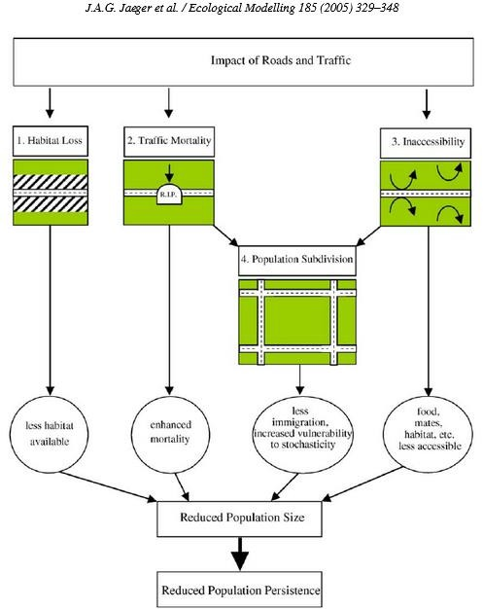This behavior was most often observed in small mammals and hedgehogs, which prefer dense vegetation and avoid exposed areas.

Avoidance of traffic emissions was primarily seen in birds, particularly regarding road noise. Songbirds were the most impacted by road noise. Fahrig and Rytwinski (2009) discussed how songbirds avoided roadways due to the masking effect of road noise, leading to reduced populations in those areas. Car avoidance was based upon an animal’s ability to move out of the way of an incoming vehicle. It was found in Jaeger et al., (2005)

that black bears have been able to learn to

cross roads by avoiding traffic. *Figure 1: Impacts of Roads and Traffics on wildlife*

*populations (Jaeger et al. 2005)*

A key overlap in these papers is that the behaviors noted fall mainly into two negative categories of responses to roadways. First is the barrier effect, where a species is unwilling or otherwise incapable of attempting a road crossing. For example, small mammals discussed in Fahrig and Rytwinski (2009) experience a barrier effect due to the road surface being inhospitable due to lack of shelter from predators. The second is the roadkill effect, where a species is willing to attempt a road crossing but unsuccessful. Reptiles and amphibians, for instance, enter roadways either for thermoregulation purposes or to move between bodies of water such as drainage ditches or riparian areas.

It should be noted that some species fall into another, positive category, listed by Fahrig and Rytwinski (2009). These are species attracted to roads but are relatively able to avoid traffic, such as carrion birds like golden eagles, vultures, and ravens, which routinely consume roadkill. While roadways can provide a positive response to a species overall, that does not mean there isn’t a negative impact to individuals of a species. Slater, Maloney, and Taylor (2022) recorded 2,146 golden eagle-vehicle interactions at 58 carcasses during the winters of 2016, 2017, 2018, and 2019 and determined that moving a carcass 12m from the roadway resulted in a 4-fold decrease in flushing and negative vehicle interactions.

In addition to noise, artificial light and car emissions can impact the behavior and movement of species across roadways. Artificial light has been shown to impact the navigation ability of some species and affect bird songs. It also attracts invertebrates, which can increase the roadkill of insectivorous species. Vehicle emissions have also been found to negatively impact sensitive invertebrate species reducing pollination services (Ryalls et al., 2022).

## Noise

Noise is described in the WSDOT Biological Assessment as the movement of an object creating an air wave that is registered as sound when it reaches the ears of an animal. Noise is

measured in decibels (dB) through the equation (𝑑𝐵 = 20 ∗ log ( 𝑃𝐼 )) with PI being noise

Pr ⬚

pressure and Pr being reference pressure. On the logarithmic scale that decibels are measured, every 10 dB doubles the sound. The pressure waves that create noise decrease in intensity over distance, this is known as attenuation, reduction in decibel level per doubling of distance from the source.

The source that creates noise is categorized as either point source or line source. Point source noise is associated with a source that remains in one place for an extended period. This is mainly used to categorize construction equipment such as jackhammers and excavators, but a single traveling car is also considered a point source. Noise from a point source spreads out, creating a dome effect with a standard reduction of 6 dB per doubling distance.

Line source noise is associated with a series of moving objects along a linear corridor, such as highway traffic. Road noise, a form of line source noise, spreads cylindrically along the length of the line. The standard reduction for line source noise is 3 dB per doubling distance.

Road noise originates from a series of cars or trucks traveling in a straight line down a highway, creating a cylinder of noise that expands from the length of the line traveled. Table 7.3 from the

WSDOT BA manual outlines typical noise levels for traffic based on number of vehicles per hour traveling at a specific speed (Table 1).

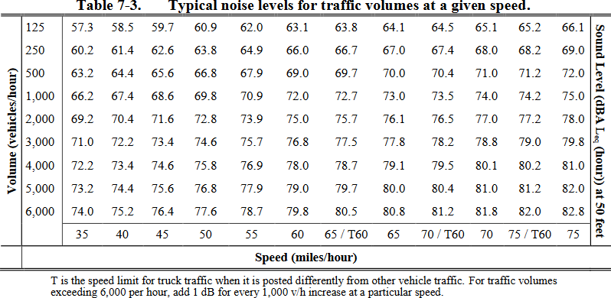

*Table 1: WSDOT BA Manual typical noise levels for traffic rates at a given speed (Washington*

*State Department of Transportation, 2023, Biological Assessment Handbook, Chapter 7).*

Noise is impacted by soft sites and hard sites. A hard site is where noise travels away from the source across reflective ground, such as hard packed soil, concrete, or water. In these conditions, the ground does not provide any attenuation to the noise. A soft site is where there is attenuation based on unpacked earth, ground cover, or topography that does not amplify noise. A break in the line of sight from the noise source either through vegetation or topography provides additional attenuation. Factors such as ambient humidity, temperature, and weather all impact noise attenuation. Background noise differs significantly from location to location due to site specific factors.

## Road Noise as a deterrent

Different species have varying sensitivity to noise and different methods of hearing. Responses to noise are complex and depend upon on a variety of factors such as noise level, frequency, distance, event duration, frequency of noise events over time, slope, topography, weather conditions, exposure to similar noises, hearing sensitivity, reproductive status, time of day, behavior during noise event, and location relative to noise (Delaney and Grubb 2003). Each species has a unique threshold distance, the known distance where noise at a given level elicits some response from a target species (WSDOT BA Manual, 2020). Threshold distance responses can be as little as a head turn or even being flushed from a nest in response to a noise event.

Road noise has been shown to cause a variety of impacts. First, increasing the perceived risk of predation but also providing protection from disturbance-sensitive predators (Shannon et al., 2014). Second, increasing stress in both prey and predator species. Third, impacting the ability of species to hear other individuals of the same species as well as the ability to hear predators. And fourth, significant amounts of noise can cause temporary to permanent hearing loss (Parris, 2015). Disturbance-sensitive predators such as cougars (*Puma concolor*) have been shown to avoid high traffic roadways (Banefield et al., 2020).

## Raccoon and Coyote Urbanization

Raccoons have shown a unique ability to adapt to the urban environment (Prange et al., 2003). As generalist mammals, they have shown a high level of intelligence, including innovation, learning, and inhibitory control (Daniels et al., 2019). Their significant behavioral flexibility that has allowed them to integrate into the urban environment in ways that other species have struggled, including changes in diet and home range size compared to non-urban populations (Bozek et al., 2007; McKinney, 2002). This level of flexibility in habitat, diet, and

behavior is also seen in urban coyote populations (Gehrt et al., 2009; Quinn, 1997). Additionally, coyotes in an urban setting have been shown to be genetically distinct from non-urban populations (Adducci et al., 2020).

In the last 120 years, coyotes have expanded their geographic range by 40% and are now the largest carnivore throughout most of the Eastern United States. In the Western United States, specifically Washington State, the size and prey of coyotes is limited due to the presence of other large carnivores, such as wolves and cougars (Jensen et al., 2022). Coyotes have demonstrated a high level of plasticity in their behavior, social ecology, and diet, which has allowed them to thrive in the urban environment in ways other carnivores have not (Gese and Bekoff, 2004).

Both raccoons and coyotes are found to be in high densities in urban environments, often taking advantage of human-built structures for denning. Raccoons have shown a fondness for denning in sewers, attics, and buildings (Bozek, 2007), while coyotes exhibit similar behaviors and den in culverts, vacant lots, overgrown areas such as blackberry brambles, and even under porches (Urban Coyote Initiative). They have also been shown to consume anthropogenic food sources, with remnants of garbage and non-native foods being found during fecal analysis for both coyotes and raccoons (Bateman and Flemming, 2012; Bozek et al., 2007).

## Coyote and Raccoon Diet

Raccoons have a unique diet characterized by its variability. Non-urban populations of raccoons have diets that vary significantly based on habitat and seasonal availability, ranging from primarily plant and invertebrate based in forest settings to marine invertebrates and fish in coastal marine populations. They have also been found to consume eggs from diamond backed terrapins, spiny-tailed iguanas, American crocodiles, and sea turtles (Hoffman and Gottschang, 1977). In an urban setting, their diets are less impacted by seasonal availability and consist

mainly of anthropogenic resources such as pet food and food waste, supplemented by lagomorphs, rodents, and additional plant materials (Hoffman and Gottschang, 1977).

Jensen et al. (2022) found that a coyote’s diet largely depends upon its size, with larger coyotes consume larger prey animals. However, a majority of their diet consists of small mammals, lagomorphs, vegetation, and ungulates. Anthropogenic food sources have been shown to increase the likelihood of generalist carnivore presence in the urban environment (Johnson- Ulrich and Holekamp, 2022). Coyotes are also known to regularly consume house cats (Krug, 2022) and take advantage of other anthropogenic food sources such as pet food and garbage (Havrad, 2022; Quinn, 1997).

There is significant overlap in the diets of both coyotes and raccoons. Primary food sources for both species mainly consist of rodents, small mammals, lagomorphs, plant material such as fruit, and anthropogenic resources such as pet food. Additionally, raccoons are also a dietary component of coyotes, particularly urban coyotes. The main difference between the diets is the consumption of ungulates by coyotes, though more research is needed to determine the extent of ungulate roadkill consumed by coyotes (Lange, 2011).

## Conclusion

A majority of roadkill in Washington state is made up of ungulates, specifically deer including white-tailed deer, black-tailed deer, and mule deer. Elk also contribute to roadkill, but to a smaller degree (Figure 2). This is closely followed by raccoons and coyotes, suggesting that these species frequently interact with roadways. As discussed by Fahrig and Rytwinski (2009), ungulates fall into the category of species that have a negative relationship with roadways due to having large home ranges. As migratory species, they are often pushed to cross roadways to move between habitat cores, find adequate food, and for reproductive purposes. This negative

relationship is likely due to their size, behavior as a prey species (freeze and flight before fight), and herd-based movement, resulting in more individuals being struck. Additionally, their size makes them a risk on the roadway after being struck, leading to a higher likelihood of collection or reporting to road maintenance crews, which may skew the data towards a higher collection rate.

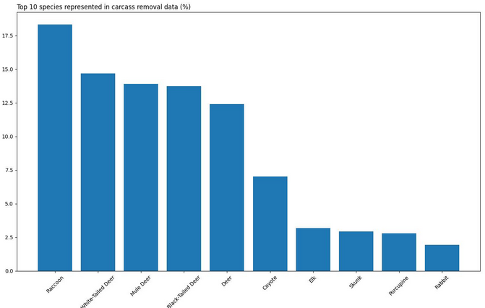

*Figure 2: Graph showing top ten species in carcass removal data from the WSDOT carcass removal database 2017-2022 (Stone, 2023)*

This is in contrast with coyotes, which are a mid-sized species categorized as likely having a positive relationship with roadways. There is a gap in population studies of coyotes, as they are often seen as nuisance animals. Similarly, limited studies have been conducted on urban

raccoon population sizes, with most research focusing on disease transmission, such as rabies (Ripley et al., 1998).

As detailed in this literature review, raccoons take advantage of and thrive in urban environments, even developing different behaviors (Bateman and Flemming, 2012). The diet of urban raccoon populations shows significant changes in both composition and seasonality compared to non-urban populations (Hoffman and Gottschang, 1977). Additionally, raccoons utilize anthropogenic structures such as sewers, attics, and buildings for denning (Bozek, 2007). However, there is a lack of understanding regarding how raccoons utilize or interact with roadways. This gap in research highlights the need for studies focused on how specific species are impacted by roads.

This is seen similarly in urban coyote populations, which are genetically drifting from non-urban populations (Adducci et al., 2020). The diet of coyotes differs between urban and non- urban populations, with fecal analysis showing an inclusion of garbage, non-native foods (Havrad, 2022; Quinn, 1997), and house cats (Krug, 2022). There is strong evidence that the presence of anthropogenic food sources increases the likelihood of generalist carnivore presence in urban environments (Johnson-Ulrich and Holekamp, 2022). With fecal analysis, it is difficult to determine if a species was hunted and consumed or if it comes from roadkill or scavenge. This could explain the gap in understanding of what percentage of coyote diets are made from roadkill (Lange, 2011).

This lack of understanding of both raccoon and coyote diets, as well as how and why they interact with roadways, are questions this thesis aims to provide insight into. Both species constitute a significant percentage of roadkill collected along Washington State Highways, yet little is known about the reasons behind these occurrences. Could it be that coyotes and raccoons

are present along roadsides seeking food, or are they there by happenstance due to their proximity and use of the urban landscape? As urban thrivers, they are less likely to be impacted by road noise or see it as a deterrent and may be struck by vehicles due to unknown factors. This thesis seeks to explore these possibilities and provide a clearer understanding of the behaviors and risks associated with these species in and out of the urban environment.

# Methods and Data:

## Carcass removal data

Carcass removal data is collected by WSDOT maintenance staff during the removal of a dead animal from the highway and recorded in the Carcass Removal Database. The focus species of this study are coyotes *(Canis latrans*) and raccoons (*Procyon lotor*) with the addition of four ungulate species: White-tailed deer (*Odocoileus virginianus*), Columbian black-tailed deer

(*Odocoileus hemionus columbianus*), Rocky Mountain mule deer (*Odocoileus hemionus*

*hemionus*), and Rocky Mountain elk (*Cervus canadensis nelsoni*). An additional category was included for deer carcass removals which include removals where species was unable to be identified. Elk and deer are included in the data set studied as coyotes and raccoons are both scavengers and coyotes are known to hunt ungulates. Additionally, ungulates make up much of the roadkill collected by WSDOT maintenance crews (Figure 3).

For this study I used carcass removal data from the WSDOT Carcass Removal Database and selected the years 2015-2019. In 2015, WSDOT maintenance crews were given iPads to facilitate the recording process of carcass removals, resulting in an increase in reports, species details, and accuracy of removals. Prior to the introduction of iPads, data collection was done by hand and reported after collecting, resulting in less complete data. The years after 2019 are excluded from the dataset as the COVID pandemic impacted traffic levels worldwide and, as a result, reduced the number of vehicle-animal collisions on roadways and limited the number of individuals working in maintenance and on road crews. Removals lacking coordinates were approximated through Python by referencing the WSDOT mileposts values data to the nearest tenth milepost. Due to errors in collecting data in the field, carcass removals with incorrect

mileposts or roadway data were removed automatically through the WSDOT carcass removal database web app during download.

## Highways, State routes, and Mileposts

This study is limited to Washington State highways and State Routes, excluding county and private roadways. Carcass removal data is limited to Highways and State Routes. The roadways used in ArcGIS come from the WSDOT GIS database. The lack of carcass removal data within cities on private and county roads is due to local animal control and waste management collecting disposing of carcasses. Due to the scale of this study, it is not feasible currently to contact local agencies to collect carcass removal data outside of Washington State routes and highways.

## Traffic, Background Noise, and Speed Limits

Road noise was determined using WSDOT Biological Assessment noise guidelines. Due to the limitations of this study, traffic makeup was set to the default guidelines of 90% light vehicle and trucks, which include standard passenger vehicles, 6% medium trucks, and 4% heavy trucks and modeled at 50ft from the source (Table 1). Background noise is excluded from this study as road noise will attenuate within one mile based upon WSDOT guidelines for soft site noise attenuation (Washington State Department of Transportation, 2023, Biological Assessment Handbook, Chapter 7). The WSDOT BA manual classifies a soft site as areas where ground cover such as vegetation is present between the source of the noise and the receptor. As both coyotes and raccoons do not exceed 22in in height on average, all sites within range of coyote or raccoon can be classified as soft sites based upon ground cover and natural behaviors limiting the amount of exposure each species has to large, open areas of impervious surface such as airports and open bodies of water.

Traffic rate data was collected from the 2019 WSDOT Highway Traffic Report Historic Traffic Counts to provide the most accurate match to the range of this study. Speed limit data was provided by WSDOT upon request and was dated to 2022 but significant changes in speed limits have not occurred during the years of this study.

## Data Management

Data was maintained in Excel, analyzed in Python version 3.12.2 and JMP version 18 and then visualized in ArcGIS Pro. Carcass removal data locations were obtained from a database (WSDOT Carcass Removal Database) and displayed using geographic information system (ArcGIS). Sound data was constructed by using typical noise levels for traffic rates at a given speed provided in the Biological Assessment Handbook Chapter 7 (Table 1), and traffic data provided in the 2019 WSDOT Highway Report. Speed limit data was provided by WSDOT upon request.

## Python Data Processing

### Milepost Data

The milepost data was read from the provided WSDOT dataset (WSDOT_-

_Milepost_Values_One_Tenth_Mile). Columns were selected to include the state route number, 1/10th milepost, direction, longitude, and latitude. The milepost data contains duplicate mileposts based on the direction or side of the roadway. The “I” and “D” in direction column refers to “increasing” and “decreasing” mileposts respectively indicating the direction of north to south and east to west for increasing for the “I” direction and south to north and west to east for the “D” direction. Data was filtered to keep only the “I” direction referring to “increasing” along the state route. This reduced the data set down by half but did not change the location of each milepost, merely standardized them to a given longitude and latitude column. Milepost

measurements were then rounded to the nearest tenth of a mile to match the format of the speed limit, carcass removal, and traffic rate data (Appendix 1, Section 1).

### Speed Limit Data

Speed limit data was read from WSDOT provided dataset (WSDOT_-

_Roadway_Data_Speed_Limits). Relevant columns selected included state route number, beginning state route milepost, end state route milepost, and speed limit. The state route number was parsed to extract route number as several state routes had unique identifiers based upon intersections that are not relevant to this study. Speed limits were then assigned to each milepost based on intervals between changes in speed limit (Appendix 1, Section 2).

### Traffic Rate Data

Traffic rate data was read from WSDOT provided dataset (WSDOT_-

_Historic_Traffic_Counts_2019) in the terms of annual average daily traffic (AADT). Columns for state route number, location, and AADT were selected. Milepost locations were extracted from the “location” column due to field data collection requiring collection at, before, or after mileposts, by extracting mileposts the location was approximated to the nearest stated milepost. Duplicate entries for the same route-milepost combination were resolved by retaining the maximum AADT value (Appendix 1, Section 3).

### Road Noise (dB) Data

Road noise, indicating average decibels produced by vehicles at a given speed and traffic rate, was read in from a complied dataset from Typical Road noise Levels provided in the Biological Assessment Manual, Chapter 7 (Table 1). Columns for speed, rate (VH), and decibels (dB) were selected. Sound levels were then assigned to each milepost by matching traffic rates and speed limits to the closest value in the dataset (Appendix 1, Section 4).

### Carcass Removal Datasets

Carcass removal data for the various species in this study including black-tailed deer, white-tailed deer, deer (unspecified), elk, raccoons, and coyotes were read from separate datasets (WSDOT_-_carcass_removal_data_search) downloaded from the WSDOT Carcass removal Database. Columns selected were state route number and milepost. Milepost measurements were rounded to the nearest tenth mile to approximate location and match the other datasets (Appendix 1, Section 5).

## Data Integration

### Merging Datasets

Milepost and speed limit datasets were merged based on state route number and milepost (Appendix 1, Section 6). Traffic rate was merged similarly (Appendix 1, Section 7). Road Noise (dB) data was merged based on the closest matching traffic rate and speed limit (Appendix 1, Section 8).

### Carcass Aggregation

For each species, carcass data was aggregated to count the number of strikes of each species at each milepost location. Locations without carcass removals were removed. These counts were then merged into a single dataset with each row representing a milepost location and the corresponding counts of carcasses for each species (Appendix 1, Section 9).

### Final Preparation

All datasets were merged into a single data frame. Null values for carcass removals were replaced with zeros to indicate no recorded removals for that particular species. This resulted in a dataset containing milepost locations including state route number, speed limits, traffic rates, road noise (dB), and carcass removal counts for each species (Appendix 1, Section 10).

## ArcGIS Visualization and Hotspot Analysis

These datasets were then loaded into ArcGIS and converted into points using the XY Table to Point function. From there they were merged to create noise and carcass feature classes to prepare for analysis. A heat map was created by symbolizing the point data into a gradient using the heat map function to show average road noise (dB) (Figure 3), rate (vehicles per hour per day) (Figure 4), and carcass removals for coyote (Figure 5), and raccoons (Figure 6).

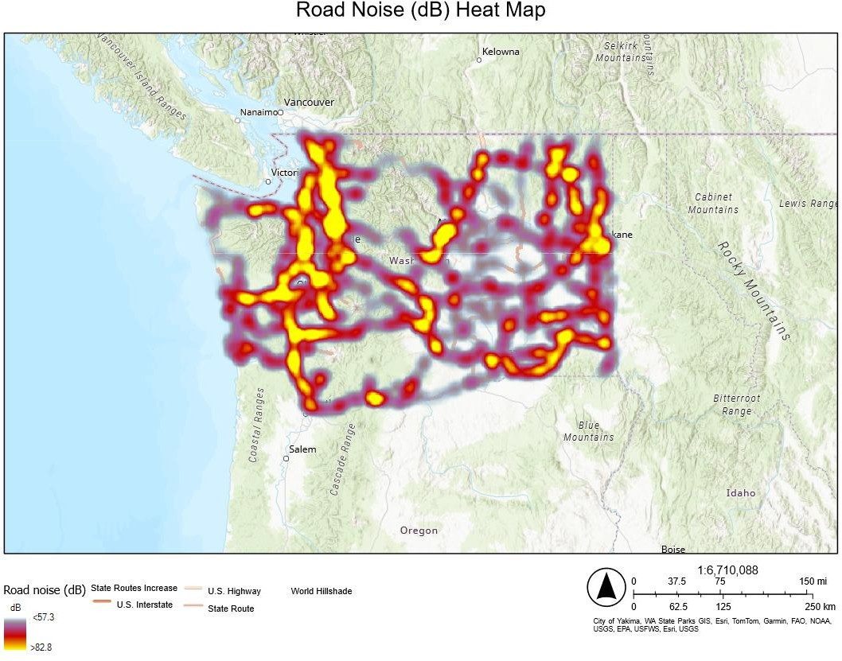

*Figure 3: Heat map showing average road noise (dB) in decibels on Washington*

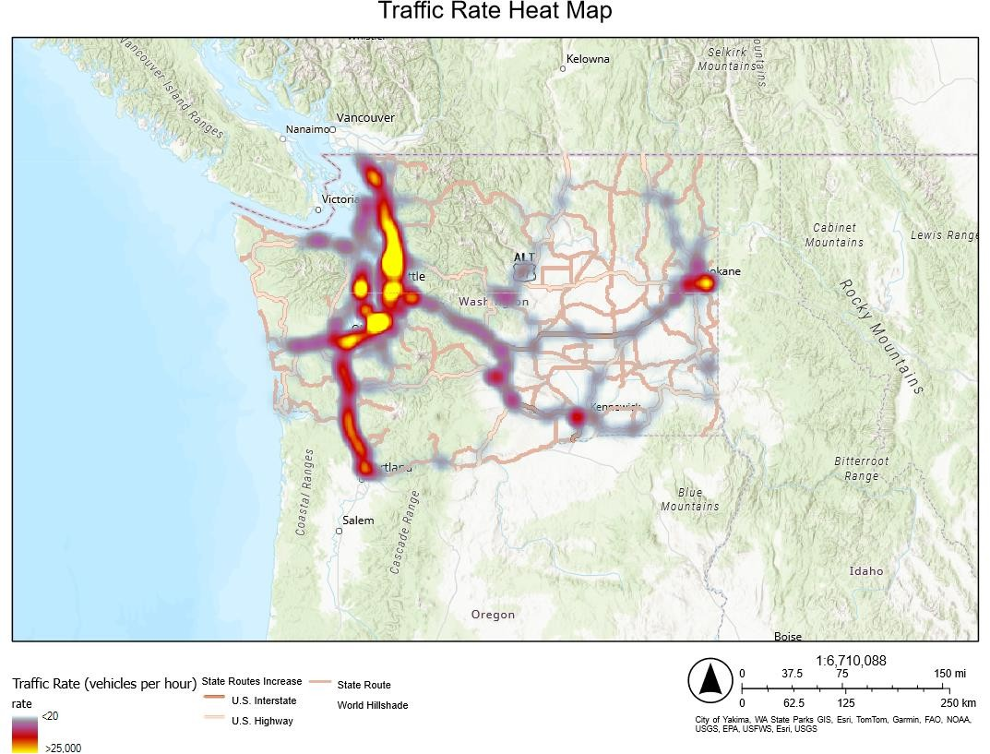

*Figure 4: Heat map showing traffic rate (vehicles per hour) on Washington State*

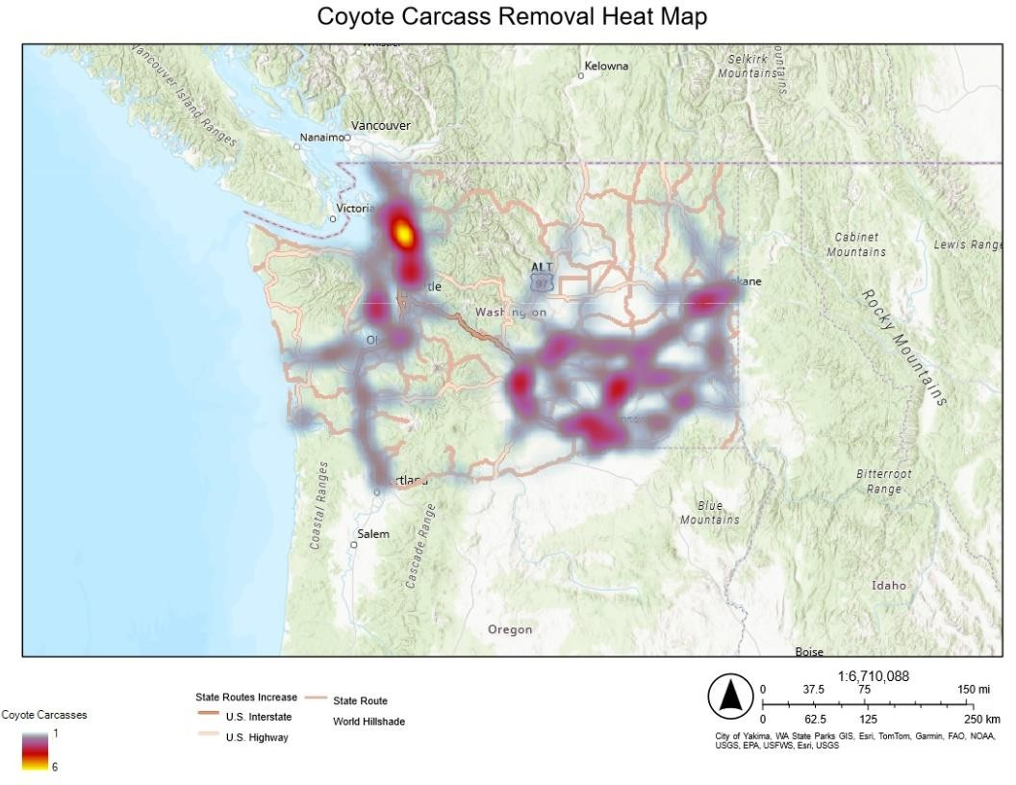

*Figure 6: Heat Map showing concentration of raccoon carcass removals on Washington State Highways*

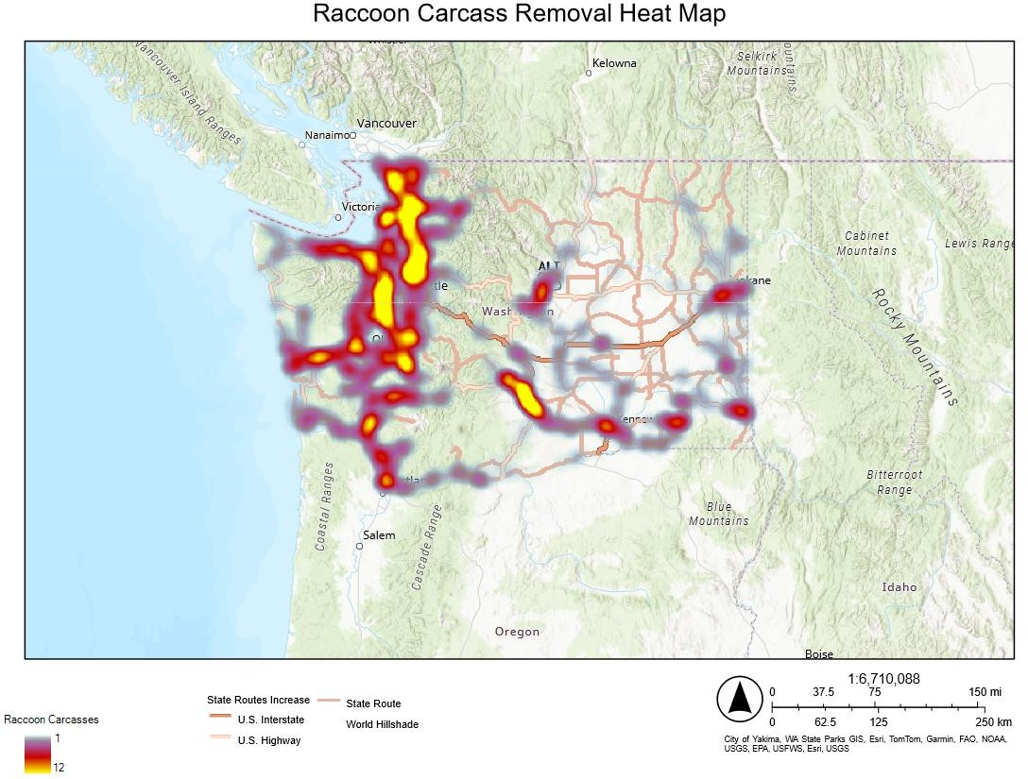

*Figure 5: Heat Map showing concentration of coyote carcass removals on Washington State Highways*

To explore the associations between coyote carcass removals and other species, a hot spot analysis was completed on coyote carcasses along with the other species within and then a Hot Spot comparison analysis was run (Figure 7). This was then repeated for raccoons (Figure 8).

Hot spot analysis was then completed and analyzed through ArcGIS (Appendix 2). Each hot spot was then analyzed using the summary statistics function to determine the average GiPValue Fixed and GiZScore Fixed to determine overall significance.

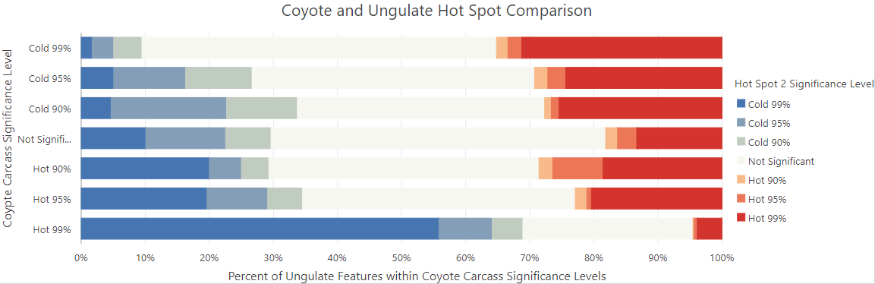

*Figure 7: Coyote and Ungulate Hot Spot Comparison. This chart compares the percentage of prey hot spot features within coyote hot spot significance levels, illustrating that significant*

*overlaps occur primarily in cold spots, indicating low activity areas for both coyotes and ungulates.*

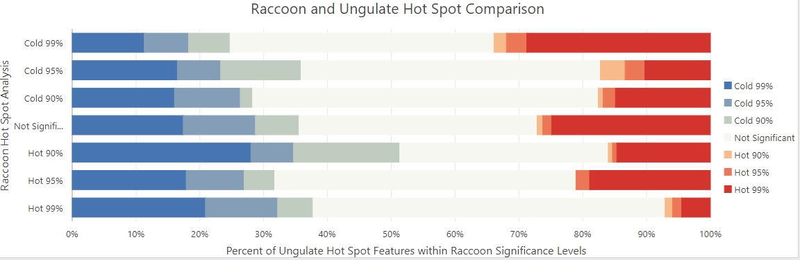

*Figure 8: Raccoon and Ungulate Hot Spot Comparison. This chart compares the percentage of*

*ungulate hot spot features within raccoon hot spot significance levels, illustrating that significant overlaps occur primarily in cold spots, indicating low activity areas for both coyotes and*

*ungulates.*

Hotspot analysis is a statistical technique used to determine significant clustering of high or low values within a spatial dataset. In this study, coyote and raccoon carcasses were examined using each milepost and state route location identifier to determine the number of strikes per given area, creating count data. This count data was visualized in a hotspot analysis to identify statistically significant clusters of strikes in each area. This method helps to reveal areas with a higher or lower frequency of carcass removals, indicating potential hotspots for wildlife-vehicle collisions.

The GiPValue Fixed, also known as the Getis-Ord Gi* statistic with a Fixed Distance Band, calculates a p-value for the selected feature in the dataset based on the values of its neighbors within a fixed distance band. In this study, the fixed distance band was set to within 1

U.S. survey mile. The GiZScore, on the other hand, uses a variable distance band to calculate a z-score for each feature, considering both the values and distances to its neighbors. This method auto-adjusts the distance band for each feature based on the average distance between points, allowing for more flexibility in detecting spatial clusters. This approach provides a nuanced understanding of clustering patterns by adapting to local variations in feature distribution.

# Results

## Hot Spot Analysis

Hotspot analysis of coyotes and average road noise (dB) per milepost was statistically insignificant (GiPValue = 0.11, GiZScore = 0.11), indicating that average road noise (dB) likely does not impact the presence of coyote strikes along Washington State routes. Additionally, hotspot analysis of coyote strikes compared to traffic rate yielded similarly statistically insignificant results (GiPValue = 0.11, GiZScore = 0.86). This suggests that neither road noise nor traffic rate significantly affects the occurrence of coyote strikes on roadways. However, significant clusters of coyote carcasses were identified in specific areas, such as along the I-5

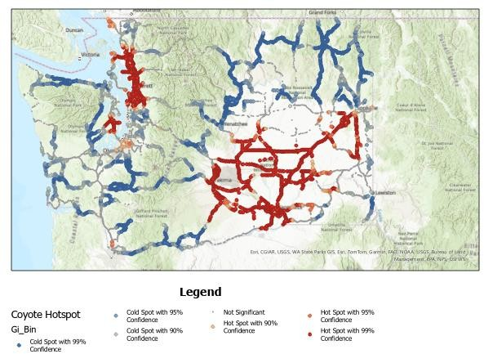

*Figure 9: Hot Spot Analysis of Coyote Carcass Removals in Washington State. The map illustrates significant clustering of raccoon carcass removals, with red dots indicating hot spots and blue dots indicating cold spots. Hot spots are areas with a high concentration of carcass removals, while cold spots have lower*

*concentrations.*

corridor north of Seattle and the Columbia National Wildlife Refuge. These clusters likely indicate regions with higher coyote populations (Figure 9).

This analysis was repeated with raccoons (Figure 10). The results indicated slightly more clustering around areas of high noise for raccoons (GiPValue = 0.08, GiZScore = 1.1), but this still lacks strong statistical significance, suggesting that there is little to no relationship between road noise and the likelihood of raccoon strikes. Additionally, the hotspot analysis of coyote carcasses in comparison to those of other species also yielded statistically insignificant results (GiPValue = 0.1, GiZScore = 0.1). This indicates that there is no significant relationship between the presence of coyotes and other species along roadways. Furthermore, the hotspot analysis of strike rates among the different species also resulted in statistically insignificant findings

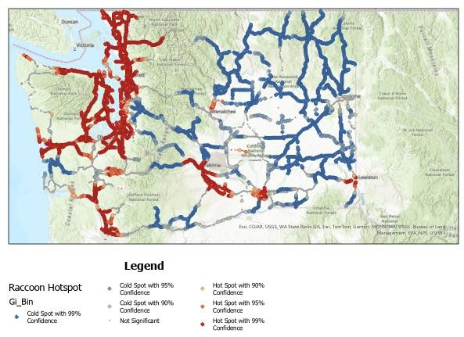

*Figure 10: Hot Spot Analysis of Raccoon Carcass Removals in Washington State. The map illustrates significant clustering of raccoon carcass removals, with red dots*

*indicating hot spots and blue dots indicating cold spots. Hot spots are areas with a high concentration of carcass removals, while cold spots have lower concentrations.*

(GiPValue = 0.1, GiZScore = 0.1), reinforcing the conclusion that there is no substantial correlation between the tested variables and the observed patterns of roadkill.

The measurement of statistical significance, as indicated by the GiZScores and GiPValues, quantifies the likelihood that observed results occurred by random chance. In the context of this study, the observed GiZScores and GiPValues for both raccoon and coyote carcasses compared to average road noise (dB) and the presence of other carcasses indicate that the tested variables show an insignificant or negligible relationship. Specifically, the GiPValues and GiZScores for raccoon carcasses (GiPValue = 0.08, GiZScore = 1.1) and coyote carcasses (GiPValue = 0.11, GiZScore = 0.11) relative to average road noise (dB), as well as for coyote carcasses compared to those of other species (GiPValue = 0.1, GiZScore = 0.1), suggest that any observed clustering is likely due to random chance rather than a significant underlying pattern. This implies that factors such as road noise and the presence of other species do not significantly influence the distribution of raccoon and coyote carcasses along roadways.

Garrah et al. (2015) conducted a similar study using ArcGIS Getis-Ord analysis with road segment lengths of 100, 200, 500, and 1000 meters along the 1000 Islands Parkway in southeastern Ontario, Canada, to determine the magnitude and hot spot locations for road mortality in various species. Their study revealed time-dependent hot spot locations, indicating that road mortality patterns can vary significantly over time.

While this thesis excludes time data and instead focuses on hot spot analysis for a set number of years (2015-2019), the results from Garrah et al. (2015) suggest that hot spot analysis provides valuable insights into areas requiring more mitigation strategies to prevent animal- vehicle collisions. Although the observed GiPValues and GiZScores in this study are statistically insignificant in determining why coyotes and raccoons are being struck in these areas, they do

highlight specific locations that require further examination and mitigation strategies. This indicates that hot spot analysis can still be useful in identifying critical areas for intervention, even when direct causal factors are not immediately apparent.

### HotSpot Comparison

The comparison between coyote hotspot analysis and average road noise (dB) per milepost (Figure 11) indicates that statistically significant clusters exist where both datasets intersect. However, the stronger presence of overlaps in cold spots suggests that areas with low road noise also have low coyote strike activity, highlighting a weak relationship between average road noise (dB) and coyote strikes. This implies that factors other than road noise, such as habitat features and population density, may play a more critical role in influencing the distribution of coyote strikes.

Similarly, the analysis of coyote carcass removals and traffic rate (vehicles per hour) shows a weak relationship (Figure 12). Significant overlaps occur primarily in cold spots for both coyotes and traffic rate with overlap in hot spots being insignificant.

Additionally, there is sparse overlap in the comparison for coyote strikes and speed limit (Figure 13). Significant overlaps are mainly seen in cold spots with minimal, insignificant overlap in hot spots. These findings collectively suggest that while traffic rate, road noise, and speed limit contribute to vehicle-animal collisions, there are other ecological factors that may be more influential in determining coyote strike distribution. Furthermore, a similar relationship is observed between coyote carcass removals and ungulate carcass removals (Figure 14). Overlap is predominantly in cold spots with limited overlap in hot spots, indicating that areas with low ungulate carcass activity also tend to have low coyote strike activity.

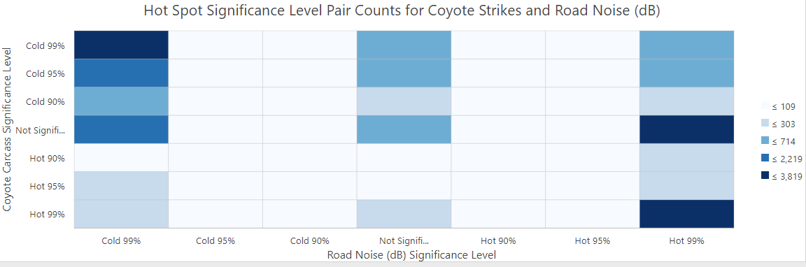

*Figure 11: Hot Spot Significance Level Pair Counts for Coyote Strikes and Road Noise (dB). The chart shows a weak correlation, with low road noise areas having low coyote strike activity, and minimal significant overlaps in hot spots.*

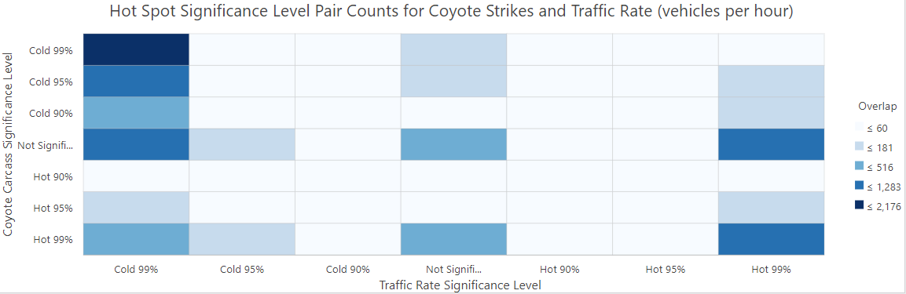

*Figure 12: Hot Spot Significance Level Pair Counts for Coyote Strikes and Traffic Rate (vehicles per hour). The chart shows a weak correlation, with low traffic rate areas having low coyote*

*strike activity, and minimal significant overlaps in hot spots.*

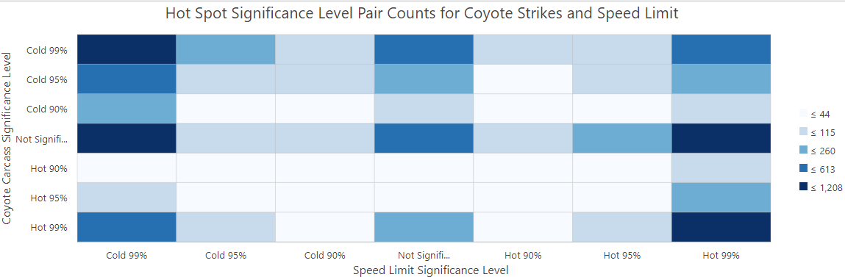

*Figure 13: Hot Spot Significance Level Pair Counts for Coyote Strikes and Speed Limit. The*

*chart shows a weak correlation, with significant overlaps primarily in cold spots, indicating low speed limit areas also have low coyote strike activity. Minimal significant overlaps in hot spots suggest speed limits have little impact on coyote strikes.*

29

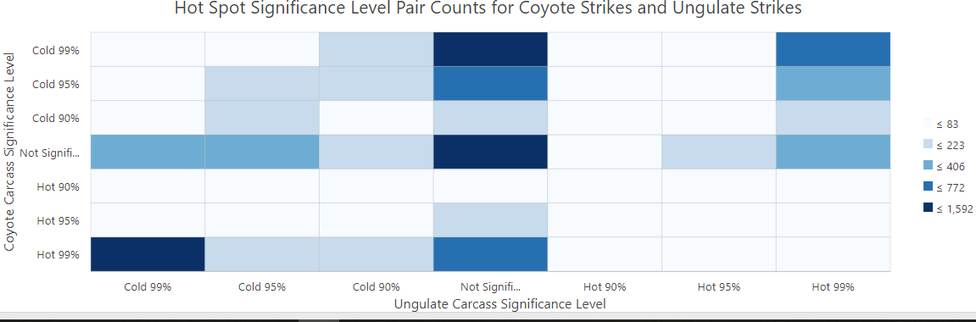

*Figure 14: Hot Spot Significance Level Pair Counts for Coyote Strikes and Ungulate Strikes. The*

*chart shows a strong correlation in cold spots, indicating that areas with low ungulate carcass activity also have low coyote strike activity. Overlaps in hot spots are less common, suggesting limited impact of ungulate strikes on coyote strikes.*

The relationship between raccoon strikes and various factors, including road noise, speed limit, traffic rate (vehicles per hour), and ungulate carcass removals, shows similar patterns to coyote strikes. The comparison with road noise revealed a more significant overlap in hot spots between raccoon strikes and higher noise levels, suggesting some influence of road noise on raccoon strikes (Figure 15). The hotspot analysis of raccoon strikes and speed limit (Figure 16) indicated little to no relationship, similar to the findings for coyote strikes. This pattern is consistent in the comparisons with traffic rate (Figure 17) and ungulate carcass presence (Figure 18), neither of which showed a significant relationship with raccoon strikes.

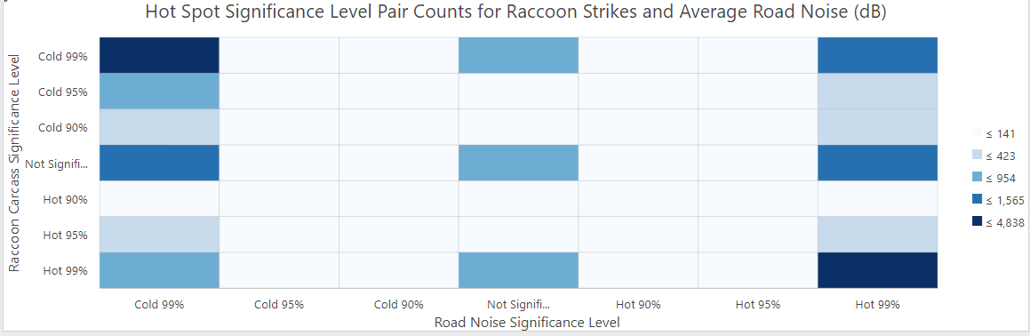

*Figure 15: Hot Spot Significance Level Pair Counts for Raccoon Strikes and Average Road*

*Noise (dB). The chart illustrates a strong correlation in cold spots, indicating areas with low road noise also have low raccoon strike activity, while significant overlaps in hot spots suggest some influence of road noise on raccoon strikes.*

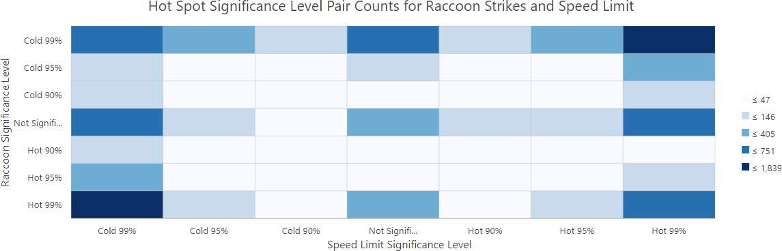

*Figure 16: Hot Spot Significance Level Pair Counts for Raccoon Strikes and Speed Limit. The*

*chart shows a weak correlation, with significant overlaps primarily in cold spots, suggesting that lower speed limit areas have lower raccoon strike activity and minimal significant overlaps in*

*hot spots.*

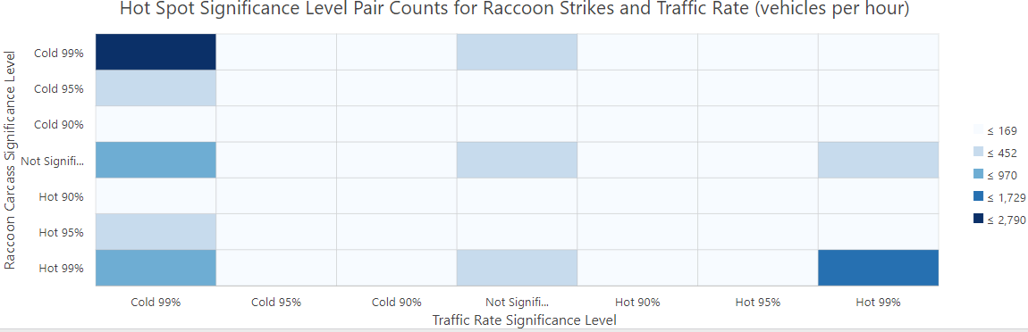

*Figure 17: Hot Spot Significance Level Pair Counts for Raccoon Strikes and Traffic Rate*

*(vehicles per hour). The chart indicates a weak relationship, with significant overlaps mostly in cold spots, showing that areas with low traffic rates have lower raccoon strike activity.*

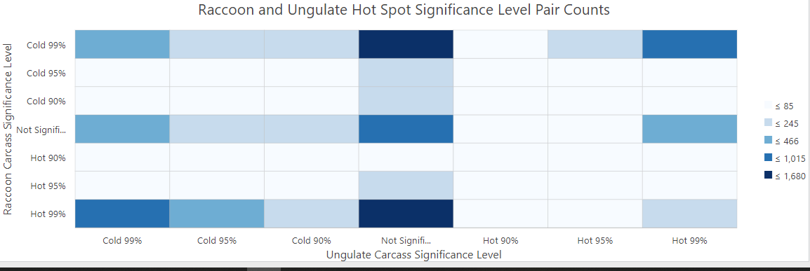

*Figure 18: Raccoon and Ungulate Hot Spot Significance Level Pair Counts. The chart*

*demonstrates a strong correlation in cold spots, suggesting areas with low ungulate carcass activity also have low raccoon strike activity, with limited overlaps in hot spots indicating minimal impact of ungulate carcass activity on raccoon strikes.*

# Discussion

After completing hot spot analysis of roadkill data collected by WSDOT maintenance teams, coyotes and raccoons do not appear to be significantly impacted by road noise or the presence of other species carcasses throughout Washington State roadways, despite both being known scavengers who use roadways and consume roadkill. The lack of association with road noise and presence of a food source (carcasses) suggests that there are other factors to be analyzed to determine why these species make up a significant portion of roadkill collected by WSDOT between 2015 and 2019.

There are limitations to the use of ArcGIS Getis–Ord hot spot analysis. As discussed in Garrah et al., (2015), hot spot analysis is employed to determine areas of point clustering with statistically high significance, meaning areas of clusters that are determined to not be random.

In this thesis, areas of highly significant clustering were found in both species being analyzed suggesting that their distribution throughout Washington State roadways is not a random occurrence and that those areas require further investigation.

As raccoons and coyotes are both found in urban and exurban areas (Bozek, 2007), it is likely that these species could be struck incidentally while crossing roadways between habitat cores. Research into behavior, habitat use, and other food sources will likely yield more information as to why they are placed in danger. There is a lack of research on current raccoon and coyote urban and non-urban population dynamics. It is possible that urban populations are coming into contact more frequently with roads and therefore vehicles. This would align with the hot spot analysis completed in this study for raccoons, showing the most significant areas of clustering are around the I-5 corridor and Highway 101 (Figure 10).

Additionally, an analysis of the presence and availability of crossing structures, such as overland crossing bridges or culverts, could explain these results. If there is a lack of safe crossing areas along these roadways, raccoons and coyotes may be more frequently entering roadways to cross, increasing their risk of vehicle collisions. Understanding these dynamics and improving safe crossing structures could help mitigate the dangers these species face on roadways.

Coyotes now occupy almost all habitat types and locations, with the exclusion of alpine and subalpine areas (<https://wdfw.wa.gov/species-habitats/species/canis-latrans>). The spatial

distribution of coyote carcass removals found in this study indicates that there is a significant population of coyotes found in Eastern Washington on the Columbia Plateau that are at risk of vehicle strikes. This area warrants further study for the possible inclusion of crossing structures and other mitigation factors.

These species were also selected for this study based upon size; they are more likely to be spotted by carcass removal teams or pose a danger to vehicles if left in the roadways. Their contribution to overall carcasses collected could also be based upon this factor meaning they are not being struck more frequently but are more frequently collected than other species. This could be similar amongst ungulates due to their size and habitat ranges.

# Conclusion

This thesis explored the complex interactions between two mesocarnivores in Washington State with several variables such as presence of ungulate carcasses, traffic rate (vehicles per hour), and average road noise (dB) produced at each milepost. Several key insights have been produced throughout the course of this study which further inform our understanding of these complex interactions. These insights can also help improve our understanding of the dynamics of wildlife-vehicle interactions throughout Washington State roadways.

First, raccoons and coyotes demonstrate remarkable adaptability to the urban environment. This includes their abilities to utilize urban structures for denning and habitat (Bozek, 2007; Urban Coyote Initiative). In addition, their astounding use of anthropogenic food sources (Bateman and Flemming, 2012) shows great flexibility in both diet and foraging capabilities. Raccoons have shown significant ability to adapt to urban ecosystems (Prange et al., 2003) characterized by their high level of intelligence and behavioral flexibility (Daniels et al., 2019) which has allowed them to extensively integrate into new environments. This is mirrored in coyotes which not only survive in urban habitats but thrive (Gese and Bekoff, 2004). Both mesocarnivores are now showing distinct behavioral and even genetic changes between urban and non-urban populations (Adducci et al., 2020; Bozek et al., 2007).

Second, despite their clear capabilities to adapt and thrive in the urban ecosystem, they remain vulnerable to collisions with vehicles on roadways. The analysis of carcass removal data collected by WSDOT maintenance teams revealed that these species make up a significant portion of roadkill collected each year.

Third, hotspot analysis further revealed several areas of concern for both species indicating the need for further analysis to determine effective mitigation strategies. Surprisingly,

this study found little to no evidence of a relationship between traffic rate, average road noise (dB), and the presence of other carcasses in concerns to the likelihood of raccoon and coyote carcass removals. This included finding an anomaly in Spokane, Washington (Figure 9). In this area, despite being a major urban center, was shown to be insignificant in concerns to clustering. In general, major urban centers correlate with statistically significant hotspots for carcass removals. A likely reason for this finding is that Spokane County Public Work crews remove dead non-domestic animals from county right-of-way property, thereby limiting the number of carcasses removed and recorded by WSDOT road maintenance teams.

Despite the lack of a strong association between raccoon and coyote carcass removals, traffic rate, and average road noise (dB), it is crucial to understand that these species remain vulnerable to collisions with vehicles leading to roadkill incidents. Understanding the patterns of roadkill, such as the prominence of coyotes and raccoons, is essential for implementing effective mitigation strategies to lessen the negative impacts of roadways on species.

A more in-depth analysis focusing on the hotspot locations, excluding areas without carcass removals for these species, could reveal the cause behind these significant clusters of removals. Factors such as the frequency of road maintenance needed near urban areas or areas of high traffic could result in a higher frequency of carcass removals due to ongoing construction and road upkeep. Roads with higher traffic rates may cause an increase in the frequency of carcasses being reported for removal due to safety concerns. Exploring habitat fragmentation, crossing structure availability, and population densities for these species may influence their roadkill patterns.

Additionally, there are limitations to our ability to quantify the amount of roadkill for any species on a statewide level. Not every carcass is being reported and collected and many of the

roads in Washington State are rural with low traffic rates resulting in a lack of data throughout large portions of the state. There is likely no way to truly know how significantly raccoons and coyotes are being impacted by roadways without advances in studies of their populations. Both species are considered to be nuisance populations with a majority of studies found to be focusing on removal and deterrence from urban and agricultural areas due to their frequent interactions with humans (Poessel et al., 2017).

In conclusion, while coyotes and raccoons have demonstrated remarkable resilience and adaptability to the urban environment, they remain at risk and face ongoing threats from roadway mortality. Understanding the complex interplay between their behavior, ecology, and roadway infrastructure is crucial for developing effective mitigation strategies to prevent further wildlife- vehicle interactions. Incorporating additional studies into transportation planning and management concerning these complex and highly intelligent species is essential to mitigate risks they face integrating into the urban landscape. Human expansion will continue as our population increases, leading to more roads and vehicles, thus increasing the risk of wildlife- vehicle collisions. These species are unique and fascinating in their abilities to adapt and thrive in the urban landscape and deserve consideration as we change the world at an unprecedented pace.

# References:

* 1. Adducci, Anthony, et al. "Urban coyotes are genetically distinct from coyotes in natural habitats." *Journal of Urban Ecology* 6.1 (2020): juaa010.
  2. Banfield, Jeremiah E., et al. "Cougar roadside habitat selection: Incorporating topography and traffic." *Global Ecology and Conservation* 23 (2020): e01186.
  3. Barthelmess, Erika L., and Margot S. Brooks. "The influence of body-size and diet on road-kill trends in mammals." *Biodiversity and Conservation* 19 (2010): 1611-1629.
  4. Bateman, Philip W., and Patricia A. Fleming. "Big city life: carnivores in urban environments." *Journal of Zoology* 287.1 (2012): 1-23.
  5. Bozek, Clare K., Suzanne Prange, and Stanley D. Gehrt. "The influence of anthropogenic resources on multi-scale habitat selection by raccoons." *Urban Ecosystems* 10 (2007): 413-425.
  6. Coffin, Alisa W. "From roadkill to road ecology: a review of the ecological effects of roads." *Journal of transport Geography* 15.5 (2007): 396-406.
  7. Daniels, Sarah E., et al. "Behavioral flexibility of a generalist carnivore." Animal cognition 22 (2019): 387-396.
  8. Dean, W. Richard J., et al. "A review of the impacts of roads on wildlife in semi-arid regions." *Diversity* 11.5 (2019): 81.
  9. Fahrig, Lenore, and Trina Rytwinski. "Effects of roads on animal abundance: an empirical review and synthesis." *Ecology and society* 14.1 (2009).
  10. Forman, Richard TT. "Estimate of the area affected ecologically by the road system in the United States." *Conservation biology* 14.1 (2000): 31-35.
  11. Gehrt, Stanley D., Chris Anchor, and Lynsey A. White. "Home range and landscape use of coyotes in a metropolitan landscape: conflict or coexistence?." *Journal of*

*mammalogy* 90.5 (2009): 1045-1057.

* 1. Havrda, Michael Vladimir. *Carnivore responses to urbanization and human presence along an urban-wildland gradient in western Washington*. University of Washington, 2022.
  2. Hoffmann, Cliff O., and Jack L. Gottschang. "Numbers, distribution, and movements of a raccoon population in a suburban residential community." *Journal of Mammalogy* 58.4 (1977): 623-636.
  3. Jaeger, Jochen AG, et al. "Predicting when animal populations are at risk from roads: an interactive model of road avoidance behavior." *Ecological modelling* 185.2-4 (2005): 329-348.
  4. Jensen, Alex J., et al. "Coyote diet in North America: geographic and ecological patterns during range expansion." *Mammal Review* 52.4 (2022): 480-496.
  5. Johnson-Ulrich, Lily, Zoe Johnson-Ulrich, and Kay E. Holekamp. "Natural conditions and adaptive functions of problem-solving in the Carnivora." Current Opinion in Behavioral Sciences 44 (2022): 101111.
  6. Krug, Bethany. "A comparison of coyote diets in urban and rural habitats in the Piedmont of South Carolina." (2020).
  7. Lange, Karen E. (2011) "Coyotes Among Us," *Serial - All Animals 2009-15*: Vol. 14: Iss.

3, Article 5.

* 1. Laurance, William F., et al. "A global strategy for road building." *Nature* 513.7517 (2014): 229-232.
  2. McAllister, Kelly. "Wildlife Use of Highway Underpass Structures in Washington State."
  3. Parris, Kirsten M. "Ecological impacts of road noise and options for mitigation."

*Handbook of road ecology* (2015): 151-158.

* 1. Prange, Suzanne, Stanley D. Gehrt, and Ernie P. Wiggers. "Demographic factors contributing to high raccoon densities in urban landscapes." *The Journal of wildlife management* (2003): 324-333.
  2. Prange, Suzanne, Stanley D. Gehrt, and Ernie P. Wiggers. "Influences of anthropogenic resources on raccoon (Procyon lotor) movements and spatial distribution." *Journal of Mammalogy* 85.3 (2004): 483-490.
  3. Riitters, Kurt H., and James D. Wickham. "How far to the nearest road?." *Frontiers in Ecology and the Environment* 1.3 (2003): 125-129.
  4. Ryalls, James MW, et al. "Anthropogenic air pollutants reduce insect-mediated pollination services." *Environmental Pollution* 297 (2022): 118847.
  5. Schwartz, Amy LW, et al. "Roadkill scavenging behaviour in an urban environment."

*Journal of Urban Ecology* 4.1 (2018): juy006.

* 1. Shannon, Graeme, et al. "Road road noise modifies behaviour of a keystone species."

*Animal Behaviour* 94 (2014): 135-141.

* 1. Stone, Ashe. “Urban Raccoons: Intelligence or Generalist?” Unpublished work. 2023
  2. Trombulak, Stephen C., and Christopher A. Frissell. "Review of ecological effects of roads on terrestrial and aquatic communities." *Conservation biology* 14.1 (2000): 18-30.
  3. Washington State Department of Transportation. “7.0 Construction Noise Impact Assessment” *Biological Assessment Preparation Manual* (2020).
  4. Washington Department of Fish and Wildlife. (n.d.). *Coyote (Canis latrans)*. Retrieved from <https://wdfw.wa.gov/species-habitats/species/canis-latrans>
  5. Washington State Geospatial Open Data Portal. (2024). Washington State City Urban Growth Areas. Retrieved from https://geo.wa.gov/datasets/wa-geoservices::washington-

state-city-urban-growth-areas-1/explore.

# Appendices

## Appendix A

#ipython3

#Python 3.10.12 (main, Nov 20 2023, 15:14:05) [GCC 11.4.0]

import pandas as pd import numpy as np import re

### ### ### PREPARE DATASETS ### ### ###

'''

Section 1: PREPARE MILEPOST DATA '''

# read in milepost data

mp_cols = ['StateRouteNumber', 'SRMP', 'Direction', 'Longitude', 'Latitude']

mp = pd.read_csv('WSDOT_-_Milepost_Values_One_Tenth_Mile', usecols = mp_cols) # rename columns

mp_names = {'StateRouteNumber':'route', 'SRMP':'milepost', 'Direction':'direction', 'Longitude':'lon', 'Latitude':'lat'}

mp.rename(mp_names, axis = 1, inplace = True) # keep only 'i' posts

mp = mp[mp['direction'] == 'i'] # reduce columns

mp = mp[['route', 'milepost', 'lon', 'lat']]

# round milepost measurements to 1/10 mp['milepost'] = mp['milepost'].round(1)

'''

Section 2: PREPARE SPEED LIMIT DATA '''

# read in speed limit data

sp_cols = ['RouteIdentifier', 'BeginAccumulatedRouteMile', 'EndAccumulatedRouteMile', 'SpeedLimit']

sp = pd.read_csv('WSDOT_-_Roadway_Data_Speed_Limits', usecols = sp_cols) # rename columns

sp_names = {'BeginAccumulatedRouteMile':'begin', 'EndAccumulatedRouteMile':'end', 'SpeedLimit':'limit'}

sp.rename(sp_names, axis = 1, inplace = True) # remove route id noise, leaving just number

sp.insert(1, 'route', sp['RouteIdentifier'].str.extract(r'(\d+)')[0].astype(int)) # keep only the columns we need

sp = sp[['route', 'begin', 'end', 'limit']]

'''

Section 3: PREPARE TRAFFIC RATE (CARS/DAY) DATA '''

# read in traffic rate data

tr_cols = ['StateRouteNumber', 'Location', 'AADT']

tr = pd.read_csv('WSDOT_-_Historic_Traffic_Counts_2019', usecols = tr_cols) # rename columns

tr_names = {'StateRouteNumber':'route', 'AADT':'rate'} tr.rename(tr_names, axis = 1, inplace = True)

# remove rows w/ ambiguous route-milepost filter = tr['Location'].str.contains(r'On')

tr = tr[~filter]

# get mileposts

tr.insert(1, 'begin', tr['Location'].str.extract(r'(\d+\.\d+)')) # round mileposts to 1/10 mile

tr['begin'] = tr['begin'].astype(float).round(1) # assume 10% rate <i>for some reason?!</i> tr['rate'] = (tr['rate'] * 0.10).astype(float)

# take the highest traffic rate when there are multiple values for same route-milepost tr = tr.groupby(['route', 'begin'], as_index = False).max()

# create column for end of traffic corridor tr['end'] = tr['begin'].shift(-1)

# keep only the columns we need tr = tr[['route', 'begin', 'end', 'rate']]

'''

Section 4: PREPARE TRAFFIC VOLUME (dB) DATA '''

# read in traffic rate data

tv = pd.read_csv('dBA.csv') # rename columns

tv_names = {'Speed':'limit', 'dBAL':'db'} tv.rename(tv_names, axis = 1, inplace = True) tv.insert(1, 'rate', tv['VH'].str.replace(',', '').astype(int)) tv = tv[['rate', 'limit', 'db']]

'''

Section 5: PREPARE STRIKE DATASETS '''

# reusables

strike_cols = ['State Route', 'Mile Post', 'Species']

strike_names = {'State Route':'route', 'Mile Post':'milepost', 'Species':'species'}

'''

PREPARE BLACK TAILED DEER DATA '''

# read in strike data

btd = pd.read_csv('WSDOT_-_carcass_removal_data_search_BTD', usecols = strike_cols) # rename columns

btd.rename(strike_names, axis = 1, inplace = True) # round mileposts to 1/10 mile

btd['milepost'] = btd['milepost'].astype(float).round(1)

'''

PREPARE WHITE TAILED DEER DATA '''

# read in strike data

wtd = pd.read_csv('WSDOT_-_carcass_removal_data_search_WTD', usecols = strike_cols) # rename columns

wtd.rename(strike_names, axis = 1, inplace = True) # round mileposts to 1/10 mile

wtd['milepost'] = wtd['milepost'].astype(float).round(1)

'''

PREPARE MULE DEER DATA '''

# read in strike data

md = pd.read_csv('WSDOT_-_carcass_removal_data_search_MuleD', usecols = strike_cols) # rename columns

md.rename(strike_names, axis = 1, inplace = True) # round mileposts to 1/10 mile

md['milepost'] = md['milepost'].astype(float).round(1)

'''

PREPARE DEER DATA '''

# read in strike data

deer = pd.read_csv('WSDOT_-_carcass_removal_data_search_Deer', usecols = strike_cols) # rename columns

deer.rename(strike_names, axis = 1, inplace = True) # round mileposts to 1/10 mile

deer['milepost'] = deer['milepost'].astype(float).round(1)

'''

PREPARE ELK DATA '''

# read in strike data

elk = pd.read_csv('WSDOT_-_carcass_removal_data_search_Elk', usecols = strike_cols) # rename columns

elk.rename(strike_names, axis = 1, inplace = True) # round mileposts to 1/10 mile

elk['milepost'] = elk['milepost'].astype(float).round(1)

'''

PREPARE RACCOON DATA '''

# read in strike data

raccoon = pd.read_csv('WSDOT_-_carcass_removal_data_search_Raccoon', usecols = strike_cols) # rename columns

raccoon.rename(strike_names, axis = 1, inplace = True) # round mileposts to 1/10 mile

raccoon['milepost'] = raccoon['milepost'].astype(float).round(1)

'''

PREPARE COYOTE DATA '''

# read in strike data

coyote = pd.read_csv('WSDOT_-_carcass_removal_data_search_Coyote', usecols = strike_cols) # rename columns

coyote.rename(strike_names, axis = 1, inplace = True) # round mileposts to 1/10 mile

coyote['milepost'] = coyote['milepost'].astype(float).round(1)

### ### ### MERGE SETS ### ### ###

'''

Section 6: MERGE MILEPOST AND SPEED LIMIT DATA '''

# apply speed limit to each 1/10 milepost based on intervals between limit changes

list_sl = []

for _, row in mp.iterrows(): try:

list_sl.append( (

sp['limit'].loc[

(row['route'] == sp['route'])

C (row['milepost'] >= sp['begin'])

C (row['milepost'] < sp['end'])

]

).iloc[0]

)

except:

list_sl.append(np.NaN) mp['limit'] = list_sl

'''

Section 7: MERGE TRAFFIC RATE DATA '''

list_sl = []

for _, row in mp.iterrows(): try:

list_sl.append( (

tr['rate'].loc[

(row['route'] == tr['route'])

C (row['milepost'] >= tr['begin'])

C (row['milepost'] < tr['end'])

]

).iloc[0]

)

except:

list_sl.append(np.NaN) mp['rate'] = list_sl

'''

Section 8: MERGE TRAFFIC VOLUME DATA '''

list_sl = []

for _, row in mp.iterrows(): try:

list_sl.append( (

tv['db'].loc[

# find tv['rate'] closest to mp['rate'] to match on

(tv['rate'] == tv['rate'].iloc[(tv['rate']-

row['rate']).abs().argsort()[1]])

C (row['limit'].astype(int) == tv['limit'])

]

).iloc[0]

)

except:

list_sl.append(np.NaN) mp['db'] = list_sl

'''

Section 9: MERGE STRIKES '''

## BLACK TAILED DEER

btd_data = mp.merge(btd, how = 'left', on = ['route', 'milepost'])

## WHITE TAILED DEER

wtd_data = mp.merge(wtd, how = 'left', on = ['route', 'milepost'])

## MULE DEER

md_data = mp.merge(md, how = 'left', on = ['route', 'milepost'])

## DEER

deer_data = mp.merge(deer, how = 'left', on = ['route', 'milepost'])

## ELK

elk_data = mp.merge(elk, how = 'left', on = ['route', 'milepost'])

## RACCOON

raccoon_data = mp.merge(raccoon, how = 'left', on = ['route', 'milepost'])

## COYOTE

coyote_data = mp.merge(coyote, how = 'left', on = ['route', 'milepost'])

'''

RETURN DATA TO CSV '''

btd_data.to_csv('btd_data.csv') wtd_data.to_csv('wtd_data.csv') md_data.to_csv('md_data.csv') deer_data.to_csv('deer_data.csv') elk_data.to_csv('elk_data.csv')

raccoon_data.to_csv('raccoon_data.csv') coyote_data.to_csv('coyote_data.csv')

'''

Section 10: REDUCE DATASETS '''

def get_stat(df):

# remove non-strike locations filter = pd.notnull(df['species']) temp = df[filter]

# count strikes at each location

temp = temp.value_counts().reset_index() temp.rename({0:'count'}, axis = 1, inplace = True) return temp

stat_btd = get_stat(data_btd) stat_wtd = get_stat(data_wtd) stat_md = get_stat(data_md) stat_deer = get_stat(data_deer) stat_elk = get_stat(data_elk)

stat_raccoon = get_stat(data_raccoon) stat_coyote = get_stat(data_coyote)

def full(df1, df2):

temp = df1.merge(df2, how = 'outer', on = ['route', 'milepost', 'lat', 'lon', 'limit', 'rate', 'db']) return temp

full_df = full(stat_btd, stat_wtd)

full_df.rename({'count_x':'btd_strikes', 'count_y':'wtd_strikes'}, axis = 1, inplace = True) full_df = full_df[['route', 'milepost', 'lon', 'lat', 'limit', 'rate', 'db', 'btd_strikes', 'wtd_strikes']] full_df = full(full_df, stat_md)

full_df.rename({'count':'md_strikes'}, axis = 1, inplace = True)

full_df = full_df[['route', 'milepost', 'lon', 'lat', 'limit', 'rate', 'db', 'btd_strikes', 'wtd_strikes', 'md_strikes']]

full_df = full(full_df, stat_deer)

full_df.rename({'count':'deer_strikes'}, axis = 1, inplace = True)

full_df = full_df[['route', 'milepost', 'lon', 'lat', 'limit', 'rate', 'db', 'btd_strikes', 'wtd_strikes', 'md_strikes','deer_strikes']]

full_df = full(full_df, stat_elk)

full_df.rename({'count':'elk_strikes'}, axis = 1, inplace = True)

full_df = full_df[['route', 'milepost', 'lon', 'lat', 'limit', 'rate', 'db', 'btd_strikes', 'wtd_strikes', 'md_strikes','deer_strikes', 'elk_strikes']]

full_df = full(full_df, stat_raccoon)

full_df.rename({'count':'raccoon_strikes'}, axis = 1, inplace = True)

full_df = full_df[['route', 'milepost', 'lon', 'lat', 'limit', 'rate', 'db', 'btd_strikes', 'wtd_strikes', 'md_strikes','deer_strikes', 'elk_strikes', 'raccoon_strikes']]

full_df = full(full_df, stat_coyote) full_df.rename({'count':'coyote_strikes'}, axis = 1, inplace = True)

full_df = full_df[['route', 'milepost', 'lon', 'lat', 'limit', 'rate', 'db', 'btd_strikes', 'wtd_strikes', 'md_strikes','deer_strikes', 'elk_strikes', 'raccoon_strikes', 'coyote_strikes']]

full_df = full_df.fillna(0)

'''

RETURN DATA TO CSV '''

#data_btd.to_csv('data_btd.csv')

#data_wtd.to_csv('data_wtd.csv') #data_md.to_csv('data_md.csv') #data_deer.to_csv('data_deer.csv') #data_elk.to_csv('data_elk.csv')

#data_raccoon.to_csv('data_raccoon.csv') #data_coyote.to_csv('data_coyote.csv')

#

#stat_btd.to_csv('stat_btd.csv') #stat_wtd.to_csv('stat_wtd.csv') #stat_md.to_csv('stat_md.csv') #stat_deer.to_csv('stat_deer.csv') #stat_elk.to_csv('stat_elk.csv')

#stat_raccoon.to_csv('stat_raccoon.csv') #stat_coyote.to_csv('stat_coyote.csv')

full_df.to_csv('full_df.csv')

''' END '''

## Appendix B

Tile Layer

[https://tiles.arcgis.com/tiles/0IbpLwS460cn4psv/arcgis/rest/services/Bell_or_Barrier_Thesis_WTL1](https://tiles.arcgis.com/tiles/0IbpLwS460cn4psv/arcgis/rest/services/Bell_or_Barrier_Thesis_WTL1/MapServer)

[/MapServer](https://tiles.arcgis.com/tiles/0IbpLwS460cn4psv/arcgis/rest/services/Bell_or_Barrier_Thesis_WTL1/MapServer)

Service Definition

[https://tiles.arcgis.com/tiles/0IbpLwS460cn4psv/arcgis/rest/services/Bell_or_Barrier_Thesis_WTL1](https://tiles.arcgis.com/tiles/0IbpLwS460cn4psv/arcgis/rest/services/Bell_or_Barrier_Thesis_WTL1/MapServer/WMTS/1.0.0/WMTSCapabilities.xml)

[/MapServer/WMTS/1.0.0/WMTSCapabilities.xml](https://tiles.arcgis.com/tiles/0IbpLwS460cn4psv/arcgis/rest/services/Bell_or_Barrier_Thesis_WTL1/MapServer/WMTS/1.0.0/WMTSCapabilities.xml) Feature Layers

[https://services3.arcgis.com/0IbpLwS460cn4psv/arcgis/rest/services/Bell_or_Barrier_Thesis_WFL](https://services3.arcgis.com/0IbpLwS460cn4psv/arcgis/rest/services/Bell_or_Barrier_Thesis_WFL1/FeatureServer) [1/FeatureServer](https://services3.arcgis.com/0IbpLwS460cn4psv/arcgis/rest/services/Bell_or_Barrier_Thesis_WFL1/FeatureServer)