EFFECTS OF OCEAN ACIDIFICATION ON EARLY LIFE STAGES OF FORAGE FISH

by
Dominic Moreschi

A Thesis
Submitted in partial fulfillment
Of the requirements for the degree
Master of Environmental Studies
The Evergreen State College
May 2024

©2024 by Dominic Moreschi. All rights reserved.

This Thesis for the Master of Environmental Studies Degree
by
Dominic Moreschi

has been approved for
The Evergreen State College
by

_______________________________
Carri LeRoy, Ph.D.
Member of Faculty

6/3/24
_________________________________
Date
ABSTRACT
Effects of ocean acidification on early life stages of forage fish
Dominic Moreschi

Ocean acidification (OA) is a major threat to marine ecosystems globally. Its strongest effects are reported among calcifying phytoplankton and zooplankton, but it can result in negative afflictions to marine fish as well. The varies naturally in acidity depending on location, due to movements of surface and deep waters caused by currents. For example, the western Atlantic Ocean is considerably warmer and less acidic than the eastern Pacific. This acidity difference can be explained by factors such as the Gulf Stream and coastal upwelling. Forage fish, which are important food sources for both larger fish and marine mammals, are among the fish affected by OA, with most effects occurring during early life stages. Negative effects of OA include organ damage, reduced hatching success, and increased embryonic mortality. These negative outcomes are reported among forage fish in both the Atlantic and Pacific Oceans, but with trends towards greater severity among Atlantic forage fish species. This paper presents a meta-analysis of literature on the hatching success and embryonic deformities for forage fish affected by OA, and demonstrates overall stronger effects of OA on Atlantic forage fish species, likely due to adaptations to acidic conditions for Pacific forage fish. The effects of OA on forage fish carry implications for marine food webs in the near future due to the importance of forage fish in the diets of larger marine predators.

Table of Contents
Acknowledgements vii
Chapter 1: Introduction 1
Chapter 2: Ocean Acidification in the Pacific and Atlantic Oceans: a Literature Review 3
Introduction 3
Background on Ocean Acidification 4
Coastal Upwelling 4
Ocean Acidification and Primary Producers 6
Impact of Ocean Acidification on Forage Fish 8
Pacific Herring Response to OA 9
Sand Lance Response to OA 9
Impact of OA on Atlantic Forage Fish 10
Conclusion 12
TITLE: Influence of Ocean Acidification on Early Life Stages of Forage Fish: A Meta-Analysis 13
Abstract 14
Introduction 15
Methods 17
Criteria for Inclusion in Meta-Analysis 17
Source Paper Selection 18
Data Extraction 18
Statistical Analysis 19
Results 20
Discussion 22
Conclusion 25
References 32
Appendix 41

List of Figures
Figure 1. Effect Size of CO2 on all Forage Fish Species’ Hatching Success 26
Figure 2. Effect Size of CO2 on Atlantic Forage Fish Species’ Hatching Success 27
Figure 3. Effect Size of CO2 on Pacific Forage Fish Species’ Hatching Success 28
Figure 4. Effect Size of CO2 on Hatching Abnormalities for all Species of Forage Fish 29
Figure 5. Effect Size of CO2 on Hatching Abnormalities for Atlantic Forage Fish 30
Figure 6. Effect Size of CO2 on Hatching Abnormalities for Pacific Forage Fish 31

Acknowledgements
A special thanks to my thesis reader, Carri LeRoy, for all of the assistance and support she provided. Additionally, I would like to thank Brady Olson for overseeing the production of the studies used in the meta-analysis. Finally, I would like to thank the Evergreen library staff for helping me find papers to use.

Chapter 1: Introduction
Ocean acidification (OA), often dubbed “global warming’s twin” (United Nations, 2013), has far-reaching consequences for marine ecosystems across the globe. However, relatively little research has been conducted on potential disparate impacts of OA depending on the region of the ocean. Due to the influence of the Gulf Stream (Rowe et. al, 2009), the western Atlantic Ocean experiences an inflow of warm, alkaline water. This contrasts with the cold-water currents and coastal upwelling of the eastern Pacific Ocean, which bring cold, more acidic water to the surface (Schwing et. al, 1996). The Pacific Ocean’s average pH is significantly lower than that of the Atlantic Ocean (Takahashi et. al, 2014). Coldwater currents associated with coastal upwelling include the California Current System, which flows south from the North Pacific to Baja California and supports a large marine ecosystem through its transfer of cold water and nutrients (Checkley and Barth, 2009). The Pacific Ocean is also home to local extremities in water chemistry. For example, the pH of the Puget Sound is roughly 7.8 (Murray et. al, 2015), compared to a pH of 8.1 for the ocean as a whole (EPA, 2023). The significantly less alkaline water of the Puget Sound owes its presence to a combination of high natural aerobic respiration, with a small contribution from global ocean acidification (Murray et. al, 2015).
Ocean acidification can negatively affect the ability of marine fish to survive and reproduce, with effects including an altered sense of smell among marine fish (Leduc et. al, 2013) and reduced hatching success (Murray et. al, 2019). Marine fish operate at a constant internal pH which necessitates the use of energy to maintain; if the ocean’s acidity continues to increase, juvenile fish may have to expend calories that otherwise would be used for development and growth. Studies have found that the responses of larval fish to ocean acidification range from neutral (Murray and Klinger, 2022) to strongly negative (Baumann et. al, 2022). Small fish that occupy the bottom of the food chain, referred to as “forage fish,” are particularly vulnerable to the impacts of OA. Juvenile forage fish reared in conditions designed to mirror future ocean acidity often hatch with damaged organs (Singh et. al, 2022; Frommel et. al, 2014). Additionally, forage fish reared in some studies show reduced rates of hatching success, with embryonic mortality increasing in response to elevated acidity (Villalobos et. al, 2020). Although some species of forage fish display high tolerance to acidic conditions (Murray and Klinger, 2022), many are vulnerable to less successful hatches, organ damage, and mortality. Forage fish are important for many reasons, one of which being that they constitute a large portion of the diets of threatened salmon species in the Puget Sound region, such as Chinook salmon (Duffy et. al, 2010).
This thesis reports the results of several meta-analyses, which are studies that analyze already published results in scientific literature to test for trends in findings across all studies as well as biases in the literature. For these meta-analyses, the statistics program JASP was used to analyze many papers which measured how hatching success and larval abnormalities responded to increased ocean acidification. The overall hypothesis was that Pacific forage fish species would be less influenced than Atlantic species by the effects of OA due to the Pacific ocean’s naturally lower pH during times of heavy upwelling.

Chapter 2: Ocean Acidification in the Pacific and Atlantic Oceans: a Literature Review

Introduction
Since the beginning of the Industrial Revolution in the 1800s, large amounts of carbon dioxide (CO₂) have been emitted into the atmosphere from the combustion of fossil fuels (Allen et. al, 2018), causing a range of consequences for the Earth. The increase in atmospheric CO₂ has led to rapid warming of global temperatures, creating more extreme seasonal weather events and changes in weather patterns (IPCC, 2023). However, not all CO₂ produced from fossil fuels ends up in the atmosphere; nearly one-third of human-produced CO₂ is absorbed by the ocean (Gruber et. al, 2019). This process has led to higher levels of dissolved CO₂ in the ocean and lowered oceanic pH (Riebsell et. al, 2000). This phenomenon is known as Ocean acidification (OA) (Ma et. al, 2023), and it occurs in tandem with global warming (Riebsell et. al, 2020) as carbon dioxide emissions continue to increase.
Ocean acidification occurs because of the chemical interaction between CO₂ and water. When CO₂ chemically interacts with water, it forms carbonic acid, a weak acid that partially dissociates into H⁺ ions and HCO₃⁻ (bicarbonate) ions. These free-floating H⁺ ions can also combine with existing carbonate ions to create extra bicarbonate ions (NOAA, 2024a). Because acidity is measured by concentrations of H⁺ ions, these chemical reactions increase the acidity of ocean water. Additionally, removal of bicarbonate ions takes away a necessary ingredient for shell production by many marine invertebrates (Riebesell et. al, 2000).
This literature review covers two main issues relating to the effects of OA on forage fish in the Puget Sound. First is the relationship between OA and the Pacific Ocean, concerning the influences of coastal upwelling and naturally elevated acidity, followed by the influences of OA on juvenile forage fish in both the Atlantic and Pacific Oceans, including hatching success rates, organ damage, and survival.

Background on Ocean Acidification
Ocean acidification is a process that occurs when atmospheric CO₂ is absorbed by sea water, shifting the ionic balance of the ocean to favor free hydrogen ions. Ocean acidification in the modern era has been driven by high greenhouse gas emissions with atmospheric carbon dioxide concentrations having increased from 360 ppm in 1960 to 420 ppm in 2020 (NOAA 2024b), with roughly 30% of this carbon dioxide absorbed by the ocean (Guinotte et. al, 2008). The progression of ocean acidification is undermined by global warming, as warmer water is less able to carry dissolved gases than colder water (USGS, 2018). This leads to a negative feedback loop between atmospheric carbon dioxide concentrations and the rate of ocean acidification; however, oceanic pH has continued to drop as more carbon dioxide enters the atmosphere.

Coastal Upwelling
Coastal upwelling is responsible for large amounts of nutrient-rich, cold, more acidic water reaching the surface of North America’s Pacific coast (Schwing et. al, 1996; Checkley and Barth, 2009). These upwelling patterns, which manifest themselves as cold-water currents such as the California Current System, are a consequence of the positioning of the west coast of continents because of prevailing winds (Schwing et. al, 1996). The Atlantic coast of North America is influenced by the Gulf Stream, a warm water current that originates from the Northern Equatorial Current off the coast of western Africa and splits into two forks upon contacting the Americas (Rowe et. al, 2009). This warm water current runs north to New England and then east towards Europe (Stommel et. al, 1958). Due to the Gulf Stream, the western Atlantic Ocean maintains a higher pH and temperature than the eastern Pacific (Takahashi et. al, 2014).
Regarding Washington State, The Puget Sound is exposed to naturally high levels of dissolved carbon dioxide because of water exchange with upwelling currents along the West Coast of North America (Climate Impacts Group, 2014). The Puget Sound could be uniquely impacted by ocean acidification due to the influence of upwelled waters rich in dissolved carbon dioxide and the lack of outflows from the Puget Sound. The pH of the Puget Sound is roughly 7.8, substantially lower than the oceanic average pH of 8.1 (Murray et. al, 2015). The already-elevated concentration of carbon dioxide in the Puget Sound has increased in recent years because of anthropogenic carbon emissions. Murray et. al (2015) found that roughly 11-13% of the increase in dissolved inorganic carbon (DIC) in the Puget Sound can be attributed to human activity. The Puget Sound has been a high-CO₂ environment for most of its existence but is rapidly approaching record high levels of dissolved inorganic carbon and record-low pH (Murray et. al, 2015).
The eastern Pacific Ocean’s coastal waters are generally more acidic than those of the coastal western Atlantic, excepting cold water near the Arctic where ocean layers mix more easily (Takahashi et. al, 2014). This occurs due to the prevalence of coastal upwelling along the west coasts of continents which brings up colder, nutrient-rich deep water (Schwing et. al, 1996). Upwelling occurs on both coasts, but it is more frequent and intense along the western coasts of continents due to the friction between prevailing winds and surface water (Schwing et. al, 1996). The Atlantic Ocean, due to the Gulf Stream, experiences an opposite phenomenon, where warm surface water moves northward across the North American coastline (Stommel et. al, 1958). Consequently, the Atlantic coast of North America maintains warmer and less acidic surface waters than the Pacific Coast.

Ocean Acidification and Primary Producers
Ocean acidification is a threat to many marine primary producers, but may result in increased growth for others. These primary producers include phytoplankton that depend on adequate supplies of carbonate ions to produce calcium carbonate shells. The shells produced by these organisms can be dissolved because of lack of available carbonate to produce the calcium carbonate shells (Riebesell et. al, 2000). Phytoplankton threatened by ocean acidification include coccolithophores, which are found in the Pacific Northwest and globally in temperate waters (Riebesell et. al, 2000). Diatoms, another group of primary producers, have shown positive responses to increased levels of dissolved CO₂ in lab studies, though research on in situ responses of diatoms to OA is not yet available. Unlike other marine phytoplankton, which often depend on calcium and bicarbonate ions for their body structure, diatoms have silicate frustules. Shi et. al (2019) found that diatoms increased their rates of photosynthetic carbon capture under elevated dissolved CO₂. This could increase the total biomass of diatoms, increasing the amount of food available for larval Pacific Herring and potentially offsetting the higher caloric needs of these fish in response to OA. Wu et. al (2014) similarly found that growth rates of marine diatoms were enhanced by OA, though they found that increases in growth rates were primarily concentrated amongst larger diatoms.
Ocean acidification has been shown to negatively influence secondary producers such as zooplankton. The increased stress from the shifting ionic composition of the ocean could lead to higher consumption of energy as zooplankton expend their energy reserves on maintaining consistent internal chemistry (McLaskey et. al, 2019). Secondary producers affected by this phenomenon include krill (McClaskey et. al, 2016) and copepods (Wei et. al, 2012). These secondary consumers serve as food sources for small fish (Friedenberg et. al, 2009) and are thus highly important to the marine food web (Pikitch et. al, 2014).
Forage fish are defined as small fish preyed upon by larger fish and marine predators, and their food sources consist of various small marine organisms (Friedenberg et. al, 2012) which are likely to be impacted by OA (Waldbusser et. al, 2015). Forage fish feed primarily on phytoplankton and zooplankton, both of which demonstrate various responses to rising CO₂ concentrations. As variable plankton species respond differently to OA, their respective predators could gain a competitive advantage over other predators. Interestingly, some forage fish species could have higher overall food availability in a high-CO₂ Ocean.
Pacific Herring largely feed upon diatoms and bivalve larvae, two groups that show different physiological reactions to OA. Diatoms become the primary food source for Pacific Herring in years when the availability of bivalve prey declines (Friedenberg et. al, 2012). Bivalves, the primary food source for Pacific Herring, are directly threatened by OA. Oceanic aragonite concentrations have a negative relationship with dissolved CO₂ due to the creation of hydrogen ions that reduce available bicarbonate ions. Aragonite is an important ingredient in the formation of the outer shells of bivalves (Riebsell et. al, 2000), and shell production displays a strong positive relationship with aragonite concentration. Larval bivalves demonstrate impeded shell production under lower levels of aragonite (Waldbusser et. al, 2015). Frieder et. al (2016) found that oyster shell development can be impeded up to 28% in response to OA. Forage fish, due to their documented reliance on these producers as a food source, could indirectly be influenced by OA through decreasing bivalve availability.

Impact of Ocean Acidification on Forage Fish
Forage fish are a category of marine fish that are preyed upon by predators such as larger fish, marine birds and marine mammals (Pikitch et. al, 2012). Forage fish are a large proportion of the diet of the Puget Sound’s threatened Salmon, making them integral to the wellbeing of the Puget Sound food web. The category of “forage fish” includes Pacific Herring, Surf Smelt and Sand Lance. The prevalence of forage fish in the diet of endangered salmonids such as Chinook Salmon (Hunt et. al, 1999) make them an important object of conservation.
Increases in the concentration of dissolved CO₂ could have substantial negative influences on forage fish populations. Effects of OA due to higher pCO₂ have been found primarily in the embryonic and larval stages of forage fish development. These effects include lower hatching success and survival rates, combined with damaged organs (including the liver, the pancreas and fins) upon hatching (Frommel et. al, 2014). In vitro studies on these fish species show varying levels of stress response to heightened carbon dioxide concentrations after hatching, with energy expenditure often increasing in response to new environmental stress (Villalobos et. al, 2020). This heightened use of energy is compounded by OA-induced stress on forage fish prey such as larval bivalves, which struggle to produce calcium carbonate-based structures under acidic conditions (Frieder et. al, 2016). This section of the literature review will first examine the relationships between Pacific forage fish species and OA before reviewing the impacts of OA on Atlantic forage fish species.

Pacific Herring Response to OA
Pacific Herring (Clupea pallasii) have displayed negative responses to OA in early phases of their development, in tandem with deleterious effects caused by rising water temperatures. Pacific Herring larvae show a positive correlation between carbon dioxide concentrations and embryonic mortality (Villalobos et. al, 2020). Additionally, the relationship between embryonic mortality and CO₂ concentrations was found to be stronger at higher water temperatures (Villalobos et. al, 2020). It was also found that embryonic heart rates increased in response to higher temperatures, with this effect being amplified when elevated temperatures were combined with elevated CO₂ levels (Villalobos et. al, 2020). The increase in embryonic heart rate was accompanied by higher rates of yolk depletion among embryonic Pacific Herring (Villalobos et. al, 2020). These findings replicated those of a similar study by Love et. al (2018) which found more abnormal breathing patterns in Pacific Herring reared in the high-temperature, high-CO₂ treatment. Such results were further replicated by Singh (2022) who found that Pacific Herring reared in an elevated CO₂ environment had significantly higher rates of embryonic abnormalities as well as decreased time to hatch; however, Singh (2022) did not find any impact on overall embryonic mortality or hatching success rates for Pacific Herring. As the acidity of ocean waters increases, Pacific Herring populations could be threatened both directly and indirectly.

Sand Lance Response to OA
Pacific Sand Lance (Ammodytes hexapterus), an intertidal zone-inhabiting fish species, is an important source of food for young salmonids (WA DNR, 2014). Although no research exists on the relationships between OA and Pacific Sand Lance, closely related species of fish have demonstrated negative responses to OA in early life stages similar to those of Pacific Herring. Murray et. al (2019) found that the Atlantic Sand Lance (Ammodytes dubius) experienced a nearly 90% decline in successful hatches under pCO₂ conditions equal to those projected by the end of the century. Additionally, they found that embryonic fish depleted more of their initial energy reserves, grew slower, and hatched significantly later under elevated CO₂ conditions, relative to Sand Lance reared in ambient CO₂ conditions (Murray et. al, 2019). A follow-up study by Murray et. al (2022) found similar results, projecting a 71% decline in hatching success among A. dubius by 2100. However, they found little change in the size of Sand Lance larvae at the time of hatching (Murray et. al, 2022).
Pacific forage fish species overall show moderate-to-high vulnerability to the impacts of ocean acidification. Sand Lance and Pacific Herring both display changes in metabolic rates, growth and hatching patterns under elevated carbon dioxide conditions. If global OA trends continue in the Salish Sea, already declining forage fish populations (Puget Sound Partnership, 2024) could suffer under increased stress and lower hatching rates. This would bring negative effects to the Puget Sound food web where forage fish are a crucial link between the primary producer phytoplankton and large fish such as salmonids.

Impact of OA on Atlantic Forage Fish
Atlantic forage fish have high vulnerability to OA, with elevated pCO₂ conditions being associated with organ damage, reduced hatching success and lower RNA/DNA ratios (Frommel et. al, 2014; Franke and Clemmesen, 2011; Murray et. al, 2019; Baumann et. al, 2022). Ocean acidification is thus a concern for marine conservation in the western Atlantic Ocean. Atlantic forage fish are vulnerable to the negative effects of OA. Atlantic Herring and Atlantic Sand Lance have shown impaired hatching abilities when reared under high-CO₂ conditions (Frommel et. al, 2014; Murray et. al, 2019). Impaired hatching abilities may pose a threat to the ability of Atlantic forage fish populations to sustain themselves under acidified conditions.

Atlantic Herring larvae respond poorly to higher dissolved CO₂ concentrations in lab studies, potentially with implications for Atlantic marine food webs. Atlantic Herring larvae reared under high-CO₂ conditions hatch with lower RNA/DNA ratios, damaged fins, and damaged internal organs (Frommel et. al, 2014; Franke and Clemmesen, 2011). Hatching success declined among Atlantic Herring under high pCO₂ conditions; one study found a significant negative difference in hatching success between ambient- and high-CO₂ treatments, but only at 6 °C (Leo et. al, 2018). Due to the importance of Atlantic Herring in the diets of marine predators such as sea mammals, larger fish, and seabirds (Read and Brownstein, 2003) fewer successful herring hatches could disrupt the marine food web.
Atlantic Sand Lance larvae, like Atlantic Herring larvae, respond negatively to OA in in vitro research. Atlantic Sand Lance larvae have lower rates of hatching under higher dissolved CO₂ conditions (Murray et. al, 2019). Atlantic Sand Lance embryos appear uniquely vulnerable to reduced hatching success under ocean acidification scenarios (Baumann et. al, 2022). This species of fish is an important source of food for larger fish as well as marine mammals such as seals and dolphins (Baumann et. al 2022). If Atlantic Sand Lance hatching success is reduced due to future acidification, larger marine predators could see a large source of food become less available (Baumann et. al, 2022).

Conclusion
Forage fish are potentially influenced by OA in many ways, owing to the effect of OA on the ionic balance of these fish and on the wellbeing of their prey. The negative physical effects of OA on forage fish include both direct and indirect effects. The pH stress inflicted by OA can manifest in higher metabolic rates, with more energy expended on maintaining internal chemistry compared to on growth or development. Higher metabolic rates can also lead to reduced yolk mass upon hatching. Additionally, forage fish can experience lower rates of successful hatches due to the effects of acidification, including both pH stress and decreased yolk mass. Indirect effects of OA on forage fish include reduced prey availability due to OA’s harmful effects on phyto- and zooplankton that make up these fish species’ diets.
The Pacific Ocean is more acidic than the Atlantic Ocean, due in part to colder temperatures and coastal upwelling. Despite the theoretical influence of acidic conditions on Pacific Ocean life, research has not yet been conducted on how Pacific fish species respond to OA relative to Atlantic fish species. I intend to answer the question of whether Pacific forage fish species will be more adept at handling more acidic ocean waters than Atlantic forage fish using meta-analyses and published literature.

Manuscript
RUNNING HEAD: Ocean Acidification Effects on Forage Fish

TITLE: Influence of Ocean Acidification on Early Life Stages of Forage Fish: A Meta-Analysis

Dominic Moreschi¹
¹The Evergreen State College, 98505, Olympia, WA

*Corresponding author:
Dominic Moreschi
The Evergreen State College
2700 Evergreen Parkway NW
Olympia, WA 98505
Phone: 561-542-5226
Email: Dominic.M@evergreen.edu

Abstract
Ocean acidification (OA), which occurs due to the absorption of CO₂ by the ocean, has devastating consequences for marine ecosystems. These include reduced primary and secondary productivity among phytoplankton and zooplankton, as well as physiological influences on fish, but it is unclear how forage fish are affected by OA. Forage fish are an important food source for both large marine predators and endangered salmonids, so their abundance is an important piece of marine conservation. In this study, meta-analyses were conducted on the influences of ocean acidification on early life stage response variables for forage fish such as herring and sand lance. These variables included hatching success and hatching abnormalities/mortalities. Additionally, separate meta-analyses were conducted on forage fish species depending on their native ocean (Pacific or Atlantic) due to differing ocean chemistry between the two. For all forage fish species, there was a negative and significant effect of OA on hatching success (effect size for hatching success = -8.45 + 6.18), and a positive and significant effect of OA on hatching abnormalities (effect size for abnormality = 4.16 + 2.62). These findings were especially pronounced among Atlantic forage fish species (effect size for hatching success = -11.33 + 10.01; effect size for abnormality = 3.27 + 2.74). In contrast, Pacific forage fish species showed no significant effects of OA on either hatching success rates or abnormalities such as organ damage. This result adds to the growing body of literature suggesting a negative effect of OA on the wellbeing of fish. It also suggests adapted resilience to acidic conditions among Pacific forage fish species.

KEY WORDS:
Ocean acidification, Pacific Ocean, Atlantic Ocean, forage fish, herring, carbon dioxide, CO₂, sand lance

Introduction
There is a growing body of literature focusing on the effects of ocean acidification (OA) on forage fish. Specifically, the literature examines the effects of OA on the early life stages of these fish, such as during the embryonic and larval stages of development. Ocean acidification can affect larval and embryonic fish in negative ways. Although marine fish are usually able to efficiently exchange ions with seawater to filter out salts, larval and embryonic fish lack fully developed gills that adult fish use to perform these functions (Villalobos et. al, 2020). This means that the introduction of carbonic acid and its ions to water can add stress to larval fish. Consequences of excess ions in forage fish include altered gene regulation of metabolic functions such as glycolysis and electron transport (Tseng et. al, 2013). These factors could affect hatching success and the ability of embryonic fish to develop properly.
There is considerable variation in literature over how different fish species respond to stress related to elevated pCO₂. Papers such as Leo et. al (2018) and Murray et. al (2019) found strong negative effects of CO₂ on hatching success of embryonic forage fish, while papers such Villalobos et. al (2020) and Baumann et. al (2022) found strong resilience of embryonic forage fish to the effects of elevated pCO₂. I hypothesize that such differences could be a consequence of the naturally lower pH of the regions of the ocean, such as the eastern Pacific (Takahashi et. al, 2014) inhabited by species of fish with greater resilience to the effects of OA.
To reconcile the inconsistencies of literature on the topic of how forage fish respond to ocean acidification, as well as to compare how fish species associated with different oceanic regions respond to OA, a series of meta-analyses was performed. This involved extracting the mean values for CO₂ treatment and controls from each dataset, along with corresponding standard deviations, and calculating effect sizes. Effect sizes can be compared across studies to determine overall effects of OA on larval forage fish.

Methods
I gathered data from eight studies (14 experiments) concerning the response of hatching success of forage fish to elevated dissolved oceanic CO₂. Additionally, I gathered data from six studies (11 experiments) on the response of larval deformities to elevated dissolved oceanic CO₂. I gathered data for response variables such as mean hatching success rate and larval mortality or abnormality rates as mean values, standard deviations, and F-values from each experiment (and from both control and elevated CO₂ treatments). These data points, consisting of control means, treatment means, standard deviations, and statistics (F-values, p-values from each experiment) were compiled and saved as a csv file. I then sorted the studies into Pacific forage fish species and Atlantic forage fish species for three separate meta-analyses per data set: 1) all studies, 2) Atlantic species, and 3) Pacific species for each response variable, for a total of six meta-analyses.

Criteria for Inclusion in Meta-Analysis
These meta-analyses were performed using studies quantifying larval-stage responses to elevated dissolved CO₂ concentrations. The first eight studies that were included measured hatching success among forage fish species in control- and high-CO₂ treatments. I defined ‘forage fish’ as species of fish preyed upon by larger fish such as salmonids (Duffy et. al, 2010). These include the Sand Lance, Surf Smelt and Herring families. The experimental designs employed by these papers typically included one group of forage fish eggs reared at control (ambient) levels of dissolved CO₂ and one group of forage fish eggs reared at treatment (elevated) levels of dissolved CO₂. The control treatment level of dissolved CO₂ was generally 600 micro-atmospheres (μatm) of CO₂ while high treatment groups ranged from 1000 to 4600 μatm of CO₂ (Villalobos et. al, 2020; Baumann et. al, 2022; Singh et. al, 2023). The response variable measured in the first three meta-analyses was hatching success, which is defined as the percentage of eggs that hatch into a larval fish. A hatch is generally considered to be ‘successful’ if the larval fish emerges alive and without significantly damaged organs. Five of these studies examined the hatching success of Atlantic forage fish species while another three examined Pacific forage fish species. Another six studies were included in a second set of meta-analyses that examined abnormal hatching and mortality among forage fish species in control- and high-CO₂ treatments. Abnormal hatches are defined as hatches which result in significant organ damage or death. CO₂ treatments were generally similar to those in the hatching success studies, with low-CO₂ treatments generally around 400 µatm and high-CO₂ treatments at 1200-2000 µatm. Four studies examined Atlantic species while two studies examined Pacific species.

Source Paper Selection
The research papers used in these meta-analyses were found through databases such as Google Scholar and EBSCO host. Papers were retrieved using search terms such as “ocean acidification,” “carbon dioxide,” “forage fish,” “herring,” “sand lance,” “mackerel,” “mortality,” “larval,” “deformities” or “deformity,” “organ damage,” and “hatching success.” Terms were searched in both abstracts and titles of papers. Dates of publication did not influence our decision to include or exclude studies; however, all studies used in these meta-analyses were published after 2015.

Data Extraction
Most data used in these meta-analyses were obtained from published tables (treatment means and standard deviations). However, for papers in which tabulated statistical data were unavailable, data were extracted from figures using WebPlot Digitizer’s 2D bar plot function. Pooled standard deviations were calculated from standard deviations (s) and sample sizes (n) for each treatment using the formula SQRT ((n₁-1)(s₁)(n₂-1)(s2)/(n₁+n₂-2).

Statistical Analysis
Mean values were used to calculate the raw mean differences and pooled standard deviations in a spreadsheet in Microsoft Excel. Raw mean differences and pooled standard deviations were imported into the statistics program JASP to allow for the use of the meta-analysis function to test for significant statistical differences between the control means and the treatment means across many studies. This meta-analysis function also calculated the average effect size for the CO₂ treatments with calculated standard deviations.
Separate meta-analyses were run for each response variable (hatching success and hatching abnormalities/mortalities) on: 1) all forage fish species, 2) Atlantic forage fish species, and 3) Pacific forage fish species. I ran a Q test for significance concerning the raw mean differences and their calculated effect sizes for each meta-analysis. For these meta-analyses, any Q-test with an accompanying p-value <0.05 was considered a significant meta-analytic result. Results are presented as forest plots displaying overall mean effect size for each meta-analysis, with corresponding Q-statistics and p-values. These are accompanied by funnel plots that serve to display publication bias, if any (Appendix A). Funnel plots were also created in JASP. They are paired with rank tests that check for publication bias. These two options allow the user to test for the robustness of their results and whether the studies they draw from may be significantly biased.

Results
For the first set of meta-analyses, exploring the effects of CO₂ on hatching success, a meta-analysis conducted on all 14 datasets found a small but significant negative effect of increased levels of dissolved CO₂ on forage fish hatching success overall (Q = 7.284, p = 0.007). This finding suggests that forage fish across all studies are susceptible to the negative effects of ocean acidification during the embryonic stage of development. However, the effect size of CO₂ on hatching success varied greatly depending on the study (Figure 1). For the overall meta-analysis, the effect size ranged from a high of 14 + 23.4 to a low of -37 + 14.12. The overall effect size was -8.45 + 6.18, which was statistically significant (p < 0.05).
When the meta-analysis was confined to only Atlantic forage fish species, a larger negative influence was found between heightened CO₂ concentrations and hatching success (Q = 4.913, p = 0.027). The effect size varied from a high of -0.05 + -4.9 to a low of -37 + 14.12. The overall effect size was -11.33, + 10.01, which is statistically significant (p < 0.05; Figure 2). However, when the meta-analysis was confined to only Pacific forage fish species, no effect of CO₂ on hatching success was found (Q = 1.376, p = 0.241). Effect sizes ranged from a high of 14 + 5.34 to a low of -28 + 39.7. The overall effect size was -3.8 + 6.35, which was not statistically significant (p > 0.05; Figure 3).
An overall meta-analysis was also conducted on the effect size of elevated CO₂ on hatching abnormalities, such as mortality and deformities. The meta-analysis on all datasets found that there was a significant positive effect of CO₂ concentrations on hatching abnormalities (Q = 6.665, p = 0.010) with an effect size of 4.16 + 2.62 (Figure 4). Individual effect sizes ranged from a high of 6.95 + 5.35 to a low of -0.006 + 0.10.
For Atlantic forage fish species, there was an effect size of 3.27 + 2.74 (Q = 5.456, p = 0.020), signifying a significant positive effect of CO₂ concentration on hatching malformities (Figure 5). The effect size range was the same as that for all studies. In contrast, for Pacific forage fish species, there was an average effect size of 2.04 + 4.45 (Q = 0.818, p = 0.366), a positive but non-significant result (Figure 6). The individual effect sizes ranged from a high of 4.9 + 2.7 to a low of 0 + 0.83. These results suggest that forage fish hatching is influenced in ways other than simply whether the eggs complete their hatches. Like the results for hatching success, Pacific forage fish hatching abnormalities display less sensitivity to ocean acidification. Overall, these findings suggest negative impacts of OA on the hatching success and morphology of forage fish.
Rank tests for all studies (Kendall’s T = -0.121, p = 0.591; Appendix Figure 1) and Pacific studies (Kendall’s T = -0.143, p = 0.773; Appendix Figure 3) show little bias. However, the rank test for bias in Atlantic studies shows a large though non-significant amount of publication bias (Kendall’s T = -0.524, p = 0.136; Appendix Figure 2). There was no significant publication bias in the meta-analyses exploring hatching abnormality in all forage fish species (Kendall’s T = 0.200, p = 0.445; Appendix Figure 4). There was also no significant publication bias for hatching abnormalities in Atlantic forage fish (Kendall’s T = 0.333, p = 0.381; Figure 5) or Pacific forage fish (Kendall’s T = 0.333, p = 0.750; Figure 6).

Discussion
This study is the first meta-analysis conducted on the topic of forage fish’s early life stages and their response to ocean acidification. The results suggest a link between ocean acidification and hatching-related ailments, such as reduced hatching success, embryonic mortality and organ damage. Examinations of forage fish species in the Atlantic and Pacific Oceans showed a potential resilience among Pacific forage fish to the harmful impacts of higher dissolved CO₂. There is a roughly 8-point difference between the effect sizes of CO₂ on Atlantic and Pacific forage fish hatching success. This suggests that Atlantic forage fish could be more vulnerable to the deleterious effects of OA on early larval development.
These results are consistent with recent literature, which has found negative effects of ocean acidification on the early life stages of fish. It is also more evidence against a previously widespread belief that fish species were less likely to be affected by OA than other marine organisms (Heuer and Grossell, 2014). The finding that forage fish are more likely to experience hatching mortality or deformity under elevated pCO₂ replicates the findings of Frommel et. al (2014), which found that specific deformities such as fin and kidney malformation were more likely under elevated acidity. Additionally, it provides statistical evidence that altered behaviors linked with elevated pCO₂, such as the abnormal breathing patterns displayed by Pacific Herring in Love et. al (2018), may be harmful to the development of these fish. These results further validate studies such as Murray et. al (2019) which project large future declines in hatching success for forage fish. The findings of this study, along with previous research on the topic, also support a literature review which found that numerous fish species displayed developmental changes in response to ocean acidification, such as length grown at hatch, yolk size, tissue damage and organ damage (Heuer and Grossell, 2014).
The finding that higher dissolved CO₂ is associated with higher rates of larval deformities and mortality across all species is consistent with papers examining individual species of forage fish. For example, Singh et. al (2022) found that Pacific Herring reared in high-CO₂ treatments were more likely to hatch with malformities. These meta-analyses confirm that such effects can happen to other forage fish species, including Sand Lance and Atlantic Herring as well. These findings also reaffirm what was found by Franke and Clemessen (2011), where Atlantic Herring reared in elevated pCO₂ environments hatched with substantial damage to internal organs and fins. However, the mechanisms driving OA-linked organ damage and mortality have not been explored by literature. Villalobos et. al (2020) found that embryonic Pacific Herring expended more energy in high-CO₂ treatments relative to ambient CO₂ treatments. Future research on the topic of OA and hatching abnormalities could explore a potential link between higher energy expenditure and increased embryonic mortality or hatching abnormalities.
This paper adds more evidence to the growing consensus that OA directly impacts marine fish (Heuer and Grossell, 2014; Esbaugh et. al, 2018), especially during the early stages of the fish life cycle. The range of fish species affected by OA includes salmonids (Mota et. al, 2020) and forage fish like Herring (Villalobos et. al, 2020; Leo et. al, 2018; Frommel et. al, 2014). Although some studies show little effect on hatching success (Murray and Klinger, 2022; Franke and Clemmesen, 2011), it can no longer be assumed that fish are resilient to the impacts of elevated pCO₂ (Cameron, 1978).
The effect size of ocean acidification on hatching success of Pacific forage fish is not statistically significant, in contrast to the significant effects found on Atlantic forage fish and all forage fish species together. This finding is consistent with a hypothesis that more active coastal upwelling which brings more acidic waters to the surface (Schwing et. al, 1996) has led to Pacific forage fish species being less disrupted by acidified conditions. One driver of Pacific Ocean chemistry, the California Current, is associated with seasonal upwelling and high productivity that supports marine fish communities (Checkley and Barth, 2009).
Publication bias is a slight concern with this meta-analysis, particularly in Atlantic forage fish studies. This indicates a large number of potential studies on Atlantic forage fish that have not been published. Reasons for this could be an excess of studies conducted on Atlantic fish due to the larger human population on the east coast of North America. It could also be a product of a large number of studies without interesting results, as studies which do not find anything are often not published. Consequently, extrapolations from this data on Atlantic forage fish resilience to OA should be done with caution. Rather, this meta-analysis should serve as a ‘jumping-off’ point into further research relating to how ocean acidification and other phenomena associated with climate change affect forage fish.
Forage fish are an important component of the marine food web, serving as one of the largest food sources for salmonids (Duffy et. al, 2010). These salmonids, in turn, are the largest source of food for large marine predators like the Southern Resident Killer Whales (Hanson et. al, 2021). Forage fish are therefore an important object of marine conservation, as they support secondary and tertiary marine consumers. Their ability to survive acidifying conditions is of interest to marine research because of the current rate of OA, which is the fastest in scientific history (EPA, 2024).

Conclusion
Ocean acidification is continuing to occur at the fastest rate ever recorded (US EPA, 2016). It carries a host of consequences for marine life, from primary producers (Riebesell et. al, 2000) to primary consumers such as forage fish, to secondary consumers such as salmonids (Williams et. al, 2019). The changes in seawater chemistry associated with OA affect processes that depend on the ambient concentrations of carbonate ions and free-floating H⁺ ions. These effects include the dissolution of calcium carbonate shells and the blocking of ion receptors. Ocean acidification’s effects on forage fish, though not as heavily explored as those on calcifying marine phytoplankton, are beginning to be explored by researchers who find either neutral or negative results. Forage fish such as Pacific Herring are of high importance to conservationists in the Salish Sea region because of the role they play as a food source for ESA-listed salmonids (Duffy et. al, 2010).
The conservation of endangered salmon is important to the cultural recovery of the Salish Sea’s indigenous peoples. Due to the importance of forage fish in the diets of Chinook Salmon, one of the most culturally relevant food sources of Salish tribal communities, the response of forage fish to ocean acidification is highly important. Chinook Salmon play a vital role especially in the culture of the Chinook people, with rituals and celebrations revolving around the timing of the Chinook runs (Chinook Nation, 2021). Additionally, one of the core promises of treaties signed by coast Salish peoples and the United States government was the guarantee of access to salmon in their ancestral fishing lands (Wilkinson, 2006). The right of indigenous people to roughly half of the total salmon was further upheld by the Boldt Decision (United States v. State of Washington). This promise is indirectly threatened by the effects of ocean acidification.
Figure 1. Effect Size of CO2 on all Forage Fish Species’ Hatching Success
Effect Size of CO₂ on all Forage Fish Species’ Hatching Success

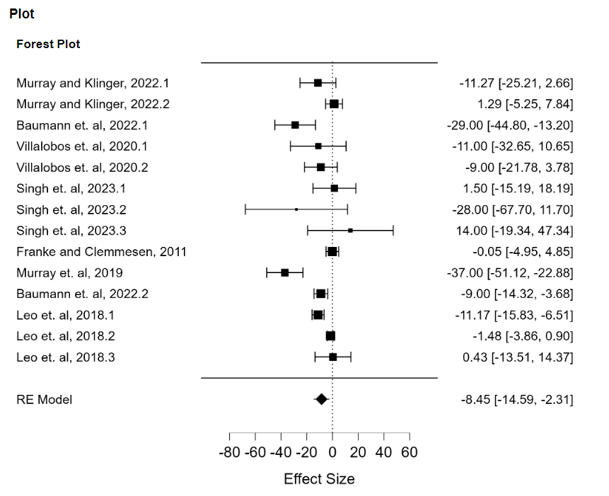
Note. Effect size of CO₂ on the likelihood of a forage fish egg hatching successfully. A negative value signifies reduced success, and a positive value signifies increased success. Includes Pacific and Atlantic forage fish species. Each point represents the mean effect size + the standard deviation. The overall effect is shown at the base of the figure, labeled "RE model."

Figure 2. Effect Size of CO2 on Atlantic Forage Fish Species’ Hatching Success
Effect Size of CO₂ on Atlantic Forage Fish Species’ Hatching Success
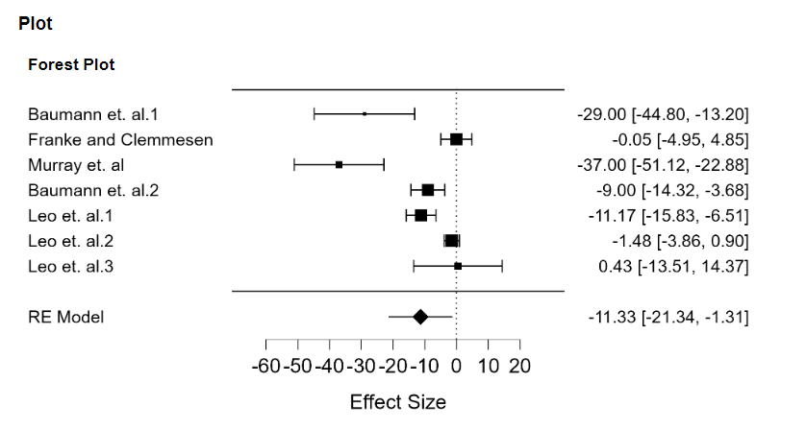
Note. Effect size of CO₂ on the likelihood of a forage fish egg hatching successfully. A negative value signifies reduced success, and a positive value signifies increased success. Includes Atlantic forage fish species. Each point represents the mean effect size + the standard deviation. The overall effect is shown at the base of the figure, labeled "RE model."

Figure 3. Effect Size of CO2 on Pacific Forage Fish Species’ Hatching Success
Effect Size of CO2 on Pacific Forage Fish Species’ Hatching Success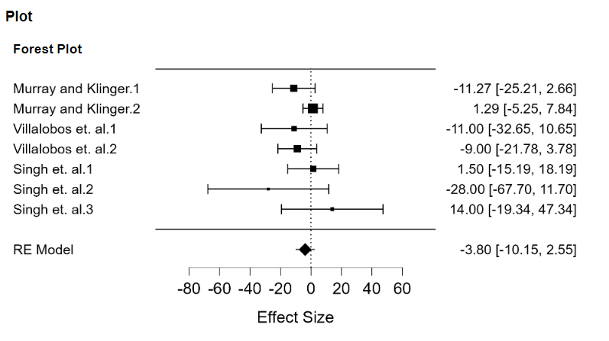
Note. Effect size of CO₂ on the likelihood of a forage fish egg hatching successfully. A negative value signifies reduced success, and a positive value signifies increased success. Includes Pacific forage fish species. Each point represents the mean effect size + the standard deviation. The overall effect is shown at the base of the figure, labeled "RE model."

Figure 4.Effect Size of CO2 on Hatching Abnormalities for all Species of Forage Fish
Effect Size of CO₂ on Hatching Abnormalities for all Species of Forage Fish
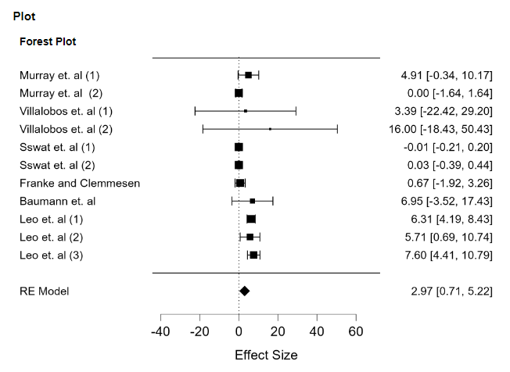
Note. Effect size of CO₂ on the likelihood of a forage fish egg hatching with abnormalities, such as deformities or mortality. A negative value signifies reduced odds, and a positive value signifies increased odds. Includes Atlantic and Pacific forage fish species. Each point represents the mean effect size + the standard deviation. The overall effect is shown at the base of the figure, labeled "RE model."

Figure 5. Effect Size of CO2 on Hatching Abnormalities for Atlantic Forage Fish
Effect Size of CO₂ on Hatching Abnormalities for Atlantic Forage Fish
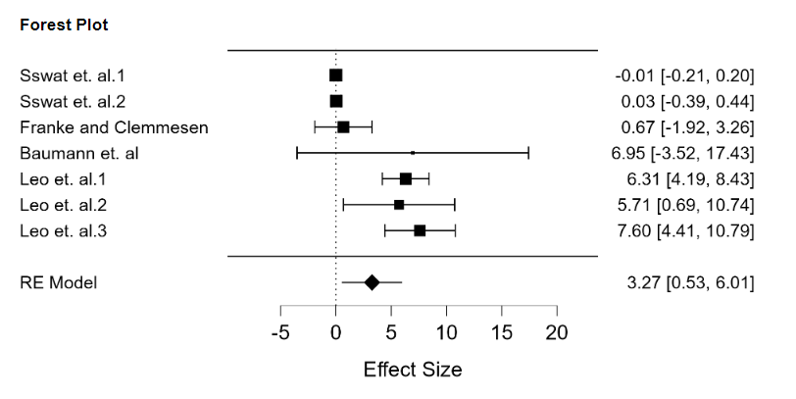
Note. Effect size of CO₂ on the likelihood of a forage fish egg hatching with abnormalities, such as deformities or mortality. A negative value signifies reduced odds, and a positive value signifies increased odds. Includes Atlantic forage fish species. Each point represents the mean effect size + the standard deviation. The overall effect is shown at the base of the figure, labeled "RE model."

Figure 6. Effect Size of CO2 on Hatching Abnormalities for Pacific Forage Fish
Effect Size of CO₂ on Hatching Abnormalities for Pacific Forage Fish
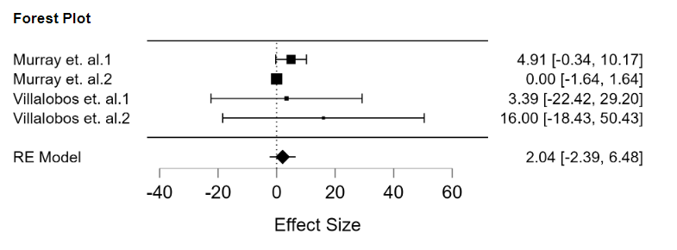
Note. Effect size of CO₂ on the likelihood of a forage fish egg hatching with abnormalities, such as deformities or mortality. A negative value signifies reduced odds, and a positive value signifies increased odds. Includes Pacific forage fish species. Each point represents the mean effect size + the standard deviation. The overall effect is shown at the base of the figure, labeled "RE model."

References
Baumann, H., Jones, L. F., Murray, C. S., Siedlecki, S. A., Alexander, M., & Cross, E. L. (2022). Impaired hatching exacerbates the high CO₂ sensitivity of embryonic sand lance Ammodytes dubius. Marine Ecology Progress Series, 687, 147–162. https://doi.org/10.3354/meps14010
Busch, D. S., Maher, M., Thibodeau, P., & McElhany, P. (2014). Shell condition and survival of Puget Sound pteropods are impaired by ocean acidification conditions. PLOS ONE, 9(8), e105884. https://doi.org/10.1371/journal.pone.0105884
Calvin, K., Dasgupta, D., Krinner, G., Mukherji, A., Thorne, P. W., Trisos, C., Romero, J., Aldunce, P., Barrett, K., Blanco, G., Cheung, W. W. L., Connors, S., Denton, F., Diongue-Niang, A., Dodman, D., Garschagen, M., Geden, O., Hayward, B., Jones, C., … Péan, C. (2023). IPCC, 2023: Climate Change 2023: Synthesis Report. Contribution of Working Groups I, II and III to the Sixth Assessment Report of the Intergovernmental Panel on Climate Change [Core Writing Team, H. Lee and J. Romero (eds.)]. IPCC, Geneva, Switzerland. (First). Intergovernmental Panel on Climate Change (IPCC). https://doi.org/10.59327/IPCC/AR6-9789291691647
Cameron, J. N. (1978). Regulation of blood pH in teleost fish. Respiration Physiology, 33(1), 129–144. https://doi.org/10.1016/0034-5687(78)90092-0
Checkley, D. M., & Barth, J. A. (2009). Patterns and processes in the California Current System. Progress in Oceanography, 83(1), 49–64. https://doi.org/10.1016/j.pocean.2009.07.028
Chinook Tribe. First Salmon Ceremony – chinook Indian Nation (n.d.). Retrieved May 1, 2024, from https://chinooknation.org/first-salmon-ceremony/
Duffy, E. J., Beauchamp, D. A., Sweeting, R. M., Beamish, R. J., & Brennan, J. S. (2010). Ontogenetic diet shifts of juvenile Chinook salmon in nearshore and offshore habitats of Puget Sound. Transactions of the American Fisheries Society, 139(3), 803–823. https://doi.org/10.1577/T08-244.1
Esbaugh, A. J. (2018). Physiological implications of ocean acidification for marine fish: Emerging patterns and new insights. Journal of Comparative Physiology B, 188(1), 1–13. https://doi.org/10.1007/s00360-017-1105-6
Fisheries, N. (2024, January 17). Chinook Salmon (Protected) | NOAA Fisheries (West Coast). NOAA. https://www.fisheries.noaa.gov/species/chinook-salmon-protected
Franke, A., & Clemmesen, C. (2011). Effect of ocean acidification on early life stages of Atlantic herring (Clupea harengus L.). Biogeosciences, 8(12), 3697–3707. https://doi.org/10.5194/bg-8-3697-2011
Friedenberg, L. E., Bollens, S. M., & Rollwagen-Bollens, G. (2012). Feeding dynamics of larval Pacific herring (Clupea pallasi) on natural prey assemblages: The importance of protists. Fisheries Oceanography, 21(2–3), 95–108. https://doi.org/10.1111/j.1365-2419.2011.00611.x
Frieder, C. A., Applebaum, S. L., Pan, T.-C. F., Hedgecock, D., & Manahan, D. T. (2017). Metabolic cost of calcification in bivalve larvae under experimental ocean acidification. ICES Journal of Marine Science, 74(4), 941–954. https://doi.org/10.1093/icesjms/fsw213
Frommel, A. Y., Carless, J., Hunt, B. P. V., & Brauner, C. J. (2020). Physiological resilience of pink salmon to naturally occurring ocean acidification. Conservation Physiology, 8(1), coaa059. https://doi.org/10.1093/conphys/coaa059
Frommel, A. Y., Maneja, R., Lowe, D., Pascoe, C. K., Geffen, A. J., Folkvord, A., Piatkowski, U., & Clemmesen, C. (2014). Organ damage in Atlantic herring larvae as a result of ocean acidification. Ecological Applications, 24(5), 1131–1143. https://doi.org/10.1890/13-0297.1
Gruber, N., Clement, D., Carter, B. R., Feely, R. A., van Heuven, S., Hoppema, M., Ishii, M., Key, R. M., Kozyr, A., Lauvset, S. K., Lo Monaco, C., Mathis, J. T., Murata, A., Olsen, A., Perez, F. F., Sabine, C. L., Tanhua, T., & Wanninkhof, R. (2019). The oceanic sink for anthropogenic CO₂ from 1994 to 2007. Science, 363(6432), 1193–1199. https://doi.org/10.1126/science.aau5153
Guinotte, J. M., & Fabry, V. J. (2008). Ocean acidification and its potential effects on marine ecosystems. Annals of the New York Academy of Sciences, 1134(1), 320–342. https://doi.org/10.1196/annals.1439.013
Hanson, M. B., Emmons, C. K., Ford, M. J., Everett, M., Parsons, K., Park, L. K., Hempelmann, J., Doornik, D. M. V., Schorr, G. S., Jacobsen, J. K., Sears, M. F., Sears, M. S., Sneva, J. G., Baird, R. W., & Barre, L. (2021). Endangered predators and endangered prey: Seasonal diet of Southern Resident killer whales. PLOS ONE, 16(3), e0247031. https://doi.org/10.1371/journal.pone.0247031
Heuer, R. M., & Grosell, M. (2014). Physiological impacts of elevated carbon dioxide and ocean acidification on fish. American Journal of Physiology-Regulatory, Integrative and Comparative Physiology, 307(9), R1061–R1084. https://doi.org/10.1152/ajpregu.00064.2014
Hunt, S. L., Mulligan, T. J., & Komori, K. (1999). Oceanic feeding habits of Chinook salmon, Oncorhynchus tshawytscha, off northern California. Fishery Bulletin-National Oceanic and Atmospheric Administration, 97, 717-721.
Leduc, A. O. H. C., Munday, P. L., Brown, G. E., & Ferrari, M. C. O. (2013). Effects of acidification on olfactory-mediated behaviour in freshwater and marine ecosystems: A synthesis. Philosophical Transactions of the Royal Society B: Biological Sciences, 368(1627), 20120447. https://doi.org/10.1098/rstb.2012.0447
Leo, E., Dahlke, F. T., Storch, D., Pörtner, H.-O., & Mark, F. C. (2018). Impact of ocean acidification and warming on the bioenergetics of developing eggs of Atlantic herring Clupea harengus. Conservation Physiology, 6(1), coy050. https://doi.org/10.1093/conphys/coy050
Ma, D., Gregor, L., & Gruber, N. (2023). Four decades of trends and drivers of global surface ocean acidification. Global Biogeochemical Cycles, 37(7), e2023GB007765. https://doi.org/10.1029/2023GB007765
McLaskey, A. K., Keister, J. E., Schoo, K. L., Olson, M. B., & Love, B. A. (2019). Direct and indirect effects of elevated CO₂ are revealed through shifts in phytoplankton, copepod development, and fatty acid accumulation. PLOS ONE, 14(3), e0213931. https://doi.org/10.1371/journal.pone.0213931
Mota, V. C., Nilsen, T. O., Gerwins, J., Gallo, M., Kolarevic, J., Krasnov, A., & Terjesen, B. F. (2020). Molecular and physiological responses to long-term carbon dioxide exposure in Atlantic salmon (Salmo salar). Aquaculture, 519, 734715. https://doi.org/10.1016/j.aquaculture.2019.734715
Murray, C. S., & Klinger, T. (2022). High p CO₂ does not alter the thermal plasticity of developing Pacific herring embryos during a marine heatwave. Journal of Experimental Biology, jeb.243501. https://doi.org/10.1242/jeb.243501
Murray, C. S., Wiley, D., & Baumann, H. (2019). High sensitivity of a keystone forage fish to elevated CO₂ and temperature. Conservation Physiology, 7(1), coz084. https://doi.org/10.1093/conphys/coz084
Murray, J. W., Roberts, E., Howard, E., O’Donnell, M., Bantam, C., Carrington, E., Foy, M., Paul, B., & Fay, A. (2015). An inland sea high nitrate-low chlorophyll (HNLC) region with naturally high pCO₂. Limnology and Oceanography, 60(3), 957–966. https://doi.org/10.1002/lno.10062
NOAA (National Oceanic and Atmospheric Administration). Ocean acidification | National Oceanic and Atmospheric Administration. (n.d.). Retrieved January 9, 2024, from https://www.noaa.gov/education/resource-collections/ocean-coasts/ocean-acidification
NOAA (National Atmospheric and Oceanic Administration) SST Annual Animator: NOAA Physical Sciences Laboratory. (n.d.). Retrieved February 27, 2024, from https://psl.noaa.gov/map/clim/sst.anim.year.html
Our World. Climate Change’s “Evil Twin”: Ocean Acidification (n.d.). Retrieved January 7, 2024, from https://ourworld.unu.edu/en/climate-changes-evil-twin-ocean-acidification
Pikitch, E. K., Rountos, K. J., Essington, T. E., Santora, C., Pauly, D., Watson, R., Sumaila, U. R., Boersma, P. D., Boyd, I. L., Conover, D. O., Cury, P., Heppell, S. S., Houde, E. D., Mangel, M., Plagányi, É., Sainsbury, K., Steneck, R. S., Geers, T. M., Gownaris, N., & Munch, S. B. (2014). The global contribution of forage fish to marine fisheries and ecosystems. Fish and Fisheries, 15(1), 43–64. https://doi.org/10.1111/faf.12004
Puget Sound Partnership. Vital Signs | Biomass of spawning Pacific Herring. (n.d.). Retrieved April 24, 2024, from https://vitalsigns.pugetsoundinfo.wa.gov/VitalSignIndicator/Detail/36
Read, A. J., & Brownstein, C. R. (2003). Considering other consumers: fisheries, predators, and Atlantic herring in the Gulf of Maine. Conservation Ecology, 7(1). https://www.jstor.org/stable/26271914
Riebesell, U., Zondervan, I., Rost, B., Tortell, P. D., Zeebe, R. E., & Morel, F. M. M. (2000). Reduced calcification of marine plankton in response to increased atmospheric CO₂. Nature, 407(6802), Article 6802. https://doi.org/10.1038/35030078
Rowe, E., Mariano, A., & Ryan, E. (n.d.). The Antilles Current. Retrieved April 21, 2024, from https://oceancurrents.rsmas.miami.edu/atlantic/antilles.html
Schwing, F. B., O’Farrell, M., Steger, J. M., & Baltz, K. (n.d.). Coastal Upwelling Indices, West Coast of North America, 1946-95.
Shi, D., Hong, H., Su, X., Liao, L., Chang, S., & Lin, W. (2019). The physiological response of marine diatoms to ocean acidification: Differential roles of seawater pCO₂ and pH. Journal of Phycology, 55(3), 521–533. https://doi.org/10.1111/jpy.12855
Singh, N. R., Love, B., Murray, C. S., Sobocinski, K. L., & Cooper, W. J. (2023). The combined effects of acidification and acute warming on the embryos of Pacific herring (Clupea pallasii). Frontiers in Marine Science, 10. https://www.frontiersin.org/articles/10.3389/fmars.2023.1307617
Sswat, M., Stiasny, M. H., Jutfelt, F., Riebesell, U., & Clemmesen, C. (2018). Growth performance and survival of larval Atlantic herring, under the combined effects of elevated temperatures and CO₂. PLOS ONE, 13(1), e0191947. https://doi.org/10.1371/journal.pone.0191947
Stommel, H. (1959). The Gulf Stream: A Physical and Dynamical Description. Univ of California Press.
Takahashi, T., Sutherland, S. C., Chipman, D. W., Goddard, J. G., Ho, C., Newberger, T., Sweeney, C., & Munro, D. R. (2014). Climatological distributions of pH, pCO₂, total CO₂, alkalinity, and CaCO₃ saturation in the global surface ocean, and temporal changes at selected locations. Marine Chemistry, 164, 95–125. https://doi.org/10.1016/j.marchem.2014.06.004
Tseng, Y.-C., Hu, M. Y., Stumpp, M., Lin, L.-Y., Melzner, F., & Hwang, P.-P. (2013). CO₂-driven seawater acidification differentially affects development and molecular plasticity along life history of fish (Oryzias latipes). Comparative Biochemistry and Physiology Part A: Molecular & Integrative Physiology, 165(2), 119–130. https://doi.org/10.1016/j.cbpa.2013.02.005
UNEP (United Nationals Environment Programme). (2020, December 15). Native fish: Indigenous communities lead fight to save Sacramento’s salmon. https://www.unep.org/youngchampions/news/Story/Native fish: Indigenous communities lead fight to save Sacramento’s salmon
United States v. State of Washington, 384 F. Supp. 312 (Dist. Court 9213). https://law.justia.com/cases/federal/district-courts/FSupp/384/312/1370661/
US EPA (United States Environmental Protection Agency). O. (2016a, September 8). Understanding the Science of Ocean and Coastal Acidification [Overviews and Factsheets]. https://www.epa.gov/ocean-acidification/understanding-science-ocean-and-coastal-acidification
US EPA (United States Environmental Protection Agency). O. (2016b, September 8). Understanding the Science of Ocean and Coastal Acidification [Overviews and Factsheets]. https://www.epa.gov/ocean-acidification/understanding-science-ocean-and-coastal-acidification
USGS (United States Geological Survey). Temperature and Water | U.S. Geological Survey. (n.d.). Retrieved April 23, 2024, from https://www.usgs.gov/special-topics/water-science-school/science/temperature-and-water
Villalobos, C., Love, B. A., & Olson, M. B. (2020). Ocean acidification and ocean warming effects on Pacific Herring (Clupea pallasi) early life stages. Frontiers in Marine Science, 7. https://www.frontiersin.org/articles/10.3389/fmars.2020.597899
Waldbusser, G. G., Hales, B., Langdon, C. J., Haley, B. A., Schrader, P., Brunner, E. L., Gray, M. W., Miller, C. A., Gimenez, I., & Hutchinson, G. (2015). Ocean acidification has multiple modes of action on bivalve larvae. PLOS ONE, 10(6), e0128376. https://doi.org/10.1371/journal.pone.0128376
Wildlife Conservation Society. Nature’s Strongholds—WCS.org. (n.d.). Retrieved December 11, 2023, from https://www.wcs.org/our-work/natures-strongholds
Williams, C. R., Dittman, A. H., McElhany, P., Busch, D. S., Maher, M. T., Bammler, T. K., MacDonald, J. W., & Gallagher, E. P. (2019). Elevated CO₂ impairs olfactory-mediated neural and behavioral responses and gene expression in ocean-phase coho salmon (Oncorhynchus kisutch). Global Change Biology, 25(3), 963–977. https://doi.org/10.1111/gcb.14532

Appendix
Figure 1 Funnel plot testing for publication bias in all studies. Kendall’s T = -0.121, p = 0.591
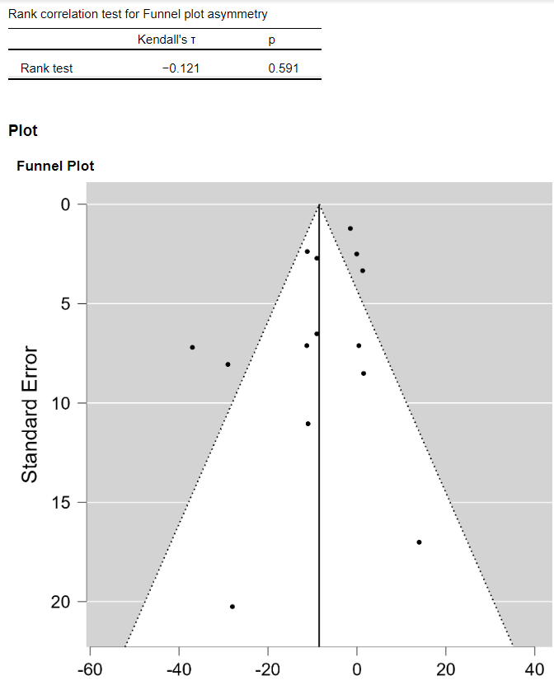

Figure 2 Funnel plot testing publication bias in Atlantic studies. Kendall’s T = -0.524, p = 0.136
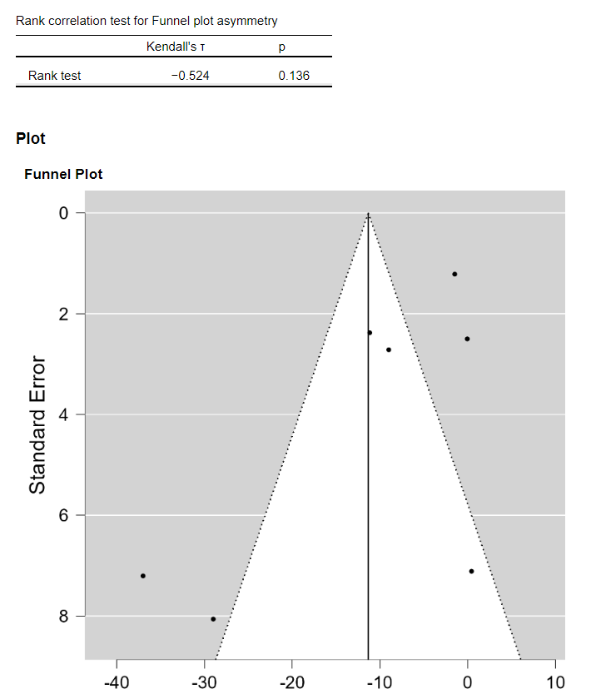

Figure 3 Funnel plot testing publication bias in Pacific studies of hatching success. Kendall’s T = -0.143, p = 0.773
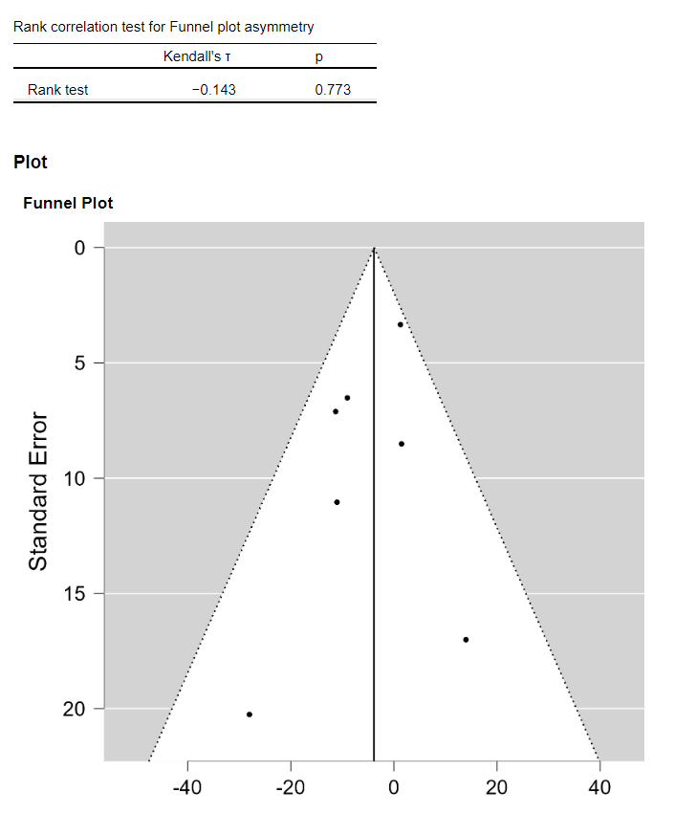

Figure 4 Funnel plot testing publication bias in hatching abnormalities studies for Atlantic and Pacific. Kendall’s T = 0.200, p = 0.445
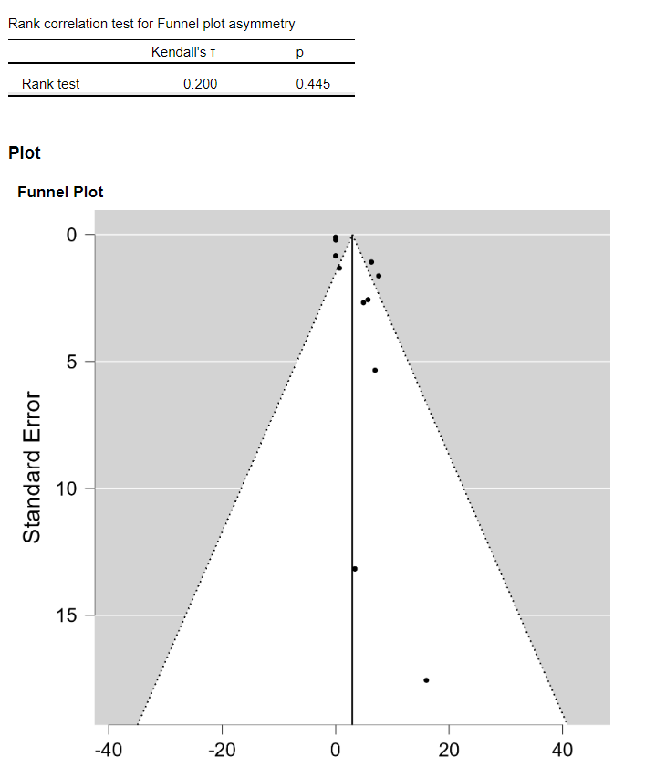

Figure 5 Funnel plot testing for publication bias in Atlantic hatching abnormalities studies. Kendall’s T = 0.333, p = 0.381
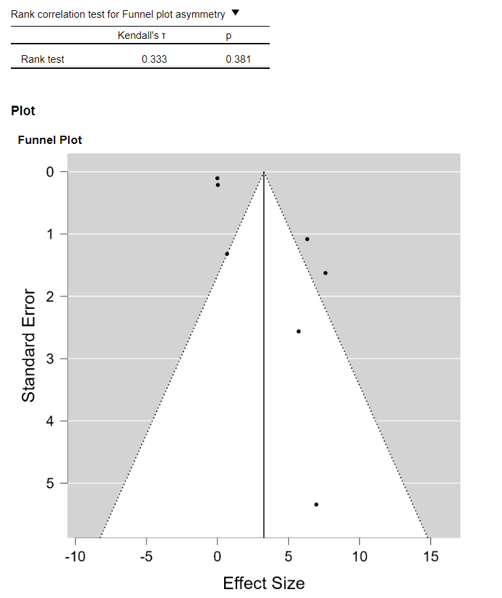
Figure 6 Funnel plot testing for publication bias in Pacific hatching abnormalities studies. Kendall’s T = 0.333, p = 0.750