DESCHUTES RIVER PRESERVE CAMERA TRAPPING
DESCHUTES RIVER PRESERVE WILDLIFE MONITORING

by
Matthew Einhorn

A Thesis
Submitted in partial fulfillment
Of the requirements for the degree
Master of Environmental Studies
The Evergreen State College
June 2024

©2024 by Matthew Einhorn.. All rights reserved.

This Thesis for the Master of Environmental Studies Degree
by
Matthew Einhorn

has been approved for
The Evergreen State College
by

_______________________________
John Withey, Ph.D.
Member of Faculty

June 21, 2024
_______________________________
Date

ABSTRACT

Deschutes river preserve camera trapping
Deschutes river preserve wildlife monitoring

Matthew Einhorn

The Deschutes River Preserve is a species-rich land preserve stewarded by the local non-profit organization Olympia Ecosystems in Olympia, Washington. Between the months of mid November 2023 and early Mach 2024, camera trap data was collected and assessed for relative wildlife abundance in different habitat types, and wildlife community composition in different habitats. This assessment was achieved by distributing 16 cameras across 7 different habitat types: forest, forest riparian, mixed tree and shrub, clear-cut, wetland, field, and marsh. Among species with sufficient detections to analyze with a chi-squared goodness-of-fit test, coyotes had a higher chance of being detected in wetlands and a lower chance to be detected in the field habitat. Black-tailed deer had a higher chance of detection in the clearcut habitat, and a lower chance of detection in forest riparian habitat. Roosevelt Elk were uniformly distributed across the three habitat types in which they were present. Using NMDS ordination also illustrated how habitat types were more or less evenly distributed in ordination space, reflecting different wildlife communities but with a lack of any clustering/closely similar habitats. Certain species were more associated with specific habitat types, while others (like the coyote) were more ubiquitous. The Deschutes River Preserve is relatively rich in wildlife presence, and is appropriate for more systematic and longer duration studies. The preserve is deserving of increased protection as urban development increases in its surrounding area.

Table of Contents
List of Figures v
List of Tables vi
Acknowledgements vii
Introduction 1
Literature Review 3
Wildlife Monitoring 3
Trail Camera Availability 4
Trail Camera Placement 6
Urban and Exurban 6
Random vs. Deliberative sampling 7
Satellite and Drones 8
Statistical Analysis 8
Random Forest 9
Maxent 9
Seasonal Occupancy Model 10
Methods 11
Camera Site Assessment 11
Installation 13
Data Collection 14
Remotely sensed data 15
Statistical Analysis 16
Results 17
Camera Trap Detections 17
Focal Species 21
Discussion & Conclusion 24
Conclusion 28
References 30

List of Figures
Figure 1. Deschutes River Preserve Habitat Type Map 12
Figure 2. Example Wildlife Imagery 20
Figure 3. Non-metric Multidimensional Scaling Ordination Plot 23

List of Tables
Table 1. Camera Reporting Efforts 13
Table 2. Relative Species Abundance per every 30 Days 17
Table 3. Per Habitat Types Mean Canopy Cover and Mean Distance to Road 21
Table 4. Focal Species Standardized Residuals 22

Acknowledgements

Introduction
Western Washington has experienced increased urban expansion as demand for housing increases with a growing human population. Associated risks to wildlife habitats can be seen through habitat fragmentation, increased risk of invasive weed spread and introduction of unwanted species. The population of Western Washington has nearly doubled between the years 1970 and 2006 alone (Gray et al., 2013). With the ever-increasing need to home our growing population, the areas we classify as wilderness become increasingly at risk and thus become an increasingly important subject of study.
Monitoring wildlife in a particular geographic area or habitat type is important to determine abundance and population status of different species (Fuller et al., 2016). Dependable monitoring programs are also important for agencies monitoring for shifts in biodiversity, (Burton, 2012). The shear breadth of camera trap studies can seem innumerable as the methodology continues to spread and innovate (Burton et al., 2015). Having reliable data can sometimes be an issue depending on the level of coverage in the area and differing methods in the medium of wildlife monitoring, (Burton, 2012).
The Deschutes River Preserve (DRP, also known as Elwanger) is one such wilderness reserve that is both threatened by continued expansion of local urban expansion while being heavily utilized by local wildlife. DRP has recently been acquired by the nonprofit organization Olympia Ecosystems (OlyEcosystems) to be converted into a nature preserve for eventual public use. DRP is a 367 acre property, consisting of several different habitat types that serve as a base for a multitude of ecological processes. The preserve will protect this environment from being modified for human housing as development progresses in the area. OlyEcosystems routinely hosts volunteer programs for invasive plant removal as they try to reintroduce native plant life to the ecosystem. The nature preserve is still young and will be looking to expand its territory as time and conservation activities progress. With the purchase of Deschutes River Preserve, OlyEcosystems can look to develop programs that can contribute reliable data to wildlife monitoring discourse. Camera trapping is a widely implemented tool in animal monitoring and research, recurringly featuring in scientific literature (Burton et al., 2015). Camera traps, or trail cameras are also highly regarded amongst recreational hunters and wildlife enthusiasts. This wide-ranging audience has commercially made for a marketplace where camera traps are readily accessible and at a fair price. This has led to a larger volume of cameras being able to be deployed for research.
Trail cameras are advantageous to both researchers and recreational users for their constant monitoring of a desired area. Cameras traps are triggered by motion, capturing passing wildlife. Each photo and video utilize infrared light, a light source invisible to the naked eye, to harmlessly record without disturbing its subjects (Webb, 2020). Trail cameras will be the base of wildlife data acquisition from Deschutes River Preserve.
This project focused on documenting wildlife presence in the different habitat types present in Elwanger. Sixteen trail cameras recorded wildlife detections in the following habitats: marsh, mixed tree & shrub, field, wetland, forest, and mixed forest and riparian. The data collected by the trail cameras would be analyzed in R, ArcGIS Pro, and Excel to assess species habitat community and species distribution amongst the habitat types.

Literature Review
Western Washington is host to a magnitude of different species. Their spatial and temporal features are often monitored and analyzed in scientific literature by independent, federal, and state organizations, (O’Neil & Johnson, n.d.). Actively monitoring wildlife populations is important for informing conservation management of various species (Fuller et al., 2016). OlyEcosystems and their various stakeholders also want to know what wildlife species they are helping by preserving their habitats. As a recently acquired preserve, they have been working to restore the property to provide valuable habitat for wildlife and to protect it from further development. Research is currently being conducted using trail cameras, GIS, and remote sensing technologies to assess the habitat usage from various species. This literature review is in service of reviewing the technologies and methods available for undertaking such research. Trail camera usage in wildlife studies will be reviewed, with the goal to provide an overview of wildlife study strategies involving trail cameras and to assess their efficacy if applied on the Deschutes River Preserve. The first section will discuss the general overview and how animal movement can be monitored. The second section will review trail camera methods and different kinds of sampling. The third section will include a description and history of the property. For the fourth section, statistical approaches will be covered including Random Forest. Maxent and seasonal occupancy models, as applied to monitoring wildlife.

Wildlife Monitoring
In fragmented and degraded habitats, ecosystems that experience habitat change may affect the survival of many wildlife species (Wilson et al., 2016). As urban development expands into many natural areas, what wildlife corridors remain becomes increasingly important for species that avoid urban environments, (Newburn & Berck, 2011). Trail camera efforts can be seen along major roads and wildlife corridors in Western Washington; monitoring sensitive species response to I-90 (Moskowitz et al., n.d.). Habitat connectivity monitoring in general is a subject that is seeing more attention in the scientific community, particularly in this last decade, (Correa Ayram et al., 2016). With changing climate conditions habitat connectivity is an ecological service that sees stress from many factors such as: developing infrastructure, fire, disease, and insect outbreaks (Singleton & McRae, 2013).
Wildlife monitoring programs often incorporate trail cameras for their additional wealth of data they provide by being able to monitor an area for as long as researchers need (Rovero et al., 2013). Researchers have several methods and techniques to choose from. The methods and techniques are often tailored to the research site and questions at hand. If a researcher’s goal is to study one species, you can tailor your program to maximize data collection for that species (Kolowski & Forrester, 2017). Due to the mobility of wildlife and vast expanses of lands that they cover, implementing a trail camera protocol ensures that specific areas needed for analysis are covered (Terrestrial Vertebrate Monitoring Protocol, n.d.).

Trail Camera Availability
Trail Cameras, or camera traps, have become widely available commercially in recent decades due to a demand from hunter communities to use them to detect their targets. As camera technology advances, the market has become more saturated, leading to more retail competition and driving the price of cameras down, making them a more viable option for both research and recreation (Webb, 2020). This market trend can have results in an uptick in research involving trail cameras used to collect data in the field on wildlife (Rovero et al., 2013). Trail cameras can be purchased from a variety of outdoor recreational stores and online markets.
Trail cameras have gained popularity in being a monitoring tool that are easy to install and can be deployed while only creating minimal disturbance in the habitat that animals are using. Once installed, the cameras can be left for months at a time depending on battery life. The camera is triggered by movement within a certain distance of the camera in both the daytime and nighttime (Elizondo & Loss, 2016). To reduce disturbance, infrared light is deployed from the camera to capture the footage. Cameras can also provide other important information such as temperature at the time of recording and date. Reviewing footage from trail cameras, researchers can identify species presence as well as collecting demographic and other useful information such as age, sex, and behavior (Burton et al., 2015).
Trail cameras can also provide insight on how healthy an ecosystem is and if it is providing the necessary requirements needed for wildlife to survive. In some studies, they have been able to assess vegetation structure and link wildlife habitat use (Sun et al., 2021). By using vegetation data and coupling it with wildlife detections in each plot, they could determine occurrence in a specific growing season to see if there was a correlation between the two. Understanding these linkages between habitat viability and wildlife occurrence is crucial for conservation research (Sun et al., 2021). Often habitat data is assessed through satellite or aerial data (NAIP, NDVI), but what is often impacted in these methods are the collection of conditions under thick canopy areas, (Sun et al., 2021). Camera traps can be left in remote areas for long periods of time to assess vegetation under thick canopy (Sun et al., 2021). Trail cameras provide a lens into the occurrence of environmental variables that can be measured to provide inference into wildlife habitat usage—for example, bird abundance in southwestern China in relation to temperature and vegetation (Li et al., 2021).

Trail Camera Placement
For trail camera placement, researchers take into consideration many different factors before deciding upon a location. Depending on the species that is being studied, understanding the movement of the animal throughout the environment can help determine the best place to install the camera for the highest chance of footage. Game trails and other markings like antler rubs on trees, animal tracks, and other animal signs can be beneficial in deciding placement. To estimate abundance of wildlife, Ausband et al. (2022) were able to monitor sensitive wolf populations in Idaho (2016-2018) by opportunistically placing trail cameras in areas they knew wolf rendezvous sites had historically been and sites where they believed would make for probable rendezvous sites. They had a clear objective and adjusted their trapping protocol to find success in camera trapping wolves to access their population metrics. Unfortunately, there is no ultimate camera trapping guide that can apply to all research programs (Tanwar et al., 2021). There are many specifications to consider when installing cameras such as ensuring that vegetation is not blocking the view, number and location of cameras, survey duration, and what settings to set on the camera for the footage.

Urban and Exurban
With the expansion of human populations, many remaining wildlife habitat areas are being rapidly built-upon, reducing habitat and ecosystem services. Elwanger can be classified as an exurban site since it sits on the edge of urban and rural areas (Newburn & Berck, 2011). Urban and exurban landscapes have been expanding rapidly since the 1990s, (Krausman, n.d.). Increased development has been attributed to declines in numerous species populations and increased instances of habitat fragmentation, (Glennon & Kretser, 2013). Scientific studies of exurban and urban effects on wildlife will most likely remain relevant as land development continues into the surrounding areas of DRP.

Random vs. Deliberative sampling
In the literature, there exists two prominent methods of trail camera distribution, deliberative sampling, and random sampling. Deliberate sampling often involves aiming trail camera installations to be and aimed at features associated with wildlife use for an increased likelihood of animal capture (Tanwar et al., 2021). Random sampling differs from deliberate sampling because it doesn’t take aim to be at features present on the ground that result in more wildlife traffic and therefore detections (Tanwar et al., 2021). Each method of sampling has been found to have its merits: in Ranthambhore National Park, deliberate sampling yielded more data on larger predators (carnivores) while the random sampling yielded more data on ungulates (Tanwar et al., 2021). This was attributed to the cameras placed using deliberate sampling being along paths and features that tigers and leopards would use to patrol their territories, while ungulates avoided these locations to better their chances of survival (Tanwar et al., 2021).
While using deliberate sampling, i.e. focusing on features such as game trails or signs of wildlife use, can lead to increased data collection, some authors warn that this can lead to bias in data and should be explicitly stated in the literature (Kolowski & Forrester, 2017). There isn’t a single standard method of camera trapping, leading to inconsistent methods amongst various ecosystems and habitat types (Burton et al., 2015). Whether to be deliberate or random in the sampling should be tailored to research objectives (Tanwar et al., 2021).

Satellite and Drones
Habitat monitoring can be conducted with data provided by satellites over time and large spatial scopes (Harrity et al., 2020). Paired with abundance data, satellite data like NDVI and Landsat can be used to make habitat suitability models of different species (Harrity et al., 2020). The challenges to Landsat data are that it can be obscured by weather conditions and are generally at a resolution of 30m (Harrity et al., 2020). Researchers can adapt to this by either using camera traps to monitor habitat conditions under canopy cover (Sun et al., 2021), or using drones to collect higher resolution data (Jiménez López & Mulero-Pázmány, 2019). For Deschutes River Preserve, we can pair remote sensed land classification data, high resolution drone collected imagery, GIS designated habitat zones, and camera trap data to assess habitat usage from the various local terrestrial wildlife.

Statistical Analysis
Chi-squared analysis run in R, is a statistical test that looks for association between 2 variables. Chi-squared analysis is well suited for a wide range of questions and can often be found in preliminary statistical analysis, (Turhan, 2020). Questions looking for correspondence between variables spatially and temporally often employ chi-square tests. Kušta et al (2014) tested Czech Republic for patterns in wildlife vehicle collisions using chi-squared tests in R.
Nonmetric multidimensional scaling test (NMDS) is a statistical test that assesses communities compared to descriptor variables and each other (“NMDS Tutorial in R,” 2012). Ordination can be conducted in R, making use of the ‘vegan’ package (Oksanen et al., 2024). Keehn & Feldman (2018) used NMDS to describe ecological communities with and without wind turbines; ascertaining that wind turbines had a negative impact on species diversity.

Random Forest
Although not applied to this study, “Random Forest,” is a method which is a forest-based and boosted classification and regression and classification tool that can be used to create models and to generate predictions for habitat data. It takes random samples from observations and builds multiple decision trees to provide more accurate predictions (“Random Forest Approach in R Programming,” 2020). Random Forest can also be used to rank the importance of variables in a classification problem (R, P. T. 2015).
This program is useful in that it can be used in wildlife studies. In this study by Shanley et al. (2021), they were able to use remotely sensed vegetation data using LiDAR and Random Forest to help improve habitat maps used in conservation and restoration planning (Shanley et al. 2021). Looking at conservation review for the keystone species Alexander Archipelago wolf (Canis lupus ligoni) and the Sitka black-tailed deer (Odocoileus hemionus sitkensis) in southeast Alaska, they observed how land use change has decreased populations. They combined GPS data from the Sitka black-tailed deer with LiDAR to see if they could get machine-learning methods to predict deer habitat selection (Shanley et al. 2021). Using the data from 62 adult female deer and LiDAR land use data, they ran it with Random Forest habitat modeling to analyze for any correlations and found correlations from using Random Forest. This study showcases the benefits of using machine-learning methods with LiDAR in wildlife conservation research.

Maxent
For understanding species distributions and habitat suitability, some researchers have used a maximum entropy approach (Also known as Maxent) to identify suitable movement corridors and to help with improve management and conservation strategies (Kabir et al. 2017). Maxent is a model that predicts species occurrences by finding the distributions particularly those that are most spread out or closest to uniform (Maxent. (n.d.). It uses only presence data and compares the locations of where a species has been to the environments that are available in the study area (Maxent. (n.d.). This is also a machine-learning method, and it can create multiple models. Kabir and team (2017) analyzed camera traps from 798 locations to observe Gray Wolf abundance in Pakistan and habitat suitability while also looking at genetic sampling from wolf scat. The Maxent model was helpful in this study in that it helped suggest suitable wolf habitat in Pakistan. It also summarized how useful machine-learning methods can be in conservation research and provide tools for identifying suitable habitats and movement corridors for species.

Seasonal Occupancy Model
Another modeling approach that can be useful for trail camera studies is occupancy modeling. Occupancy models are applied to wildlife camera data to estimate distribution, habitat use, and relative abundance of animals (Neilson et al. 2018). This can help aid in studying wildlife movement in the landscape that is being studied and can help estimate the proportion of sites where a species may occur (Neilson et al. 2018).

Methods
This study required access to the Deschutes River Preserve (also known as Elwanger, Fig. 1) and remotely sensed data. Olympia Ecosystems, a local nonprofit organization that owns the preserve, facilitated access to the site. I obtained remotely sensed data including drone-based mosaics created through previous work, as well as habitat designation polygons that were derived from a WDFW land classification raster. Additional input for spatial analysis was taken from the National Land Classification Database Canopy Cover map (NLCD 2021 USFS Tree Canopy Cover (CONUS) | Multi-Resolution Land Characteristics (MRLC) Consortium, n.d.).

Camera Site Assessment
Different possible sites for camera placement were visited on foot, to assess each site for features that indicate wildlife movement such as deer rub, wildlife paths, tracks, and animal scat. Wildlife paths were indicated by depressed earth and parted foliage, suggesting repeated travel from animals. Six cameras were placed by Olympia Ecosystems on November 16th, 2023. Initial findings yielded positive results, indicating our methods were effective and could be replicated with more cameras.
Site assessment was repeated for 10 more cameras. The purpose of all 16 cameras would be to detect wildlife across the different habitat types at the Deschutes River Preserve. Cameras in each habitat type were placed at a minimum of 50 meters apart. There was no cap on how far cameras could be from each other. Minimum distance wasn’t applied to cameras in different habitat types. Camera GPS locations were collected using Esri’s Field Maps survey app for further spatial analysis in ArcGIS Pro. 10 additional cameras were installed on December 31st, 2023. Not all cameras recorded continuously from their installation date due to technical issues. After all technical issues were fixed, there was continuous camera monitoring for 70 days (Table 1).
Figure 1. Deschutes River Preserve Habitat Type Map
Deschutes River Preserve Habitat Type Map
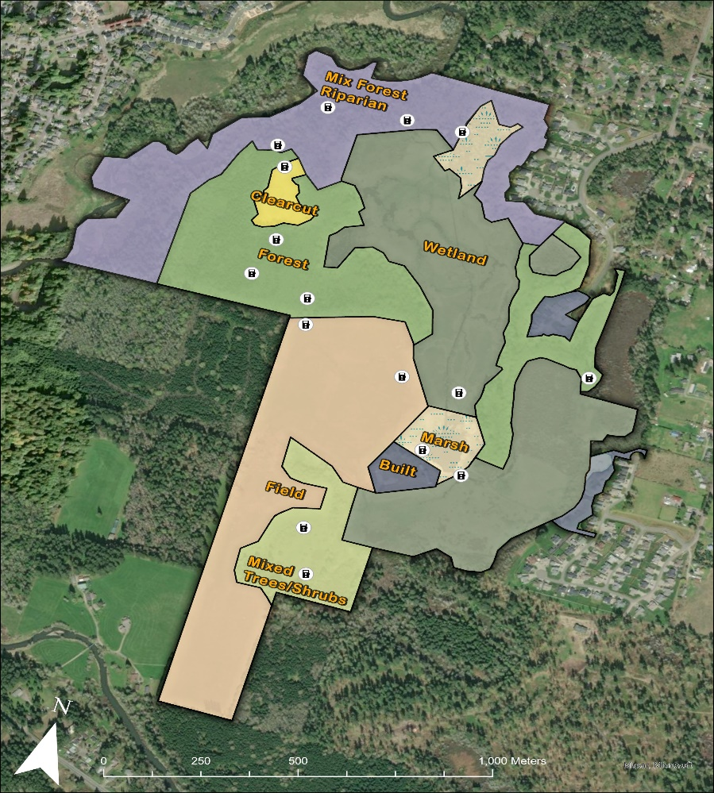
Note. Map of the Deschutes River Preserve showing the various habitat types and trail camera placements.

For each image that represented a detection, the date, camera ID, duration, time, temperature, habitat type, species, sex (when possible), behavior, count, and age. Camera monitoring effort varied per camera due to either installation date or technical issues. Cameras were spaced at least 50 meters apart in each habitat type.
Relative abundance was calculated per species by dividing the species count by the total camera days each camera was operational, then multiplying the total value by 30 to get abundance per 30 days.
Table 1. Camera Reporting Efforts
Camera Reporting Efforts
Camera # | Habitat  Type | Installation Date | Last Recording Date | Camera Days
1 | Marsh | 12/16/2023 | 3/8/2024 | 84
2 | Forest | 11/17/2023 | 3/8/2024 | 113
3 | Mixed Trees & Shrubs | 11/17/2023 | 3/8/2024 | 113
4 | Forest Riparian | 11/17/2023 | 3/8/2024 | 113
5 | Forest | 11/17/2023 | 3/8/2024 | 66
6 | Forest | 11/17/2023 | 3/8/2024 | 66
7 | Field | 12/30/2023 | 3/8/2024 | 70
8 | Wetland | 12/30/2023 | 3/8/2024 | 70
9 | Forest | 12/30/2023 | 3/8/2024 | 36
10 | Wetland | 12/30/2023 | 3/8/2024 | 70
11 | Forest Riparian | 12/30/2023 | 3/8/2024 | 70
12 | Clearcut | 12/30/2023 | 3/8/2024 | 70
13 | Forest Riparian | 12/30/2023 | 3/8/2024 | 70
14 | Marsh | 12/30/2023 | 3/8/2024 | 70
15 | Field | 12/30/2023 | 3/8/2024 | 70
16 | Mixed Trees & Shrubs | 12/30/2023 | 3/8/2024 | 70

Note. Recording effort of camera traps based on their installation dates, last recording dates, camera number and habitat type. Camera 5, 6, and 11 had technical issues and did not record between 12/30/23 and 2/2/24, leading to less total days recording then the other cameras.

Installation
Trail cameras were installed on trees for 12 sites, with metal T-posts used for 4 sites (in areas bereft of suitable trees, like the field and mixed tree/shrub habitat zones). A steel lockbox was screwed into the tree to house the trail camera. Lockboxes were secured with a padlock. T-posts were secured to the ground by use of a post hole driver. The steel lockbox, camera, and padlock were then secured to the t-post by cinch straps and cable locks to keep it in place.
Cameras were set with preference to video capture of wildlife at all times of the day. Motion capture sensitivity was set to normal, video length to 20 seconds, with the lowest possible interval between video recordings (0.6s), and the date time were made current for temporal record keeping. These settings are used with the goal of maximizing wildlife capture rates and minimizing false triggering from swaying brush and vegetation. Where applicable, the immediate line of sight of each camera was cleared of possible sources of false triggers like small hanging branches or tall grass.

Data Collection
Camera SD cards were collected once in February and once in March. I switched out one set of SD cards for analysis while leaving a new set of SD cards in the field for continued data collection. Images and sound were examined and transferred to a data sheet in Excel. Each row represented an individual detection, with columns for specific variables such as: animal species, camera ID, Date, time, and notable behaviors.
Roads locations were surveyed and recorded in Esri Field Maps app. I did this by streaming my GPS position from an iPhone 6S while traversing the service roads at DRP. I exported the road layer to ArcGIS Pro and measured each camera’s distance to the nearest part of the road. I then measured the distance of each camera to nearest part of the service roads. I calculated the mean distance to road for each habitat type for further NMDS testing (Table 3).

Remotely sensed data
National land cover dataset (NLCD) 2021 USFS tree canopy cover (CONUS) is a raster classification layer of the continental United States. This raster dataset depicts canopy cover percentage derived from multispectral satellite data at 30m resolution. National Land Cover Data (NLCD) 2021 was used to calculate tree canopy cover mean above the different habitat types at DRP. Mean pixel value was calculated from the NLCD using zonal statistics tool in ArcGIS Pro, gaining an mean canopy cover value for each habitat type. Zonal statistics were then analyzed for correlation between relative abundance of each species at each habitat’s mean canopy coverage value.
LiDAR collected from USGS 3DEP Lidar Explorer was used to analyze canopy, and elevation data to subject habitat designation for forested areas. This led to redesignation of some wetland areas to forest.
Drone photography of the site was collected and compiled into ortho mosaics using a Mavic 2 Pro drone and Drone2Map software by Mike Ruth at The Evergreen State College. The advantage of the drone data compared to other remote sensing options is that it was able to collect imagery at higher resolution compared to aerial fixed wing or satellite counterparts due to both relative speed of the drone and how close it can get to ground.
WDFW’s 1m Land Classification was originally used in conjunction with Mavic 2 Pro drone photogrammetry to aid in habitat designation within DRP. Land cover data was derived from the National Agricultural Imagery program (2017) and classified by the Washington Department of Fish & Wildlife. This classification aided Evergreen State College student, Melinda Wood, in designating habitat types at DRP with aid of on the ground surveying and Drone Imagery. The habitat zones were designated as forest, field, mixed forest and riparian, mixed tree and shrub, wetland, clearcut, marsh, and built.

Statistical Analysis
R was used in the statistical analysis of spatial and temporal features relating to wildlife recorded in DRP’s respective habitat types. An alpha of 0.10 was used for all null hypothesis testing. A chi squared (χ²) goodness of fit test asked whether the a given species’ wildlife detections were higher than what you would expect by chance alone (i.e. compared to a uniform distribution) in the different habitat types it was found in. χ² tests were run for coyote, black-tailed deer, and Roosevelt elk based on being found in at least three habitat types. The ordination method non-metric multidimensional scaling (NMDS) was used on habitat types (except for marsh, which had many unique species) with species detections in those habitats NMDS was conducted in R using the package ‘vegan’ (), returning a stress score of 0.046 (with the rule of thumb of any stress score below 0.05 is excellent). The function ‘envfit’ in vegan was also used to fit mean canopy cover (from the habitat type as a whole), as well as Mean distance to roads, based on the distance of each camera in a given habitat type to the nearest road, onto these ordination results.

Results

Camera Trap Detections
Sixteen trail cameras in the Deschutes River Preserve returned over 1,050 instances of wildlife detections from November 2023 through March 2024, which represented 2,182 individual sightings (Figure 3). Notably high numbers of detections can be seen for a number of species (Table 2). Mallards had highest relative abundance out of all species at 79.9 detections/30 camera days. Their abundance however could only be seen at high numbers in marsh. Mallard was an example of a species that was numerically sufficient but was not distributed enough amongst the habitat types to be considered for chi-squared analysis. Coyote’s highest abundance was in wetland, Black-tailed deer’s in clearcut, and Roosevelt Elk in Field.
Table 2. Relative Species Abundance per every 30 Days
Relative Species Abundance per every 30 Days
Species | Marsh | Wetland | Riparian | Forest | Mixed | Field | Clearcut
Frogs | 0 | 8.14 | 0 | 0.21 | 1.31 | 0 | 0
Birds
American Bushtit | 0 | 0 | 0 | 0.11 | 0 | 0 | 0
American Crow | 0 | 1.5 | 0 | 0 | 0 | 0 | 0
American Robin | 0 | 2.36 | 0 | 0 | 1.48 | 0.86 | 0
American Wigeon | 15.97 | 0 | 0 | 0 | 0 | 0 | 0
Anna's Hummingbird | 0 | 0 | 0.12 | 0 | 0 | 0 | 0
Bald Eagle | 0.39 | 0.21 | 0 | 0 | 0 | 0 | 0
Barred Owl | 0 | 0 | 1.9 | 0 | 0 | 0 | 0
Belted Kingfisher | 0.78 | 0 | 0 | 0 | 0 | 0 | 0
Bewick's Wren | 0 | 0 | 0 | 0 | 0.33 | 0.21 | 0.43
Black-capped Chick. | 0.19 | 0 | 0 | 0 | 0 | 0.21 | 0
Bufflehead | 40.13 | 0.21 | 0 | 0.32 | 0 | 0 | 0
Cackling Goose | 4.68 | 0 | 0 | 0 | 0 | 0 | 0
California Scrub Jay | 0 | 1.5 | 0 | 0 | 0 | 0 | 0
Canada Goose | 26.3 | 0 | 0 | 0 | 0 | 1.5 | 0
Common Raven | 0.39 | 0 | 0 | 0.21 | 0 | 0 | 0
Cormorant spp. | 0.19 | 0 | 0 | 0 | 0 | 0 | 0
Dark-eyed Junco | 0 | 0 | 0 | 0 | 0.82 | 0 | 0
Gadwall | 58.25 | 0 | 0 | 0 | 0 | 0 | 0
Golden-cr. Kinglet | 0 | 0 | 0 | 0 | 0.16 | 0 | 0
Golden-cr. Sparrow | 0 | 0.64 | 0 | 0 | 3.28 | 0 | 0
Great-blue Heron | 1.95 | 0 | 0.36 | 0 | 0 | 0 | 0
Great-horned Owl | 0 | 1.5 | 0 | 0 | 0 | 0 | 0
Green-winged Teal | 20.84 | 0 | 0 | 0.96 | 0 | 0 | 0
Hooded Merganser | 2.14 | 0 | 0 | 0 | 0 | 0 | 0
Species (cont.) | Marsh | Wetland | Riparian | Forest | Mixed | Field | Clearcut
Killdeer | 0 | 1.5 | 0 | 0 | 0 | 0 | 0
Mallard | 79.87 | 0 | 0 | 1.49 | 0 | 0 | 0
Marsh Wren | 0.19 | 3.43 | 0 | 0 | 0 | 0 | 0
Mourning Dove | 0.19 | 0 | 0 | 0 | 0 | 0 | 0
Northern Flicker | 0 | 1.5 | 0 | 0 | 0 | 0 | 0
Northern Shoveler | 3.31 | 0 | 0 | 0 | 0 | 0 | 0
Pacific Wren | 0 | 1.5 | 0.12 | 0.53 | 0 | 0 | 0.86
Pied-billed Grebe | 1.36 | 0 | 0 | 0 | 0 | 0 | 0
Pileated Woodpecker | 0 | 0 | 0 | 0 | 0 | 0.21 | 0
Red-tailed Hawk | 0.58 | 0 | 0 | 0 | 0 | 0 | 0
Red-winged Blackbird | 3.9 | 1.71 | 0 | 0 | 0 | 0.21 | 0
Ring-necked Duck | 5.45 | 0 | 0 | 0 | 0 | 0 | 0
Song Sparrow | 0.19 | 4.93 | 0 | 0 | 0 | 0 | 0
Spotted towhee | 0 | 0 | 0 | 0 | 1.8 | 0 | 0
Steller's Jay | 0.19 | 0 | 0 | 0 | 0 | 0 | 0
Mammals
Beaver | 0.39 | 0.64 | 0 | 0 | 0 | 0 | 0
Black-tailed Deer | 0 | 0 | 2.49 | 6.94 | 5.74 | 6.86 | 18.43
Coyote | 2.14 | 31.5 | 3.32 | 3.1 | 4.43 | 1.5 | 3
Deer Mouse | 0 | 6.86 | 0 | 0 | 0 | 0 | 0
Douglas Squirrel | 0 | 0 | 0 | 0.75 | 0 | 0 | 0
Eastern Cottontail | 0 | 0 | 0 | 0.32 | 9.18 | 0 | 0
Eastern Gray Squirrel | 0 | 0 | 0.36 | 0.85 | 0.66 | 0 | 0
Nutria | 0 | 1.93 | 0 | 0 | 0 | 0 | 0
Opossum | 0 | 0 | 0 | 0.64 | 0 | 0 | 0
Otters | 0.39 | 0 | 0 | 0 | 0 | 0 | 0
Raccoon | 0.58 | 3.0 | 1.19 | 0.85 | 0.16 | 0.21 | 0
Roosevelt Elk | 0 | 0 | 0 | 3.52 | 9.67 | 10.93 | 0

Note. Relative abundance for every 30 camera days for all species detected at Deschutes River Preserve. Mixed is representative of mixed/shrub and tree, and riparian is representative of forest riparian habitats. The table is ordered in taxidermic order, from amphibians, to birds, then mammals, then alphabetically.

Figure 2. Example Wildlife Imagery
Example Wildlife Imagery
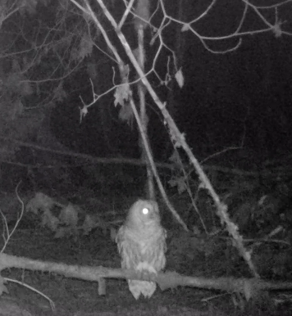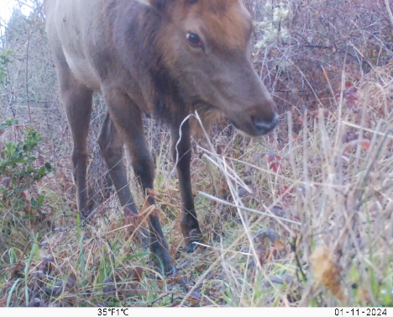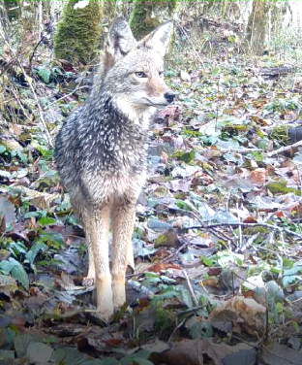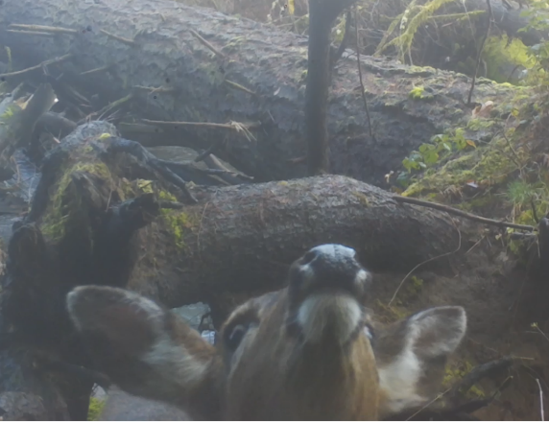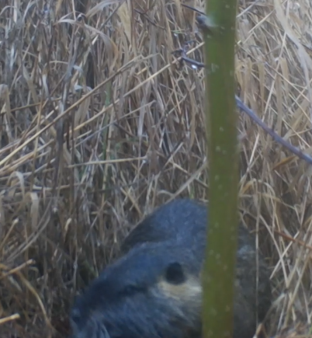
Note. Example species observed in Deschutes River Preserve. Barred owl, Roosevelt elk (F), Coyote, Black-tailed deer, American beaver

Table 3. Per Habitat Types Mean Canopy Cover and Mean Distance to Road
Per Habitat Types Mean Canopy Cover and Mean Distance to Road
Habitat |  | Canopy Mean | Mean Distance to Road
Wetland | 18.86 |  | 56.40
Field | 3.56 |  | 297.67
Clearcut | 26.05 |  | 73.29
Forest | 61.41 |  | 197.28
Riparian | 58.47 |  | 53.52
Mixed | 25.21 |  | 231.46

Note. Mean canopy coverage and camera distance to road in each habitat type.

Focal Species
Coyotes were more likely to be detected in the wetland habitat type, and less likely to be detected in the field habitat type, than by chance alone (χ²₆ = 100.8, p < 0.001, Table 4). Deer were more likely to be detected in the clearcut habitat type, and less likely in the forest riparian type (χ²₄ = 18.12, p = 0.0012). Elk detections were not significantly different across habitat types than would be expected if they were distributed uniformly (χ²₂ = 3.91, p = 0.14).

Table 4. Focal Species Standardized Residuals
Focal Species Standardized Residuals
Species | Riparian | Forest | Mixed | Field | Clearcut | Wetland | Marsh
Coyote | -1.50 | -1.59 | -1.05 | -2.25 | -1.63 | 10.00 | -1.98
Roosevelt Elk | X | -1.95 | 0.70 | 1.25 | X | X | X
Black-tailed Deer | -2.20 | -0.45 | -0.92 | -0.48 | 4.06 | X | X

Note. χ2 standardized residuals from separate χ2 goodness of fit tests, one for each focal species (assuming a uniform distribution across the habitat types they were found in). Values > 2 are used to indicate the species has more detections in that habitat type than by chance alone, values < -2 indicate the species has fewer detections in that habitat type than by chance alone.

Ordination using NMDS showed that the six habitat types were more or less evenly spaced, with no clear pairings or clusters (Figure 3). In addition, mean canopy cover of habitat types was negatively correlated with axis 1 (R2= 0.80, permutation test, p=0.09). Mean distance to roads was not significantly correlated with ordination results (R2= 0.19 , permutation test, p= 0.7). The forest and riparian habitat types have the highest mean canopy cover (Table 3) and are also associated with negative values of axis 1. Areas that were more open with less mean canopy cover were associated with positive values on axis 1. The mixed habitat type is more or less in the middle of the ordination plot. The wetland habitat type is also low on axis 1 but showed the highest value on axis 2. Clearcut had the highest positive value on axis 1 (and lowest mean canopy cover) but shared similar axis 2 scores with mixed and forest.
Species with similar axis 1/axis 2 scores as specific habitat types (i.e. occupying similar ordination space, Figure 3) had clear associations with those habitats based on the detections recorded by the camera traps. For example, frogs, red-winged blackbird, and song sparrows were only detected in the wetlands (Table 2). Coyote, being by far the most widely distributed species across all habitat types in the study, can be seen in the closest-to-center position compared to all the other species. Black-tailed deer and Bewick’s wren showed the closest association with clearcut. There are some species not named in the plot be the hold the same position as other species in the plot. This can be seen as dots overlapping with species like Canada goose, spotted towhee, great-blue heron, and song sparrow.
Figure 3. Non-metric Multidimensional Scaling Ordination Plot
Non-metric Multidimensional Scaling Ordination Plot
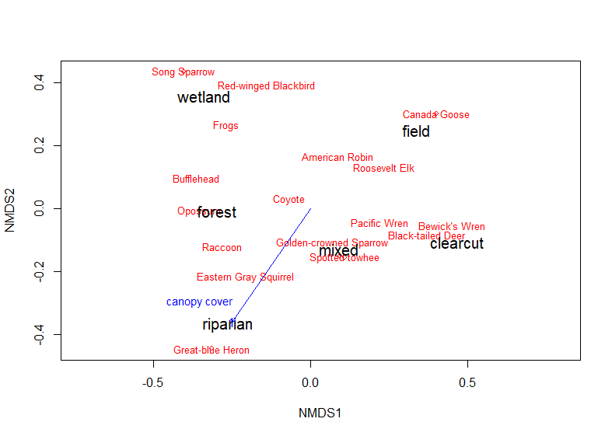
Note. NMDS ordination results plotted with habitat type and species scores on Axis 1 (NMDS1) and Axis 2 (NMDS2). The closer each species (red) is to each habitat (black), the more related they are. The closer each habitat type is to each other on the plot, the more similar they are to species composition. The mean canopy cover correlation with NMDS axis 1 and axis 2 ais represented with a blue line.

Discussion & Conclusion
Currently, Olympia Ecosystem’s wildlife monitoring program has been active for 113 days. In those 113 days, the program was able to use camera traps to capture sufficient wildlife data to assess relative wildlife abundance from early to late winter (~December to March) in the various habitat types at Deschutes River Preserve. The statistical analysis resulting from the chi-squared test and NMDS ordination, as well as the available raw data of over 2,000 species identifications will help inform the conservation team at Olympia Ecosystems about the various wildlife species present at DRP. Although we have completed monitoring during winter, there is still a lot to understand about wildlife spatial and temporal use on the preserve that could be the subject of further studies.
Our camera trapping effort, although significant, could not systematically cover every area of the reserve, so some individuals could have avoided camera capture. Having more cameras and possibly a more systematic approach to placement could lead to better representation of the species present at Deschutes River Preserve. More systematic methodologies that deploy 50-meter grid captures could be replicated on the reserve, although it would require significant manpower (Tanwar et al., 2021). If deployed, grid camera studies would be able to account for parts of the reserve while covering more movement of individuals (Fonteyn et al., 2021).
This study was conducted in 2023-2024 Winter season. Winter could have played an effect in the movements and abundance of the various species on the preserve. One of the most obvious examples of this is that during the early months of the study, the northern marsh was frozen over, allowing species who are not normally represented in marsh, like coyotes, to traverse the frozen surface and be captured on camera. Species distribution in general is also subject to change as seasons change, we could get significantly different statistical results in summer.
The camera effort was also not exactly the same across all cameras for the entirety of the study. 6 cameras were installed on the preserve, collecting data from 11-17-23 to when the additional 10 cameras were installed on the preserve on 12-30-23. In the time between 11-17 and 12-30, only mixed forest, riparian forest, and forest were represented. The second set of camera installations would see that marsh, field, wetland, and clear-cut were represented in the study. That is a 6-week gap that underrepresents marsh, field, wetland, and clear-cut, but is mitigated somewhat by the 70 days of continuous overlap of all habitat types between 12-30-23 and 03-08-24. Of the 16 cameras, 3 cameras suffered technical issues on recording data after their installation on 12-30-23. We accounted for the gaps by standardizing the detection data (using detections/30 camera days) and 70 camera days did have 100% overlap of each habitat type.
Coyotes were one of the 3 most prevalent and well distributed species amongst the habitat types, making them appropriate for chi-squared tests alongside NMDS. Coyote presence showed significantly higher chances to be detected than what you’d expect in wetland and a significantly lower chance in field habitat types. Although with the data we currently have, it is not apparent why this species showed higher presence in wetlands over other habitat types. There is room to study and draft future research into their spatial use on the preserve. Coyotes are a generalist that make use of almost all habitat types but are often seen in open agricultural areas near urban centers or mixed vegetation (Hinton et al., 2015, Quinn, 1990). There could be several factors playing into why coyotes on DRP had more detections in wetlands than would be expected by chance alone. The wetland habitat type offers the most protection and cover due to a high presence of tall reed canary grass which provide substantial line of sight breaks to potentially transient coyotes. Wetland habitat types also might be the main hunting spots of coyotes on that preserve. The coyote population might also be mitigating its chances with conflict with the local elk and deer herds. Coyotes normally only can take the risk of predating on deer and elk calves (Gese & Grothe, 1995), so wetlands might be a seasonal alternative route coyotes may take when calves are not present on the reserve. It’s hard to definitively state the reason for the substantial presence of Coyote on the wetlands, but further innovation and implementation of more sophisticated technology could help answer that in the future. Although possible, camera traps lack the ability to reliably identify specific individuals in a population without distinctive and individualistic physical traits. This problem is not shared by GPS and radio collar tracking. research could possibly assess the coyote populations in DRP further by tracing their spatial patterns in more detail than what camera traps can provide. Using either collaring technique would let researchers determine coyote home ranges in the area, if coyotes moving through the preserve are transient, and possibly allow researchers to survey possible coyote predation sites (Hickman et al., 2015).
Black-tailed deer data indicated a higher chance of being detected in clear-cut habitat types and a lower chance in forest-riparian. Clear-cut was one of the smallest habitat types (4.7 acres) in the DRP, and it only had one camera installed. This could reflect an association of black-tailed deer with edge habitat types which is often studied in ungulate species (Kirchhoff et al., 1983). It is unclear why forest-riparian is less likely to produce deer detections. It is possible that with the winter flooding deer were spending less time by the Deschutes River in favor for higher ground. Black-tailed deer would also be appropriate for GPS and radio collar studies (Bose et al., 2018).
The Roosevelt Elk chi squared test did not show any significant deviation from a uniform distribution across habitat types, however on the NMDS ordination plot (Figure 4) elk were location the closest to the field habitat type. Elk could be grazing in the field, and/or making use of the edge between the field and the forest (Figure 1). Elk spatial use would be appropriate for GPS and radio collar studies. It would be informative to be able to track their movement in and out of the Deschutes River Preserve. It is also worth investigating local Roosevelt Elk populations’ general health for hoof rot. Hoof rot has been reported in southwestern Washington since 2008 (Han et al., 2019). It would be appropriate to assess the local herds at DRP for infection and possibly treat for this disease.
One species group that we were able to confirm the presence of, but could not survey as properly as terrestrial wildlife, were frog species present on the reserve. We were significantly reliant on frog chorus for data entry. It is a species group that could be fruitfully studied. They continuously gave audio confirmation on the trail cameras. A more hands on approach or different camera placement method might be necessary to study DRP’s frog population in greater depth.
Of the numerous and diverse avian populations captured on camera, some stood out either as species of conservation concern, or as species with federal protections. As of 2007, the Bald Eagle is formerly a species listed on the Endangered Species Act (Watts & Byrd, 2022). Although they are no longer listed as a species of conservation concern, bald eagles still enjoy federal protections under the Bald and Golden Eagle Protection Act (Iraola, 2004). Bald Eagles are also protected under the Migratory Bird Treaty Act, and the Lacey Act (Kalasz & Joseph, 2016). Bald Eagles were removed from state protections in 2016 in Washington (Kalasz & Joseph, 2016). Although infrequent, bald eagles were detected in marsh and field habitats (Table 2). Bald eagles are one of those species recovery success stories, and although we don’t have historical records, Deschutes River Preserve seems to have played or is playing a part in bald eagle recovery.
Other avian species stood out for being listed in United States Department of Fish and Wildlife’s Birds of Conservation Concern list and as protected species under the Migratory Bird Species Act (USFWS Bird Species of Concern | FWS.Gov, 2024). The birds included in these listing are: Belted Kingfisher, Bewick's Wren, Black-capped Chickadee, Marsh Wren, Great Blue Heron, and Song Sparrow. It is useful for the Olympia Ecosystems to know which protected species they are serving by preserving their wilderness because they can apply for grants relating to these species.
The California scrub jay is a bird of interest surveyed by the camera traps that is worth following in the DRP. California scrub jays were historically a rarity in the Pacific Northwest but have progressively been recoded more in Washington. Breeding began in the 1990s and the home rage of the California scrub jay still progressively pushes north (Ward, 2021). Deschutes River Preserve could be an area of study to monitor for California scrub jays (in this study, found in the wetland habitat type).

Conclusion
The Deschutes River Preserve is frequented or is part of the home range of an exuberant number of species. The richness of wildlife is an important factor to preserve, and it is especially important to frequently and routinely monitor as the surrounding areas of Tumwater, Washington continue to urbanize. DRP could possibly be an integral part of wildlife connectivity in southwestern Washington. The more we study and learn about the Deschutes River Preserve, the more apparent the need for the replication and expansion of its type of protections provided to its local wildlife and habitats from an increasing urbanizing landscape (Newburn & Berck, 2011, Glennon & Kretser, 2013)

References
Ausband, D. E., Lukacs, P. M., Hurley, M., Roberts, S., Strickfaden, K., & Moeller, A. K. (2022). Estimating wolf abundance from cameras. Ecosphere, 13(2), e3933. https://doi.org/10.1002/ecs2.3933
Bengsen, A. J., Leung, L. K.-P., Lapidge, S. J., & Gordon, I. J. (2011). Using a general index approach to analyze camera-trap abundance indices. The Journal of Wildlife Management, 75(5), 1222–1227. https://doi.org/10.1002/jwmg.132
Border Wildlife Study. (n.d.). Sky Island Alliance. Retrieved November 23, 2023, from https://skyislandalliance.org/our-work/science/borderwildlife/
Bose, S., Forrester, T. D., Casady, D. S., & Wittmer, H. U. (2018). Effect of activity states on habitat selection by black-tailed deer. The Journal of Wildlife Management, 82(8), 1711–1724. https://doi.org/10.1002/jwmg.21529
Breiman, L. (2001). Forest-based and Boosted Classification and Regression (Spatial Statistics). Machine Learning, 45(1), 5–32. https://doi.org/10.1023/A:1010933404324
Burns, E. (2020, July 24). 90 Days and 71 Species at the Border. Sky Island Alliance. https://sia2023.wpengine.com/2020/07/90-days-and-71-species-at-the-border/
Burton, A. C., Neilson, E., Moreira, D., Ladle, A., Steenweg, R., Fisher, J. T., Bayne, E., & Boutin, S. (2015). REVIEW: Wildlife camera trapping: a review and recommendations for linking surveys to ecological processes. Journal of Applied Ecology, 52(3), 675–685. https://doi.org/10.1111/1365-2664.12432
Burton, C. (2012). Critical evaluation of a long-term, locally-based wildlife monitoring program in West Africa. Biodiversity and Conservation, 21. https://doi.org/10.1007/s10531-012-0355-6
Correa Ayram, C., Mendoza, M., Etter, A., & Pérez-Salicrup, D. (2016). Habitat connectivity in biodiversity conservation: A review of recent studies and applications. Progress in Physical Geography, 40, 7–37. https://doi.org/10.1177/0309133315598713
Deschutes River Preserve – OlyEcosystems. (n.d.). Retrieved December 21, 2023, from https://olyecosystems.org/preserves/deschutes-river-preserve/
Elizondo, E. C., & Loss, S. R. (2016). Using trail cameras to estimate free-ranging domestic cat abundance in urban areas. Wildlife Biology, 22(5), wlb.00855. https://doi.org/10.2981/wlb.00237
Evans, B. E., Mosby, C. E., & Mortelliti, A. (2019). Assessing arrays of multiple trail cameras to detect North American mammals. PLOS ONE, 14(6), e0217543. https://doi.org/10.1371/journal.pone.0217543
Fonteyn, D., Vermeulen, C., Deflandre, N., Cornelis, D., Lhoest, S., Houngbégnon, F. G. A., Doucet, J.-L., & Fayolle, A. (2021). Wildlife trail or systematic? Camera trap placement has little effect on estimates of mammal diversity in a tropical forest in Gabon. Remote Sensing in Ecology and Conservation, 7(2), 321–336. https://doi.org/10.1002/rse2.191
Fuller, R., Marshall, M., Wilkinson, P., & Wright, K. (2016). THE INCREASING IMPORTANCE OF MONITORING WILDLIFE RESPONSES TO HABITAT MANAGEMENT. British Wildlife.
Gese, E. M., & Grothe, S. (1995). Analysis of Coyote Predation on Deer and Elk during Winter in Yellowstone National Park, Wyoming. The American Midland Naturalist, 133(1), 36–43. https://doi.org/10.2307/2426345
Glennon, M. J., & Kretser, H. E. (2013). Size of the ecological effect zone associated with exurban development in the Adirondack Park, NY. Landscape and Urban Planning, 112, 10–17. https://doi.org/10.1016/j.landurbplan.2012.12.008
Gray, A. N., Azuma, D. L., Lettman, G. J., Thompson, J. L., & McKay, N. (2013). Changes in land use and housing on resource lands in Washington state, 1976–2006 (PNW-GTR-881; p. PNW-GTR-881). U.S. Department of Agriculture, Forest Service, Pacific Northwest Research Station. https://doi.org/10.2737/PNW-GTR-881
Han, S., Mansfield, K. G., Bradway, D. S., Besser, T. E., Read, D. H., Haldorson, G. J., Alt, D. P., & Wilson-Welder, J. H. (2019). Treponeme-Associated Hoof Disease of Free-Ranging Elk (Cervus elaphus) in Southwestern Washington State, USA. Veterinary Pathology, 56(1), 118–132. https://doi.org/10.1177/0300985818798108
Harrity, E. J., Stevens, B. S., & Conway, C. J. (2020). Keeping up with the times: Mapping range-wide habitat suitability for endangered species in a changing environment. Biological Conservation, 250, 108734. https://doi.org/10.1016/j.biocon.2020.108734
Hickman, J. E., Gulsby, W. D., Killmaster, C. H., Bowers, J. W., Byrne, M. E., Chamberlain, M. J., & Miller, K. V. (2015). Home Range, Habitat Use, and Movement Patterns of Female Coyotes in Georgia: Implications for Fawn Predation.
Hinton, J. W., Manen, F. T. van, & Chamberlain, M. J. (2015). Space Use and Habitat Selection by Resident and Transient Coyotes (Canis latrans). PLOS ONE, 10(7), e0132203. https://doi.org/10.1371/journal.pone.0132203
Iraola, R. (2004). The Bald and Golden Eagle Protection Act. Albany Law Review, 68, 973.
Jiménez López, J., & Mulero-Pázmány, M. (2019). Drones for Conservation in Protected Areas: Present and Future. Drones, 3(1), Article 1. https://doi.org/10.3390/drones3010010
Kabir, M., Hameed, S., Ali, H., Bosso, L., Din, J. U., Bischof, R., Redpath, S., & Nawaz, M. A. (2017). Habitat suitability and movement corridors of grey wolf (Canis lupus) in Northern Pakistan. PLOS ONE, 12(11), e0187027. https://doi.org/10.1371/journal.pone.0187027
Kalasz, K., & Joseph, B. (2016). Periodic Status Review for the Bald Eagle. Washington Deparment of Fish and Wildlife. https://wdfw.wa.gov/sites/default/files/about/commission/meetings/2016/11/nov0416_5_summary_eagle.pdf
Keehn, J. E., & Feldman, C. R. (2018). Disturbance affects biotic community composition at desert wind farms. Wildlife Research, 45(5), 383–396. https://doi.org/10.1071/WR17059
Kirchhoff, M. D., Schoen, J. W., & Wallmo, O. C. (1983). Black-Tailed Deer Use in Relation to Forest Clear-Cut Edges in Southeastern Alaska. The Journal of Wildlife Management, 47(2), 497–501. https://doi.org/10.2307/3808522
Kolowski, J. M., & Forrester, T. D. (2017). Camera trap placement and the potential for bias due to trails and other features. PLOS ONE, 12(10), e0186679. https://doi.org/10.1371/journal.pone.0186679
Krausman, P. R. (n.d.). SUBURBAN AND EXURBAN INFLUENCES ON WILDLIFE AND FISH.
Kušta, T., Keken, Z., BARTÁK, V., HOLÁ, M., JEŽEK, M., HART, V., & HANZAL, V. (2014). The mortality patterns of wildlife-vehicle collisions in the Czech Republic. The Mortality Patterns of Wildlife-Vehicle Collisions in the Czech Republic, 10(2), 393–399.
Li, Z., Tang, Z., Xu, Y., Wang, Y., Duan, Z., Liu, X., Wang, P., Yang, J., Chen, W., & Prins, H. H. T. (2021). Habitat Use and Activity Patterns of Mammals and Birds in Relation to Temperature and Vegetation Cover in the Alpine Ecosystem of Southwestern China with Camera-Trapping Monitoring. Animals, 11(12), Article 12. https://doi.org/10.3390/ani11123377
Maxent. (n.d.). BCCVL. Retrieved December 25, 2023, from https://support.bccvl.org.au/support/solutions/articles/6000083216-maxent
Merced Hoyos, J. (2021). Where in Washington State is the pygmy saxifrage? The predicted distribution of Saxifraga hyperborea. The Evergreen State College.
Moskowitz, D., Clarke, M., Martin, A., Mazowita, S., & Baum, L. (n.d.). CITIZEN WILDLIFE MONITORING PROJECT 2019-2020 WINTER FIELD SEASON REPORT.
Mukeka, J., Ogutu, J., Kanga, E., & Røskaft, E. (2020). Spatial and Temporal Dynamics of Human–Wildlife Conflicts in the Kenya Greater Tsavo Ecosystem. Human–Wildlife Interactions, 14(2). https://doi.org/10.26077/bf21-497e
Neilson, E. W., Avgar, T., Burton, A. C., Broadley, K., & Boutin, S. (2018). Animal movement affects interpretation of occupancy models from camera-trap surveys of unmarked animals. Ecosphere, 9(1), e02092. https://doi.org/10.1002/ecs2.2092
Newburn, D., & Berck, P. (2011). Exurban development. Journal of Environmental Economics and Management, 62(3), 323–336. https://doi.org/10.1016/j.jeem.2011.05.006
NLCD 2021 USFS Tree Canopy Cover (CONUS) | Multi-Resolution Land Characteristics (MRLC) Consortium. (n.d.). Retrieved May 5, 2024, from https://www.mrlc.gov/data/nlcd-2021-usfs-tree-canopy-cover-conus
NMDS Tutorial in R. (2012, October 24). Sample(ECOLOGY). https://jonlefcheck.net/2012/10/24/nmds-tutorial-in-r/
Oksanen, J., Simpson, G. L., Blanchet, F. G., Kindt, R., Legendre, P., Minchin, P. R., O’Hara, R. B., Solymos, P., Stevens, M. H. H., Szoecs, E., Wagner, H., Barbour, M., Bedward, M., Bolker, B., Borcard, D., Carvalho, G., Chirico, M., Caceres, M. D., Durand, S., … Weedon, J. (2024). vegan: Community Ecology Package (2.6-6.1) [Computer software]. https://cran.r-project.org/web/packages/vegan/index.html
O’Neil, T. A., & Johnson, D. H. (n.d.). Oregon and Washington Wildlife Species and Their Habitats.
Quinn, T. (1990). Coyote (Canis latrans) habitat selection in urban areas of Western Washington via analysis of routine movements. Northwest Science, Vol.71(4), 289–297.
R, P. T. (2015). A Comparative Study on Decision Tree and Random Forest Using R Tool. IJARCCE, 196–199. https://doi.org/10.17148/IJARCCE.2015.4142
Random Forest Approach in R Programming. (2020, May 31). GeeksforGeeks. https://www.geeksforgeeks.org/random-forest-approach-in-r-programming/
Rovero, F., Zimmermann, F., Berzi, D., & Meek, P. (2013). “Which camera trap type and how many do I need?” A review of camera features and study designs for a range of wildlife research applications. Hystrix, the Italian Journal of Mammalogy, 24(2), 148–156. https://doi.org/10.4404/hystrix-24.2-8789
Sales, L. P., Hayward, M. W., & Loyola, R. (2021). What do you mean by “niche”? Modern ecological theories are not coherent on rhetoric about the niche concept. Acta Oecologica, 110, 103701. https://doi.org/10.1016/j.actao.2020.103701
Shanley, C. S., Eacker, D. R., Reynolds, C. P., Bennetsen, B. M. B., & Gilbert, S. L. (2021). Using LiDAR and Random Forest to improve deer habitat models in a managed forest landscape. Forest Ecology and Management, 499, 119580. https://doi.org/10.1016/j.foreco.2021.119580
Singleton, P., & McRae, B. (2013). Assessing habitat connectivity. (pp. 245–270). https://doi.org/10.13140/2.1.3905.7607
Sun, C., Beirne, C., Burgar, J. M., Howey, T., Fisher, J. T., & Burton, A. C. (2021). Simultaneous monitoring of vegetation dynamics and wildlife activity with camera traps to assess habitat change. Remote Sensing in Ecology and Conservation, 7(4), 666–684. https://doi.org/10.1002/rse2.222
Tanwar, K. S., Sadhu, A., & Jhala, Y. V. (2021). Camera trap placement for evaluating species richness, abundance, and activity. Scientific Reports, 11(1), Article 1. https://doi.org/10.1038/s41598-021-02459-w
TEAMTerrestrialVertebrate-PT-EN-3.1. (2020, July 24). Sky Island Alliance. https://skyislandalliance.org/2020/07/90-days-and-71-species-at-the-border/teamterrestrialvertebrate-pt-en-3-1/
Terrestrial Vertebrate Monitoring Protocol. (n.d.).
Turhan, N. S. (2020). Karl Pearson’s Chi-Square Tests. Educational Research and Reviews, 16(9), 575–580.
USFWS Bird Species of Concern | FWS.gov. (2024, March 8). https://www.fws.gov/media/usfws-bird-species-concern
Vandermeer, J. H. (1972). Niche Theory. Annual Review of Ecology and Systematics, 3(1), 107–132. https://doi.org/10.1146/annurev.es.03.110172.000543
Ward, C. A. (2021). Ornithological society. WOSNews, 192. https://doi.org/10.1093/nq/s5-VI.145.289f
Watts, B. D., & Byrd, M. A. (2022). Policy and the social burden of bald eagle recovery. Conservation Science and Practice, 4(9), e12764. https://doi.org/10.1111/csp2.12764
Webb, K. (2020). PRICE AND PERFORMANCE TRENDS FOR CELLULAR TRAIL CAMERAS EXPLAINED WITH A TIME TREND, GOOGLE KEYWORD TRENDS, AND A USE CASE OF SUBURBAN DEER MANAGEMENT. Issues In Information Systems, 21(2), 196–205. https://doi.org/10.48009/2_iis_2020_196-205
Wilson, M. C., Chen, X.-Y., Corlett, R. T., Didham, R. K., Ding, P., Holt, R. D., Holyoak, M., Hu, G., Hughes, A. C., Jiang, L., Laurance, W. F., Liu, J., Pimm, S. L., Robinson, S. K., Russo, S. E., Si, X., Wilcove, D. S., Wu, J., & Yu, M. (2016). Habitat fragmentation and biodiversity conservation: Key findings and future challenges. Landscape Ecology, 31(2), 219–227. https://doi.org/10.1007/s10980-015-0312-3

