DENSITIES OF UNDERSTORY MACROALGAE AND SUBSTRATE CLASSIFICATION IN SOUTHERN HOOD CANAL

by

Max Wiecek

A Thesis

Submitted in partial fulfillment

Of the requirements for the degree

Master of Environmental Studies

The Evergreen State College

December 2023

©2023 by Max Wiecek. All rights reserved.

This Thesis for the Master of Environmental Studies Degree

by

Max Wiecek

has been approved for

The Evergreen State College

by

_______________________________

John Kirkpatrick, Ph.D.

Member of Faculty

_______________________________

Date

ABSTRACT

Densities of Understory Macroalgae and Substrate Classification in Southern Hood Canal

Max Wiecek

A cross-sectional study was conducted using SCUBA surveys to collect densities of understory kelp and percent cover of other macroalgae at Yellow House Cove (Site A) and Sund Rock Marine Preserve (Site B) in southern Hood Canal. Primary and secondary cover of different substrate types were also collected. Two species of understory kelp were present throughout the study, including *Saccharina latissima* and *Neoagarum fimbriatum*. Site A contained the highest mean densities for both species, with 3.8 individuals m-2 for *S. latissima*, and 2.8 individuals m-2 for *N. fimbriatum*. Mean densities of *S. latissima* and *N. fimbriatum* at Site B were 2.4 individuals m-2 and 1.0 individuals m-2, respectively. *S. latissima* densities varied significantly between sites (w= 637, p = 0.005). *N. fimbriatum* densities also varied significantly between sites (w = 625.5, p = 0.007). Using cover scores of 1-5, percent cover measurements were taken for green and red algae, along with the invasive *Sargassum muticum*. Cover levels of green algae (*Ulva sp.*) were greater at Site A (3.3 or approx. 45%) than at Site B (2.4 or approx. 30%). Cover levels of red algae (Florideophyceae) at Sites A and B were 1.3 and 1.9, respectively. The invasive brown algae, *S. muticum*, was found at both sites, though occurred at higher cover levels at Site B (1.5, or approx. 15%) than at Site A (0.6 or approx. 6%). Substrate type and corresponding cover levels also varied significantly between sites and within samples at each site. Taken together, this work provides small-scale, high-resolution data on understory kelp populations and substrate characteristics and offers preliminary data for future research and resource management efforts.

# Table of Contents

Table of Contents iv

List of Figures v

List of Tables vi

Acknowledgements vii

Introduction 1

Literature Review 3

Kelp Biology and Life History 3

Current Status, Trends, and Threats 4

Cultural, Ecological, and Commercial Significance 6

Kelp Restoration and Conservation 8

Measuring Kelp Densities 10

Importance of Substrate in Kelp Populations 11

Materials and Methods 14

Site Selection 14

Field Work 15

Density and Percent Cover Measurements 20

Substrate Classification and Cover Type 21

Statistical Analysis 22

Macroalgae Cover Classes 22

Substrate Type and Cover Level 23

Results 24

Kelp densities 24

Macroalgae cover 31

Substrate Type and Cover Level 37

Relationship Between Substrate and Macroalgae 43

Discussion 47

Conclusion 52

References 53

Appendix 61

Dive Safety Plan 61

# List of Figures

**Figure 1.** Study Area and Site Location 17

**Figure 2.** Map of Site A 18

**Figure 3**. Map of Site B 19

**Figure 4.** Kelp Densities and Depth at Site A 25

**Figure 5.** Kelp Densities and Depth at Site B 26

**Figure 6.** Histogram of S. latissima Densities 27

**Figure 7.** Histogram of N. fimbriatum Densities 28

**Figure 8.** Boxplot of S. latissima Densities 29

**Figure 9.** Boxplot of N. fimbriatum Densities 30

**Figure 10.** Macroalgae Cover and Depth at Site A 32

**Figure 11.** Macroalgae Cover and Depth at Site B 33

**Figure 12**. Green Algae Cover at Sites A and B 34

**Figure 13.** Red Algae Cover at Sites A and B 35

**Figure 14.** Sargassum muticum Cover at Sites A and B 36

**Figure 15.** Mosaic Plot of Substrate Type and Cover at Site A 39

**Figure 16.** Standardized Residuals of Substrate Type and Cover at Site A 40

**Figure 17.** Mosaic Plot of Substrate Type and Cover at Site B 41

**Figure 18.** Standardized Residuals of Substrate Type and Cover at Site B 42

# List of Tables

**Table 1.** Substrate Matrix Table for Site A 37

**Table 2.** Substrate Matrix Table for Site B 38

**Table 3.** Green Algae and Substrate Contingency Table 44

**Table 4.** Red Algae and Substrate Contingency Table 45

**Table 5.** S. muticum and Substrate Contingency Table 46

# Acknowledgements

I want to thank my beloved friends and family for their support while writing this thesis. Thank you to my partner, Lacey, for her unrelenting love, patience, and reassurance. Also, to my parents, who have worked so hard in life to get me to this point; thank you so much. This work would not have been possible without the support of my employer, The Puget Sound Estuarium, who sponsored this research and the data collection process. Additionally, I want to thank Alex Foskett who assisted me with fieldwork and offered his knowledge on underwater sampling and survey design. Thank you to Evergreen State College faculty members for their expertise and for providing an environment to learn and grow while pursuing this research. A special thanks to my thesis reader, John Kirkpatrick, for his immense support throughout the entirety of this process. Additionally, thank you to Kevin Francis, Erin Martin, and Averi Azar for their continued support and making this work possible. To anyone who I may have failed to mention, just know that I am exceptionally grateful for any help you provided along the way.

# Introduction

In the cold, temperate waters surrounding Washington State, kelp forests serve as critical habitat for a diverse array of marine life and provide valuable ecological and commercial services to nearshore communities (Calloway et al., 2020). Among the morphological variations of kelp, the floating kelp species *Nereocystis luetkeana (*bull kelp) is the most well-studied within the region (Berry et al., 2021; Thom & Hallum, 1990). Understory kelps, such as prostrate and stipitate kelps, are still poorly understood despite their relative importance and abundance (Calloway et al., 2020). In fact, prostrate kelps, which lack a rigid stipe or gas-filled buoy, are the most widely distributed among these species (ShoreZone, 2001). Some of the species within this group include *Saccharina latissima, Costaria costata, and Agarum fimbriatum* (Calloway et al., 2020). They are believed to provide important primary production, refuge, and habitat for numerous marine species throughout Puget Sound (Mumford, 2007). Despite this importance to subtidal ecosystems, there is a lack of rigorous data concerning their densities and community dynamics over time. As such, more preliminary evidence and data are needed to quantify densities, distributions, and overall trends of understory kelp species within the region.

Between 1994 and 2000, scientists at the Washington Department of Natural Resources surveyed approximately 3,000 miles of intertidal areas throughout Puget Sound using helicopter-based aerial photography. By doing so, they were able to create geographic data that describes shoreline geomorphology, vegetation, and anthropogenic development. These surveys revealed that shorelines with floating kelp are less common (11%) than those containing non-floating kelp species (31%) (Nearshore Habitat Program, 2001). While the project serves as a valuable regional characterization and screening tool, it does not contain data that is site specific. As a result, it is likely to be used to complement site specific surveys such as the ones conducted for this research. The preliminary data collected through these aerial surveys, however, provides an important framework for this study.

Collecting data through site-specific surveys encompasses the primary objective of this research. As such, this work proposed the following research questions:

1. What are the densities of understory kelp and percent cover of other macroalgae at two different sites in southern Hood Canal?
2. Do densities of understory kelp and percent cover of other macroalgae vary significantly between each site?
3. What are the dominant and non-dominant substrate types at each site?
4. Does substrate type vary significantly between each site?

There is currently little information on changes in abundances or distributions of the 16 understory kelp species that reside in Puget Sound (Mumford, 2007). To address the lack of understory kelp data throughout Puget Sound, densities of understory kelp species, along with percent cover of other red, green, and brown algae have been measured using SCUBA surveys at two different sites in southern Hood Canal. In addition to density measurements, primary and secondary cover of various substrate types were documented to further characterize these sites. While this research only covered a small area within Puget Sound, it aimed to acquire precursory data on the structure of understory kelp communities and contribute a small-scale dataset for coordinating future conservation efforts.

# Literature Review

The following literature review examines historical and contemporary information on kelp and seaweed species in Puget Sound and in other regions. To better understand the primary ecosystem functions of understory kelp species in this region, it is important to introduce large brown macroalgae, or Laminariales, as a collective group of organisms first. To begin, I will broadly describe the biology and life history of kelp, followed by an analysis of the status and trends in their distributions within Puget Sound. Next, I will include information on the cultural, commercial, and ecological significance of kelp species in this region, as well as common restoration and conservation initiatives being taken to replenish their populations. Finally, I will conclude by examining different approaches used to measure understory kelp densities and how substrate complexity plays an important role in shaping kelp communities.

## Kelp Biology and Life History

Most kelp species in Puget Sound are understory kelp. In fact, among the 22 species present, 20 of those are classified as understory kelp species (Calloway et al., 2020). Much of what is known about kelp biology and life history in Puget Sound pertains to the canopy-forming species, bull kelp (*Nereocystis luetkeana*). Although different species of kelp may have different reproductive cycles, brown macroalgae generally alternate between two multicellular forms: the gametophyte and the sporophyte. The gametophyte develops sexually active reproductive cells, which, when they merge, create the sporophyte. In turn, spores produced by the sporophyte give rise to the gametophyte (Druehl & Clarkston, 2016). Depending on the species, kelp can either be annual or perennial in the macroscopic phase (Dayton, 1985). In Puget Sound, kelp have become adapted to cold temperate waters and have been observed to grow ideally between 5 to 15 degrees Celsius (Maxell & Miller, 1996). Species such as bull kelp and sugar kelp, both common species throughout the region, typically die back in the late fall and winter and may appear as early as February (Calloway et al., 2020).

Following recruitment and development of the sporophyte, kelp continues to grow near the bottom of the blade, which has been demonstrated by hole-punch experiments on *Saccharina latissima* (sugar kelp) in the Salish Sea (Meng & Mumford, 2020). As the kelp ages and erodes, the ends tatter off, releasing important particulate organic material (POM) into the surrounding environment. It is believed that the kelp will subsequently turn over around 4-6 times a year (Duggins et al., 2016). This process, which can be explained as the progressive degradation and renewal of tissue and biomass, is still poorly understood in macroalgae (Rodriguez, 2014).

## Current Status, Trends, and Threats

Historical changes in kelp abundance and distribution, primarily *Nereocystis*, have been observed throughout Puget Sound. More specifically, recent research has indicated that these bull kelp populations, when compared to a baseline in 1878, experienced a 63% decrease in extent by the year 2017 (Berry et al., 2021). Other sub-basins in Puget Sound have shown losses up to 96%, and are believed to have persisted for decades, across a range of climatic conditions (Berry et al., 2021). Some environmental factors contributing to these observations may include temperature increases due to climate change (Lind & Konar, 2017), water quality issues, increased grazing due to shifts in the marine food web, competition with invasive seaweeds (i.e., *Sargassum*), and increasing water turbidity and sedimentation (Calloway et al., 2020).

While many of these observations primarily involve canopy-forming species, it has been noted that understory kelp species may also be vulnerable to environmental disturbances. While research on this topic is extremely limited within the region, data collected in British Columbia revealed that kelp diversity and abundance decreased in wave-sheltered areas compared to wave-exposed areas (Starko et al., 2019). Their analysis included long-term monitoring data that suggested a substantial heat wave from 2013-2016 may have contributed to these declines in understory and canopy kelp species (Starko et al., 2019). Warm summer temperatures and the effects of low current velocity (i.e., elevated water temperatures and lower nutrient concentrations), may be affecting *N. luetkeana* populations in the protected waters of South Puget Sound (Berry et al., 2021). Wave-sheltered environments are quite common throughout Puget Sound, which may suggest that numerous species of kelp, including understory kelp species, are increasingly vulnerable to the effects of climate change. In addition to wave exposure, understory kelp has been observed to respond negatively to increased sedimentation following dam removal. At the mouth of the Elwha River, the removal of two dams led to a massive influx of sediment that altered nearshore subtidal communities. Where persistent sediment deposits formed, macroalgae such as kelp and foliose red algae experienced decreases in combined cover levels (Rubin et al., 2017).

Although environmental disturbances pose a great risk to these populations, recent observations from drop-camera surveys suggests that understory kelp is currently widespread throughout Puget Sound. In fact, it is believed to be just as widespread as eelgrass within the region, with an estimated total area of 1,338 ha, while eelgrass covers approximately 1,314 ha (Christiaen, 2020). There are distinct spatial patterns between different sites, however, with variables such as substrate type and competitive interactions between species playing important roles (Christiaen, 2020). As stressors such as anthropogenic climate change and water quality degradation continue, data such as this provides an important baseline for assessing future changes in marine vegetation.

## Cultural, Ecological, and Commercial Significance

Intricate relationships exist between numerous Pacific Northwest Tribes and coastal kelp ecosystems. These relationships have been, and continue to be, conveyed through various traditions and teachings that elders pass along to younger generations. One such tradition, as told by the Samish Tribe, includes a maiden named Ko-kwal-alwoot who risked her life to save her people from starvation. This was done by marrying a man of the sea, which would allow the tribe to continue enjoying the plentiful sea-life of the area (Clark & Peck, 2018). And so, it is said the maiden lives eternally underwater, where glimpses of her hair (bull kelp) can be seen around Deception Pass (Rector & Karsen, 2015).

In addition to kelp’s role in symbolic and spiritual aspects of traditional Northwest culture, they also served a prominent role in subsistence and technological uses. Bull kelp has been used for a variety of applications such as fishing, hunting, food preparation, and storage (Turner & Bell, 1973). For example, by placing fir and hemlock knots into bull kelp bulbs, the Coast Salish tribes were able to craft cod and halibut bentwood fishing hooks (Williams, 2021). To achieve this, branches were cut and shaved before being placed inside the kelp stipe, where they were then filled with water and plugged at the end. After being buried in hot ashes overnight, the wood was flexible and could be bent or placed into molds depending on the desired utility (Turner, 2001). Technological uses of kelp inevitably extended into daily household life for many tribes as well. The bulbs and stipes of bull kelp allowed for the long-term storage of eulachon, dogfish, seal, and whale oils (Boas & Hunt, 1921). Kelp populations represent a sustainable social-ecological system for Pacific Northwest Tribes. This long history of traditional ecological knowledge, subsistence practices, and symbolic meaning is vital to the conservation and recovery of kelp within Puget Sound.

Kelp is widely recognized as an important habitat-forming species. This three-dimensional living habitat serves as critical infrastructure for a wide variety of marine organisms (Teagle et al., 2017). In the waters throughout Puget Sound, for example, Pacific herring have been observed spawning directly on floating and submerged kelp fronds (Calloway et al., 2020). Once the larvae hatch, they remain close to their spawning grounds, protected by the structure provided by numerous kelp species (Northwest Straits, 2021). Out-migrating juvenile salmon are also known to seek shelter in both canopy and shallow-water kelp environments, while adult salmon, including coho and chinook salmon, hunt for prey along the fringes of kelp communities (Calloway et al., 2020). Further supporting these observations, a recent study conducted in the Strait of Juan de Fuca revealed that herring, surf smelt, and juvenile salmonids are consistently more abundant inside kelp forests compared to open-water sites (Shaffer et al., 2020). These interactions demonstrate the ecological value of kelp forests and their multi-dimensional habitat qualities.

Coastal kelp ecosystems experience significantly high rates of photosynthesis, fueling both marine and terrestrial food webs. In fact, primary production in Washington’s kelp forests is up to six times greater than that of phytoplankton per unit volume (Pfister et al., 2019). By absorbing carbon dioxide from the surrounding waters and converting it into biomass, the resulting kelp tissue provides an important food source for a variety of ecologically and commercially important species (Calloway et al., 2020). For instance, the surface of many kelp species continuously exude slimy polysaccharides, which is dissolved organic material that accounts for around 15-35 % of overall productivity (Duggins & Eckman, 1994). This dissolved organic matter is then consumed by bacteria and plankton, which in turn feeds commercially valuable filter feeders such as oysters, clams, and mussels (Duggins & Eckman, 1994).

## Kelp Restoration and Conservation

Restoring kelp forests within Puget Sound has been an active area of interest for a variety of stakeholders, including local Tribes, governmental management agencies, and non-governmental organizations. For example, in order to protect several culturally and economically important species covered by treaty rights, Washington Tribes reserve the right to conserve kelp habitats as critical habitat (Calloway et al., 2020). The conservation of critical fish habitat was reaffirmed as a fundamental treaty right under phase II of the Boldt Decision. As such, kelp restoration activities are now considered “fish habitat enhancement projects” by the Washington Department of Fish and Wildlife (WDFW) (RCW 77.55.181).

Additionally, the Puget Sound Restoration Fund, a local non-profit organization, has been developing restoration practices through the active out-planting of bull kelp. Three main facets of their work include: (1) observing natural recruitment on natural and kelp-enhanced substrates, (2) investigating the effect of adult bull kelp presence on recruitment of a second generation, and (3) evaluating the spatial gradient of seed dispersal (Bull Kelp Recovery, 2021). In some locations, including restoration efforts off Doe-Kag-Wats and Jefferson Head on the Kitsap Peninsula, researchers have successfully out-planted bull kelp populations. However, these sites were unable to successfully produce self-sustaining populations over time. This currently represents one of the largest barriers to their long-term success (Doughton, 2021).

A multitude of restoration techniques have been implemented across different regions and with varying levels of success. Current efforts to restore kelp forests focus on high investment approaches such as predator protection or ex situ recruitment enhancement. Additionally, most initiatives have been restricted to smaller scales due to financial and temporal constraints (Wood et al., 2019). In the waters of Washington State, researchers have examined two different techniques to re-establish *N. luetkeana* populations (Allen, 2014; Carney et al., 2005). This included: (1) out-planting zoospores and microscopic sporophytes (0.5-1.0 mm blade length) grown in laboratory culture onto natural substrate, and (2) transplanting juvenile sporophytes (<15 cm stipe length) from pre-existing, natural populations. The juvenile transplants were more successful than individuals grown in lab culture and contained a 10 to 30% higher survival rate compared to previous studies using larger individuals (Carney et al., 2005). A recent study conducted in Norway, however, discovered that a new approach known as “green gravel” may reduce upfront costs and labor associated with kelp transplants. In this technique, small rocks were seeded with *S. latissima* (sugar kelp) and reared in the laboratory until lengths of 2-3 cm were reached. The kelp was then out planted into the field using scuba divers and by dropping them from boats. The out-planted kelp demonstrated high survival and growth rates between different starting densities and deployment types (Fredriksen et al., 2020).

To increase success rates with future restoration initiatives, some practitioners recommend utilizing positive species interactions. Positive species interactions have been described as occurring when one organism benefits while the other is not harmed, and encompasses interactions such as mutualism, commensalism, and facilitation (Bruno et al., 2003). In the context of kelp forest restoration, Eger et al. identify four primary approaches that may increase restoration success: (1) facilitation between primary producers, (2) indirect trophic effects or top-down control, (3) genotypic and microbial interactions, and (4) anthropogenic synergies (aquaculture, market-based solutions, etc.) (2020). Additionally, the Puget Sound Kelp Conservation and Recovery Plan highlights the importance of adopting the precautionary principle and adaptive management. In other words, managing entities are encouraged to implement conservation measures for critical habitats such as kelp forests despite the absence of scientific certainty (Calloway et al., 2020). As our understanding of kelp ecosystems continues to develop, adopting innovative restoration and conservation measures will likely serve a vital role in preventing continued losses.

## Measuring Kelp Densities

The Washington State Department of Natural Resources manages state-owned aquatic lands and is considered the state steward for Washington’s seaweed resources (Calloway et al., 2020). Their recent work investigating seaweed harvest of two important understory kelp species, *A. marginata* and *Saccharina spp*., found that unsustainable harvesting practices impacts kelp resources by hindering their regrowth (Kilgo, 2019). Utilizing a randomized block design, they assigned three treatments (sustainable, unsustainable, control) across five blocks and a treatment type was randomly assigned between three 1-m2 plots in each block (Kilgo, 2019). By assessing sporophyte density, size, growth, and survivorship across each plot, they found that unsustainable harvest just once during the early growing season negatively affected kelp density within the same year and the following year (Kilgo, 2019). In a study conducted in South Africa, researchers similarly assessed the effects of harvesting on the recovery of kelp and understory biota. Their findings, however, revealed no obvious reduction in the density of mature plants in the post-harvested *E. maxima* population. Instead, they suggest the density of *E. maxima* at the site is determined by factors such as grazing and the availability of primary space on the substratum (Levitt et al., 2002). As such, monitoring understory kelp densities may reveal important ecosystem dynamics that are highly variable across time and space. These findings support the implementation of this approach and its role within a larger practical framework.

Detailed density estimates of understory kelp populations have primarily been carried out in other regions, which often includes the use of SCUBA surveys. These surveys typically employ a variety of different sampling techniques. Schoenrock et al. (2018) demonstrated this by conducting community surveys at three scales in fjord-like environments in Greenland. A 30 x 1 meter swath survey was done at each site, where one observer counted the number of each kelp species on the swath (primarily *S. longicruris* or *A. clathratum*) (Schoenrock et al., 2018). However, similar methods have also proven to be effective at estimating understory kelp densities in Puget Sound. Near the Tacoma Narrows bridge, individual species whose holdfasts were attached within five randomly chosen 1 x 30 m transects were counted in a 900 m2 plot. *Laminaria saccharina* reached the highest densities among the species observed (5.6 individuals m-2) (Maxwell & Miller, 1996). My study aims to contribute detailed information on understory kelp densities in Puget Sound while employing practical survey techniques described within the literature.

## Importance of Substrate in Kelp Populations

While kelp can be found intermixed with other marine vegetation (i.e., eelgrass) in areas with mixed substrate, they are typically associated with areas that contain hard, rocky substrate (Calloway et al., 2020). A widespread understory kelp species in Puget Sound, *Agarum clathratum* (sieve kelp), for example, is described as commonly inhabiting rock in the very low intertidal to subtidal zones of semi-protected shores (Klinkenberg, 2020). Other species within the region, including *Nereocystis luetkeana* and *Costaria costata*, have been noted for their precarious attachment to a variety of substrate types. Out of 142 individuals measured during a demographic study near the Tacoma Narrows, 42% were attached to cobble less than 5 cm in diameter, 34% were unattached, 19% were attached to sand grains, and 5% were attached to metal, rocks, or other submerged vegetation (Maxell & Miller, 1996).

Understanding the factors that regulate kelp forest dynamics encompasses a key component to their conservation and management. Among these factors, substrate complexity (surface rugosity) has been identified as a potential contributor. In a study analyzing four decades of kelp monitoring data in California, researchers found that low-complexity sites corresponded to abrupt, high-intensity phase shifts that propelled species into unstable state-space (Randell et al., 2022). Conversely, high-complexity sites exhibited a single state of resilient kelp-urchin coexistence (Randell et al., 2022). Similarly, research conducted in south-central Alaska investigated fish communities that were characterized by a range of substrate complexities and varying densities of understory kelps and canopy kelps. The understory and canopy kelp species were positively associated with structurally complex substratum (Hamilton & Konar, 2007). This association was further supported by an experiment that mimicked two common rock types in Stillwater Cove, CA. The experiment emphasized the importance of small-scale changes in rugosity, or complexity, and its ability to affect kelp recruitment (Muth, 2012).

The literature has demonstrated that kelp, particularly *N. luetkeana*, have been experiencing losses in historical abundance throughout Puget Sound (Berry et al., 2021; Calloway et al., 2020). However, these changes remain to be understood for understory kelp species despite their relative importance in the region (Calloway et al., 2020). Additionally, Northwest Tribes share a long and intricate history with kelp species, integrating them in technological uses, subsistence practices, and ceremonial and spiritual practices (Boas & Hunt, 1921; Turner & Bell, 1973). The ecological and commercial significance of kelp is also demonstrated through its habitat-forming qualities (Teagle et al., 2017) and food production for highly coveted species (Duggins & Eckman, 1994). Lastly, the utility of employing density estimates for understory kelp, along with assessing the variability of substrate types, encompasses the foundation of this research.

# Materials and Methods

Densities of understory kelp and percent cover of macroalgae were collected using line transects and quadrat surveys at two pre-determined sites in southern Hood Canal. These surveys were deployed using SCUBA and followed guidelines prepared by globally recognized organizations such as Reef Check and Coral Watch (Thurstan et al., 2014). The primary methodology for data collection was adapted from kelp monitoring protocols published by the Marine Plan Partnership for the North Pacific Coast, hereinafter referred to as MaPP (Thompson, 2021). In short, five representative transect lines were identified at each site and were oriented perpendicular to the shoreline. The transect lines were initially recorded on the shore using ArcGIS Field Maps, a mobile data collection application. Following identification of transect lines, a 1-m2 quadrat was placed along each line five times to record understory kelp densities and percent cover of other macroalgae. In addition, primary and secondary cover of substrate was recorded for each quadrat placement. The following sections provide a more detailed overview of the study area, methodology, and statistical analysis.

## Site Selection

Two sites were pre-selected for underwater SCUBA surveys, including Sund Rock Marine Preserve and the “Yellow House Cove” that is maintained by Hoodsport N’ Dive. Sund Rock (hereafter referred to as “Site B”) is a Marine Protected Area north of Hoodsport, WA, and is protected from both recreational and commercial harvest of salmon, trout, shellfish, bottom fish, and other marine species (*WAC 220-303-080,* 1998). The location is popular among scuba divers and is well-known for its diverse marine life, including, but not limited to, giant pacific octopus, lingcod, wolf eel, nudibranch, and sea cucumbers (PADI, 2023). Additionally, sedimentary bedrock from the Olympic Mountains is exposed along the western side of the canal north of Hoodsport (Miller & Cowan, 2017), creating notable underwater features at Sund Rock such as boulders and reef-like walls (PADI, 2023). This site was selected due to easy access to the shoreline and for previous observations of understory kelp populations. The Yellow House Cove (hereafter referred to as “Site A”), while not officially known by that name, is located approximately 2.8 miles south of Sund Rock. This site was also selected for its shore accessibility and favorable conditions for SCUBA surveys (minimal current, gradual depth profile, etc.). Significant populations of understory kelp and macroalgae have been observed here as well.

## Field Work

Research took place at sites A and B on August 5th and August 15th, respectively. Density measurements were taken during this period based on previous observations of species such as *N. luetkeana, C. costata,* and *L. saccharina* reaching their highest mean densities in Puget Sound around these late summer months (Maxell & Miller, 1996). All dive surveys were completed by two observers during slack tide. Corrections to depth were made using a 0’ tide as reference, with sampling depths adjusted to accommodate changing tide levels. Randomly selected starting points for transect lines were identified using points of interest located on shore. Two divers then entered the water and navigated directly east from these starting points using compass headings (Figures 2 and 3). Beginning at depths around 3 meters (10 feet) relative to mean lower low water (MLLW), one diver deployed a 30-meter open-reel tape measure along the seafloor while moving east, perpendicularly to shore. The second diver followed along this line with a collapsible 1-m2  PVC quadrat and took density and percent cover measurements at intervals of 5 meters. For each quadrat placement, depth, along with substrate type and cover, were also recorded. Following similar methods proposed by MaPP, the quadrat was flipped over five times to reach the next quadrat location on each transect (Thompson, 2021). This process was repeated until six separate measurements were made on each transect, at which point the assisting diver would retrieve the line and move on to the next transect location. Each successive transect was located 5 meters north of the starting point of the previous transect. This survey method was replicated five times within each site (n = 30), yielding a sample size of 60 1-m2 quadrats across the entire study area.

**Figure 1.** Study Area and Site Location

*Map of Study Area and Site Locations*

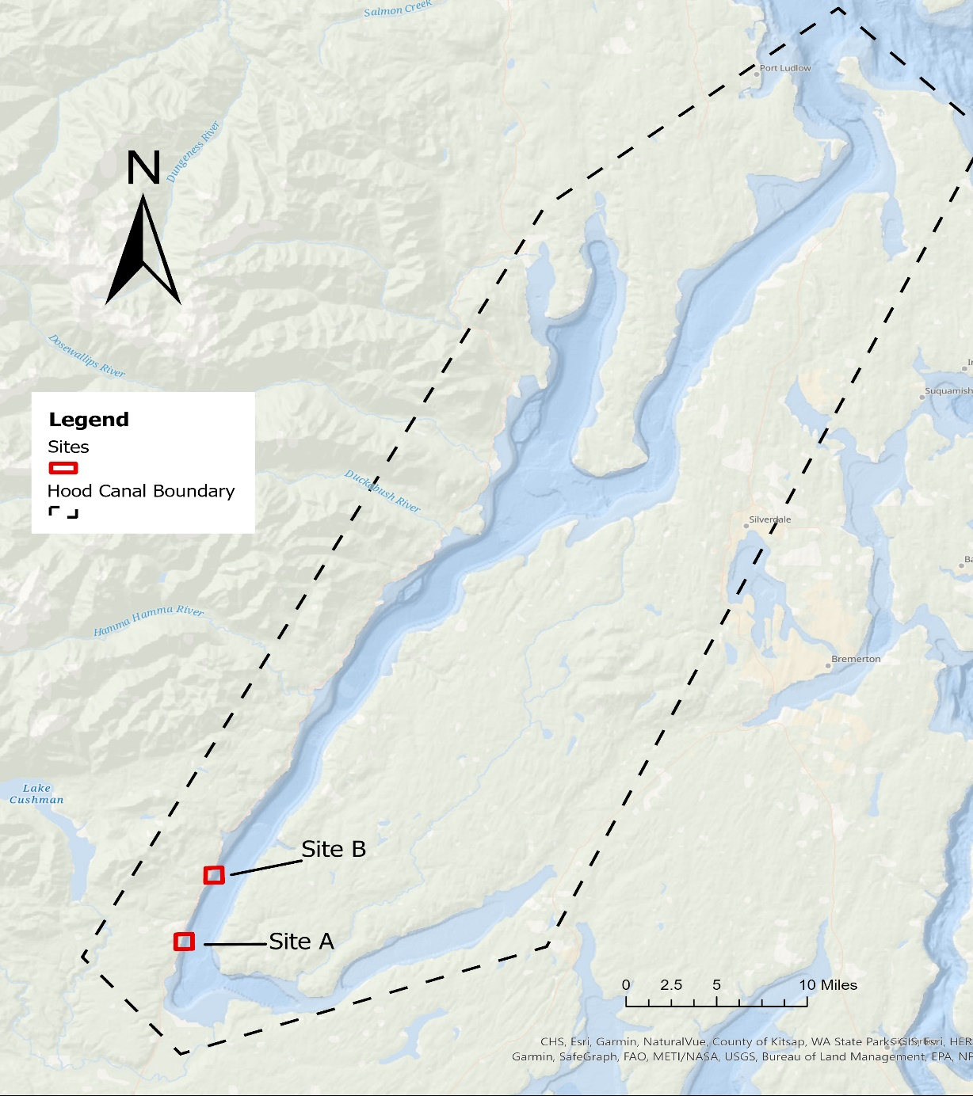

Note. Map of study area and site locations. An arbitrary boundary for Hood Canal is also shown for reference. Created by Max Wiecek, 2023, using the ArcGIS Pro Software

**Figure 2.** Map of Site A

Map of Site A

Note. Study area and survey design for Site A (Yellow House Cove). Numbers represent the order in which transects were deployed and arrows depict direction. Created by Max Wiecek, 2023, using the ArcGIS Pro Software.

**Figure 3**. Map of Site B

*Map of Site B*

Note. Study area and survey design for Site B (Sund Rock Marine Preserve). Numbers represent the order in which transects were deployed and arrows depict direction. Created by Max Wiecek, 2023, using the ArcGIS Pro Software.

## Density and Percent Cover Measurements

Densities of understory kelps, along with percent cover of other green, red, and brown algae were measured as part of a one-time survey at each site. Only large brown algae in the taxonomic order Laminariales, along with the invasive brown algae *Sargassum muticum*, were identified at the species level. Red and green algae were instead classified at the division level, Rhodophyta and Chlorophyta, respectively. This method was chosen as their pigmentations are easily distinguished and identifying these organisms to lower taxonomic levels can be difficult in the field.

For understory kelps, individuals with holdfasts attached within the 1 m2 quadrat were counted and recorded on an underwater dive slate. Individuals were counted only when they could be identified at the species level. Following field data collection, the average density (individuals per m-2) of each species was estimated at both sites using the following equation:

Average density of *species a* per quadrat = $\frac{Total number of species a found in all plots}{(size of quadrat)(\# of plots sampled)}$

To estimate the percent cover of red and green algae, along with the invasive brown algae *S. muticum*, cover scores of 1 to 5 were used. This approach was adapted from kelp monitoring methods published by MaPP and includes the following ranking system for estimating macroalgal abundance: (1) Very low density: less than 20 percent coverage, (2) Low density: 20-40 percent, (3) Medium density: 40-60 percent, (4) High density: 60-80 percent, (5) Very high density: 80-100 percent (Thompson, 2021). To ensure accurate estimates were made for smaller algae within each quadrat, the diver would gently move kelp fronds as needed to achieve a better view of the benthic environment. The cover score of each type of macroalgae was recorded on the dive slate and later transferred to an Excel spreadsheet for further analysis.

## Substrate Classification and Cover Type

Substrate type and relative cover were recorded for each quadrat placement at both sites. Descending in order from largest grain size to smallest, the following classifications were used to describe substrate type: boulder, cobble, pebble, and sand. Similar classifications have been used throughout Puget Sound and the North Pacific where substrate information was collected (Cochrane et al., 2015; Thompson, 2021). Once the substrate could be accurately identified, primary and secondary cover were observed and recorded. The level of cover was separated into three categories: dominant, non-dominant, and absent. If a substrate type was observed as covering more than fifty percent of the 1-m2 quadrat, it was labeled as dominant. Any percentage of a different substrate type, therefore, was noted and recorded as non-dominant.

# Statistical Analysis

Field data was transferred from dive slates into Microsoft Excel spreadsheets for further analysis. Understory kelp densities, as well as cover scores of macroalgae and substrate were analyzed using the R statistical software.

*Understory Kelp Densities*

A non-parametric, two-sample t-test known as the Mann-Whitney U Test (Wilcox Rank Sum Test) was used to compare mean densities of understory kelp populations at each site. Two columns of data were required to complete this analysis. Therefore, site names, “A” and “B”, were both placed into one column, while stipe counts for individual kelp species were placed into another column. The sample size for this dataset was n = 60, with an alpha value set as α = 0.05. Under the assumption that the values in these columns are independent of one another, the null hypothesis was set as the following:

Ho: Mean densities of understory kelp at Site A are equal to the mean densities of understory kelp at Site B.

HA: Mean densities of understory kelp at Site A are not equal to the mean densities of understory kelp at Site B.

## Macroalgae Cover Classes

Cover scores (1-5) for other red, green, and brown algae were compared using a Kruskal-Wallis H-test. This non-parametric test was used to compare the ranked means across both sites. The null hypothesis for this group was set as:

Ho: Mean cover scores of understory macroalgae at Site A are equal to the cover scores of macroalgae at Site B.

HA: Mean cover scores of understory macroalgae at Site A are not equal to the cover scores of macroalgae at Site B.

Similar to the Mann-Whitney U Test used for measuring kelp densities, the Kruskal-Wallis test was chosen as it does not assume a normal distribution of the underlying data (Xia, 2020). It was anticipated that cover scores for understory macroalgae would not follow a normal distribution. Therefore, it was determined that using ranks rather than actual values would alleviate testing issues associated with outliers or the non-normal distribution of data.

## Substrate Type and Cover Level

A Pearson’s chi-square test was done on substrate samples for each site. Two categorical variables, substrate type and cover level, were arranged in contingency tables and their distributions compared. Substrate type was identified as the independent variable, and contained four subgroups: Boulder, Cobble, Pebble, and Sand. Cover level, the dependent variable, contained three subgroups: Dominant, Non-dominant, and Absent. Once these variables were arranged in contingency tables, they were uploaded to R for statistical analysis. The following null and alternative hypotheses for this test were set as:

Ho: Cover level is independent of substrate type

HA: Cover level is somewhat dependent upon substrate type

Once the initial chi square analysis was complete, the data was also processed for Pearson residuals. This was done to identify categories that contained either higher than expected counts (+ residuals) or lower than expected counts (- residuals).

# Results

## Kelp densities

Two species of understory kelp were identified and counted at Sites A and B: *Saccharina latissima* (Sugar kelp) and *Neoagarum fimbriatum* (Fringed sieve kelp). Site A contained the highest mean densities for both species, with 3.8 individuals m-2 (*SD* = 2.4) for *S. latissima*, and 2.8 individuals m-2 (*SD* = 2.8) for *N. fimbriatum*. Mean densities for *S. latissima* and *N. fimbriatum* at Site B were 2.4 individuals m-2 (*SD* = 3.9) and 1.0 individuals m-2 (*SD* = 1.3), respectively. However, the highest recorded density within a single quadrat was at site B, with 15 individuals of *S. latissima* appearing in sample number 27 (Figure 4). Out of 30 quadrat placements at Site A, 20 contained both species, 6 contained only *S. latissima*, 1 contained only *N. fimbriatum*, and 3 contained neither. Similarly, out of 30 samples at Site B, 13 contained both species, 1 contained only *S. latissima*, 1 contained only *N. fimbriatum*, and 15 contained neither. Total average densities across both sites for *S. latissima* and *N. fimbriatum* equaled 3.1 individuals m-2 and 1.9 individuals m-2, respectively (Figures 7 and 8).

A non-parametric, two sample t-test was used to compare understory kelp densities across both sites. The Wilcox rank sum test with continuity correction was generated for densities of both species. *Saccharina latissima* densities varied significantly between sites A and B (w= 637, p = 0.005). *Neoagarum fimbriatum* densities also varied significantly between both sites (w = 625.5, p = 0.007). Therefore, with combined p-values less than 0.05 for both species, we reject the null hypothesis that densities of *S. latissima* and *N. fimbriatum* are equal between sites.

**Figure 4.** Kelp Densities and Depth at Site A

*Kelp Densities and Depth at Site A*

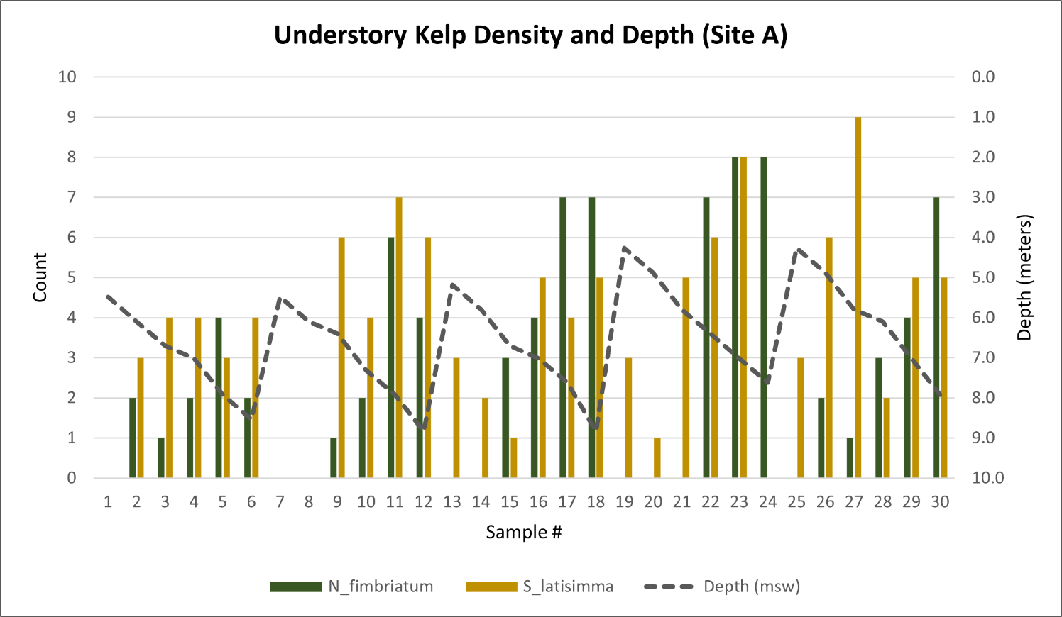

Note. Densities of N. fimbriatum (green) and S. latissima (yellow) plotted against depth at Site A.

**Figure 5.** Kelp Densities and Depth at Site B

*Kelp Densities and Depth at Site B*

Note. Densities of N. fimbriatum (green) and S. latissima (yellow) plotted against depth at Site B.

**Figure 6.** Histogram of S. latissima Densities

*Histogram of S. latissima Densities*

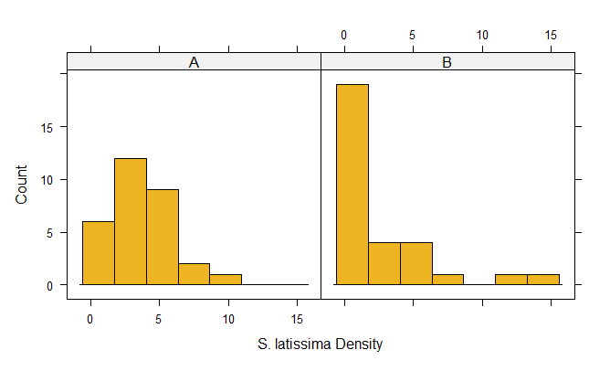

Note. The occurence (count) of Saccharina latissima densities at Sites A and B.

**Figure 7.** Histogram of N. fimbriatum Densities

*Histogram of N. fimbriatum Densities*

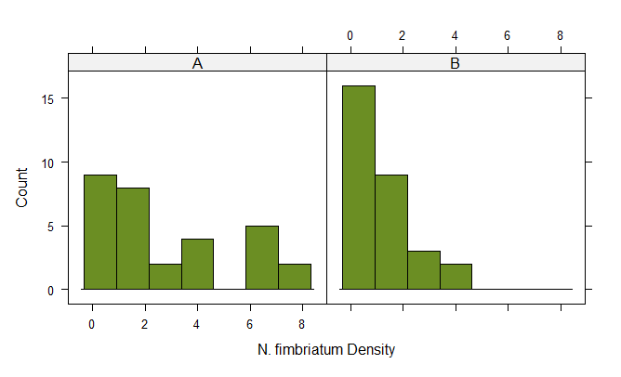

Note. The occurence (count) of Neoagarum fimbriatum densities at Sites A and B.

**Figure 8.** Boxplot of S. latissima Densities

*Boxplot of S. latissima Densities*

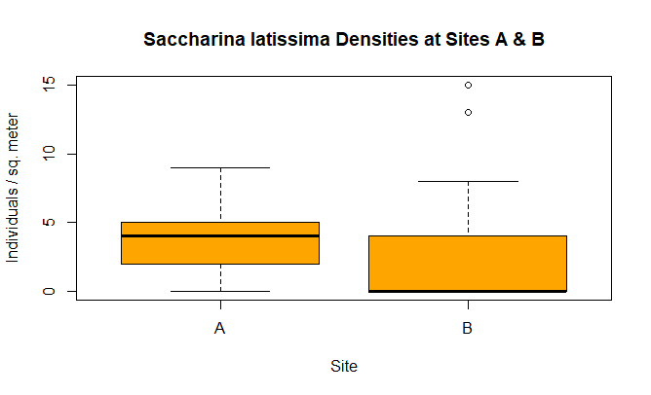

Note. Box and whisker plots of S. latissima densities for both Sites A and B.

**Figure 9.** Boxplot of N. fimbriatum Densities

*Boxplot of N. fimbriatum Densities*

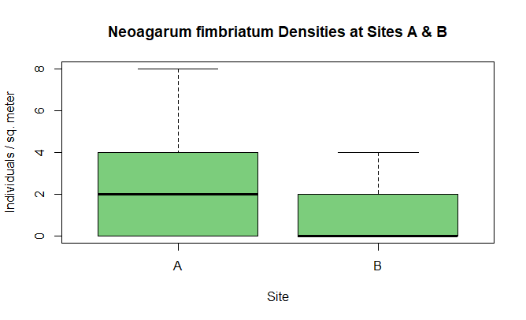

Note. Box and whisker plots of N. fimbriatum densities for both Sites A and B.

## Macroalgae cover

Cover scores from 1-5 were documented for observations of other red and green macroalgae, as well as the non-native species of brown algae, *Sargassum muticum*. Also, the ranked means were compared using a Kruskal-Wallis rank sum test from cover scores of all three categories. All three groups of macroalgae were present throughout the study, with green algae (Ulva sp.) reaching the highest cover scores among these groups at both sites (Figures 10 & 11). Differences in mean cover scores for green algae were significant (Kruskal-Wallis chi-squared = 7.3, df = 1, p = 0.007), with average scores of 3.3 at Site A and 2.4 at Site B. These scores correspond to cover percentages around 45% and 30%, respectively. Florideophyceae, or red algae, were also quite common throughout the study, however, at slightly lower cover levels. Average cover scores for this group at sites A and B were 1.3 and 1.9, respectively, and varied significantly between sites (Kruskal-Wallis chi squared = 6.5, df = 1, p = 0.01) Thus, across both sites, the average percent cover for red algae was approximately 13-20%. The invasive brown algae, *S. muticum* (Japanese wireweed), reached the highest percent cover at Site B, and varied significantly between sites (Kruskal-Wallis chi-squared = 6.6, df = 1, p = 0.01). The average cover score at site B was 1.5 (Approx. 15% cover), while Site A contained an average of only 0.6 (Approx. 6% cover). Therefore, with p-values less than 0.05 and critical chi-square values greater than 5.991, we reject the null hypothesis that mean cover scores of macroalgae are equal between Sites A and B.

**Figure 10.** Macroalgae Cover and Depth at Site A

*Macroalgae Cover and Depth at Site A*

Note. Cover levels (1-5) of green and red algae, along with S. muticum, plotted against depth at Site A. (1) Very low density: less than 20 percent coverage, (2) Low density: 20-40 percent, (3) Medium density: 40-60 percent, (4) High density: 60-80 percent, (5) Very high density: 80-100 percent

**Figure 11.** Macroalgae Cover and Depth at Site B

*Macroalgae Cover and Depth at Site B*

Note. Cover levels (1-5) of green and red algae, along with S. muticum, plotted against depth at Site B.

**Figure 12**. Green Algae Cover at Sites A and B

*Green Algae Cover at Sites A and B*

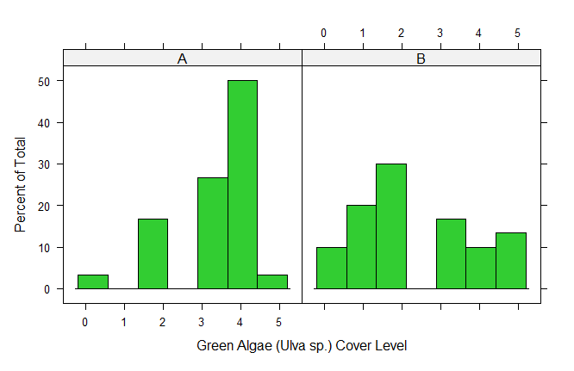

Note. Cover levels of green algae represented as the percentage of observations within a cover class at Sites A and B.

**Figure 13.** Red Algae Cover at Sites A and B

*Red Algae Cover at Sites A and B*

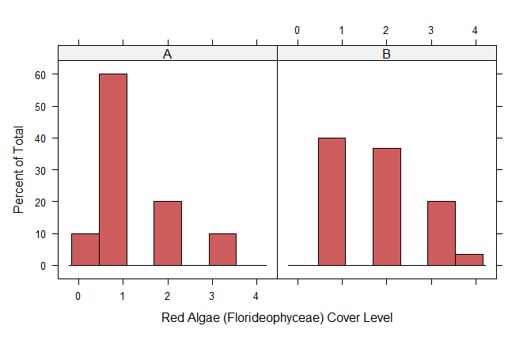

Note. Cover levels of red algae represented as the percentage of observations within a cover class at Sites A and B.

**Figure 14.** Sargassum muticum Cover at Sites A and B

*Sargassum muticum Cover at Sites A and B*

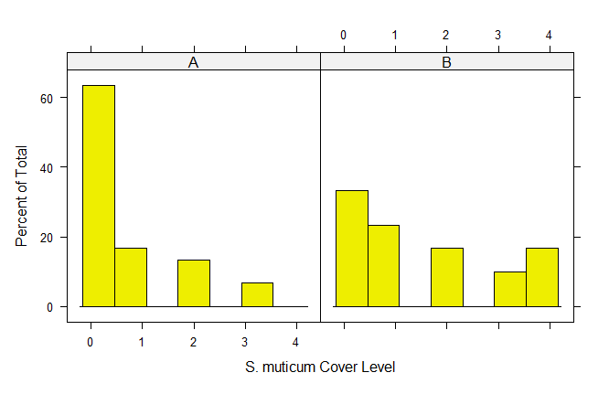

Note. Cover levels of Sargassum muticum represented as the percentage of observations within a cover class at Sites A and B.

## Substrate Type and Cover Level

Four types of substrate varying in grain size and level of cover were documented at both sites. Descending in order from largest grain size to smallest, this included boulder, cobble, pebble, and sand. The primary substrate at Site A was sand, with 20 out of 30 samples labeled as “dominant” for this substrate type. Other dominant substrates included cobble (n=5) and pebble (n=5). There was also significant secondary cover (< 50%) of these substrate types. Out of 30 samples, cobble was non-dominant in 14 and pebble was non-dominant in 15. None of the samples at Site A contained boulders. Site B was characterized by larger grain sizes such as cobble and boulder. Cobble was labeled as dominant in 16 out of 30 samples and was therefore the primary substrate at this site. Secondary cover of this substrate type was also noteworthy (n=10). Boulder was the dominant substrate type in only 2 samples, and was more commonly found as non-dominant, secondary cover (n=5)

**Table 1.** Substrate Matrix Table for Site A

*Substrate Matrix Table (Site A)*

|  |  |  |  |  |  |
| --- | --- | --- | --- | --- | --- |
|  | Boulder | Cobble | Pebble | Sand | Total |
|  |  |  |  |  |  |
| Dominant | 0 | 5 | 5 | 20 | 30 |
| Non-Dominant | 0 | 14 | 15 | 10 | 39 |
| Absent | 30 | 11 | 10 | 0 | 51 |
| Total | 30 | 30 | 30 | 30 | 240 |

Note. A matrix table showing the occurrence of substrate types and cover levels for Site A. Row and column totals are shown in blue.

**Table 2.** Substrate Matrix Table for Site B

*Substrate Matrix Table (Site B)*

|  |  |  |  |  |  |
| --- | --- | --- | --- | --- | --- |
|  | Boulder | Cobble | Pebble | Sand | Total |
|  |  |  |  |  |  |
| Dominant | 2 | 16 | 1 | 11 | 30 |
| Non-Dominant | 5 | 10 | 8 | 13 | 36 |
| Absent | 23 | 4 | 21 | 6 | 54 |
| Total | 30 | 30 | 30 | 30 | 240 |

Note. A matrix table showing the occurrence of substrate types and cover levels for Site B. Row and column totals are shown in blue.

Contingency tables created in Excel were uploaded into R for further analysis. Results from the Pearson’s Chi Square test show substantial differences in substrate type and cover level at both Sites A & B. Within Site A, cover levels were not the same across all subgroups (x2 = 81.36, df = 6, p = 1.87 x 10-15). The standardized residuals reveal a higher-than-expected absence of boulder substrate, as well as a higher-than-expected dominance of sand. These account for the greatest differences observed at Site A. Similarly, at Site B, cover levels of different substrate types were not equal across subgroups (x2 = 46.42, df = 6, p = 2.45 x 10-8). Boulder and pebble substrate were less dominant than expected, and cobble was more dominant than expected. The absence of boulder and pebble were higher than expected, while the absence of cobble and sand were lower than expected. The contingency analysis also found that substrate and corresponding cover levels were significantly different between sites (x2 = 98.18, df = 6, p = 2.2 x 10-16).

**Figure 15.** Mosaic Plot of Substrate Type and Cover at Site A

*Mosaic Plot of Substrate Type and Cover at Site A*

Note. Primary and secondary cover of the four subgroups of substrate. Cells are proportional to the frequency of each combination of variables.

**Figure 16.** Standardized Residuals of Substrate Type and Cover at Site A

*Standardized Residuals of Substrate Type and Cover at Site A*

Note. Standardized residuals for the four subgroups of substrate at Site A. Darker colors represent either higher (blue) or lower (red) than expected counts. Cells are proportional to the frequency of each combination of variables.

**Figure 17.** Mosaic Plot of Substrate Type and Cover at Site B

*Mosaic Plot of Substrate Type and Cover at Site B*

Note. Primary and secondary cover of the four subgroups of substrate at Site B. Cells are proportional to the frequency of each combination of variables.

**Figure 18.** Standardized Residuals of Substrate Type and Cover at Site B

*Standardized Residuals of Substrate Type and Cover at Site B*

Note. Standardized residuals for the four subgroups of substrate at Site B. Darker colors represent either higher (blue) or lower (red) than expected counts. Cells are proportional to the frequency of each combination of variables.

## Relationship Between Substrate and Macroalgae

To determine if there is an association between substrate type and cover levels of macroalgae, contingency tables were created in Excel and chi-square tests were run in R across all subgroups (green algae, red algae, and *S. muticum*). With macroalgae cover level set as the dependent variable and substrate type set as the independent variable, the following null and alternative hypotheses were assigned:

Ho: Macroalgae cover is independent of substrate type

Ha: Macroalgae cover is somewhat dependent upon substrate type

In this case, both primary and secondary cover of substrate types were included in the analysis to avoid statistical errors associated with having too many expected values of zero. The subsequent Pearson’s chi-squared test revealed no association between cover levels of green algae and substrate type (x2 = 10.78, df = 15, p = 0.77). Similarly, no association was detected between cover levels of red algae and substrate type (x2 = 7.7, df = 12, p = 0.81). As such, we were unable to reject the null hypothesis that cover levels of both green and red macroalgae are independent of substrate type. For the invasive *Sargassum muticum*, however, the resulting chi-square test suggested that cover levels of this species are associated with substrate type (x2 = 24.63, df = 12, p = 0.02).

**Table 3.** Green Algae and Substrate Contingency Table

*Green Algae and Substrate Contingency Table*

|  |  |  |  |  |  |
| --- | --- | --- | --- | --- | --- |
| **Green Algae Cover** | **Boulder** | **Cobble** | **Pebble** | **Sand** | **Row Total** |
| Absent | 1 | 4 | 2 | 2 | ***9*** |
| Very Low (<20%) | 2 | 5 | 3 | 5 | ***15*** |
| Low (20-40%) | 3 | 12 | 5 | 12 | ***32*** |
| Medium (40-60%) | 1 | 9 | 8 | 12 | ***30*** |
| High (60-80%) | 0 | 11 | 10 | 18 | ***39*** |
| Very High (80-100%) | 0 | 4 | 1 | 5 | ***10*** |
| **Column Total** | ***7*** | ***45*** | ***29*** | ***54*** | ***270*** |

Note. Contingency table showing observed values of green algae cover and substrate type across all samples. The grand total, as well as column and row totals, are bolded and italicized.

**Table 4.** Red Algae and Substrate Contingency Table

*Red Algae and Substrate Contingency Table*

|  |  |  |  |  |  |
| --- | --- | --- | --- | --- | --- |
| **Red Algae Cover** | **Boulder** | **Cobble** | **Pebble** | **Sand** | **Row Total** |
| Absent | 0 | 1 | 3 | 3 | ***7*** |
| Very Low (<20%) | 3 | 19 | 16 | 29 | ***67*** |
| Low (20-40%) | 3 | 17 | 5 | 13 | ***38*** |
| Medium (40-60%) | 1 | 7 | 4 | 8 | ***20*** |
| High (60-80%) | 0 | 1 | 1 | 1 | ***3*** |
| **Column Total** | ***7*** | ***45*** | ***29*** | ***54*** | ***270*** |

Note. Contingency table showing observed values of red algae cover and substrate type across all samples. The grand total, as well as column and row totals, are bolded and italicized.

**Table 5.** S. muticum and Substrate Contingency Table

*Sargassum muticum and Substrate Contingency Table*

|  |  |  |  |  |  |
| --- | --- | --- | --- | --- | --- |
| **Sargassum Cover** | **Boulder** | **Cobble** | **Pebble** | **Sand** | **Row Total** |
| Absent | 0 | 23 | 15 | 28 | ***66*** |
| Very Low (<20%) | 0 | 9 | 6 | 11 | ***26*** |
| Low (20-40%) | 3 | 4 | 6 | 7 | ***20*** |
| Medium (40-60%) | 1 | 4 | 2 | 5 | ***12*** |
| High (60-80%) | 3 | 5 | 0 | 3 | ***11*** |
| **Column Total** | ***7*** | ***45*** | ***29*** | ***54*** | ***270*** |

Note. Contingency table showing observed values of S. muticum cover and substrate type across all samples. The grand total, as well as column and row totals, are bolded and italicized.

# Discussion

By using SCUBA surveys and kelp monitoring protocols developed by MaPP, understory kelp densities, percent cover of red, green, and brown algae, as well as substrate type and cover were documented at two sites in southern Hood Canal. Scuba-based monitoring programs have been used to assess understory kelp populations in the central Strait of Juan de Fuca (Rubin et al., 2017; Rubin, 2020), but such efforts have largely been absent in the Hood Canal. Large-scale aerial imagery, also known as tier 1 surveys, have previously been used to collect baseline information on kelp location and extent within the region (Berry et al., 2001). However, tier 2 surveys such as species ID, substrate type, and measures of kelp density (Thompson, 2021) have not been previously recorded at these two sites. Thus, this work presents high-resolution data on species abundance and substrate characteristics on a smaller, site-specific level.

By utilizing site-specific surveys, this research has demonstrated that two sites in the southern limits of Hood Canal host populations of understory kelp species such as *Neoagarum fimbriatum* (Fringed sieve kelp) and *Saccharina latissima* (Sugar kelp). *S. latissima* reached the highest mean densities between the two species, which is consistent with similar studies done in Puget Sound. At Titlow Beach near the Tacoma Narrows, for example, researchers found that *S. latissima* reached the highest mean densities (5.6 individuals m-2) among the species studied there (Maxell & Miller, 1996), which is slightly greater than the mean densities observed in this research (3.1 individuals m-2). Although occurring at lower mean densities (1.9 individuals m-2), *N. fimbriatum* may also have potential implications on food availability for local filter feeders. Previous research utilizing two suspension feeders, including a serpulid polychaetae and the mussel *Mytilus trossulus,* found that aged *Agarum fimbriatum* particles promoted some of the highest growth rates in both consumers (Duggins & Eckman, 1997). While more research is needed to evaluate the ecological effects of *N. fimbriatum* in the field, the presence of this kelp species in southern Hood Canal may suggest a positive effect on local species of filter feeders.

There appeared to be significant differences in depth distributions of both kelp species at either site. At Site A, both species were found at depths ranging from -5 m to about -9 m (MLLW). *N. fimbriatum* typically began to appear slightly deeper than *S. latissima* at this site, starting at depths around -6 m (MLLW) (Figure 3). At Site B, however, the kelps were restricted to deeper depths ranging between -8 m and -10 m, with no kelp observed above depths of -6.1 m (MLLW). When both species were found at shallower depths around -6.1 to -7 m (MLLW), they occurred at much lower densities (Figure 4). These depth distributions are consistent with recent observations that found high cover of understory kelp frequently occupying depths between -3 and -7 m throughout Puget Sound (MLLW) (Christiaen et al., 2023).

One potential reason for the deeper depth distributions of kelp at Site B could be the presence of the invasive brown algae, *Sargassum muticum*, which occurred at medium to high cover levels (3-4) between depths of -2.4 and -6.4 m (MLLW) (Figure 10). *Sargassum* can form large dense beds that are capable of displacing native seaweeds and other marine vegetation (Druehl & Clarkston, 2016). This invasive species has become well adapted to local waters and occupies a much wider range of situations along Puget Sound’s shorelines than in its home waters of Japan (Druehl & Clarkston, 2016). It is often found in the lower intertidal and subtidal zones (-3 to -5 m) attached to rocky substrate in wave-sheltered areas (Lewis, 2009). Although it never reached 100 % cover in any of the samples, *S. muticum* appeared to favor the conditions present at Site B. Compared to Site A, which had dominant substrate of smaller grain size (sand and pebble), Site B contained more cobble and boulder substrate (Figure 16). Stable boulder substratum (>10 cm in diameter) was found to facilitate *S. muticum* growth and abundance in other regions as well (Abbott & Hollenberg, 1976; Thomsen et al., 2006). While multiple factors are likely contributing to these observations, this could partially explain why cover levels of *S. muticum* were higher and understory kelp densities were lower at Site B.

Other red, green, and brown macroalgae were consistently observed across all samples at both sites. Green algae, primarily *Ulva sp.*, dominated shallower depths of -4 to -6 m at Site A (Figure 9), while at Site B their cover levels were greater at deeper depths around -7 to -10 m (MLLW) (Figure 10). The depth range of green algae at Site A is more consistent with previous observations that found high cover levels of green algae frequently occurring at depths shallower than -5 m (MLLW) in Puget Sound (Christiaen et al., 2023). Although primarily occurring at lower cover classes (1-2), red algae was distributed across the entire depth range at both sites. This pattern is also similar to observations made in the Salish Sea, where red-brown algae were found throughout entire depth ranges and occurred in low to medium percent cover classes (Christiaen et al., 2023). As previously mentioned, *Sargassum muticum* was found at both sites A and B, though it was more common at Site B. Out of 30 samples at Site B, 20 contained *S. muticum*, while Site A only yielded 11 samples containing *S. muticum*. This invasive brown algae is a species of concern as it displaces native marine vegetation (Druehl & Clarkston, 2016) and is less palatable to commercially important grazers like the green sea urchin (Britton-Simmons, 2004).

This study also aimed to acquire preliminary information on primary and secondary cover of various substrate types. Collecting information on substrate represents a Tier 2+ survey (Thompson, 2021), which was done in an effort to characterize the benthic environment and better understand available habitat for marine vegetation in southern Hood Canal. In addition, this study documented significant differences in substrate type between the two sites. Grain size was highly variable within samples, and quadrats would commonly contain 2-3 different types of substrates. For instance, Site A was characterized by smaller grain sizes, with sand being the dominant substrate type. There was also significant secondary cover of larger grain sizes such as pebble and cobble. Conversely, Site B was characterized by cobble substrate and was the only site that contained both primary and secondary cover of boulder. There appeared to be an even distribution of boulder, cobble, pebble, and sand as secondary cover at this site as well. It is important to note that while bedrock is present at Site B and, based on anecdotal evidence, constitutes a major substrate type in that area, it was not recorded in this research. However, these findings still suggest that substrate complexity is considerably different between each site. Complex substrate (large cobble and boulders) was more prevalent at Site B, while homogenous substrate (small cobble, pebble, and sand) was more common at Site A. Structural complexity can have significant impacts on top-down and bottom-up processes and influences kelp-forest stability at both large and small spatial scales (Randell et al., 2022). Previous research has demonstrated that canopy and understory kelp species are positively associated with structurally complex substratum (Hamilton & Konar, 2007). This small-scale heterogeneity may have important implications for understory macroalgae and other marine organisms residing in nearshore ecosystems of Hood Canal.

There are several inherent limitations with this study as well. First, the SCUBA surveys that were conducted only capture a snapshot in time and do not reflect the annual or seasonal variability of understory macroalgae and kelp at these two sites. Rather, this research was part of a one-time survey effort to collect preliminary density estimates at sites that had not been previously surveyed. As a result, it is recommended that these sites are revisited and surveyed regularly to obtain long-term density measurements and demographic information. Additionally, this research did not measure the effects of environmental variables (light, salinity, temperature, etc.) or inter- and intra-specific competition on macroalgal densities. These factors are known to impact densities and recruitment in understory kelp communities (Maxell & Miller, 1996; Umanzor et al., 2018), and encompasses an area of research that is critical in understanding community dynamics within these ecosystems. Next, due to issues surrounding liabilities, administrative restrictions, and volunteer availability, the SCUBA surveys were on a smaller scale than anticipated. In other words, we were unable to capture the desired extent of the subtidal environment at each site. While this likely does not undermine the data collected, it prompts the need for more comprehensive SCUBA surveys that can provide robust data on macroalgal densities and substrate cover on a larger scale.

# Conclusion

Prostrate kelps are unlike canopy-forming species in that they lack a rigid stipe (stem) or floating mechanism (buoy), rendering them horizontal on the seafloor and forming what is known as the “understory” (Calloway et al., 2020). While they may not always be visible from the surface, they are among the most widely distributed forms of kelp found throughout the region (ShoreZone, 2001). Species such as *Saccharina latissima, Costaria costata, and Agarum fimbriatum* are believed to provide important primary production, refuge, and habitat for numerous marine species throughout Puget Sound (Calloway et al., 2020; Mumford, 2007). There is evidence to suggest that understory kelp and other macroalgae are ubiquitous throughout Puget Sound (Christiaen et al., 2023), however, a significant lack of information regarding changes in their abundances or distributions over time remains (Mumford, 2007).

The lack of research on understory kelp throughout Puget Sound has prompted the need for site-specific surveys and higher resolution data. We aimed to address this by collecting preliminary data on understory kelp populations at two sites with no previous history of marine vegetation surveys. Despite being located far from the influence of oceanic conditions (high current, cold temperatures, higher salinity), varying densities of two understory kelp species, along with mixed cover levels of other macroalgae were documented at two sites in southern Hood Canal. Combining information on species identification, relative abundances, substrate, and other variables should remain a high priority for researchers and management agencies.

# References

Abbott, I. A., & Hollenberg, G. J. (1976). Marine Algae of California. In *Marine Algae of California*. Stanford University Press. <https://doi.org/10.1515/9781503621053>

Berry, H. D., Mumford, T. F., Christiaen, B., Dowty, P., Calloway, M., Ferrier, L., Grossman, E. E., & VanArendonk, N. R. (2021). Long-term changes in kelp forests in an inner basin of the Salish Sea. *PLOS ONE*, *16*(2), e0229703. <https://doi.org/10.1371/journal.pone.0229703>

Boas, F., & Hunt, G. (1921). *Ethnology of the Kwakiutl, based on data collected by George Hunt*. Government Printing Office. <http://hdl.loc.gov/loc.gdc/scd0001.00112360347>

Britton-Simmons, K. (2004). Direct and indirect effects of the introduced alga Sargassum muticum on benthic, subtidal communities of Washington State, USA. *Marine Ecology-Progress Series - MAR ECOL-PROGR SER*, *277*, 61–78. <https://doi.org/10.3354/meps277061>

Brown, A. (2013). *The effect of fresh and aged Agarum fimbriatum and Nereocystis luetkeana diets on the population growth of Tigriopus californicus*. <https://digital.lib.washington.edu:443/researchworks/handle/1773/27185>

Bruno, J. F., Stachowicz, J. J., & Bertness, M. D. (2003). Inclusion of facilitation into ecological theory. *Trends in Ecology & Evolution*, *18*(3), 119–125. <https://doi.org/10.1016/S0169-5347(02)00045-9>

Calloway, M., D. Oster, H. Berry, T. Mumford, N. Naar, B. Peabody, L. Hart, D. Tonnes, S. Copps, J. Selleck, B. Allen, and J. Toft. 2020. Puget Sound kelp conservation and recovery plan. Prepared for NOAA-NMFS, Seattle, WA. 52 pages plus appendices. Available at: <https://nwstraits.org/our-work/kelp/>.

Carney, L. T., Waaland, J. R., Klinger, T., & Ewing, K. (2005). Restoration of the bull kelp Nereocystis luetkeana in nearshore rocky habitats. *Marine Ecology Progress Series*, *302*, 49–61. <https://doi.org/10.3354/meps302049>

Christiaen, B. (2020). Spatial and depth distribution of understory kelp and other marine vegetation in Central Puget Sound. *Salish Sea Ecosystem Conference*. <https://cedar.wwu.edu/ssec/2020ssec/allsessions/83>

Christiaen B., H. Berry, L. Ferrier, P. Dowty, J. Gaeckle, L. Johnson, M. Sanchez and T. Cowdrey. 2023. Marine Vegetation in the southern Salish Sea. Final report to the SeaDoc Society. A17-0568-S012. Nearshore Habitat Program. Washington State Department of Natural Resources, Olympia, WA.

Christiaen B., L. Ferrier, M. Sanchez, L. Johnson. 2022. Marine Vegetation along the Snohomish County shoreline between Edmonds and Everett. Final report to Snohomish County. IAA 93-102327. Nearshore Habitat Program. Washington State Department of Natural Resources, Olympia, WA.

Dayton, P. K. (1985). Ecology of Kelp Communities. *Annual Review of Ecology and Systematics*, *16*(1), 215–245. <https://doi.org/10.1146/annurev.es.16.110185.001243>

DNR. (n.d.). *Washington Marine Vegetation Atlas*. Washington State Department of Natural Resources. Retrieved April 12, 2022, from [http://mva-test.apphb.com/index.html#](http://mva-test.apphb.com/index.html)

Doughton, S. (2021, October 31). *An ambitious new alliance works to identify what’s happening to our crucial kelp forests in order to protect—And, hopefully, restore—Them*. The Seattle Times. <https://www.seattletimes.com/pacific-nw-magazine/an-ambitious-new-alliance-works-to-identify-whats-happening-to-our-crucial-kelp-forests-in-order-to-protect-and-hopefully-restore-them/>

Druehl, L., & Clarkston, B. (2016). *Pacific Seaweeds: Updated and Expanded Edition* (Updated, Expanded edition). Harbour Publishing.

Duggins, D., Gomez-Buckley, M., Buckley, R., Lowe, A., Galloway, A., & Dethier, M. (2016). Islands in the stream: Kelp detritus as faunal magnets. *Marine Biology*, *163*, 17. <https://doi.org/10.1007/s00227-015-2781-y>

Duggins, D. O., & Eckman, J. E. (1994). The role of kelp detritus in the growth of benthic suspension feeders in an understory kelp forest. *Journal of Experimental Marine Biology and Ecology*, *176*(1), 53–68. <https://doi.org/10.1016/0022-0981(94)90197-X>

Duggins, D. O., & Eckman, J. E. (1997). Is kelp detritus a good food for suspension feeders? Effects of kelp species, age and secondary metabolites. *Marine Biology*, *128*(3), 489–495. <https://doi.org/10.1007/s002270050115>

Duggins, D. O., Eckman, J. E., & Sewell, A. T. (1990). Ecology of understory kelp environments. II. Effects of kelps on recruitment of benthic invertebrates. *Journal of Experimental Marine Biology and Ecology*, *143*(1), 27–45. <https://doi.org/10.1016/0022-0981(90)90109-P>

Duggins, D. O., Simenstad, C. A., & Estes, J. A. (1989). Magnification of secondary production by kelp detritus in coastal marine ecosystems. *Science (New York, N.Y.)*, *245*(4914), 170–173. <https://doi.org/10.1126/science.245.4914.170>

*E-Flora BC Photo Gallery: Photo Details*. (n.d.). Retrieved October 15, 2022, from <http://linnet.geog.ubc.ca/ShowDBImage/ShowStandard.aspx?index=14777>

Eger, A. M., Marzinelli, E., Gribben, P., Johnson, C. R., Layton, C., Steinberg, P. D., Wood, G., Silliman, B. R., & Vergés, A. (2020). Playing to the Positives: Using Synergies to Enhance Kelp Forest Restoration. *Frontiers in Marine Science*, *7*. <https://www.frontiersin.org/articles/10.3389/fmars.2020.00544>

Fredriksen, S., Filbee-Dexter, K., Norderhaug, K. M., Steen, H., Bodvin, T., Coleman, M. A., Moy, F., & Wernberg, T. (2020). Green gravel: A novel restoration tool to combat kelp forest decline. *Scientific Reports*, *10*(1), Article 1. <https://doi.org/10.1038/s41598-020-60553-x>

Hamilton, J., & Konar, B. (2007). Implications of substrate complexity and kelp variability for south-central Alaskan nearshore fish communities. *Http://Aquaticcommons.Org/Id/Eprint/8891*. <https://aquadocs.org/handle/1834/25535>

Levitt, G. J., Anderson, R. J., Boothroyd, C. J. T., & Kemp, F. A. (2002). The effects of kelp harvesting on its regrowth and the understorey benthic community at Danger Point, South Africa, and a new method of harvesting kelp fronds. *African Journal of Marine Science*, *24*, 71–85.

Lewis, J. (2009). Sargassum muticum (wire weed). *CABI Compendium*, *CABI Compendium*, 108973. <https://doi.org/10.1079/cabicompendium.108973>

Lind, A. C., & Konar, B. (2017). Effects of abiotic stressors on kelp early life-history stages. *ALGAE*, *32*(3), 223–233. <https://doi.org/10.4490/algae.2017.32.8.7>

Mac Monagail, M., Cornish, L., Morrison, L., Araújo, R., & Critchley, A. T. (2017). Sustainable harvesting of wild seaweed resources. *European Journal of Phycology*, *52*(4), 371–390. <https://doi.org/10.1080/09670262.2017.1365273>

Maiden of Deception Past Guardian of Her Samish People. (n.d.). *Red Nation Film Festival*. Retrieved November 14, 2022, from <https://www.rednationff.com/maiden-of-deception-past/>

Maxell, B. A., & Miller, K. A. (1996). *Demographic Studies of the Annual Kelps Nereocystis luetkeana and Costaria costata (Laminariales, Phaeophyta) in Puget Sound, Washington*. *39*(1–6), 479–490. <https://doi.org/10.1515/botm.1996.39.1-6.479>

Meng, C., & Mumford, T. (2020). *Patterns of Growth and Erosion of blades of the kelp Saccharina latissima*. <https://digital.lib.washington.edu:443/researchworks/handle/1773/45591>

Muth, A. F. (2012). Effects of Zoospore Aggregation and Substrate Rugosity on Kelp Recruitment Success. *Journal of Phycology*, *48*(6), 1374–1379. <https://doi.org/10.1111/j.1529-8817.2012.01211.x>

Pfister, C. A., Altabet, M. A., & Weigel, B. L. (2019). Kelp beds and their local effects on seawater chemistry, productivity, and microbial communities. *Ecology*, *100*(10), e02798. <https://doi.org/10.1002/ecy.2798>

Randell, Z., Kenner, M., Tomoleoni, J., Yee, J., & Novak, M. (2022). Kelp-forest dynamics controlled by substrate complexity. *Proceedings of the National Academy of Sciences*, *119*(8), e2103483119. <https://doi.org/10.1073/pnas.2103483119>

*RCW 77.55.181: Fish habitat enhancement project—Permit review and approval process—Fees—Limitation of liability.* (n.d.). Retrieved November 19, 2022, from <https://app.leg.wa.gov/rcw/default.aspx?cite=77.55.181>

Rodriguez, G. E. (2014). *Turnover dynamics of the giant kelp, Macrocystis pyrifera* [UC Santa Barbara]. <https://escholarship.org/uc/item/8h14b54x>

Rubin, S. (2020). Assessing understory kelp dynamics with a nine year scuba survey time series. *Salish Sea Ecosystem Conference*. <https://cedar.wwu.edu/ssec/2020ssec/allsessions/11>

Rubin, S. P., Miller, I. M., Foley, M. M., Berry, H. D., Duda, J. J., Hudson, B., Elder, N. E., Beirne, M. M., Warrick, J. A., McHenry, M. L., Stevens, A. W., Eidam, E. F., Ogston, A. S., Gelfenbaum, G., & Pedersen, R. (2017). Increased sediment load during a large-scale dam removal changes nearshore subtidal communities. *PLOS ONE*, *12*(12), e0187742. <https://doi.org/10.1371/journal.pone.0187742>

Sasha Horst (Director). (2021, February 24). *Clallam MRC Kelp Webinar*. <https://www.youtube.com/watch?v=Q-d1mczexWk>

Schoenrock, K. M., Vad, J., Muth, A., Pearce, D. M., Rea, B. R., Schofield, J. E., & Kamenos, N. A. (2018). Biodiversity of Kelp Forests and Coralline Algae Habitats in Southwestern Greenland. *Diversity*, *10*(4), Article 4. <https://doi.org/10.3390/d10040117>

*Seaweeds of Alaska*. (n.d.). Retrieved October 15, 2022, from <https://www.seaweedsofalaska.com/seaweed.asp?phylum=Ochrophyta>

Shaffer, J. A. (2000). Seasonal Variation in Understory Kelp Bed Habitats of the Strait of Juan de Fuca. *Journal of Coastal Research*, *16*(3), 768–775.

Shaffer, J. A., Munsch, S. H., & Cordell, J. R. (2020). Kelp Forest Zooplankton, Forage Fishes, and Juvenile Salmonids of the Northeast Pacific Nearshore. *Marine and Coastal Fisheries*, *12*(1), 4–20. <https://doi.org/10.1002/mcf2.10103>

Starko, S., Bailey, L. A., Creviston, E., James, K. A., Warren, A., Brophy, M. K., Danasel, A., Fass, M. P., Townsend, J. A., & Neufeld, C. J. (2019). Environmental heterogeneity mediates scale-dependent declines in kelp diversity on intertidal rocky shores. *PLOS ONE*, *14*(3), e0213191. <https://doi.org/10.1371/journal.pone.0213191>

Tatsumi, M., & Wright, J. T. (2016). Understory algae and low light reduce recruitment of the habitat-forming kelp Ecklonia radiata. *Marine Ecology Progress Series*, *552*, 131–143. <https://doi.org/10.3354/meps11743>

Teagle, H., Hawkins, S. J., Moore, P. J., & Smale, D. A. (2017). The role of kelp species as biogenic habitat formers in coastal marine ecosystems. *Journal of Experimental Marine Biology and Ecology*, *492*, 81–98. <https://doi.org/10.1016/j.jembe.2017.01.017>

Thompson, Markus (2021) MaPP Kelp Monitoring Protocol. Marine Plan Partnership.

Thomsen, M. S., Wernberg, T., Stæhr, P. A., & Pedersen, M. F. (2006). Spatio-temporal distribution patterns of the invasive macroalga Sargassum muticum within a Danish Sargassum-bed. *Helgoland Marine Research*, *60*(1), 50–58. <https://doi.org/10.1007/s10152-005-0016-1>

Thurstan, R., Flower, J., Beger, M., Dudgeon, C., Gomez, K., Ortiz, J., Kovacs, E., Loder, J., Saunders, M., Passenger, J., Kleine D. and Roelfsema, C (2014). Survey Methods Manual Unidive Point Lookout Ecological Assessment (PLEA). The University of Queensland Underwater Club, Brisbane, Australia.

Turner, N. C., & Bell, M. A. M. (1973). The Ethnobotany of the Southern Kwakiutl Indians of British Columbia. *Economic Botany*, *27*(3), 257–310.

Turner, N. J. (2001). *Coastal peoples and marine plants on the northwest coast*. <https://darchive.mblwhoilibrary.org/handle/1912/2545>

Umanzor, S., Ladah, L., & Zertuche-González, J. A. (2018). Intertidal Seaweeds Modulate a Contrasting Response in Understory Seaweed and Microphytobenthic Early Recruitment. *Frontiers in Marine Science*, *5*. <https://www.frontiersin.org/articles/10.3389/fmars.2018.00296>

*Washington 100*. (n.d.). Retrieved October 4, 2022, from <https://wa100.dnr.wa.gov/puget-lowland/hood-canal>

Wood, G., Marzinelli, E. M., Coleman, M. A., Campbell, A. H., Santini, N. S., Kajlich, L., Verdura, J., Wodak, J., Steinberg, P. D., Vergés, A., Wood, G., Marzinelli, E. M., Coleman, M. A., Campbell, A. H., Santini, N. S., Kajlich, L., Verdura, J., Wodak, J., Steinberg, P. D., & Vergés, A. (2019). Restoring subtidal marine macrophytes in the Anthropocene: Trajectories and future-proofing. *Marine and Freshwater Research*, *70*(7), 936–951. <https://doi.org/10.1071/MF18226>

# Appendix

## Dive Safety Plan

Safety concerns for this thesis work involve the various hazards associated with scuba diving. Utilizing SCUBA for research is potentially more dangerous as it requires task-loading and deployment of additional equipment while underwater. While volunteers will not be required to deploy any additional equipment, they will go through the following screening process before heading out into the field.

**Screening Process**

* Proof that volunteer diver has at least 20 logged dives in Puget Sound
* Volunteer must show a valid Open Water or Advanced Open Water certification
  + Follow the link for PADI certifications and their descriptions: <https://www.padi.com/courses?experience=continuing-education>
* Due to the cold conditions in Puget Sound, they must be familiar with diving in a dry suit. Thus, a dry suit certification is highly recommended
  + Link to Dry Suit Certification: <https://www.padi.com/courses/dry-suit-diver>
* Equipment will be checked prior to entering the water to ensure all components are functioning properly. This follows SDI/TDI guidelines and includes:

1. Air on – Ask buddy to open valve all the way and ensure pressure gauge is functioning. Also, locate alternate air source in the event of an out-of-gas emergency
2. BCD (buoyancy compensator device) inflated – Inflate BCD and verify it holds gas… notice any differences in gear configuration
3. Computer on – Confirm computer is ON and working (sufficient battery, straps secure, and verify correct gas is used)
4. Dive equipment complete – Ensure all necessary equipment is present and in good condition: mask, fins, snorkel, weights, and other potential necessities
5. Enter water safely – No back roll or giant stride necessary for field work… entry will simply be walking in from the shoreline

* Volunteers will be asked to stay hydrated and drink plenty of water the day before diving. This is done to avoid muscle cramping and fatigue, increased heart rate and blood pressure, and confusion
* They must NOT have had any intoxicating substance in in their system 8 hours before the dive, including alcohol, marijuana, or prescription drugs that might cause drowsiness or confusion. They should not have travel plans that involve flying at high altitudes within 24 hours of the last dive

**Field Methods Disclaimer**

*Note:* Field methods have been adapted for SCUBA using kelp monitoring protocols developed by the Marine Plan Partnership for the North Pacific Coast (MaPP). More information can be found by following the link: <https://mappocean.org/science-and-planning-tools/regional-kelp-monitoring/>

Source: Thompson, Markus (2021) MaPP Kelp Monitoring Protocol. Marine Plan Partnership.

Additional guidelines for field work safety and methodologies were acquired from globally recognized organizations such as Reef Check and Coral Watch

**Links:**

Reef Check: <https://www.reefcheck.org/wp-content/uploads/2021/03/RCCA_Manual_10th_Edition_web.pdf>

Coral Watch: <https://coralwatch.org/monitoring/survey-methods/>

**Field Work Safety Steps**

***Before***

* If environmental conditions are unsafe for scuba diving such as extremely poor visibility, lightning, strong winds, etc., then surveys will be postponed
  + Criteria for re-scheduling fieldwork include:
    - Visible white-water from cresting waves
    - Winds exceeding speeds of 15 mph
    - Visibility less than 6 ft (roughly the wingspan of lead researcher)
    - Heavy/torrential rain (light rain is permitted and does not interfere with SCUBA activities as long as lightning and strong winds are absent)
  + **Note** – Currents associated with tidal changes are not prevalent in this study area, but surface currents may occasionally become noticeable. Overall, this is not anticipated to be a significant hazard to divers

***During***

* Divers will conduct a preliminary safety check underwater before each dive:
  + Checking each other’s first stage regulators for leaks
  + Check for leaks in hoses, BCD valves, etc.
  + Identify any other malfunctions with their equipment
* Divers will be given a knife in the event of any potential entanglement. While the transect line consists of a fiberglass reel measuring tape, it is not anticipated that this will create an entanglement hazard.
* Navigation / Locational Awareness
  + Divers will be familiar with their compass bearings to avoid getting disoriented… following a west-oriented compass reading will always lead divers back to shore, with an east-oriented reading leading to open water
  + If divers become separated, they will follow these steps as prepared by SDI/TDI:

1. As soon as you realize that your buddy is gone, stop and take a good look around you, looking up and down, as well as from side to side.
2. It helps to rise a few feet when you survey the area around you. If your buddy has stayed at the same depth, you may see the reflection of light off the tops of his bubbles
3. Spend no more than about a minute looking for your buddy. It may help to backtrack a bit to determine if he stopped for some reason, rather than wandered off on his own.
4. Ascend to the surface, always observing the correct ascent rates and procedures.
5. If not already there looking for you, your buddy should arrive shortly.
6. If your buddy has not returned to the surface after 5 minutes, there may indeed be a problem and you should consider calling for assistance.

* Oxygen bottles will be kept nearby in the event of decompression sickness
* First-Aid kits will be available for each fieldwork day

***After***

* Divers will go through a safety debrief following each dive. During this time, participants will:
  + Discuss general observations (wildlife, visibility, marine vegetation, etc.) and level of comfort (buoyancy, trim, gear configuration, etc.)
  + Write down or discuss any possible safety issues or general approaches that could be improved upon (Prompt: Did all divers feel comfortable with the task at hand? If no, explain why and seek improvements)
  + Compare any notes if taken (species ID, density counts, substrate, etc.)
  + Bring up any concerns with personality conflicts or trouble communicating underwater