BEFORE AND AFTER SEA STAR WASTING DISEASE: SUBTIDAL SUNFLOWER STAR (*PYCNOPODIA HELIANTHOIDES*) OBSERVATIONS IN THE US CENTRAL STRAIT OF JUAN DE FUCA

by

Melissa Sanchez

A Thesis

Submitted in partial fulfillment

of the requirements for the degree

Master of Environmental Studies

The Evergreen State College

December 2023

© 2023 by Melissa Sanchez. All rights reserved.

This Thesis for the Master of Environmental Studies Degree

by

Melissa Sanchez

has been approved for

The Evergreen State College

by

Erin Martin, PhD

Member of the Faculty

Date

ABSTRACT

Before and After Sea Star Wasting Disease: Subtidal Sunflower Star (*Pycnopodia helianthoides*) in the Central

US Strait of Juan de Fuca

Melissa Sanchez

Between 2013 and 2015, a sea star wasting disease (SSWD) epidemic led to a large die-off affecting over 20 species of sea stars from Alaska to Baja California. The impacts of SSWD to intertidal populations have been well documented but less is known about its impact on subtidal species, including the critically endangered sunflower star (*Pycnopodia helianthoides*). This thesis uses towed underwater imagery along 50 km of the central US Strait of Juan de Fuca; annual surveys were completed between 2010 and 2017 and again in 2020, allowing for a comparison of populations before, during, and after the SSWD epidemic. The study repeated transects along 40 km of seafloor, from the shallow subtidal to -15 m (Mean Lower Low Water). While this remote methodology is lower resolution than some other field techniques, it enabled an assessment of changes in *Pycnopodia* populations over a much larger area not previously studied. The imagery was classified for *Pycnopodia* and showed significant decline in density in the epidemic stage (93.5%) and post-epidemic stage (58.4%) when compared to pre-epidemic levels. Additionally, in the post-epidemic stage, mean size of individuals in 2017 decreased to about half the size of those observed in 2012 but returned to pre-epidemic mean size by 2020. Overall, we documented continuing presence of *Pycnopodia* at low levels, including adult individuals > 30 cm, which is nevertheless hopeful news about the perseverance and potential for the recovery of this critically endangered species which has disappeared in other areas. The substantial shift in abundance observed raises important questions like how this change in a keystone species has cascaded through the nearshore community.

Table of Contents

List of Figures vi

List of Tables vii

1. Introduction 9

2. Literature Review 11

2.1 *Pycnopodia helianthoides* 12

2.1.1 Biology 12

2.1.2 Distribution 13

2.1.1 Ecological role 14

2.2 Sea Star Wasting Disease 15

2.2.1 Symptoms 15

2.2.2 Timing and geographical extent 16

2.2.3 Etiology 16

2.3 *Pycnopodia* Populations 19

2.3.1 Pre-outbreak populations 19

2.3.2 Post-outbreak populations 21

2.4 Trophic shifts related to *Pycnopodia* declines 23

3. Methods 26

3.1 Study Area and Field Sampling 27

3.2 Video Review 29

3.3 Analysis: Density 30

3.4 Analysis: Size Measurements 31

4. Results 32

4.1 Overview of Changes in Density 32

4.1.1 Density by site 33

4.1.2 Density by depth 36

4.2 Size measurements 37

5. Discussion & Conclusion 39

References 44

# List of Figures

Figure 1. Photo of *Pycnopodia helianthoides* ……………………………………..…………….13

Figure 2. Map of Study Area ..…………………………………………………………………. 28

Figure 3. *Pycnopodia* abundance by transect ………………………………………………...…33

Figure 4. Site Mean Density ………………………….……………………………………..…. 35

Figure 5. Density by Depth …………………………………………………………………….. 37

Figure 6. *Pycnopodia* Size …………………………………...…………………………..…….. 38

# List of Tables

Table 1. Site Information ………………………………………………………………………. 26

# 1. Introduction

In the middle of 2013, the largest documented sea star epidemic began to unfold, reaching sea stars on the North American West Coast from Alaska to Baja California. Over 20 species of sea stars were affected by a set of symptoms, collectively referred to as sea star wasting disease (SSWD) (Eisenlord et al., 2016; Hewson et al., 2014). The onset and rapid spread of symptoms over a large geographical area prompted many to research the cause and pathology of SSWD, as well as to increase the monitoring of sea star populations throughout the North American Pacific Coast (Hewson et al., 2014; Hewson et al., 2016; Kohl et al., 2016). From 2013 to 2015, SSWD spread and remained prevalent among sea star populations. This resulted in a massive die-off of sea stars (Harvell et al., 2019), which included ecologically critical species, such as the sunflower star, *Pycnopodia heliathoides*.

Like many sea stars, *Pycnopodia* can play a key role in the ecosystems they inhabit. This sea star has been named a keystone species for their effect on community structure within kelp beds. *Pycnopodia* living within subtidal kelp forest environments lead to healthy mosaic patterns of kelp growth by regulating urchin populations through predation (Duggins, 1983). In some places where *Pycnopodia* populations have declined or disappeared, urchin populations have expanded and led to urchin barrens where diverse kelp bed ecosystems once thrived (Rogers-Bennet & Catton, 2019). A major ecological and community shift such as this is a major concern, as it may lead to further unwanted cascading effects within these ecosystems.

Pre- and post- epidemic monitoring data across subtidal depths are essential for assessing the impacts of SSWD and recovery trends for populations of *Pycnopodia*. One of the largest ongoing datasets is collected through the Multi-Agency Rocky Intertidal Network (MARINe), where many groups have contributed to intertidal monitoring efforts, including data on sea stars. Data from the MARINe surveys were the basis for the study by Miner et al. (2018), which tracked the major population decline of the intertidal sea star *Pisaster ochraceous* as a result of SSWD. However*,* *Pycnopodia* are a subtidal species whose habitat ranges from the intertidal to depths of up to 450 m (Gravem et al., 2021). Throughout its range, *Pycnopodia* is an ecologically critical species, but after SSWD many populations of this keystone species have dramatically declined, particularly in areas south of Washington State (Rogers-Bennet & Catton, 2019). Within Washington State, there are few studies that incorporate large subtidal areas. In order to get a better understanding of the impact of SSWD on *Pycnopodia* populations, pre and post epidemic data of large areas of subtidal habitat are needed.

This thesis uses a set of underwater towed videography collected in the central Strait of Juan de Fuca between the years 2010 and 2020 to analyze changes in *Pycnopodia* populations before and after the onset of SSWD. The footage captures the seafloor habitat along transects set perpendicular to shore from the intertidal to shallow subtidal depths at six different sites. After reviewing the footage and marking the presence of *Pycnopodia* individuals, this thesis will utilize this data to ask how density has changed over the years between sites and depth. Furthermore, the videography allows for a comparison of average size among *Pycnopodia* individuals observed each year. Size information can help give insight on the recovery status of current populations. By addressing these questions, this thesis will help track the impacts of SSWD on subtidal sea star populations in the nearshore central US Strait of Juan de Fuca and provide an outlook on trends toward recovery for *Pycnopodia.*

# 2. Literature Review

From the rocky intertidal to deep subtidal plains, sea stars are important marine invertebrates that can largely affect the ecosystems they inhabit. Among them is the sunflower sea star, *Pycnopodia helianthoides,* a key predator amongst its habitat. Beginning in 2013, a sea star wasting disease (SSWD) epidemic led to one of the largest sea star die-off events seen on the Northeast Pacific coast (Harvell et al., 2019; Miner et al., 2018). This epidemic affected over 20 species of sea stars but among the hardest hit were the populations of *Pycnopodia* (Harvell et al., 2019). As a keystone species capable of influencing the dynamics of the environment it lives in, tracking the effects of SSWD on *Pycnopidia* populations can be crucial for the health and stability of critical environments. Furthermore, assessing the impact of SSWD on *Pycnopodia* populations requires having data before and after the onset of the breakout. Such datasets, like the one presented in this thesis, are available through surveys and long-term monitoring programs that have captured data over time.

The following literature review will begin by describing the sunflower sea star, *Pycnopodia helianthoides,* and the key role it plays within its ecosystems. Next, a review of the extent and etiology of the Northeast Pacific SSWD event is presented. After reviewing SSWD, this literature review will highlight studies that have analyzed changes in *Pycnopodia* populations associated with the SSWD epidemic.

## 2.1 *Pycnopodia helianthoides*

### 2.1.1 Biology

*Pycnopodia* are the largest, heaviest and one of the fastest moving sea stars in the world (Feder, 1980). *Pycnopodia* have a characteristic star shape (Figure 1) that begins with a central disk and five rays as a juvenile and grows up to 24 rays over time (Greer, 1962). Beneath each arm of the sea star there are small and cylindrical tube feet, often powerful, with tips like suction cups (Kozloff, 1983). These tube feet work in conjunction to allow for movement, attachment, burrowing, and predation (Lawrence, 2013). With an arm-to-arm length of up to 1 m (Harbo, 2011), *Pycnopodia* is a formidable opponent to many invertebrates and some fish. *Pycnopodia* are generalist feeders (Lambert, 1981) and will feed on a large range of prey (depending on availability), including other sea stars, fish, bivalves, sea urchins, sea cucumbers, and more (Paul & Feder, 1975).

Figure 1.

Photo of *Pynopodia helianthoides*

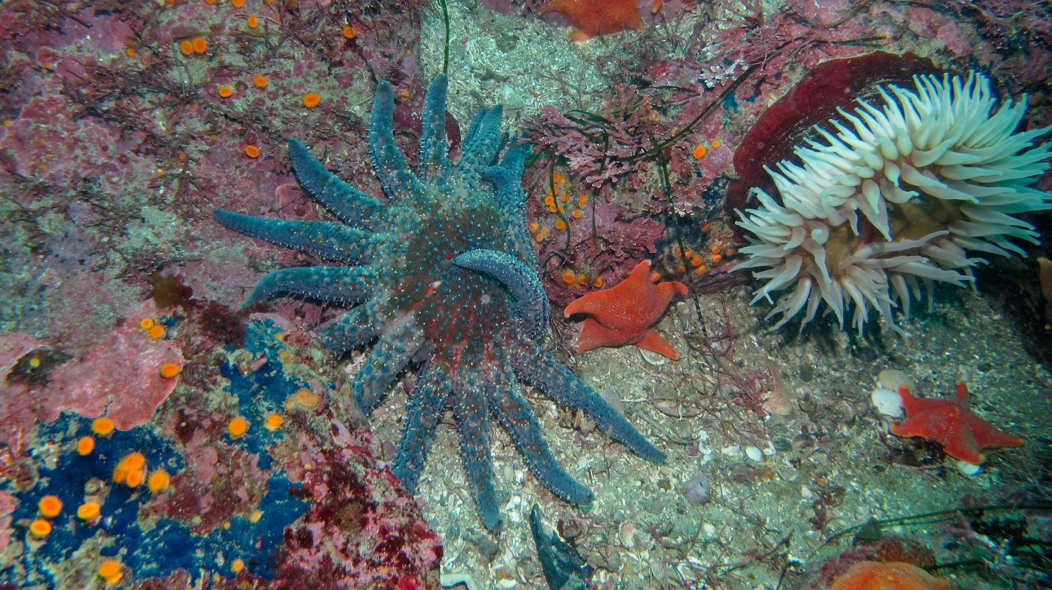

*Note*. Photo of *Pycnopodia helianthoides* next to an anemone and other sea stars. Photo by Bierman (2012).

### 2.1.2 Distribution

Historically, *Pycnopodia* are found in benthic communities across different habitat types along the Northeast Pacific Coast (Gravem et al., 2021, Shivji et al., 1983,). After analyzing a global dataset of *Pycnopodia* distribution, Gravem et al. (2021) established that the range of *Pycnopodia* is patchy and extends from the Aleutian Islands, Alaska to Isla Navidad, Baja California. Previous literature marked the southern extent of *Pycnopodia* as San Diego, California, just north of Baja (Herrlinger, 1983). Furthermore, *Pycnopodia* have a wide depth range, with records showing individuals found in depths between 0 to 455 m (Gravem et al., 2021). According to the dataset of “pre-crash populations” collected by Gravem et al. (2021), *Pycnopodia* was “most abundant in shallow nearshore waters less than 25 m,” less so between 25 to 50 m, and present but not common from 50 to 300 m.

### 2.1.1 Ecological role

In subtidal habitats, *Pycnopodia* can significantly affect community structure through predation. *Pycnopodia* are considered keystone species as their diverse diet and fierce predation foster biodiversity in their ecosystem (Duggins, 1983). Sea urchins are among the preferred prey of *Pycnopodia.* Urchins are herbivores that graze on algae, but if their populations go unchecked by predators, productive kelp communities can turn into deserted urchin barrens (Burt et al., 2018; Eisaguirre et al., 2020; Rogers-Bennet & Catton, 2019). In the Northeast Pacific coast, sunflower stars are the only natural widespread urchin predator. By regulating the spatial presence of urchin populations through predation, sunflower stars help create mosaic algal patterns in benthic communities (Duggins, 1983). In Duggins’ study of Torch Bay, Alaska, sunflower stars werethe only observed predator of sea urchins living in a nearshore kelp ecosystem, yet their predation on them caused those urchins to move around the kelp beds to the point of influencing community structure (Duggins, 1983). *Pycnopodia* co-existing with urchin help maintain a stable ecosystem in rocky subtidal kelp beds (Bonaviri et al., 2017; Duggins, 1983; Eisaguirre et al., 2020; Schultz et al., 2019), therefore tracking the effects of SSWD on *Pycnopodia* poulationscan alert the scientific community of any imminent imbalance that can lead to a cascade of negative effects.

## 2.2 Sea Star Wasting Disease

In June 2013, the first of many observations of wasting symptoms in sea stars was documented on the outer coast of Washington State (Harvell 2019, Miner et al., 2018,). The series of symptoms, described as sea star wasting disease, affected more than 20 different species of sea stars on the West Coast of North America (Hewson et al., 2014, Miner et al., 2018). Although wasting in sea stars and other marine organisms has been observed in the past (Bates et al., 2009, Eckhart et al., 1999, Staehli et al., 2009), the 2013 Northeast Pacific SSWD epidemic has been the largest mortality event of sea stars, and likely of any marine animal, recorded to date (Hewson et al.,2014). Wasting in stars was heavily observed from 2013 to 2015, leading to declines of sea star populations across much of the North American Pacific Coast (Burt et al., 2018; Harvell et al., 2019; Konar et al., 2019; Miner et al., 2018; Montecino-Latorre et al., 2016; Rogers-Bennet & Catton, 2019).

### 2.2.1 Symptoms

The symptoms of wasting in sea stars are visible and progress quickly over a matter of days, ending in death. The first observable signs in the process of wasting are a deflated appearance and the twisting of the body and arms. Next, white lesions begin to appear and spread throughout the individual, signaling decaying tissue. This tissue damage progresses rapidly over the sea star and leads to body fragmentation, where the star begins to lose its limbs. Within just days of the first observed lesion, a star will lose its limbs and completely disintegrate into a pile of slimy tissue (Schultz et al., 2016). The same early stages of wasting can be seen in sea stars after experiencing stressful circumstances, such as an injury or desiccation. (Miner et al., 2018). However, the difference with the 2013 Northeastern Pacific epidemic is that the stars began to waste within their ordinary habitat and conditions, without signs of injury or desiccation. Additionally, wasting had been observed throughout groups of individuals in a community, not isolated events like in previous times.

### 2.2.2 Timing and geographical extent

Due to its wide geographical extent, the Northeast Pacific sea star wasting epidemic is characterized as the largest sea star die-off event (Hewson et al., 2014). Wasting has been observed in over 2,000 miles of coastline, ranging from observations as south as Baja California to South Alaska into the Aleutian Islands (Gravem et al., 2021; Miner et al., 2018). In June 2013, the first signs of wasting for this epidemic were observed in ochre stars by monitoring groups surveying the Olympic Coast of Washington State (Marine et al., 2018, Harvell 2019). Towards the end of summer 2013, surveyors observed sea star wasting in Central California and the Salish Sea. By the end of 2013, wasting was observed throughout the Puget Sound and later down toward southern California and Mexico. SSWD slowly made its way northward until it reached the Aleutian Islands in 2016.

### 2.2.3 Etiology

While the outbreak of SSWD has been previously linked with multiple agents, the true etiology of the disease has not been identified. Early research by Hewson et al. (2014) pointed toward a plausible cause. They suggested a sea-star associated densovirus as the pathogen responsible for the disease. The densovirus had been seen in sea star die-off events in the past, but never at this geographical extent and across so many species (Hewson et al., 2018). However, further research by Hewson et al. (2018) concluded that the densovirus was associated with wasting in *Pycnopodia* but not any of the other sea star species tested. The ongoing hypothesis for causation is the pairing of a pathogen with changing environmental conditions, such as higher temperatures in *Pycnopodia* (Harvell et al., 2019, Hewson et al., 2018). The appearance of SSWD in some species of stars coincided with a warming water anomaly in the Pacific Ocean (Peterson et al., 2015), leading many to hypothesize that the rise in water temperature triggered the wasting. In their lab, Harvell et al. (2019) observed higher wasting intensities on sea stars in correlation with rising temperatures.

Elevated temperatures have been deemed the culprit in past SSWD outbreaks throughout the Northeast Pacific Ocean as well as other parts of the world. In the Channel Islands and nearby areas of southern California, SSWD had been detected in sea stars since 1978 (Eckhart et al., 1999). Although previously present, SSWD was observed at a higher frequency during the years 1982 and 1984, which coincided with an El Niño period and warmer temperatures (Eckhart et al., 1999).

More recently, SSWD observed in the sea star *Pisaster ochraceus* near Vancouver Island prompted Bates et al. (2009) to consider the effects of temperature on SSWD infection intensity. After keeping *Pisaster* stars in aquaria with varying temperature treatments, their study showed elevated infection rates and wasting in the stars exposed to higher temperatures, regardless of size or sex. Similarly, observations of wasting and population declines in the burrowing star species *Astropecten jonstoni* prompted scientists in Sardinia to test the effects of temperature on SSWD rates (Staehli et al 2009). Their lab experiments also demonstrated higher SSWD infection rates at higher temperatures, however larger individuals were affected at a higher rate than smaller ones. Like the recent wasting epidemic, temperature seems to play a key role in the fate of infection rates and wasting intensity in sea stars.

One of the most well-documented and substantial declines due to SSWD occurred in *Pisaster ochraceus,* the ochre star. The adult population of this intertidal species dropped to one fourth of its pre-outbreak total throughout its entire geographical range by 2015 (Eisenlord et al., 2016). Laboratory research by Eisenlord et al. (2019) showed a higher mortality rate and faster development of symptoms in diseased ochre adults than juveniles under elevated temperature treatments. As the decline in ochre stars started in 2013 and continued into 2014, research by Kay et al. (2019) showed an increase in the ochre stars’ slightly more SSWD-resistant competitor, *Evasterias troscheli,* commonly known as the mottled star. The ‘competitive release’ of mottled stars from ochre stars points to the importance of keystone species and how quickly the effects of SSWD were seen. In one of many efforts to understand the 2013 wasting, Lloyd et al. (2018) studied ochre stars’ microbial composition and found an imbalance of microbes on diseased individuals. However, much like rising temperature, they could not determine if the microbial imbalance made the stars more susceptible to SSWD, or if the SSWD caused the microbial imbalance. Nevertheless, the ochre star continues to be widely studied under SSWD and their role as keystone species in the intertidal has garnered ample attention from many.

Soon after the wasting outbreak, Hewson et al. (2014) set out to identify the pathogen behind the disease by inoculating asymptomatic *Pycnopodia* with virus-sized material from symptomatic star tissues. Individuals exposed to these materials developed wasting symptoms and because a known densovirus was present in this material, a link between the densovirus and SSWD was made. However, later work by Hewson et al. (2018) exposed that the link between SSWD and the densovirus only held true among *Pycnopodia* and two other sea star species (*Pisaster ochaceus and Evasterias troscheli*). Furthermore, subtidal monitoring of *Pycnopodia* between 2013 and 2014 showed that environmental factors like changes in temperature showed no correlation with SSWD outbreaks in *Pycnopodia*.

In summary, the origin and exact mechanisms of SSWD in *Pycnopodia* and other sea star species continue to be examined. There is not one single factor that can explain the cause and spread of SSWD among all sea stars species affected in the 2013 SSWD epidemic. For *Pycnopodia,* the presence of a viral pathogen can be correlated with increased SSWD. However, environmental conditions such as elevated temperature, only correlate with increased SSWD in some species, and not in *Pycnopodia.* For these reasons, Hewson et al. (2018) believe that SSWD may be an all-encompassing suite of symptoms brought on by different etiologies dependent on geographical location, species or a combination of both.

## 2.3 *Pycnopodia* Populations

Following the outbreak of a disease with a large mortality, it is essential to track the affected populations in order to assess status and recovery. Furthermore, to get a better idea of the degree of impact from the disease, having historical data to compare with the recent post-outbreak data is imperative. The largest collection of long-term surveys that include sea stars in the northeast Pacific can be found through the MARINe network, where hundreds of rocky intertidal habitats are periodically studied. In addition to intertidal surveys, there is literature capturing subtidal *Pycnopodia* abundance using methods that include remotely operated vehicles (ROVs), scuba divers, video surveys, and trawl surveys. Past survey data from long-term studies and ongoing monitoring programs suggest that historically, *Pycnopodia* was common from Alaska to California.

### 2.3.1 Pre-outbreak populations

Throughout California, studies within kelp forests have provided extensive data on *Pycnopodia* populations. Surveys as early as 1980 show *Pycnopodia* densities around Monterrey, California kelp forests were 0.03 m2 (Herrlinger, 1983). Benthic surveys used to track invertebrate abundance in kelp forests near the Northern Channel Islands show *Pycnopodia* densities ranging from 0.10 to 0.14 m2 between 2010 and 2012 (Eisaguirre et al., 2020). In central and northern California, Rogers-Bennet and Catton (2019) reported average densities between 0.01 and 0.12 m2 among the surveyed kelp forests in the years before 2013.

Further north, near British Columbia, Canada and throughout the Salish Sea, pre 2013 epidemic *Pycnopodia* abundance and densities were established. Scuba-based surveys in subtidal communities of Howe Sound, Canada, established *Pycnopodia* mean density at 6.4 individuals per 15 m2 (0.43 m2) between 2009 and 2010 (Schultz et al., 2016). Throughout five basins of the Salish Sea and Washington outer coast, roving diver surveys conducted between 2006 and 2013 documented about 6-14 sunflower stars per survey (Montecino-Latorre et al., 2016). On the outer coast of Washington, trawl surveys in deep water habitats observed biomass of *Pycnopodia* to be 3.11 kg/ha for survey years between 2004 and 2014 (Harvell et al., 2019). Similar surveys in Oregon showed biomass at 1.73 kg/10 ha (Harvell et al., 2019).

Alaska was the last region to see the effects of SSWD. Before SSWD reached Alaska in 2016, Konar et al. (2019) began tracking sea star populations in the rocky intertidal around Alaska. Within its range, *Pycnopodia* was common and varied in density. Densities were calculated for different areas prior to the outbreak, including Katmai National Park (0.048 m2), Kachemak Bay (<0.005 per m2), Kenai Fjord National Park (0.075 per m2) and Prince William Sound (0.233 per m2). Decades before Konar et al. (2019), Duggins (1983) looked at *Pycnopodia* in the rocky subtidal of Torch Bay, Alaska, and saw high densities as well (0.09 m2).

The whole of these studies cover a great proportion of the geographical range of *Pycnopodia,* however it is difficult to compare among them for a number of reasons. First, although the habitat depth range for *Pycnopodia* extends from 0 to 455 m, an analyses of “pre-crash population” studies by Gravem et al. (2021) shows *Pycnopodia* populationsare most abundant among the shallow subtidal habitat less than 25 m in depth. Therefore, intertidal studies like those completed by the MARINe network, although high in volume and frequency, are not ideal for capturing accurate population densities for a subtidal species like *Pycnopodia.* Similarly, deep trawl surveys in depths where *Pycnopodia* are historically present but not common, can misrepresent population densities as well. Second, most of the studies available are each confined to one type of habitat. Whether it’s all within the rocky intertidal, floating kelp bed habitats, or deep subtidal plains, there is little variation within each study. Finally, some survey techniques limit the study area and its sample size, which may skew results. For example, intertidal surveys (usually completed on foot) and scuba surveys generally cover smaller areas when compared to boat or ROV surveys.

When tracking the population of a subtidal species like *Pycnopodia,* it is necessary to have surveys that not only document many years of data over time, but implement a technique that allows for a large area to be sampled – one that encompasses varying habitat types, and a range of depths where *Pycnopodia* are commonly found.

### 2.3.2 Post-outbreak populations

Populations of *Pycnopodia* have declined dramatically throughout their known range in the years following the SSWD epidemic. In California, the declines of *Pycnopodia* have been the most drastic and they may in fact now be completely locally extinct. Between 2014 and 2017, benthic transect surveys analyzed by Eisaguirre et al. (2020) failed to detect any *Pycnopodia* around the Channel Islands. Similarly, nearshore surveys in two counties along the northern and central California coast captured one individual between 2014 and 2015, and zero from 2016-2019 (Rogers-Bennet and Catton, 2019). Rogers-Bennet and Catton (2019) write that the lack of *Pycnopodia* observations in recent years is “strongly suggesting that this species is now locally extinct.” Deep trawl surveys off the coasts of California and Oregon that extended to higher depths (55 to 1280 m), showed a 100% decline in biomass of *Pycnopodia* from 2013 to 2015 (Harvell et al., 2019). Deep trawl and nearshore surveys in California showed no *Pycnopodia* observations in 2016 (Harvell et al., 2019). Although *Pycnopodia* may be extinct from the California coasts, some individuals remain in sites further north.

Similar high mortality trends in *Pycnopodia* were observed from Washington State, British Columbia and Alaska. Throughout 5 basins in the Salish Sea and the Washington outer coast, Montecino-LaTorre et al. (2016) reported that dive surveys conducted in 2014 and 2015 were averaging 0-3 *Pycnopodia* observations per survey following the wasting epidemic, when pre-outbreak sightings averaged 6-14. Deep trawl surveys from 2015-2016 off the Washington coast saw a 92% decline in average *Pycnopodia* biomass (Harvell et al., 2019). After analyzing roving-diver surveys in nearshore habitats, Harvell et al. (2019) saw a similar drastic decline in biomass. In British Columbia, a 96% decrease in biomass in nearshore habitats occurred between 2015 -2017 compared to pre-outbreak surveys from 2010-2014 (Harvell et al., 2019). In addition, Schultz et al. (2016) reported a decline of 86% of *Pycnopodia* biomass in Howe Sound for 2015, compared to the biomass from 2009 and 2010. As the wasting outbreak made its way up to Alaska, Konar et al. (2019) showed *Pycnopodia* density declines of 67% to 94% in four intertidal regions in the Gulf of Alaska.

There is a need for large scale surveys of *Pycnopodia* within inland Washington and the Salish Sea. Post-outbreak, *Pycnopodia* populations have declined at varying levels depending on location. In many areas of their southern extent, *Pycnopodia* are locally extinct or experienced little recovery (Rogers-Bennet and Catton, 2019), but have fared slightly better toward their northern extent. In Washington State, deep trawl surveys are common on the outer coast, helping cover large scale areas where *Pycnopodia* are found. However, further inland from the outer coast in Washington, small-scale dive surveys are more common. A large scale study is ideal, as it would capture a greater proportion of the depth where *Pycnopodia* are most commonly found. Additionally, using a survey method such as underwater videography can allow for further analyses, such as changes in average individual size. As a proxy for age, size measurements can aid in describing the age and overall status of the changing populations post- epidemic.

## 2.4 Trophic shifts related to *Pycnopodia* declines

The cascading effects of *Pycnopodia* population declines due to the sea star wasting epidemic have already been observed. Like many sea stars, *Pycnopodia* are important predators within nearshore ecosystems and their top-down predatory control over sea urchin populations is especially crucial in macroalgal habitats where sea otters and other urchin predators are absent (Bonaviri et al., 2017; Duggins, 1983, Schultz et al., 2019,). *Pycnopodia’s* predation keep urchin populations stable, however when urchin populations grow after a sizeable recruitment or in the absence of a predator, kelp is rapidly depleted (Schultz et al., 2019). Growing sea urchin populations have been observed to overgraze, causing a regime shift from biodiverse macroalgal ecosystems, to unproductive urchin barrens (Ling et al., 2015).

Following the loss of *Pycnopodia* in the Northern Channel Islands of Southern California, the nearshore ecosystem shifted from kelp forests to urchin barrens. Eisaguirre et al. (2020) studied the ecosystem shifts and changes in predator assemblages that occurred within kelp forests as a result of *Pycnopodia* being “functionally extirpated” due to the wasting outbreak. Changes in abundance of sea urchin predators can affect the stability of urchin populations and tip the scale between phase states. The study found that in Marine Protected Areas (MPAs) where urchin predators like the California spiny lobster and California sheep head were larger and most abundant, urchin populations remained contained. In the absence of *Pycnopodia,* a competitive release occurred for both the lobster and sheephead, which let them take advantage of the resources within the MPAs. Outside of the MPAs, fewer and smaller predators were present, therefore urchin populations became overabundant and transformed the ecosystem into urchin barrens.

In Northern California, the collapse in *Pycnopodia* populations, along with other stressors, have led to a trophic cascade. Along the Northern California coast of Mendocino and Sonoma counties, the historically productive and diverse kelp forests have recently shifted toward urchin barrens (Rogers-Bennet and Catton 2019). The initial catalyst toward this shift was a marine heat wave and El Niño that led to prolonged warm water temperatures and caused algal blooms in 2013. These stressors, paired with a booming purple sea urchin population and ‘local extinction’ of *Pycnopodia,* resulted in a dramatic decline in bull kelp canopy. Rogers-Bennet and Catton (2019) state that urchin populations increased 60-fold post the onset of SSWD (by 2015). Without *Pycnopodia* to prey on the sea urchin, increased grazing by urchin populations may hinder the return of the many ecosystem services provided by kelp forests.

Further north, benthic assemblages in Howe Sound, British Columbia were affected shortly after the disappearance of *Pycnopodia.* In the nearshore between 8 and 15 m depth, Schultz et al (2016) tracked the abundance of *Pycnopodia,* sea urchins and other invertebrates, and kelp cover.After *Pycnopodia* declined by 86% in Howe Sound, changes in the community structure were led by a four-fold increase in green sea urchin populations that began at the same time *Pycnopodia* began to disappear. It is unclear if urchin populations thrived in the absence of Pycnopodia due to decreased predation or if they thrived after occupying the physical space where the sea stars previously stood (Schultz et al 2016). Following the increase of urchin populations, kelp cover experienced an 80% decline. After the reduction of algal cover, cup corals increased in abundance. This trophic cascade, triggered by the absence of *Pycnopodia,* occurred at half of the sites studied in the Howe Sound (Schultz et al. 2016).

# 3. Methods

This thesis uses observations of *Pycnopodia* from a set of underwater videography to analyze changes in density and size before, during, and after the Northeast Pacific sea star wasting epidemic. The imagery used in this thesis was initially collected by the Washington State Department of Natural Resources (DNR) as part of a study to assess changes in nearshore subtidal communities following the removal of the Elwha River dams (Rubin et al., 2017). The study area encompasses six sites along the nearshore US Strait of Juan de Fuca (Figure 2) along the Northern end of the Olympic Peninsula in Washington State (Crescent Bay, Freshwater Bay, Elwha Bluffs and Ediz Hook, Dungeness Bluffs, and Dungeness Spit). As part of the Elwha dam removal study, video surveys were completed annually in the summer months, beginning in 2010 and continuing through 2014. DNR completed additional years of sampling from 2015-2017 and in 2020 in order to have long-term monitoring data for this study site and provide recent post-epidemic data on sea stars.

The methods for this thesis begin with an overview of the study area and field sampling methods used by Rubin et al. (2017) to collect the videography. Then, a description of the video review process used to record sea star observations, including caveats associated with this method of data collection. After the sea star data collection process, the methods for calculating and comparing *Pycnopodia* density across site and depth across epidemic stages are described. Finally, this section will end by detailing the methods used to analyze changes in average *Pycnopodia* size observed before, during and after the Northeast Pacific sea star wasting epidemic.

## 3.1 Study Area and Field Sampling

The Strait of Juan de Fuca is a narrow passage of water that connects the Salish Sea to the Pacific Ocean. It is just over 150 km long and the center of the channel marks the international boundary between the U.S and Canada, separating Washington State and Vancouver Island, British Columbia. About midway along the Strait, off the Washington shoreline is the mouth of the Elwha River. In 2011, a large-scale dam removal project began on the Elwha River. Two dams were removed over a 3-year period, a process that released millions of tonnes of sediment and deposited about 3.5 million tonnes of sediment onto the river mouth within the first two years (Warrick et al. 2015). The changes to the Elwha delta and adjacent subtidal communities following the major influx of sediment were studied by Rubin et al. (2017) between the years 2010 and 2014.

Six sites were outlined by Rubin et al. (2017) to study the effects of the Elwha Dam removal on macroalgae and other organisms within the nearshore habitat. The sites nearest to the Elwha mouth (Freshwater Bay, Elwha Bluffs and Ediz Hook) were established as experimental sites and had corresponding control sites (Crescent Bay, Dungeness Bluffs and Dungeness Spit) that were adjacent to the experimental sites, but far enough away from the effects of the Elwha dam removal. Crescent Bay and Freshwater Bay represent large embayments, Elwha Bluffs and Dungeness Bluffs are characterized by feeder bluffs, and Ediz Hook and Dungeness Spit are deposition bars. At each site, five to ten fixed transects were established for annual sampling (Table 1). Each transect runs perpendicular from shore to about 15 m depth relative to Mean Lower Low Water (MLLW).

Figure 2.

Map of Study Area

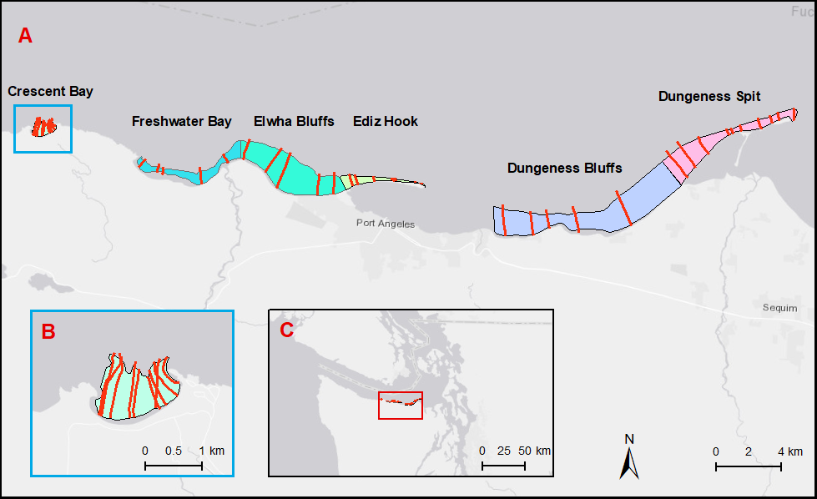

*Note.*Map of study area in central Strait of Juan de Fuca. A. Colored polygons represent six sites with transect lines in red. B. Crescent Bay site. C. Study area over Western Washington.

|  |  |  |  |
| --- | --- | --- | --- |
| **Site name** | **# of transects** | **total transect**  **length (km)** | **site area**  **(km²)** |
| Crescent Bay | 10 | 7.90 | 1.08 |
| Freshwater Bay | 5 | 3.20 | 17.03 |
| Elwha Bluffs | 5 | 8.26 | 10.27 |
| Ediz Hook | 10 | 2.58 | 1.45 |
| Dungeness Bluffs | 5 | 8.21 | 3.56 |
| Dungeness Spit | 10 | 8.85 | 7.03 |
| Total | 45 | 39.01 | 40.42 |

Table 1.

Site Information

*Note*. Transect and area information for each site in study area.

Between the months of June and September of the sampling years, the research vessel R/V Brendan D II traveled along each transect at a speed of approximately 1 m·s-1 with an underwater camera (SplashCam Deep Blue Pro Color, *Ocean Systems, Inc*). The underwater camera was attached to a weighted towfish and positioned at a downward-facing angle to capture a 1-m wide swath of the benthic habitat. Along with the camera, two lasers were fixed 10 cm apart to provide a scale reference throughout the imagery. To accompany the imagery, corresponding site information, time, depth, and differential global positioning system data were generated for each survey. In addition, the video imagery was overlayed with the corresponding site, time and transect identification information.

## 3.2 Video Review

Changes and updates to the video recording equipment occurred over the decade in which the videography was recorded. Video collected between 2010 and 2015 was recorded using Hi-8 tapes. Before reviewing the video, all Hi-8 tapes were digitized into .mp4 format using the VIDBOX Video Conversion Suite. Video collected in 2016, 2017 and 2020 was recorded in a digital format. All video was reviewed using VLC media player.

During video review, a spreadsheet generated at the time of video collection was used to mark the presence of *Pycnopodia* to their matching timestamp. Each timestamp (collected at one-second intervals) had corresponding geospatial and depth data throughout the imagery. When reviewing video, the first step was to classify video quality for all timestamps. Video quality was considered useable when the benthic habitat could be seen within the video frame. Unusable video may be a result of the following situations: 1) the camera was moving through the water column, 2) the camera was obstructed by floating kelp, 3) poor visibility due to turbid water or low light and 4) blurred imagery. Only the videography classified as having useable video quality was used determine the presence of *Pycnopodia* individuals. In addition to tracking sea star presence, size estimations (in cm) were recorded for visible individuals.

Video surveys offer a lower resolution than other survey types, therefore absence of stars could not be confirmed. Inconspicuous sea stars were likely missed in the classification of video, including juvenile stars, individuals under 10 cm in diameter, and stars obstructed by rocks and marine vegetation.

## 3.3 Analysis: Density

To begin the analysis of *Pycnopodia* density, the spatial data was used to map star abundance along sections of transects across the study area. Each transect was divided into 200 m long sections that were established in Rubin et al. (2017). Using R 3.6.3, the number of stars were summed within each section, per year, to calculate abundance of stars. Then, individual years were grouped by epidemic stage (pre-epidemic: 2010-2013, epidemic: 2014-2015, post-epidemic 2016-2017 and 2020) in order to calculate average abundance per 200 m section for each stage. The post-epidemic stage was split into two separate panels (2016-2017 and 2020) due to the 3-year data gap between the two latter years. Using ESRI ArcMap software, each 200 m transect subdivision was symbolized according to the average number of stars found within.

Site mean density was calculated to compare density at a large spatial scale. First, density was calculated for each transect using the sum of *Pycnopodia* per transect over the transect area (calculated from the 1-m swath and transect length). Then, the average densities of all transects within a site were used to estimate mean sea star density per site across each year. Each site mean density served as a replicate for its corresponding epidemic stage. Using a one-way analysis of variance (ANOVA), the average mean density per site was tested for significant differences between epidemic stages. Further, by comparing average density on the site level, we can assess if density across the years follows the same pattern for each site, regardless of location on the Strait of Juan de Fuca and shoreline type. This data could help inform on the type of area where populations were affected most or are on the rebound.

Calculations of density by depth were calculated for each year. By subsetting data points by depth categories, we can see if average *Pycnopodia* density followed the same patterns among depth across pre and post epidemic stages. To begin with, the data was subset to include only data points where depth was between 0 and -15 m relative to MLLW. From this subset, points were grouped and labeled according to three subdivisions of depth: shallow (0 to -5 m), mid (-5 to -10 m) and deep (-10 to -15 m). For each depth group, density was summarized by taking the sum of stars per transect, divided by the transect area. Average density by depth was tested for significant differences between each epidemic stage using a one-way ANOVA. Patterns in mean density by depth over time can help determine whether shifts in depth were made during and post the wasting epidemic.

## 3.4 Analysis: Size Measurements

Mean star size per year was analyzed among four different years (2012, 2014, 2017 and 2020), representing each period related to the sea star wasting epidemic. Using the size measurements recorded during video review, boxplots were produced for each period using R- (ggplot2). A one-way ANOVA was performed to compare the effect each epidemic stage had on the average size of *Pycnopodia* observed. Following the ANOVA, a post-hoc Tukey HSD test was conducted to identify significant differences. As size is a proxy for age, any emerging patterns in the range of sizes observed or mean size across time can help inform on the status of recovery or perhaps continued wasting among *Pycnopodia* populations.

# 4. Results

Underwater towed videography collected on the Strait of Juan de Fuca near the Elwha River delta was reviewed in order to evaluate changes in *Pycnopodia* populations before, during, and after the sea star wasting epidemic. Annual summer transect surveys taken between 2010 and 2020 capture the nearshore benthic habitat at six adjacent sites from shallow to -15 m relative to MLLW. From this data, density of *Pycnopodia* was calculated and analyzed by transect, site and depth over each year and epidemic stage. Additionally, average *Pycnopodia* size measurements were calculated and compared over time.

## 4.1 Overview of Changes in Density

The average density of *Pycnopodia* dropped drastically during the epidemic, and showed variable recovery following the epidemic (Figure 3). Densities in the pre-epidemic stage show *Pycnopodia* were common and widespread, appearing in every site and across depths. Average density between 2014 and 2015, the epidemic stage, showed individuals across all sites at low abundance and variable depths. The post-epidemic years showed some variability with the average density between 2016 and 2017 surveys showing signs of a rebound toward pre-epidemic densities in the four easternmost sites. Within those sites (Dungeness Spit, Dungeness Bluffs, Ediz Hook and Elwha Bluffs) *Pycnopodia* were once again observed across most depths, albeit with fewer observations on the shallow end of transects. Compared to the 2016-2017 average, abundances in 2020 were generally less across all sites. In 2020, a single individual was observed at the Crescent Bay and Freshwater Bay sites. In the remaining four sites, individuals occurred more frequently at the deeper end of transects.

Figure 3.

*Pycnopodia* Abundance By Transect

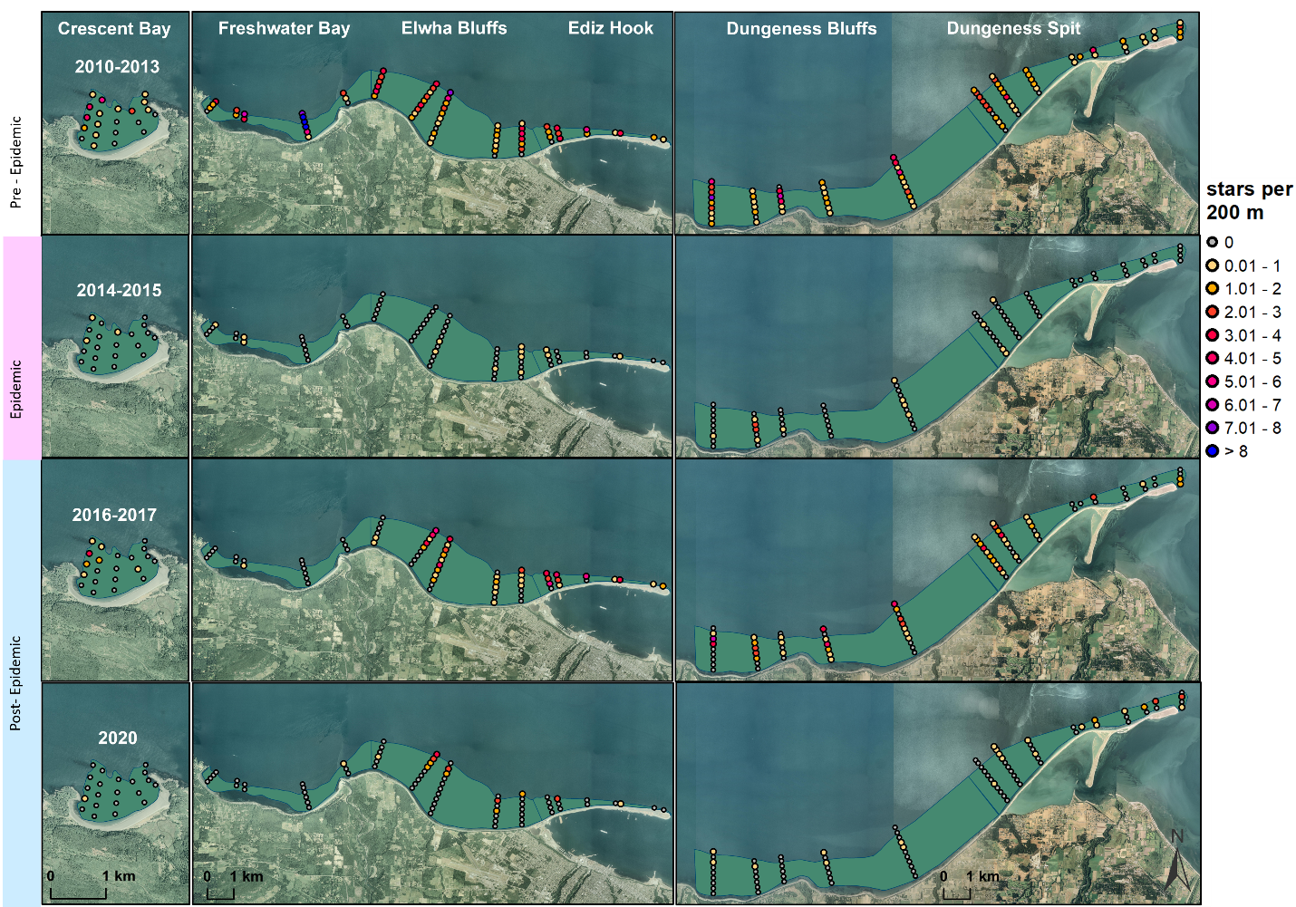

*Note*. Map of *Pycnopodia* abundance per 200 m section of transect by location between 2010-2020.

### 4.1.1 Density by site

The average density of *Pycnopodia* (individuals/m2) decreased by 93.5% and 58.4% in the epidemic and post-epidemic stages respectively, when compared to pre-epidemic levels (Figure 4). *Pycnopodia* were present at each site in the pre-epidemic stage between 2010 and 2013, with densities ranging from 0.0019 ± 0.0006 to 0.0189 ± 0.0030 individualsper m2. A drastic decline in *Pycnopodia* density was seen in 2014 and 2015 among all sites. During the epidemic years, average site density ranged between 0 to 0.001 ± .0008individuals per m2, a substantial decrease at all sites. In addition, *Pycnopodia* were not captured in the 2014 surveys at Dungeness Bluffs and Dungeness Spit, as well as in 2015 surveys in Freshwater Bay. Post-epidemic, *Pycnopodia* density ranged from 0.0001 ± 0.00006 to 0.0107 ± 0.002 individuals per m2 and showed variable recovery at each site. The post-epidemic survey years began with 2016, where a small rebound toward pre-epidemic year density levels was seen in the four easternmost sites. Ediz Hook, Dungeness Bluffs and Dungeness Spit experienced a rebound toward pre-epidemic density levels but declined once again in 2017 and continued to further decline into 2020. At the Elwha Bluffs site, average site density climbed for two consecutive years of the post-epidemic stage, only to plummet to low levels in 2020. Density at the remaining two sites (Freshwater Bay and Crescent Bay) remained low from 2016 through 2020.

Figure 4.

Site Mean Density

*Note*. *Pycnopodia* mean density (m2) by site per year, including error bars. Vertical dotted lines indicate periods of Elwha River dam removals (blue) and first wasting observance (red). The salmon-colored overlay represents the duration of the epidemic period and in purple is the post-epidemic period.

*Pycnopodia* mean site density was significantly different between epidemic stages (F(2,45) = 18.44, p=<1.42e-06). Post-hoc Tukey HSD test results show that site mean density calculated in the epidemic and post-epidemic stages was significantly lower than the pre-epidemic stage. There was no significant difference in density between the epidemic stage and post-epidemic stage. Density at the four easternmost sites was elevated in 2016 and 2017, relative to the epidemic stage. Furthermore, density at all the sites returned to low levels in 2020, similar to those observed during the epidemic stage.

### 4.1.2 Density by depth

The density observed in the deep depth bin was consistently highest, followed by the mid and shallow bins respectively, with the exception of 2015 (Figure 5). Density at each depth experienced a drastic decline during the epidemic, starting in 2014 and remained low in 2015. In 2016, mid and deep depth groups climbed closer to pre-epidemic densities, but declined once again in 2017 and further declined in 2020. Density in the shallow end has remained low since 2014.

In both the deep and mid depth groups, pre-epidemic density was significantly higher than both the density in epidemic and post-epidemic stages [(deep: F(3,276) = 28.63, p=<3.77e-16), (mid: F(3,111) = 12.54, p=<4.04e-07)]. After subsetting the data into depth categories, site mean density calculations followed the same trends observed at site level.

Figure 5.

Density by Depth

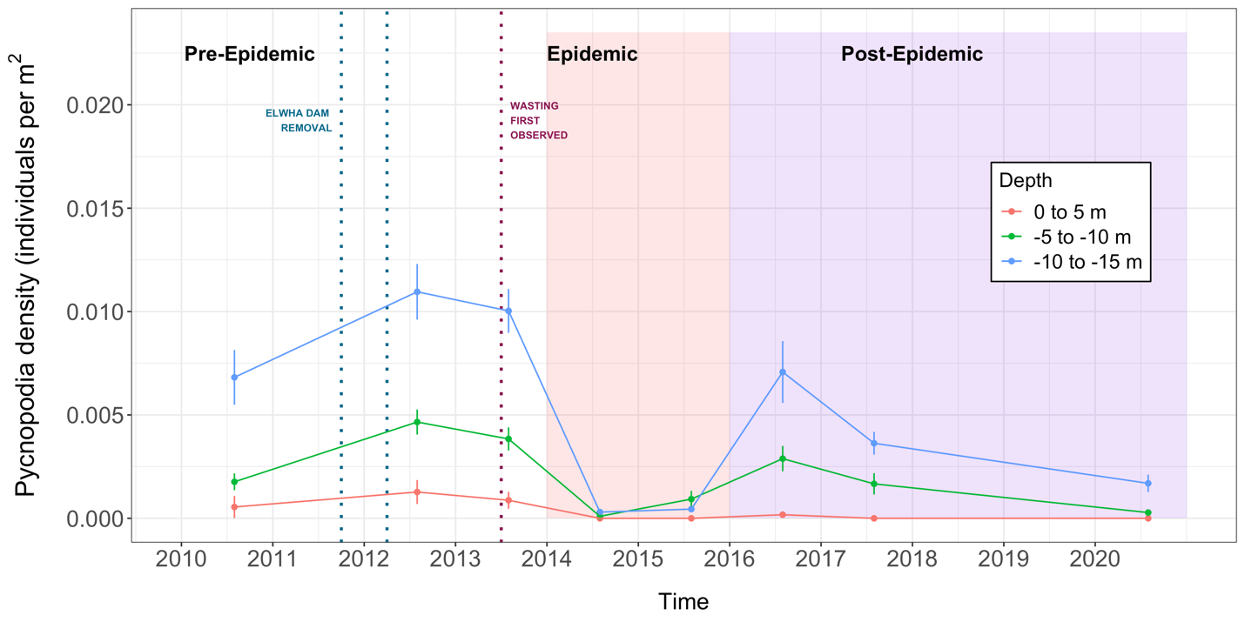

*Note. Pycnopodia* mean density (m2) across three separate depth ranges per year, including error bars. Vertical dotted lines indicate periods of dam removal (blue) and first wasting observance (red). The salmon-colored overlay represents the duration of the epidemic period and in purple is the post-epidemic period.

## 4.2 Size measurements

The epidemic caused a change in the size of *Pycnopodia*. The widest range in size (10 to 80 cm) was observed in the pre-epidemic stage, represented by individuals in the 2012 surveys (Figure 6). The range among the epidemic and post-epidemic sizes decreased by almost half when compared to the pre-epidemic stage. In addition, the mean size of individuals was significantly smaller in the first year post-epidemic, compared to pre-epidemic and the last year of the post-epidemic stage (F(3,555) = 68, p= <2e-15), with 2012 and 2020 having individuals about twice as large relative to 2017. There was no significant difference in mean size between 2012 (pre-epidemic stage) and 2020 (the latest year of the post-epidemic stage).

Figure 6.

*Pycnopodia* Size

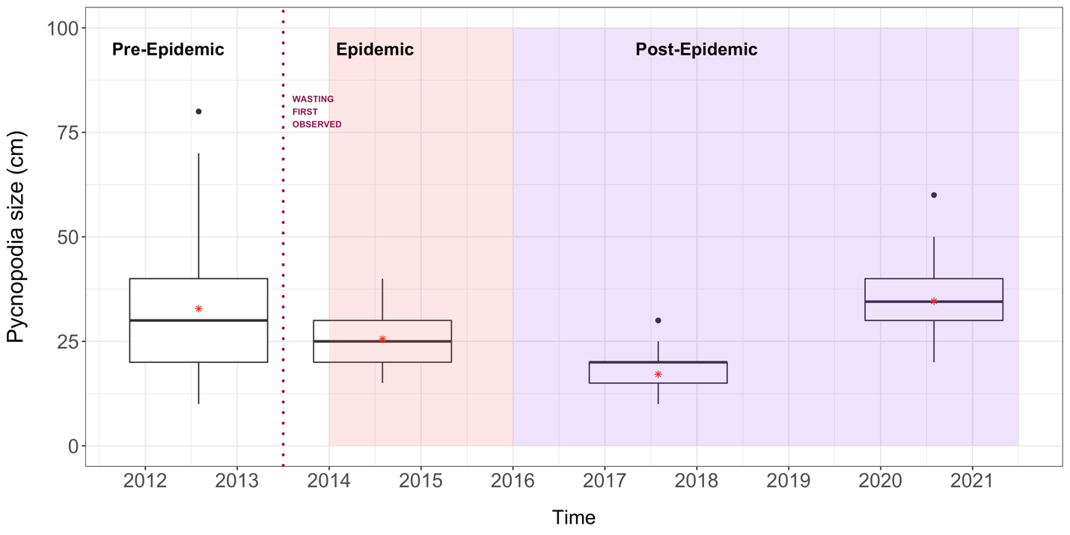

*Note*. Boxplots of *Pycnopodia* size (cm) for the years 2012, 2014, 2017 and 2020. The red star represents the mean size for each year and black dots represent outliers from the boxplots. The red vertical dotted line indicates timing of the first wasting observance. The salmon-colored overlay represents the duration of the epidemic period and in purple is the post-epidemic period.

# 5. Discussion & Conclusion

A decade of underwater videography spanning about 40 km of benthic habitat in the US Strait of Juan de Fuca captured the effects of sea star wasting disease on *Pycnopodia helianthoides* populations. The Northeastern Pacific wasting epidemic led to a massive sea star die off event (Eisenlord et al., 2016; Hewson et al., 2014), altering ecosystem dynamics and leaving the door open to drastic change. *Pycnopodia* are important predators in nearshore habitats (Duggins, 1983), therefore tracking changes in their populations before and after the wasting epidemic allows us to assess status and recovery in this area.

It is important to note that the influx of sediment following the Elwha River dam removal may have affected density levels at sites near the Elwha River during the pre-epidemic stage. This is because the largest influx of sediment near the river mouth occurred in the first two years following the dam removal in 2011 (Rubin et al., 2017). Furthermore, subsequent declines in algae cover observed by Rubin et al. extended from Freshwater Bay to Ediz Hook, but not to control sites Crescent Bay, Dungeness Bluffs and Dungeness Spit. *Pycnopodia* have a wide range of habitat type (Shivji et al., 1983), therefore changes in sediment type likely did not affect density, but rather the decrease in algae cover caused by sediment deposition could have affected visibility of individuals throughout the videography. Lower algae cover and increased visibility of *Pycnopodia* could explain the higher density observed at the Freshwater Bay site in 2012, compared to 2010 and 2013. Nevertheless, the same pattern of higher density in pre-epidemic vs. epidemic surveys was observed at all sites, including the control sites which were far enough to escape the dam removal effects. As such, SSWD, not the Elwha dam removal, is the culprit behind the rapid decline of *Pycnopodia.*

The decrease in *Pycnopodia* density from the pre-epidemic to the epidemic period is drastic and abundantly clear. One of the key factors of this study is the batch of pre-epidemic surveys which established a baseline for *Pycnopodia* populations before wasting was first observed. At all six sites, pre-epidemic density was significantly higher than that observed in the epidemic stage (Figure 4). The 93.5% decrease in density at the epidemic stage aligns with multiple studies showing significant declines in *Pycnopodia* abundance beginning in 2013. For example, on the Washington outer coast, *Pycnopodia* biomass decreased by 92%, and in nearshore habitats of British Columbia, biomass decreased by 96% (Harvell et al., 2019). Due to the large decline in populations of many sea star species between 2013 and 2015, Harvell et al. noted this time to be the epidemic phase of the Northeast Pacific sea star wasting event (2019). However, Hamilton et al. (2021) listed 2017 and 2018 as the “crash date” (the date when pre-outbreak occurrence level decreased by 75%) for *Pycnopodia* on the Washington outer coast and Salish Sea respectively. The massive decline observed in this thesis’ data matches the epidemic stage outlined by Harvell et al. (2029) but is earlier than expected when compared to the “crash date” determined by Hamilton et al. (2021). Density at all six sites of this study sank to near zero just one year after the first documented case of sea star wasting in Washington State in 2013. The low levels of individuals continued through 2015, rounding out the height of the epidemic stage for in this area.

In contrast to many other regions outside of the PNW, *Pycnopodia* abundance in four of six sites experienced an unprecedented rebound from 2016 to 2017 relative to the epidemic stage. At this time, arm-to-arm measurements of individuals taken from four different years in the videography showed that stars recorded in 2017 were significantly smaller (about half the size) than those observed in 2012. Not only were *Pycnopodia* smaller, but the range in sizes decreased by a half, with few observations in individuals over 30 cm. Evidently, this rebound was made up of a combination of smaller individuals that survived the first population crash in the epidemic stage, and individuals born after the epidemic that were successful in evading infection. Studies on other species of sea stars have shown that large individuals were more susceptible to infection than smaller ones (Eisenlord et al., 2019; Staehli et al., 2009), which may hold true for this region’s *Pycnopodia* as well. Although density remained low in 2020, the presence of larger individuals could be a signal for local recovery or a decreased mortality caused by SSWD in the coming years.

By 2020, density at all six sites returned to low, epidemic-level densities. This timing lines closer with the “crash date” of *Pycnopodia* in nearby regions – 2017 and 2018 for the outer Washington coast and Salish Sea respectively (Hamilton et al., 2021) than the earlier epidemic phase declared by Harvell et al. (2019). Further, the “crash dates” for Washington are delayed when compared to lower latitude areas such as Baja California (crash date: 2014), central California (crash date: 2015) and Oregon (crash date: 2017). The data in this thesis show that *Pycnopodia* populations in this study area were able to persevere at the start of the post-epidemic stage after plummeting in 2014 yet decreased once again by 2020. Nonetheless, without a definitive etiology for SSWD, it is difficult to determine why this rebound, followed by a return to low levels in 2020, was observed.

The effects of *Pycnopodia* population declines due to the sea star wasting epidemic have been observed in other locations where *Pycnopodia* have become locally extinct or have experienced little recovery (Eisaguirre et al., 2020; Rogers-Bennet and Catton, 2019; Schultz et al., 2019). *Pycnopodia’s* top-down predatory control over sea urchin populations is especially crucial in macroalgal habitats where sea otters and other urchin predators are absent (Duggins 1983; Bonaviri et al., 2017; Schultz et al., 2019). Within a couple years of the epidemic, the absence of this keystone species in kelp forests along Northern California has led to documented increases in urchin populations which have led to the loss of kelp canopy and resulted in urchin barrens and loss of diversity (Rogers-Bennet and Catton, 2019). Unlike California, this area of the Strait of Juan de Fuca showed lingering individuals after the epidemic. In areas further north, like Howe Sound, *Pycnopodia* also remain at low levels (Konar et al., 2019). The substantial shift in abundance that we observed in these six sites raises important questions like how this change in a keystone species has cascaded through the nearshore community in this region and if there are any signs of pre-epidemic level recovery.

*Pycnopodia* remain at this stretch of the Strait of Juan de Fuca even after 2020 (2021-2022, personal observation) but the variability in abundance in the post-epidemic surveys warrant the continuation of surveys. The recovery of *Pycnopodia* populations may help prevent cascading effects in key ecosystems and surrounding fisheries. If a natural recovery is not observed, then we can support more efforts like those taken by scientists at University of Washington Friday Harbor Labs to breed *Pycnopodia* in captivity. Efforts like these can be an alternative to rebuild a population that lost millions of individuals over a short period of time.

In conclusion, this study shows the incredible value of long-term surveys and collaborative monitoring in any capacity. Returning to sample the Elwha sites years after the dam removal allowed us to get insight in the area beyond the dam removal effects. Similarly, data collected by the Multi-Agency Rocky Intertidal Network was key in detecting the onset of SSWD soon after it began across a wide region. As climate change and other anthropogenic disturbances continue to affect our ecosystems, having access to continuous, long term baseline data will be pivotal in detecting changes and finding solutions going forward.

# References

Bates, A. E., Hilton, B. J., & Harley, C. D. G. (2009). Effects of temperature, season and locality on wasting disease in the keystone predatory sea star Pisaster ochraceus. *Diseases of Aquatic Organisms*, *86*(3), 245–251. <https://doi.org/10.3354/dao02125>

Bierman, Ed (2012). [Photograph of sunflower star amid anemone and other critters]. Flickr. https://www.flickr.com/photos/edbierman/6783310229

Bonaviri, C., Graham, M., Gianguzza, P., & Shears, N. T. (2017). Warmer temperatures reduce the influence of an important keystone predator. *Journal of Animal Ecology*, *86*(3), 490–500. <https://doi.org/10.1111/1365-2656.12634>

Burt, J. M., Tinker, M. T., Okamoto, D. K., Demes, K. W., Holmes, K., & Salomon, A. K. (2018). Sudden collapse of a mesopredator reveals its complementary role in mediating rocky reef regime shifts. *Proceedings of the Royal Society B: Biological Sciences*, *285*(1883), 20180553. <https://doi.org/10.1098/rspb.2018.0553>

Duggins, D. O. (1983). Starfish Predation and the Creation of Mosaic Patterns in a Kelp-Dominated Community. *Ecology*, *64*(6), 1610–1619. <https://doi.org/10.2307/1937514>

Eckert, G., Engle, J., & Kushner, D. (1999). *SEA STAR DISEASE AND POPULATION DECLINES AT THE CHANNEL ISLANDS*. <https://www.semanticscholar.org/paper/SEA-STAR-DISEASE-AND-POPULATION-DECLINES-AT-THE-Eckert-Engle/b653d992bc55f176a576783eb0a1e45500467a0c>

Eisaguirre, J. H., Eisaguirre, J. M., Davis, K., Carlson, P. M., Gaines, S. D., & Caselle, J. E. (2020). Trophic redundancy and predator size class structure drive differences in kelp forest ecosystem dynamics. *Ecology*, *101*(5), e02993. <https://doi.org/10.1002/ecy.2993>

Eisenlord, M. E., Groner, M. L., Yoshioka, R. M., Elliott, J., Maynard, J., Fradkin, S., Turner, M., Pyne, K., Rivlin, N., van Hooidonk, R., & Harvell, C. D. (2016). Ochre star mortality during the 2014 wasting disease epizootic: Role of population size structure and temperature. *Philosophical Transactions of the Royal Society B: Biological Sciences*, *371*(1689), 20150212. <https://doi.org/10.1098/rstb.2015.0212>

Feder, H.M., H. M. (1980). In R. H. Morris, D. P. Abbott, & E. C. Haderlie (Eds.), *Intertidal Invertebrates of California* (First Edition, pp. 117–135). Stanford Univ Pr.

Greer, D. L. (1962). *Studies on the Embryology of Pycnopodia helianthoides (Brandt) Stimpson*. <http://hdl.handle.net/10125/5944>

Hamilton, S. L., Saccomanno, V. R., Heady, W. N., Gehman, A. L., Lonhart, S. I., Beas-Luna, R., Francis, F. T., Lee, L., Rogers-Bennett, L., Salomon, A. K., & Gravem, S. A. (2021). Disease-driven mass mortality event leads to widespread extirpation and variable recovery potential of a marine predator across the eastern Pacific. *Proceedings of the Royal Society B: Biological Sciences*, *288*(1957), 20211195. <https://doi.org/10.1098/rspb.2021.1195>

Harbo, R. M. (2011). *Whelks to Whales: Coastal Marine Life of the Pacific Northwest*. Harbour Pub.

Harvell, C., Caldwell, J., Burt, J., Bosley, K., Keller, A., Heron, S., Salomon, A., Lee, L., Pontier, O., Pattengill-Semmens, C., & Gaydos, J. (2019). Disease epidemic and a marine heat wave are associated with the continental-scale collapse of a pivotal predator ( Pycnopodia helianthoides ). *Science Advances*, *5*, eaau7042. <https://doi.org/10.1126/sciadv.aau7042>

Herrlinger, T. J. (1983). The Diet and Predator-Prey relationships of the Sea Star Pycnopodia Helianthoides ( Brandt ) From a Central California Kelp Fores. *San Jose State University*.

Hewson, I., Bistolas, K. S. I., Quijano Cardé, E. M., Button, J. B., Foster, P. J., Flanzenbaum, J. M., Kocian, J., & Lewis, C. K. (2018). Investigating the Complex Association Between Viral Ecology, Environment, and Northeast Pacific Sea Star Wasting. *Frontiers in Marine Science*, *5*, 77. <https://doi.org/10.3389/fmars.2018.00077>

Hewson, I., Button, J. B., Gudenkauf, B. M., Miner, B., Newton, A. L., Gaydos, J. K., Wynne, J., Groves, C. L., Hendler, G., Murray, M., Fradkin, S., Breitbart, M., Fahsbender, E., Lafferty, K. D., Kilpatrick, A. M., Miner, C. M., Raimondi, P., Lahner, L., Friedman, C. S., … Harvell, C. D. (2014). Densovirus associated with sea-star wasting disease and mass mortality. *Proceedings of the National Academy of Sciences of the United States of America*, *111*(48), 17278–17283. <https://doi.org/10.1073/pnas.1416625111>

Kay, S. W. C., Gehman, A.-L. M., & Harley, C. D. G. (2019). Reciprocal abundance shifts of the intertidal sea stars, Evasterias troschelii and Pisaster ochraceus, following sea star wasting disease. *Proceedings of the Royal Society B: Biological Sciences*, *286*(1901), 20182766. <https://doi.org/10.1098/rspb.2018.2766>

Kohl, W. T., McClure, T. I., & Miner, B. G. (2016). Decreased Temperature Facilitates Short-Term Sea Star Wasting Disease Survival in the Keystone Intertidal Sea Star Pisaster ochraceus. *PLOS ONE*, *11*(4), e0153670. <https://doi.org/10.1371/journal.pone.0153670>

Konar, B., Mitchell, T. J., Iken, K., Coletti, H., Dean, T., Esler, D., Lindeberg, M., Pister, B., & Weitzman, B. (2019). Wasting disease and static environmental variables drive sea star assemblages in the Northern Gulf of Alaska. *Journal of Experimental Marine Biology and Ecology*, *520*, 151209. <https://doi.org/10.1016/j.jembe.2019.151209>

Kozloff, E. N. (1983). *Seashore Life of the Northern Pacific Coast: An Illustrated Guide to Northern California, Oregon, Washington, and British Columbia* (1st edition). University of Washington Press.

Lambert, P., & Museum, R. B. C. (1981). *Sea Stars of British Columbia, Southeast Alaska, and Puget Sound*. UBC Press.

Lawrence, J. M. (2013). *Starfish: Biology and Ecology of the Asteroidea*. JHU Press.

Ling, S. D., Scheibling, R. E., Rassweiler, A., Johnson, C. R., Shears, N., Connell, S. D., Salomon, A. K., Norderhaug, K. M., Pérez-Matus, A., Hernández, J. C., Clemente, S., Blamey, L. K., Hereu, B., Ballesteros, E., Sala, E., Garrabou, J., Cebrian, E., Zabala, M., Fujita, D., & Johnson, L. E. (2015). Global regime shift dynamics of catastrophic sea urchin overgrazing. *Philosophical Transactions of the Royal Society B: Biological Sciences*, *370*(1659), 20130269. <https://doi.org/10.1098/rstb.2013.0269>

Lloyd, M. M., & Pespeni, M. H. (2018). Microbiome shifts with onset and progression of Sea Star Wasting Disease revealed through time course sampling. *Scientific Reports*, *8*(1), 16476. <https://doi.org/10.1038/s41598-018-34697-w>

Miner, C. M., Burnaford, J. L., Ambrose, R. F., Antrim, L., Bohlmann, H., Blanchette, C. A., Engle, J. M., Fradkin, S. C., Gaddam, R., Harley, C. D. G., Miner, B. G., Murray, S. N., Smith, J. R., Whitaker, S. G., & Raimondi, P. T. (2018). Large-scale impacts of sea star wasting disease (SSWD) on intertidal sea stars and implications for recovery. *PLOS ONE*, *13*(3), e0192870. <https://doi.org/10.1371/journal.pone.0192870>

Montecino-Latorre, D., Eisenlord, M. E., Turner, M., Yoshioka, R., Harvell, C. D., Pattengill-Semmens, C. V., Nichols, J. D., & Gaydos, J. K. (2016). Devastating Transboundary Impacts of Sea Star Wasting Disease on Subtidal Asteroids. *PLoS ONE*, *11*(10), e0163190. <https://doi.org/10.1371/journal.pone.0163190>

Paul, A. J., & Feder, H. M. (1975). The food of the sea star Pycnopodia helianthoides (Brandt) in Prince William Sound, Alaska. *Ophelia*, *14*(1–2), 15–22. <https://doi.org/10.1080/00785236.1975.10421968>

Peterson, W., Robert, M., & Bond, N. (2015). The warm blob—Conditions in the northeastern Pacific Ocean—ProQuest. *PICES Press*, *23*(2), 44–46.

Rogers-Bennett, L., & Catton, C. A. (2019). Marine heat wave and multiple stressors tip bull kelp forest to sea urchin barrens. *Scientific Reports*, *9*(1), 15050. <https://doi.org/10.1038/s41598-019-51114-y>

Rubin, S. P., Miller, I. M., Foley, M. M., Berry, H. D., Duda, J. J., Hudson, B., Elder, N. E., Beirne, M. M., Warrick, J. A., McHenry, M. L., Stevens, A. W., Eidam, E. F., Ogston, A. S., Gelfenbaum, G., & Pedersen, R. (2017). Increased sediment load during a large-scale dam removal changes nearshore subtidal communities. *PLOS ONE*, *12*(12), e0187742. <https://doi.org/10.1371/journal.pone.0187742>

Schultz, J. A., Cloutier, R. N., & Côté, I. M. (2016). Evidence for a trophic cascade on rocky reefs following sea star mass mortality in British Columbia. *PeerJ*, *4*, e1980. <https://doi.org/10.7717/peerj.1980>

Shivji, M., Parker, D., Hartwick, B., & Smith, M. J. (1983). Feeding and Distribution Study of the Sunflower Sea Star Pycnopodia helianthoides (Brandt, 1835). *Pacific Science*, *37*(2).

Staehli, A., Schaerer, R., Hoelzle, K., & Ribi, G. (2009). Temperature induced disease in the starfish Astropecten jonstoni. *Marine Biodiversity Records*, *2*. <https://doi.org/10.1017/S1755267209000633>

Stierhoff, K. L., Neuman, M., & Butler, J. L. (2012). On the road to extinction? Population declines of the endangered white abalone, Haliotis sorenseni. *Biological Conservation*, *152*, 46–52. <https://doi.org/10.1016/j.biocon.2012.03.013>

Warrick, J. A., Bountry, J. A., East, A. E., Magirl, C. S., Randle, T. J., Gelfenbaum, G., Ritchie, A. C., Pess, G. R., Leung, V., & Duda, J. J. (2015). Large-scale dam removal on the Elwha River, Washington, USA: Source-to-sink sediment budget and synthesis. *Geomorphology*, *246*, 729–750. <https://doi.org/10.1016/j.geomorph.2015.01.010>