STORMWATER GRANULAR MEDIA FILTERS

EVALUATION OF TOTAL PHOSPHATE REMOVAL

FOR APPLICATIONS IN OLYMPIA, WA

by Megan Folkers

A Thesis

Submitted in partial fulfilment of

the requirements for the degree

Master of Environmental Studies

The Evergreen State College

June 2023

`

© 2023 by Megan Folkers. All rights reserved.

This Thesis for the Master of Environmental Studies Degree

by

Megan Folkers

has been approved for

The Evergreen State College

by

___________________________

John Kirkpatrick

Member of the Faculty

_____________________________

Date

# Table of Contents

List of Figures v

List of Tables vii

CHAPTER 1: INTRODUCTION 1

Research Question: 2

Roadmap: 2

CHAPTER 2: LITERATURE REVIEW 4

Gray Stormwater Infrastructure/History of Stormwater Filters: 4

Impervious Surfaces 6

Media Filters: 8

Phosphorus in Stormwater: 9

Stormwater Media Filters for Phosphorus: 15

CHAPTER 3: METHODS 18

Sample Collection: 18

Lab Analysis: 31

Preparation of reagents: 32

Sulfuric Acid (H2SO4): 32

Mixed Reagent: 32

Ascorbic Acid Solution: 33

Phosphate Standard Solution: 33

Preparation of Standards: 33

Preparation of Samples: 34

CHAPTER 4: RESULTS 35

Percival Landing: 35

East Bay Location: 37

CHAPTER 5: DISCUSSION 41

Standards: 41

Sampling: 41

Phosphate in Samples: 42

CHAPTER 6: CONCLUSION 44

Bibliography: 45

# List of Figures

Figure 1. A map of concentrated cartridge filter vault locations in Olympia, WA. 5

Figure 2. Granular Media Filters. 9

Figure 3. How Phosphorus Enters Stormwater 10

Figure 4. East Bay Filter Vault Location (Mission Dr). 20

Figure 5. Outfall pipe to the Budd Inlet; on May 5, 2023 21

Figure 6. Inside of the outfall pipe to Budd Inlet; on May 5, 2023. 22

Figure 7. Weather/tide conditions at Budd Inlet 23

Figure 8. Percival Landing Park Vault Location. 23

Figure 9. The outfall to the Budd Inlet; on May 5, 2023. 25

Figure 10. Catch Basin 129278 and surrounding stormwater where a sample was obtained on April 22, 2023. 26

Figure 11. The seawater of Budd Inlet outside of the outfall on April 22, 2023. 27

Figure 12. The outfall to Budd Inlet on April 22, 2023. 28

Figure 13. Anthony’s Hearthfire Grill Location. 29

Figure 14. The seawater past the outfall at Budd Inlet where samples were obtained on April 22, 2023. 30

Figure 15. The outfall pipe set to discharge to Budd Inlet on April 22, 2023. 30

Figure 16. Catch basin 10904 with surrounding stormwater from where one sample was taken on April 22, 2023. 31

Figure 17. Stormwater sample results for phosphate by location type, with gray representing surface water, blue representing outfall results, and green showing resulting seawater measurements. 37

Figure 18. Phosphate results by sample location type, with gray representing surface water samples and blue representing samples taken at the outfall. 39

Figure 19. Phosphate results by sample location type, with blue representing surface water samples and green representing samples taken from seawater. 40

# List of Tables

Table 1. Total Phosphorus Emissions by Detergents. 14

Table 2. Inorganic phosphate results from samples taken at Percival Landing. 36

Table 3. Phosphate reduced after introduction of media filter in the storm drainage system 37

Table 4. Inorganic phosphate results taken from East Bay sampling location. 38

Table 5. Phosphate reduced after introduction of media filter in the storm drainage system 39

Table 6. Inorganic phosphate results for Anthony’s Restaurant location. 40

# CHAPTER 1: INTRODUCTION

**Introduction:**

Urban cities such as Olympia, Washington are well known for their dense populations and well-developed communities. Worldwide, the number of full time urban residents is increasing as approximately 60 percent of the world’s population is expected to live in urban cities by 2030 (Narducci et al., 2019). This increase is not equally distributed to all areas. For example, the western United States is experiencing significant migration and as a result, increase in urbanization (Narducci et al., 2019).

Increases in population density and urbanization are not recent challenges for the United States. Since the evolution and development of large cities and resulting increase of impervious surfaces, it has been understood that the increase in volume of stormwater from these areas requires management (Barbosa et al., 2012). Impervious surface changes to natural landscapes consisting of vegetation removal, large-scale commercial and residential building, and other man-made changes to the exterior of our planet have in turn increased stormwater runoff volume (Barbosa et al., 2012). This also increases contamination levels for elements such as phosphate (Deng, 2020).

The need for stormwater treatment solutions is met with the challenge of a lack of space in urban cities. The expansion of developing cities has taken priority over time, with urban land areas growing by 307 percent from 1945 to 2007 and the United States’ population almost doubling during this time (Zank et al., 2016). As a result of this, stormwater solutions have traditionally been engineered to take up as little space as possible to allow for the economic and aesthetic prosperity of emerging communities. This is evident when analyzing stormwater treatment designs in Olympia, WA. Contrasting the commercially developed historic district that contains mainly businesses and restaurants to residential neighborhoods with single-family residences, it is clear that space-saving underground system treatments such as detention vaults, media filters, and other similar routes are much more common than larger alternatives such as wet ponds and infiltration trenches (City of Olympia, 2022).

To focus on the infrastructure treatment of interest, stormwater media filters containing granular adsorbent materials are commonly used throughout urban cities, and heavily in Olympia, Washington. These filters are designed to improve stormwater quality by removing fine particles and substances present in stormwater, and then maintaining these materials inside of a contained substrate before routine replacement takes place (Egemose, 2018). There are many substances removed, including phosphate, that are introduced to stormwater from urban runoff in excess amounts. The hope for granular media filters in removing limiting nutrients such as phosphate is that the reduction of dissolved substances is sufficient in preventing against environmental events that occur from nutrient pollution (Egemose, 2018) (Y. Wang et al., 2022).

## Research Question:

What is the effectiveness of stormwater media filters in removing phosphate from urban stormwater runoff?

## Roadmap:

My thesis will begin by providing foundational knowledge to traditional or gray stormwater infrastructure in urban cities. My literature review will discuss the use of stormwater media filters to remove phosphate from the storm drainage system, as well as outline the impact this nutrient in excess can cause the impact of excessive phosphate. Following this, my methods section will discuss my sampling technique to collect stormwater for analysis. After outlining my methods, I will discuss the analysis of my samples and the data I have obtained before sharing my results and concluding key results from my research.

# CHAPTER 2: LITERATURE REVIEW

## Gray Stormwater Infrastructure/History of Stormwater Filters:

The use of gray stormwater infrastructure in urban cities primary goal is to fulfill needs for flood prevention and to reduce the impact of stormwater runoff. This is evident from infrastructure designs that combine flow control features and temporary flood water storage housing to reduce hydraulic impact (Egemose, 2018). Underground drainage networks with traditional pipe systems are undoubtably the most popular solution to urban inundation. Gray infrastructure uses deep tunnels for storage and in turn provides excellent stormwater regulation capacity, while allowing space for close urban development (W. Chen et al., 2021).

As stormwater infrastructure has advanced overtime, granular media filters were first implemented in 1980 to fill a need for growing pollution present in urban cities. While flood prevention was already properly addressed in stormwater infrastructure, water quality improvements were lacking and thus drove the implementation of sand filters. The City of Austin, Texas began transporting stormwater through a sedimentation chamber of sand to fulfill the needs of their unique environmental conditions and ultimately led to the development of sand filtration cartridges for treatment of stormwater contaminants (Center for Watershed Protection, 1995). By engineering media capable of absorbing various substances affecting water quality, as well as filtering fine particles introduced to infrastructure that lacked the capability, sand filters began to supplement gray infrastructure and incorporate water treatment into the existing drainage system (Center for Watershed Protection, 1995)(Egemose, 2018).

While gray stormwater infrastructure may alleviate urban communities from potential flooding impacts, it is important to note that the ecosystem services it provides are lacking in ecological and socio-economical benefits. The nature of gray stormwater infrastructure located underground means that community members are provided with its service in a way that is not visible and oftentimes not known. Due to this, green stormwater infrastructure such as green roofs and rain gardens are becoming increasingly popular as a way to treat stormwater while supplementing community needs as well. However, it is important to acknowledge that the majority of flood prevention and water quality services to stormwater in Olympia, WA are provided by gray infrastructure (W. Chen et al., 2021). Currently, there are 229 stormwater cartridge filter vaults installed inside the City of Olympia limits, both privately and publicly owned. Each one contains at least one cartridge filter, with the largest vault on current record housing 80 Contech Stormfilter units (City of Olympia, n.d.). As for vegetative treatments that are maintained by a regulatory authority within city limits, there are 16 rain gardens, 74 swales, and 4 green roofs.

Figure 1. A map of concentrated cartridge filter vault locations in Olympia, WA.

<https://olympiawa.maps.arcgis.com/apps/webappviewer/index.html?id=e33702d6bb554f83b0ff19425baeb854>

As granular media filters developed over time to fill the needs of communities experiencing poor or polluted water quality, it became clear that urban areas encounter diverse environmental pollutant concerns. As a result of this, the emergence of an assortment of granular media materials are now available, designed to target individual pollutants or nutrients of concern. Available in a variety of forms, media can be specialized for performance in removing specific stormwater contamination factors such as total phosphorus, oil and grease, acid rain, ammonium, metals, herbicides, and pesticides to name a few (Contech Engineered Solutions, LLC, 2023).

## Impervious Surfaces

The use of impervious surfaces in urban areas has led to many implications caused by stormwater runoff. Impervious surfaces, where water cannot penetrate downward and instead flows laterally, include places such as roads, parking lots buildings, driveways, and so on. Their implications include, but are not limited to, increased amounts of stormwater runoff, hydrological cycle water losses, and depression storage (Barbosa et al., 2012)(Skotnicki & Sowiński, 2015). In addition, the nature of impervious surface use is largely associated with high vehicle and pedestrian traffic and as a result, high amounts of pollutants are present (Poudyal et al., 2021).

Increased nutrient emissions can be directly linked to the uses of impervious surfaces in urban areas. A 2022 study where changes were made to increase to the imperviousness of a surface characteristic resulted in the total phosphorus content in stormwater runoff increasing up to 31.8 percent when simulated (Nguyen et al., 2022). This can be attributed to many activities that occur primarily on pavement, such as vehicle washing and maintenance, roadway traffic, pavement wear, and accidental spills in addition to several other phosphorus sources (Poudyal et al., 2021). In addition, a 2007 study that analyzed the implications associated with the development of a residential neighborhood subdivision showed that as impervious surface area increased from 1 percent to 32 percent, annual precipitation runoff increased from 0.1cm to 50cm, or by 49,000 percent (Dietz & Clausen, 2008). Not only is impervious surface area increasing, but stormwater runoff volume is rising with carried pollutants.

Urban stormwater drainage systems hope to diminish potential losses and damages caused by flooding. However, with rapidly increasing amounts of impervious surfaces present in cities, both runoff amount and rate are increasing. Areas of Snohomish County and King County, approximately 87 and 69 miles from Olympia respectively have seen a 255 percent increase in impervious surface area from 1972 to 2006. A recent study of changes to a stormwater network compared the relationship between population density and impervious surfaces within city limits to stormwater travel time distributions (Kaeseberg et al., 2018). When analyzing subnetworks within this area with a population equivalent of 650,000, it was found that travel time distributions of wastewater from stormwater networks and impervious surfaces were decreased with subnetworks serving lower population densities (Kaeseberg et al., 2018). This further emphasizes the connection between impervious surfaces and population equivalents and explains the use of space-saving stormwater treatment methods such as stormwater filters in densely populated urban areas.

Impervious surfaces largely contribute to the “first flush” phenomenon present in storm events. The “first flush” refers to the beginning of a precipitation event when pollutants present on impervious surfaces are transported to drainage systems and receiving waters by stormwater. As a result of the lack of precipitation prior to the storm event, an accumulation of debris and contaminants is present on impervious surfaces and causes the first rain event to contain higher amounts of heavy metals and pollutants (S. Wang et al., 2023). This contributes to variability in the concentration of various pollutants, making overall budgets harder to quantify.

## Media Filters:

As a result of increasing impervious surface changes contributing to increased runoff and pollutants, granular stormwater media filters serve as a space-saving treatment option for urban cities. Located inside of underground vaults, adsorbent material inside of large plastic casings is designed to remove sediment, oil and grease, and pollutants such as phosphorus. This substrate is monitored and replaced on a routine and scheduled basis to ensure maximum efficiency in retaining any undesired components. As stormwater passes through filter vaults, it has a residence time of approximately 24 hours to undergo treatment by filters. During this time, contaminants that are absorbed by filter media substrate is retained in the upper regions of the filter while treated water is slowly discharged. To ensure the proper maintenance is conducted to remove any soiled media or sediment present in the filter vault, routine inspections of privately owned stormwater systems are conducted by the City of Olympia. In addition, stormwater treatments owned by the City of Olympia are routinely maintained to make necessary media replacements (City of Olympia, n.d.)(Egemose, 2018)(Contech Engineered Solutions, LLC, 2023).

The aesthetic advantages to a filter media system that include efficient uses of space and below-ground treatment options (Min et al., 2007) can be considered appealing to property owners for several reasons. However, this “out of sight, out of mind” treatment system has the potential to show adverse effects. As with any filter system, regular replacements of filter media are required to ensure that units are functioning properly. While several independent vendors are employed by property owners to change soiled filter media on a routine basis, it can be difficult to tell when this service is required. Underground treatment vaults are shielded by large cast iron lids that can sometimes require a mobile magnet system to remove. In addition, a large plastic casing that shields filter media must be manually extracted to access any adsorbent materials. These hurdles make it difficult, and in most cases impossible, for property owners to simply check the filter on their stormwater system. The cost of replacement filters also disincentivizes people from performing maintenance. Due to the special heavy-lifting equipment and labor required to verify stormwater filters, the importance of local water quality jurisdictions to implement stormwater programs is stressed.

Figure 2. Granular Media Filters. Source: <https://oceanprotect.com.au>

## 

## Phosphorus in Stormwater:

Stormwater runoff from developed cities and urban areas carries excess nutrients from ground surfaces to receiving waters (Y. Wang et al., 2022). Phosphorus is introduced to stormwater through fertilizer application, erosion, wild animal and pet waste, industrial and wastewater discharges among many other sources (Adhikari et al., 2016) (Smith et al., 2020). Among limiting nutrients, phosphorus is one of the highest concerns as it supports microbial growth in receiving waters and can lead to potential ecological imbalances such as eutrophication or algal growth if present under supporting conditions (Correll, 1998)(Settle et al., 2007)(Adhikari et al., 2016)(Wu & Sansalone, 2013)(Y. Wang et al., 2022). For these reasons phosphate detergents were banned for most purposes in Washington state in 1994, but other sources of phosphate remain. Excessive algal growth in water bodies is known to cause blooms toxic to humans and animals and can lead to fish kills as well (Smith et al., 2020).

Figure 3. How Phosphorus Enters Stormwater. Source: [**https://www.willmarmn.gov/departments/stormwater_management_same.php**](https://www.willmarmn.gov/departments/stormwater_management_same.php)

Phosphorus is a widely known nutrient utilized by plants and animals as it is an essential element for all forms of life (Correll, 1998). However, excess amounts of phosphorus in water bodies will support extensive algal blooms in water bodies (Correll, 1998) (Settle et al., 2007) (Berretta & Sansalone, 2012) (Y. Wang et al., 2022). As a limiting nutrient, any introduction of phosphorus relieves growth limitations and thus supports excessive primary productivity and population growth. For example, Lake Washington adjacent to Seattle was previously heavily supplied with nitrogen and phosphorus for several years through a sewage outflow and as a result showed severe eutrophication consistently (Correll, 1998). Once the nutrient flow was removed, phosphorus input to the lake declined by 28 percent, while nitrogen input declined by only 10-20 percent (Correll, 1998). However, Lake Washington primary producers then returned to an oligotrophic state, indicating that phosphorus was the limiting nutrient and the cause of eutrophic conditions (Correll, 1998).

Primary producing organisms such as phytoplankton have the ability to maintain a consistent nutrient composition under stable conditions between nitrogen and phosphorus levels in what is referred to as the Redfield Ratio. Further analysis of this composition has enhanced our ability to understand homeostasis and how excess nutrients such as phosphorus are able to create dangerous eutrophic environments. Alfred C. Redfield first observed the consistent nutrient ratio pattern in the early 1900’s with phytoplankton continually presenting a 16:1 nitrogen to phosphorus ratio (Redfield, 1958)(Gruber & Deutsch, 2014). The consistent nitrogen to phosphorus ratio is explained by phytoplankton expressing the nutrient composition of the ocean, and presents the relationship between organisms and their chemical environment (Redfield, 1958)(Gruber & Deutsch, 2014). This relationship also supports the significant regulation of primary producers to achieve stability and maintain homeostasis though a feedback system that withstands disturbances (Redfield, 1958)(Gruber & Deutsch, 2014).

Algae and suspended solid collections in a recent study were taken from a lake associated with having significant algal blooms (Jin et al., 2022). When the algae and solids were analyzed for total phosphorus content, concentrations were found to contain between 42 percent and 102 percent total phosphorus for algae and between 51.9 percent and 97.4 percent total phosphorus content in suspended solids (Jin et al., 2022). This study emphasized that the phosphorus present in suspended solids of water content and sediment can both contribute to algal blooms (Jin et al., 2022). This is essential to recognize, as suspended sediment is defined by corresponding authors in a recent article as “sediment transported by a fluid that it is fine enough for turbulent eddies to outweigh settling of the particles through the fluid” (Parsons et al., 2015). This definition aligns with any potential phosphorus introduced through stormwater via transportation and supports stormwater’s contribution to toxic algae events. In addition, fine sediment that becomes trapped inside of stormwater filter vaults or media filters may contain high amounts of phosphorus as the distribution and storage of phosphorus particles in stormwater consists of mostly small particles between 11 μm and 150 μm (Vaze & Chiew, 2004).

Animal feces is a significant source of excess nutrient contribution as a large amount of its content is phosphorus (Shafqat & Pierzynski, 2013). Animal feces contains such a significant source of this nutrient that it is often used as soil fertilizer and will cause a spike on soil phosphorus testing (Shafqat & Pierzynski, 2013). A study measuring phosphorus concentrations in animal waste concluded that soils contaminated or fertilized with animal feces resulted in 0.17 mg to 0.57 mg of excess phosphorus per kilogram when compared to non-contaminated samples (Shafqat & Pierzynski, 2013). The amount of phosphorus present in animal feces depends on species, age, and diet, is still a significant contribution for total stormwater phosphorus additions (Shafqat & Pierzynski, 2013).

Another significant source of phosphorus pollution in stormwater is commercially produced detergents (Adhikari et al., 2016)(X. Chen et al., 2022). Contributing excess phosphorus to water quality issues and eutrophication, commercial detergent environmental exposures are a consequential concern to both public and environmental health (X. Chen et al., 2022). The use of phosphorus as a detergent additive is practiced in commercial industry in order to remove calcium and magnesium and increase the effectiveness of the product (X. Chen et al., 2022). As shown in the table below, commercial dish detergents and laundry detergents account for approximately one-third of the phosphorus in global sewage influents in 2010, with North America contributing a significant amount (van Puijenbroek et al., 2018). Federal and state governments have taken measures to reduce phosphate in detergents, but the impacts of these policies are still being quantified.

Table 1. Total Phosphorus Emissions by Detergents.

**Source:** **van Puijenbroek, P. J. T. M., Beusen, A. H. W., & Bouwman, A. F. (2018). Datasets of the phosphorus content in laundry and dishwasher detergents.**

A recent study of seasonal phosphorus concentrations present in stormwater taken from outfalls over 30 months measured between 0.16 mg/L and 0.25 mg/L throughout the year. At all sampling locations, the concentration of total phosphorus was highest in the fall, followed by spring, then summer (Smith et al., 2020). This seasonal phosphorus concentration variation was found to be due to variation of decomposing woody debris and leaf detritus among other decomposition of organic materials. These seasonal changes to debris provide phosphorus contributions to stormwater that are connected to the sampling location outfalls present in the study (Smith et al., 2020)(Y. Wang et al., 2022). Seasonal changes are important to consider when conducting sampling at stormwater. The amount of observed leaf litter in the surrounding area as well as the time of year can cause sampling variabilities associated with decomposition rates.

## Stormwater Media Filters for Phosphorus:

Stormwater filter vaults as well as media cartridge filters vary in size and treatment options depending on each individual site location, environmental factors, volume of stormwater, and overall needs. Various mulches, oyster shells, sawdust, clay, sand, zeolite, perlite, and several other materials can function as adsorbents in stormwater filter media, again depending on the focal elements or contaminants of removal the stormwater site requires (Adhikari et al., 2016). The interaction that occurs with these materials as filter media is an ion exchange that can effectively remove heavy metals and contaminants from stormwater while it is temporarily stored in treatment vaults (Min et al., 2007). The adsorbent material is essentially able to act as a sponge for harmful materials removed from stormwater and prevent re-entry of contaminants and heavy metals into stormwater while temporary storage of water is taking place inside of the filter vault (Egemose, 2018).

A study of various types of filter media when introduced to highly concentrated aqueous phosphorus solutions show filter exhaustion overtime (Wu & Sansalone, 2013). Filter exhaustion can lead to a degraded efficiency and gradual decrease in phosphorus removal overtime (Wu & Sansalone, 2013). However, filters containing Calcium, Aluminum, and Iron have the potential to increase adsorption of dissolved phosphorus in stormwater, such as Fe-coated perlite that provides up to 99 percent removal of aqueous phosphorus (Wu & Sansalone, 2013). The high variability between filter media efficiency raises concern for stormwater filter media systems that have not undergone routine maintenance or filter changing. In addition, this data stresses the importance of evaluating media filter efficiencies to ensure contaminants are actively being removed from stormwater, and the filters still show capacity to provide effective treatment.

Potential factors that may influence the performance of stormwater filters was analyzed in a 2020 study focused on urban stormwater (Okaikue-Woodi et al., 2020). Since there is a wide variety of materials that can be used to treat stormwater, negative implications have the potential to take place if an a non-beneficial filter material is chosen (Okaikue-Woodi et al., 2020). Porous granular materials and those with low bulk density are prone to breaking down and degrading, which can put filter systems at-risk for frequent clogging (Okaikue-Woodi et al., 2020). In addition, porous materials have the potential to cause high water retention and can decrease stormwater infiltration capacity and overall permeability. Certain materials such as clays and zeolites have the potential to expand when introduced to water and reduce permeability, causing infiltration complications (Okaikue-Woodi et al., 2020).

The potential for leaching can also contribute to decreased efficiency. The above study (Okaikue-Woodi et al., 2020), showed leaching can lead to de-sorption of absorbed materials if a media material is not designed for long-term stability. When contaminants such as phosphorus are loosely adsorbed, chemical desorption from media itself can occur and effectively overwrite the purpose of stormwater treatment filters to improve water quality (Okaikue-Woodi et al., 2020). In addition, adsorbent materials coated in aluminum, calcium, or iron perlite have the potential to cause leaching of metals into stormwater (Wu & Sansalone, 2013). While the materials can be advantageous in treating stormwater, the substrate bond has the potential to be weak as with perlite material and may be prone to oxidation or leaching (Wu & Sansalone, 2013). Due to this knowledge, it is important that filter media is engineered specifically to treat contaminants of concern, while being able to withstand long-term use and adsorption.

The company Contech© provides stormwater filtration services to a large percentage of property owners in Olympia, WA. Of the stormwater cartridge filters currently implemented inside Olympia city limits, most of the structures are manufactured by Contech© as observed on the City of Olympia stormwater GIS database (City of Olympia, n.d.).

Contech©’s Phosphosorb® filter media containing perlite as an adsorbent is specifically designed to target phosphorus removal from stormwater (Contech Engineered Solutions, LLC, 2015). When Phosphosorb® filter media was analyzed in a three year field performance evaluation, it is stated by Contech© that it can provide an 82 percent reduction of total phosphorus measured in treated and discharged stormwater, with the average removal percentage being 72 percent (Contech Engineered Solutions, LLC, 2015). In addition, the upper 95 percent confidence interval for total phosphorus effluent concentration was 0.084 mg/L (Contech Engineered Solutions, LLC, 2015).

# CHAPTER 3: METHODS

**Methods:**

Strategic sampling locations were taken from three stormwater drainage systems. All samples were taken in Olympia, WA with the East Bay location in a private residential neighborhood and the Percival Landing location as well as Anthony’s Restaurant site in the urban downtown area. These three sites all met the criteria set for measuring the efficiency of media filters in place, being that their storm drainage system consists of a stormwater catch basin draining through a granular media filter vault containing Phosphosorb® filter media and then discharging at a water body through an outfall pipe.

The collection of stormwater samples took place during significant precipitation events with low tides. The criteria set for determining a “significant” precipitation events was being enough to create visible runoff from the street to the storm drainage system, where a water sample could be taken. In circumstances where visible runoff lacked the depth required for sample collection, a pooled location of stormwater was used for obtaining a water sample.

In order to analyze total phosphate content in samples, laboratories at the Evergreen State College were used to generate standard phosphate curves where samples were then compared using a colorimetric technique (Grasshoff et al., 1999). Laboratory analysis included preparation of a reagent to react with and saturate phosphate, creating standard phosphate solutions, and measuring the absorbance of phosphate present in my samples. More detail on each individual data collection step is included in the sections below.

## Sample Collection:

Samples were taken using standard operating procedures to collect 50mL of stormwater. During selected storm events, sampling was conducted at the 3 sampling locations selected prior to implementation. Syringes with corresponding tubing were used to extend either tubing attached to the syringe, or the syringe collection tip into stormwater and drawn to collect ≥60 mL. After each syringe sample, the entire syringe containing stormwater was filtered through a 0.2 μm filter and transferred to a 60 mL bottle and placed on ice for storage. Bottles containing each sample were labeled with the collection site address, sampling location, and date. After each round of samples, the bottles on ice were then transferred to the laboratory and frozen awaiting analysis.

Samples were taken from all three sampling locations over several dates and precipitation events. Sample collection was conducted by differing personnel, but only after standardization of methods. Conditions noted at each site included weather, precipitation patterns/history, as well as any observed environmental conditions or factors that may affect total phosphate content in stormwater. Below are the locations, dates, times, and site conditions of each date sampled:

### East Bay Filter Vault Location (Mission Dr.):

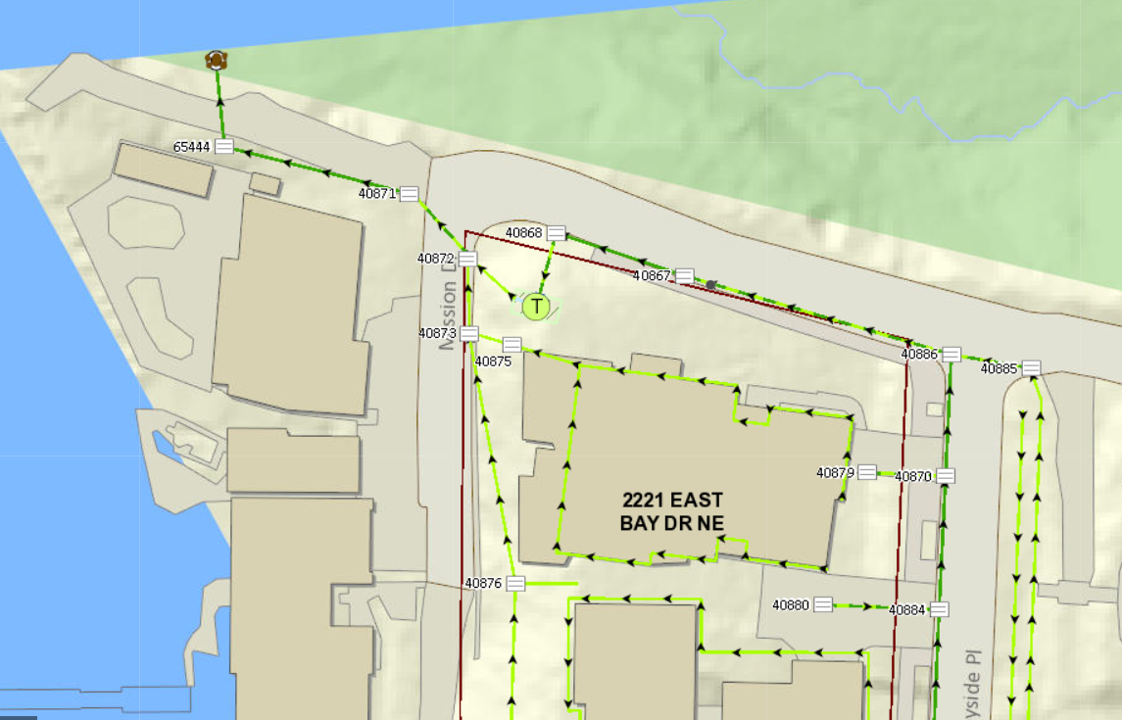

Figure 4. East Bay Filter Vault Location (Mission Dr).

This filter location (called East Bay) is on Mission Dr NE in Olympia, WA labeled as “T,” for treatment. The closest address to the outfall sampling location is 503 Mission Dr NE, and the filter vault is located at approximately 47.066792, -122.896589.

Samples:

May 5, 2023; 50 degrees F, cloudy with moderate rain. No abnormal conditions observed. Three samples were taken between catch basins labeled 40884 and 40870, and two additional samples were drawn from the outfall pipe discharging to the Budd Inlet.

May 15, 2023; 70 degrees F, light to moderate rain. No abnormal conditions observed. One sample of surface water was taken and one sample from the outflow pipe was taken.

June 9, 2023; 55 degrees F, mostly cloudy with light to moderate rain. No abnormal conditions observed. Three samples of surface water were taken and three samples at the outfall pipe were taken.

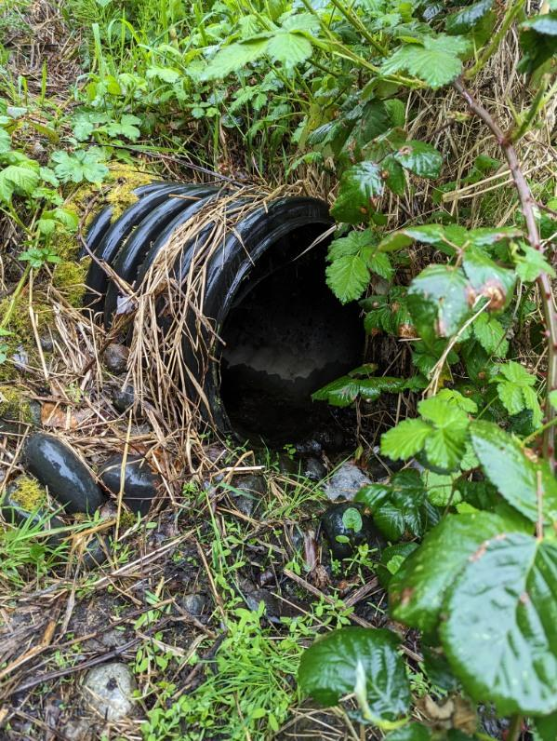

Figure 5. Outfall pipe to the Budd Inlet; on May 5, 2023

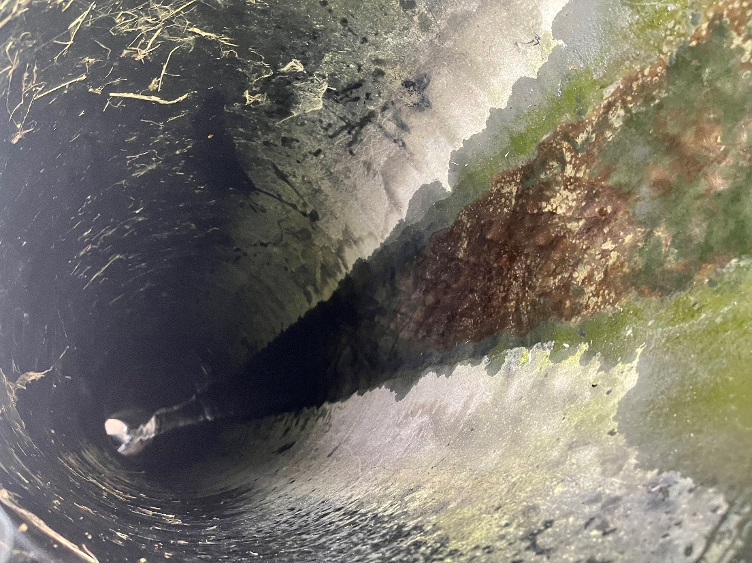

Figure 6. Inside of the outfall pipe to Budd Inlet; on May 5, 2023.

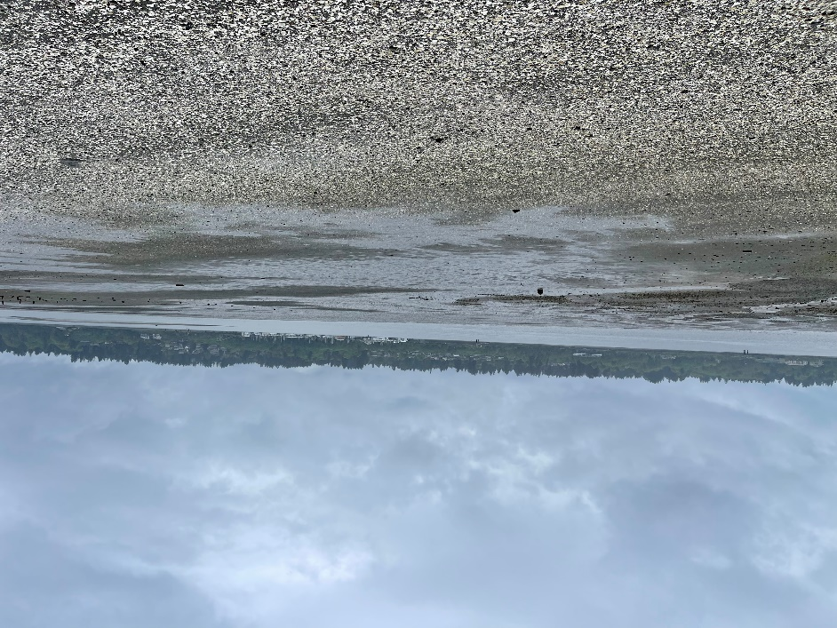

Figure . Weather/tide conditions at Budd Inlet; overcast with moderate rainfall, on May 5, 2023.

### Percival Landing Park Vault Location

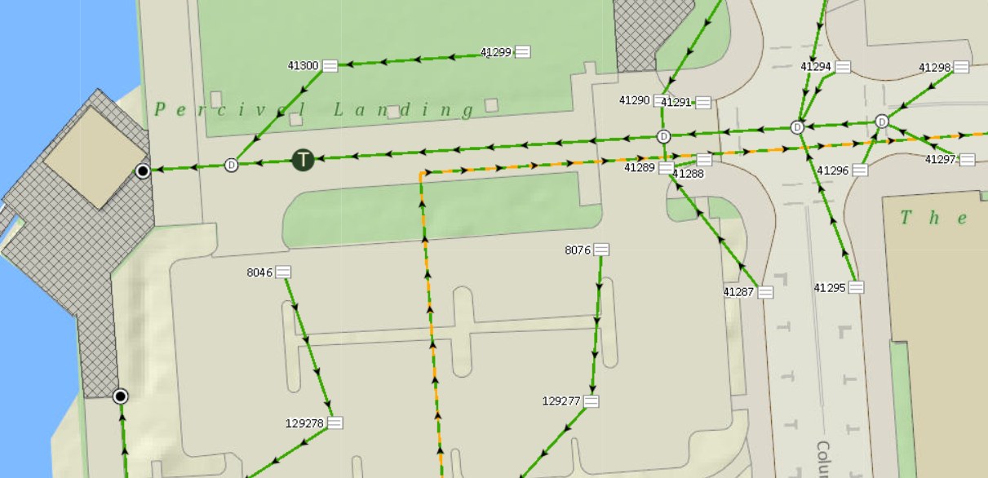

Figure . Percival Landing Park Vault Location. This sampling location is located just south of Percival Landing Park in Olympia, WA on Olympia Ave NW. The filter vault’s approximate location is 47.046385, -122.904102.

Samples:

April 18, 2023; 43 degrees F, cloudy with moderate rain. No abnormal conditions observed. Samples were collected at catch basin 41288, as well as the outfall to Budd Inlet, and the seawater at the Budd Inlet.

April 22, 2023; 50 degrees F, cloudy with light rain. No abnormal conditions observed. One sample was taken near catch basin 129278, one sample was taken near catch basin 8076, two samples were taken at the outfall to Budd Inlet, and one sample was taken of seawater at Budd Inlet.

May 5, 2023; 50 degrees F, cloudy with moderate rain. One sample was taken near catch basin 41288, one sample was taken at the outfall to Budd Inlet, and one sample was taken of seawater at Budd Inlet.

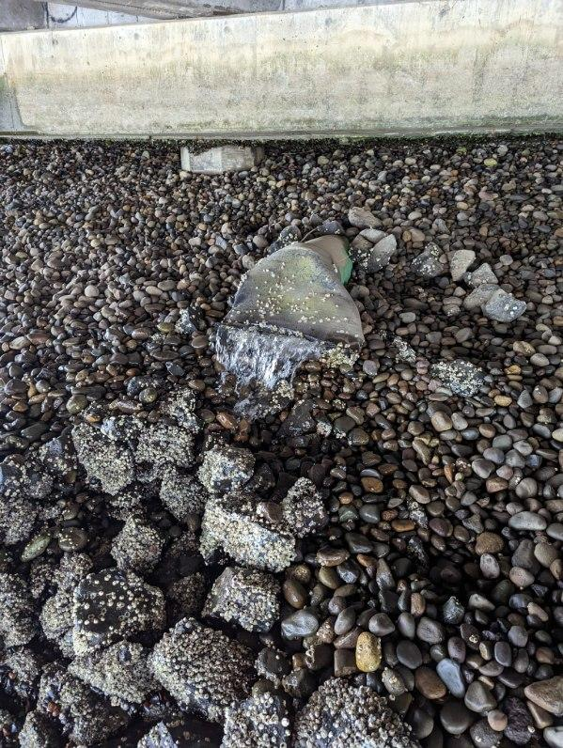

Figure . The outfall to the Budd Inlet; on May 5, 2023.

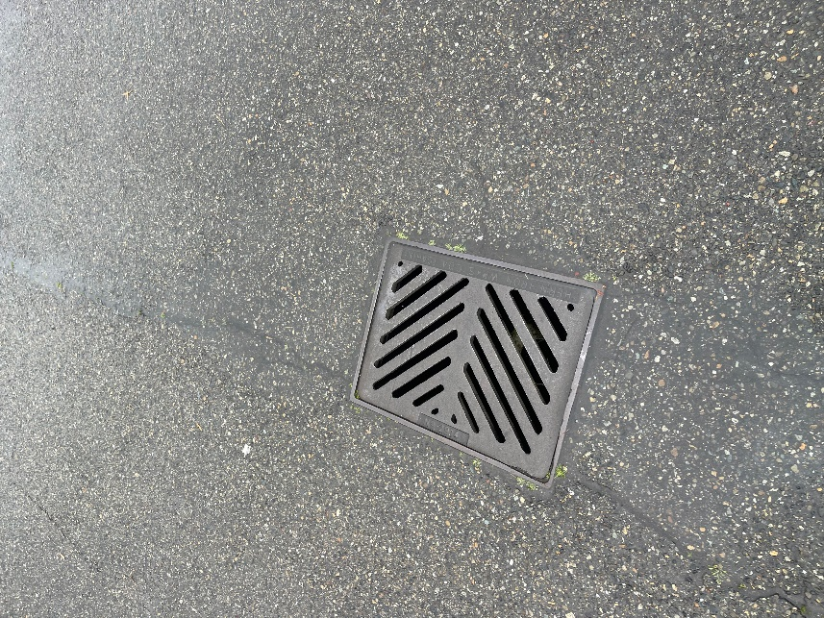

Figure . Catch Basin 129278 and surrounding stormwater where a sample was obtained on April 22, 2023.

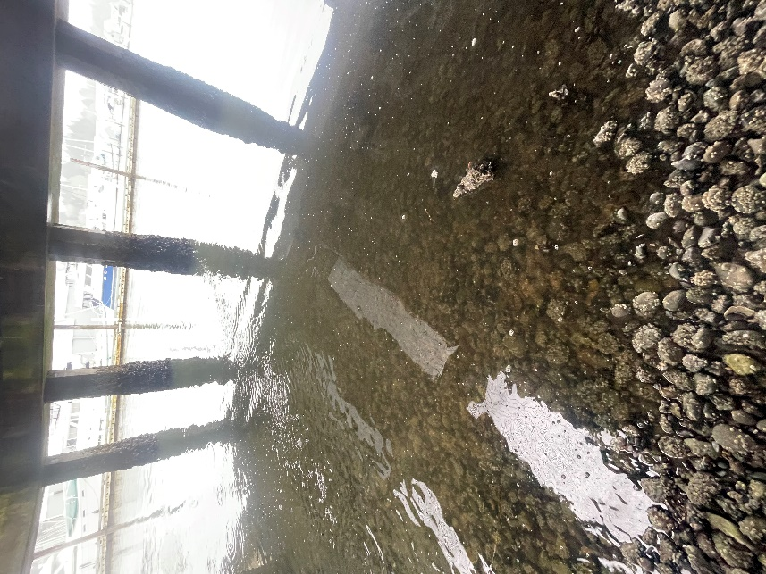

Figure . The seawater of Budd Inlet outside of the outfall on April 22, 2023.

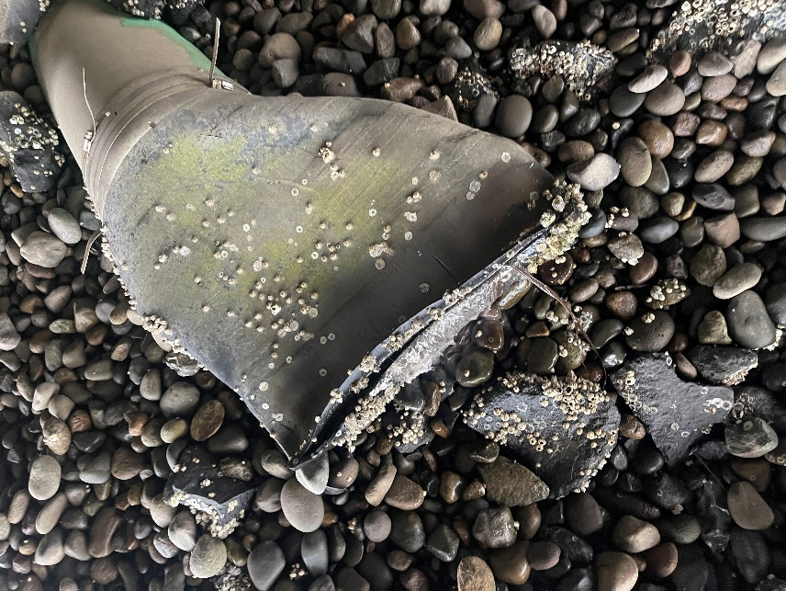

Figure . The outfall to Budd Inlet on April 22, 2023.

Anthony’s Hearthfire Grill Location: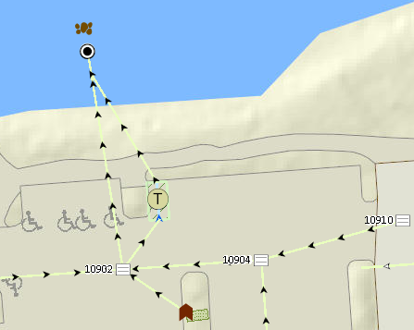

Figure . Anthony’s Hearthfire Grill Location. This filter is located in the parking lot of Anthony’s Hearthfire Grill in Olympia, WA. The approximate location is 47.058534, -122.904577.

April 22, 2023; cloudy with light rain. No abnormal conditions observed. One sample was taken from catch basin 10910, one sample was taken from catch basin 10904, and two samples were taken from the seawater past the outfall to Budd Inlet. I was not able to take a sample at the outfall pipe due to inadequate water flow from this location, as well as the pipe being significantly buried. Figure X below shows a photo of this sampling location and its inaccessibility.

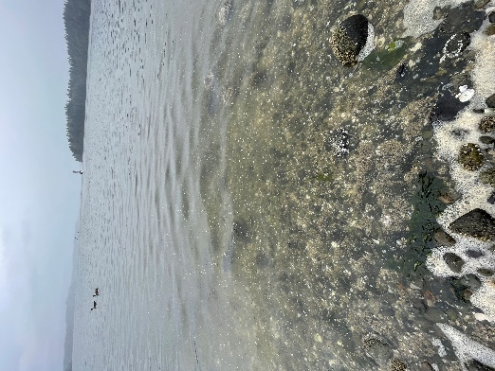

Figure . The seawater past the outfall at Budd Inlet where samples were obtained on April 22, 2023.

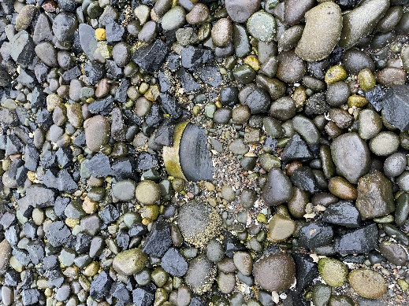

Figure . The outfall pipe set to discharge to Budd Inlet on April 22, 2023. Inadequate water flow prohibited me from sampling at this location. South of this photo faces to the seawater.

Figure . Catch basin 10904 with surrounding stormwater from where one sample was taken on April 22, 2023.

## Lab Analysis:

Phosphate analysis was performed on stormwater samples using a colorimetric technique in order to determine dissolved inorganic phosphate removal amounts. The third edition of Methods of Seawater Analysis by Dr. K. Grasshoff and others (Grasshoff et al., 1999) was used for phosphate analysis laboratory protocol and instructions. Use of the reagents ammonium molybdate, ascorbic acid, antimony potassium tartrate, ammonium molybdate, and sulfuric acid were used to produce results.

In order to determine dissolved inorganic phosphate, the acidified molybdate reagent will react with phosphate ions present in samples and yield phosphomolybdate heteropoly acid which will reduce to a saturated blue pigment, able to be measured on a diode array spectrophotometer (Grasshoff et al., 1999). These measurements will then be compared to my standard phosphate solutions created from a stock solution, measuring 0.25 μm, 0.75 μm, 2.5 μm, and 7.5 μm PO43-.

## Preparation of reagents:

### Sulfuric Acid (H2SO4):

To create this solution, 100 mL of concentrated sulfuric acid was slowly added to 500 mL of de-ionized water, over two stages and in a plastic container. To prevent any corrosion of the bottle, 100 mL of concentrated H2SO4 was added twice, with a short 20-minute lapse in time to allow the solution to cool in the freezer. After the 200 mL of H2SO4 had been added to the 500 mL of water, additional water was added to bring the solution to 800 mL and effectively yield a concentration of 4.5 mol/Liter as stated in the laboratory protocol. This solution was then stored in a corrosive acids cabinet under a fumigation hood.

### Mixed Reagent:

The mixed reagent consists of a combination of ammonium heptamolybdate tetrahydrate, potassium antimony tartrate, and sulfuric acid (as prepared above).

Ammonium Heptamolybdate Tetrahydrate Solution:

This solution was prepared combining 12.4973 g (stated as 12.5 g in the laboratory protocol) of stock ammonium heptamolybdate tetrahydrate in 125 mL of de-ionized water. This solution was combined using a beaker and stir plate.

Potassium Antimony Tartrate Solution:

This solution was prepared using 0.4938 g (listed as 0.5 g in the laboratory protocol) of stock potassium antimony tartrate in 20 mL of de-ionized water. This solution was combined inside a volumetric flask and inverted to mix.

To then produce the mixed reagent, the ammonium heptamolybdate tetrahydrate solution was combined into 350 mL of the sulfuric acid solution (as prepared above) while continuously stirred. After this, the potassium antimony tartrate solution was combined and stirred, and the solution stored in a dark cabinet at room temperature.

### Ascorbic Acid Solution:

This solution was prepared using 15.0008 g of stock ascorbic acid (listed as 10 mL in the laboratory protocol) to 75 mL of de-ionized water (listed as 50 mL in the laboratory protocol). From here, 75 mL (listed as 50 mL in the laboratory protocol) of sulfuric acid (as prepared above) were added to the ascorbic acid and water to yield the solution. Slight adjustments were made to the amount of ascorbic acid solution produced, however the concentration of this solution remains the same as stated in the laboratory protocol. This solution was stored in brown plastic bottles under refrigeration.

### Phosphate Standard Solution:

To create this solution, 0.01701 g of potassium dihydrogen phosphate was added to one liter of de-ionized water in a volumetric flask and inverted to combine. This amount differs from the laboratory protocol as it yields one liter as opposed to 100 mL, however the concentration remains the same at 125 μm/L of phosphate. This solution was stored under refrigeration.

### Preparation of Standards:

Standard phosphate concentrations of 0.25 μm/L, 0.75 μm/L, 2.5 μm/L, 7.5 μm/L, as well as a blank of de-ionized water were created from the phosphate standard solution, ascorbic acid, and mixed reagent. The phosphate standard solution containing a concentration of 125 μm/L was diluted to yield 50 mL of each standard concentration. From here, 1 mL of ascorbic acid as well as 1 mL of mixed reagent was added to the 50 mL concentrated standard solutions, as well as the blank with de-ionized water and combined in a volumetric flask.

Once all standard solutions including the blank have been created, the absorbance was measured on a diode array spectrophotometer at 880 nm, and the values used to generate a linear graph of phosphate absorbances for each concentration. The graph should plot a linear line with an r2 value of at least 0.99.

### Preparation of Samples:

Samples were thawed out overnight under refrigeration in preparation of analysis. In the same manner as used to prepared standard phosphate solutions, each sample was transferred to a volumetric flask and 1 mL of ascorbic acid as well as 1 mL of mixed reagent were added then combined.

After combined, samples were read on a diode array spectrophotometer at 880 nm and measured using the y = mx+b template equation generated from my phosphate standard solution graph. From here, results for total dissolved inorganic phosphate present in my stormwater samples were able to be measured as detailed in my results section below.

# CHAPTER 4: RESULTS

**Results:**

Overall, 32 total stormwater samples were measured throughout April, May, and June. Of these, only three samples were not in measurable range of my phosphate standard solutions which were used to determine the concentration of phosphate.

### Percival Landing:

A total of 17 samples were taken from Percival Landing over three sampling dates on April 18, April 22, and May 5, 2023. Measurable concentrations of inorganic phosphate in these samples range from 0.468 μmol/L to 3.596 μmol and were obtained through laboratory analysis on June 6, June 16, June 25, and June 28, 2023. These results show detectable phosphate in 15/17 samples, and notable higher concentrations occurring in samples taken from seawater and the outfall pipe than street runoff entering catch basins upstream. (Table 1)

Table . Inorganic phosphate results from samples taken at Percival Landing.

Figure . Stormwater sample results for phosphate by location type, with gray representing surface water, blue representing outfall results, and green showing resulting seawater measurements.

Table . Phosphate reduced after introduction of media filter in the storm drainage system. The “Phosphate reduction after introduction of filter” figure is representative of the concentration of phosphate present when the “Average Outfall Water” is subtracted from “Surface Water” samples.

### East Bay Location:

A total of 12 samples were taken from the East Bay location over three sampling dates on May 5, May 15, and June 9, 2023. Measurable concentrations of inorganic phosphate in these samples ranged from 0.468μm/L to 3.596μm/L and were obtained through laboratory analysis on June 6, June 16, June 25, and June 28, 2023. These results show detectable phosphate in 11/12 samples, and notable higher concentrations occurring in samples taken from seawater and the outfall pipe than street runoff entering catch basins upstream. (Table 3)

Table . Inorganic phosphate results taken from East Bay sampling location.

Figure . Phosphate results by sample location type, with gray representing surface water samples and blue representing samples taken at the outfall.

Table . Phosphate reduced after introduction of media filter in the storm drainage system. The “Phosphate reduction after introduction of filter” figure is representative of the concentration of phosphate present when the “Average Outfall Water” is subtracted from “Surface Water” samples.

Anthony’s Restaurant Location:

A total of 3 samples were taken from the East Bay location on April 22, 2023. Measurable concentrations of inorganic phosphate in these samples ranged from 0.788μm/L to 1.967μm/L and were obtained through laboratory analysis on June 16, June 25, and June 28, 2023. These results show detectable phosphate in all samples, and notable higher concentrations occurring in samples taken from seawater than street runoff entering catch basins upstream. (Table 5)

Table . Inorganic phosphate results for Anthony’s Restaurant location.

Figure . Phosphate results by sample location type, with blue representing surface water samples and green representing samples taken from seawater.

# CHAPTER 5: DISCUSSION

**Discussion:**

### Standards:

Two separate sets of phosphate standards with concentrations of 0.25μm, 0.75μm, 2.5μm, and 7.5μm were created in advance of measuring actual sample absorbances to ensure accuracy and replication in the technique used for standards. The results of the first round of phosphate standards produced an R-squared value of 0.9977, meaning 99.77% of the data presented does not present variance or discrepancy from the trendline equation. The second round of phosphate standards produced an R-squared value of 0.8104, meaning 81.04% of the data present does not produce variance or discrepancy from the trendline equation. From here, adjustments were made including the elimination of a 20μm/L standard to ensure the trendline equation was linear.

### Sampling:

Stormwater samples were collected throughout April, May, and June, months with continually decreasing precipitation as Spring weather patterns transition to Summer. With precipitation patterns becoming less frequent and lighter as the season progressed, sampling of stormwater was dependent on several factors in addition to inconsistent weather including availability and tidal patterns.

The determination and interpretation of results would carry more weight if I had the opportunity to collect more samples and expand the timeline in which samples were collected. Due to the timeline of collecting materials for my data collection, I was not able to begin sampling stormwater until April but may have had different or more varied results had I began sampling earlier in the calendar year or been able to obtain and analyze additional samples.

### Phosphate in Samples:

It was evident from my results for phosphate removed from surface water that in most cases, phosphate levels were not reduced. In some cases values were reduced but in other cases they were higher in the outfall waters. In comparing the outfall concentrations to the surface water concentrations, in most cases the difference was not remarkable or there was more phosphate present in the outfall than in surface water.

In comparing the samples taken at each site, surface water samples had high variability in comparison to those taken from the outfall. Outfall samples all fell within 0.5 μmol/L of replicates from the same sampling location and day, however surface samples were extremely varied. Surfaces where sampling was taken was done either directly from the street or from water flowing into a catch basin. Due to contaminants that flow over and into these surfaces during rainfall, surface samples with phosphate concentrations higher than those at the resulting outflow are affected by introductions to urban runoff that contain inorganic phosphate. In other words, point sources at the surface could be missed by surface water sampling but contribute greatly to overall values at the outfall. Examples of this could be traces of animal feces from a yard or on the street that has been picked up by stormwater, or nutrient coated grass seeds saturated with storm runoff that are most often planted in the springtime by homeowners, among other common sources. Regardless, phosphate levels exceeding 1 μmol/L are notable as filter manufacturers advertise an 82% removal efficiency of total phosphorus. The fact that detectable and quantifiable concentrations of phosphate were present in waters exiting the vaults indicates that the performance of these filters in the field is not effective as advertised based on laboratory tests.

High phosphate values were also observed in seawater. Given winter mixing, this is not a surprise, but it does raise the question if some seawater mixing at high tide could introduce phosphorus into the outflow pipes and vaults. In figure 13, it is apparent that the Percival Landing outfall pipe is periodically submerged, given the presence of barnacles. However, in figure 6 the outfall pipe at East Bay is shown, and this is above the high tide line. While saltwater intrusion can’t be ruled out at Percival landing, despite the presence of a valve covering to reduce inflow, the fact that the results were consistent across the two sites despite their varying elevation indicates seawater intrusion cannot account for all of the phosphorus measured exiting the vaults.

Outfall samples showing little variability could be due to a number of factors. The design of stormwater vaults that contain media filters is to temporarily store stormwater for approximately 24-48 hours while slowly discharging water through an outfall pipe to allow for storage of water as a means of flood prevention as well as proper treatment while pollutants are slowly absorbed through the filtration media. During this time, mixing or combining of entering water is occurring with existent water present in the vault. This explains how surface water with a low concentration of phosphate can enter the filtration system and exit through the outfall pipe with a higher concentration.

# CHAPTER 6: CONCLUSION

**Conclusion:**

Urban cities face many challenges to maintain large and dense populations. One of the largest of public and environmental health concern is water quality. Maintaining and properly treating stormwater of common environmental contaminants such as phosphate is essential for the protection of public and environmental health.

In order for urban cities to properly maintain safe and healthy water quality many stakeholders and factors must be taken into account such as large and dense populations, impervious surfaces, and contamination of materials such as phosphate. These listed are all significant public and environmental health concerns without quick or easy solutions. It is important to note that detectable phosphate was present throughout all stormwater samples taken at multiple sampling locations throughout Olympia. This is in spite of the fact that sampling was done after winter months had passed and this systems had been thoroughly flushed by winter storms. With this knowledge, using stormwater media filters to remove excess nutrients such as phosphate in urban runoff can potentially ease water bodies of eutrophication and other adverse effects. The many sources of phosphate contamination in urban cities cannot be eliminated overnight, but treatment options are available and engineered to specifically improve water quality if implemented and maintained correctly.

# Bibliography:

Adhikari, R. A., Krishna, K. C. B., & Sarukkalige, R. (2016). Evaluation of phosphorus adsorption capacity of various filter materials from aqueous solution. *Adsorption Science & Technology*, *34*(4/5), 320–330. Academic Search Complete.

Barbosa, A. E., Fernandes, J. N., & David, L. M. (2012). Key issues for sustainable urban stormwater management. *Special Issue on Stormwater in Urban Areas*, *46*(20), 6787–6798. https://doi.org/10.1016/j.watres.2012.05.029

Berretta, C., & Sansalone, J. (2012). Fate of phosphorus fractions in an adsorptive-filter subject to intra- and inter-event runoff phenomena. *Journal of Environmental Management*, *103*, 83–94. https://doi.org/10.1016/j.jenvman.2012.02.028

Center for Watershed Protection, (TRS). (1995). Developments in Sand Filter Technology to Treat Stormwater Runoff. *Watershed Protection Techniques*, *1 (2)*(Article 105), 47–54.

Chen, W., Wang, W., Huang, G., Wang, Z., Lai, C., & Yang, Z. (2021). The capacity of grey infrastructure in urban flood management: A comprehensive analysis of grey infrastructure and the green-grey approach. *International Journal of Disaster Risk Reduction*, *54*, 102045. https://doi.org/10.1016/j.ijdrr.2021.102045

Chen, X., Wang, Y., Bai, Z., Ma, L., Strokal, M., Kroeze, C., Chen, X., Zhang, F., & Shi, X. (2022). Mitigating phosphorus pollution from detergents in the surface waters of China. *Science of The Total Environment*, *804*, 150125. https://doi.org/10.1016/j.scitotenv.2021.150125

City of Olympia. (n.d.). *Private Stormwater Systems* [GIS]. https://olympiawa.maps.arcgis.com/apps/webappviewer/index.html?id=e33702d6bb554f83b0ff19425baeb854

Contech Engineered Solutions, LLC. (2015). *The Stormwater Management Stormfilter®- PhosphoSorb® Field Performance Summary*.

Contech Engineered Solutions, LLC. (2023). *Filter Media Options*.

Correll, D. L. (1998). The Role of Phosphorus in the Eutrophication of Receiving Waters: A Review. *Journal of Environmental Quality*, *27*(2), 261–266. https://doi.org/10.2134/jeq1998.00472425002700020004x

Deng, Y. (2020). Low-cost adsorbents for urban stormwater pollution control. *Frontiers of Environmental Science & Engineering*, *14*(5), 83. https://doi.org/10.1007/s11783-020-1262-9

Dietz, M. E., & Clausen, J. C. (2008). Stormwater runoff and export changes with development in a traditional and low impact subdivision. *Microbial and Nutrient Contaminants of Fresh and Coastal Waters*, *87*(4), 560–566. https://doi.org/10.1016/j.jenvman.2007.03.026

Egemose, S. (2018). Removal of particulate matter and phosphorus in sand filters treating stormwater and drainage runoff: A case study. *Urban Water Journal*, *15*(4), 388–391. Academic Search Complete.

Grasshoff ,K., Hansen, H. P., & Koroleff, F. (1999). Determination of nutrients. In *Methods of Seawater Analysis* (pp. 159–228). https://doi.org/10.1002/9783527613984.ch10

Gruber, N., & Deutsch, C. (2014). Redfield’s evolving legacy. *Nature Geoscience*, *7*, 853–855. https://doi.org/10.1038/ngeo2308

Jin, Z., Wang, J., Jiang, S., Yang, J., Qiu, S., & Chen, J. (2022). Fuel from within: Can suspended phosphorus maintain algal blooms in Lake Dianchi. *Environmental Pollution*, *311*, 119964. https://doi.org/10.1016/j.envpol.2022.119964

Kaeseberg, T., Kaeseberg, M., Zhang, J., Jawitz, J. W., Krebs, P., & Rao, P. S. C. (2018). The nexus of inhabitants and impervious surfaces at city scale—Wastewater and stormwater travel time distributions and an approach to calibrate diurnal variations. *Urban Water Journal*, *15*(6), 576–583. Academic Search Complete.

Min, S.-H., Eberhardt, T. L., & Min Jang. (2007). Base-Treated Juniper Fiber Media for Removing Heavy Metals in Stormwater Runoff. *Polish Journal of Environmental Studies*, *16*(5), 731–738. Academic Search Complete.

Narducci, J., Quintas-Soriano, C., Castro, A., Som-Castellano, R., & Brandt, J. S. (2019). Implications of urban growth and farmland loss for ecosystem services in the western United States. *Land Use Policy*, *86*, 1–11. https://doi.org/10.1016/j.landusepol.2019.04.029

Nguyen, H. H., Gericke, A., & Venohr, M. (2022). Importance of different imperviousness measures for predicting runoff and nutrient emissions from non-urban and urban land-uses at large spatial coverage. *Journal of Environmental Management*, *315*, 115105. https://doi.org/10.1016/j.jenvman.2022.115105

Okaikue-Woodi, F. E. K., Cherukumilli, K., & Ray, J. R. (2020). A critical review of contaminant removal by conventional and emerging media for urban stormwater treatment in the United States. *Water Research*, *187*, 116434. https://doi.org/10.1016/j.watres.2020.116434

Parsons, A. J., Cooper, J., & Wainwright, J. (2015). What is suspended sediment? *Earth Surface Processes and Landforms*, *40*(10), 1417–1420. https://doi.org/10.1002/esp.3730

Poudyal, S., Cochrane, T. A., & Bello-Mendoza, R. (2021). Carpark pollutant yields from first flush stormwater runoff. *Environmental Challenges*, *5*, 100301. https://doi.org/10.1016/j.envc.2021.100301

Settle, S., Goonetilleke, A., & Ayoko, G. A. (2007). Determination of Surrogate Indicators for Phosphorus and Solids in Urban Stormwater: Application of Multivariate Data Analysis Techniques. *Water, Air, and Soil Pollution*, *182*(1), 149–161. https://doi.org/10.1007/s11270-006-9328-2

Shafqat, M. N., & Pierzynski, G. M. (2013). Soil test phosphorus dynamics in animal waste amended soils: Using P mass balance approach. *Chemosphere*, *90*(2), 691–698. https://doi.org/10.1016/j.chemosphere.2012.09.050

Skotnicki, M., & Sowiński, M. (2015). The influence of depression storage on runoff from impervious surface of urban catchment. *Urban Water Journal*, *12*(3), 207–218. Academic Search Complete.

Smith, J. S., Winston, R. J., Tirpak, R. A., Wituszynski, D. M., Boening, K. M., & Martin, J. F. (2020). The seasonality of nutrients and sediment in residential stormwater runoff: Implications for nutrient-sensitive waters. *Journal of Environmental Management*, *276*, 111248. https://doi.org/10.1016/j.jenvman.2020.111248

van Puijenbroek, P. J. T. M., Beusen, A. H. W., & Bouwman, A. F. (2018). Datasets of the phosphorus content in laundry and dishwasher detergents. *Data in Brief*, *21*, 2284–2289. https://doi.org/10.1016/j.dib.2018.11.081

Vaze, J., & Chiew, F. H. S. (2004). Nutrient Loads Associated with Different Sediment Sizes in Urban Stormwater and Surface Pollutants. *Journal of Environmental Engineering*, *130*(4), 391–396. Academic Search Complete.

Wang, S., Feng, L., & Min, F. (2023). Optimizing first flush diverter for urban stormwater pollution load reduction by most efficiently utilizing first flush phenomena. *Journal of Environmental Management*, *335*, 117563. https://doi.org/10.1016/j.jenvman.2023.117563

Wang, Y., Thompson, A. M., & Selbig, W. R. (2022). Predictive models of phosphorus concentration and load in stormwater runoff from small urban residential watersheds in fall season. *Journal of Environmental Management*, *315*, 115171. https://doi.org/10.1016/j.jenvman.2022.115171

Wu, T., & Sansalone, J. (2013). Phosphorus Equilibrium. II: Comparing Filter Media, Models, and Leaching. *Journal of Environmental Engineering*, *139*(11), 1325–1335. Academic Search Complete.

Zank, B., Bagstad, K. J., Voigt, B., & Villa, F. (2016). Modeling the effects of urban expansion on natural capital stocks and ecosystem service flows: A case study in the Puget Sound, Washington, USA. *Landscape and Urban Planning*, *149*, 31–42. https://doi.org/10.1016/j.landurbplan.2016.01.004