Request to Extend Thesis Research
Master of Environmental Studies
The Evergreen State College
Graduate students who require additional time to complete their thesis work may request an extension for the Summer or Fall quarter immediately following the Spring Thesis Workshop. The extension must be requested by the student and approved by the reader and the MES Director. Starting in 2017, students who are approved to continue work on their thesis will be signed up for a one-quarter extension and pay an extension fee of $500.
If the student does not complete the thesis by the end of the requested quarter, it may result in the student receiving No Credit for their thesis and the student being withdrawn from the program. Reader: Please attach any further stipulations for thesis completion.
I, ____Sarah Brady_________________, request an extension to complete my thesis in (choose only one quarter):
__X_ Summer Quarter 2023 OR ___ Fall Quarter 2023
I also understand that I must pay the $500 fee to extend my thesis work for one quarter.
I have read the information outlined in the MES Student Handbook about the services I can use at Evergreen while I am a thesis extension student.
I have attached my answers to the questions below to this form.
- Describe your progress on your thesis thus far.
- Describe the reason(s) for not completing your thesis by this quarter’s deadline.
- Provide a detailed plan for completing your thesis during the next quarter.
Approved: 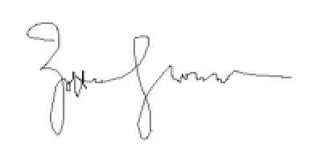Zoltán Grossman, Thesis Reader, May 5, 2023
Approved: ________________________________________ (Director / Date)

So far I have a near-complete draft of my literature review, introduction, and methods section. I have reached out to various individuals to complete my questionnaire, which I received approval from the IRB to distribute. I have gotten completed questionnaires from three sources so far, including the Tribal Historic Preservation Officer for the Quinault Nation. I’ve received confirmation from two others that they will complete it. I am scheduled to conduct an interview with the Chehalis Tribe Historic Preservation Officer on May 16th, as that is their preferred method for sharing their input.
My thesis timeline has been delayed because my wife and I welcomed our first baby on April 8th. She has had some complications postpartum that have made it very difficult for me to complete the data collection portion of my project.
I hope to finish collecting questionnaires by the end of May, analyze my results in June and complete the final draft of my thesis in June and July.

