INFLUENCES ON

SOIL ORGANIC CARBON IN

SOUTHWEST WASHINGTON PASTURELANDS

by

Christina M. Wagner

A Thesis

Submitted in partial fulfillment

Of the requirements for the degree

Master of Environmental Studies

The Evergreen State College

June 2023

©2023 by Christina M. Wagner. All rights reserved.

This Thesis for the Master of Environmental Studies Degree

by

Christina M. Wagner

has been approved for

The Evergreen State College

by



_______________________________

Sarah T. Hamman, Ph.D.

Member of Faculty

June 9, 2023

___________________________

Date

ABSTRACT

Influences on Soil Organic Carbon in Southwest Washington Pasturelands

Christina M. Wagner

Interest in soil organic carbon sequestration is gaining traction worldwide, although the dynamic nature of soil and the influences of climate and human interaction make accurate predictions difficult. In the Pacific Northwest, the primary avenue for carbon sequestration has been through the abundant forests. However, climate change and anthropogenic pressures may impact forest carbon sinks in unpredictable ways. Soil carbon sequestration, on the other hand, offers what may be an effective, less vulnerable alternative to forest carbon sinks. Assessment of soil organic carbon is largely unexplored in the northwest. This study analyzed the effects of habitat types and management on soil organic carbon levels in Southwest Washington. Unexpectedly, soil organic carbon levels were highest in the Puget Lowlands Prairie soils rather than forest soil types, a very surprising finding given the high sand content and shallow, rocky nature of Puget Lowlands Prairie soils. Analysis of management practices, such as weed management, irrigation, fertilization, application of soil amendments, pasture renovation, and tilling, were not conclusive, although some trends were suggested. Comparison of pasture history, current use, animal species, relative animal numbers, and grazing styles indicated management techniques that support soil organic carbon accumulation. Southwest Washington soil is as diverse as its agricultural operations, which complicated the analysis in this study. Nonetheless, the data indicated that soil organic carbon sequestration is a viable climate mitigation tool.

# Table of Contents

Table of Contents iv

List of Figures vi

List of Tables vii

Acknowledgements viii

Chapter 1. Introduction 1

Chapter 2. Literature Review 6

2.1 Climate change 6

2.2 Introduction to Soils 11

2.2.a Soil properties 11

2.2.a.1 Soil physical properties 11

2.2.a.2 Soil biological properties 12

2.2.a.3 Soil chemical properties 14

2.2.b Soil as an ecosystem 15

2.2.b.1 Ecosystem services 15

2.2.b.2 Role in climate change mitigation 16

2.2.b.2.i Carbon sequestration 17

2.2.b.2.ii Flood and drought resistance/resilience 18

2.2.c Soil analysis 19

2.2.c.1 Physical 22

2.2.c.2 Biological 22

2.2.c.3 Carbon sequestration stabilization 23

2.2.d Soil Texture 24

2.3 Biomes in Southwest Washington 25

2.3.a Native Forest 25

2.3.b Native Prairies 26

2.4 Pasturelands 28

2.4.a Role in carbon cycle 29

2.4.b Management practices 31

2.5 Conclusion 35

Chapter 3. Methods 37

Chapter 4. Results 42

4.1 Habitat type outcomes 43

4.2 Bulk density outcomes 47

4.3 Soil physical and chemical outcomes 52

4.4 Land management outcomes 55

4.5 Land use outcomes 62

4.6 Confounding factors 69

Chapter 5. Discussion 70

5.1 Soil organic carbon 70

5.2 Land management 73

Chapter 6. Conclusion 76

References 77

Appendix 1 Management Survey Questions 95

Appendix 2 Management Survey Responses 99

Appendix 3 Soil Test Results 118

# List of Figures

Figure 1. Bulk density corer and step probe with 12" (30.08 cm) soil core 39

Figure 2. Bulk density samples in the lab 40

Figure 3. Google map of survey sites 43

Figure 4. ESD effect on soil organic carbon 47

Figure 5. Linear regression of soil organic carbon with bulk density 48

Figure 6. ESD effect on bulk density 49

Figure 7. Bulk density core example 50

Figure 8. Weed management effect on bulk density 51

Figure 9. Grazing style effect on bulk density 52

Figure 10. Linear regression of soil organic carbon with soil silt percentage 53

Figure 11*.* Linear regression of soil organic carbon with soil clay percentage 54

Figure 12*.* Linear regression of soil organic carbon with cation exchange capacity 55

Figure 13. Prior history effect on soil organic carbon 56

Figure 14. Linear regression of soil organic carbon with start of current practices 57

Figure 15. Weed management effect on soil organic carbon 59

Figure 16. Land management effect on soil organic carbon 61

Figure 17. Current primary use effect on soil organic carbon 63

Figure 18. Grazing style effect on soil organic carbon 64

Figure 19. Linear regression of soil organic carbon with animal unit equivalent 66

Figure 20. Animal species effect on soil organic carbon 67

# List of Tables

Table 1. Soil textures of Southwest Washington Ecological Site Descriptions 25

Table 2. Site characteristics 44

Table 3. Site use 58

Table 4. Land management practices 68

# Acknowledgements

Many thanks are due to many people, including Evergreen faculty and staff: Kevin Francis, Averi Azar, John Withey, John Kirkpatrick, Kathleen Saul, Shawn Hazboun, Ralph Murphy, Steve Scheuerell. Thank you to the fellow members of Team Dirt: Derek Thedell, Claire Kerwin, and Corey Franklin. Thank you to Chuck Francis, Sierra Smith, Stephen Bramwell, Dani Gelardi, Marty Chaney, Erik Dahlke, Marcie Cleaver, Jake Yancey, Gina Smith, and Adam Peterson for answering questions, offering insight, delivering equipment on a Saturday morning, and helping focus this project. Teagan Wagner, Lily Wagner, and Tony Leung were my home team and helped save my arthritic knees. A special thank you to Sarah Hamman, my reader and all-around inspiration for me (and everyone else). Most of all, thank you from the bottom of my heart to all 25 land managers for your time, for letting me sample dirt on your property, pet your dogs, meet your horses, sheep, and cows, and for being wonderful stewards of the land. I am grateful.

# Chapter 1. Introduction

Escalating climate change impacts—floods, droughts, extreme temperatures, unpredictable precipitation patterns—drive scientists and leaders to find successful, cost-effective, readily available, lasting mitigation solutions without harmful consequences (Lal, 2004; IPCC, 2021). Of the many approaches to alleviate climate change, the potential for soil carbon sequestration is high, requires little new technology or equipment, is extremely low cost, and may offset anthropogenic carbon emissions for decades if not longer (Lal, 2007). The estimated 2344 Gt of organic carbon held in soil is the largest land-based carbon pool (Stockman et al., 2012; He et al., 2016). Even at the lower end of the anticipated attainable soil carbon sequestration capacity, the global soil organic carbon (SOC) sequestration rate is estimated to be 0.5Pg of carbon per year (Lorenz, 2018). In contrast, net forest ecosystems may sequester 1.7±0.5Pg of carbon per year (Lal, 2007). The difference between these two carbon pools is in where the carbon is stored—below ground versus above ground—and how they each respond to climate change impacts over time. This paper explores the nuances of soil carbon sequestration and why it is a valuable, secure, long-term climate mitigation strategy.

However, accurate assessment of soil carbon stocks across landscapes is incredibly difficult because of the dynamic nature of organic matter, the heterogeneity of inherent soil properties, the variability of management practices, fluctuating climatic conditions, and the temporal and spatial variations in carbon fractions. Soil carbon is an inherently responsive component in soil, influenced by several factors, including the interplay of soil physical, chemical, and biological properties (Amorim et al., 2020; Fu et al., 2021; Hudson, 1994; Naylor et al., 2020; Sakin, 2012; Taboada et al., 2011).

In the Pacific Northwest, extensive regional forests are traditionally viewed as the primary carbon sink (Case et al., 2021). However, because of the difference in how and where carbon is stored, grasslands have the potential to sequester larger amounts of carbon for a longer time frame than forests (Bai and Cotrufo, 2022; Dass et al., 2018; Lorenz, 2018; Fu et al., 2021). Grasslands, which include native prairies and pasturelands, contain roughly one third of the terrestrial carbon worldwide in their soil (Bai and Cotrufo, 2022; Kim et al., 2023). In the United States, grasslands are nearly a third of the land surface area and almost a quarter—51 million hectares—of the privately held grazing lands (Schnabel et al., 2000; Havstad et al., 2009). Consequently, small increases in soil carbon stocks in pasturelands may have significant impact on climate mitigation goals, ranging from 0.02 to 1Mg of carbon per hectare per year.

Variations in sequestration rates are tied to climate, land use, and management practices such as irrigation, fertilization, amendments, seeding, and grazing strategies (Lal, 2004, 2006, 2008; Taboada et al., 2011; Mudge et al., 2016; Abdalla et al., 2018; Khalil et al., 2019; Paustian et al., 2019; Naidu et al., 2022; Kim et al., 2023). Active management of soil to enhance soil carbon sequestration has proponents (Aguilera et al., 2016; Lal 2004, 2007, 2013, 2015, 2020) and skeptics with reservations about both the universal capacity of soil to successfully sequester significant amounts of carbon and the extent to which carbon sequestration will mitigate climate change effects (He et al., 2016; Six et al., 2002; Yin et al., 2022). To advance understanding in this area, this study asks, **“What effects do habitat types and management practices have on Soil Organic Carbon (SOC) in Southwest Washington pasturelands?”**

Most soil carbon sequestration studies focus on long-term experiments in cropping systems, where similar crops can be grown at sufficient scale over time to draw adequate research data. Far fewer studies examine pasturelands, and those that do have been focused primarily on New Zealand, Australia, China, South America, Europe, Latin America, and the Midwest and Southeastern US, where climate and edaphic conditions are dissimilar to the Pacific Northwest (Abdalla et al., 2018). A large proportion of agricultural land—6% in Grays Harbor County, 14% in Mason County, 25% in Thurston County, and 30% in Lewis County—in Southwest Washington (SW WA) is dedicated to pastureland, making the study of soil organic carbon levels in pasturelands salient over a large area (USDA NASS, 2017). I am not aware of any studies that examine pasture management practices in SW WA. The region, which has a unique combination of climate and soil features, may offer exceptional soil carbon sequestration potential using pasture management practices to enhance natural carbon sequestration processes.

Assessing carbon sequestration rates over a multi-year timeframe is beyond the scope of this study. Instead, in situ soil samples from each site paired with a management survey capturing land use, land management practices, and grazing over a 20-year period sought to determine the influence of those management practices on SOC levels. The sites included 23 pastures in 4 counties in SW WA as well as 3 restored native prairies within 2 counties. Midwest Labs tested soil samples for soil organic matter percentage, total carbon percentage, available phosphorus, extractable potassium, magnesium, calcium, hydrogen, pH, buffering capacity, cation exchange capacity, and percent base saturation of cation elements. Bulk density (BD) cores (a measure of soil mass per unit volume which has implications for soil porosity, water holding capacity, and biological populations) were also extracted from each site. Laboratory analysis of bulk density was conducted within the Evergreen Science Support Center.

Analysis of SOC levels in SW WA pasturelands showed consistently high levels of SOC in one habitat type—Puget Lowland Prairie ecological sites—in comparison with Puget Lowlands Forest, Moist Forest, Wet Forest, and Riparian Forest ecological sites. Soil organic carbon levels’ negative association with soil textural components such as clay and silt percentages are noteworthy. Grazing styles showed some influence on SOC levels, with higher SOC levels for rotational styles and lower with continuous styles. Animal species grazing on the pasturelands influenced SOC, not to a statistically significant level. The pre-2003 historical use of the pastureland played a role in SOC for some sites. As expected, BD correlated inversely with SOC levels, confirming previous findings that lower BD supports SOC accrual (Sakin, 2012). These findings indicate that despite concerns about SOC sequestration limitations due to inherent soil properties, management of pasturelands can have a positive effect on SOC levels.

As scientists and political leaders seek solutions to mitigate anthropogenic climate changes, the knowledge accrued in this study about SOC levels in Southwest Washington grasslands will allow policy makers to devise incentive programs to reward agricultural producers who are contributing to climate solutions with SOC sequestration in their pasturelands. On 27 September 2022 the USDA announced its intention to support the development of a soil carbon monitoring network with an investment of $8 million dollars to “train partners on soil sampling and processing methods, conduct outreach to producers to use soil carbon monitoring practices, coordinate with NRCS national and state centers for technical support, identify and recruit specialists to help producers with soil carbon monitoring, and reach diverse producers to participate in soil carbon monitoring and other NRCS conservation practices” (USDA NRCS, 2023). This is a growing field in which my work establishes baseline information and research protocols, as well as provides a map for future studies by MES students and others.

Following the Chapter 1 Introduction, a thorough Literature Review in Chapter 2 offers a brief context for the project, an overview of soils, and a comparison of the major biomes in Southwest Washington. A deeper look at the role of pasturelands in the carbon cycle and pastureland management practices concludes Chapter 2. Chapter 3, Methods, details the development of the management survey, including recruitment, data collection, and data assimilation. Site descriptions, field soil sampling, soil data collection, laboratory tests, and statistical analysis are also included in the Methods chapter. Results (Chapter 4) and Discussion (Chapter 5) examine in detail the data and analyses. The conclusion (Chapter 6) expresses the primary implications of the findings and suggestions for further study.

# Chapter 2. Literature Review

## 2.1 Climate change

Globally, climate change, the long-term alteration of temperature and precipitation patterns, has become an urgent priority. Addressing climate change impacts was named a top concern in the Thurston 2045 survey (Thurston County Community Planning and Economic Development, 2022), second only to requests to address water issues such as flooding, landslides, surface and ground water, and preserve wildlife habitat. In the Pacific Northwest, climate change is expected to manifest in several areas: higher temperatures favor increased disease, pathogen, and pest occurrences. Warmer temperatures stress agriculture, forests, and aquatic species. Reduced mountain snowpack and earlier snowmelt from higher temperatures are likely to increase winter flooding and amplify droughts conditions in the summer. More intense but less consistent rainfall events enhance the likelihood of floods and erosion during downpours but means more drying between showers. Extended drying, especially in summer, added to higher temperatures exacerbates wildfire risks, as evident by repeated record-setting wildfire outbreaks in the past decade (TRPC, n.d.; USGCRP, 2018; Osterberg et al., 2020). Adapting to these changes requires a thorough understanding of how our local environment will respond. More importantly, planners need comprehensive information about all the options available to address climate change.

The Thurston Regional Planning Council adopted a final mitigation plan in 2020, naming a suite of strategies to reduce local greenhouse gas emissions to below 2015 levels (45% by 2030 and 85% by 2050). The actions identified in the Thurston Climate Mitigation Plan (TCMP) are the regional effort to keep global temperatures from rising above 2oC (3.6oF). The plan—primarily focused on building energy use, transportation, and waste—also includes agriculture, forests, and prairies as potential carbon sinks. In the report, agriculture, forestry, and prairies are low emission sources (2%, largely fertilizer application and livestock release of methane and waste) but also have value as potential carbon (C) sinks. The plan calls for reforestation, afforestation, and increased urban tree cover, as well as preservation of prairies and promotion of regenerative agricultural practices and education on the benefits of increased organic matter and water retention in soils (Osterberg et al., 2020). It makes sense to focus efforts on the highest emissions sectors, but given the options of reducing energy consumption, developing alternative fuel sources, or sequestering carbon to mitigate climate effects, carbon sequestration may be a significant, low cost, readily available option (Lal, 2007; Griscom et al., 2017; Bossio et al., 2020). More importantly, soil carbon sequestration may offer more potential for long-term, secure storage than forestry projects because of the differences in how the carbon is stored within the ecosystems. Climate change and anthropogenic pressures place large-scale forest vegetative carbon storage at risk, whereas carbon sequestered in the soil is less likely to be lost to wildfires (Bossio et al., 2020; Halofsky et al., 2020). It is likely that the most stable terrestrial carbon sinks in the future may be grasslands and pasturelands, where up to 80% of the carbon is stored belowground and is protected from climate effects such as increased wildfire and reduced productivity resulting from precipitation and temperature fluctuations (Dass et al., 2018; Bossio et al., 2020; Halofsky et al., 2020). Furthermore, it is possible that grasslands may not have a saturation point, as continued accumulation of organic matter in every form will lead to higher soil organic carbon levels in toto (Mayerfeld, 2023).

In the Pacific Northwest, conversation about carbon sequestration often references the astounding capacity of our native forests, such as the 80 Mg of carbon per hectare stored in our moist coastal forests (Case et al., 2021). However, this measure is dwarfed by the capacity of soil to amass carbon. Across the global carbon spectrum, soil holds 2500 Pg of carbon, including 1550 Pg of soil organic carbon (SOC) and 950 Pg of soil inorganic carbon (SIC), more than four times the carbon held in all earthly vegetation (Lal, 2004; Weil and Brady, 2017; Gurmu, 2019; Gutwein et al., 2022). For every ton of carbon stored in the soil, 3.67 tons of CO2 is removed from the atmosphere (Fynn et al., 2009). Soil carbon sequestration rates are estimated to be between 300 and 500 Kg of carbon per hectare per year (and as much as 1.0 to 1.5 Mg carbon per hectare per year for severely degraded soils) (Lal, 2007). Estimates of carbon storage capacity vary, depending on climate, edaphic factors, vegetation, and management. In humid, temperate climates, the potential for carbon sequestration can be as much as 1000 Kg carbon per hectare per year (Lal, 2007). What’s more, simple practices such as grazing at optimal intensity may increase carbon levels 0.06 Mg per hectare per year on 712 million hectares of global rangelands and pasturelands; including legumes to 72 million hectares of global pasturelands may increase storage by a further 0.56 Mg C per hectare per year (Griscom et al., 2017; Bossio et al., 2020)—an annual sequestration rate of 0.08 Pg C across the globe. Regardless of sequestration or emission rates, the magnitude of the soil carbon pool indicates that small changes have large impacts on the global carbon cycle (Fynn et al., 2009; Gutwein et al., 2020; Bai and Cotrufo, 2022).

Despite growing enthusiasm for high potential soil carbon sequestration, realistic estimates of soil carbon sequestration capacity are warranted. Claims of 100% offset of anthropogenic greenhouse gas emissions may undermine more accurate but still substantial soil carbon sequestration amounts (Giller et al., 2021). Estimates of carbon levels are complicated by the complexity of soil, external factors such as climate, management, and anthropogenic pressures, and the responsiveness of different portions of soil to those external influences (Kibblewhite et al., 2008; Karlan, Stott, and Mikha, 2021). Limits to carbon sequestration due to inherent thresholds in the mineral structure of soil, saturation of carbon stocks, and restrictions resulting from nitrogen deficiencies may restrict soil carbon sequestration to 0.14 ±0.1 Pg C (Six et al., 2002; Bai and Cotrofu, 2022; Janzen et al., 2022). He et al. (2016) calls into question Earth Systems Models (ESM), pointing out faults in the models: lack of moisture, temperature, and other conditional data effects; inconsistent depths; and in situ versus lab-incubation studies. As a result, the ability of soil to add significant amounts of long-term carbon storage may be overestimated by a factor of two (40% ±27%) (He et al., 2016). Another study questioning the positive impact of soil sequestration in managed grasslands indicates that while rangelands and grasslands in North America and Europe act as carbon sinks, conversion of tropical forests into pastures and pastures into croplands to produce food for livestock are tipping the balance toward net carbon loss (Chang et al., 2021). Both studies juggle a great deal of ambiguity, with unknown warming and CO2 fertilization effects and unpredictable anthropogenic management choices and pressures complicating soil carbon sequestration capacity estimates.

Uncertainty about climate change effects include soil response to elevated CO2 levels, which could result in increased net plant productivity (NPP—above ground plant growth) and increased SOC stocks with attendant drawdown in greenhouse gases (CO2) or in higher respiration and decreases in SOC stocks (He et al., 2016). In studies of warming effects on soil carbon, mean average temperature (MAT) most directly influenced soil carbon levels as increased temperatures spurred microbial mineralization and respiration of carbon dioxide into the atmosphere, with negative correlation higher in warmer climates than cooler (Lal, 2004; Reynolds et al., 2015; Yin et al., 2022). When all conditions were equal, however, mean average precipitation (MAP) became the primary indicator (Reynolds et al., 2015). Higher precipitation in warmer climates spurs carbon emission from soil, which decreases soil carbon storage. In most cases, warmer temperatures increased NPP, which increases carbon inputs to soil (Reynolds et al., 2015; Yin et al., 2022). In Massachusetts, drainage class of soil was a significant predictor of SOC stock (Gutwein et al., 2020), which may be unique to that region or may be a significant indicator globally. Given projected climate change scenarios for the Pacific Northwest, increased rainfall in the winter and early spring would likely combine with a warmer spring season to increase plant productivity without reaching optimal conditions for significant microbial respiration. However, drier summer weather would likely lead to neutral or negative soil carbon emissions, resulting in an overall increase in soil carbon storage. Karlan, Stott, and Mikha (2021) point out the heterogeneity of soils and their different responses to climate and management, calling for holistic, balanced assessment of the physical, chemical, and biological components of soil. Kibblewhite et al. (2008) also call for holistic assessment, pointing out the full picture lost in reductionist approaches. They indicate the adaptability of the biotic components as responsive to external environment and anthropogenic pressures, while the abiotic elements are less reactive.

These uncertainties emphasize the spatially distinct and variable results of soil carbon sequestration studies. Accruing baseline soil carbon levels will permit more accurate estimates of climate change and management influences on soil carbon storage over time. Consistent collection methodology, including depth of measurement, laboratory analysis, indicator selection and interpretation, and input assessment will yield more reliable data for policy makers. Soil carbon sequestration may not be a permanent solution to climate change, but rather offers short-term mitigation without negative side effects. Indeed, the ancillary benefits of increased soil carbon levels—improved water infiltration, enhanced water storage, enriched nutrient cycling, and decreased nutrient and sediment runoff—are motivation enough to encourage practices that promote soil carbon expansion (Lal, 2013; Giller et al., 2021). Bottom line, whether soil carbon sequestration achieves the theoretical greenhouse gas offset potential or more modest offsets, it is one of the few options with virtually no negative consequences and many positive additional benefits.

To illuminate in more detail how soil carbon sequestration occurs and how management affects carbon levels in pasturelands, a brief explanation of soil components is followed by a look at measurement standards, biomes in Southwest Washington, and finally how pasture management affects soil and ultimately carbon levels within pastures.

## 2.2 Introduction to Soils

It is necessary to understand how soils work to recognize the relationship between soil and climate change mitigation. Soil is an extraordinarily complex system that influences nearly every aspect of terrestrial life. The physical, chemical, and biological components of soil act together to create growth media for plants, animals, and humans, and is one of the most diverse ecosystems on earth (FAO, 2015). Healthy soils provide “continued capacity of soil to function as a vital living ecosystem that sustains plants, animals, and humans” (NRCS, n.d.; Weil and Brady, 2017). The inverse, unhealthy soils, restricts sustained growth and well-being, and therefore require attentive care and management.

### 2.2.a Soil properties

#### 2.2.a.1 Soil physical properties

Soil is one of the most overlooked yet valuable natural resources on earth. Ubiquitous and seemingly inexhaustible, the rate at which natural soil forms—between 0.017mm and 0.083mm per year from a combination of parent minerals, vegetation, climate, and time—is beyond the human time scale for regeneration (Montgomery, 2007; Weil & Brady, 2017). The physical components of soil provide a framework for soil biotic and chemical interactions controlling soil functions. Soil texture, or particle size distribution, from clay (fine) to silt to sand (coarse) determines the ability of soil to attract and hold water and nutrients, which influences soil carbon content. Soil texture influences soil aeration, drainage, erodibility, compactibility, and plant root and microbial movement through soil (Weil & Brady, 2017).

While some aspects of soil physical properties are unchangeable—sand will remain sand—biotic interaction influences processes such as soil aggregate formation. Plant roots and fungal hyphae bind soil particles, bacteria and fungi organically affix soil, and soil fauna—often earthworms—mold soil aggregates (Weil & Brady, 2017). Finer textured soils such as silt loams, clays, and clay loams tend to have lower bulk densities—a measure of soil weight over unit volume—than sandy soils because their aggregation, especially with organic matter, makes more soil pores. (Reganold, 1993). Soils with high bulk density and compacted subsoils have reduced biological activity because water and air movement, as well as root growth and faunal movement, through the soil are restricted (Reganold, 1988; Weil and Brady, 2017). Bulk density is negatively correlated with soil organic carbon, is influenced by management (especially grazing), and must be calculated to estimate soil organic carbon stocks (Van Haveren, 1983; Sakin, 2012; Li et al., 2017).

#### 2.2.a.2 Soil biological properties

Soil microorganisms such as bacteria, fungi, archaea, nematodes, worms, and arthropods contribute function in soil through oxidation of plant carbon compounds (root exudates or leaf litter), nutrient release, compound synthesis, or protection of organic materials (Schjonning et al., 2004; Weil and Brady, 2017). Soil microorganisms exchange plant-derived carbohydrates for water, nitrogen, phosphorus, potassium, and other nutrients while respirating carbon dioxide back into the soil and atmosphere (Ladoni et al., 2015; Li et al., 2017; Weil and Brady, 2017). The synchrony between these exchanges is very tight, and there is little extra carbon dioxide released into the air or excess nutrients left in the soil. In a symbiotic dance, a variety of plant materials supports diverse soil microbial biomass, who in turn increase plant phosphorus uptake, enhance nitrogen availability (Mader et al., 2002; Naylor et al., 2020; Giller et al., 2021), and balance nutrient mineralization, particularly nitrogen (N) with plant uptake cycles. In natural ecosystems, these events are also choreographed with seasonal precipitation and temperature changes. Soils with higher soil organic matter content have much higher biodiversity of bacteria, mycorrhizal fungi, protozoa, nematodes, earthworms, and arthropods between and within species (Mader et al., 2002; Esperschutz et al., 2007; Crowder et al., 2010; Naylor et al., 2020). These diverse populations perform a host of functions, nitrogen fixation, macropore tunnel creation, and microaggregate formation (Schjonning et al., 2004).

Soil organic matter (SOM) includes living and deceased plants and animals and is estimated to be 50-58% soil organic carbon (Pribyl, 2010; Weil and Brady, 2017; Gurmu, 2019). The degree of SOM in soil affects soil capacity to hold water. Hudson (1994) found that silt loams containing 4% organic matter had more than twice the available water content than a silt loam with 1% organic matter. This contradicted previous beliefs that greater amounts of organic matter increased plant wilting points and effectively reduced plant available water. The increase of soil organic matter increases water infiltration capacity and water storage capacity, as much as 144,000 liters of water/ha for a 1% increase in soil organic matter (Sullivan, 2002, as quoted by White, 2020).

#### 2.2.a.3 Soil chemical properties

Chemical properties of soil refer to processes mediated by inherent physical soil characteristics, organic inputs, environmental conditions such as moisture or temperature, and biological activities. The ratio between carbon and nitrogen, determined by plant input and microbial processing, also affects the productivity and diversity of the microbial biomass, because diverse microbiota have different input requirements. (Weil and Brady, 2017). A balance of organic materials of differing maturity creates deeper, more diverse pools of carbon materials.

The variety of materials creates higher diversity in microbial biomass, with fresher materials spurring rapid processing and nitrification by some microorganisms and older, more stable materials processed by other microorganisms. (Clark et al., 1997; Mader et al., 2002; Wachter, 2019). Lower C:N ratios found in more labile carbon matter (i.e., proteins, enzymes, and carbohydrates from fresh plant materials) spur rapid nitrification and thus high respiration rates by resource-acquisitive organisms that process labile organic matter quickly, reducing soil organic matter levels and soil carbon stocks. Higher C:N ratios found in more mature plant matter (lignin and cellulose) create nitrogen deficiencies and slow respiration rates as k-strategist organisms more slowly process recalcitrant carbon, reducing CO2 emissions and resulting in higher SOC storage. As microbes process carbon, portions of the organic material become unavailable—recalcitrant—to the microbial population or to plant uptake in a process called humification. The tiny fragments of carbon matter are adsorbed or chemically bonded to the smallest soil particles, what we call sequestered soil organic carbon (Weil and Brady, 2017).

This adsorption increases the cation exchange capacity (CEC) of the soil. Increased CEC capacity in soil plays many roles in soil health. Micronutrients needed for plant and microorganism health are held on cation exchange sites. Increased CEC found at higher soil organic matter levels increases soil fertility. Hydrogen cations (H+) released from microbial respiration can also be held on the cation exchange site, which has direct implications for the pH level of the soil. While increased H+ released from elevated microbial respiration typically leads to lower pH, higher CEC found in soil organic matter expands the number of cation exchange sites, which enhances the pH buffering capacity of the soil, enhancing fertility and production (Franzluebbers, 2010). This is an example of how increases in SOM matter (increased SOC) provides ancillary benefits.

Additionally, soil microbial diversity influences soil pathogen suppression. Soil pH can support or inhibit microorganisms at differing levels, affecting the uptake of micronutrients by soil biota. The dominance of particular communities of soil microorganisms influences the ability of others to affect soil and plant health. Greater diversity of microbial biomass increases evenness within the populations and creates functional redundancy as well as increases suppressiveness of the soil (Crowder, 2010).

### 2.2.b Soil as an ecosystem

#### 2.2.b.1 Ecosystem services

Soil provides many ecosystem services: water filtration and storage; pollutant attenuation; flood regulation; habitat and biodiversity; nutrient cycling; provision of food, fiber, and fuel; provision of construction materials; carbon sequestration; and climate regulation. Moreover, soils with high SOC content typically have good soil structure and efficient nutrient cycling, creating natural CH4 and N2O sinks (Lal, 2013). Over the past forty years, inimitable and irreplaceable soil ecosystem services have gained increasing attention (Kibblewhite et al., 2008; Lal, 2015; Adhikari and Hartemink, 2016), but not enough to make soil health and preservation a top priority. The essential nature of a healthy, diverse soil microbial population is echoed in the functions and services provided. In this most diverse ecosystem—25% of earth’s biodiversity—thousands of bacterial species, hundreds of fungal and insect species, and tens of mites and nematodes, and several vertebrates and earthworms consume and process plants, organic matter, and even pollutants. They increase soil fertility, enhance water and nutrient use efficiency, support plant production, and moderate the carbon cycle (FAO, 2015). Without these species and their functional diversity, many ecosystem processes cease to function.

#### 2.2.b.2 Role in climate change mitigation

Globally, the largest pool of organic carbon, 2344 Pg, exists in soil with conservative estimates of lost SOC ranging from 42-78 Pg due to land clearing, oxidation of organic matter, and erosion (Lal, 2004; Franzluebber, 2010; Stockman et al., 2012; Zomer et al., 2017). Cultivation of soils has led to the release of 50-70% of soil carbon—10 to 30 Mg/ha, depending on how the land has been used and soil type—creating the opportunity for increased SOC sequestration (Lal, 2004; Lal, 2013: Zomer et al., 2017). By comparison, carbon losses from soil from land use conversion (136 ±55 Pg) and SOC depletion (214±67 Pg) are greater than terrestrial carbon losses due to fossil fuel consumption (270±30 Pg). A single petagram (Pg) soil carbon is approximately equal to 0.47 ppm or mg/kg of atmospheric CO2 (Lal, 2013). Replacing depleted soil organic carbon through carbon sequestration has substantial potential for drawing down atmospheric CO2 (Lal, 2004; Lal, 2007; Aguilera et al., 2016). Land systems, including pasturelands, are a major sink for CO2 in live organic matter, 100-1000kg C/ha in humid and cool climates. (Lal, 2004).

##### 2.2.b.2.i Carbon sequestration

Soil organic carbon sequestration is the method by which atmospheric CO2 is conveyed through plant photosynthesis into the soil as plant matter, residues, or exudates that become part of the soil organic matter for some amount of time, days to millennia (Olson, 2010). The plant inputs are consumed by soil biota who either utilize and respirate a portion of the carbon (CO2) back into the atmosphere or break the organic carbon down further. The senesced bodies of the initial biotic carbon consumers are consumed in turn by other biota, who repeat the process. The degree of soil carbon sequestration is dependent on endogenous factors: soil texture, parent material, internal drainage, biotic, and chemical factors. It is also dependent on exogenous factors: land use, disturbance, vegetation, climate, and mineralogy (Lal, 2013; Zomer et al., 2017).

Other factors influencing soil carbon storage include the source of input—root associated carbon is more stable partly because greater chemical recalcitrance, partly because of physical depth and µm scale protects from mycorrhizae and root-hair activity (Stockman et al., 2012), while leaf litter is more labile (Stockman et al., 2012) Current research indicates that particulate organic matter (POM) is more labile and mineralizable, with a mean residence time (MRT) of less than 10 years than mineral associated organic matter (MAOM) whose MRT is 10s to 100s of years (Bai and Cotrufo, 2022). Saturation of MAOM and increase in decomposition (loss of SOC) may reduce realistic sequestration rates to 0.14 Pg C/year in cropping systems, but perennial vegetation, such as in pasturelands, could increase SOC levels (Janzen et al., 2022; Conant et al., as quoted in Mayerfeld, 2023). SOC stocks also increase as mean average temperatures (MAT) decrease (Stockman et al., 2012), while laboratory studies of warming indicate SOC loss, particularly in the whole-soil profile (3.1 Pg C/year with 4oC) (Hicks Pries, 2017). Vegetation coverage and input influence SOC stocks, with perennial pastures offering great potential year-round growth and manure deposition (Franzluebber, 2010). Potential for carbon sequestration is highest in North America (0.60 to 1.22 t C/ha/year/0.17-.35 Pg C annually (Zomer et al., 2017) particularly in temperate climates where NPP is high and microbial respiration is low. Potential for carbon sequestration is higher at higher latitudes, and highest globally in the United States (Zomer et al., 2017).

Grasslands in low temperature, high precipitation (greater than 500mm annually) zones have the highest initial SOC stocks globally, due to nutrient limitations and low pH hindering microbial activity. Grazing stimulates growth in grasslands, particularly for C4 grass species, which can increase SOC storage; however, pugging (animal treading on soil) can spur microbial decomposition and loss of SOC (Abdalla et al., 2018). With MAP ranging from 1300mm to more than 2400mm and MAT from 47oF to 51oF in Southwest Washington (NOAA-NCEI, n.d.), carbon stocks should be relatively high.

##### 2.2.b.2.ii Flood and drought resistance/resilience

As competition for water resources increases, increasing soil water capacity has substantial benefits not only for producers, but also for all water users. Hudson (1994) found that silt loams containing 4% organic matter had more than twice available water content than a silt loam with 1% organic matter, contradicting previous beliefs that greater amounts of organic matter increased plant wilting points and effectively reduced plant available water. The increase of soil organic matter increases water infiltration capacity and water storage capacity, as much as 144,000 liters of water/ha for a 1% increase in soil organic matter (Sullivan, 2002, as quoted by White, 2020). For example, a study in New Zealand found a 1% increase in SOC had a positive effect on non-readily available water, increasing the water holding capacity of dry pastures (Fu et al., 2012). Given projected precipitation changes in the coming years in Southwest Washington, having water available under drought conditions is valuable.

### 2.2.c Soil analysis

One of the factors discouraging adoption of soil carbon sequestration as a climate change mitigation pathway is the difficulty assessing soil in spatially and climatically heterogeneous conditions. Soil is a dynamic, responsive system that reacts to management and exogenous influences in varying ways and complicates efforts to quantitatively assess soil. Extensive review by scientists, agricultural producers, and technical service providers resulted in four benchmarks for selecting indicators: effectiveness, accessibility, consistency, understandability for management applications (Karlan, Stott, and Mikha, 2021). Effectiveness evaluates responsiveness to management changes and applicability of the criteria assessed. Ease of use and cost effectiveness determine accessibility, while consistency refers to uniform results for the same measurements. Understandability is perhaps the most difficult to standardize, because it is more nuanced for local ranges, results, management practices and outcomes. In this study, the selection of which indicators to measure, which methods to use collecting samples, which laboratories and laboratory tests to employ, and which interpretations to apply are based on a synthesis of soil health frameworks.

USDA-ARS Greenhouse Reduction through Agricultural Enhancement network (GRACEnet) protocols examine agricultural soil C stocks related to greenhouse gas sequestration to examine agricultural system influence on SOC (Karlan, Stott, & Mikha, 2021). The GRACEnet data entry template (DET) stores site descriptions (latitude, longitude, topographical descriptions—slope, flat, etc.); soil characterization (taxonomy of most common soils at the site, soil type, texture, typical pH, bulk density, and soil nutrient information—total C and N, organic and inorganic C, NO3, NH4); research design details (number and size of sites, replications, and treatments, depth of sampling, implements for collection, whether the sample is a composite); climate (mean annual temperature and precipitation, weather for at least the last two years, and possibly information about the nearest weather recording station); soil management (amendments—fertilizer/pesticides/organics with rates and application details, land use history, irrigation, drainage); and livestock management (animal species and class, stocking rates, duration of grazing, frequency of rotational grazing, manure management). I did not use this framework because the components for study design and treatment were not applicable.

Other frameworks include the Soil Management Assessment Framework (SMAF) from USDA-ARS and NRCS and Comprehensive Assessment of Soil Health (CASH) from Cornell University. Both assessments examine soil function as influence by management. SMAF looks at 13 factors on a scoring curve: wet aggregate stability (WAS), bulk density, water-filled pore spaces (WFPS), available water capacity (AWC), electrical conductivity (EC), pH, sodium adsorption ratio (SAR), extractable P and K, SOC, microbial biomass C (MBC), potentially mineralizable N (PMN), and β-glucosidase activity (BG). Most of the scoring curves are calibrated for the North American Great Plains region, from Canada to TX, and internationally. A long-term study in Arkansas used SMAF assessments to assess soil across five different categories with at least one indicator each for physical, chemical, and biological soil properties to determine the impacts of pasture management on soil (Amorim et al., 2020). My study in Southwest Washington pasturelands echoes the Arkansas study with examination of pH and extractable P and K (chemical), bulk density (physical), and SOC (biological).

The CASH assessment was developed using SMAF concepts but sought greater sensitivity and more rapid processing (autoclave-citrate extractable (ACE) proteins substitute for PMN and permanganate-oxidizable carbon (POXC) for MBC). CASH has been used in Kenya, Pakistan, Colombia, North Carolina, and New York, and usually indicates that easily digestible types of C and N (POXC, ACE protein) and WAS respond readily to management changes, making them good indicators of soil biological and physical properties (Karlan, Stott, & Mikha, 2021). However, as in the case with the SMAF structure, CASH is not calibrated for a wide geographical area. In both systems, site-specific details such as soil type and texture, environmental conditions, research protocols, and management practices were important factors and should be considered in assessing soil quality. I used portions of the CASH/SMAF frameworks for my study, which is also the framework for the ongoing Washington State Department of Agriculture State (WSDA) of the Soils assessment (WSDA, 2022).

Consistency in sampling and testing impacts soil assessment results. Protocols for handling and preparation of samples, equipment calibration, decisions determining which tools and tests to utilize, and proficiency at following established procedures vary. Even research design decisions influence the level of information relayed in a single experiment, as changes in soil health due to management practices in temperate climates can take 3-5 years, maybe as much as 10 years, to detect (Franzluebber, 2010; Karlen, Stott, & Mikha, 2021; Chase, 2022). Furthermore, differences between field tests and laboratory tests in both level of data revealed and timeliness of results require careful consideration of goals. Soil biological properties are the most dynamic and difficult to assess but are the drivers of most soil functions. USDA NRCS and ARS initiated a national database review to select actionable soil indicators. In data evaluated from 38 states, 60% reported SOC as the primary indicator of soil health (Karlen, Stott, & Mikha, 2021). The SOM and SOC results from each site are the primary data for my study.

#### 2.2.c.1 Physical

There are many methods to measure bulk density as a common indicator of soil physical health. One of the most common and inexpensive is the core method. In comparison to the clod method, excavation method, radiation method, and regression method, core method shows no significant difference at varying depths, does not require expensive equipment or knowledge, and is less susceptible to operator error. Use of a 100cm3 steel core is often the most reliable, as smaller cores impact the soil structure (Al-Shammary et al., 2020). The relationship between SOC and SOM are strongly positively correlated, although the ratio may differ between soil types and depth. On the other hand, bulk density is strongly negatively correlated to SOC (Sakin, 2012). Bulk density as an indicator reveals information about soil physical health such as soil aggregation and available water content (Lal, 2013), factors that heavily influence SOC accrual.

#### 2.2.c.2 Biological

Soil organic matter exerts an acute influence on the functions of soil despite its small proportion of soil, affecting nutrient cycles, water processes, plant growth, and pollution management, and needs to be at least 1.1-1.5% by weight of soil to provide minimal function (Gurmu, 2019; Lal, 2015). Although SOM and SOC are preferred biological health indicators, the influences of physical and chemical properties can affect SOM and therefore SOC levels, sometimes invalidating its worth as an indicator. In a 15-year study of five management practices using the SMAF framework, researchers found little differences in SOM or soil degradations except phosphorous concentrations (attributed to long-term inputs from livestock), and instead found soil health was best described by soil fertility (Amorim et al., 2020). Measurement of short-term mineralizable carbon (SMC) is recommended for assessing management-induced changes in SOC is recommended, rather than particulate organic carbon (POC) or Total organic carbon (TOC). TOC requires a substantial difference (80% with an acceptable type II error of 0.20) and is slow to respond to management changes, and POC variability is too great, at several soil depths. In contrast, SMC shows rapid response to management changes and lower variability; the addition of topographical and soil information increases the statistical power of tests and chance of detecting changes, especially in large fields where heterogeneity is large (Ladoni et al., 2015). As a reliable, rapidly obtained, economically feasible assessment of biological soil properties, I used SOM as the biological indicator in my tests.

#### 2.2.c.3 Carbon sequestration stabilization

Native soils have measurable SOC levels that may be constrained by exogenous or endogenous limitations, such as temperature-induced rapid decomposition or water limitations. Agricultural or other management can overcome inherent soil limitations (for instance, by correcting nutrient deficiencies) impacting net primary production (NPP) inputs to soil carbon levels. However, despite substantial carbon sequestration potential in soil, conflicting analysis about limits of soil carbon sequestration cloud the issue. Protection of SOM through several mechanisms (physical protection in silt and clay, microaggregation occlusion, and biochemical protection) can be maximized, but not exceeded. Sequestration of SOC follows the path from unprotected, active carbon found in light fraction and particulate organic matter (POM) to the increasingly unavailable slow and passive fractions—mineral associated organic matter (MAOM) hidden in microaggregates, adsorbed to soil particles, and biochemically transformed into stable SOC pools (Six et al., 2002). Furthermore, limits to soil carbon sequestration are tied to plant productivity and nutrient balances. For every 24 g of carbon processed by soil microbes, an average of 1 g of nitrogen is required (Weil and Brady, 2017; Janzen et al., 2022). Nutrient imbalances can be addressed by increased nitrogen inputs (fertilizer or manure applications) or reduced nitrogen losses (legume inclusion). MAOM, 55% originating from root exudates and root tissues, is nitrogen dependent and limited by the textural composition of the soil. POM, on the other hand, is not dependent on nitrogen for microbial processing and may continue to accumulate. POM is less stable and subject to land management and environmental factors such as temperature and precipitation (Bai and Cotrufo, 2022), but it does not have an inherent upper limit (Conant et al., 2017 as quoted in Mayerfeld, 2023). Grassland topsoil contains 50-75% SOC in MAOM, and has a microbial necromass average of 50%, larger than agricultural or temperate forest soils, which indicates a more stable SOC pool in grasslands (Bai and Cotrufo, 2022). The good news for climate mitigation via soil carbon sequestration is that SOC levels—in either fraction—are far from saturation today.

### 2.2.d Soil Texture

Soils in the Southwest Washington sites in my study are grouped by the Natural Resource Conservation Service (NRCS) Ecological Site Descriptions (ESD) of Puget Lowlands Forest, Puget Lowlands Moist Forest, Puget Lowlands Wet Forest, Puget Lowlands Riparian Forest, and Puget Lowlands Prairie (Table 1). Nearly all these soils were formed by glacial and volcanic activity, with some alluvial influences. Everett-Spanaway complex, Everett very gravelly sandy loam, Kapowsin stony loam, and Alderwood gravelly sandy loam are the Puget Lowlands Forest (PLF) soils in the study. While they have a high amount of sand, ranging from 42% to 68%, they also have high levels of silt, 25% to 37% (Figure 1). The Puget Lowlands Forest soils have relatively low levels of clay, 5% to 8% (except Kapowsin, with 20% clay). The Puget Lowland Moist Forest (PLMF) soils are Doty silt loam, Melbourne loam, Yelm fine sandy loam, and Cathcart gravelly loam. These soils have higher levels of clay, 10% to 28%, and silt, 22% to 53%. As the moisture level increases to the Puget Lowlands Wet Forest (PLWF) soils—Skipopa silt loam, Everson clay loam, and Bellingham silt loam—the clay levels are much higher, 18% to 33%. Sand hovers around 30%, and silt levels range from 32% to 54%. Soils in the Puget Lowlands Riparian Forest (PLRF) are Chehalis silty clay, Puyallup silt loam, Elma-Fordprairie Complex, and Maytown-Chehalis-Rennie Complex. Silt levels are highest among the Puget Lowlands Riparian Forest soils, ranging from 47% to 66%. Clay is also higher in the 9% to 45% range. The amount of sand in PLRF soils is lower, 7% to 38%. The Puget Lowlands Prairie (PLP) soils, Spanaway-Nisqually complex and Spanaway gravelly sandy loam, are highest in sand content, 68% to 82% and unsurprisingly low in clay, 4% to 8%, given the glacial outwash source of these soils (WSS, n.d.).

Table 1.

Soil textures of Southwest Washington Ecological Site Descriptions

|  |  |  |  |  |  |
| --- | --- | --- | --- | --- | --- |
|  | PLP | PLF | PLMF | PLWF | PLRF |
| Clay % | Mean: 7.1%  Median: 8%  SD: 1.29% | Mean: 8.7%  Median: 5.1%  SD: 6.53% | Mean: 17.6%  Median: 15.9%  SD: 8.51% | Mean: 24.8%  Median: 24%  SD: 6.76% | Mean: 24.1%  Median: 20.9%  SD: 15% |
| Sand % | Mean: 71.1%  Median: 68.2%  SD: 4.81% | Mean: 59%  Median: 62.9%  SD: 9.5% | Mean: 43.7%  Median: 41.4%  SD: 16.63% | Mean: 28.7%  Median: 27.3%  SD: 3.76% | Mean: 22.8%  Median: 22.9%  SD: 14.91% |
| Silt % | Mean: 21.8%  Median: 23.5%  SD: 3.95% | Mean: 32.3%  Median: 32.1%  SD: 4.50% | Mean: 38.8%  Median: 39.4%  SD: 13.14% | Mean: 46.1%  Median: 49.2%  SD: 9.73% | Mean: 53.1%  Median: 50.6%  SD: 0.50% |

*Note.* PLP = Puget Lowlands Prairie, PLF = Puget Lowlands Forest, PLMF = Puget Lowlands Moist Forest, PLWF = Puget Lowlands Wet Forest, PLRF = Puget Lowlands Riparian Forest. Soil texture data is from Web Soil Survey weighted averages (NRCS, n.d.), descriptive statistics from R Studio.

## 2.3 Biomes in Southwest Washington

### 2.3.a Native Forest

Volcanic soils scoured by glaciers provide a deep, rich seed bed for native forests, (Pojar and MacKinnon, 1994). Soil heterogeneity, common in Southwestern Washington, ranges from the Scatter-Fordprairie-Roundtree complex to Melbourne loam to Buckpeak silt loam (NRCS, n.d.). Large evergreen trees such as Douglas fir (Pseudotsuga menziesii), Western hemlock (Tsuga heterophylla), Western redcedar (Thuja plicata), and Pacific madrone (Arbutus menziesii) are complemented by large deciduous trees, including Red alder (Alnus rubra), Bigleaf maple (Acer macrophylla), and Black cottonwood (Populus balsamifera). Understory shrubs include salal (Gaultheria shallon), several species of huckleberry (Vaccinumium spp), rhododendron (Rhododendron macrophyllum), elderberry (Sambucus racemose), snowberry (Symphoricarpos albus), oceanspray (Holodiscus discolor), Indian-plum (Oemleria cerasiformis), and a host of berries (Rubus spp) (Pojar and MacKinnon, 1994). All these native species are well-adapted to the wet winter, dry summer, temperate climate typical of the Pacific Northwest, although long-term adaptability to climate changes is unknown. Fire-opportunists like Douglas fir and red alder have encroached on previously open grasslands, expanding forested lands (Dunwiddie et al., 2014) and giving credence to those species’ adaptability to non-forest environmental conditions. The highly productive forests, due to high precipitation levels and relatively nutrient rich soils define much of the vegetation of Southwestern Washington, particularly Lewis, Mason, and Grays Harbor counties (NRCS, n.d.). In fact, potential carbon sequestration by Pacific Northwest forests is considered very high—often more than 80Mg per hectare, compared to 40-60Mg for Midwestern forests and 60-80Mg in Northeast forests—contained in the aboveground tree matter (Case et al., 2021).

### 2.3.b Native Prairies

Native grasslands, or prairies, exist in the Pacific Northwest because of fire. Drier, well-drained soils supported native perennial grasses and were maintained by anthropogenic burning (Pojar and MacKinnon, 1994). Indigenous communities burned to retain open spaces and cultivate berries, nuts, vegetables, and forage for ungulate game. Suppression of fire has transitioned open grasslands to woodlands and then forests in many areas in Southwest Washington (Pojar and MacKinnon, 1994). Formed from glacial outwash, native prairies are well-drained and often marked by low organic matter, although some have improved water and nutrient characteristics from wind-deposited silt. Common prairie soils in Southwest Washington are Spanaway gravelly sandy loam and Nisqually loamy fine sand (NRCS, n.d.).

Typical native vegetation includes Roemer’s fescue (Festuca roemeri), Common camas (Camassia quamash), Western buttercup (Ranunculus occidentalis), Spring gold (Lomatium utriculatum), Slender cinquefoil (Potentilla gracilis), Paintbrush species (Castilleja spp), Lupine species (Lupinus spp), Menzies’ larkspur (Delphinium menziesii), Chocolate lily (Fritillaria lanceolata), and Garry oak (Quercus garryana). These species are perennials well adapted to the soils and climatic conditions of the Southwest Washington native prairies. Common invasive plants dominating Southwest Washington prairies are Scotch broom (Cytisus scoparius), Himalayan blackberry (Rubus armeniacus), Rat-tail fescue (Vulpia myuros), and Tansy ragwort (Senecio jacobaea) (Pojar and MacKinnon, 1994). Exclusion of fire from the native prairies and the adaptive and aggressive nature of the invasive species make them a significant threat to the native species.

Belowground allocation—30% to 50%—of carbon in grassland species, higher levels of arbuscular mycorrhizal fungi found in grasslands, and better water use efficiency in grasslands systems, especially those dominated by annual species, result in increased MAOM fractions (Bachelet et al., 2011, Dass et al., 2018; Bai and Cotrufo, 2022). Comparing carbon stocks in temperate grasslands and forests, the German Advisory Council on Global Change estimated 9 Pg of carbon in vegetation and 295 Pg in soil (304 Pg total) for grasslands versus 59 Pg in vegetation and 100 Pg in soil (159 Pg total) for forests (German Advisory Council on Global Change, 2000, as quoted by Bachelet et al., 2011). Although soil carbon storage levels are highest when MAT is less than 0oC and MAP is 900mm to 1000mm—Southwest Washington MAT ranges between 8oC and 10oC and MAP between 1300mm and 2400mm—the potential for significant SOC storage remains high in the region (NOAA-NCEI, n.d.; Bai and Cotrufo, 2022). Prairies have the potential to mitigate climate change as a carbon sink, if they are not degraded through poor management practices that promote erosion or (in a pastoral setting) overgrazing (Bachelet et al., 2011; Chang et al., 2021). Prairie restoration may boost species diversity, enhancing soil biodiversity and soil functions, resulting in improved soil carbon stocks—430 Kg/hectare of carbon—and ancillary benefits such as increased water storage (Matamala et al., 2008; Bachelet et al., 2011). Due to land use change, human development, and cessation of Indigenous fire management, approximately 97% of Southwestern Washington prairies have been lost (Dunwiddie et al., 2014). Restoration of native prairies may increase SOC stocks as much as 28% over cultivated or degraded soils (Kampf et al., 2016). Preserving and restoring the remaining native prairies provides another avenue to increase soil carbon sequestration in Southwest Washington.

## 2.4 Pasturelands

Pasturelands—managed and grazed habitats—in Southwest Washington are most often former prairies, particularly those with reduced fertility and water-holding capacity, although some evolved from cleared forest lands. Pasturelands worldwide constitute roughly 40% of land and 70% of agricultural acreage (Abdalla et al., 2018). In Southwest Washington (Thurston, Lewis, Mason, and Grays Harbor counties), there are nearly 25,000 hectares of pasturelands, which is 19.9% of agricultural land (USDA NASS, 2017). Some native species persist in pasturelands, while introduced forage species such as Tall fescue (Schedonorus aurundinaceus), Tall oat grass (Arrhenatherum elatius), Sweet vernal grass (Anthoxanthum odoratum), Timothy grass (Phleum pratense), Field meadow-foxtail (Alopecurus pratensis), Brome species (Bromus spp), Kentucky bluegrass (Poa pratensis), Colonial bentgrass (Agrostis capillaris), Orchard grass (Dactylis glomerata), Thistle species (Cirsium spp), Clover species (Trifolium spp), and Vetch species (Vicia spp) are the dominant species. The density of nonnative species and competing goals for livestock management may impact the functioning of pasture ecosystems, creating a distinct difference from native prairies. Comparison of soil carbon levels between the two systems may illustrate management practices that can optimize soil carbon sequestration.

### 2.4.a Role in carbon cycle

Carbon stocks in pasturelands are primarily determined by pasture plant dynamics—most C is stored in belowground biomass and deposited in the rhizosphere, and roots grow and senesce rapidly (Lorenz, 2018)—and influenced by environmental factors. Precipitation increases primary vegetation growth, increasing soil carbon, and temperature increases decomposition, reducing the soil carbon pool. Vegetative production and decomposition are highest in the 25oC to 35oC range when soil moisture is between 50% to 80% of water-filled pore space. Decreases in temperature hinder decomposition more than plant growth, as does either soil saturation or excessive dryness (Schnabel et al., 2000). Mean temperatures in Southwest Washington are well below that threshold for most of the growing season (US Climate Data, n.d.), which indicates continuous plant production without attendant decomposition and SOC loss.

Through the process of photosynthesis, plants combine energy from the sun and carbon dioxide from the air to create energy. Grasses store their long-term energy in the bottom three to six inches of their stems, whereas herbaceous species like clover (Trifolium spp), alfalfa (Medicago sativa), birdsfoot trefoil (Lotus corniculatus), and legumes store their reserves in their roots, rhizomes, and crowns (Shewmaker & Bohle, eds., 2010). When growth is disturbed by grazing, the plant regrows from meristematic tissues—growth points, or nodes—in stems, roots, and leaves. Apical meristems may be vegetative or reproductive at the growing tip of a plant, either shoot or root. Growth from vegetative apical meristem can persist until it is eaten, dies due to natural causes (overshading or old age), or changes to reproductive stock, where it stops shoot growth. Apical meristems also control two other meristematic tissues: intercalary and axillary meristems. Found at the base of leaves, grass blades, or blade sheaths, intercalary meristematic tissues drive extension of tissues and can be dormant at times. If the apical meristem is defoliated, an active intercalary meristem may generate new growth until the leaf is completely grown. The axillary meristem, also called the tiller bud, crown bud, or basal bud, is frequently inert until the apical meristem ages into reproductive stage or death or until it is removed, allowing the axillary meristem to become the apical meristem (Shewmaker & Bohle, eds., 2010), a process of new shoot formation called tillering.

Tillering varies among species, but in general increases the density of both roots and shoots as new tissues replace dead (Shewmaker & Bohle, eds., 2010). This raises the amount of carbon input to the soil as the senesced material is replaced by living. Related to the amount of plant growth, and therefore carbon inputs, is the seasonal growth cycle. Typical growth is highest in late spring and drops as temperatures rise. Additionally, reduced soil water and even lower soil nitrogen slow growth (Shewmaker & Bohle, eds., 2010). Maximizing regrowth is therefore dependent on management of herbivory in concert with growth of pasture vegetation.

### 2.4.b Management practices

In pastures, the soil-plant-animal relationship is managed by producers who control the number of livestock on a pasture and the length of time they are allowed to feed. While we have looked at the relationship between soils and plants in previous sections, the relationship between plants and animals—herbivory—bears examination. Because grazing animals may consume 20-75% of the aboveground production, their management directly impacts the carbon cycle in pasturelands (Taboada et al., 2011; Kampf et al., 2016; Abdalla et al., 2018). Vegetative production increases with precipitation, creating a larger effect on aboveground fodder consumption in more humid areas such as Southwest Washington (Taboada et al., 2011; Lorenz, 2018). Root effects from grazing are generally positive. Grass with 50% of its foliage removed loses only 2%-4% of its root growth, indicating that belowground functions are largely unhindered by grazing (Crider, 1955). Overall, grazing reduces carbon inputs from aboveground biomass—leaf litter—to POM because of animal ingestion. In fact, decomposition by microbial biomass of labile carbon is reduced when above ground inputs from leaf litter are decreased and less digestible root carbon, twice as slow to decompose as leaf carbon, is the primary source of microbial energy. The increase of the MAOM carbon pool from root carbon and reduction of POM inputs increases SOC stocks. Grazing affects the composition and function of the microbial pool by altering the quantity and quality of the carbon input they receive. Partially processed carbon in feces are high quantity and quality inputs with limited distribution. Above ground, grazing in productive pasturelands increases leaf nutrient content, increasing litter quality and decomposition, while below ground, carbon allocated to root exudation increases, initiating the microbial activity-nutrient feedback cycle in the root area that supports plant growth. (Taboada et al., 2011; Naidu et al., 2022). Plant community structure influences microbial activity when the types of plants are more readily digested, such as invasives that accelerate the carbon cycle or C4 grasses whose daily growth is 19% to 88% higher than C3 grasses. In areas of high vegetative growth, stimulation of above and below ground productivity—by grazing, for example—can offset the loss of litter carbon inputs. (Taboada et al., 2011; Lorenz, 2018; Naidu et al., 2022). Finally, grazing affects the microbial community composition, although studies contradict the specific effects. Taboada et al. (2011) suggest grazing shifts the microbial community composition toward a faster, bacterial dominated population, rather than a slower, fungal dominated one. In contrast, Naidu et al. (2022) suggest grazing has a stabilizing effect on soil carbon because it extends the stoichiometric coupling between nitrogen and carbon.

Managers of grazing systems primarily focus on the number of animals in a pasture (the stocking rate) to achieve financial, environmental, and other objectives. Management methods control the length and timing of grazing, the amount and type of forage consumed by different animals, and how much time each pasture is grazed (Shewmaker & Bohle, eds., 2010; Moore et al., 2019). The type of management practiced depends on climate, geography and topography, inputs (seeding, fertilizer, irrigation), management intensity, which part(s) of the year the pasture is utilized, animal type and goal for production, defoliation management by animal (continuous or rotational grazing), and surplus forage management (Shewmaker & Bohle, eds., 2010). Because grazing animals is a dynamic soil-plant-animal system, consideration of soil and other resource (water for irrigation) limitations are part of pasture management decisions (Shewmaker & Bohle, eds., 2010). Matching animal numbers with adequate forage availability to maximize growth, aided by pasture management, optimizes grazing systems (Schnabel et al., 2000; Shewmaker & Bohle, eds., 2010; Lorenz, 2018; Moore et al., 2019). Several pasture management methods improve forage production: adding legumes, irrigation, fertilization, adoption of higher-production C4 grass species, and inclusion of manure (Lorenz, 2018). Fertilization with phosphorus can increase production without spurring soil carbon decomposition, while adding nitrogen increases plant growth and reduces legumes (Schnabel et al, 2000). Irrigation can increase forage production but has been shown to decrease SOC stocks and soil nitrogen levels (Mudge et al., 2016). However, the effectiveness of all these techniques is dependent on the forage species, plant density, stage of growth, level of defoliation, and nutrient balance before fertilization (Moore et al., 2019). Highly defoliated species in the reproductive stage with high levels of existing nutrients will not show marked increases in growth.

Grazing management systems range from continuous grazing that offers unfettered access to the whole pasture to rotational grazing that moves livestock through (typically) smaller subdivisions called paddocks. Revegetation occurs with animals onsite and often shows excessive wear and evidence of preferential grazing in continuously grazed systems. Rotationally grazed systems offer longer regrowth periods during the animal-excluded period (Holochek, 1983; Shewmaker & Bohle, eds., 2010). Large mammal herbivory in short duration, high density rotation indicates higher levels of SOC than continuously grazed systems or ungrazed systems (Khalil et al., 2019; Naidu et al., 2022; Kim et al., 2023). Adaptive multi-paddock (AMP) grazing shows higher biomass production, improved water infiltration, and higher soil nitrogen levels in comparison to heavy continuous grazing (Hillenbrand et al., 2019; Kim et al., 2023), conditions that support higher soil carbon levels. Studies of light continuous or rotational grazing show contradictory results. Preferential grazing in light grazing systems leads to overgrazing in some areas and increases undesirable and invasive species in other areas, impacting plant growth and carbon inputs. (Hillenbrand et al., 2019). Loss of animal treading to initiate decomposition in light grazing systems decreases SOC levels (Schnabel et al., 2000). On the other hand, light grazing causes the least reduction in SOC in some systems, particularly where there is adequate water and high-growth C4 grasses (Bai and Cotrufo, 2022).

Treading and trampling by animal hooves impacts soil structure directly by changing the form and stability of soil aggregates, which affects bulk density, pore size and soil strength. The degree of influence depends on animal class, soil type, vegetation response to climate conditions, and pasture management system. Dry animal-trampled soil results in aggregate crushing and smaller aggregates at the surface of the soil. Moist soils are compressed by animal hooves, resulting in the collapse of larger soil pores and higher bulk density. On saturated soils, animal hooves can poach the soil, creating compacted lumps of soil. Both dry and moist trampling effects alter water infiltration, which potentially increases flooding and runoff and decreases water holding and plant productivity (Taboada et al., 2011). While infiltration rate may be a sensitive indication of soil physical health, soil texture (sandy soils are resistant to compaction) and organic matter content—above and belowground—may reduce the impacts of grazing on soil physical properties (Taboada et al., 2011). In continuously grazed systems, physical soil changes are influenced by moisture content, soil type, and stocking rates, although even in lightly stocked pastures, uneven trampling near water sources or other high-traffic areas can impact erosion and compaction rates (Taboada et al., 2011). Rotational grazing impacts on soil physical properties are mixed, depending on soil type and climatic factors such as water for vegetative regrowth (Taboada et al., 2011). Harm to soil physical properties may be mediated by natural precipitation cycles, plant growth and senescence, and exclusion of grazers, although some rotational systems may not allow a full natural recovery cycle (Taboada et al., 2011). In silty loam and clay loam soils with high organic matter (>4.5%), infiltration rate and soil macropores showed the greatest improvement (up to 127%) after grazing stopped and visible signs of poaching decreased 50% within 87 to 165 days. Additionally, macroinvertebrates (earthworms) create macropores naturally in the top 5cm of soil in areas of manure deposition. (Taboada et al., 2011). Recovery in drier climates may take several years for full recovery, which is not a problem in temperate climates like Southwest Washington.

## 2.5 Conclusion

Soil organic carbon levels are determined by the interplay between soil physical, chemical, and biological properties. Soil is a dynamic ecosystem that is highly responsive to management practices. Systems that increase carbon inputs without impeding soil functions, such as rotational grazing and management of soil pH may show higher carbon soil levels than those who retard plant growth after grazing and decrease diversity.

Recent interest in soil carbon sequestration highlights the need to identify systems and practices that optimize carbon storage for long time periods. Variations in climate and edaphic factors make development of best management practices (BMPs), indicators, and assessment extremely challenging. Long term studies in Wisconsin showed that rotationally grazed systems, in contrast to cropping systems, sequestered carbon at 0-15cm depth. All systems in the study lost SOC across the whole 0-90cm soil profile, however, calling into question realistic climate mitigation potential of soil carbon sequestration (Sanford et al., 2012). A repeat of the study in 2022 looked at SOC at 0-30cm depth and found 18% - 29% higher SOC MAOM in pastures than cropping systems, findings that were validated by comparison to studies in similar systems globally. This is due to the continuous, undisturbed input of high-quality inputs from animals and root matter that promotes carbon accrual and impedes decomposition or SOC loss. (Rui et al., 2022). Although Rui et al. (2022) did not test at the same depth as Sanford et al. (2012), recognition that most soil biological responses occur in the top 30 cm of soil may have driven the focus on the upper profile. A third study found that cool-season perennial pasture with undisturbed soils offers the best soil carbon sequestration mitigation potential (Becker et al., 2022). In each of these studies, the soil types and climate are very different from Southwest Washington, making direct inference unlikely. The conditions identified for high soil carbon sequestrations, however, indicate that Southwest Washington pasturelands may offer significant climate mitigation potential.

Furthermore, soil organic carbon depends on the relationship between climate, inherent soil properties, and management—disturbances and inputs (Schjonning et al., 2004). The variability of highly heterogeneous soil conditions requires careful collection and monitoring of valid soil data and management practices across time. Adoption of land-based carbon sequestration receives only 2.5% of mitigation funding (Griscom et al., 2017) Uncertainty about potential and cost, the longevity of stored carbon, and social and cultural barriers hinder widespread acceptance of soil carbon sequestration. Consistency in measurement, baseline information, and calibration of equipment, tests, and methods ensures valid data about soil carbon levels (Olson, 2013). This study provides baseline data, consistent with WSDA State of the Soils assessment, on soil organic carbon levels and management practices in Southwest Washington pasturelands.

# Chapter 3. Methods

In this two-part study, I used management practice surveys and in situ soil sampling to compare the effects of management practices on soil organic carbon (SOC) levels and bulk density (BD) in Southwest Washington pasturelands. The management practice surveys completed by landowners in January and February 2023 provided historical information to contextualize the soil data. I collected in-field soil samples to measure soil organic matter, soil pH, cation exchange capacity, nutrients, and bulk density (BD) in pastures and native prairies during a two-week period in late winter. Statistical analysis compared the effects of management on SOC levels and BD in different soil series.

Participants in the study were recruited from the Southwest Washington Grazing Association and from Thurston County community members who had submitted pasture soils for testing to Thurston Conservation District in 2020 and 2021. Both populations were emailed a request to participate in the study. Those who agreed were not compensated for their participation; however, a complimentary copy of the soil test and the results of the study were provided to each participant. The survey, approved by the Evergreen State College Institutional Review Board, was released on 3 January 2023 to participants. The survey obtained information regarding practices such as grazing, haying, fertilization, irrigation, weed control, soil amendment applications, length of practices, and history of land use. The specific questions included in the survey can be found in Appendix 1. All responses were captured by 10 February 2023. I clarified some responses with follow up email or phone calls. All responses (with identifying information redacted) are included in Appendix 2.

In-field sampling followed the Washington State Department of Agriculture Standard Operating Procedures (WSDA, 2022). Samples were collected to assess baseline soil organic carbon levels and bulk density. Eight soil cores were extracted from each of 5 random points within a pasture, then homogenized prior to testing, yielding one sample for each pasture. I used Google Earth Pro to establish a polygon outlining the pasture, dropped five pins to establish the five sampling points, and downloaded the maps onto my handheld device (Google, n.d.). The maps allowed me to navigate the pasture to the collection points. To collect the samples, I removed any plant material (grass, roots, and crop residue) on the top 1-2 inches, then inserted a 7/8-inch diameter soil-sampling probe at a 90-degree angle to the surface of the soil to a depth of 12 inches (30.48 cm), a depth compatible with the IPCC (Abdalla et al, 2018). I deposited the soil from the probe into a clean, non-galvanized bucket. I homogenized the pasture sample by mixing the soil in the bucket with gloved hands. I placed at least two cups of soil into a labeled and resealable plastic bag and stored it in a refrigerator at 40oF before shipment to Midwest Laboratories within seven days from collection (Figure 1).

Soil organic matter, nutrients, pH, and cation exchange capacity (S1A) tests and Total Carbon tests were done by Midwest Laboratories, 13611 B Street, Omaha, NE, 68144. Midwest Laboratories are fully accredited in Washington state through the NAPT program (Midwest, n.d.). Time constraints and laboratory proficiency were the determining factors in selection of Midwest to conduct these tests. Soil organic matter (SOM) was determined by loss on ignition and is expressed as a percentage. Total carbon (TC) was measured from dry combustion on a LECO analyzer, indicates both SOC and soil inorganic carbon (SIC), and is also expressed as a percentage. Although all soil data was shared with participants, nutrients were not examined in this study. Complete soil test results are listed in Appendix 3.

Figure 1.

*Bulk density corer and step probe with 12” (30.08 cm) soil core*

As a soil physical indicator relevant to root establishment, plant growth, and soil carbon stocks, I collected bulk density cores at three random points co-located with the five sampling points within the pasture. To collect soil for BD testing, I used a 6” soil core cup containing three 2” rings, attached to a compact slide hammer, to obtain samples from a 4-inch (0.10 m) depth (Figure 1). A single core from the center ring was carefully pared from the outer two rings and placed into a lidded disposable aluminum baking cup after all visible rocks or large organic matter was removed. The three BD specimens collected from each site were refrigerated at 40oF until analyzed. I measured bulk density in the Evergreen State College Science Support Center laboratory by drying the cores in their aluminum cups for 24 hours at 105oC in a Yamato DKN602C oven. I weighed each dried sample in its cup and then weighed each empty cup with a Sartorius Group Acculab analytical balance to determine the net mass of the dried sample (Figure 2). The known volume of each core was 102.96296 cm3 (2" x 2" cylinder). The data for bulk density is expressed in g soil/cm3.

Figure 2.

*Bulk density samples in the lab*

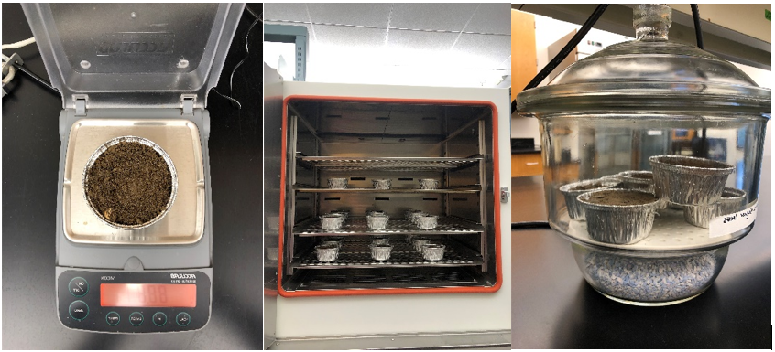

*Note*. From left to right: Bulk density sample on the analytical balance; Bulk density samples in the oven; Bulk density samples in the desiccator waiting to be weighed.

For each site, organic matter percentage was multiplied by both the van Bemmelen Index (0.58) and a more conservative constant (0.50) to determine soil organic carbon content (Franzluebber, 2010; Pribyl, 2010; Heaton et al., 2016; Weil and Brady, 2017).

Statistical analysis was done using R version 4.1.3 (2022-03-10)— “One Push-Up” Copyright © 2022) The R Foundation for Statistical Computing Platform: x86_64-w64-mingw32/x64 (64-bit). Correlation, linear regression, and ANOVA examined the relationship between edaphic factors, land management, and livestock management on SOC levels. The alpha level α = 0.10 was used to determine significance. Significant findings were further analyzed with Tukey’s HSD to determine which factors are most influential. Shapiro tests to determine normality of the data were used. Those data that were not normally distributed were log10 transformed.

# Chapter 4. Results

Despite a relatively small geographical area—just over 182,000 hectares (450,000 acres)—and a small sample size (26 sites), extraordinary diversity in site characteristics, land use, livestock, and management practices complicated analysis. The sites were distributed across five counties—Pierce, Thurston, Mason, Grays Harbor, and Lewis—and consisted of 23 pastures and three restored native prairies (Figure 3). Pasture and prairie sample areas ranged from 0.3 acres to 17.5 acres, with a median of 3.3 acres and mean of 5.3 acres. Three prairie sites and one pasture site were selected as controls. Although there is a long history of dairy farming in the control pasture, rare prairie species have been documented onsite, and organic and floral species-protective practices have been followed for many years.

Figure 3.

Google map of survey sites

Note. The range of sites includes Pierce, Thurston, Mason, Grays Harbor, and Lewis counties.

## 4.1 Habitat type outcomes

Heterogeneity in soil series both within and among the 26 sites included 36 different soil series as either single, dominant series or components of complexes. Sample areas were selected within the pastures and prairies to be representative of single dominant soil series rather than multiple soil series. Soil series descriptions from USDA/NRCS Web Soil Survey were combined with data from Google Earth Pro and EDIT (Ecosystem Dynamics Interpretive Tool) Ecological Site Descriptions (ESD). The sites in this study include soils from the Puget Lowlands Forest (Ecological Site AX002X01X004), Puget Lowlands Moist Forest (Ecological Site AX002X01X005), Puget Lowlands Prairie (Ecological Site AX002X01X006), Puget Lowlands Wet Forest (AX002X01X007), and Puget Lowlands Riparian Forest (Ecological Site AX002X01X008) groups (Table 2). Although these descriptions are not complete within the EDIT system, soils grouped within have similar ecological characteristics, including similar ranges of MAP and MAT, similar parent materials, and similar vegetation. Parent materials included glacial outwash, glacial drift, volcanic ash, shale, sandstone, siltstone, alluvium, loess, lacustrine and glaciomarine deposits, igneous rocks, and herbaceous organic deposits. Soil textures within each ESD were more consistent, while variations between ESD were markedly different.

Table 2.

Site Characteristics

|  |  |  |  |  |  |  |
| --- | --- | --- | --- | --- | --- | --- |
| Site ID | County | ESD | Acres total | Acres sampled | Dominant Soil Series | Subordinate Soil Series |
| Prairie1 | Thurston | PLP | 580 | 15.9 | Spanaway (60%)-Nisqually (30%) Complex | -- |
| Prairie 2 | Pierce | PLP | 153 | 14.8 | Spanaway gravelly sandy loam (100%) | -- |
| Prairie 3 | Thurston | PLF | 232 | 3.5 | Everett (50%)-Spanaway (35%) Complex | Nisqually (10%), Semiahoo (5%) |
| Prairie 4 | Lewis | PLMF | 60 | 17.5 | Doty silt loam (90%) | Klabe (5%), Lacamas (5%) |
| S2TEST23 | Thurston | PLWF | 2 | 1.3 | Skipopa silt loam (90%) | Yelm (10%) |
| TCSCAS23 | Thurston | PLF | 10 | 5.4 | Everett very gravelly sandy loam (80%) | Alderwood (10%), Indianola (10%) |
| LCCHEH23 | Lewis | PLRF | 7 | 2.2 | Chehalis silty clay (90%) | Alvor (5%), Reed (5%) |
| TCGENI23 | Thurston | PLWF | 24 | 5.3 | Everson clay loam (85%) | Everson (5%), McKenna (5%), Cagey (3%), Bellingham (2%) |
| TCMEDI23 | Thurston | PLRF | 5 | 1.8 | Puyallup silt loam (85%) | Newberg (5%), Semiahoo (3%), Sulta (2%) |
| TCCLMA23 | Thurston | PLWF | 3 | 2.4 | Skipopa silt loam (90%) | Yelm (10%) |
| TCPRAI23 | Thurston | PLP | 50 | 5.9 | Spanaway gravelly sandy loam (100%) | -- |
| TCROCH23 | Thurston | PLP | 1 | 0.3 | Spanaway gravelly sandy loam (100%) | -- |
| TCTENI23 | Thurston | PLP | 2.5 | 1.2 | Spanaway gravelly sandy loam (100%) | -- |
| LCLINC23 | Lewis | PLMF | 7 | 4.6 | Melbourne loam (95%) | Scamman (5%) |
| GHBLAC23 | Grays Harbor | PLRF | 8 | 2 | Elma (65%)-Fordprairie (20%) complex | Scatter (10%), Roundtree (5%) |
| TCBLAC23 | Thurston | PLF | 23 | 2.2 | Everett very gravelly sandy loam (80%) | Alderwood (10%),  Indianola (10%) |
| TCYELM23 | Thurston | PLF | 10 | 8.1 | Kapowsin stony loam (85%) | Norma (2%) |
| TCWOOD23 | Thurston | PLF | 1 | 1 | Alderwood gravelly sandy loam (85%) | Indianola (5%), Everett (5%), Shalcar (3%), Norma (2%) |
| TCSCAW23 | Thurston | PLMF | 20 | 12.1 | Yelm fine sandy loam (85%) | Everson (5%), Norma(5%), Skipopa (3%) |
| MCJONE23 | Mason | PLWF | 5 | 2.6 | Bellingham silt loam (100%) | -- |
| TCCENT23 | Thurston | PLP | 12 | 3.4 | Spanaway gravelly sandy loam (100%) | -- |
| TCSCAN23 | Thurston | PLP | 1 | 0.7 | Nisqually fine loamy sand (85%) | Yelm (3%), Norma (2%) |
| TCCHEH23 | Thurston | PLP | 8 | 2.1 | Spanaway gravelly sandy loam (100%) | -- |
| GHCHEH23 | Grays Harbor | PLRF | 17 | 15 | Maytown (45%)-Chehalis (30%)-Rennie (15%) complex | Scatter (5%), Elma (5%) |
| TCMIMA23 | Thurston | PLP | 4 | 3.2 | Spanaway (60%)-Nisqually (30%) complex | -- |
| TCTEHS23 | Thurston | PLMF | 79 | 4.4 | Cathcart gravelly loam (100%) | -- |

*Note.* ESD= Ecological Site Description: PLP = Puget Lowlands Prairie, PLF = Puget Lowlands Forest, PLMF = Puget Lowlands Moist Forest, PLWF = Puget Lowlands Wet Forest, PLRF = Puget Lowlands Riparian Forest.

Climatically, mean average temperatures (MAT) are warmest in Thurston County (10.7oC), followed by Grays Harbor (10.1oC), Mason (9.6oC), and Lewis (8.8oC) Counties. Pierce County MAT is coolest at 8.4oC (NOAA NCEI, 2023). Mean average precipitation (MAP) ranges from 1,300 mm in Thurston County to 1,674 mm in Pierce, followed by 1,867 mm in Lewis, 2,344 mm in Mason, and 2,461 mm in Grays Harbor Counties (NOAA NCEI, 2023). Surprisingly, given the high MAP for this region and the February sampling window, the soil at most sites was at field capacity. Only two sites had saturated soil during the sampling period: TCGENI23 and MCJONE23.

The most influential factor in every analysis of SOC in this study derived from the ESD (p < 0.01) (Figure 4). This is closely related to the findings of soil texture influence on SOC explained in Section 4.3. Climatic influences on SOC levels in each ESD was not included in this study but may in the future provide more information about potential for SOC sequestration in each ESD.

Figure 4.

ESD Effect on Soil Organic Carbon

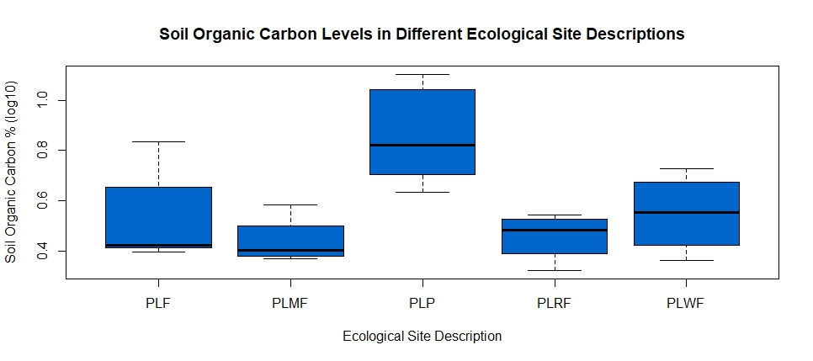

Soil Organic Carbon % (log10)

Ecological Site Description

Note. From left to right on the x-axis: Puget Lowlands Forest, Puget Lowlands Moist Forest, Puget Lowlands Prairie, Puget Lowlands Riparian Forest, Puget Lowlands Wet Forest.

## 4.2 Bulk density outcomes

In the realm of physical soil properties, SOC is moderately negatively correlated with the average bulk density of each site. (Pearson’s r= -0.4632, F1,24 = 6.212, p = 0.02) (Figure 5). This finding is consistent with other studies indicating higher bulk density values are associated with lower SOC levels.

Figure 5.

*Linear Regression of Soil Organic Carbon with Bulk Density.*

Soil Organic Carbon % (log10)

Bulk Density Average (g/cm3)

The effect of ESD on BD was statistically significant (p= 0.06), although the large variation in PLWF values was likely due to two hydric soil types that were the only saturated soils sampled during the study. (Figure 6). Additionally, two outliers in sample the PLP data contributed to the unusual results. On occasion, large pieces of organic matter may have been undetected in the BD sample, such as the large chunks of wood in this (rejected) from one of the PLP sites (Figure 7).

**Ecological Site Description**

**Bulk Density (g/cm3)**

Figure 6.

*ESD Effect on Bulk Density*

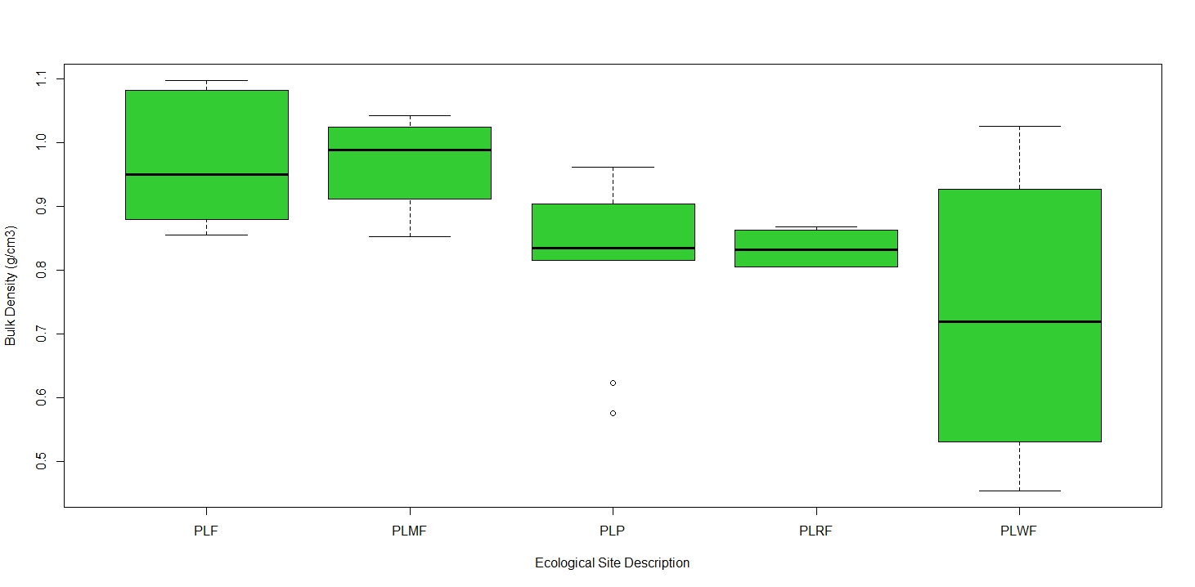

Ecological Site Description

Bulk Density (g/cm3)

Note. From left to right: Puget Lowlands Forest, Puget Lowlands Moist Forest, Puget Lowlands Prairie, Puget Lowlands Riparian Forest, Puget Lowlands Wet Forest.

Tukey’s HSD post-hoc assessment showed the effect of PLF was significantly different from the effect of PLWF (p = 0.10) on BD. There were no significant differences for the other ESD effects.

Figure 7.

*Bulk Density Core Example*

*Note.* This sample with large chunks of organic matter was discarded.

The relationship between BD and weed management by mechanical means suggests lower BD with weed control including mechanical means. However, two of the three BD outliers in this data set coincide with the mechanical weed management, which may skew these results (Figure 8).

Figure 8.

*Weed Management Effect on Bulk Density*

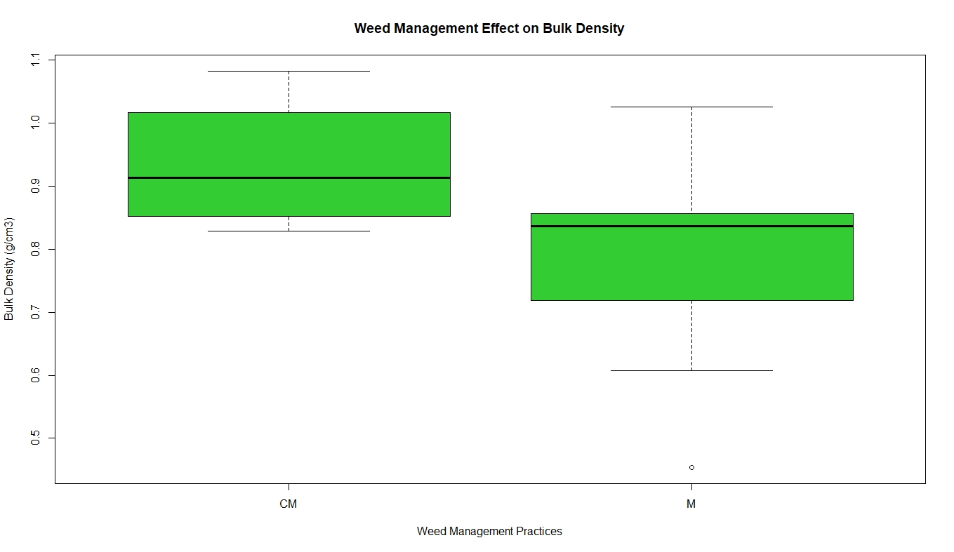

Bulk Density (g/cm3)

Weed Management Practices

Note. CM = Chemical and mechanical (n=4). M = Mechanical (n=12). Other practices not included in statistical analysis CMF= Chemical, mechanical, and fire (n=2), CF= Chemical and Fire (n=2), C=Chemical (n=1), and MF= Mechanical and Fire (n=1).

The influence of grazing styles on bulk density measurements, while not statistically significant at p = 0.19, suggests that rotational grazing styles result in lower BD measurements than other grazing styles (Figure 9). Another noteworthy point is the higher BD measurement for WG, which includes pastures utilized for hay.

Figure 9.

*Grazing Style Effect on Bulk Density*

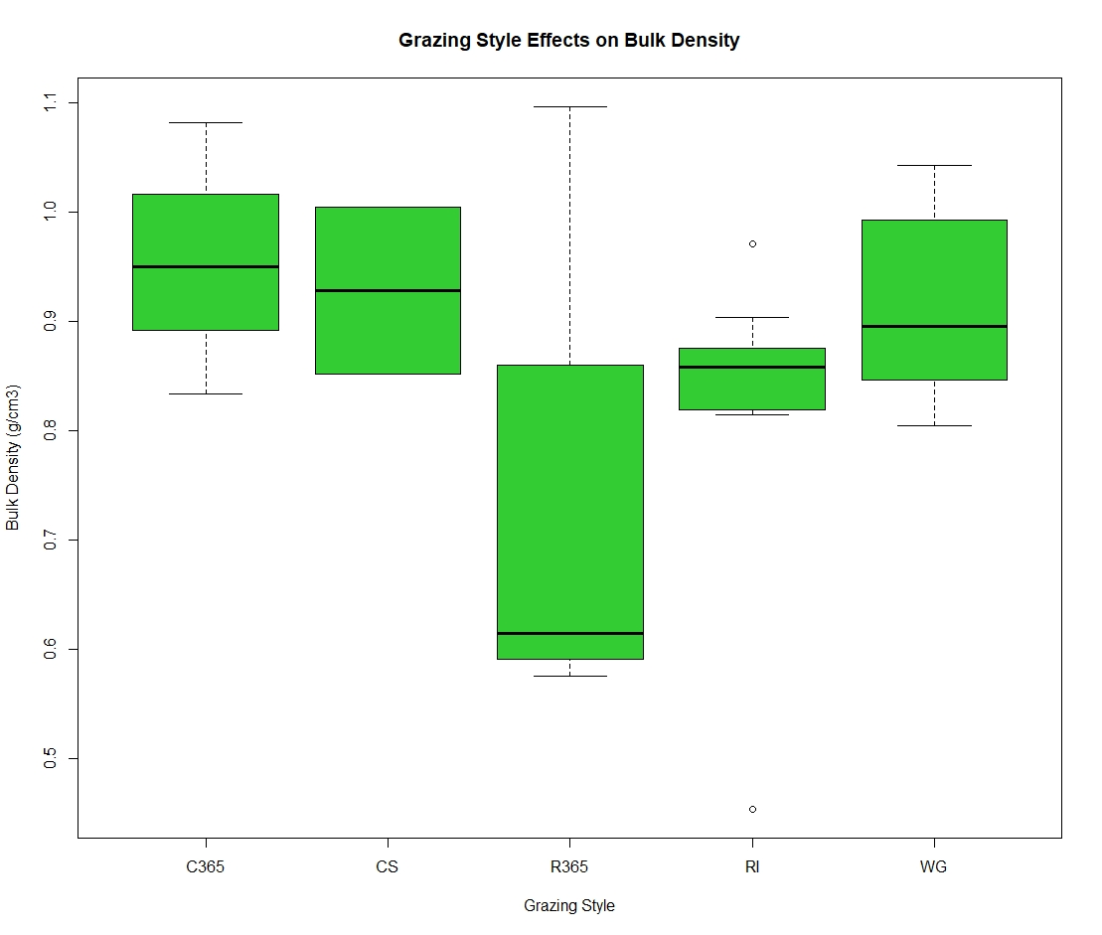

Bulk Density (g/cm3)

Grazing Style

Note. C365= Continuous 365 days annually (n= 3), CS=Continuous seasonal April-October (n=2), R365=Rotational 365 annually (n=4), RI=Rotationally integrated (n=9), WG= Wild grazing (n=8).

## 4.3 Soil physical and chemical outcomes

The relationship between SOC levels and soil silt and clay percentages were most notable of the inherent soil property findings. There was strong negative correlation between SOC and percentage of silt (Pearson’s r = -0.51, F1,24 = 8.27, p < 0.01) (Figure 10) and between SOC and percentage of clay in the soil (Pearson’s r = -0.48, F1,24 = 7.362, p = 0.01) (Figure 11). These findings were unexpected. Soils with higher sand content typically do not have high levels of organic carbon because sand particles do not support large accumulations of organic matter.

Figure 10.

*Linear regression of Soil Organic Carbon with Soil Silt Percentage*

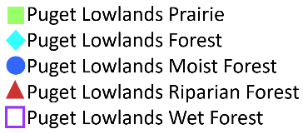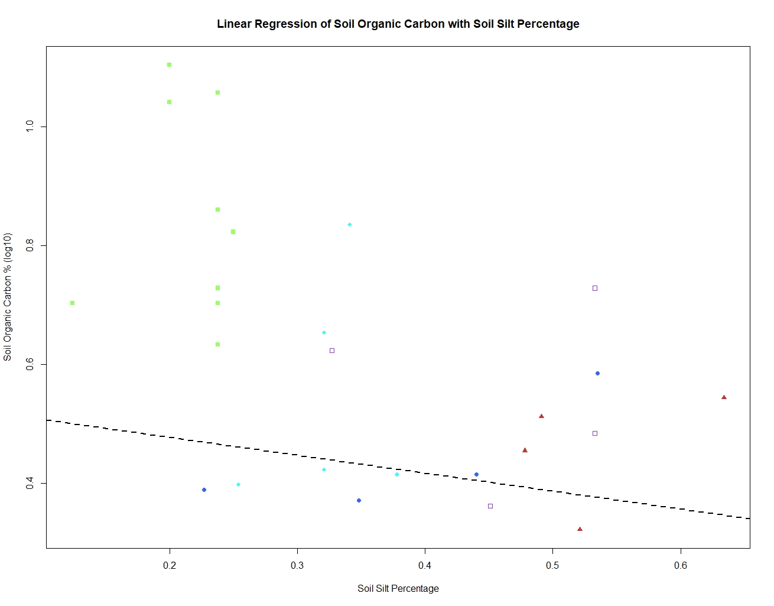

Soil Silt Percentage

Soil Organic Carbon % (log10)

Figure 11*.*

*Linear regression of Soil Organic Carbon with Soil Clay Percentage*

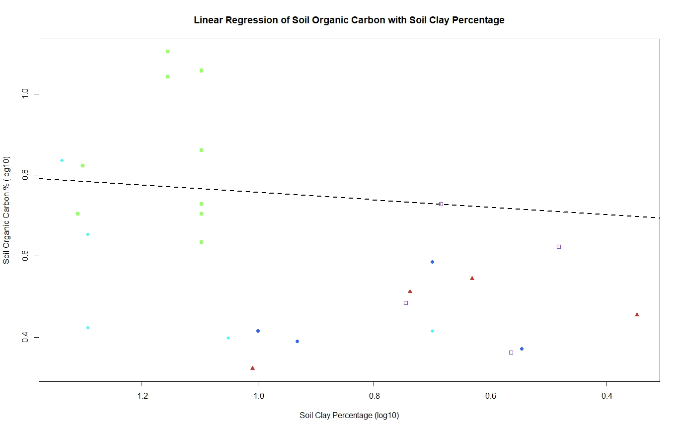

Soil Clay Percentage (log10)

Soil Organic Carbon % (log10)

The chemical soil properties tested in this study, pH and cation exchange capacity (CEC), did not have a strong association with SOC (p = 0.84 and p = 0.11, respectively). Cation exchange capacity (CEC) (log10) had a moderate negative correlation (Pearson’s r = -0.32) to SOC (Figure 12). This is an unusual finding, because typically CEC has a positive correlation with SOC due to its positive correlation to clay. In this study, clay and silt are negatively associated with higher SOC, corroborating the negative CEC association with SOC.

Figure 12*.*

*Linear Regression of Soil Organic Carbon with Cation Exchange Capacity*

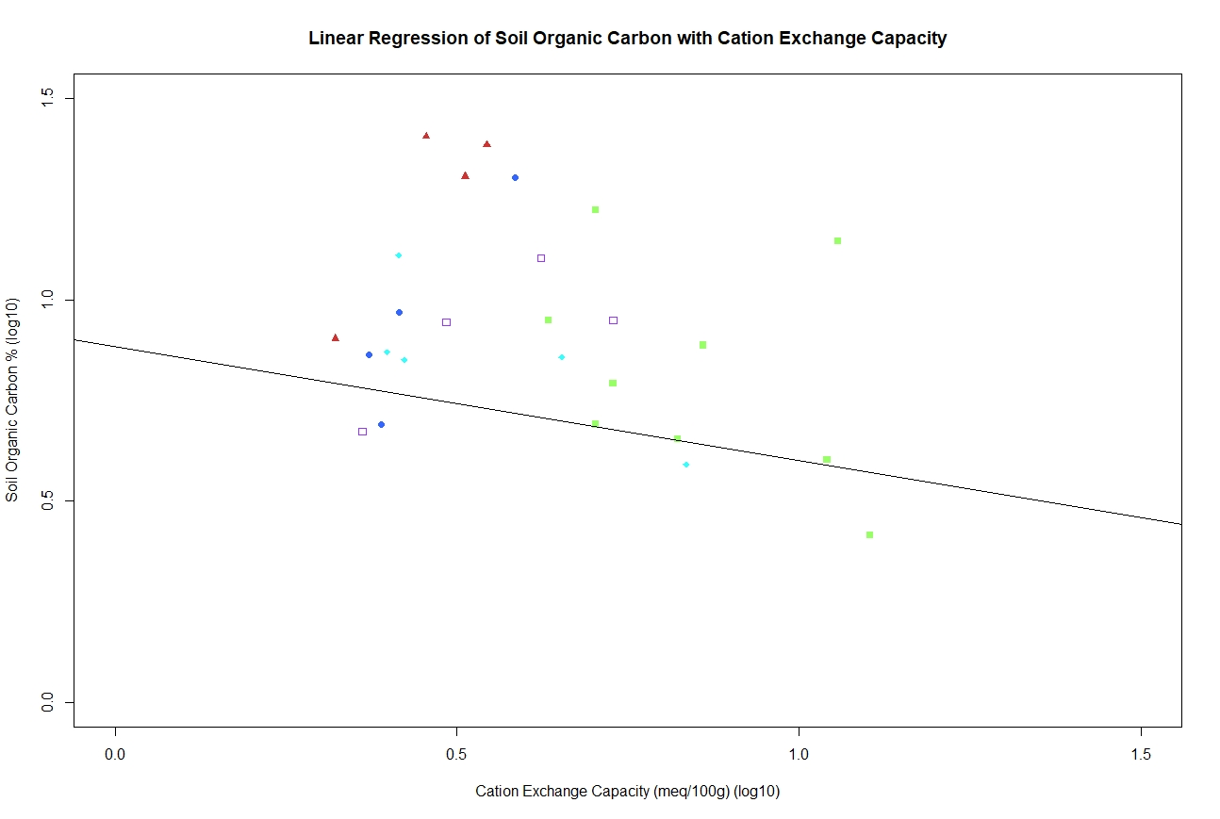

Soil Organic Carbon % (log10)

Cation Exchange Capacity (meq/100g) (log10)

Pearson’s r = -0.32

p = 0.11

## 4.4 Land management outcomes

Survey information obtained from land managers addressed length of practices and history of land use (Table 3), as well as irrigation, fertilization, weed management, and soil amendments (Table 4). Participants reported a wide variety of land uses prior to 2003, including forestry, prairie, hay, row cropping, and pasture for horses, beef and dairy cattle, and sheep. Current management practices began in a wide range of periods, from more than 50 years ago to this year. Participants at six sites started their current practices 20 or more years ago, eight began between 10 and 19 years ago, and twelve participants began their current practices less than 10 years ago. Some of the sites have complicated histories, however, such as the native restored prairies, which were farmed, utilized for various military training purposes, and overrun with invasive species in the past 170 years. Current practices for the prairie sites reflect records for invasive species removal and treatment, as well as restoration efforts. Among the permutations of pre-2003 history of the pastures in this study, ANOVA revealed a strong effect from pre-2003 history as a native prairie versus as a hay field or pasture (p = 0.02) on SOC levels (Figure 13). Limited replicates of reported pre-2003 history as a site for row cropping (2 sites), mow and fallow (1), or permutations of historical use precluded statistical analysis of those options.

Figure 13.

*Prior History Effect on Soil Organic Carbon*

History Prior to 2003

Soil Organic Carbon % (log10)

Note. H= hay (n=3), N= native prairie (n=3), P= pasture (n=12). Other history not included in statistical analysis PH= pasture and hay (n=2), FP= forest and pasture (n=1), F= forest (n=1), PH= pasture and hay (n=2), FPH= forest, pasture, and hay (n=1), MFa= mow and fallow (n=1), HRC= hay and row crops (n=1), RC= row crops (n=1), NA= no answer (n=2).

Analysis of the effects of the start of current practices were confounded by two participants who began in 2023 (resulting in a duration of 0 years, which causes errors in R). Adding 0.1 to each value reported for the start of current management practices yielded a moderate positive correlation (Pearson’s r = 0.33) between the SOC level and the start of current practices, at a statistically significant level (p= 0.10) (Figure 14).

Figure 14.

*Linear Regression of Soil Organic Carbon with Start of Current Practices*

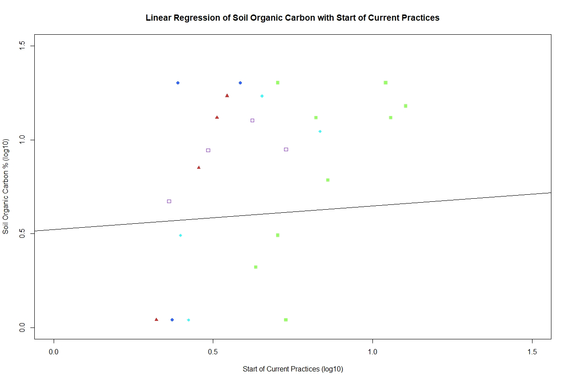

Start of Current Practices (log10)

Soil Organic Carbon % (log10)

Pearson’s r = 0.33

p= 0.10

Table 3.

Site Use

|  |  |  |  |  |
| --- | --- | --- | --- | --- |
| Site ID | ESD | Pre-2003 History | Start of Current  Practices | Primary Use |
| Prairie1 | PLP | N | 15.1 | U |
| Prairie 2 | PLP | N | 13.1 | U |
| Prairie 3 | PLF | N | 11.1 | U |
| Prairie 4 | PLMF | P | 20.1 | G |
| S2TEST23 | PLWF | FPH* | 11.1 | G |
| TCSCAS23 | PLF | P | 1.1 | G |
| LCCHEH23 | PLRF | P | 7.1 | G |
| TCGENI23 | PLWF | PH * | 2.1 | G |
| TCMEDI23 | PLRF | HRC* | 1.1 | G |
| TCCLMA23 | PLWF | P | 20.1 | G |
| TCPRAI23 | PLP | P | 2.1 | G |
| TCROCH23 | PLP | FA* | 1.1 | G |
| TCTENI23 | PLP | H | 20.1 | G |
| LCLINC23 | PLMF | P | 1.1 | U |
| GHBLAC23 | PLRF | FP* | 13.1 | G |
| TCBLAC23 | PLF | H | 17.1 | H |
| TCYELM23 | PLF | F* | 0.1 | G |
| TCWOOD23 | PLF | P | 3.1 | G |
| TCSCAW23 | PLMF | P | 20.1 | G |
| MCJONE23 | PLWF | PH* | 5.1 | H |
| TCCENT23 | PLP | RC* | 6.1 | G |
| TCSCAN23 | PLP | P | 3.1 | G |
| TCCHEH23 | PLP | P | 13.1 | G |
| GHCHEH23 | PLRF | P | 17.1 | H |
| TCMIMA23 | PLP | FAM* | 20.1 | U |
| TCTEHS23 | PLMF | P | 56.1 | G |

*Note.* **Pre-2003 History**: N= native prairie, P= pasture, FPH= forest, pasture, and hay, H= hay, PH= pasture and hay, HRC= hay and row crops, FA= fallow, RC= row crops, FAM= fallow and mow. **Start of current practices** is number of years from completion of the management survey in 2023 plus the addition of 0.1. **Primary use**: U= unmanaged pasture or native restored prairie, G= grazing, H= hay. Items marked with * were not included in statistical analysis.

Participants at 22 of 26 sites practice weed management of some sort, a mix of grazing and cover cropping (biological), mechanical (hand pulling, mowing, digging, brush cutting, weed whacking, hoeing), chemical (herbicides), and fire (prescribed burning). The limited number of replicates for biological and several combinations of other practices precluded statistical analysis. However, for the sites that used mechanical alone and chemical and mechanical together, those management practices affected SOC levels to a statistically significant degree (p = 0.05) (Figure 15). Most participants employed a combination of weed management practices.

Figure 15.

*Weed Management Effect on Soil Organic Carbon*

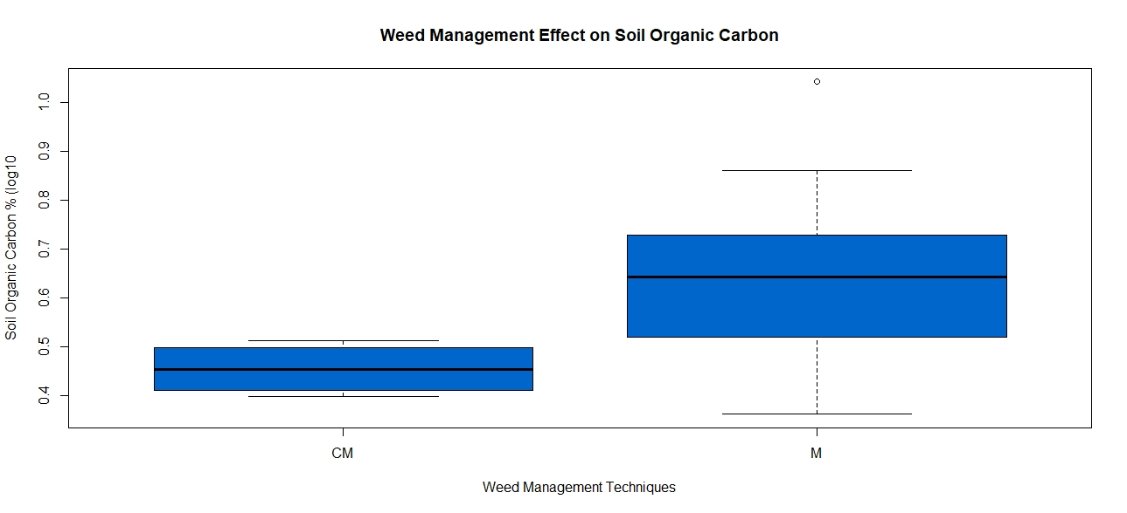

Soil Organic Carbon % (log10)

Weed Management Technique

Note. CM= Chemical and mechanical control (n=4), M= Mechanical control (n=12). Other practices not included in statistical analysis: C= chemical (n=1), CF= chemical and fire (n=2), MF= mechanical and fire (n=1), and CMF= chemical, mechanical, and fire (n=2).

Questions about dominant forage species yielded disparate answers. Commonly known species are orchardgrass (Dactylis glomerata), tall fescue (Schedonorus arundinaceus), white clover (Trifolium repens), ryegrass (Lolium perenne and Lolium multiflorum), bent grass (Agrostis capillaris), Kentucky bluegrass (Poa pratensis), reed canary grass (Phalaris arundinacea), meadow foxtail (Alopecurus pratensis), tall oatgrass (Arrhenatherum elatius), and subterranean clover (Trifolium subterraneum). Six participants reported unknown species, while others named pasture grass/mix, prairie species, mixed Pacific Northwest grass, and native grass. Without a specific foliage assay of each site to confirm, this data was unable to be analyzed effectively in this study.

In a similar vein, for the nine seeded pastures and two seeded prairies, records of seed species varied widely. Among the seeds applied to pastures are bird’s foot trefoil (Lotus corniculatus), blue wildrye (Elymus glaucus), chicory (spp), tetramag rye, t-raptor (turnipxrape), redtop turnip, peas, oats, clover (Trifolium repens and Trifolium subterraneum), fescue (Schenodorus aundinaceus), orchardgrass (Dactylis glomerata), Kentucky bluegrass (Poa pratensis), and a 42-species cover crop mix. Seeding data on the two native restored prairies included a single species on one site and more than 67 species on the other. Without comparable data from each site, effective analysis is limited. Indeed, ANOVA indicated no relationship between seeding and SOC levels. Future studies examining the species richness of each site and its impact on SOC may offer insight into another significant factor in SOC levels in SW WA pasturelands, as some evidence indicates that the sites with the highest species richness may also be the sites with highest SOC levels.

In the five grazing and three hay renovated pastures—an uncommon practice—only two grazing pastures were tilled, whereas all three hay pastures were tilled. One grazing participant indicated no renovation but reported tilling and seeding with an unknown seed species in the past. On the other hand, one of the most common land management practices is fertilization, with 12 of 23 pastures fertilized according to soil tests (5 pastures), with annual application of dairy manure (three pastures), via chicken tractor (1 pasture), or using a commercial fertilizer (1 pasture). Only six of 23 pastures are irrigated, and only four of 23 employ soil amendments such as lime (3), gypsum (2), imported liquid dairy (3) or chicken (1) manure, compost (1), and potash (1). As a note: restored native prairies are not managed for fertility, irrigated, or treated with soil amendments and were not assessed for these practices. ANOVA tests revealed no notable effects on SOC levels from fertilization, irrigation, soil amendments, pasture renovation, or tilling (p = 0.68) (Figure 16).

Figure 16.

*Land Management Effect on Soil Organic Carbon*

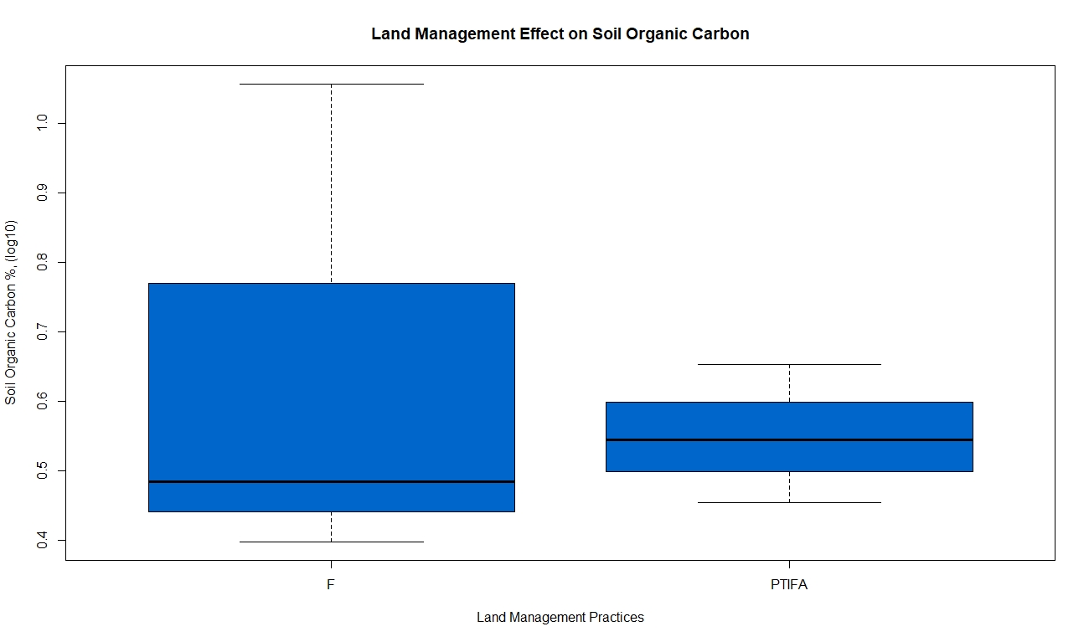

Soil Organic Carbon % (log10)

Land Management Practices

Note. F= Fertilization (n=3), PTIFA= Pasture renovation, tilling, irrigation, fertilization, and soil amendments (n=3). Other land management practice combinations not included in statistical analysis include: P= Pasture renovation (n=1), PIF= Pasture renovation, irrigation, and fertilization (n=1), FA= Fertilization and soil amendments (n= 1), PTF= Pasture renovation, tilling, and fertilization (n=2), TIF= Tilling, irrigation, and fertilization (n=1), PF= Pasture renovation and fertilization (n=1), and I= Irrigation (n=1).

## 4.5 Land use outcomes

Primary uses of the pasturelands included five unmanaged and/or native restored prairie (U) sites, three hay (H) sites, and 18 grazing (G) locations (Figure 17.) Grazing styles are comprised of wild grazing (WG) [physical signs of deer and/or elk at prairies, unmanaged, and hayed sites provided evidence that, in keeping with Lorenz (2018), almost all undeveloped lands are grazed by wildlife], continuous seasonal (CS) grazing [typically during the growing season from April-October], continuous all year without rest (C365), rotationally grazed all year (R365), and rotationally integrated (RI) grazing [pastures are grazed in rotation during the growing season, with pasture rest periods appropriate for forage growth and defoliation, livestock species, weather conditions for forage growth and recovery, and other restrictions, such as deferment for ESA species] (Figure 18).

Figure .

*Current Primary Use Effect on Soil Organic Carbon*

Soil Organic Carbon % (log10)

*Note.* Unmanaged includes native restored prairies and sites not utilized for grazing or hay.

**Grazing Hay Unmanaged**

Figure 18.

*Grazing Style Effect on Soil Organic Carbon*

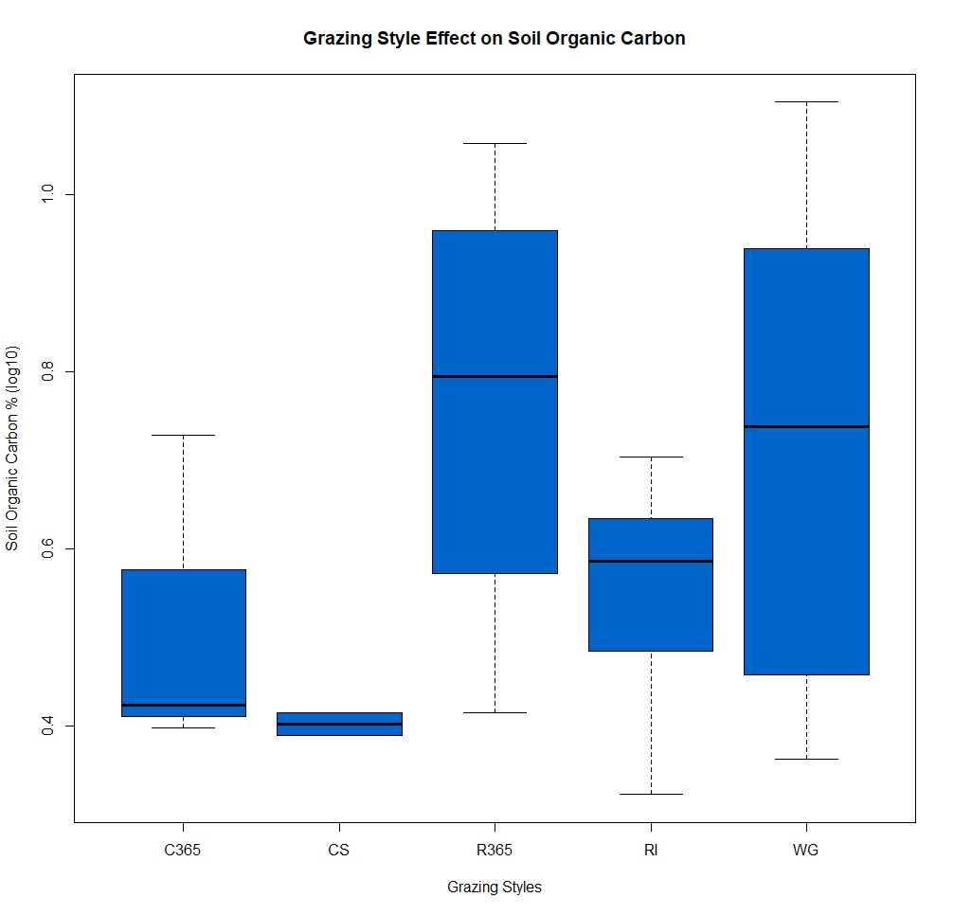

Soil Organic Carbon % (log10)

Grazing Style

Note. C365= Continuous grazing 365 days annually (n= 3), CS= Continuous seasonal grazing April to October (n=2), R365= Rotational grazing 365 days annually (n=4), RI= Rotationally integrated grazing based on animal forage needs, forage growth and defoliation rates, and other considerations (n= 9), WG= Wild grazing by deer and elk (n=8).

Primary use as an unmanaged or native restored prairie (U) resulted in substantially higher levels of SOC than either grazing (G) or hay (H) (p=0.05). However, the combination of hay (where wild grazing occurs) with unmanaged pastures and native restored prairies created a much larger variation in SOC levels when sites are assessed by grazing style. While the results were not statistically significant for grazing style influences on SOC (p = 0.18), all rotationally based grazing styles (including hay, where large amounts of biomass are removed from the ecosystem) showed markedly more SOC than either of the continuously grazed systems.

Evidence of herbivores such as feces and elk and deer tracks suggested at least some grazing was likely at every site, including those whose primary purpose was listed as hay, leading to the animal designation of deer and elk at sites that do not have human managed livestock. Farm animals in this study included dairy and beef cattle, sheep, goats, chickens, geese, guinea fowl, and ducks. Although livestock variations complicated statistical analysis, they are representative of pastoral operations in SW WA (USDA NASS, 2017). To compare species while there is some evidence that species impact on SOC differs, in this study I used Animal Unit Equivalents (AUE) to convert different species into a comparable reference frame (Pate et al., 2022). With an adjusted range of values from 0.1 to 100 AUE on the 18 sites with reported livestock, analysis indicated a slight negative influence of higher AUE on SOC levels, although not to a statistically significant level (Pearson’s r = -0.38, F1,16= 2.724, p = 0.12) (Figure 19). Future studies with more consistent animal species deployed on the sites and less variation of AUE within the species may offer more insight into the effects of animal density on SOC.

Figure 19.

Animal Unit Equivalent (log10)

*Linear Regression of Soil Organic Carbon with Animal Unit Equivalent*

Animal Unit Equivalent (log10)

Soil Organic Carbon % (log10)

Pearson’s r = -0.38

p = 0.12

Different animal species exerted different influences on the SOC levels in the soil. Higher levels of SOC were associated with deer and elk and sheep, in comparison with cattle, although none to a statistically significant degree (p = 0.12) (Figure 20). The effect of animal species on SOC levels was largest for deer and elk versus cattle (p = 0.10) and sheep versus cattle (p = 0.37).

Figure 20.

*Animal Species Effect on Soil Organic Carbon*

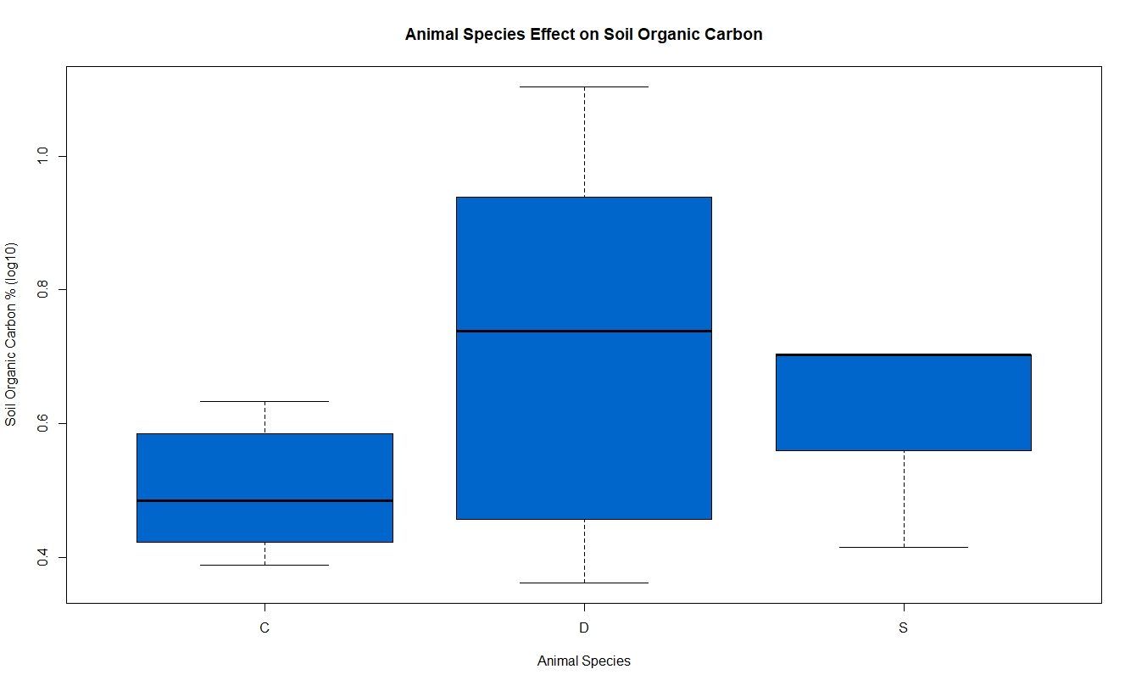

Soil Organic Carbon % (log10)

Animal Species

Note. C= Cattle (n= 9), D= Deer and elk (n= 8), S= Sheep (n= 4). Other species not included in statistical analysis: Goats (n=2), Horses (n= 1), Chickens (n=1), Guinea fowl/Ducks/Geese (n= 1).

Table 4.

Land Management Practices

|  |  |  |  |  |  |  |
| --- | --- | --- | --- | --- | --- | --- |
| Site ID | ESD | LM | WM | Grazing Style | Animal  Species | AUE |
| Prairie1 | PLP | -- | CMF* | WG | D | NA |
| Prairie 2 | PLP | -- | CF* | WG | D | NA |
| Prairie 3 | PLF | -- | CF* | WG | D | NA |
| Prairie 4 | PLMF | -- | C* | RI | C | 30.0 |
| S2TEST23 | PLWF | -- | M | R365 | CSCh* | 0.6 |
| TCSCAS23 | PLF | -- | CM | C365 | C | 100.0 |
| LCCHEH23 | PLRF | PTIFA | M | RI | C | 60.0 |
| TCGENI23 | PLWF | -- | M | RI | C | 45.5 |
| TCMEDI23 | PLRF | -- | -- | RI | CS* | 36.0 |
| TCCLMA23 | PLWF | F | CM | RI | C | 9.0 |
| TCPRAI23 | PLP | PIF* | M | RI | C | 90.0 |
| TCROCH23 | PLP | -- | M | C365 | Ch* | 0.1 |
| TCTENI23 | PLP | FA* | -- | RI | S | 2.1 |
| LCLINC23 | PLMF | -- | -- | WG | D | NA |
| GHBLAC23 | PLRF | -- | CM | RI | C | 24.0 |
| TCBLAC23 | PLF | PTIFA | M | WG | D | NA |
| TCYELM23 | PLF | PTF* | -- | R365 | S | 4.0 |
| TCWOOD23 | PLF | TIF* | C | C365 | Ho* | 2.5 |
| TCSCAW23 | PLMF | PTF* | M | CS | C | 7.0 |
| MCJONE23 | PLWF | PF* | M | WG | D | NA |
| TCCENT23 | PLP | F | M | R365 | SGDuGeGu* | 11.0 |
| TCSCAN23 | PLP | I* | M | RI | S | 1.4 |
| TCCHEH23 | PLP | F | MF* | R365 | SG* | 5.0 |
| GHCHEH23 | PLRF | PTIFA | CMF* | WG | D | NA |
| TCMIMA23 | PLP | -- | CM | WG | D | NA |
| TCTEHS23 | PLMF | -- | M | CS | C | NA |

*Note.* **LM (Land management practices):** PTIFA= pasture renovation, tilling, irrigation, fertilization, and soil amendments, F= fertilization, PIF= pasture renovation, irrigation, and fertilization, FA= fertilization and soil amendments, PTF= pasture renovation, tilling, and fertilization, TIF= tilling, irrigation, and fertilization, PF= pasture renovation and fertilization, I= irrigation. **WM (Weed management practices):** CMF= chemical, mechanical, and fire, CF= chemical and fire, C= chemical, M= mechanical, CM= chemical and mechanical. **Animal species:** D= deer/elk, C= cattle, S= sheep, Ch= chickens, Du= ducks, G= goats, Ge= geese, Gu= guinea fowl, Ho= horses. **AUE (Animal Unit Equivalent):** one cow-calf pair= 1.0, one yearling cattle= 0.60, one mature sheep= 0.20, one broiler chicken= 0.008 (Pate, et al., 2022). Items marked with an * were not included in statistical analysis.

## 4.6 Confounding factors

Confounding factors include the selection bias of the participants, who were either members of the Southwest Washington Grazing Association or previous soil testing clients of Thurston Conservation District. Both groups have a demonstrated level of commitment to agricultural education and implementation of new techniques or processes. At the very least, they demonstrated enough interest in their soil to submit samples for analysis and asked for recommendations to improve their soil health. Another source of bias is the large proportion of cattle ranchers who participated in the study. The effects of bovine (11 participants) versus ovine (7), caprine (2), equine (1), or poultry (3) herbivory may impact study results. Also unmeasured is the effect of deer and elk, signs of which were observed, but the number of animals was not. Bulk density measurements correlated as expected with SOC, despite complications arising in the sampling. One site with hydric soil yielded BD measurements more than 50% lower than the expected NRCS Web Soil Survey values, likely due to saturated soil. In other cases, rocks within the BD core were not visible until after the sample was dried and weighed. Similarly, BD cores with occluded organic matter such as large wood chunks or root masses also may have produced skewed results. The final confounding factor in field sampling arose from the gravelly soils at several sites. Full insertion of the 12-inch step probe was not always possible, although every reasonable effort was made to consistently sample to the full 12-inch depth.

# Chapter 5. Discussion

## 5.1 Soil organic carbon

Ecological site description (ESD) was the most influential factor for SOC. Soils within the Puget Lowlands Prairie (PLP) contained significantly higher SOC levels than Puget Lowlands Forests (PLF), Puget Lowlands Moist Forests (PLMF), Puget Lowlands Wet Forests (PLWF), or Puget Lowlands Riparian Forests (PLRF). Given the sandy, gravelly nature of most soils within the PLP ESD, this was a surprising result. High sand content is typically associated with low soil organic matter (and thus SOC levels), while silt and clay are associated with high SOC content (Li et al., 2017; Weil and Brady, 2017). This unexpected outcome is corroborated by strong negative correlations with clay to SOC levels for all ESDs.

While the negative correlation between bulk density and SOC in this study replicated other findings (Van Haveren, 1983; Reganold, 1988; Sakin, 2012; Li et al., 2017; Weil and Brady, 2017), the results were again unanticipated. Typically, high sand content soils have higher bulk density and thus lower SOC; in this case, the higher sand content soils did not follow expectations with SOC results. It is a somewhat surprising finding, because the overwhelmingly high SOC ESD was PLP, which has low silt and clay percentages and high sand content. BD is usually higher in sandy soils because there is less organic matter and less pore space in sandy soils than in finely textured soils (Weil and Brady, 2017). In this case, however, PLP bulk densities were on par with PLRF and substantially lower than PLF and PLMF, although two outlier low values (of nine total PLP sites) may have skewed the data. The exceptionally low values of the PLWF were likely due to soil saturation at one site and undetected large chunks of organic matter in the sample at another. Regardless, bulk density results in this study were consistent with expectations, in that bulk density values negatively correlated with SOC levels. The twist is that the soil textural profiles did not support bulk density or SOC expectations.

There are a few possible explanations for the unusual findings. The SOC levels for nearly all sites were high, ranging from 2.1% at the lowest end to 12.7% at the highest. In contrast, expected NRCS Web Soil Survey values vary from 1.4% to 5.3%. Climatic conditions (high mean annual precipitation and temperate mean annual temperatures) favor continual vegetative growth for most of the year while limiting microbial decomposition and loss of SOC (Stockman et al., 2012). Overall, SOC levels in Southwest Washington in this study offer a promising premise for SOC sequestration.

One explanation for the higher levels of SOC in PLP soil may rest with the allocation of vegetative carbon in prairies versus forests. Up to 50% of the carbon produced from photosynthesis in a prairie or grassland is stored belowground in the root structure (Dass et al., 2018), whereas the carbon in a forest system is largely in the aboveground biomass (Bachelet et al., 2011; Case et al., 2021). When the forest is converted into pasturelands, the forest SOC pool—not as large as a prairie to begin with—is depleted (Khalil et al., 2019). The pre-2003 history of the sites corroborates SOC accumulation, with high SOC levels for sites identified as previous native prairies or pastures, and mostly low SOC levels in prior forest or hay fields. The positive correlation between the start of the current practices—the length of time as a pasture—and SOC supports the hypothesis that SOC recovery after forest conversion is possible, although perhaps a long-term process.

Another possible explanation for high SOC levels in low clay and silt percentage soils such as the PLP soils is that the SOC in the PLP soils is particulate organic matter (POM) rather than mineral associated organic matter (MAOM). Limited clay and silt in PLP soils provide less surface area or chemical bond potential for organic matter (organic carbon) to accumulate as MAOM in the soil. Although POM is considered less stable than MAOM, it is not constrained by saturation limits of clay and silt particles and can continue to accrue in the soil (Conant et al., 2017 as quoted in Mayerfeld, 2023; Bai and Cortrufo, 2022). Land management practices and climatic factors such as temperature and precipitation are POM vulnerabilities, which will be discussed later in this document. Nevertheless, this finding is a positive indicator for SOC sequestration potential in the PLP soils. The findings in this study do not provide SOC sequestration rates; however, replication of this study over time will determine the SOC sequestration rate.

A third possible explanation is the species diversity in PLP versus the forested ESDs. Particularly in mature forests, understory species are limited by competition for resources and photosynthetic occlusion (Pojar and MacKinnon, 1994; Brockway, 1998) while open grasslands historically can host over 250 species (Dunwiddie et al., 2007). Unfortunately, this study did not have the appropriate data to make this assessment.

A final possible explanation for the unexpectedly high SOC levels in PLP is the history of anthropogenic burning of native prairies (Pojar and MacKinnon, 1994; Dunwiddie and Bakker, 2011). Four of the five sites that reported weed management by fire have PLP soils; although it was not included in the analysis, another PLP site also reported fire within the last twenty years. Although regular burning has not been widely practiced in the past 150 years or more, charcoal from fires persists for thousands of years. Ancient Indigenous burning practices on the native prairies likely left an enduring legacy of high soil carbon levels on the historical native prairies.

## 5.2 Land management

Analysis of land management practices—weed management, pasture renovation, renovation tilling, fertilization, irrigation, seeding, and application of soil amendments—revealed that their effects on SOC were less distinct than those of ESD. Fertilization, irrigation, seeding, and application of soil amendments did not influence SOC levels in this study. These practices were not uniformly utilized across the sites, and thus were not an effective predictor of SOC levels in this study.

Control of weeds by mechanical means was more influential on SOC levels than control by chemical and mechanical means. Although the inclusion of fire as a weed management technique was not statistically analyzed because the number of replicates was too low, the sites incorporating fire as a weed management tool were high in SOC. This result is likely because three of five sites indicating fire as a weed management tool were PLP sites; two of those three had the highest SOC scores. The third highest SOC level, also a PLP site, has a history of fire, although it was not a datapoint for analysis. In addition to legacy SOC from historical anthropogenic burning, current practices seem to enhance SOC in gravelly, sandy soils that would not be expected to have high SOC levels.

Pasture renovation showed little influence on SOC, unless renovation tilling was employed. Of the six sites that practiced renovation tilling, all were forested ESD. While I did not analyze the direct relationship between forested ESD sites that tilled to renovate the pasture and SOC, there seemed to be a negative impact of this practice on SOC.

**5.3 Land use**

All the sites in this study are currently grassland. Historical use, prior to 2003, influenced SOC levels significantly for prior native prairies and pastures, although history as a forest or as a hayfield was not influential. This is likely due to the loss of SOC due to land use conversion from forest to pasture and the removal of biomass carbon from the hayfield without return of carbon to the soil through animal deposition or plant senescence. Current land use, including unmanaged pastures, grazing pastures, and hayfields, showed a strong relationship between primary use and SOC levels. Unmanaged pastures, including the native restored prairies, were significantly higher in SOC than either grazing or haying sites. Four of the five unmanaged sites were PLP with high SOC levels, suggesting that two use factors influenced SOC: ESD and leaving as much biomass as possible in the pasture instead of removing the organic materials through haying or animal consumption.

Time elapsed since beginning the current practices showed a moderate positive correlation with SOC levels. Although the findings were not statistically significant (p = 0.103), use of the land as a pasture, for grazing, hay, or unmanaged and/or native prairies, had a positive effect on SOC as the organic matter slowly builds in a pasture and accumulates over time. While unmanaged and/or native restored prairies had the highest levels of SOC, the continuous, diverse vegetative coverage, integration of livestock (or wild ungulates), and lack of soil disturbance in pasturelands over time should expand SOC for all Southwest Washington soils in this study.

Grazing style influence on SOC in pastures was complicated by the combination of hay sites with unmanaged sites wherein both are “wild grazed” by deer and elk. The decision to include “wild grazing” as a category rather than exclude hay sites as ungrazed acknowledges the impact of grazing on all pastures, although the added removal of biomass carbon from the hay sites reduces organic material and thus SOC on those sites. Although not statistically significant, rotational grazing styles were associated with higher SOC levels than continuous grazing styles. Rotational 365 (R365) and wild grazing (WG) were associated with a higher but not statistically significant SOC level than continuous seasonal (CS) grazing, and SOC levels at PLP sites were statistically significant compared to all four forested ESDs. The results suggest grazing styles with adequate forage recovery periods, particularly on PLP soils, allow SOC to accumulate to a higher level than continually grazing for the length of the growing season.

In addition to the grazing style, there is some indication the number of animals grazed exerts an influence on the SOC level. This study used the term AUE (animal unit equivalent) to express the relative quantity of animals grazing. Although not statistically significant, the number of animals grazing bears further examination to determine the appropriate stocking rate to maximize SOC levels. A more dominant factor in this study is the species of animal grazing. The negative relationship between cattle and SOC may be in part explained by ESD, because only one PLP site grazes cattle, whereas three of four sites each in PLMF, PLRF, and PLWF graze cattle. In contrast, four PLP sites graze sheep, three have deer/elk, and one grazes chickens, in general representing low AUE values. Lower SOC levels in forest soils as a group influence the low cattle/SOC association. If one does not have the benefit of PLP pastures, grazing at lower AUE, in a rotational or WG-like manner, appears most likely to result in higher SOC.

# Chapter 6. Conclusion

Historically, fire was used to manage prairies for open space, floral species cultivation, and other purposes. The PLP pastures in this study had significantly higher SOC than the other pasture ESDs. While there may be other factors contributing to the higher SOC levels in the PLP pasture, the legacy of Indigenous burning is likely a primary influence. Proximity to human assets and infrastructure, unprecedented fuel loads, and suburban and rural sprawl can preclude large-scale burning at many sites to maintain or enhance SOC levels. An effective alternative is to utilize carefully managed rotational grazing to support diverse species and curtail invasives (Khalil et al., 2019). However, one must avoid practices such as renovation tilling and overstocking animals. Furthermore, while grazing in moist cool climates may decrease SOC in some areas (Abdallah et al., 2018), properly managed rotational grazing in Southwest Washington pasturelands has great potential to preserve and sequester soil organic carbon.

# References

Abdalla, M., Hastings, A., Chadwick, D. R., Jones, D. L., Evans, C. D., Jones, M. B., Rees, R. M., & Smith, P. (2018). Critical review of the impacts of grazing intensity on soil organic carbon storage and other soil quality indicators in extensively managed grasslands. *Agriculture, Ecosystems & Environment*, *253*, 62–81. <https://doi.org/10.1016/j.agee.2017.10.023>

Adhikari, K., & Hartemink, A. E. (2016). Linking soils to ecosystem services—A global review. *Geoderma*, *262*, 101–111. <https://doi.org/10.1016/j.geoderma.2015.08.009>

Aguilera, E., Lassaletta, L., Gattinger, A., & Gimeno, B. S. (2013). Managing soil carbon for climate change mitigation and adaptation in Mediterranean cropping systems: A meta- analysis. *Agriculture, Ecosystems & Environment*, *168*, 25–36. <https://doi.org/10.1016/j.agee.2013.02.003>

Al-Shammary, A., Kouzani, A., Kaynak, A., Khoo, S., Norton, M., & Gates, W. (2018). Soil bulk density estimation methods: A Review. *Pedosphere*, *28*(4), 581–596. <https://doi.org/10.1016/S1002-0160(18)60034-7>

Amorim, H. C. S., Ashworth, A. J., Moore, P. A., Wienhold, B. J., Savin, M. C., Owens, P. R., Jagadamma, S., Carvalho, T. S., & Xu, S. (2020). Soil quality indices following long- term conservation pasture management practices. *Agriculture, Ecosystems & Environment*, *301*, 107060. <https://doi.org/10.1016/j.agee.2020.107060>

Augarten, A. J., Malone, L. C., Richardson, G. S., Jackson, R. D., Wattiaux, M. A., Conley, S. P., Radatz, A. M., Cooley, E. T., & Ruark, M. D. (2023). Cropping systems with perennial vegetation and livestock integration promote soil health. *Agricultural & Environmental Letters*, *8*(1), e20100. <https://doi.org/10.1002/ael2.20100>

Bachelet, D., Johnson, B., Bridgham, S., Dunn, P., Anderson, H., & Rogers, B. (2011). Climate change impacts on western Pacific Northwest prairies and savannas. *Northwest Science*, *85*(2), 411–429. <https://doi.org/10.3955/046.085.0224>

Bai, Y., & Cotrufo, M. F. (2022). Grassland soil carbon sequestration: Current understanding, challenges, and solutions. *Science*, *377*(6606), 603–608. <https://doi.org/10.1126/science.abo2380>

Becker, A. E., Horowitz, L. S., Ruark, M. D., & Jackson, R. D. (2022). Surface-soil carbon stocks greater under well-managed grazed pasture than row crops. *Soil Science Society of America Journal*, *86*(3), 758–768. <https://doi.org/10.1002/saj2.20388>

Bossio, D. A., Cook-Patton, S. C., Ellis, P. W., Fargione, J., Sanderman, J., Smith, P., Wood, S., Zomer, R. J., von Unger, M., Emmer, I. M., & Griscom, B. W. (2020). The role of soil carbon in natural climate solutions. *Nature Sustainability*, *3*(5), 391–398. <https://doi.org/10.1038/s41893-020-0491-z>

Britannica, T. Editors of Encyclopaedia (2018). What is the climate of the Great Plains? Encyclopedia Britannica.

<https://www.britannica.com/question/What-is-the-climate-of-the-Great-Plains>

Brockway, D. G. (1998). Forest plant diversity at local and landscape scales in the Cascade Mountains of southwestern Washington. *Forest Ecology and Management*, *109*(1–3), 323–341.

Case, M. J., Johnson, B. G., Bartowitz, K. J., & Hudiburg, T. W. (2021). Forests of the future: Climate change impacts and implications for carbon storage in the Pacific Northwest, USA. *Forest Ecology and Management*, *482*, 118886. <https://doi.org/10.1016/j.foreco.2020.118886>

Castellano, G., Santos, L., & Menegário, A. (2022). Carbon soil storage and technologies to increase soil carbon stocks in the South American savanna. *Sustainability*, *14*, 5571.  https://doi.org/10.3390/su14095571

Chang, J., Ciais, P., Gasser, T., Smith, P., Herrero, M., Havlík, P., Obersteiner, M., Guenet, B., Goll, D. S., Li, W., Naipal, V., Peng, S., Qiu, C., Tian, H., Viovy, N., Yue, C., & Zhu, D. (2021). Climate warming from managed grasslands cancels the cooling effect of carbon sinks in sparsely grazed and natural grasslands. *Nature Communications*, *12*(1), 118. <https://doi.org/10.1038/s41467-020-20406-7>

Chappell, C. B., & Crawford, R. C. (1997). Native vegetation of the South Puget Sound prairie landscape. Ecology and conservation of the South Puget Sound Prairie landscape*. The Nature Conservancy of Washington, Seattle, WA*, 107–122.

Chase, A. (2022). Using Soil Testing Data to Examine Organic Carbon Changes During the Past 27 Years in Maine Agricultural Soils. *Electronic Theses and Dissertations*, *3681*. <https://digitialcommons.library.umain.edu/etd/3681>

Cho, R. (2018, February 21). Can Soil Help Combat Climate Change? *State of the Planet*. <https://news.climate.columbia.edu/2018/02/21/can-soil-help-combat-climate-change/>

Clark, S., Horwath, W. R., Shennan, C., & Scow, K. M. (1998). Changes in Soil Chemical Properties Resulting from Organic and Low-Input Farming Practices. *Agronomy Journal*, *90*, 662–671. <https://doi.org/10.2134/agronj1998.00021962009000050016x>

Colla, G., Mitchell, J., Joyce, B., Huyck, L., Wallender, W., Temple, S., Hsiao, T., & Poudel, D. D. (2000). Soil physical properties and tomato yield and quality in alternative cropping systems. *Agronomy Journal - AGRON J*, *92*. <https://doi.org/10.2134/agronj2000.925924x>

Crider, F. J. (1955a,b). Root-growth stoppage resulting from defoliation of grass (Issue 1102). US Department of Agriculture.

Dass, P., Houlton, B. Z., Wang, Y., & Warlind, D. (2018). Grasslands may be more reliable carbon sinks than forests in California. *Environmental Research Letters*, *13*(7), 074027. <https://doi.org/10.1088/1748-9326/aacb39>

Derner, J., Smart, A., Toombs, T., Larsen, D., McCulley, R., Goodwin, J., Sims, S., & Roche, L. (2018). Soil health as a transformational change agent for US grazing lands management. R*angeland Ecology and Management*, *71*(4), 403–408. <https://doi.org/10.1016/j.rama.2018.03.007>

Dunwiddie, P., Alverson, E., Stanley, A., Gilbert, R., Pearson, S., Hays, D., Arnett, J., Delvin, E., Grosboll, D., & Marschner, C. (2006). The Vascular Plant Flora of the South Puget Sound Prairies, Washington, USA. *Davidsonia*, *17*, 51–69.

Dunwiddie, P., Alverson, E., Martin, R., & Gilbert, R. (2014). Annual species in native prairies of South Puget Sound, Washington. *Northwest Science*, *88*(2), 94–105. <https://doi.org/10.3955/046.088.0205>

Dunwiddie, P. W., & Bakker, J. D. (2011). The future of restoration and management of prairie- oak ecosystems in the Pacific Northwest. *Northwest Science*, *85*(2), 83–92.

EDIT. (n.d.). Retrieved April 8, 2023, from <https://edit.jornada.nmsu.edu/>

Esperschütz, J., Gattinger, A., Mäder, P., Schloter, M., & Fließbach, A. (2007). Response of soil microbial biomass and community structures to conventional and organic farming systems under identical crop rotations. *FEMS Microbiology Ecology*, *61*(1), 26–37. <https://doi.org/10.1111/j.1574-6941.2007.00318.x>

Evans, D. L., Quinton, J. N., Davies, J. A. C., Zhao, J., & Govers, G. (2020). Soil lifespans and how they can be extended by land use and management change. *Environmental Research Letters*, *15*(9), 0940b2. <https://doi.org/10.1088/1748-9326/aba2fd>

Follett, R. F., Kimble, J. M., & Lal, R. (2001). The effects of pasture management practices. In *The potential of U.S. grazing lands to sequester carbon and mitigate the greenhouse effect*. Lewis Publishers.

Food and Agriculture Organization of the United Nations. (2015). *Soils and biodiversity: Soils host a quarter of our planet’s biodiversity*. [Soils and biodiversity: Soils host a quarter of our planet’s biodiversity (fao.org)](https://www.fao.org/3/i4551e/i4551e.pdf)

Foster, J. R., & Shaff, S. E. (2003). Forest colonization of Puget Lowland Grasslands at Fort Lewis, Washington. *Northwest Science.*, *77*(4), 283–296.

Franzluebbers, A. J. (2010). Will we allow soil carbon to feed our needs? *Carbon Management*, *1*(2), 237–251. <https://doi.org/10.4155/cmt.10.25>

Fu, Z., Hu, W., Beare, M., Thomas, S., Carrick, S., Dando, J., Langer, S., Müller, K., Baird, D., & Lilburne, L. (2021). Land use effects on soil hydraulic properties and the contribution of soil organic carbon. *Journal of Hydrology*, *602*, 126741. <https://doi.org/10.1016/j.jhydrol.2021.126741>

Giller, K. E., Hijbeek, R., Andersson, J. A., & Sumberg, J. (2021). Regenerative agriculture: An agronomic perspective. *Outlook on Agriculture*, *50*(1), 13–25. <https://doi.org/10.1177/0030727021998063>

Google (n.d). <https://www.google.com/earth/versions/#download-pro>

Gosnell, H., Gill, N., & Voyer, M. (2019). Transformational adaptation on the farm: Processes of change and persistence in transitions to ‘climate-smart’ regenerative agriculture. *Global Environmental Change*, *59*, 101965. <https://doi.org/10.1016/j.gloenvcha.2019.101965>

Griscom, B. W., Adams, J., Ellis, P. W., Houghton, R. A., Lomax, G., Miteva, D. A., Schlesinger, W. H., Shoch, D., Siikamäki, J. V., & Smith, P. (2017). Natural climate solutions. *Proceedings of the National Academy of Sciences*, *114*(44), 11645–11650.

Gurmu, G. (2019). Soil organic matter and its role in soil health and crop productivity improvement. *Forest Ecology and Management*, *7*(7), 475–483. <https://doi.org/10.14662/ARJASR2019.147>

Gutwein, S., Zaltzberg-Drezdahl, K., Toensmeier, E., & Ferguson, R. S. (2022). Estimating land cover-based soil organic carbon to support decarbonization and climate resilience planning in Massachusetts. *Soil Security*, 100076. <https://doi.org/10.1016/j.soisec.2022.100076>

He, Y., Trumbore, S. E., Torn, M. S., Harden, J. W., Vaughn, L. J. S., Allison, S. D., & Randerson, J. T. (2016). Radiocarbon constraints imply reduced carbon uptake by soils during the 21st century. *Science*, *353*(6306), 1419–1424. <https://doi.org/10.1126/science.aad4273>

Heaton, L., Fullen, M., & Bhattacharyya, R. (2016). Critical analysis of the van Bemmelen conversion factor used to convert soil organic matter data to soil organic carbon data: Comparative analyses in a UK loamy sand soil. *Espaço Aberto*, *6*, 35–44. <https://doi.org/10.36403/espacoaberto.2016.5244>

Hicks Pries, Caitlin E., Castanha C., Porras R. C., & Torn M. S. (2017). The whole-soil carbon flux in response to warming. *Science*, *355*(6332), 1420–1423. <https://doi.org/10.1126/science.aal1319>

Hillenbrand, M., Thompson, R., Wang, F., Apfelbaum, S., & Teague, R. (2019). Impacts of holistic planned grazing with bison compared to continuous grazing with cattle in South Dakota shortgrass prairie. *Agriculture, Ecosystems & Environment*, *279*, 156–168. <https://doi.org/10.1016/j.agee.2019.02.005>

Holechek, J. L. (1983). Considerations concerning grazing systems. *Rangelands Archives*, *5*(5), 208–211.

[*http://www.nrcs.usda.gov/conservation-basics/natural-resource-concerns/land/range-*](http://www.nrcs.usda.gov/conservation-basics/natural-resource-concerns/land/range-) *pasture*. (n.d.).

Hudson, B. D. (1994). Soil organic matter and available water capacity. *Journal of Soil and Water Conservation*, *49*(2), 189.

Janowiak, M., Connelly, W. J., Dante-Wood, K., Domke, G. M., Giardina, C., Kayler, Z., Marcinkowski, K., Ontl, T., Rodriguez-Franco, C., Swanston, C., Woodall, C. W., & Buford, M. (2017). *Considering Forest and Grassland Carbon in Land Management*. U.S. Department of Agriculture, Forest Service, Washington Office. <https://doi.org/10.2737/wo-gtr-95>

Janzen, H., van Groenigen, K. J., Powlson, D. s, Schwinghamer, T., & Van Groenigen, J. W. (2022). Photosynthetic limits on carbon sequestration in croplands. *Geoderma*, *416*, 115810. <https://doi.org/10.1016/j.geoderma.2022.115810>

Kämpf, I., Hölzel, N., Störrle, M., Broll, G., & Kiehl, K. (2016). Potential of temperate agricultural soils for carbon sequestration: A meta-analysis of land-use effects. *Science of The Total Environment*, *566–567*, 428–435. <https://doi.org/10.1016/j.scitotenv.2016.05.067>

Karlen, D. L., & Rice, C. W. (2017). *Enhancing Soil Health to Mitigate Soil Degradation*. MDPI AG. <https://www.mdpi.com/books/pdfview/book/318>

Karlen, D. L., Stott, Diane E., & Mikha, Maysoon M. (2021). Soil Health Series Vol 1 Approaches to Soil Health Analysis. In *Soil Health Series: Vol. Volume 1 Approaches to Soil Health Analysis* (pp. i–xvii). John Wiley & Sons, Ltd. <https://doi.org/10.1002/9780891189817.fmatter>

Khalil, M. I., Francaviglia, R., Henry, B., Klumpp, K., Koncz, P., Llorente, M., Madari, B. E., Muñoz-Rojas, M., & Nerger, R. (2019). Strategic management of grazing grassland systems to maintain and increase organic carbon in soils. In *CO2 Sequestration* (pp. 1– 20). IntechOpen.

Kibblewhite, M., Ritz, K., & Swift, M. (2008). Soil health in agricultural systems. *Philosophical Transactions of the Royal Society B: Biological Sciences*, *363*(1492), 685–701.

Kim, J., Ale, S., Kreuter, U. P., Richard Teague, W., DelGrosso, S. J., & Dowhower, S. L. (2023). Evaluating the impacts of alternative grazing management practices on soil carbon sequestration and soil health indicators. *Agriculture, Ecosystems & Environment*, *342*, 108234. <https://doi.org/10.1016/j.agee.2022.108234>

Krzic M., Nauglerj, T., Dyanatkar, S., and Crowley, C. (2010). *Soil bulk density*. Soil Lab Modules. The University of British Columbia, Vancouver. Retrieved November 23, 2022, from <https://labmodules.soilweb.ca/soil-compaction-bulk-density>

Lal R. (2004). Soil Carbon Sequestration Impacts on Global Climate Change and Food Security. *Science*, *304*(5677), 1623–1627. <https://doi.org/10.1126/science.1097396>

Lal, R. (2006). Managing soils for feeding a global population of 10 billion. *Journal of the Science of Food and Agriculture*, *86*(14), 2273–2284. <https://doi.org/10.1002/jsfa.2626>

Lal, R. (2007a). Carbon management in agricultural soils. *Mitigation and Adaptation Strategies for Global Change*, *12*(2), 303–322. <https://doi.org/10.1007/s11027-006-9036-7>

Lal, R. (2007b). Carbon sequestration. *Philosophical Transactions of the Royal Society B: Biological Sciences*, *363*(1492), 815–830. <https://doi.org/10.1098/rstb.2007.2185>

Lal, R. (2008). Carbon sequestration. *Philosophical Transactions of the Royal Society B: Biological Sciences*, *363*(1492), 815–830. <https://doi.org/10.1098/rstb.2007.2185>

Lal, R. (2013). Intensive Agriculture and the Soil Carbon Pool. *Journal of Crop Improvement*, *27*. <https://doi.org/10.1080/15427528.2013.845053>

Lal, R. (2015). Restoring Soil Quality to Mitigate Soil Degradation. *Sustainability*, *7*(5), 5875– 5895. <https://doi.org/10.3390/su7055875>

Lal, R. (2020). Regenerative agriculture for food and climate. *Journal of Soil and Water Conservation*, jswc.2020.0620A. <https://doi.org/10.2489/jswc.2020.0620A>

Li, C., Fultz, L. M., Moore-Kucera, J., Acosta-Martínez, V., Horita, J., Strauss, R., Zak, J., Calderón, F., & Weindorf, D. (2017). Soil carbon sequestration potential in semi-arid grasslands in the Conservation Reserve Program. *Geoderma*, *294*, 80–90. <https://doi.org/10.1016/j.geoderma.2017.01.032>

Lorenz, K. (2018). *Carbon sequestration in agricultural ecosystems*. Springer.

Lorenz, K., & Lal, R. (2018). Carbon sequestration in grassland soils. In K. Lorenz & R. Lal (Eds.), *Carbon Sequestration in Agricultural Ecosystems* (pp. 175–209). Springer International Publishing. <https://doi.org/10.1007/978-3-319-92318-5_4>

Maeder Paul, Fliessbach Andreas, Dubois David, Gunst Lucie, Fried Padruot, & Niggli Urs. (2002). Soil Fertility and Biodiversity in Organic Farming. *Science*, *296*(5573), 1694– 1697. <https://doi.org/10.1126/science.1071148>

Matamala, R., Jastrow, J. D., Miller, R. M., & Garten, C. T. (2008). Temporal changes in c and n stocks of restored prairie: Implications for c sequestration strategies. *Ecological Applications*, *18*(6), 1470–1488. <https://doi.org/10.1890/07-1609.1>

Mayerfeld, D. (Ed.). (2023). *Our Carbon Hoofprint. The Complex Relationship Between Meat and Climate* (1st ed.). Springer Cham.

Mitchell, J., Harben, R., Sposito, G., Shrestha, A., Munk, D., Miyao, G., Southard, R., Ferris, H., Horwath, W. R., Kueneman, E., Fisher, J., Bottens, M., Hogan, P., Roy, R., Komar, J., Beck, D., Reicosky, D., Leinfelder-Miles, M., Aegerter, B., & Six, J. (2016). Conservation agriculture: Systems thinking for sustainable farming. *California Agriculture*, *70*(2), 53–56.

Montgomery, D. R. (2007). Soil erosion and agricultural sustainability. *Proceedings of the National Academy of Sciences*, *104*(33), 13268. <https://doi.org/10.1073/pnas.0611508104>

Montgomery, D. R., Biklé, A., Archuleta, R., Brown, P., & Jordan, J. (2022). Soil health and nutrient density: Preliminary comparison of regenerative and conventional farming. *PeerJ*, *10*, e12848.

Mount, D. (n.d.). The once and future Northwest Prairie. *Pacific Horticulture*. Retrieved May 16, 2023, from [https://pacifichorticulture.org/articles/the-once-and-future- northwest- prairie/](https://pacifichorticulture.org/articles/the-once-and-future- northwest-prairie/)

Mudge, P. L., Kelliher, F. M., Knight, T. L., O’Connell, D., Fraser, S., & Schipper, L. A. (2017). Irrigating grazed pasture decreases soil carbon and nitrogen stocks. *Global Change Biology*, *23*(2), 945–954. <https://doi.org/10.1111/gcb.13448>

NRCS. (n.d.). *Official Soil Series Descriptions (OSD)*. Natural Resources Conservation Service, United States Department of Agriculture. Retrieved March 26, 2023, from <http://www.nrcs.usda.gov/resources/data-and-reports/official-soil-series-descriptions-osd>

NRCS. (n.d.). *Web soil survey (WSS)*. Natural Resources Conservation Service, United States Department of Agriculture. Retrieved November 20, 2022, from <https://websoilsurvey.sc.egov.usda.gov/App/HomePage.htm>

Naidu, D. G. T., Roy, S., & Bagchi, S. (2022). Loss of grazing by large mammalian herbivores can destabilize the soil carbon pool. *Proceedings of the National Academy of Sciences*, *119*(43), e2211317119. <https://doi.org/10.1073/pnas.2211317119>

Naylor, D., Sadler, N., Bhattacharjee, A., Graham, E. B., Anderton, C. R., McClure, R., Lipton, M., Hofmockel, K. S., & Jansson, J. K. (2020). Soil microbiomes under climate change and implications for carbon cycling. *Annual Review of Environment and Resources*, *45*(1), 29–59. <https://doi.org/10.1146/annurev-environ-012320-082720>

Newton, P., Civita, N., Frankel-Goldwater, L., Bartel, K., & Johns, C. (2020). What is regenerative agriculture? A review of scholar and practitioner definitions based on processes and outcomes. *Frontiers in Sustainable Food Systems*, *4*. <https://doi.org/10.3389/fsufs.2020.577723>

NOAA National Centers for Environmental information, Climate at a Glance: County Time Series, published March 2023, retrieved on April 7, 2023 from <https://www.ncei.noaa.gov/access/monitoring/climate-at-a-glance/county/time-series>

Noland, S., & Carver, L. (2011). *Prairie landowner guide for western Washington*. US Fish and Wildlife. [https://cascadiaprairieoak.org/wp-content/uploads/2013/08/Prairie-Landowner- Guide-Western-WA1.pdf](https://cascadiaprairieoak.org/wp-content/uploads/2013/08/Prairie-Landowner-%09Guide-Western-WA1.pdf)

Olson, K.R. (2010). Impacts of tillage, slope, and erosion on soil organic carbon retention. *Soil Science*, *175*, 562–567

Olson, K. R. (2013). Soil organic carbon sequestration, storage, retention and loss in U.S. croplands: Issues paper for protocol development. *Geoderma*, *195–196*, 201–206. <https://doi.org/10.1016/j.geoderma.2012.12.004>

Osterberg, A. (2020). Final plan: Thurston Regional Planning Council, WA. Thurston Regional Planning Council, WA. Retrieved November 11, 2022, from https://trpc.org/1026/Final-Plan

Page, K. L., Dang, Y. P., & Dalal, R. C. (2020). The ability of conservation agriculture to conserve soil organic carbon and the subsequent impact on soil physical, chemical, and biological properties and yield. *Frontiers in Sustainable Food Systems*, *4*. <https://doi.org/10.3389/fsufs.2020.00031>

Parker, L. E., & Abatzoglou, J. T. (2016). Projected changes in cold hardiness zones and suitable overwinter ranges of perennial crops over the United States. *Environmental Research Letters*, *11*(3), 034001. <https://doi.org/10.1088/1748-9326/11/3/034001>

Pate, Johanna, Hilken, T., Leech, R., Smith, S., & Carpenter, G. (2022). *USDA NRCS National Range and Pasture Handbook Subpart H – Livestock Nutrition, Husbandry, and Behavior*. USDA NRCS. <https://directives.sc.egov.usda.gov/OpenNonWebContent.aspx?content=48466.wba>

Paulino, V. (2014). How can I convert percent soil organic matter into soil C? [Research Gate]. [https://www.researchgate.net/post/How_can_I_convert_percent_soil_organic_matter_int o_soil_C/5422c572d5a3f20a328b4590/citation/download.](https://www.researchgate.net/post/How_can_I_convert_percent_soil_organic_matter_int%09o_soil_C/5422c572d5a3f20a328b4590/citation/download.)

Paustian, K., Larson, E., Kent, J., Marx, E., & Swan, A. (2019). Soil C sequestration as a biological negative emission strategy. *Frontiers in Climate*, *1*. <https://www.frontiersin.org/articles/10.3389/fclim.2019.00008>

Pellant, M., Shaver, P., Pyke, D., Herrick, J., Lepak, N., Riegel, G., Kachergis, E., Newingham, B., Toledo, D., & Busby, F. (2020). *Interpreting indicators of rangeland health Version 5*. U.S. Department of the Interior, Bureau of Land Management. [https://www.blm.gov/documents/national-office/blm-library/technical- reference/interpreting-indicators-rangeland-health-0](https://www.blm.gov/documents/national-office/blm-library/technical-%09reference/interpreting-indicators-rangeland-health-0)

Pojar, J., & MacKinnon, A. (1994). *Plants of the Pacific Northwest Coast*. Lone Pine Pub.

Pribyl, D. W. (2010). A critical review of the conventional SOC to SOM conversion factor. *Geoderma*, *156*(3), 75–83. <https://doi.org/10.1016/j.geoderma.2010.02.003>

Reganold, J. (1988). Comparison of soil properties as influenced by organic and conventional farming systems. *American Journal of Alternative Agriculture*, *3*, 144–155. <https://doi.org/10.1017/S0889189300002423>

Reganold, J. P., Palmer, A. S., Lockmart, J. C., & Macgregor, A. N. (1993). Soil quality and financial performance of biodynamic and conventional farms in New Zealand. *Science*, *260*(5106), 344+.

Reynolds, L. L., Johnson, B. R., Pfeifer-Meister, L., & Bridgham, S. D. (2015). Soil respiration response to climate change in Pacific Northwest prairies is mediated by a regional Mediterranean climate gradient. *Global Change Biology*, *21*(1), 487–500. <https://doi.org/10.1111/gcb.12732>

Rhodes, C. J. (2017). The imperative for regenerative agriculture. *Science Progress*, *100*(1), 80– 129. Academic Search Complete. <https://doi.org/10.3184/003685017X14876775256165>

Rowntree, J. E., Stanley, P. L., Maciel, I. C. F., Thorbecke, M., Rosenzweig, S. T., Hancock, D. W., Guzman, A., & Raven, M. R. (2020). Ecosystem impacts and productive capacity of a multi-species pastured livestock system. *Frontiers in Sustainable Food Systems*, *4*. <https://www.frontiersin.org/articles/10.3389/fsufs.2020.544984>

Rui, Y., Jackson, R. D., Cotrufo, M. F., Sanford, G. R., Spiesman, B. J., Deiss, L., Culman, S. W., Liang, C., & Ruark, M. D. (2022). Persistent soil carbon enhanced in Mollisols by well-managed grasslands but not annual grain or dairy forage cropping systems. *Proceedings of the National Academy of Sciences*, *119*(7), e2118931119. <https://doi.org/10.1073/pnas.2118931119>

Sakin, E. (2012). Organic carbon organic matter and bulk density relationships in arid-semi arid soils in Southeast Anatolia region. *African Journal of Biotechnology*, *11*(6), 1373–1377.

Sanford, G. R., Posner, J. L., Jackson, R. D., Kucharik, C. J., Hedtcke, J. L., & Lin, T.-L. (2012). Soil carbon lost from Mollisols of the North Central USA with 20 years of agricultural best management practices. *Agriculture, Ecosystems & Environment*, *162*, 68–76. <http://dx.doi.org/10.1016/j.agee.2012.08.011>

Schjonning, P., Elmholt, S., & Christensen, B.T. (2004). *Managing Soil Quality*. CABI Publishing.

Schnabel, R. R., Franzluebbers, A., Stout, W. L., Sanderson, M., & Stuedeman, J. A. (2000). The effects of pasture management practices. In *The Potential of U.S. Grazing Lands to Sequester Carbon and Mitigate the Greenhouse Effect*. <https://doi.org/10.1201/9781420032468.ch12>

Silveira, M., Hanlon, E., Azenha, M., & da Silva, H. (2018). Carbon sequestration in grazing land ecosystems. University of Florida, Institute of Food and Agricultural Sciences (UF/IFAS). <https://edis.ifas.ufl.edu/publication/SS574>

Singh, Bhupinder Pal, Cowie, Annette L., & Chan, K. Yin. (n.d.). *Soil Health and Climate Change* (2011th ed., Vol. 29). Springer.

Six, J., Conant, R. T., Paul, E. A., & Paustian, K. (2002). Stabilization mechanisms of soil organic matter: Implications for C-saturation of soils. *Plant and Soil*, *241*, 155–176. <https://doi.org/10.1023/A:1016125726789>

Shewmaker and Bohle, eds. (2010) Pasture and grazing management in the Northwest. PNW 614. A Pacific Northwest Extension Publication.

Smith, L., Hicks, J., Lusk, S., Hemmovich, M., Green, S., McCord, S., Pellan, M., Mitchell, J., Dyess, J., Sprinkle, J., Gearhart, A., Karl, S., Hannemann, M., Spaeth, K., Karl, J., Reeves, matt, Pyke, D., Spaak, J., Brischke, A., … Kachergis, E. (2017). Does size matter? Animal units and animal unit months. *Rangelands*, *39*(1), 17–19. <https://doi.org/10.1016/j.rala.2016.12.002>

Smith, P., Andrén, O., Karlsson, T., Perälä, P., Regina, K., Rounsevell, M., & Van Wesemael, B. (2005). Carbon sequestration potential in European croplands has been overestimated. *Global Change Biology*, *11*(12), 2153–2163. [https://doi.org/10.1111/j.1365- 2486.2005.01052.x](https://doi.org/10.1111/j.1365-%092486.2005.01052.x)

Spratt, E., Jordan, J., Winsten, J., Huff, P., van Schaik, C., Jewett, J. G., Filbert, M., Luhman, J., Meier, E., & Paine, L. (2021). Accelerating regenerative grazing to tackle farm, environmental, and societal challenges in the upper Midwest. *Journal of Soil and Water Conservation*, *76*(1), 15A-23A. <https://doi.org/10.2489/jswc.2021.1209A>

Stockmann, U., Adams, M. A., Crawford, J. W., Field, D. J., Henakaarchchi, N., Jenkins, M., Minasny, B., McBratney, A. B., Courcelles, V. de R. de, Singh, K., Wheeler, I., Abbott, L., Angers, D. A., Baldock, J., Bird, M., Brookes, P. C., Chenu, C., Jastrow, J. D., Lal, R., … Zimmermann, M. (2013). The knowns, known unknowns and unknowns of sequestration of soil organic carbon. *Agriculture, Ecosystems & Environment*, *164*, 80– 99. <https://doi.org/10.1016/j.agee.2012.10.001>

Taboada, M. A., Rubio, G., & Chaneton, E. J. (2011). Grazing impacts on soil physical, chemical, and ecological properties in forage production systems. In *Soil Management: Building a Stable Base for Agriculture* (pp. 301–320). <https://doi.org/10.2136/2011.soilmanagement.c20>

Thurston Regional Planning Council, WA. (n.d.). *Thurston Climate Adaptation Plan, Appendix A Science Summary.* Retrieved January 16, 2022, [ApxA_ClimatePlanDRAFT (trpc.org)](https://www.trpc.org/DocumentCenter/View/4930/ApxA_ClimatePlanDRAFT?bidId=)

USA Facts*. (2023) Climate in Thurston County, Washington*. <https://usafacts.org/issues/climate/state/washington/county/thurston-county>

USDA National Agricultural Statistics Service. (2017). *Census of agriculture county profile Grays Harbor County*. [cp53027.pdf (usda.gov)](https://www.nass.usda.gov/Publications/AgCensus/2017/Online_Resources/County_Profiles/Washington/cp53027.pdf)

USDA National Agricultural Statistics Service. (2017). *Census of agriculture county profile Lewis County*. [cp53041.pdf (usda.gov)](https://www.nass.usda.gov/Publications/AgCensus/2017/Online_Resources/County_Profiles/Washington/cp53041.pdf)

USDA National Agricultural Statistics Service. (2017). *Census of agriculture county profile Mason County*. [cp53045.pdf (usda.gov)](https://www.nass.usda.gov/Publications/AgCensus/2017/Online_Resources/County_Profiles/Washington/cp53045.pdf)

USDA National Agricultural Statistics Service. (2017). *Census of agriculture county profile Thurston County*. [cp53067.pdf (usda.gov)](https://www.nass.usda.gov/Publications/AgCensus/2017/Online_Resources/County_Profiles/Washington/cp53067.pdf)

USGCRP. (2018). *Fourth National Climate Assessment* (pp. 1–470). U.S. Global Change Research Program, Washington, DC. <https://nca2018.globalchange.gov>

Van Haveren, B. P. (1983). Soil bulk density as influenced by grazing intensity and soil type on a shortgrass prairie site. *Journal of Range Management*, *36*(5), 586–588. JSTOR. <https://doi.org/10.2307/3898346>

Washington Department of Fish and Wildlife. (n.d.) Westside prairies. Retrieved November 28, 2022, from [https://wdfw.wa.gov/species-habitats/ecosystems/westside- prairie#resources](https://wdfw.wa.gov/species-habitats/ecosystems/westside-%09prairie#resources)

WDFW (n.d.). *Westside prairie*. Washington Department of Fish & Wildlife. Retrieved November 28, 2022, from [https://wdfw.wa.gov/species-habitats/ecosystems/westside- prairie](https://wdfw.wa.gov/species-habitats/ecosystems/westside-%09prairie)

WSDA. (2022). Standard Operating Procedure. Soil Health Monitoring in Washington State. AGR Pub 102-923. <https://agr.wa.gov/departments/land-and-water/natural-resources/soil-health/funding-opportunities>

Wachter, J. M., Painter, K. M., Carpenter-Boggs, L. A., Huggins, D. R., & Reganold, J. P. (2019). Productivity, economic performance, and soil quality of conventional, mixed, and organic dryland farming systems in eastern Washington State. *Agriculture, Ecosystems & Environment*, *286*, 106665. <https://doi.org/10.1016/j.agee.2019.106665>

Weil, R., & Brady, N. (2017). *The Nature and Properties of Soils. 15th edition*. Pearson Education.

Yin, S., Wang, C., & Zhou, Z. (2022). Globally altitudinal trends in soil carbon and nitrogen storages. *CATENA*, *210*, 105870. <https://doi.org/10.1016/j.catena.2021.105870>

Zomer, R. J., Bossio, D. A., Sommer, R., & Verchot, L. V. (2017). Global sequestration potential of increased organic carbon in cropland soils. *Scientific Reports*, *7*(1), 15554. <https://doi.org/10.1038/s41598-017-15794-8>

# Appendix 1 Management Survey Questions

1. Email address

2. Informed Consent

You are being invited to participate in a research survey titled “Management Survey for Southwest Washington Pasturelands.” This study is being conducted as part of a Master of Environmental Studies thesis project at Evergreen State College. The purpose of this survey is to understand how management practices impact soil organic carbon levels and bulk density in pasturelands. If you agree to take part in this study, you will be asked to complete a management survey. This survey will ask questions regarding your pasture management practices. It will take you approximately thirty minutes to complete.  
  
There will be no compensation for participating in this survey. As a token of our gratitude, land managers will receive an individual soil health report in mid-2023. We expect that your participation in the study will help increase understanding of the impacts of pasture management practices on soil health parameters in the Southwest Washington area.   
  
Risks to you are minimal and are likely to be no more than mild discomfort with sharing your pasture management practices. To the best of our ability, your answers in this study will remain confidential. Your participation in this study is completely voluntary and you can withdraw at any time. You are free to skip any question that you choose. Data collected from you for this project will be combined across all respondents. Results will not be reported in a way that makes individuals identifiable. Any personally identifying information will be removed before your information is shared.

If you have questions about this project or if you have a research-related problem, you may contact the researcher, Christina Wagner, MES candidate, Evergreen State College at 111-222-3333 or christina.wagner@evergreen.edu. If you have any questions concerning your rights as a research subject, or you experience problems as a result of participating in this research project, you may contact the Evergreen State College Human Subjects Research Committee with any concerns that you have about your rights or welfare as a study participant. This office can be reached by email at [irb@evergreen.edu](mailto:irb@evergreen.edu).

**By clicking “I agree” below you are indicating that you are at least 18 years old, have read and understood this consent form and agree to participate in this research study. Please print a copy of this page for your records.**

3. Farm name

4. Name of Land Manager

5. Farm Address

6. Date Survey Completed

7. Unique Sample Identification for Pasture (assigned by researcher)

8. Please describe the land use prior to its current use. (Example: Continuous dairy field 1950-1995. Fallow 1995-2004. Rotational beef cattle 2005-present)

9. When did the pasture begin to be used in its CURRENT capacity? (Unsure, or select prior to 2003, 2003-2022)

10. How many TOTAL acres do you manage, including fallow and other pastures or fields?

11. How many acres are in THIS pasture?

12. What percentage of your operation is managed similarly to this specific pasture? (Select 1-10%, 11-20%...91-100%)

13. What year did you begin managing this specific pasture?

14. What is the PRIMARY use of this pasture? (Hay, Grazing, Unmanaged)

15. Please estimate which years you hayed this pasture (Please select all that apply)(Unsure, prior to 2003, 2003-2022)

16. For grazed pastures, what is the dominant forage species?

17. For grazed pastures, have you seeded this pasture?

18. For SEEDED pastures, what have you seeded and when?

19. What animal species graze this pasture? (Please select all that apply) (Cattle, sheep, horses, hogs, chickens, other)

20. If you answered Other to “What animal species grazes this pasture?” please explain here.

21. How many times a year do you typically graze this pasture? Please indicate number of passes per month or season.

22. What is the typical length of grazing period in this pasture? Please be as specific as possible. If all parts of the pasture are managed the same way, this question asks how you manage a single paddock or partition. It does not require the sum of all grazing cells. (Example: 3 consecutive days two times a month Apr-June, 1 day two times a month Jul, no grazing Aug-Sep, 3 days two times a month Oct, no grazing Nov-Mar)

23. What is the length of the rest period in this pasture? Please be as specific as possible. (Example: 24 rest days a month Apr-Jun, 30 rest days Jul, rest Aug-Sep, 24 days a month Oct, no grazing Nov-Mar)

24. For the grazing cells described above, how many animals were grazed during the periods identified? Please be as specific as possible.

25. Please estimate what years this pasture was grazed in this manner. (Select all that apply) (Prior to 2003, 2003-2022)

26. If any part of this pasture has been replanted or renovated since its original planting, please describe when and why. (Example: 30% replanted in 2010 due to rust.) (If this pasture has not been replanted please enter N/A)

27. When you renovated this pasture, did you till?

28. Please estimate what years you tilled this pasture to renovate. (Please select all that apply)(Prior to 2003, 2003-2022)

29. When you renovated this pasture, how many tillage passes did you make on average?

30. What is your primary tillage implement? (Example: Chisel plow, field cultivator, Offset disk)

31. Please estimate what years you sub-soiled (deep ripped) this pasture. (Select all that apply)(Never, Prior to 2003, 2003-2022)

32. Is this pasture certified?

33. What certifications apply to this pasture? (Please check all that apply)(Organic, Salmon Safe, Farmed Smart, Other)

34. Please indicate the year(s) you received each certification(s).

35. If you answered Other to “What certifications apply to this pasture?” please explain here.

36. Do you manage weeds in this pasture?

37. How do you manage weeds in this pasture? (Please select all that apply)(Chemical control, Mechanical control, Green mulch, Cover crops, Other)

38. Please describe weed control. (Example: Brush cut followed by glyphosate application once in spring annually)

39. Do you irrigate this pasture?

40. How do you determine water needs in this pasture? (Select all that apply)(Calculating evapotranspiration, Evaluating by site, Evaluating by infrared, Same rate nearly every year, Soil moisture by feel method, Soil moisture sensors, Other)

41. If you answered Other to “How do you determine water needs in this pasture?” please explain here.

42. Please estimate the number of acre-inches (ac-in) applied to this pasture in a typical year.

43. Do you fertilize this pasture?

44. How do you decide what rate to fertilize this pasture? (Please select all that apply)(Plant tissue samples, Same rate for entire farm based on annual soil tests, Different rates for different part of farm based on soil tests, Precision nutrient application, Same rate every year, Other)

45. If you answered Other to “How do you determine what rate to fertilize this pasture?” please explain here.

46. Do you ever add any soil amendments to this pasture (NOT including crop residues, cover crops, or manure from livestock integration)?

47. Have you added lime to this pasture?

48. Please estimate what years you applied lime and average rate applied. (Example: 2 tons/acre in 2010 and 2017)

49. Have you added gypsum to this pasture?

50. Please estimate what years you applied gypsum and average rate applied. (Example: 2 tons/acre in 2010 and 2017)

51. Have you added manure (trucked in) to this pasture?

52. Please estimate what years you applied manure, source of manure (unsure, chicken, dairy cow, feedlot cattle, hog, sheep, slurry, other), and average rate applied. (Example: 50lbs/acre chicken manure in 2010 and 2017)

53. Have you added compost to this pasture?

54. Please estimate year compost was applied, average rate applied, and if known, carbon to nitrogen ratio (unsure, 10, 15, 20, 25, other). (Example, 2009—50lbs/acre applied 2009, C:N 10, 2015—100lbs/acre, C:N unsure)

55. Have you added biochar to this pasture?

56. Please estimate year(s) biochar was applied and average rate applied (Example: 50lbs/acre applied 2009)

57. Have you added biosolids to this pasture?

58. Please estimate year(s) biosolids were applied and average rate applied. (Example: 50lbs/acre applied 2009)

59. Have you added humic acids to this pasture?

60. Please estimate year(s) humic acids were applied and average rate applied. (Example: 50lbs/acre applied 2009)

61. Have you added microbial inoculants to this pasture?

62. Please estimate year(s) microbial inoculants were applied and average rate applied. (Example: 50lbs/acre)

63. Have you added other soil amendments to this pasture?

64. Other soil amendments. Please describe type, year(s) of application and rate of application.

65. Did you (or do you) receive any cost share or incentive funding to add soil amendments?

66. Is there anything else you would like us to know about his pasture (Optional)

# Appendix 2 Management Survey Responses

**PRAIRIE 1**

Has this prairie ever been seeded? Yes

Which species? 67 seeded species

When? 2008, 2009, 2010, 2011, 2012, 2013, 2014, 2015, 2016, 2017, 2018, 2019, 2020, 2021, 2022

Do you manage weeds on this prairie? Yes

Please describe weed control. Burned 2012, 2014, 2016. Sprayed triclopyr (not for last 5 years), spot treat tall oat grass with clethodium. Manually pull scotch broom.

**PRAIRIE 2**

Has this prairie ever been seeded? No

Which species?

When?

Do you manage weeds on this prairie? Yes

Please describe weed control. Glyphosate for tall oat grass 2015, 2018; sulphur cinquefoil Milestone 2009, 2010, Garlon 3A 2007, 2011, 2012, 2015, 2018, Vastlan 2020, 2022. Spot spray all. Burned 2009, 2011, 2014, 2016, 2019

**PRAIRIE 3**

Has this prairie ever been seeded? Yes. Did not overlap with sample area.

Which species? Fescue

When? 2013

Do you manage weeds on this prairie? yes

Please describe weed control. Burned 2011, 2012, 2016

**PRAIRIE 4**

Please describe land use prior to its current use. Dairy pasture

What year did the land begin to be used in its current capacity? Prior to 2003

How many TOTAL acres do you manage, including fallow and other pastures or fields? 100+

How many acres are in THIS pasture? 60

What percentage of your operation is managed similarly to this specific pasture? 81-90%

What year did you begin managing this specific pasture? 1967

What is the PRIMARY use of this pasture? Grazing

For grazed pastures, what is the dominant forage species? Prairie species

For grazed pastures, have you seeded this pasture? No

What animal species graze this pasture? Cattle

How many times in a year do you typically graze this pasture? Varies due to weather and deferment periods

What is the typical length of grazing period in this pasture? Varies due to weather and species protection

What is the length of the rest period in this pasture? April thru August

For grazing cells described above, how many animals were grazed during the periods identified? 30

Please estimate what years this pasture was grazed in this manner. Prior to 2003- 2022

If any part of this pasture has been replanted or renovated since its original planting, please describe when and why. No

When you renovated this pasture, did you till? No

Is this pasture certified? Yes

What certifications apply to this pasture? Organic

Please indicate the year(s) you received each certification. 2001-present

Do you manage weeds in this pasture? Yes

How do you manage weeds in this pasture? Mechanical control

Please describe weed control. Cutting, weed hoe, manual pulling

Do you irrigate this pasture? No

Do you fertilize this pasture? No

Do you ever add any soil amendments to this pasture? No

**S2TEST23**

Please describe land use prior to its current use. Overgrazed with cows, sheep and goats on a fixed pasture rotation or potentially continuous. Likely haying at times. 100 years ago this was a logging headquarter site, potentially log yard.

What year did the land begin to be used in its current capacity? Prior to 2003

How many TOTAL acres do you manage, including fallow and other pastures or fields? <30

How many acres are in THIS pasture? 2

What percentage of your operation is managed similarly to this specific pasture? 71-80%

What year did you begin managing this specific pasture? 2012

What is the PRIMARY use of this pasture? Grazing

For grazed pastures, what is the dominant forage species? Tall fescue

For grazed pastures, have you seeded this pasture? No

What animal species graze this pasture? Cattle, sheep, chickens

What is the typical length of grazing period in this pasture? Rotationally grazed

For grazing cells described above, how many animals were grazed during the periods identified? 3

Please estimate what years this pasture was grazed in this manner. 2012, 2013, 2014, 2015, 2016, 2017, 2018, 2019, 2020, 2021, 2022

Please estimate what years you till this pasture to renovate. Prior to 2003

Please estimate what years you sub-soiled (deep ripped) this pasture. Never

Is this pasture certified? No

Do you manage weeds in this pasture? Yes

How do you manage weeds in this pasture? Mechanical control, Other

Please describe weed control. Seasonally timed grazing by a mixture of animal types. Cows first when available. Sheep clean up. Wintertime sheep grazing of blackberry followed by manual weed whacking of canes. High moving of Canada thistle following July grazing.

Do you irrigate this pasture? No

Do you fertilize this pasture? No

Do you ever add any soil amendments to this pasture? No

**TCSCAS23**

Please describe land use prior to its current use. Continuous grazing with beef cattle 1940’s-2020

What year did the land begin to be used in its current capacity? 2022

How many TOTAL acres do you manage, including fallow and other pastures or fields? 100+

How many acres are in THIS pasture? Pastures are 5-50 acres each. Follow up email: 5

What percentage of your operation is managed similarly to this specific pasture? 71-80%

What year did you begin managing this specific pasture? 2020

What is the PRIMARY use of this pasture? Grazing

For grazed pastures, what is the dominant forage species? Orchard grass, rye grass

For grazed pastures, have you seeded this pasture? No

What animal species graze this pasture? Cattle

How many times a year do you typically graze this pasture? Pastures are grazed 5-10 times, some are continuously grazed. Follow up email: continuous

What is the typical length of grazing period in this pasture? April-October

What is the length of the rest period in this pasture? 15-30 days

For grazing cells described above, how many animals were grazed during the periods identified? I have several different herds on several different pastures, it depends. Follow up email: 100

Please estimate what years this pasture was grazed in this manner. 2018, 2019, 2020, 2021, 2022

WSU overseeded some native seed on the study pasture around 2019?

When you renovated this pasture, did you till? No

Is this pasture certified? No

Do you manage weeds in this pasture? Yes

How do you manage weeds in this pasture? Chemical control, Mechanical control

Please describe weed control. Spot chemical spray, hand pull, mowing

Do you irrigate this pasture? No

Do you fertilize this pasture? No

Do you ever add any soil amendments to this pasture? No

**LCCHEH23**

Please describe land use prior to its current use. Continuous dairy pasture ground

What year did the land begin to be used in its current capacity? 2020

How many TOTAL acres do you manage, including fallow and other pastures or fields? 100+

How many acres are in THIS pasture? 7

What percentage of your operation is managed similarly to this specific pasture? 31-40%

What year did you begin managing this specific pasture? 2016

What is the PRIMARY use of this pasture? Grazing

For grazed pastures, what is the dominant forage species? No dominant species

For grazed pastures, have you seeded this pasture? Yes

For SEEDED grazed pastures, what have you seeded and when? 2020 tetramag rye, stf 43, forb feast chicory, t-raptor, red top turnip, approximately 3 lbs/acre of each

What animal species graze this pasture? Cattle

How many times in a year do you typically graze this pasture? 7-9 on a 21 day rotation

What is the typical length of grazing period in this pasture? Strip graze according to season and stubble height. May cut if needed.

What is the length of the rest period in this pasture? 21-24 April through October. No grazing Nov-April

For grazing cells described above, how many animals were grazed during the periods identified? 60

Please estimate what years this pasture was grazed in this manner. 2016, 2017, 2018, 2019, 2020, 2021, 2022

If any part of this pasture has been replanted or renovated since its original planting, please describe when and why. 2020 was total new renovation including plowing

When you renovated this pasture, did you till? Yes

Please estimate what years you tilled this pasture to renovate. 2020

When you renovated this pasture, how many tillage passes did you make on average? 1 plow, 2 disk, 1 drill, 1 cultipac

What is your primary tillage implement? Moldboard plow 2 bottom

Please estimate what years you sub-soiled (deep ripped) this pasture. Never

Is this pasture certified? Yes

What certifications apply to this pasture? Organic

Please indicate the year(s) you received this certification. 1998 til present

Do you manage weeds in this pasture? Yes

How do you manage weeds in this pasture? Mechanical control, Cover crops

Please describe weed control. Manual hoe as needed

Do you irrigate this pasture? Yes

How do you determine water needs in this pasture? Evaluating by site. Evaluating by infrared. Same rate nearly every year. Soil moisture by feel method

Please estimate the number of acre-inches applied to this pasture in a typical year. 6

Do you fertilize this pasture? Yes

How do you decide what rate to fertilize this pasture? Same rate for entire farm based on annual soil tests

Do you ever add any soil amendments to this pasture? Yes

Have you added lime to this pasture? No

Have you added gypsum to this pasture? Yes

Please estimate what years and average rate applied. 2022 150lbs/acre

Have you added manure (trucked in) to this pasture? Yes

Please estimate what years you applied manure, source of manure, and average rate applied. Dairy will let you know

Have you added compost to this pasture? No

Have you added biochar to this pasture? No

Have you added biosolids to this pasture? No

Have you added microbial inoculants to this pasture? No

Have you added other soil amendments to this pasture? No

Did you (or do you) receive any cost share or incentive funding to add soil amendments? No

**TCGENI23**

Please describe land use prior to its current use. ~1950-2021 continuous grazing and hay, 2021-present rotational grazing

What year did the land begin to be used in its current capacity? 2021

How many TOTAL acres do you manage, including fallow and other pastures or fields? 30-100

How many acres are in THIS pasture? 24

What percentage of your operation is managed similarly to this specific pasture? 91-100%

What year did you begin managing this specific pasture? 2021

What is the PRIMARY use of this pasture? Grazing

For grazed pastures, what is the dominant forage species? Cool season mix (Tall fescue, meadow foxtail, orchard grass, reed canary grass)

For grazed pastures, have you seeded this pasture? No

What animal species graze this pasture? Cattle

How many times in a year do you typically graze this pasture? Once

What is the typical length of grazing period in this pasture? We put cows in 0.5 acre paddocks for 3-5 days from July-Oct

What is the length of the rest period in this pasture? 360-362 days

For grazing cells described above, how many animals were grazed during the periods identified? 45 in 2021, 36 in 2022

Please estimate what years this pasture was grazed in this manner. 2021, 2022

If any part of this pasture has been replanted or renovated since its original planting, please describe when and why. N/A (as far as I know)

When you renovated this pasture, did you till? No

Please estimate what years you till this pasture to renovate. 2020

Is this pasture certified? Yes

What certifications apply to this pasture? Organic

Please indicate the year(s) you received this certification. 2022

Do you manage weeds in this pasture? Yes

How do you manage weeds in this pasture? Mechanical control

Please describe weed control. Hand pull tansy, blackberry, and thistle throughout the year with a heavy focus on spring and early summer

Do you irrigate this pasture? No

Do you fertilize this pasture? No

Do you ever add any soil amendments to this pasture? No

**TCMEDI23**

Please describe land use prior to its current use. Hay and row crops

What year did the land begin to be used in its current capacity? 2021

How many TOTAL acres do you manage, including fallow and other pastures or fields? <30

How many acres are in THIS pasture? 5

What percentage of your operation is managed similarly to this specific pasture? 41-50%

What year did you begin managing this specific pasture? 2022

What is the PRIMARY use of this pasture? Grazing

For grazed pastures, what is the dominant forage species? Pasture grasses

For grazed pastures, have you seeded this pasture? No

What animal species graze this pasture? Cattle, sheep

How many times in a year do you typically graze this pasture? 5 passes a year

What is the typical length of grazing period in this pasture? Grazed Mar-Sep 4 days in each paddock

What is the length of the rest period in this pasture? 25 days in summer, then from Oct til March

For grazing cells described above, how many animals were grazed during the periods identified? 30 sheep, 1 cow

Please estimate what years this pasture was grazed in this manner. 2022

When you renovated this pasture, did you till? No

Is this pasture certified? No

What certifications apply to this pasture? Organic

Please indicate the year(s) you received this certification. 1998 til present

Do you manage weeds in this pasture? No

Do you irrigate this pasture? No

Do you fertilize this pasture? No

Do you ever add any soil amendments to this pasture? No

**TCCLMA23**

Please describe land use prior to its current use. Pasture

What year did the land begin to be used in its current capacity? Prior to 2003

How many TOTAL acres do you manage, including fallow and other pastures or fields? <30

How many acres are in THIS pasture? ~3

What percentage of your operation is managed similarly to this specific pasture? 91-100%

What year did you begin managing this specific pasture? 1994

What is the PRIMARY use of this pasture? Grazing

For grazed pastures, what is the dominant forage species? Cool season grasses, fescue, orchard and rye

For grazed pastures, have you seeded this pasture? No

What animal species graze this pasture? Cattle

How many times in a year do you typically graze this pasture? 1-2 times a month

What is the typical length of grazing period in this pasture? Pasture is sectioned into cells with one strand electrical fence. In the spring when the grass is growing fast, the pasture is strip grazed. Fences are moved twice a day. In the summer when growth is slowed down the animals are grazed in larger cells. Depending on the number of animals land the grass, the animals are moved when the grass length dictates it.

What is the length of the rest period in this pasture? The rest period is dependent on the rate of growth of the grass. Again, it is an approximately 3-acre pasture divided up into cells with a strand of electrical poly wires. In the spring the rate of movement is faster with strip grazing so the rest period can be up to 35 days. Again, this id dependent on the number of head of cattle that are grazing at that time. In the summer there is a sacrifice area that is over grazed while the slow growing grass in the other parts of the pasture recover.

For grazing cells described above, how many animals were grazed during the periods identified? It can range from 5 to a mix of cow/calves and yearlings up to 13 head

Please estimate what years this pasture was grazed in this manner. 2003-2022

If any part of this pasture has been replanted or renovated since its original planting, please describe when and why. No

When you renovated this pasture, did you till? No

Is this pasture certified? No

Do you manage weeds in this pasture? Yes

How do you manage weeds in this pasture? Mechanical control

Please describe weed control. Manual pull undesirable plants. Will spot spray for Canadian thistle this spring

Do you irrigate this pasture? No

Do you fertilize this pasture? Yes

How do you decide what rate to fertilize this pasture? Spread aged manure to needed areas. Also use 16-16-16 commercial fertilizer

Do you ever add any soil amendments to this pasture? No

Is there anything else you would like us to know about the history of this pasture? The cattle are taken off the pasture in the winter. Given the clay soil it is the best way to preserve the health of the grasses.

**TCPRAI23**

Please describe land use prior to its current use. Year round cow calf operation

What year did the land begin to be used in its current capacity? 2021

How many TOTAL acres do you manage, including fallow and other pastures or fields? 100+

How many acres are in THIS pasture? 50

What percentage of your operation is managed similarly to this specific pasture? 51-60%

What year did you begin managing this specific pasture? 2021

What is the PRIMARY use of this pasture? Grazing

For grazed pastures, what is the dominant forage species? Rye and not sure

For grazed pastures, have you seeded this pasture? Yes

For SEEDED grazed pastures, what have you seeded and when? Inter seeded rye

What animal species graze this pasture? Cattle

How many times in a year do you typically graze this pasture? Total of 12 passes over a 7 month period with the early spring the fastest rotation

What is the typical length of grazing period in this pasture? Start approximately April first and end late September early October

What is the length of the rest period in this pasture? April through June 15 to 20 days after July 30 days-I strip graze and move the fence every day sometimes 2 a day based on grass and consumption, so it varies and it is a learned trait not a set system

For grazing cells described above, how many animals were grazed during the periods identified? 150 calves 400-800 lbs

Please estimate what years this pasture was grazed in this manner. 2021, 2022

If any part of this pasture has been replanted or renovated since its original planting, please describe when and why. I inter seeded all pastures with rye and clover mix

When you renovated this pasture, did you till? No

Is this pasture certified? No

Do you manage weeds in this pasture? Yes

How do you manage weeds in this pasture? Mechanical control

Do you irrigate this pasture? Yes

How do you determine water needs in this pasture? Evaluating by site. Check soil for depth of water penetration

Please estimate the number of acre-inches applied to this pasture in a typical year. No idea

Do you fertilize this pasture? Yes

How do you decide what rate to fertilize this pasture? Same same for entire farm based on annual soil tests

Do you ever add any soil amendments to this pasture? No

**TCROCH23**

Please describe land use prior to its current use. No management

What year did the land begin to be used in its current capacity? 2022

How many TOTAL acres do you manage, including fallow and other pastures or fields? <30

How many acres are in THIS pasture? 1

What percentage of your operation is managed similarly to this specific pasture? 71-80%

What year did you begin managing this specific pasture? 2022

What is the PRIMARY use of this pasture? Grazing

For grazed pastures, what is the dominant forage species? Unknown

For grazed pastures, have you seeded this pasture? No

What animal species graze this pasture? Chickens

How many times in a year do you typically graze this pasture? Free range (30 passes per month)

What is the typical length of grazing period in this pasture? All year

What is the length of the rest period in this pasture? No rest

For grazing cells described above, how many animals were grazed during the periods identified? 4-7 chickens

Please estimate what years this pasture was grazed in this manner. 2022

If any part of this pasture has been replanted or renovated since its original planting, please describe when and why. N/A

When you renovated this pasture, did you till? No

Is this pasture certified? No

Do you manage weeds in this pasture? Yes

How do you manage weeds in this pasture? Mechanical control

Please describe weed control. Hand pull tansy and scotch broom

Do you irrigate this pasture? No

Do you fertilize this pasture? No

Do you ever add any soil amendments to this pasture? No

Did you (or do you) receive any cost share or incentive funding to add soil amendments? No

Is there anything else you would like us to know about the history of this pasture? Unmanaged pasture, not previously grazed, small chicken flock grazing since December 2022

**TCTENI23**

Please describe land use prior to its current use. Hay production

What year did the land begin to be used in its current capacity? 2003

How many TOTAL acres do you manage, including fallow and other pastures or fields? <30

How many acres are in THIS pasture? 2.5

What percentage of your operation is managed similarly to this specific pasture? 91-100%

What year did you begin managing this specific pasture? About 2003, not exactly sure when we completely fenced it

What is the PRIMARY use of this pasture? Grazing

For grazed pastures, what is the dominant forage species? I don’t know

For grazed pastures, have you seeded this pasture? Yes

For SEEDED grazed pastures, what have you seeded and when? About 2010-bird’s foot trefoil, chicory, and white clover. Only seeded about 1/3 of the field. 2022-a commercial sheep-oriented pasture mix

What animal species graze this pasture? Sheep

How many times in a year do you typically graze this pasture? Pasture is cross fenced. Starting in March or April we rotationally graze

What is the typical length of grazing period in this pasture? March-June grazing till grass is only 4”, on to next etc. Total of 6 areas. Return to first as it seems appropriate. Each sub-pasture is usually good for 3-6 days, depending on the herd size in a given year.

What is the length of the rest period in this pasture? Depends

For grazing cells described above, how many animals were grazed during the periods identified? Between 7-14

Please estimate what years this pasture was grazed in this manner. 2007, 2008, 2009, 2010, 2011, 2012, 2013, 2014, 2017, 2018, 2019, 2020, 2021, 2022

If any part of this pasture has been replanted or renovated since its original planting, please describe when and why. N/A

When you renovated this pasture, did you till? No

Is this pasture certified? Yes

What certifications apply to this pasture? Greener World

Please indicate the year(s) you received this certification. Last 3

Do you manage weeds in this pasture? No

Do you irrigate this pasture? No

Do you fertilize this pasture? Yes

How do you decide what rate to fertilize this pasture? Different rates for different part of the farm based on soil tests

Do you ever add any soil amendments to this pasture? Yes

Have you added lime to this pasture? Yes

Please estimate what years you applied lime and average rate applied. 2017 and 2022, lime added per suggestions from soil tests

Have you added gypsum to this pasture? No

Have you added manure (trucked in) to this pasture? No

Have you added compost to this pasture? Yes

Please estimate year compost was applied, average rate, and if known, carbon to nitrogen ratio. Unsure

Have you added biochar to this pasture? No

Have you added biosolids to this pasture? No

Have you added microbial inoculants to this pasture? No

Have you added other soil amendments to this pasture? No

Did you (or do you) receive any cost share or incentive funding to add soil amendments? No

**LCLINC23**

Please describe land use prior to its current use. Pre 2020 grazed by horses, fallow 2020-2022

What year did the land begin to be used in its current capacity? 2022

How many TOTAL acres do you manage, including fallow and other pastures or fields? 30-100

How many acres are in THIS pasture? 7

What percentage of you operation is managed similarly to this specific pasture? 91-100%

What year did you begin managing this specific pasture? This parcel was purchased in November 2022 and won’t be actively managed until spring 2023

What is the PRIMARY use of this pasture? Unmanaged

**GHBLAC23**

Please describe land use prior to its current use. One area was logged in 1998; one pasture was hay. Approx 2007-2009 used for cattle

What year did the land begin to be used in its current capacity? 2010

How many TOTAL acres do you manage, including fallow and other pastures or fields? 30-100

How many acres are in THIS pasture? 8

What percentage of your operation is managed similarly to this specific pasture? 71-80%

What year did you begin managing this specific pasture? 2010

What is the PRIMARY use of this pasture? Grazing

For grazed pastures, what is the dominant forage species? Mixed fescue/bent/reed canary/rush/sedge

For grazed pastures, have you seeded this pasture? Yes

For SEEDED grazed pastures, what have you seeded and when? Blue wild rye, 2013

What animal species graze this pasture? Cattle, deer and elk

How many times in a year do you typically graze this pasture? Once or twice

What is the typical length of grazing period in this pasture? 7-10 days

What is the length of the rest period in this pasture? Grazing occurs in May only

For grazing cells described above, how many animals were grazed during the periods identified? 40 yearling cattle

Please estimate what years this pasture was grazed in this manner. 2021, 2022

If any part of this pasture has been replanted or renovated since its original planting, please describe when and why. N/A

When you renovated this pasture, did you till? No

Is this pasture certified? No

Do you manage weeds in this pasture? Yes

How do you manage weeds in this pasture? Chemical control, Mechanical control, Other

Please describe weed control. Mowing in spring and fall to deter reed canary grass; pull tansy late spring to fall, spray Canadian thistle, bull thistle with Milestone

Do you irrigate this pasture? No

Do you fertilize this pasture? No

Do you ever add any soil amendments to this pasture? No

**TCBLAC23**

Please describe land use prior to its current use. West pastures used for continuous dairy 1967-1997; rotational beef cattle grazing and hay production 1998-2022. East pastures used for hay production 1970-2022. 23 acres of west pasture converted to alfalfa/orchard grass hay production in summer 2022

What year did the land begin to be used in its current capacity? 2022

How many TOTAL acres do you manage, including fallow and other pastures or fields? 100+

How many acres are in THIS pasture? 23

What percentage of your operation is managed similarly to this specific pasture? 21-30%

What year did you begin managing this specific pasture? 2006

What is the PRIMARY use of this pasture? Hay

Please estimate which years you hayed this pasture. 2021, 2020, 2019, 2018, 2017

If any part of this pasture has been replanted or renovated since its original planting, please describe when and why. 100% of this pasture was plowed and replated to alfalfa/orchard grass hay production summer 2022

When you renovated this pasture, did you till? Yes

Please estimate what years you tilled this pasture to renovate. 2022

When you renovated this pasture, how many tillage passes did you make on average? 1 pass with bottom plow. 4 passes with disc harrow

What is your primary tillage implement? 4 bottom plow followed by offset disc harrow

Please estimate what years you sub-soiled (deep ripped) this pasture. Never

Is this pasture certified? No

Do you manage weeds in this pasture? Yes

How do you manage weeds in this pasture? Other

Please describe weed control. Hand pull or hoe thistle, dock, hedge mustard

Do you irrigate this pasture? Yes

How do you determine water needs in this pasture? Evaluating by site.

Please estimate the number of acre-inches applied to this pasture in a typical year. 30 ACY annually

Do you fertilize this pasture? Yes

How do you decide what rate to fertilize this pasture? Periodic application of liquid cow manure (3 times in 5 years 2016-2021)

Do you ever add any soil amendments to this pasture? Yes

Have you added lime to this pasture? Yes

Please estimate what years you applied lime and average rate applied. .5 ton/acre in 2017, .75 ton/acre in 2021, 1.75 ton/acre in 2022

Have you added gypsum to this pasture? Yes

Please estimate what years and average rate applied. 2022 but can’t find rate applied

Have you added manure (trucked in) to this pasture? Yes

Please estimate what years you applied manure, source of manure, and average rate applied. Liquid manure applied 2017, 2020, 2021

Have you added compost to this pasture? No

Have you added biochar to this pasture? No

Have you added biosolids to this pasture? No

Have you added microbial inoculants to this pasture? No

Have you added other soil amendments to this pasture? Yes. Potash 350lbs/acre

**TCYELM23**

Please describe land use prior to its current use. Forest land that was recently logged and turned into pasture

What year did the land begin to be used in its current capacity? 2021

How many TOTAL acres do you manage, including fallow and other pastures or fields? 30-100

How many acres are in THIS pasture? 10

What percentage of your operation is managed similarly to this specific pasture? 1-10%

What year did you begin managing this specific pasture? 2021

What is the PRIMARY use of this pasture? Grazing

For grazed pastures, what is the dominant forage species? PNW seed mix

For grazed pastures, have you seeded this pasture? Yes

For SEEDED grazed pastures, what have you seeded and when? Peas/oats cover crop planted spring 2021, then grass mix seeded in fall 2021

What animal species graze this pasture? Sheep

How many times in a year do you typically graze this pasture? Sheep have minimally grazed this pasture so far

What is the typical length of grazing period in this pasture? This pasture is newly established so grazing has been very minimal. I will let the sheep graze for a couple hours a couple of times per week

What is the length of the rest period in this pasture? I’ll put the sheep on the pasture for a couple hours, then rest the pasture for a few days

For grazing cells described above, how many animals were grazed during the periods identified? 20 sheep

Please estimate what years this pasture was grazed in this manner. 2022

If any part of this pasture has been replanted or renovated since its original planting, please describe when and why. Yes 100% renovated

When you renovated this pasture, did you till? Yes

Please estimate what years you tilled this pasture to renovate. 2021

When you renovated this pasture, how many tillage passes did you make on average? 4-5

What is your primary tillage implement? 12 foot Woods disc harrow model number DHH144T

Please estimate what years you sub-soiled (deep ripped) this pasture. 2021, 2020

Is this pasture certified? No

Do you manage weeds in this pasture? No

Do you irrigate this pasture? No

Do you fertilize this pasture? Yes

How do you decide what rate to fertilize this pasture? Other. We use liquid manure from a local dairy using a 4K gallon tanker truck. We did one pass over part of the pasture so we could cover the entire field

Do you ever add any soil amendments to this pasture? No

Is there anything else you would like us to know about the history of this pasture? This is a new pasture. The prior owners logged the land and had the stumps removed and I have turned it into new pastureland for grazing. All the topsoil was lost due to erosion so we are repairing and rebuilding the topsoil using regenerative principles. 2023 will be the first year incorporating livestock into the management plan.

**TCWOOD23**

Please describe land use prior to its current use. Native vegetation up to 1995. Pasture 1995 to present

What year did the land begin to be used in its current capacity? Prior to 2003

How many TOTAL acres do you manage, including fallow and other pastures or fields? <30

How many acres are in THIS pasture? 1

What percentage of your operation is managed similarly to this specific pasture? 91-100%

What year did you begin managing this specific pasture? 2020

What is the PRIMARY use of this pasture? Grazing

For grazed pastures, what is the dominant forage species? Pasture grass mix

For grazed pastures, have you seeded this pasture? No

What animal species graze this pasture? Horses

How many times in a year do you typically graze this pasture? Daily, 365

What is the typical length of grazing period in this pasture? 6 hours, there is no rotational grazing control

What is the length of the rest period in this pasture? none

For grazing cells described above, how many animals were grazed during the periods identified? 2 horses

Please estimate what years this pasture was grazed in this manner. 2020, 2021, 2022

If any part of this pasture has been replanted or renovated since its original planting, please describe when and why. N/A prior owner may have done something but I don’t know what actions were taken

When you renovated this pasture, did you till? No

Is this pasture certified? No

Do you manage weeds in this pasture? Yes

How do you manage weeds in this pasture? Chemical control, Mechanical control

Please describe weed control. Weed cut. Glyphosate once in last 2 years

Do you irrigate this pasture? No

Do you fertilize this pasture? Yes

How do you decide what rate to fertilize this pasture? Same rate for entire farm based on annual soil tests

Do you ever add any soil amendments to this pasture? No

Is there anything else you would like us to know about the history of this pasture? The pastures have always had composted manure spread periodically.

**TCSCAW23**

Please describe land use prior to its current use. Bought property 1969 before that was

What year did the land begin to be used in its current capacity? Prior to 2003

How many TOTAL acres do you manage, including fallow and other pastures or fields? <30

How many acres are in THIS pasture? 20

What percentage of your operation is managed similarly to this specific pasture? 31-40%

What year did you begin managing this specific pasture? 1970

What is the PRIMARY use of this pasture? Grazing

For grazed pastures, what is the dominant forage species? Orchard grass, white clover

For grazed pastures, have you seeded this pasture? Yes

For SEEDED grazed pastures, what have you seeded and when? I have seeded all productive pastures over the years but none in the last 8 to 10 years

What animal species graze this pasture? Cattle

How many times in a year do you typically graze this pasture? Summer cows are on the irrigated pasture. After hay season they graze the hay field for about 3 months

What is the typical length of grazing period in this pasture? Cows graze the irrigated pasture all the time from 5/1 to 8/31. Hay field graze 9/1 to mid Nov

What is the length of the rest period in this pasture? No rest

For grazing cells described above, how many animals were grazed during the periods identified? 7 cows and calves

Please estimate what years this pasture was grazed in this manner. 2008, 2009, 2010, 2011, 2012, 2013, 2014, 2015, 2016, 2017, 2018, 2019, 2020, 2021, 2022

If any part of this pasture has been replanted or renovated since its original planting, please describe when and why. N/A

When you renovated this pasture, did you till? Yes

Please estimate what years you tilled this pasture to renovate. 2004

When you renovated this pasture, how many tillage passes did you make on average? Unknown but lots of them

What is your primary tillage implement? Plow and disk harrow

Please estimate what years you sub-soiled (deep ripped) this pasture. 2007

Is this pasture certified? No

Do you manage weeds in this pasture? Yes

How do you manage weeds in this pasture? Chemical control

Please describe weed control. Spot spray to spray complete field if needed

Do you irrigate this pasture? Yes

How do you determine water needs in this pasture? Evaluating by site. Evaluating by infrared. Same rate nearly every year.

Please estimate the number of acre-inches applied to this pasture in a typical year. N/A

Do you fertilize this pasture? Yes

How do you decide what rate to fertilize this pasture? Same rate for entire farm based on annual soil tests

Do you ever add any soil amendments to this pasture? No

MCJONE23

Please describe land use prior to its current use. 1 annual hay cutting with intermittent cattle grazing 1942-2017

What year did the land begin to be used in its current capacity? 2018

How many TOTAL acres do you manage, including fallow and other pastures or fields? <30

How many acres are in THIS pasture? 5

What percentage of your operation is managed similarly to this specific pasture? 31-40%

What year did you begin managing this specific pasture? 2018

What is the PRIMARY use of this pasture? Hay

Please estimate which years you hayed this pasture. Prior to 2003-2022

If any part of this pasture has been replanted or renovated since its original planting, please describe when and why. About 1 acre replanted annually 1960-2017. No replantings or tillage since then

When you renovated this pasture, did you till? Yes

Please estimate what years you tilled this pasture to renovate. Prior to 2003-2017

When you renovated this pasture, how many tillage passes did you make on average? Unsure, was before my time here

What is your primary tillage implement? Unsure, was before my time here

Please estimate what years you sub-soiled (deep ripped) this pasture. Never

Is this pasture certified? No

Do you manage weeds in this pasture? Yes

How do you manage weeds in this pasture? Mechanical control

Please describe weed control. We remove blackberry and tansy by hand (only one or two plants of each per year)

Do you irrigate this pasture? No

Do you fertilize this pasture? Yes

How do you decide what rate to fertilize this pasture? Other. We fertilize by running pastured broilers over this field; 1 pass annually. We soil test every few years to ensure additional applications are beneficial

Do you ever add any soil amendments to this pasture? No

Is there anything else you would like us to know about the history of this pasture? Synthetic fertilizer was historically applied from approx. 1970-2005

**TCCENT23**

Please describe land use prior to its current use. Farming land for past 30 years

What year did the land begin to be used in its current capacity? 2017

How many TOTAL acres do you manage, including fallow and other pastures or fields? <30

How many acres are in THIS pasture? 12

What percentage of your operation is managed similarly to this specific pasture? 81-90%

What year did you begin managing this specific pasture? 2017

What is the PRIMARY use of this pasture? Grazing

For grazed pastures, what is the dominant forage species? Pasture mix and prairie grass-native

For grazed pastures, have you seeded this pasture? Yes

For SEEDED grazed pastures, what have you seeded and when? High diversity mix-42 seeds mix from Green Cover Crop-Iowa

What animal species graze this pasture? Sheep, chickens, goats, geese, guinea fowl, ducks

How many times in a year do you typically graze this pasture? 12

What is the typical length of grazing period in this pasture? 1 week

What is the length of the rest period in this pasture? 3 weeks

For grazing cells described above, how many animals were grazed during the periods identified? 55

Please estimate what years this pasture was grazed in this manner. 2018, 2019, 2020, 2021, 2022

If any part of this pasture has been replanted or renovated since its original planting, please describe when and why. 70% replanted with special forage seeds to increase biomass production

When you renovated this pasture, did you till? No

Is this pasture certified? No

Do you manage weeds in this pasture? Yes

How do you manage weeds in this pasture? Mechanical control, Green mulch, Cover crops

Please describe weed control. Scotch broom and blackberries either cut or uprooted

Do you irrigate this pasture? No

Do you fertilize this pasture? Yes

How do you decide what rate to fertilize this pasture? Same rate every year. Just winging it and adding lots of compost

Do you ever add any soil amendments to this pasture? No

Is there anything else you would like us to know about the history of this pasture? 4 orchards are nearby and we let the animals graze in our orchards also

**TCSCAN23**

Please describe land use prior to its current use. Small ruminant pasture area

What year did the land begin to be used in its current capacity? 2020

How many TOTAL acres do you manage, including fallow and other pastures or fields? <30

How many acres are in THIS pasture? 1

What percentage of your operation is managed similarly to this specific pasture? 1-10%

What year did you begin managing this specific pasture? 2020

What is the PRIMARY use of this pasture? Grazing

For grazed pastures, what is the dominant forage species? Fescue, clover, orchard, rye (one other I can’t remember)

For grazed pastures, have you seeded this pasture? Yes

For SEEDED grazed pastures, what have you seeded and when? We had the area cleared to create a pasture in May 2020 with a 5 seed mix from Kiperts Feed Store

What animal species graze this pasture? Sheep

How many times in a year do you typically graze this pasture? We have 3 rotation areas for spring through fall. We usually take them off in winter and feed them cut field hay to let the pasture rest (Nov-March)

What is the typical length of grazing period in this pasture? We are just beginning the pasture rotation process and learning

What is the length of the rest period in this pasture? No grazing Nov-Mar. We are working to rest each of the three areas for 14-15 days between rotations

For grazing cells described above, how many animals were grazed during the periods identified? We are in the middle of culling some of our flock. In Feb 2023 we will be down to 7 sheep. My plan is to rotate them together.

Please estimate what years this pasture was grazed in this manner. 2020, 2021, 2022

If any part of this pasture has been replanted or renovated since its original planting, please describe when and why. N/A

When you renovated this pasture, did you till? No

Is this pasture certified? No

Do you manage weeds in this pasture? Yes

How do you manage weeds in this pasture? Mechanical control

Please describe weed control. My biggest issue is bull thistle that I have pulled by hand over the past 3 years in the spring and throughout the summer if I find it

Do you irrigate this pasture? Yes

How do you determine water needs in this pasture? Evaluating by site.

Please estimate the number of acre-inches applied to this pasture in a typical year. Unknown

Do you fertilize this pasture? No

Do you ever add any soil amendments to this pasture? No

Is there anything else you would like us to know about the history of this pasture? This property sat abandoned for about 5 yrs. When we cleared the current pasture area we found lots of junk (a 1930s truck frame, satellite dish debris, tons of scotch broom and blackberries). We work not to use chemicals on the property. We have protected the 3 Garry oaks that are in the pasture area with fencing. But, in turn the sheep had kept down the weed/blackberry/Oregon grape population. Just wish they liked bull thistle too!

**TCCHEH23**

Please describe land use prior to its current use. Goat dairy 1974-1995. Fallow 1995 to 2000. Rented as horse pasture 2000-2002

What year did the land begin to be used in its current capacity? 2010

How many TOTAL acres do you manage, including fallow and other pastures or fields? <30

How many acres are in THIS pasture? 8

What percentage of your operation is managed similarly to this specific pasture? 91-100%

What year did you begin managing this specific pasture? 2010

What is the PRIMARY use of this pasture? Grazing

For grazed pastures, what is the dominant forage species? Native grasses - unknown

For grazed pastures, have you seeded this pasture? No

What animal species graze this pasture? Sheep, Goats

How many times in a year do you typically graze this pasture? Continually

What is the typical length of grazing period in this pasture? Pasture rests for three weeks to two months then regrazed

What is the length of the rest period in this pasture? 3 weeks to 2 months. Then grazed for 3 weeks

For grazing cells described above, how many animals were grazed during the periods identified? 20-30

Please estimate what years this pasture was grazed in this manner. 2010, 2011, 2012, 2013, 2014, 2015, 2016, 2017, 2018, 2019, 2020, 2021, 2022

If any part of this pasture has been replanted or renovated since its original planting, please describe when and why. Has not be renovated. One small area 20 x 30 feet was tilled by pigs for my garden

When you renovated this pasture, did you till? No

Is this pasture certified? No

Do you manage weeds in this pasture? Yes

How do you manage weeds in this pasture? Mechanical control, Other

Please describe weed control. Dig up and burn thistle. Sheep and goats eat scotch broom

Do you irrigate this pasture? No

Do you fertilize this pasture? Yes

How do you decide what rate to fertilize this pasture? Sheep and goats fertilize naturally. Manure from barn spread mechanically in 2009.

Do you ever add any soil amendments to this pasture? No

Is there anything else you would like us to know about the history of this pasture? No chemicals have ever been applied.

**GHCHEH23**

Please describe land use prior to its current use. Conventional dairy

What year did the land begin to be used in its current capacity? 2006

How many TOTAL acres do you manage, including fallow and other pastures or fields? 100+

How many acres are in THIS pasture? 17

What percentage of your operation is managed similarly to this specific pasture? 21-30%

What year did you begin managing this specific pasture? 2006

What is the PRIMARY use of this pasture? Hay

Please estimate which years you hayed this pasture. Prior to 2003-2022

If any part of this pasture has been replanted or renovated since its original planting, please describe when and why. N/A

When you renovated this pasture, did you till? Yes

Please estimate what years you tilled this pasture to renovate. Prior to 2003

When you renovated this pasture, how many tillage passes did you make on average? 4

What is your primary tillage implement? Plow & disc

Please estimate what years you sub-soiled (deep ripped) this pasture. Never

Is this pasture certified? Yes

What certifications apply to this pasture? Organic

Please indicate the year(s) you received this certification. 2006

Do you manage weeds in this pasture? Yes

How do you manage weeds in this pasture? Mechanical control, Other

Please describe weed control. Pull tansy ragwort, flame weed Canadian thistle, pull wild carrot

Do you irrigate this pasture? Yes

How do you determine water needs in this pasture? Soil moisture sensors

Do you fertilize this pasture? Yes

How do you decide what rate to fertilize this pasture? Same rate every year

Do you ever add any soil amendments to this pasture? Yes

Have you added lime to this pasture? Yes

Please estimate what years you applied lime and average rate applied. 1 ton/acre 2016

Have you added gypsum to this pasture? No

Have you added manure (trucked in) to this pasture? Yes

Please estimate what years you applied manure, source of manure, and average rate applied. Winter cow slurry 1400 gal/acre every year, chicken manure 1 ton/acre 2015

Have you added compost to this pasture? No

Have you added biochar to this pasture? No

Have you added biosolids to this pasture? No

Have you added microbial inoculants to this pasture? No

Have you added other soil amendments to this pasture? No

Did you (or do you) receive any cost share or incentive funding to add soil amendments? No

**TCMIMA23**

Please describe land use prior to its current use. Virginal prairie habitat covered with scotch broom and Douglas fir until 1993. Most trees removed and scotch broom removed through hand pulling and two applications of Rodeo herbicide (2004 and 2005). Pasture for horses 1998-2003. Fallow from 2003 to present, mowed for fire prevention.

What year did the land begin to be used in its current capacity? 2003

How many TOTAL acres do you manage, including fallow and other pastures or fields? <30

How many acres are in THIS pasture? Unknown

What percentage of your operation is managed similarly to this specific pasture? 91-100%

What year did you begin managing this specific pasture? 1993

What is the PRIMARY use of this pasture? Unmanaged

Is there anything else you would like us to know about the history of this pasture? We have spot sowed native forb species such as golden paintbrush, goldenrod, etc. Removing the scotch broom has allowed many species such as camas, death camas, harvest brodiaea, to recover. It is also heavily infested with non-native species such as ox eye daisy, tall oat grass, and redtop (poa species). Scotch broom has not been allowed to grow or flower since 1997, but only the herbicide treatment knocked it down for keeps. Now the property is routinely managed by pulling every damned bit of broom that dares attempt to grow. The seed bank is slowly being depleted, but still I pull an average of thirty to fifty plants a year total.

**TCTEHS23**

Please describe land use prior to its current use. Horse ranch pre-1920, rotational beef cattle 1920-present; upper forested area has been logged off three times since 1890s and used continuously for silvipasture

What year did the land begin to be used in its current capacity? Prior to 2003

How many TOTAL acres do you manage, including fallow and other pastures or fields? 30-100

How many acres are in THIS pasture? 79

What percentage of your operation is managed similarly to this specific pasture? 81-90%

What year did you begin managing this specific pasture? 2005

What is the PRIMARY use of this pasture? Grazing

For grazed pastures, what is the dominant forage species? Phalaris arundinacea, Arrhenatherum elatius, Alopecurus pratensis, Schedonorus arundinaceus, Poa pratensis, Trifolium subterraneum

For grazed pastures, have you seeded this pasture? Yes

For SEEDED grazed pastures, what have you seeded and when? Pasture hasn’t been seeded recently, but was seeded with exotic grasses and Trifolium subterraneum by my family in the 1920s

What animal species graze this pasture? Cattle

How many times in a year do you typically graze this pasture? N/A Follow up interview with operator: continuous grazing because of missing infrastructure (cross fencing)

What is the typical length of grazing period in this pasture? N/A Follow up interview with operator: Aug-Nov (deferment for camas)

What is the length of the rest period in this pasture? N/A Follow up interview with operator: November to August

For grazing cells described above, how many animals were grazed during the periods identified? 30. Follow up interview with the operator: 30 cow/calf pairs

Please estimate what years this pasture was grazed in this manner. 2018, 2019, 2020, 2021, 2022

If any part of this pasture has been replanted or renovated since its original planting, please describe when and why. N/A

When you renovated this pasture, did you till? No

Is this pasture certified? No

Do you manage weeds in this pasture? Yes

How do you manage weeds in this pasture? Mechanical control

Please describe weed control. Control blackberries, English hawthorn, and scotch broom by brush cutting and pulling

Do you irrigate this pasture? No

Do you fertilize this pasture? No

Do you ever add any soil amendments to this pasture? No

Is there anything else you would like us to know about the history of this pasture? Details of the grazing rotations might be better communicated through an interview with our operator or my father, (name redacted), who is liable to talk your ear off about his great grandfather’s love of Trifolium subterraneum and hatred for horses.

# Appendix 3 Soil Test Results

|  |  |  |  |  |  |  |  |
| --- | --- | --- | --- | --- | --- | --- | --- |
| Site ID | SOM  (%) | SOC  (50%) | TC  (%) | CEC (meq/100g) | pH | BD Average (g/cm3) | P/K/Mg/Ca (ppm) |
| Prairie1 | 25.4 | 12.7 | 15.59 | 2.6 | 5.3 | 0.91188 | 11/58/45/261 |
| Prairie 2 | 13.3 | 6.65 | 8.83 | 4.5 | 5.6 | 0.96154 | 7/95/59/542 |
| Prairie 3 | 13.7 | 6.85 | 10.91 | 3.9 | 5.4 | 0.87889 | 13/70/53/440 |
| Prairie 4 | 7.7 | 3.85 | 3.4 | 20.1 | 5.3 | 0.97135 | 2/119/547/1808 |
| S2TEST23 | 10.7 | 5.35 | 5.94 | 8.9 | 5.6 | 0.60763 | 18/174/113/1090 |
| TCSCAS23 | 5.3 | 2.65 | 3.47 | 7.1 | 5.6 | 0.95008 | 55/181/91/837 |
| LCCHEH23 | 5.7 | 2.85 | 2.76 | 25.4 | 5.6 | 0.85840 | 8/159/679/2676 |
| TCGENI23 | 8.4 | 4.2 | 5.05 | 12.7 | 5.2 | 0.45385 | 11/82/232/1228 |
| TCMEDI23 | 4.2 | 2.1 | 2.29 | 8 | 6.1 | 0.86756 | 72/31/79/1223 |
| TCCLMA23 | 6.1 | 3.05 | 3.65 | 8.8 | 5.4 | 0.82897 | 58/200/154/893 |
| TCPRAI23 | 8.6 | 4.3 | 5.54 | 8.9 | 5.9 | 0.81898 | 103/156/168/1112 |
| TCROCH23 | 10.7 | 5.35 | 8.39 | 6.2 | 5.8 | 0.83418 | 23/152/93/770 |
| TCTENI23 | 10.1 | 5.05 | 6.12 | 16.7 | 5.9 | 0.90337 | 29/103/330/2177 |
| LCLINC23 | 4.7 | 2.35 | 2.64 | 7.3 | 5.3 | 1.04232 | 24/157/126/713 |
| GHBLAC23 | 6.5 | 3.25 | 3.28 | 20.2 | 5.9 | 0.87546 | 14/115/494/2477 |
| TCBLAC23 | 9 | 4.5 | 6.36 | 7.2 | 5.2 | 0.85451 | 225/158/72/732 |
| TCYELM23 | 5.2 | 2.6 | 3.63 | 12.9 | 5.7 | 1.09677 | 41/156/371/1345 |
| TCWOOD23 | 5 | 2.5 | 2.76 | 7.4 | 5.8 | 1.08214 | 39/162/159/846 |
| TCSCAW23 | 4.9 | 2.45 | 2.85 | 4.9 | 5.7 | 1.00444 | 14/50/68/639 |
| MCJONE23 | 4.6 | 2.3 | 2.87 | 4.7 | 5.1 | 1.02493 | 51/47/68/450 |
| TCCENT23 | 14.5 | 7.25 | 10.09 | 7.7 | 5.7 | 0.62291 | 14/413/151/747 |
| TCSCAN23 | 10.1 | 5.05 | 5.66 | 4.9 | 5.2 | 0.81469 | 11/126/65/477 |
| TCCHEH23 | 22.8 | 11.4 | 14.38 | 14 | 6.1 | 0.57558 | 59/91/163/2090 |
| GHCHEH23 | 7 | 3.5 | 4.04 | 24.2 | 5.6 | 0.80446 | 9/88/515/2797 |
| TCMIMA23 | 22 | 11 | 14.3 | 4 | 5.5 | 0.83832 | 7/76/47/479 |
| TCTEHS23 | 5.2 | 2.6 | 2.8 | 9.3 | 5.2 | 0.85212 | 30/168/143/890 |

SOM= Soil organic matter, SOC= Soil organic carbon, TC= Total carbon, CEC= Cation exchange capacity, P= Phosphorus, K= Potassium, Mg= Magnesium, Ca= Calcium