**The Evergreen State College**

**Graduate Program on the Environment**

### Thesis Prospectus

|  |  |  |  |  |  |
| --- | --- | --- | --- | --- | --- |
| **Name** | **David Stocks** | | | **ID Number** | **A00400213** |
| **Mailing Address** | | | **431 Trailblazer Loop SE** | | |
|  | | | **Lacey, WA 98503** | | |
| **Telephone** | | **(360) 842-1143** | |
| **E-mail** | | Stodav26@evergreen.edu | |

**STUDENT AGREEMENT:**

**SIGNATURE: __________________________________ DATE________________**

**FACULTY READER APPROVAL:**

**SIGNATURE: __________________________________ DATE________________**

**MES DIRECTOR APPROVAL:**

**SIGNATURE:__________________________________ DATE________________**

1. **Provide the working title of your thesis**[1].

Pigeon Guillemot - prey and population dynamics.

1. **In 250 words or less, summarize the key background information needed to understand your research problem and question.**

The Pigeon Guillemot (Cepphus columba) are pigeon-sized seabirds that serve as an indicator species for the Salish Sea and more specifically the Puget Sound. They do not leave the Salish Sea, migrating from the northern to southern Puget Sound throughout the seasons, usually traveling in large numbers south during their breeding season. They live relatively long lives (8 to 10 years). Mated pairs return to their cliffside breeding sites throughout their lives. They also have a relatively large and stable population which allows dips and variances to be more observable through statistical analysis. Otherwise hard-to-observe shifts in fish stocks can be tracked by Pigeon Guillemot population shifts. There are various other factors that can impact this population in outlier events, such as high-water temperatures and pollution in the water, such as oil. In the Puget Sound surveys have been conducted on the Pigeon Guillemot providing sixteen years of data collectively for me to utilize. The surveys are conducted in the early morning when the Pigeon Guillemot are most likely to feed their chicks at their cliffside colonies to breed. The surveys have been conducted by citizen scientists for 16 years and over this time has spread to various organizations.

1. **State your research question(s).**

Do the feeding habits of Pigeon Guillemot impact their colony populations through successful chick success? Do Pigeon Guillemot colonies populations fall and rise in unison? What other factors help explain variation in their population size?

1. **Situate your research problem within the relevant literature. What is the theoretical and/or practical framework of your research problem?**

**Theoretical Framework**

Utilizing population survey data, both the general health of the Pigeon Guillemot’s environment, and their prey base (fish stock) can be evaluated. Pigeon Guillemot chicks are dependent on a specific nutritional feeding regime prior to fledging which is centered largely around three benthic fish, Gunnel, Prickleback, and Sculpin. Chick growth success is centered on high-lipid prey (Golet,2000). Through my research I will examine possible connections of the Junk-Food Hypothesis (Osterblom,2008), quality-variability trade-off hypothesis (Litzow, 2004), and their importance as indicator (Piatt, 2014) or sentinel species. This will all tie together the predator-prey dynamics of this system.

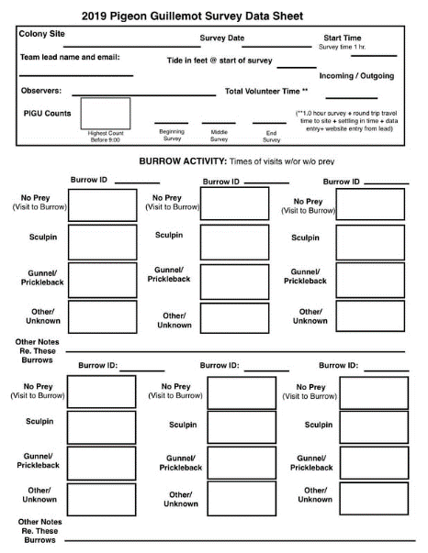**Practical Framework**

Use of volunteer’s citizen science is key to the success of this survey as it provides the ability to perform long term studies while also providing “free source of labor, skills, computational power…” (Silvertown, 2009, p.467). The ease of Pigeon Guillemot surveys with some training makes them relatively easy to gain survey data. Pigeon Guillemot return year after year to their colony to breed as a mated pair for several years, allowing a stable population for study. Those colonies tend to focus on preying on established fishing stock, therefore variances in those stocks can be represented in Pigeon Guillemot population shifts.

The data of the survey counts the Pigeon Guillemot three times per survey, once a week for an hour. The weather and tide data are also tracked but this is not being factored into my thesis. They track the prey type brought to the burrows, but they do not track which burrow, with sculpin, gunnel, other, no prey. On colonies being surveyed are surveyed at least once a week until the season ends. The season can end early some seasons but generally last enough time for two hatches to occur. The data is curated by the survey lead and then the science director with any interns.

1. **Explain the significance of this research problem. Why is this research important? What are the potential contributions of your work? How might your work advance scholarship?**

The surveys of the Pigeon Guillemot could show dips within their populations centered around their dependence on fish stocks and the impacts of water temperature rise on their chick rearing success. Having a long-term survey on-going allows us to see those dips and track possible impacts to the plankton and small fish which the PIGU fed their chicks. With this data established and put into a understandable format scientists and conservationists can utilize it for multiple reasons. Such as possible impacts on fish stocks, the impacts of warming waters, and other conservation/management concerns.

Add more – what about implications for other, fish-dependent birds? Other ways that the research could help?

1. **Summarize your study design[2]. If applicable, identify the key variables in your study. What is their relationship to each other? For example, which variables are you considering as independent (explanatory) and dependent (response)?**

The data I will be utilizing will be survey data collected since 2015 by two different organizations, the Audubon Whidbey Island, and the Nisqually Reach Nature Center. Both organizations have remarkably similar survey guidelines and data collection. They have a weekly survey per site surveyed that year. Those sites are surveyed during the optimal feeding time for Pigeon Guillemot chicks between eight and nine am. Each survey form collects the population count three times during this hour from beginning, middle, and end. During this time, they also factor in any disturbances that occur to the colony mostly pedestrian or motorized watercraft, and what type of fish are fed to their chicks. They do this through visual identification of the fish catch, due to the Pigeon Guillemots habit of “dipping” their fish identification is not as difficult as it could be. Dipping is where the bird dips their fish repeatedly into the water after catching it. The data for the prey is split between the fish types, this data and the population data are my main data sets for this thesis. The fish types fed to the chicks in one year are going to be checked against the population size of the following year, providing a baseline of survival rates among the juvenile Pigeon Guillemots. The fish types in the data is the following: Sculpin, Gunnel, and Other. I want to explore the fish types over the years to see variances in each colony to see how it shifts and impacts the population of the colony.

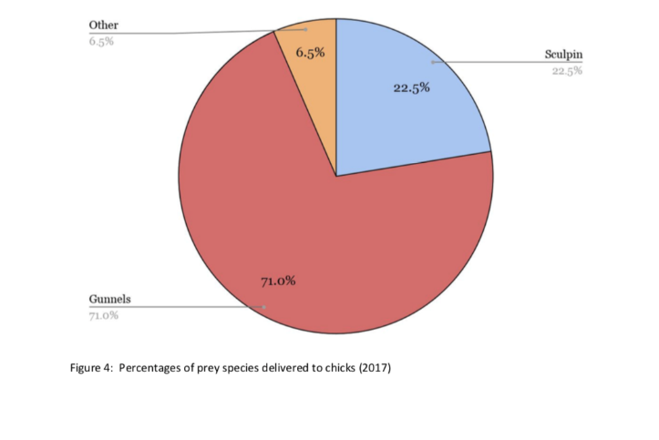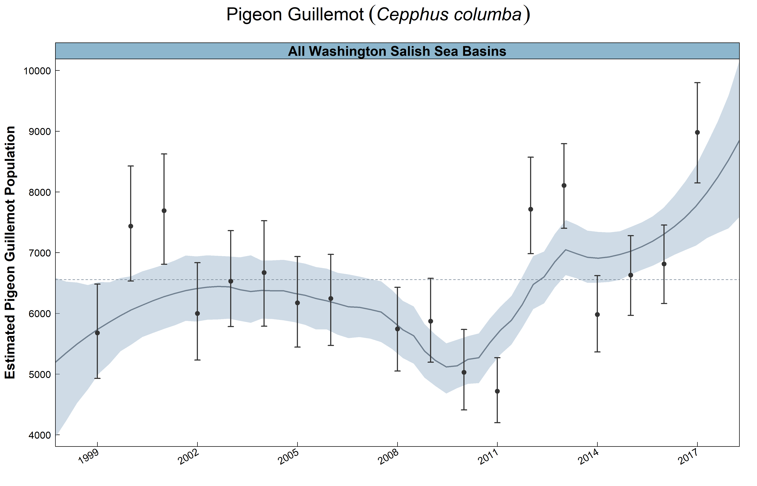

1. **Describe the data that will be the foundation of your thesis. Will you use existing data, or gather new data (or both)? Describe the process of acquiring or collecting data[3].**

I have received the data for the Pigeon Guillemot surveys from the Nisqually Reach Nature Center from their science director, Terence Lee. He has provided me the survey data through Goggle Docs, which originated in paper surveys converted into online documents and have gone through two quality controls. This provides me with the research data collected by Whidbey Island Audubon Society and the South Puget Sound data collected by the Nisqually Reach Nature Center. When I complete the thesis, I will be presenting it to the Nisqually Reach Nature Center science director. I do not plan to gather any information on my own only utilizing the existing data. I will not be requiring any equipment or need to design specific methods to collect data.

The survey is described as tracking population numbers at the start, middle, end of the survey hour. Reporting disturbances to the colony such as predators, or human distances. It also tracts the various environmental factors primarily weather conditions and tide levels. Lastly the survey tracks what prey is brought to the chicks in the colony. Those fish types are none, other, gunnel and sculpin.

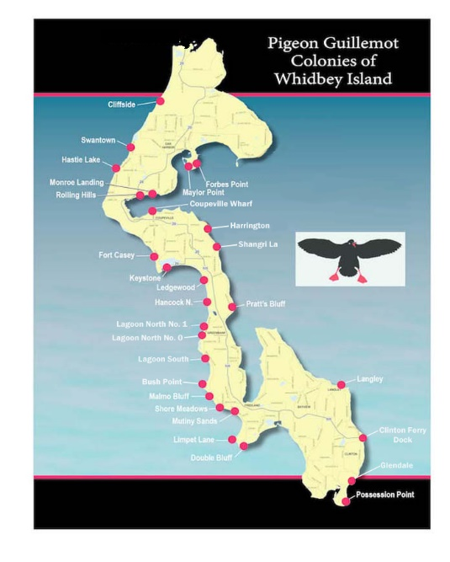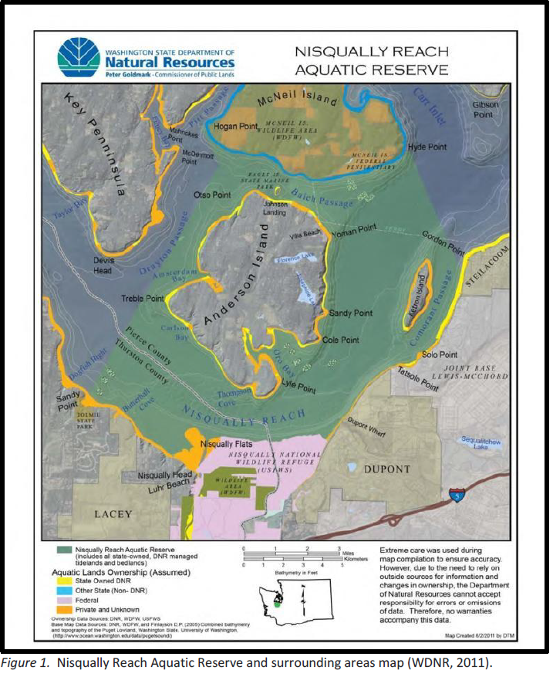

The above maps represent the areas where the colonies are located

1. **Summarize your methods of data analysis. If applicable, discuss specific techniques that you will use to understand the relationships between variables (e.g., interview coding, cost-benefit analysis, specific statistical analyses, spatial analysis) and the steps and tools (e.g., lab equipment, software) that you will take to complete your analyses.**

My main tool will be using the R software to conduct specific statistical analyses of the data as follows: I am still fine tuning what tests I will be conducting exactly. I have some options that I am looking into. But the one that seems the most likely is the Pearson Correlation test. Other options that I need to do research on include: Count base extinction models, principal components analysis, calculation of population differentiation, and generalized additive mixed models.

The **fish types** in the data is the following: Sculpin, Gunnel, and Other. I want to explore the fish types over the years to see variances in each colony to see how it shifts and impacts the population of the colony.

The objective with the data:

Plot the populations of each Pigeon Guillemot colony and by region (South Sound & Whidbey Island). Will be using the maximum counts for the populations based on the surveys.

Break the percentages of fish type (Sculpin, Gunnel, Other, None). Any colonies with small population number and limited fish data will not be factored into the analyze. Will be dividing the total count of fish types and divided by number of sites surveyed. Prey to No Prey ratio will be also factored.

Compare the fish types from one year to the population of the following year.

Fish (Explanatory) and Population Size (Response)

While I am still working out the exact statistical test with my reader. Some of the ideas are below:

Total Populations for Pigeon Guillemot over a decade: **Independent Group** t-**test,** comparing the populations of each colony region from 2015-2020. Testing the two regions from one another, South Sound & Whidbey Island.

I will compare the information of types of fish fed to the Pigeon Guillemot chicks in each of the 75+ colonies compared to the Pigeon Guillemot population of that same colony the following year. **Simple Linear Regression (Continuous –** Pigeon Guillemot **Populations, Predictor – Fish types)**

Test whether the amount of prey taken of different types is similar - **OneWay ANOVA**

1. **Address the ethical issues[4] raised by your thesis work. Include issues such as risks to anyone involved in the research, as well as specific people or groups that might benefit from or be harmed by your thesis work, perhaps depending on your results. List any specific reviews you must complete first (e.g., Human Subjects Review or Animal Use Protocol Form).**

There are no risks to any individual or animal in the research, as I am not conducting any survey or research directly. I will be using prior collected data which allows me to reduce ethical risks. This data was collected by respected organizations, Audubon Society Whidbey Island and Nisqually Nature Reach Center.

This thesis will be of benefit to the above organizations as it will give them both a large frame of reference on their own data. Showing how it appears it will either reinforce their current schemas for their surveys or it could reveal areas that they might need to improve upon.

It will also benefit those organizations affiliated with them. The University of Washington, Evergreen State College, Washington State Department of Fish and Wildlife, **​**Salish Sea Guillemot Network, and the Puget Sound Ecosystem Monitoring Program being the main affiliates.

1. **List specific research permits[5] or permissions you need to obtain before you begin collecting data (e.g. landowner permissions, agency permits).**

I do not require any permits. The data I have received was provided by the Nisqually Nature Reach’s science director Terence Lee; he can be contacted at terencelee@nisquallyestuary.org

1. **Reflect on how your positionality as a researcher could affect your results and how you will account for this in the research process[6].**

I have been involved in the survey data and worked alongside the Nisqually Nature’s Reach and the Whidbey Island Audubon Society, so I likely have a desire to see the results develop interesting/useful information for the above organizations. I also put the interest of the local environment and its flora/fauna. I have a personal interest in seeing the success of the organizations involved in the survey and to see the Pigeon Guillemot seen as an important sentinel species for the Puget Sound, but I will do all I can to avoid bias in my conclusions. I would like to see the Pigeon Guillemot be an even more important marine bird than it already it. The hard work of dozens of scientists and citizens over decades proved worth wild. I am a white male with an upper middle-class family. While I have gained my loans and paid for school entirely on my own, I have access to support which have given me the ability to pursue education as I have. As an individual with two prior degrees I have the positionality of a person who thinks they are skilled in the art of education.

1. **Provide at least a rough estimate of the costs associated with conducting your research.  Provide details about each budget item so that the breakdown of the final cost is clear.**

My research should have no cost for any materials. Anything required is already owned such as R software, Excel, and a laptop. I will not need access to any of the school’s computer labs as my personal devices are able to conduct this work. There will also be no funds required for gas as I will be doing much of my work at home.

1. **Provide a detailed working outline of your thesis.**
2. Introduction

1. Puget Sound

a. Marine Birds importance in Puget Sound

b. Concerns of Puget Sound

i. Fish stocks

ii. Coastal erosion

iii. Pollutants

iiii. Rising water temperature

iiiii. Rising sea levels

2. Pigeon Guillemot

a. Background

i. Climate threatened: Pigeon Guillemot

b. Impact on the Puget Sound

3. Citizen Surveys

a. Organizations

b. Timeline of Surveys

c. Importance of Citizen Science

i. Ecological change, sliding baselines & the importance of data

ii. A new dawn for citizen science

iii. Censusing hole-nesting Auks by visual counts

4. Prey

a. The Big Three

i. Scuplin

ii. Gunnel

iii. Other/Unknown

1. Literature Review

1. Marine seabirds

a. Seabirds as indicators of marine ecosystems

b. Birds that depend on Salish Sea

2. High- Lipid Prey vs Low-Lipid Prey

a. schooling and non-schooling prey

b. Junk-food in Marine Ecosystem

c. Adult prey choice affects chick growth & reproductive success

d. Anecdotes and shifting baseline syndrome of fisheries

3. Pigeon Guillemot Breeding Biology

a. Colonies

i. Factors influencing colony attendance by Pigeon Guillemot

b. Mating Habits

1. Methods
2. Statistical Data Analysis

1. Populations

i. Variances in populations

2. Relationship between Population and Fish type.

i. Outliers

1. Discussion
2. Conclusion

1. Prey-Population Relationship

1. Gaps in the Knowledge

1. Resolution

**14) Provide a specific work plan and a timeline for each of the major tasks in the**

**work plan.**

**\*\*MES Deadlines**

**\*\*\*All dates note listed on the above timeline is a make-up day for any tasks not successfully completed on time.**

|  |  |  |
| --- | --- | --- |
| Activity | Start Date | Due Date |
| **Poster | **11/15/20** | **12/03/20** |
| **Final thesis prospectus | **09/29/20** | **12/12/20** |
| **Thesis to MES Director | **09/29/20** | **12/10/19** |
| Lit Review: High-Lipid & Low-Lipid Fish | **12/07/20** | **12/08/20** |
| Lit Review: Breeding biology | **12/11/20** | **12/16/20** |
| Lit Review: Habitat | **12/17/20** | **12/19/20** |
| Lit Review: Citizen Science | **12/20/20** | **12/23/20** |
| Lit Review: Junk-food hypothesis | **12/26/20** | **12/27/20** |
| Methods: R | **12/30/20** | **01/01/21** |
| Introduction: PiGu | **01/06/21** | **01/12/21** |
| Introduction: NRNC | **01/13/21** | **01/19/21** |
| Introduction: other | **01/20/21** | **01/28/21** |
| Revise Lit Review | **01/29/21** | **02/04/21** |
| Revise Methods | **02/05/21** | **02/09/21** |
| Analysis: Populations | **02/10/21** | **02/19/21** |
| Analysis: Diet | **02/20/21** | **02/28/21** |
| Analysis: Connection between Population and diet | **03/01/21** | **03/04/21** |
| Results: Population dynamics | **03/05/21** | **03/10/21** |
| Results: Diet Diversity | **03/11/21** | **03/15/21** |
| Results: Diet/Population | **03/16/21** | **03/18/21** |
| Discussion | **03/28/21** | **04/03/21** |
| Conclusion | **04/04/21** | **04/05/21** |
| Revise Intro | **04/06/21** | **04/10/21** |
| **Complete Draft to Reader | **TBD** | **04/10/21** |
| Prepare presentation | **04/11/21** | **04/18/21** |
| Revisions | **TBD** | **TBD** |
| Formatting | **5/25/21** | **5/28/21** |
| **Request to present | **TBD** | **05/01/21** |
| **Thesis Presentations | **TBD** | **05/28/21** |
| **Final thesis to Reader | **TBD** | **05/29/21** |
| **Final thesis to MES Director | **TBD** | **06/05/21** |

**15) Who, beyond your MES faculty reader, will support your thesis? Indicate support both within and outside of Evergreen. Be specific about who they are and in what capacity they will support your thesis. If you are working with an outside agency or expert, be specific about their expectations for your data analysis or publication of results.**

The Nisqually Nature Reach Center’s science director, Terence Lee, will be receiving my results upon completion. This paper will be distributed to the Whidbey Island Audubon Society and the Department of Fish and Wildlife both of whom are supporting the surveys. I have no expectations to publication of my paper but as it develops, I might seek to do so through the Audubon Society or DFW as my thesis develops.

The Nisqually Reach Nature Center can be reached at (360) 459-0387. Terence Lee can be contacted directly at leeterence16@gmail.com. I have been given access to this data as I am volunteering with the Nisqually Nature Reach Center to assist them in making a new prototype survey through the GIS application Survey123 Connect. Terence Lee is aware that the data provided will be used for my thesis research.

**16) List the 3-5 most important references you have used to identify the specific questions and context of your topic, help with issues of research design and analysis, and/or provide a basis for interpretation. For each annotated reference, explain how your project specifically connects to the source by extending, challenging, or responding to the conclusions, methods, or implications. For any other sources cited in this document provide a complete bibliographic citation.**

Bibby, C. J., Jones, M., & Marsden, S. (1998). *Bird surveys: Expedition field techniques*. London, UK: Expedition Advisory Centre.

While not specifically on Pigeon Guillemot this book is important for the understanding of surveying birds. Which helps to create an understanding of how the survey data is collected and structured. Not conducting the surveys, myself I find it important to understand them as much as I can to expand my knowledge of the process of surveying birds.

Drent, R. H. (1965). *Breeding Biology of the Pigeon Guillemot, Cepphus Columba* (Unpublished master's thesis). University of British Columbia. https://dx.doi.org/10.14288/1.0106226

Understanding the breeding practices and biology of the Pigeon Guillemot is important to understand while recording their chick’s growth and survival. There is a rate of failure each year understanding this standard will help to point out specific variances in this standard. This report details the colony structures of Pigeon Guillemot which helps to properly understand how the surveying can be successful and how the adults feed their chicks. It also reinforces the strength of using Pigeon Guillemot as survey subjects due to their relatively long live (8 years on average)

Golet, G. H., Kuletz, K. J., Roby, D. D., & Irons, D. B. (2000). Adult Prey Choice Affects Chick Growth and Reproductive Success in Pigeon Guillemots. *The Auk,* *117*(1), 82-91. doi:10.1093/auk/117.1.82

Another article that points to the importance of prey choice among Pigeon Guillemot to ensure the success of their chicks through growth and survival upon leaving the colony. This study was conducted over 9 years and focused specifically on chick diet, growth rate, and reproductive success. All of this is related to the surveys which I am studying and my thesis. Having multiple studies to support the high-lipid prey equating chick success is important, especially ones of various lengths and conducted by different individuals.

Litzow, M. A., Piatt, J. F., Prichard, A. K., & Roby, D. D. (2002). Response of pigeon guillemots to variable abundance of high-lipid and low-lipid prey. *Oecologia,* *132*(2), 286-295. doi:10.1007/s00442-002-0945-1

The population of Pigeon Guillemot in the Gulf of Alaska and Bering Sea are in decline, this study suggests that this is due to the loss of lipid-rich schooling fish. They conducted this five-year study by measuring prey abundance through a variety of means. They compared the survival rate of chicks in the warmer Inner Bay with the colder Outer Bay where the Inner Bay has higher numbers of lipid-rich fish such as Pacific Sand Lance. In the Inner Bay the chick survival rate was 47% higher than the colder Outer Bay. This helped to show the difference between a diet primarily of low-lipid and that of high-lipid prey.

1. You are not locked into this title; its purpose is to help you identify the main point or topic of your thesis at an early stage.
2. You might discuss selection of case studies, sampling methods, experimental design, and/or specific hypotheses you will test. You should also address any specialized knowledge or skills that are necessary to complete the research.
3. If you are planning to use existing data, explain the specific source, contact information, arrangement with collaborating agencies, and expectations about use of data and final products of your research. If you are planning to gather new data, describe specific methods, time, place, and equipment that will be required.
4. If you’re not sure where to start, consult a ‘Code of Ethics’ or other similar document from an academic society in an applicable field of study.
5. If you are collecting ANY samples or data, even observational data, on public lands (city, county, state and/or federal) it is your responsibility to find out the permit requirements BEFORE you collect data. Conducting research with tribal members/on tribal lands will have different and additional requirements.
6. Your *positionality as a researcher* refers to the fact that one’s “…beliefs, values systems, and moral stances are as fundamentally present and inseparable from the research process as [one]’s physical, virtual, or metaphorical presence when facilitating, participating and/or leading the research project…” (The Weingarten Blog 2017).