Request to Present Thesis Research

Graduate Program on the Environment The Evergreen State College

Student Name: Timothy Leque

Reader Name: John Withey

Thesis Title: Song Discrimination Between Two Subspecies of Vesper Sparrow: *Pooecetes gramineus affinis* and *Pooecetes gramineus confinis*

Students enrolled in the thesis workshop or with approved research extension to complete their thesis work must receive approval from their thesis reader to make a public presentation of their work.

To present research, the reader must have made comments and requests for change on a complete first draft.

Student Approval:

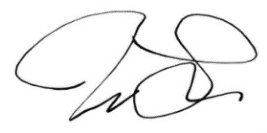*I have submitted a complete first draft of my thesis. I am ready to present my thesis work.*

*Student Signature:*

*Date:* 4/28/2021

Reader Approval:

*The above named student has received comments based on my review of a complete first draft. I approve the student’s work and support a public presentation of the research.*

*Reader Signature:*

*Date:*