**The Evergreen State College**

**Graduate Program on the Environment**

### Thesis Prospectus

|  |  |  |  |  |  |
| --- | --- | --- | --- | --- | --- |
| **Name** | **Sarah Croston** | | | **ID Number** | **A00415407** |
| **Mailing Address** | | | 1321 E Saint Andrews Drive N, Shelton, WA 98584 | | |
|  | | |  | | |
| **Telephone** | | **( 207 ) 522-1927** | |
| **E-mail** | | **sarahcroston7@gmail.com** | |

**STUDENT AGREEMENT:**

**SIGNATURE: __________________________________ DATE________________**

**FACULTY READER APPROVAL:**

**SIGNATURE: __________________________________ DATE________________**

**MES DIRECTOR APPROVAL:**

**SIGNATURE:__________________________________ DATE________________**

1. **Provide the working title of your thesis[1].**

Working Title: A spatial analysis of raptor collisions on Washington State Highways with an emphasis on owl species and recommendations for the improvement of data collection.

1. **In 250 words or less, summarize the key background information needed to understand your research problem and question.**

Avian populations are declining for a multitude of reasons around the globe. Many of these declines are a direct cause of anthropogenic activity, as outlined in the table below.

(Table from Erickson et al. 2005, p. 1039).

This table published in 2005 by Erikson et al. notes that 80 million birds die each year due to collisions with automobiles. These account for 8.5% of bird deaths—more than wind turbines, which receive a lot more attention. It is important to understand that secondary factors cause birds to be near roadways. For example, habitat fragmentation has pushed avian species and other wildlife closer to major roads, predatory birds are drawn to open areas which roadsides provide for hunting. Meunier et al. (2000) detail the importance of roadsides for raptors to hunt especially in agricultural areas. As more birds reside near roads, the chance of them getting struck by moving vehicles increases.

The decline of birds on a global scale serves as an indicator that other forms of wildlife might be well on their way to experiencing dramatic declines. Birds play important roles as pollinators, pest controllers, and a source of food to many other wildlife.

My position as a habitat connectivity intern at the Washington Department of Transportation has given me a much deeper look into how critical creating habitat corridors are for wildlife, including birds. Researchers have been cataloging animals hit on highways in Washington state for the past twenty years. The resulting database spans the entire state of Washington and the time covered by the data is unparalleled. Use of this database is critical in providing a spatial analysis of the key locations of raptor-car collisions in the state.

1. **State your research question(s).**

Does habitat fragmentation affect the frequency of owl-vehicle collisions on Washington State Highways? Does surrounding landcover affect the frequency of owl-vehicle collisions? What other factors influence owl-vehicle collisions (ex. time of year)? Are diurnal and nocturnal raptors hit in the same areas?

1. **Situate your research problem within the relevant literature. What is the theoretical and/or practical framework of your research problem?**

The number of animals killed by automobile collisions continues to grow worldwide. In California alone, an estimated 8.4 large animals are killed per day and State Farm Insurance has reported upwards of 23,000 claims per year for accidents involving deer in that state (Nguyen et al. 2020). As we build more roads, animals face lower levels of habitat connectivity, increased genetic bottlenecks, fewer areas to claim as their territories, an increase in traffic noise pollution, and more chances to be struck by oncoming traffic (Boves & Belthoff (2012), Loss et al. (2014), Stewart (2019)). While the problems which roads create for animals are well known, challenges remain with quantifying these issues and explicitly determining how automobiles affect smaller animals and birds. The bulk of the research surrounding animals and automobiles tends to focus on medium to large mammals. For smaller animals, it is harder to research how many individuals are killed by cars; we cannot directly study the implications of vehicle collisions for tiny animals, like insects.

Challenges also arise when investigating the relationship between birds and car collisions. Many of the reported yearly causalities do not reflect the vast quantity of avian species killed due to cars (Boves & Belthoff (2012), Erickson et al (2005), Guinard et al. (2012), Kociolek et al (2011), Loss et al. (2012)). Certain bird species seem to be hit more often in reporting but, as Guinard et al. explain, that is often due the size of the species. Small passerines will not be detected as frequently as raptors and thus the numbers reflect few songbirds. Smaller birds may be carried off in the grill of a vehicle, eaten but a larger species, or just too hidden to be found after being struck by a vehicle.

My research will focus on owls, which are in the raptor group. The carcasses of owls do get left behind and therefore studied more often than other avian species. Owl collisions have been researched in Europe, and barn owl mortality has been examined in relation to automobile collisions (Boves & Belthoff (2012). Other studies have examined the actual mechanisms of why birds get hit. It is difficult for birds to detect how fast vehicles are moving and often when they move to get out of the way, it is too late. The diagram below displays how birds perceive the potential threat of a moving vehicle.

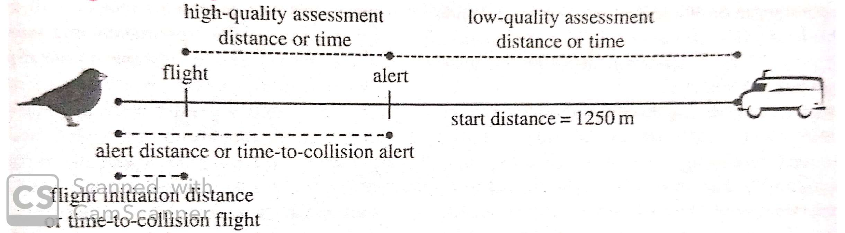

(DeVault et al. 2015, p. 2)

The research I will conduct fills a very specific niche. The timespan of this database provides key information about the avian collisions. Being able to look at data on a statewide scale will allow me to create visuals, look at trends that are currently not recognized in the scientific literature, and provide new insights.

1. **Explain the significance of this research problem. Why is this research important? What are the potential contributions of your work? How might your work advance scholarship?**

My research into understanding spatial patterns of raptor/car collisions would help advance knowledge in three areas. It will 1. expand the general understanding of raptor behavior, 2. help to inform policies to lessen the number of bird car collisions, and 3. assist in the discovery of collision hot spots for raptors in Washington.

This research would help raptor biologists to have a clearer picture of the interactions that occur between cars and raptors (For example, are there times of the year that raptors get hit more often?). Anthropogenic disturbances have had a significant impact on many wildlife species. If more is known about how traffic patterns influence bird’s behavior, then there can be more done to help raptors be successful in survival.

This research can also contribute to the planning for future wildlife crossing and making informed decisions involving key areas that need habitat corridors. Washington State agencies work to build wildlife corridors for animals to move on foot. Structures such as tunnels, bridges, and spaces under overpasses allow the movement of animals. We need to understand if raptor hot spots correlate to areas where other wildlife resides. If these areas are home to many faunae, then they could warrant enhanced crossing structures to be built. The raptors would benefit from such crossing structures because rodents would also be using them to cross the roadways. Keeping the rodents out of the road would mean raptors would be less likely to follow their prey onto the road, where they might get hit by drivers. There could also be more signage put up in raptor hot spot areas telling people be alert and more mindful of their speed. This could also decrease the number of raptor collisions.

This research could also help reduce the number of collisions between birds and cars. This would benefit humans and avian species alike. If we can better understand where and why birds are colliding with vehicles on highways, we can start to mitigate the risks. A better understanding of why birds are attracted to areas on highways, can lead to potential solutions in order to lessen the number of bird strikes. Areas of reduced speeds could be implemented for example.

1. **Summarize your study design[2]. If applicable, identify the key variables in your study. What is their relationship to each other? For example, which variables are you considering as independent (explanatory) and dependent (response)?**

My study will use Washington’s State’s carcass removal database to create spatial maps to analyze the relationship between landform cover, habitat fragmentation, and owl/ raptor kills on Washington’s highways. I will be using Excel and ArcGIS online to create maps. The explanatory or independent variable in this study is the landform cover surrounding Washington’s highways. Another independent variable that I will examine is the connectivity of the surrounding habitat, I will look at the patch sizes of intact habitat surrounding the carcass removal sites. The response variable is owl & hawk kills by automobiles.

This data has been collected for over twenty years, starting in 1996. There have been many different employees who have collected the data. I aim to provide an analysis of the hot spots in which owls/raptors are being hit on the highways in Washington.

1. **Describe the data that will be the foundation of your thesis. Will you use existing data, or gather new data (or both)? Describe the process of acquiring or collecting data[3].**

I will use a subset of the Washington Department of Transportation’s Carcass Removal Database. The process of acquiring this data began with my internship working with the habitat connectivity sector of the environmental services taskforce at Washington Department of Transportation.

I was given access to the Washington State’s “Wildlife Removal Database.” This data is collected by WSDOT’s maintenance employees, using iPads in the field. This database was first started in the mid-1990s. One area which has not been researched within their carcass removal database is bird and car collisions. I decided to narrow my focus onto owl collisions since the bulk of the database focusing on avian collisions were owl carcasses being removed. * I also might compare areas where owls and hawks are being hit to see if there is any overlap. *

I plan on using all available owl and hawk data through the end of 2020. I will then look up every recorded owl and hawk carcass to see if photos were taken of the raptor. This will help give me and the readers of my thesis a better understanding of what species of owls/hawks are being recorded.

1. **Summarize your methods of data analysis. If applicable, discuss specific techniques that you will use to understand the relationships between variables (e.g., interview coding, cost-benefit analysis, specific statistical analyses, spatial analysis) and the steps and tools (e.g., lab equipment, software) that you will take to complete your analyses.**

I have started to make maps using my data on ArcGIS maps online. As pictured below, I will illustrate owl collisions on Interstate I-5 as well as I-90. I have used a landform cover layer from USGS and a highway maps layer uploaded from WSDOT.

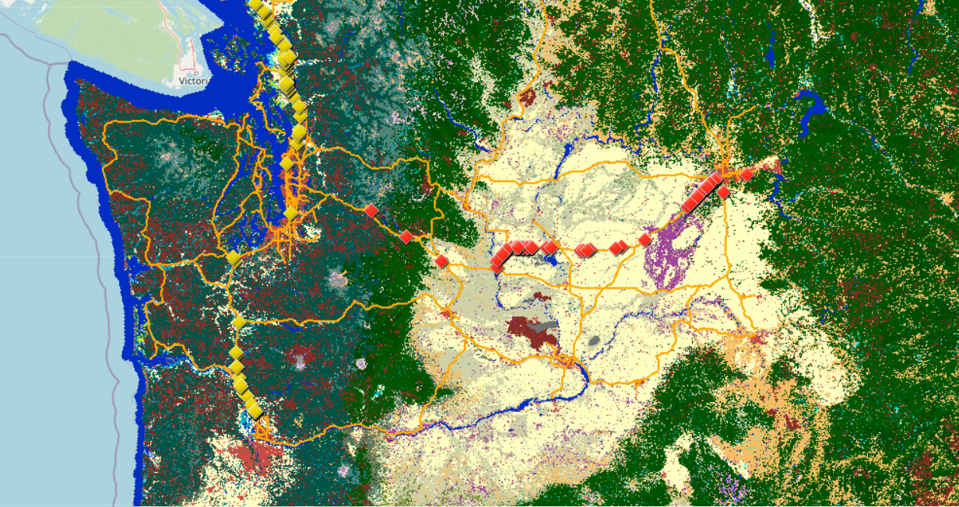

*Map created using the ArcGIS platform by Sarah Croston (data collected from WSDOT’s carcass removal database.)*

In order to display all totals of owl carcasses removed, I created a map using my Excel datasheet and linking it to ArcGIS online. This map groups the carcasses removed by general location in Washington state, the hot spots are outlined as red circles in the map below. * *As I move into the 3rd class of GIS this winter, Special Topics, I will be utilizing the techniques that I learn to create a spatial analysis of my data. \**

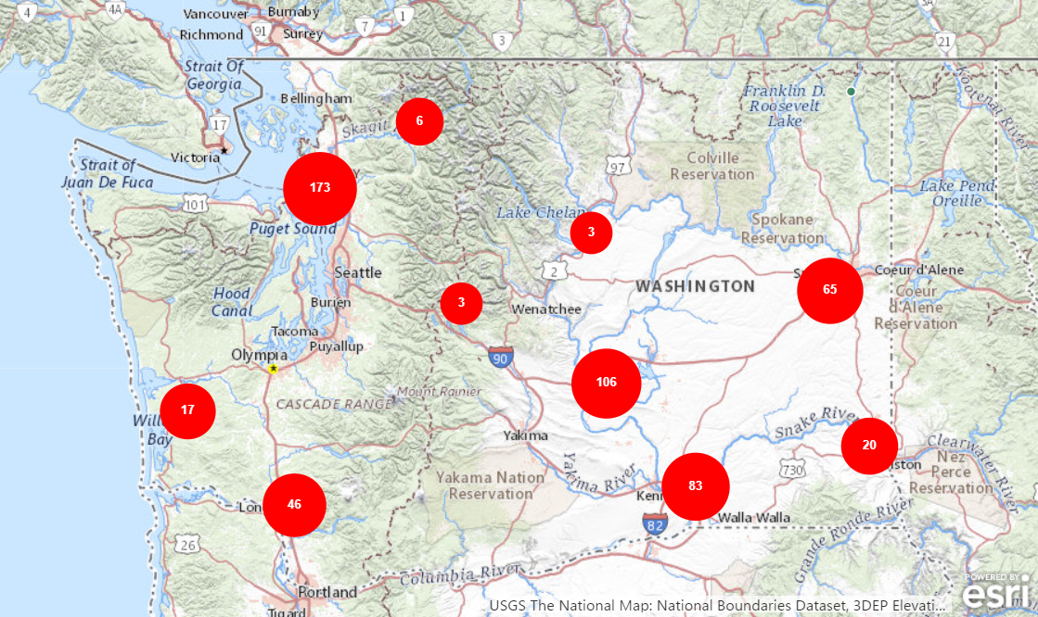

*General locations of owl carcasses removed in Washington State, data from WSDOT’s carcass removal database.*

In addition to using GIS software to create maps, examine land cover type, and look at frequencies of owl strikes, I will also be preforming statistical analyses on the datasets. I will be conducting ANOVA tests on owls from different highways to see how the mean frequencies of collisions compare. I will also examine the difference in the number of collisions per month to better understand when the majority of owl/ hawk collisions occur.

I also plan to create a new tool for the maintenance workers collecting the carcass data. I will design a more comprehensive data entry system, probably using Survey 1,2,3 techniques that I have learned in GIS class. The tool will have a more comprehensive list of avian species options and will require the WSDOT staff to photograph the carcass they are removing. This will lead to more useable data in the future and it will create a more robust database.

1. **Address the ethical issues[4] raised by your thesis work. Include issues such as risks to anyone involved in the research, as well as specific people or groups that might benefit from or be harmed by your thesis work, perhaps depending on your results. List any specific reviews you must complete first (e.g., Human Subjects Review or Animal Use Protocol Form).**

I do not foresee a need to complete any type of review for this data compilation There is a statement on WSDOT’s website which outlines potential problems with the dataset:

There is a statement on WSDOT’s website which outlines potential problems with the dataset:

“The carcass removal data are not a complete record of collisions.

* Animals sometimes survive a collision or expire outside of the road right-of-way.
* Other agencies (like the Washington Department of Fish and Wildlife) may pick up carcasses and not report them to WSDOT. Sometimes, citizens salvage deer or elk and fail to submit an online report.
* The accuracy of collision locations varies. Maintenance staff are encouraged to report locations to the nearest tenth of a mile but locations can be rounded to the nearest half or whole milepost.” <https://www.wsdot.wa.gov/environment/technical/disciplines/fish-wildlife/tracking-wildlife-carcasses>

Certain agencies and individuals will be affected by the outcome of my work. I plan to update the design of the application that the WSDOT maintenance department utilizes to collected carcass data. The prototype of my updated application will affect the way that the maintenance department collects the carcass data. The previous designer of the application may also be harmed by my updated design since they have already put a lot of time and effort into the application.

In addition to the WSDOT maintenance department being affected by my thesis work, WSDOT might also be affected by the outcome of my design. WSDOT might not agree with my proposals to create new wildlife crossing structures or other recommendations my research leads to (i.e. slower speed limits in raptor collision hot spots). Another department that would be affected by the outcome of my research would be the Washington Department of Fish and Wildlife, they might have competing theories as to why raptors are being hit on highways in the state of Washington.

1. **List specific research permits[5] or permissions you need to obtain before you begin collecting data (e.g. landowner permissions, agency permits).**

As outlined on Washington State’s Department of Transportation regarding carcass removal data:

Federal law protects transportation agencies from liability associated with the collection of data needed to improve the safety of highways. This includes wildlife collision data. Requestors of carcass removal data will be asked to review information on the legal issues and limitations of these data prior to having their request filled. (<https://www.wsdot.wa.gov/environment/technical/disciplines/fish-wildlife/tracking-wildlife-carcasses>)

1. **Reflect on how your positionality as a researcher could affect your results and how you will account for this in the research process[6].**

This data is coming from the organization I am employed and is a part of the carcass removal dataset that I work with regularly. As a habitat connectivity intern with Washington Department of Transportation, I am an advocate for wildlife. I value wildlife crossing structures and the benefits they provide animals. I understand that this does impact the way I view the data. I must be careful not to construct my results to show that correlation means causation. There are numerous factors that lead raptors to get hit on highways in the state of Washington.

I am aware of the ties I have to this dataset; I believe that my familiarity with the dataset will be beneficial in remaining as unbiased as I can be in my results. Since I am responsible for keeping the carcass removal database up to date and contacting the highway maintenance worker’s with questions, I have about species locations this helps to keep the database up to date as possible.

I am aware that because my background is in advocating for wildlife, I must pay special attention to the human component in these collisions. This means I must make informed recommendations for drivers and wildlife alike.

I also need to recognize my position as both a female and an intern. I understand that there will be challenges with my age which could lead to people thinking I am inexperienced. Research in the ornithological sciences is a field largely dominated by males, I understand that some people will not take my finding and/or recommendations seriously.

1. **Provide at least a rough estimate of the costs associated with conducting your research.  Provide details about each budget item so that the breakdown of the final cost is clear.**

I do not foresee any costs associated with my thesis. There are two areas in which costs could arise, either for special statistical application packages in R or when making my maps in GIS. (At this time, I am not expecting there to be need for funding.)

1. **Provide a detailed working outline of your thesis.**
2. Title
   1. A spatial analysis of raptor collisions on Washington State Highways with an emphasis on owl species and recommendations for the improvement of data capture.
3. Abstract
4. Acknowledgements
5. Table of Contents
6. Introduction
7. Literature Review
8. Introduction

Raptor Dynamics

* 1. Raptors in Washington State
     1. Hawks and Owls
        1. Migration information
        2. Habitat Requirements
        3. Prey Predator Dynamics
        4. Raptor Hot Spots in Washington

Habitat Fragmentation

* 1. Define habitat fragmentation and connectivity
  2. General Overview
  3. Habitat Fragmentation in Washington State
  4. Habitat Connectivity in Washington State
     1. Wildlife Crossing Structures

Animal Collisions

* 1. General information on animal/car collisions
  2. Bird Car Collisions in General
  3. Raptors Car Collisions in Washington State

Study Design

* 1. Carcass Removal Database
     1. General overview of data
     2. Birds in database
     3. Raptors in database

Significance of Animal Car Collisions

* 1. Creation of wildlife crossing structures
  2. Policy success and challenges

Current Research

* 1. General Information
  2. Why is this important?
  3. Policy success and challenges
  4. Gaps in the Research

*\*Should I include information about the current information about making certain designs in GIS spatial analyzes and in regards to statistical analysis in R ?\**

Conclusion

1. Methods
2. Statistical Analysis
   1. Tests done in R, including, but not limited to ANOVA
3. Results
   1. Include GIS spatial analysis here
4. Discussion
5. Conclusion
6. References
7. **Provide a specific work plan and a timeline for each of the major tasks in the work plan. Be as realistic as you can, even though you will probably need to alter this schedule as you complete the tasks. Remember that faculty readers take time to return your drafts and that the final polishing and formatting of your thesis for binding will take longer than you ever imagined.**

|  |  |
| --- | --- |
| **Time** | **To Do:** |
| **Fall Quarter 2020** |  |
| **Week 5** | Turn in Draft Prospectus |
| **Week 6** | Turn in Outline of Literature Review |
| **Week 7** | Turn in 1st Paragraph of Lit Review & Thesis Statement Turn in Second Draft of Prospectus to thesis reader |
| **Week 8** | Continue to work on literature review and prospectus |
| **Week 9** | Turn in Draft of Literature Review Turn in Final Prospectus |
| **Week 10** | Signed Prospectus Due |
|  |  |
| **Winter Break** | Continue to work on literature review & begin to dev. New survey tool |
|  |  |
| **Winter Quarter 2021** |  |
| **Week 1** | Collect all data through 2020 |
| **Week 2** | Begin to work on maps in GIS & new survey tool |
| **Week 3** | Begin to work on maps in GIS & new survey tool |
| **Week 4** | Meet with Mike Ruth about GIS maps and GIS survey tool, write methods section |
| **Week 5** | Turn in Maps and survey tool to thesis reader, continue to write methods |
| **Week 6** | Turn in a draft of methods to thesis reader |
| **Week 7** | Start analysis and results sections |
| **Week 8** | Continue to work on analysis and results |
| **Week 9** | Start to work on the discussion section |
| **Week 10** | Continue discussion section |
|  |  |
| **Spring Break** | Start to work on Introduction & Conclusion, finish discussion section |
|  |  |
| **Spring Quarter 2021** |  |
| **Week 1** | Work on Introduction & Conclusion |
| **Week 2** | Submit Complete Draft to Thesis Reader |
| **Week 3** | Revise and Format Work |
| **Week 4** | Revise and Format Work |
| **Week 5** | Submit Request to present to MES director |
| **Week 6** | Revise and Format Work |
| **Week 7** | Prepare Thesis Presentation |
| **Week 8** | Present Thesis |
| **Week 9** | Due in FINAL Thesis to thesis reader |

1. **Who, beyond your MES faculty reader, will support your thesis? Indicate support both within and outside of Evergreen. Be specific about who they are and in what capacity they will support your thesis. If you are working with an outside agency or expert, be specific about their expectations for your data analysis or publication of results.**

Beyond my thesis reader, my supervisor at Washington Department of Transportation, Glen Kalisz, will be supporting my thesis. He oversees the carcass removal database and will help me navigate this database and field any questions that arise. (He is also in the process of contacting a few raptor biologists so I can speak to them.)

I will also be consulting with Mike Ruth as I create maps and perform spatial analyses for my thesis work. This will happen during the winter quarter in the Special Topics GIS elective.

1. **List the 3-5 most important references you have used to identify the specific questions and context of your topic, help with issues of research design and analysis, and/or provide a basis for interpretation. For each annotated reference, explain how your project specifically connects to the source by extending, challenging, or responding to the conclusions, methods, or implications. For any other sources cited in this document provide a complete bibliographic citation.**

Boves, T. J. & Belthoff, J. R. (2012). Roadway Mortality of Barn Owls in Idaho, USA, The Journal of Wildlife Management. 76 (7). 1381-1292.

This resource is a great case study of barn owls in the neighboring state of Idaho. This resource is beneficial in looking at the study design of focusing in on one area of I-84. It was also helpful due to the mutual connection our research shares in investigating land cover. This reference helps to extend the research I am looking at in Washington State. This research specially examines the effects of vehicles on barn owls.

Cook, T.C.& Blumstein, D.T. (2013). The omnivore’s dilemma: Diet explains variation in vulnerability to vehicle collision mortality, Biological Conservation 167. 310-315.

This paper outlines a topic I had not thought about prior to reading it, how does diet influence what animals are being hit by the road? It was interesting to read how they gathered the data, which was done by accessing other journal articles. They also discuss what package they used in R (the caper package) to determine the likelihood of specific species being hit.

Jacobson, S.L .(2005). Mitigation Measures for Highway-caused Impacts on Birds, USDA Forest Service Gen. Tech. Rep. PSW-GTR-191.1043-1050.

This paper discusses policy and how we can lessen the number of bird deaths causes by roads. This is important for the wok I am doing because I want to be able to provide solutions to the birds that are getting hit by cars. The paper also details the impacts of habitat fragmentation in relation to bird deaths on roadways, this is something I will be looking into as well.

Loss, S. R., Will, T. & Marra, P. P. (2014). Estimation of Bird-Vehicle Collision Mortality on U.S. Roads, The Journal of Wildlife Management. 78 (5). 763-771.

This resource is very beneficial as it is the backbone to what I am researching. This article synthesizes the findings of a plethora of studies. This resource helps to situate my research and understand why there is inherently so much uncertainty around bird vehicle collisions. The management implications section of this review discusses the need for future research in order to, “clarify how responses vary by bird species, region, habitat, season, and road type (p. 770).” This conclusion validates the need for metadata and larger study areas. Looking at the entire state of Washington will help to clarify larger patterns.

Stewart, B. (2019) Assessing the permeability of large underpasses and viaducts on Interstate 5 in Southwest Washington State for local wildlife, with an emphasis on ungulates. Master’s Thesis, Evergreen State College. 1-271.

This resource is invaluable. It helps to set the stage in Washington State and to understand patterns of animal highway interactions. This thesis has great visuals which help me to compose my own maps. It is important to understand how other species are using crossing on I-5 as I will be looking into patterns on the I5 highway corridor as well, I will be extending these patterns to look at a state level.

**Other sources:**

DeVault T. L., Blackwell B. F., Seamans T. W., Lima S. L., Ferna´ndez-Juricic E. (2015). Speed kills: ineffective avian escape responses to oncoming vehicles. Proceedings: Biological Sciences. 282 (1801):1-8.

Erickson, W. P., Johnson, G. D., & Young, D.P. Jr. (2005). A summary and comparison of bird mortality from anthropogenic causes with an emphasis on collisions. USDA Forest Service Gen. Tech. Rep. 1029-1042.

Guinard, E., Julliard, R., & Barbraud, C. (2012). Motorways and bird traffic casualties: Carcasses surveys and scavenging bias. Biological Conservation. 147. 40-51.

Kociolek, A. V., Clevenger, A. P., St. Clair., & Proppe, D. S. (2011). Effects of road networks on bird populations. Conservation Biology. 25( 2). 241-249.

Meunier, F. D., Verheyden, C., & Jouventin, P. (2000). Use of roadsides by diurnal raptors in agricultural landscapes. Biological Conservation, 92, 291-298. Retrieved December 6, 2020.

Nguyen, T., Saleh, M., Kyaw, M., Trujillo, G., Bejarano, M., Tapia, K., . . . Shilling,, F. (2020, June 24). *Special Report 4: Impact of COVID-19 Mitigation on Wildlife-Vehicle Conflict* (Rep.). https://roadecology.ucdavis.edu/files/content/projects/COVID_CHIPs_Impacts_wildlife.pdf

1. You are not locked into this title; its purpose is to help you identify the main point or topic of your thesis at an early stage.
2. You might discuss selection of case studies, sampling methods, experimental design, and/or specific hypotheses you will test. You should also address any specialized knowledge or skills that are necessary to complete the research.
3. If you are planning to use existing data, explain the specific source, contact information, arrangement with collaborating agencies, and expectations about use of data and final products of your research. If you are planning to gather new data, describe specific methods, time, place, and equipment that will be required.
4. If you’re not sure where to start, consult a ‘Code of Ethics’ or other similar document from an academic society in an applicable field of study.
5. If you are collecting ANY samples or data, even observational data, on public lands (city, county, state and/or federal) it is your responsibility to find out the permit requirements BEFORE you collect data. Conducting research with tribal members/on tribal lands will have different and additional requirements.
6. Your *positionality as a researcher* refers to the fact that one’s “…beliefs, values systems, and moral stances are as fundamentally present and inseparable from the research process as [one]’s physical, virtual, or metaphorical presence when facilitating, participating and/or leading the research project…” (The Weingarten Blog 2017).