ENVIRONMENTAL JUSTICE OF SAFE DRINKING WATER TO DISADVANTAGED COMMUNITIES IN STANISLAUS COUNTY, CALIFORNIA

by Anna Duron

A Thesis

submitted in partial fulfillment of the requirements for the degree Master of Environmental Studies

The Evergreen State College June 2020

© 2020 by Anna Duron. All rights reserved.

This Thesis for the Master of Environmental Studies Degree By

Anna Duron

has been approved for The Evergreen State College

By

Kevin Francis Member of the Faculty

Date

ABSTRACT

Environmental Justice of Safe Drinking Water to Disadvantaged Communities in Stanislaus County, California

Anna Duron

Stanislaus County, located in the Central Valley of California, has some of the highest nitrate levels in drinking water within the state. Continued consumption of nitrates causes negative health effects such as cancer, asthma, and cardiovascular disease. A GIS analysis was conducted to determine the relationship between high nitrates and demographics of the most affected populations. This analysis showed that areas with a higher percentage of minorities, less median household income, less education, and less English speakers have higher incidences of nitrate levels above a safe level. Interviews were also conducted with government officials, technical experts, and residents that focused on health inequities, water quality, political representation, and sources. Analysis of interviews found that most participants acknowledged inequities occurring between the rural and urban areas when it comes to health, water, and political representation.

However, solutions to these issues were scarce. Most answers focused on reactive measures, such as health care access, rather than on the root problem of water quality. Finally, unincorporated communities are often not included in these studies because of the lack of data available for them, which vastly underrepresented the inequities that are already occurring in Stanislaus County.

Table of Contents

List of Figures vi

Acknowledgements vii

CHAPTER 1: INTRODUCTION 1

Introduction 1

Stanislaus County, California 3

Water Contamination 5

Research Questions 6

Importance 7

CHAPTER 2: LITERATURE REVIEW 9

Introduction 9

Effect of Poor Water 9

Nitrogen in Water 11

Clean Water 13

Government Assistance for Clean Water 15

Issues with Government Assistance: the EPA 15

Failing to Help Residents 18

Environmental Inequities Defined 19

Environmental Inequities in the Central Valley 21

Interviewing as a tool 24

GIS as a tool 25

Interviewing and GIS Used Together 27

CHAPTER 3: METHODS 29

Qualitative Analysis 30

Quantitative Analysis 32

CHAPTER 4: RESULTS AND DISCUSSION 36

Qualitative Analysis: Interviews 36

Qualitative Analysis: Discussion 48

Quantitative Analysis: GIS 51

Race Demographics 53

Income 55

Education 56

Language 57

Land Use 60

Dairy Farms 60

Quantitative Analysis: Discussion 61

CHAPTER 5: CONCLUSION 62

Bibliography 68

Appendix A 75

# List of Figures

Figure 1. Nitrate Levels over Time 52

Figure 2. Areas of Focus 53

Figure 3. Percent of Minorities… 54

Figure 4. Median Household Income 55

Figure 5. Education… 57

Figure 6. Language Data for English Speakers… 58

Figure 7. Language Data for Spanish Speakers… 59

# Acknowledgements

I would like to give thanks to my large support system. My parents for always giving me everything even when they had nothing. I would not have had this opportunity to complete my Master’s without your sacrifices. My family and friends for the continued support. Sarajane for giving me this opportunity and being there for me throughout the whole process. The Starlings for getting through these past two years with me; it would not have been as enjoyable without you all. Heidi and Julian for being a fantastic peer review group. Thank you to Kathleen Saul for inspiring this thesis topic and helping it flourish. Adam for loving me, keeping me motivated, and keeping me well fed and taken care of. I am grateful for those that participated in my interviews and helped me acquire data; without you all, my research would not have been possible.

Finally, I can’t thank Kevin Francis enough for guiding me through the MES program, being my thesis reader and for your patience with me. I could not have asked for a better thesis reader or person to aid me along my MES journey.

# CHAPTER 1: INTRODUCTION

## Introduction

I was born in Stanislaus County to a low-income family where my brother and I are first generation immigrants, and we often suffered from the negative impacts from having contaminated water. One memory I have growing up is going to a Watermill Express to fill up gallons of water bottles for drinking and cooking. A Watermill Express is a little station usually located in parking lots that had a change slot, and we used to pay a quarter per gallon of filtered water. I remember my parents telling me not to drink from the tap but to use the filtered water that they paid for. I never completely understood why we could not drink from the tap but that was just a way of life.

Often my family would complain about the high costs of bills and although a gallon of water was cheap, it added up for a family of four that did not have a large income. My family is just one of the many who have felt and continue to feel the effects of having unsafe drinking water. I figured every family had these same burdens because as a child I did not understand that inequities existed. I had a narrow view of the world where my realities were assumed to be everyone else’s. What I did not realize was that not every family had the same water experience as my family. There were families that could safely drink water from their irrigation district and did not have the extra burden of seeking safe water for their families. As I became older, I learned what the word inequality meant, and that environmental justice is not only an academic practice but an important subject to protect disadvantaged families such as mine.

Environmental justice is a movement created to pursue fairness and involvement

for groups regardless of race, color, or income that are experiencing inequities from

environmental laws, regulations or policies (Chakraborty, Maantay, & Brender, 2011; Pellow, 2000a; Strelau & Köckler, 2016). Policy makers and organizations have increased their efforts to adopt principles of environmental justice to begin addressing environmental burdens placed on disadvantaged communities (Alkon, Cortez, & Sze, 2013). These principles are a starting point for politicians and organizations alike to make a difference in helping disadvantaged communities, however a minimal amount is done in some cases. The water inequities in Stanislaus County that my family personally experiences are just one example of environmental injustice. This thesis explores water inequities in Stanislaus County, where I was born and raised, as a case study of the factors that cause such inequities to persist.

Stanislaus County, located in the Central Valley of California, makes a good area for research into issues of drinking water inequities because of the large amount of agriculture and the large immigrant population that makes it possible. This area has many dairy farms and pesticide applications that have the potential to leach nitrate into the ground and water supplies. Some of the highest nitrate levels in the state occur in the Valley (Balazs, 2011). Unsafe drinking water is a very common occurrence to those living in the Central Valley and little has been done by the state to remedy this issue.

Many residents in this area receive letters in the mail from their water suppliers with a warning about high levels of toxins in their water. One letter warning about arsenic for example states “However, some people who drink water containing arsenic in excess of the MCL over many years may experience skin damage or circulatory system problems, and may have an increased risk to getting cancer”. This letter in full can be seen in Appendix A. In addition, the Valley also contains the largest populations of Latinos in the

state according to the U.S. Census (Balazs, 2011). There are pockets of low-income populations and those without much education that experience inequities. This raises questions of environmental justice: why do disadvantaged communities bear a disproportionate burden of the use of nitrates from agriculture in California?

## Stanislaus County, California

California as a state is well known for its many benefits such as the fair weather, beaches, and large cities. The Central Valley in California is known for its vast production of agriculture that provides delicious fruits, almonds, and other crops to many parts of the United States (Huang & London, 2012). The dark side that most tourists and outsiders do not see are the negative impacts that are suffered by residents. The Central Valley may have some good qualities, but it also has high rates of health effects, poverty, and unemployment (Pannu, 2012a). The cause of these detriments is hard to identify since they come from many different directions. Because of the vast amount of water used for agriculture, residents are in a constant struggle with finding safe drinking water provided to them at an affordable rate. This makes the Central Valley an ideal study site to compare the drinking water quality to disadvantaged communities and their health because of the environmental injustices that may be occurring here. The result will likely bring a deep issue to the attention of those who are unaware of the struggles that the residents deal with every day.

Stanislaus County was founded around 1854 when hordes of individuals from around the nation moved west to stake their claim in the gold rush. Like much of the Central Valley, this area was soon in abundance of wheat and cattle due to its prime location for agriculture. The land is still used for agriculture with a shift from wheat and

cattle to orchards and dairy farms. Although a lot has changed from the saloon days, Stanislaus County is still structurally the same, with a large central city surrounded by agricultural lands (Historic Modesto Home, n.d.). Stanislaus County is just over 1,500 square miles with a total population of around 550,000 people. Modesto holds almost half of the total population of the county (around 215,000 individuals) in only 45 square miles (U.S. Census Bureau, n.d.).

Stanislaus County is comprised of a combination of cities and rural areas that contain vast amounts of agriculture (Alkon et al., 2013; Huang & London, 2012). The agriculture produced there feeds many residents in the nation and employs many people. The agriculture industry employs almost 30,000 individuals and brings in an economic output of around $7.15 billion. Stanislaus County has a large diversity of crops produced, and it is well known for its wine grapes, tomatoes, peaches, almonds and milk (Langholz & DePaolis, 2018).

However, this robust agricultural economy has some downsides. The landscape and people are disturbed by the environmental effects of the production of agriculture (Alkon et al., 2013). This area suffers from the industrial applications of pesticides and leaching of dairy lagoons which pollutes the drinking water for residents (London, Zagofsky, Huang, & Saklar, 2011).

Stanislaus County, like many other counties in the Central Valley, has some of the most contaminated water in the United States (Balazs, 2011; Pannu, 2012b). A vast majority of the individuals in the Central Valley receive their water from a contaminated source (Pannu, 2012b). Many of those suffering from unsafe water live in rural, unincorporated areas. In the lower valley alone, there are 220 disadvantaged communities

comprised of over 500,000 residents (Pannu, 2012a). The demographic there is largely low-income, people of color who have moved to this location as cheap labor for the agriculture industry (Alkon et al., 2013). Racial minorities more often than not encounter inadequate living and health conditions and are the poorest populations in this area with over 17% of the population living below the poverty line (Balazs, 2011).

## Water Contamination

Unsafe drinking water can be defined as contaminated by a variety of toxins. The most common contaminant found in drinking water for Stanislaus County is nitrogen in the form of nitrates (Burkart & Stoner, 2007; Matthews, 1998; Ward et al., 2005a).

Nitrogen deposition into the land has increased significantly due to the growth of agriculture and the dairy industry. Since Stanislaus County has large amounts of agriculture and dairies, nitrate pollution in water is prevalent (Matthews, 1998; Ward et al., 2018).

Nitrates can cause a variety of health consequences for those who consume high levels of it. The most prominent health issue is methemoglobinemia or “blue baby syndrome” which occurs in infants who consume unsafe levels of nitrates. High intake of nitrates can also cause spontaneous abortions among pregnant women, low birth rates, as well as diarrhea and other negative impacts among infants (Balazs, 2011; Suthar, 2011). Other negative health effects include various types of cancers and lymphomas, as well as Alzheimer’s disease (Bhowmik et al., 2015; Suthar, 2011; Ward et al., 2018).

## Research Questions

How are the health outcomes of different communities affected by differences in their drinking water quality? Specifically, do different demographics experience different levels of nitrates in their water?

Residents of Stanislaus County that are low-income, and people of color are generally more exposed to toxic drinking water and have higher rates of health problems than others residing nearby (Balazs, 2011). Stanislaus County has both urban and rural areas comprised of communities that come from different demographics. To analyze if there is a difference in demographics where high nitrates are located, I will compile and analyze GIS data on nitrate levels randomly sampled in the county, demographic data, and land use. I want to understand specific similarities or differences in demographics and water quality between the urban, sprawling cities like Modesto and Turlock to the rural areas that encompass towns like Oakdale and Patterson.

How do policy makers, experts, and residents view these problems and what do they believe are viable solutions? What are some areas of convergence and divergence among these groups in terms of looking at health inequities, water quality, and political representation?

Environmental justice connected to drinking water is widely recognized in Stanislaus County however, such recognition has not led to an improvement to the problem of safe drinking water to some communities. To understand why there has not been progress on this issue, I conducted interviews with different government officials, technical experts, and residents in Stanislaus County. I asked about the health trends,

water quality issues, and government assistance to assess where measures are being taken and where gaps exist in reducing environmental inequities.

Scholars have shown that middle class professional advocates have adopted an environmental justice framework to advance their own agendas. Even though the framing has led to its success in obtaining resources and political opportunities, not enough action has been done to make a difference. This way of framing allows support of politicians and media while convincing those less affected to become activists (Alkon et al., 2013). While this helps raise the profile of vital issues, along with status of these advocates, there have not been many changes in terms of improvements in living and working conditions. I want to find out if similar things are happening in relation to water inequities in Stanislaus County.

## Importance

Everyone needs a source of clean, safe drinking water to survive. Some populations live in areas with a poorer quality of water than others. High nitrates have been previously linked to different demographic factors and I will be looking at whether that is true for Stanislaus County using GIS. Stanislaus County makes for a good case study area because of the history of poor water, abundance of agriculture, and stratified demography. Since nitrates can cause serious health effects after long-term exposure, it is an important factor to look at when studying contaminated water.

Most of all, a solution of how to provide safe drinking water is needed to support healthy communities both in Stanislaus County and all over the world. The interview analysis will show how differing groups and professionals view the importance of health and safe drinking water. If populations are being unfairly exposed to contaminated water,

it is important to see what actions are being done, what opinions are held on the matter, and what steps are being done to protect those unfairly impacted. Another important issue is where these individuals get their information and how they view unsafe drinking water. Convergence and divergence of awareness, understanding, and view of solutions matters because without knowing of issues occurring in the area, no actions will be done to protect those being harmed.

# CHAPTER 2: LITERATURE REVIEW

## Introduction

Extensive research has shown that there are negative health effects that can occur from consuming toxic water, and unsafe drinking water is a common occurrence. I focus on this literature in the first section of my review. One of the biggest contamination problems in water is nitrogen in the form of nitrates. There are several studies and scholarship that has shown that which is shown in the next section. There are different ways in which nitrogen can contaminate waterways which is also discussed. Various solutions have been implemented to ensure communities have clean, potable water. In the next sections I talk about what clean, potable water is and what some solutions are. There are continuing issues with implementation from bureaucratic structure and structural racism, including from the EPA which will be discussed. Environmental justice and injustice are modern terms to discuss inequities that occur for disadvantaged communities. These definitions and meanings are described in the next section.

Stanislaus County is an ideal study site because of the geographic location and populations residing within. The environmental injustices occurring in the greater Central Valley and Stanislaus County are in the following section. Interviewing and GIS are two different research techniques, and both can be used to combat environmental injustices.

These two tools used for research are contained in the last sections.

## Effect of Poor Water

Most people in the United States take good water quality for granted every day. In fact, the United States is associated as a symbol of success for its availability of drinking water to the vast majority of the population (Balazs, 2011). Because of the severe impacts

to human health, drinking water filtration has become one of the most important public health interventions in the United States (Gifford, Chester, Hristovski, & Westerhoff, 2018). However, drinking water filtration remains costly and unaffordable in many developing countries (Pawar, 2013). In developing countries, many individuals consume contaminated drinking water regularly due to inadequate water purification methods (Bhowmik et al., 2015).

Approximately one billion people in the world do not have access to safe drinking water. We commonly associate contaminated drinking water supplies with poor, third world countries, however, hazardous drinking water is a serious issue everywhere in the world (Balazs, 2011; Pawar, 2013; Suthar, 2011). Access to uncontaminated water reduces the risk of disease and improves the overall public health (Pannu, 2012a).

Several studies have linked a correlation between unsafe drinking water and human health risks. Contaminated water can have severe implications on human health such as cardiovascular diseases, infertility, neurotoxicity, and cancers (Bhowmik et al., 2015; Ward et al., 2018). Contaminated water can have various levels of arsenic, pesticide chemicals, or organic compounds that can negatively affect human health. Poor water quality, including associated sanitation and hygiene issues, has resulted in around

* 1. million deaths worldwide per year (Suthar, 2011).

Nitrates are a significant issue in contaminated water that can cause various health concerns. Ward et al. concluded that common health issues related to high levels of nitrates in water include colorectal cancer, bladder and breast cancer, and thyroid disease (2018). There is a relationship between colon cancer and high nitrate consumption shown also by a study done in Taiwan. In another analysis completed on animals, high nitrate

intake is correlated with gastrointestinal cancer, Alzheimer’s, dementia, multiple sclerosis, lymphomas, and other health defects.

In developing countries, infant mortalities are due mostly from poor water quality (Suthar, 2011). Drinking water with high levels of nitrates in pregnant women can cause spontaneous abortion, death of the fetus, low birth weight, and congenital malformations (Ward et al., 2018). Methemoglobinemia or “blue baby syndrome” can result from a large intake of nitrogen from poor water consumption in infants. It reduces the oxygen carrying capacity in the blood and can lead to death by asphyxiation (Balazs, 2011; Suthar, 2011). Lack of clean drinking water can also lead to repeat or chronic diarrhea in children.

Additionally, diarrheal disease, malnutrition, and physical growth can inhibit children from reaching their full potential (Hunter, Macdonald, & Carter, 2010).

## Nitrogen in Water

In the past 100 years, the rate of nitrogen deposition into the land has doubled due to human activity such as production and application of fertilizers, and the growth of agriculture and the dairy industry (Ward et al., 2018). Nitrates originate from organic sources in the form of human and animal waste and wastewater treatment plant discharge (van der Schans, Harter, Leijnse, Mathews, & Meyer, 2009). In fact, agriculture remains the largest polluter of groundwater (Balazs, 2011). The increase of livestock and manure in the United States directly relates to the concentration of nitrogen available that leaches into the groundwater (Burkart & Stoner, 2007). Additional nitrogen from dairy manure accounts for approximately 240,000 tons of nitrogen in the ground, most of which leaches into the watershed (van der Schans et al., 2009).

The most common contaminant for water sources are nitrates both in the United States and in the rest of the world (Burkart & Stoner, 2007; Matthews, 1998; van der Schans et al., 2009; Ward et al., 2005b). Nitrogen originating from manure and inorganic fertilizer is easy to document and compare around the globe compared to other toxins and metals in water systems (Burkart & Stoner, 2007). Nitrate levels in the Central Valley frequently exceed the national median and the set drinking water standards. This is primarily due to the abundance of agriculture and dairy farms producing an excess of nitrates. Nitrate concentrations in the San Joaquin Valley have been increasing steadily over the past forty years (Matthews, 1998).

The World Health Organization (WHO) has set the maximum contaminant level (MCL) for nitrates in United States drinking water at 10 mg/L (Ward et al., 2018) equivalent to 27 pounds of nitrate rich fertilizer leached into one acre-foot (Hunter et al., 2010). The WHO guidelines are based on two factors: the probability of consumer exposure and the level of hazard to health (Suthar, 2011). The 10 mg/L maximum helps prevent infant methemoglobinemia, though other health effects of nitrogen were not considered (Ward et al., 2018).

Although these standards are set by WHO, most drinking water does not fall within these standards. Water quality is poorly monitored and regulated in many areas (Pannu, 2012a). Approximately 14 percent of random samples taken in the United States have exceeded the MCL for public drinking water supplies (Burkart & Stoner, 2007). In California, over 5,000 people were exposed to drinking water that exceeded the MCL nitrate levels over a three-year period, raising health concerns (Balazs, 2011). Looking at data another way, over half of the MCL violations in the entire state of California took

place in just the Central Valley where only approximately 18 percent of the state’s population resides. In 2006, over 20 percent of the Central Valley’s water systems tested above the MCL (Pannu, 2012a).

## Clean Water

A basic human right is to have access to clean, potable water (UN-Water, n.d.). Potable water means water that has physical, chemical, and bacteriological parameters that meet the standards set by WHO (World Health Organization, 2008). Potable water can be used safely for drinking and cooking (Suthar, 2011). Most individuals worldwide do not have access to clean water for daily living such as drinking, preparing food, and personal hygiene (Hunter et al., 2010). Water infrastructure failures leads to poor water quality which impacts access to potable water for some communities. Water infrastructure includes pipes, wells, and pumps which degrade over time causing failures that can contaminate water by allowing toxins to leach into the system (Pannu, 2012a). Without access to safe, potable drinking water, individuals have an increased risk of health concerns such as cancer and birth defects (Hunter et al., 2010).

Rural communities often lack potable drinking water, sewer systems, safe housing, public transportation, parks, sidewalks, and streetlights which are features of a healthy and safe region (Flegal, Rice, Mann, & Tran, 2013). Financial resources are generally limited in rural areas and those areas receive less support for resolving water poverty challenges (Pannu, 2012a). Several hundred thousand people in the Central Valley live in unincorporated areas that lack basic municipal services which leaves little information on the conditions of these areas to policy makers and regulators. Many

surveys and studies do not include these unincorporated areas which leaves these populations to rely on county governments (Balazs, 2011).

Rural areas are also notorious for their contaminated aquifers from the use of agriculture and livestock production. Many agricultural practices were done previously that contaminated both water and soil in surrounding areas unknowingly. Reform needs to occur in the way that agriculture is practiced. Focus on containment or downscaling in certain areas may need to be performed to ensure safe agricultural practices to protect nearby populations.

Those entities polluting the drinking water sources should be the ones that pay to protect residents; currently, individual communities must pay to have clean drinking water (Balazs, 2011). The excess cost of paying both for the water utility bill and clean drinking water makes household finances even more challenging (Balazs, 2011; Pannu, 2012a). Many households, on average, in the Central Valley pay around 4 to 10 percent of their income on sustaining themselves with clean water by other sources such as bottled, store bought water, or temporary water filters (Balazs, 2011). After paying these costs, individuals can also be charged remediation fees for irrigation and other water districts that do not provide residential water (Pannu, 2012a). Due to high unemployment and a sizeable elderly population in the valley, the ability to afford clean water is limited (Balazs, 2011).

Showing the association between unsafe drinking water and negative health effects along with showing which populations are exposed to the contaminated water is important to prevent public health outbreaks. Public health officials need to be involved to protect the wellbeing of populations (McDonald & Jones, 2018). Citizen engagement

should be encouraged and available to provide residents knowledge of how water regulation works and to bring awareness to government leaders (McDonald & Jones, 2018). Collaboration needs to be done with officials and residents to find an ideal solution for preventing negative health ailments due to unsafe drinking water, however government and political officials should create a resolution.

## Government Assistance for Clean Water

Several federal and state acts and boards have focused on improving water quality. In 1974, the Safe Water Drinking Act was put into place that required the protection of the nation’s surface waters. This required monitoring public water supplies, however the studies lacked water consumption which is important for exposure to drinking water contaminants (Ward et al., 2018). In 1996, amendments were done to the Safe Water Drinking Act to protect source water but not necessarily groundwater.

California also has the State and Regional Water Quality Control Boards to ensure protection of the groundwater quality. (Balazs, 2011). This agency is extremely understaffed which leaves it unable to have protection of its own group (Pannu, 2012a). There are several laws and structures that exist to fulfill the need for safe drinking water, however some are falling short of doing so. This raises the question: how do these government entities fail to keep regulations and provide clean water?

## Issues with Government Assistance: the EPA

The Environmental Protection Agency (EPA) collects data on drinking water violations and puts together reports on water quality throughout the United States. The EPA has required regulated entities to reduce the harm to any populations or community from environmental hazards, including water (Nweke & Lee, 2011). A survey done in

1994 concluded that EPA employees have a low sensitivity for cultural diversity. This study was done by surveying and interviewing individuals that worked at the EPA. Questions about policies and priorities were asked and the conclusion was that minority populations are scarcely included in major decisions about the safety of communities. (Strelau & Köckler, 2016). Although this is not representative of the entire EPA, EPA’s staff is mostly white, college-educated men who have backgrounds in engineering, science, or law. Also, in the early 1990s, an EPA senior employee was quoted claiming that environmental justice is a waste of resources and it is just a response to uninformed, unknowledgeable activists (Strelau & Köckler, 2016).

In 1994, there was an executive order to incorporate environmental justice into all federal agency programs (Environmental Protection Agency, 2006). The goal of this executive order was to emphasize environmental justice both as a process and an aspirational outcome. The Clinton Administration had large, ambitious goals to change federal agencies decision making process. These environmental justice goals would be an extension of existing civil rights laws (Konisky, 2016).

The EPA fell short of fulfilling this executive order in several places. A survey done found that the EPA has not performed environmental justice reviews that were mandatory under the executive order in 1994. These reviews were not done because management frequently did not send in requests for them (Environmental Protection Agency, 2006). This executive order was disregarded by ignoring needs of poor and minority communities. None of the EPA offices were determining if any of their programs were disproportionately effecting minority and low-income populations.

Offices also stated in a survey that their programs do not review impacts on minority and low-income populations (Environmental Protection Agency, 2006).

The EPA’s Inspector General concluded that even though the executive order was put in place, the agency still has not integrated environmental justice in their daily operations and have failed to perform reviews of its programs, policies and activities (Environmental Protection Agency, 2006). A few years after that statement, the Inspector General continued to announce EPA’s failure in incorporating environmental justice in their agency (Konisky, 2016). The EPA’s Inspector General is in office to promote economy and efficiency of the EPA along with preventing waste and abuse caused by the EPA (Environmental Protection Agency, n.d.). The Inspector General was a position created in part to prevent actions like environmental injustice within the EPA.

A few decades after the executive order in 1994 was put in place, the EPA during the Obama Administration started making changes. The EPA started prioritizing the environmental burdens experienced by disadvantaged communities and addressing the well-documented disparities. Lisa Jackson, the EPA Administrator, declared environmental justice as a priority for the EPA along with climate change, and air and water quality. In 2014, the EPA developed Plan Environmental Justice to integrate inequity issues into its regular activities and programs (Konisky, 2016). The EPA is a large federal agency that citizens rely on to protect them from environmental harms and they have been neglecting disadvantaged populations. There is hope with the new policy that the environmental harms will decrease for overlooked populations, however only time will tell.

## Failing to Help Residents

Communities with fewer social, political, and economic resources tend to be exposed to more environmental hazards (Huang & London, 2012). About one quarter of global deaths result from living or working in an unhealthy environment (Chartres, Bero, & Norris, 2019). Benefits and costs of resources become distributed unevenly because of the scarcity of them within the political, historical, and social economy (Fisher, Kelly, & Romm, 2006; Pellow, 2000b).

Government organizations put together to ensure access to clean water as a human right for populations can include individuals and groups related to the public health system and residents (Hunter et al., 2010). These organizations are positive in that they are charged with enacting change to reduce disparities; however, the actual outcome is often problematic and reflects systemic structural injustice. An analysis of these organizations and stakeholders have concluded that there are inconsistencies which leads to lack of policies. Organizations do not have set standards across the board or consistent terminology which makes it difficult to determine hazards and risks. Less than a fourth of organizations use reproducible methods and formal procedures are rarely existent (Chartres et al., 2019). What the state does with this information leaves several populations vulnerable (McDonald & Jones, 2018).

Governments often lack capacity or show institutional fragility which leaves key issues, including environmental ones, to other foundations (Hunter et al., 2010).

Negotiation and conflict among multiple stakeholders, such as social movement organizations, private sector firms, the state, residents and workers, constitute the relationship of environmental inequalities (Pellow, 2000b). The state also leaves citizens

with no option to petition to state boards beyond few regulatory exchanges to commenting at public hearings (Pannu, 2012a).

Fewer than half the organizations studying and contesting environmental injustices describe their processes used for making final decisions and recommendations. This makes it difficult to come to conclusions or develop policies to protect disadvantaged communities (Chartres et al., 2019). Governmental assistance in low income areas is inadequate. Numerous decision makers and county officials do not even know that these communities exist so no measures are ever put into place (Flegal et al., 2013).

The management distribution across state agencies and local water governments has left a structure that lacks transparency, accountability, and affordability (Pannu, 2012a). Many water systems fail to comply and monitor water quality or they neglect to notify customers when there is an issue (Balazs, 2011). The tradeoffs that the stakeholders consider are both for economic reasons and humanitarian reasons. Some of them are who should bear the health risk, what diseases occur, and how much money one’s health is worth (Gifford et al., 2018). It is difficult to raise funds to upgrade infrastructure or to develop sustainable practices based off of the stakeholders consideration (Balazs, 2011; Pannu, 2012a).

## Environmental Inequities Defined

Environmental injustice occurs when a group suffers unfairly from environmental hazards and toxins (Fisher et al., 2006; Pellow, 2000b). Environmental injustice that occurs in disadvantaged communities often happens because the government puts economic development above the people’s welfare (Lewis, 2012). The groups feeling the

impacts from environmental injustice are typically ones that are also the most vulnerable to the environmental hazards and health concerns (Huang & London, 2012). Regardless if environmental injustice stems from racism or discrimination on the end of stakeholders, the main issue is that individuals are being negatively impacted by environmental hazards, most of which can be prevented with proper policies put into place and actions taken (Maantay, 2016). There should be participation in the decision-making processes by affected populations when it comes to decisions about preventing environmental injustices. This will help ensure that the individuals being affected can have sufficient compensation and remedies to the issues (Lewis, 2012).

Environmental injustices often coincide with human rights violations (Lewis, 2012). United States municipalities have used their legal authority and police to provide or deny services and resources for certain populations in an area (Balazs, 2011).

Environmental injustices generally occur when low income or people of color are exposed to hazards while the rest of the population is not, because low income or marginalized people are less powerful than corporations or the government decision- makers. These marginalized groups are less powerful than corporations because they lack the finances and powerful individuals that make the decisions for the area (Balazs, 2011; Huang & London, 2012; Pellow, 2000b). These inequalities occur when there is negotiation and conflict among the stakeholders that leads to uneven distribution of necessary resources (Fisher et al., 2006; Pellow, 2000b).

Environmental justice pursues fairness for the suffering groups and provides mutual respect for these peoples (Chakraborty et al., 2011; Pellow, 2000b; Strelau & Köckler, 2016). The exposure to environmental hazards and availability of environmental

goods are both factors in environmental justice because they impact health outcomes of the populations being affected. These health outcomes range from asthma to cancer (Strelau & Köckler, 2016). A large element when it comes to understanding environmental justice comes from a range of economic, social, and cultural factors (Shepherd, Jepson, Watterson, & Evans, 2012). Leaving it up to citizens to pay for clean water, even when they are financially troubled is a major issue when it comes to environmental justice and clean drinking water (Balazs, 2011). This makes it even more difficult for these populations to mitigate the negative health effects and to advocate for environmental justice (Huang & London, 2012).

The research done so far has shown trends that poor and people of color populations have suffered the most from environmental hazards (Maantay, 2016). There is a higher percentage of Latinos or Blacks that endure drinking water violations in the form of high levels of toxins. They are also the groups that encounter repeat violations (McDonald & Jones, 2018). These groups are more likely to suffer from environmental injustice because of their vulnerability to changes and their lower capacity to adapt to these changes (Lewis, 2012). They have suffered years of neglect in these areas which led to instability and lack of long term viability (Pannu, 2012a). Since there is a lack of data and research completed, there is a substantial chance that the disproportionate burden has been underestimated (Maantay, 2016). Prioritizing equity helps protect all residents, not just the visible, most concentrated, or affluent (Pannu, 2012a).

## Environmental Inequities in the Central Valley

The Central Valley is a geographically large region in California with a combination of low-density rural areas and large density cities (Huang & London, 2012).

The San Joaquin Valley ranked the lowest in the nation on resident health, education, and income in a study done in 2010. Presently, the San Joaquin Valley still ranks low, under the national average (Flegal et al., 2013).

The citizens of the Central Valley have high rates of health issues. Some of the state’s highest rates of asthma, diabetes, and malnutrition appear in this area. Pesticide exposure and blue baby syndrome deaths, from the excess of nitrates, are also the highest in the state (Pannu, 2012a). Consumers of contaminated water in the Central Valley often receive Consumer Confidence Reports with claims that health impacts are not based off of immediate but lifetime exposure so there should be little concern (Balazs, 2011).

The Central Valley contains some of the most contaminated water in the United States (Balazs, 2011; Pannu, 2012a). Over 90 percent of the population in this area receives their water from these contaminated sources. Many rural communities in the Central Valley have fewer than 1,000 residents and it is impossible to build new water infrastructures at this small of a scale of population (Pannu, 2012a).

There are an abundance of agricultural products from the Central Valley that provides food for many parts of nation (Huang & London, 2012). This area suffers from the agriculture industry in the form of industrial applications of pesticides and the exploitation of inexpensive immigrant farm labor (London et al., 2011). Another way the agriculture industry affects this area is that there is a constant battle over water between the residents in the area and the large demand to water the agricultural regions. In addition to water issues, there are no regulations for private well users, most of which exist in the rural, forgotten areas (Pannu, 2012a).

Although agriculture brings in a vast amount of revenue, many working in these areas do not receive much financial support. Farm development has some of the highest subsidies, both state and federal, but the benefits do not trickle down to the low-income individuals working on these farmlands and in agriculture. The Central Valley is one of the poorest regions with high rates of poverty and unemployment despite the high production of agriculture (Pannu, 2012a).

Racial minorities in the Central Valley generally encounter inadequate living and health conditions and are also the poorest populations in this area (Balazs, 2011). The largest Latino population in the state of California is in the Central Valley (Balazs, 2011; Huang & London, 2012). Latino immigrants compared to other demographics in the area have less education, lack fluency in English, have higher birth rates and family sizes, and are younger than the state average. These immigrant populations are often left vulnerable when it comes to understanding public health warnings about contaminated water because of the language barrier. Most data available to the local communities is only in English which may not be the language used in those populations (Balazs, 2011).

There are considerable numbers of immigrants from Mexico, and indigenous and undocumented individuals living in this area. Over half of the population growth in the Central Valley is from immigrants (London et al., 2011). Many of these persons were relegated to the undesirable regions when they arrived because typically these are the only areas that these individuals can afford to live in (Pannu, 2012a). Over half the population are people of color and most of these individuals live in undesignated places (Flegal et al., 2013). In the lower valley over 220 disadvantaged designated communities are home to over 500,000 individuals, mainly made up of people of color who are

structurally excluded from the cities (Pannu, 2012a). Often, the residents living in these communities do not have a voice because they are forgotten neighborhoods.

## Interviewing as a tool

Interviewing is useful to get the kind of information and insight that I want to assess potential environmental inequities occurring in Stanislaus County. Interviewing is one of the most widely used qualitative research methods, and it engages participants in a direct conversation with the researcher to generate their experiences and opinions. An interview consists of a dialogue on a topic of common interest, generally what a researcher is trying to discover (Schultze & Avital, 2011). Communication is a complex matter along with structuring an interview to attain useable results.

Interviewing as qualitative research can help gain insights into opinions, thoughts, and real-world applications. Interviewing participants in the environmental justice field can give oppressed participants a voice. Often, those in disadvantaged communities lack the ability to express their concerns of inequities they experience, and interviewing can be a safe way for them to do so. Interviewing can also be done to see where political or regulatory disparities are. It can also provide research that is relatable to a wide array of readers.

However, interviewing comes with certain challenges, some participants in interviews have concerns over the complicated matter of transcribing and analyzing interviews. Government officials and representatives are apprehensive to do interviews because some believe that their interview will be misrepresented or misused. They believe that their words will be distorted for the purpose of the academic argument. Most interviewees feel more comfortable with giving interviews when they know the goal of

the research, however that may alter their answers to what the researcher wants to hear (Wu & Savi, 2010). Researchers can also skew interview data inadvertently to make the argument adhere to their hypothesis. Choice of words for interview questions and data analysis must be done in a thoughtful way for accurate interview results. When interviewing is done correctly, interviews can produce rich data that support political actions and identity work (Schultze & Avital, 2011).

To reduce the risk of participants and errors that may occur in interviewing, the researcher must go through an Institutional Review Board (IRB). This includes the consent of participants about potential risks of the interview process. This limits vulnerable individuals from being interviewed, however the IRB process can prevent good quality research from being conducted. There are assumptions made about the mental health of individuals that may exclude them from the interview process and it can also lead to sampling bias (Ahern, 2012). Interviews can provide data necessary for qualitative research, however precautions must be taken.

## GIS as a tool

Geographic Information Systems (GIS) technology can help understand and show environmental injustice because it integrates multiple data sources, shows a spatial analysis of data, and has a cartographic representation of data (Chakraborty et al., 2011). Many problems health agencies are dealing with are geographical (Higgs & Gould, 2001). GIS is a tool that can be used by health officials to identify populations that are most likely to be burdened with environmental hazards. This can allow for intervention and planning of health care delivery systems (Maantay, 2016). GIS matches the

populations of interest and environmental hazards to present at risk populations (Nelson, Abkowitz, & Camp, 2015).

GIS has been praised in several ways. GIS is an easy-access, functional program that is user friendly but also obtains powerful results. This allows researchers to learn the “underlying theoretical concepts regarding geospatial analysis and socionatural processes, but also some knowledge of the methodological functionality of the various analytic tools provided by the software package and the impact of uncertainty and bias in the overall process” (Brouwer Burg, 2017).

GIS can also be beneficial in understanding water systems and human health. GIS can help researchers compare water projects to see what other water utility systems are using and what has been beneficial for their system. GIS can provide geographical information about facilities and the surrounding areas. GIS has also been used in the health field for several years. It can provide information contained in the hospital information systems to look at disease patterns, environmental conditions, and population characteristics. This can help health physicians gain insights into the spatial distribution of diseases and health trends (Higgs & Gould, 2001).

GIS and using spatial analysis have had some criticisms when it comes to environmental justice. GIS has been criticized for being misleading and inaccurate, and there are claims that spatial analyses leave maps open to a variety of interpretations and second guessing. Overall, the main constraint of using GIS for environmental justice is the data deficiencies. Although methods and techniques have improved and more research has been done, it is still difficult to prove conclusive spatial results for

environmental injustices (Maantay, 2016). Progress has been made in using GIS for environmental justice research, however, more headway needs to completed.

Other criticisms include that spatial analysis generally does not have definitive findings about exposure levels or health outcomes in proximity to the hazards. Also, since race and income are linked, it is difficult to separate the two when mapping environmental justice. There is a huge lack of information in the health care field, and there is a shortage of data shared. Incomplete or inaccurate information does not reflect the assessment included about the issues. This information is imperative to bring the attention of public health and environmental protection officials to find solutions to these environmental hazards (Maantay, 2016).

## Interviewing and GIS Used Together

Using both qualitative and quantitative research methods, such as interviewing and spatial analysis, provides a fuller picture of the research topic at hand. Interviewing can provide data of first-hand experiences of inequities occurring and the thoughts and knowledge of a variety of government officials and professionals. This is imperative to research about environmental justice to see what actions have been taken and where more could be done. Using in conjunction with spatial analysis, areas that are facing more inequities can be highlighted. GIS can be used to see areas of neglect and areas that need improvement.

Although there are gaps with both methods, these two techniques can be combined to do in-depth research. Going through the IRB process and ensuring safety of the participants can reduce some risks that may occur. Thoughtful, open-ended interview questions can allow insights that portray an accurate point of view. Although data may be

lacking in GIS to provide an accurate analysis, participants in interviews could potentially help fill in the gaps. The overlap of the data between the two techniques can help focus in on where inequities may be occurring and further steps that need to be taken.

# CHAPTER 3: METHODS

This study site focuses on Stanislaus County. It is in central California and a large production of agriculture occurs here. The largest city contained in this county is Modesto with a population of over 200,000 individuals. Due to the amount of agriculture and rural areas within the county, many residents in the area live outside the city limits in disadvantaged neighborhoods, often neglected by the city and county. This made for an ideal study site because of the array of demographics contained in the area. It is also an ideal site to look at water quality issues because of the water shortages and concerns due to agriculture.

Two different types of analysis were done: one qualitative analysis conducting interviews and one quantitative mapping analysis.

The qualitative analysis was done by conducting interviews. Semi-structured interview questions were framed in a way to determine where opinions lay between different policymakers, experts, and residents and where gaps are for protecting disadvantaged communities and for providing solutions. These questions were formatted as open-ended so more in-depth opinions and information could be also collected.

A quantitative analysis was presented by creating a GIS StoryMap. Geographical Information Systems (GIS) is a tool for gathering, managing, and analyzing many different types of data. It allows for spatial analysis and organizes information using digital map layers. GIS was chosen because of its ability to conduct sophisticated spatial analyses using demographic and population data. Since negative water quality does not

affect everyone living in a county in the same way, GIS allows analysis of where the water is affecting individuals and who lives in those areas.

## Qualitative Analysis

I conducted interviews and categorized them into three different groups. The first group included those who are involved with spending the county budget and assisting in creating policies. Individuals from the Stanislaus County Board of Supervisors and California State Water Boards were included in this group. These individuals were chosen based on their professional connections to Stanislaus County. The individuals interviewed worked closely with the residents, worked on regional policies, and were the most politically knowledgeable participants in Stanislaus County.

The second group included technical experts. This group had individuals from the University of California Davis Center for Regional Change, the Office of Environmental Health Hazard Assessment, the Greater California Cancer Registry, and a hydrogeologist. Technical experts were chosen because of their knowledge on present environmental health and water topics. These individuals have careers that study and focus on the academics behind health, water, and environmental justice concerns.

The third group was comprised of residents. The residents ranged from individuals in their 20s to their 80s. The residents have lived in Stanislaus County for a large portion of their lives. They came from different demographics and political affiliations.

Before interviewing could begin, a Human Subjects Review (HSR) had to be completed. This included filling out an application and creating a consent and

informational letter to be sent to those individuals I planned on interviewing. Once my materials were completed, they were sent to a board for approval.

Most participants were emailed or phoned asking for their voluntary participation in the project. A few individuals were recruited by snowball sampling. They were recommended by other interviewees because of their career or interest related to the project.

During each interview, six questions were asked to each participant. Opting out or skipping any questions was emphasized as an option before the interviews began. The six questions asked were:

* + 1. What health inequities currently exist and what are important steps to address them?
    2. How can we effectively lower cancer rates and what are some barriers to action?
    3. What are some areas of improvement and decline for health in the past 30 or so years?
    4. How would you rate the safety of drinking water and which areas have safer water than others?
    5. How does the political influence affect those living in rural areas compared to urban areas?
    6. What are your primary sources of information?

The same six questions were asked to each person interviewed, regardless of which group they were placed in. This was done to see any similarities or differences in opinions over the same topics. Specific questions were used to also see where there were any gaps in

knowledge or opinions between individuals. Each interview lasted from 30 to 60 minutes. Some were conducted over the phone while others were conducting in California in the offices of the individual being interviewed.

Once the interviews were conducted, each one was transcribed for analysis. The first four questions were separated into two questions because of the length of most answers. There was a total of ten questions used for analysis. The written transcription was entered into the computer program ATLAS.ti. Word clouds were created to find trends and main talking points for each answer the interviewee gave to each question. A spreadsheet created with main talking points was further added to by supporting statements. Trends were searched for inside each group interviewed. Trends were also analyzed across groups to see patterns.

## Quantitative Analysis

A GIS map was created with several different layers that were overlaid on a base map. The layers included were nitrate levels in water, land use, race, income, dairy farm locations, education, and language demographics in Stanislaus County. A temporal analysis was done that compared data from 2000 to 2010 to 2017. These years were chosen because of the availability of census data needed to compare demographics. Each layer is represented by a polygon or point with different symbology which will represent each layer as a different color and symbol scheme. Each shapefile has numerical data that is relevant to that layer. The data is separated by census tract within Stanislaus County.

Census tracts were used because they were easily available open sourced data and it also allows to see the variability within the county at a more granular level. Census tracts are used by the Census Bureau to analyze populations. They are smaller than a city

but larger than a census block. This data provides valuable information about groups of individuals within a county to see a better representation of the residents living in these counties.

Water nitrate information was found on the Groundwater Ambient Monitoring and Assessment Program (GAMA) in the Groundwater Information System through the California Water Board’s public website. The information was downloaded in an Excel file and included temporal data that ranged from 1944 to 2019. Only data from 2000 to 2017 were used for this project. Data from 1995 to 2017 were graphed to see general trends before analyzing data. The latitude and longitude coordinates were included in the data along with the date and nitrate level measured. The data was imported into ArcGIS Pro.

Image classification was run in ArcGIS Pro. Landsat images were accessed by Earth Explorer on the USGS website. For the three different years examined, summer months were chosen between June-August to reduce the chance of cloud cover on the images. This would help remove the amount of noise occurring to lessen the chance of errors when running the image classification. The Supervised Classification tool was used. The five classes observed were water, developed (or urban), barren, forest, and agriculture.

Income and race data were collected by using American FactFinder on the Census Bureau’s website. Income and race are important demographics to observe when considering disadvantaged communities because they are defining factors of these communities. Disadvantaged communities are defined by government entities as those that make a low median household income which is less than 80% of the average of

California’s population. Low income and people of color communities are correlated so both factors were observed to see further associations (Balazs & Lubell, 2014).

The locations of dairy farms were added to a GIS map. This layer was found on the Living Atlas sited as WaterboardDairies. This layer was created by Steve Moorleghen from the EPA and the California Water Boards. A buffer was created around each dairy location point for a mile radius. This was done with the Buffer (Analysis) tool.

Education and language were collected from data on the U.S. Census Bureau.

This data was accessible by using American FactFinder. Data did not span back to 2000 so data from only 2010 and 2017 were used. Education and language were used along with income and race demographic data to get a greater sense of the individuals living in affected communities.

There is a vast amount of census tracts included within Stanislaus County so eight tracts were the primary focus of this study. Four census tracts were chosen that had continuous high levels of nitrates throughout the three years of focus for this study. These four tracts had a repeated number of samples that exceeded the MCL. For comparison, four tracts that had continually low levels of nitrates were chosen. These tracts were randomly chosen among the several that had multiple samples that were below the MCL.

A StoryMap in ArcGIS was created using the map made with the water, census, and other data. The StoryMap flows through an introduction of the study site and history of poor drinking water. The importance of safe drinking water is discussed. The various maps with different layers are shown with water nitrate data points overlaid on each map. The focused areas are the eight census tracts that were used as a representative sample for

census tracts with high nitrates and those with low nitrate levels. A StoryMap was chosen to show various relationships between the variables in a user-friendly interface that is readily available to the public.

# CHAPTER 4: RESULTS AND DISCUSSION

## Qualitative Analysis: Interviews

Interviews were conducted in February and March of 2020. A total of eleven interviews were completed with individuals from the three categories. In this chapter I organize the responses to each question by participant category, then discuss the responses given by the participants. I will also discuss the convergence within the three different groups as well as convergence across the groups.

Question 1: What health inequities currently exist?

Two government officials believe inequities exist because of the lack of access to care to many residents in Stanislaus County. One of those government officials explained, “There is a shortage of providers in the area from physicians, nurses, clinical technicians. This is causing it difficult for people to make appointments. There are offices that are not accepting new patients so it’s a struggle.” Education about personal health care including warning signs of illnesses and how to receive health care is also lacking which is impeding residents from getting the proper care that they need was stated by the third government official.

A point that two technical experts made were the linguistic challenges which could also hinder some non-English speaking individuals from getting the care they need. One of them called this barrier “linguistic isolation” and stated, “A lot of residents in the Valley are first generation or English is not their first language so finding a doctor who they feel comfortable with can be a challenge.” A third technical expert pointed out the disparities in the Hispanic populations saying, “This is common [health inequities] in

rural areas with high Hispanic populations, these are the racial disparities we see. In general, if you look at almost any cancer site, incidence increases the lower you are in the socioeconomic ladder and survival decreases also.” The fourth technical expert focused on transportation access which includes access to healthcare providers, mental health facilities, and nutritious food.

Two of the four resident participants looked at access to healthcare as health inequities that exist. Insurance and costs of healthcare were the two main issues focused on by these residents. A third resident spoke to the homeless population and the inequities they face. The fourth resident declined to answer.

One participant of the eleven did not comment on the question and it was a resident. There was a convergence across groups from those who answered that some form of access to healthcare is the largest health inequity. There was very little divergence both within and across the groups. Although access to care is the general theme, other topics were mentioned such as lack of education and the large homeless population in Stanislaus County. Of the topics discussed by participants, healthcare was mentioned often but environmental health was never brought up. Considering the topic of the thesis, none of the participants mentioned water quality as a component of health inequities.

Question 2: What are important steps to address the health inequities?

One government official said changing the management of agriculture is imperative because agriculture can contribute to illnesses such as asthma and cancer. This official stated, “We could change it with management of orchards, spraying pesticides.

We are way better than how we are spraying pesticides. It wasn’t because people didn’t care but because they didn’t know.” The other two government officials did not comment on this question.

All three technical experts said money, enforcement and notification systems are all important steps to take. One expert stated, “Lots of different things can be done as far as prevention and notification systems such as for example a study air day... on the environmental enforcement side, it is important to maintain environmental laws and to be able to penalize those actors that are not complying with the environmental laws such as those releasing too many air pollutants in the air or going beyond what their permit allows them to do.” Knowing the population data and population burden of disease is important in the opinion of another technical expert. One technical expert did not comment on this question.

Reducing costs is the solution stated by one resident. They believe that with reducing costs, access to healthcare would be more available which is the largest inequity faced in Stanislaus County. Three residents did not have any actions that could be taken to address health inequities and declined to answer.

Six declined to answer and were unsure of any steps that could feasibly be taken to address health inequities. Two of them were government officials, one technical expert, and three residents. There was a convergence across groups from those that answered that costs and the need for more money is imperative to reduce health inequities. Although the participants mentioned costs and the need for more money and funding, none specifically said where this money should be allocated. General, broad answers were given rather than specific solutions. There was also a convergence across

two of the groups from the participants that answered about reducing pollution and toxins that are harming residents.

Question 3: How can we effectively lower high cancer rates?

Two of the three government officials say safe drinking water can effectively lower cancer rates in Stanislaus County. They believe that toxins in drinking water contribute to cancer rates in local populations. One stated, “and now we are talking about toxic contaminants where the evidence shows that ingestion of these chemicals can lead to cancer. When we target our focus on just making sure people have access to safe drinking water, that we meet the minimum standards then we wouldn’t have these exposures that communities are exposed to right now.” A government official, in addition to mentioning safe drinking water, stated that reducing vehicle emissions to improve air quality would be effective. The other also mentioned access to care, including education and prevention, would assist in lowering cancer rates. The third government official declined to answer.

Three of the technical experts commented that reducing pollutants could effectively lower cancer rates, especially in disadvantaged communities. There was a convergence of ideas within this group that water and air pollution affect disadvantaged communities more and reducing these pollutants would help with cancer rates. One expert stated, “A lot of issues look at water access when looking at toxins. Air quality is another issue. Factories are very localized, and they tend to be near disadvantaged communities, so air quality is going to be worse there. There are so many factors that can contribute to that cancer rate.” The fourth technical expert did not comment on this question.

There was a convergence among three residents about toxins contributing to cancer, although they stated it in various ways. One resident focused on how more research needs to be done. They simply stated, “Need to find cures for cancers. Cancers may be due to what we are consuming or pesticides.” A second resident had a suggestion to remove impurities from drinking water. The third resident discussed removing exposure of dangerous toxins as an effective way to lower cancer rates. The fourth resident interviewed stated, “You can never have too much funding for diagnosis/treatment/cure research.”

Two participants did not comment on this question, one government official and one technical expert. There was a convergence of all three groups from those who answered about removing environmental toxins and pollutants, and providing a clean, safe place to live is important in lowering cancer rates.

Question 4: What are some barriers to action [of lowering cancer rates]?

Two government officials had a convergence of views, stating that more money and funding is needed for programs, especially for those that provide clean drinking water. The barriers to action generally came down to the lack of funding, regulation, and enforcement. By addressing these barriers, these two government officials believed that cancer rates would effectively be lowered. There is a lack of education and access to information for residents. One of the two government officials said, “Education is lacking not necessarily because people can’t attain it but because there is a lack of funds, teachers.” The third government official declined to answer.

Two technical experts stated linguistic or cultural barriers or differences can inhibit the lowering of cancer rates. One of the two stated “If we are talking about a population that are not primary English speakers, it is important to provide that information in culturally and language appropriate terms so that [you] can reduce as many barriers as you can to get people educated about some of the services or health initiatives that might be going on.” This person focused on how education is limited for those that are not English speakers. Two technical experts did not comment on this question.

One resident commented on lack of access to healthy food and access to care. A second resident commented on how access to care is very limited to many residents in the county. Two residents declined to respond to this question.

Five of the eleven did not answer the question which consisted of one government official, two technical experts and two residents. There was a convergence across groups about access to some sort of healthcare but divergence about type of access. Government officials focused on money and funding, technical experts spoke about linguistic and cultural access and residents talked about access to food and care. In this question, healthcare and access seems to be the dominant theme, while environmental health is overlooked, with the exception of government officials briefly mentioning safe drinking water.

Question 5: What are the areas of improvement for health in the past ~30 years?

Two of the three government officials mentioned air and water quality improvements in Stanislaus County. One of them said, “We were able to reduce the

number of days in the San Joaquin Valley that the region was in noncompliance with air quality standards, both for ozone and particulate matter. We do know that poor air quality affects vulnerable populations like the elderly, those that are immunosuppressed, asthma and children.” A third government official commented on the improvement of cancer treatment and services in the area.

Two technical experts talked about improvement of air quality due to technology and increased policies. One of the two technical experts said, “in the past 30 years, air quality in many portions of California has improved, this is because technology has gotten better, environmental laws have gotten more strict.” A third technical expert spoke about long term degradation in water quality in some areas, but improvements in other areas. Both air and water quality have been improved in recent years, mostly due to the regulations that have been put into place. A fourth technical expert said that the key indicator of health is access to care whether that is in the form of treatment or affordable insurance.

Two residents spoke about the improvement of medical services in the area. One spoke about the benefits of vaccine use for eradicating diseases. They also mentioned, “Advances in imaging technology and lab testing have been able to aid in earlier detection and treatment of illnesses.” Two of the residents declined to comment on this question.

Two participants, both residents, could not comment on this question because of their lack of knowledge about health trends in their community. There was a split between topics discussed most, with all answers focusing either on improvement of air quality or how it is linked to human health, and healthcare services in the area. Two

residential participants did not respond because of their lack of knowledge about health trends in their community.

Question 6: What are the areas of decline for health in the past ~30 years?

Two government officials spoke about how education about health care is lacking. Both mentioned the importance of education of prenatal care with one stating, “Previous public health official said the single greatest indicator of the health of a newborn child is the education attainment of the mother. Educated mothers make better health decisions, prenatal care is important.” The third government official mentioned poor air quality that is negatively affecting the elderly, immunosuppressed, and those with asthma.

One technical expert commented on water levels that are an issue in certain areas which can negatively affect health of residents. They stated, “Generally speaking if you look at certain parts of the state, there are definitely areas where there is long term degradation or appearance of degradation in water quality. Water levels are indisputable and there are certain areas where there are water level issues.” A second technical expert mentioned the large amounts of hazardous waste being created. They stated that there is a need for a better way to dispose of hazardous waste, so it does not affect disadvantaged communities. Two technical experts declined to comment.

Two residents mentioned older generations suffering and the lack of care they have. The third resident mentioned obesity has increased in the area which is causing a huge health problem for individuals. One resident did not comment on this question.

Three declined to comment, two technical experts and one resident. There is a divergence of answers across all groups but a convergence within two of the groups.

Most government officials focused on education, technical experts spoke about environmental hazards, and the residents spoke mostly about the elderly population.

Question 7: How would you rate the safety of the drinking water?

Two of the three government officials spoke about small, unincorporated communities having worse water because cities have better treatment standards. A third government official spoke about how MCLs are developed through significant research, “If you are meeting those standards it is some of the safest drinking water in the world.” This government official also emphasized that not all drinking water meets these standards.

Three of the four technical experts described the agricultural influence on water and the increase of nitrates in these areas. They stated that water located near agricultural areas have worse quality compared to other areas. A fourth technical expert commented on smaller systems in rural areas, “Other systems may suffer like systems that serve 50- 200 people, they might not have the staffing to provide adequate sampling and reporting of data. They might not have adequate technology to clean their water. An especially important point is that there may be barriers to consolidating that smaller system into a larger water system which may be a remedy to providing water to the smaller systems.”

One resident said that they believe their water is very safe. They get their water from a city irrigation district and are comfortable with drinking and using their water. The other three residents interviewed did not believe their water was completely safe, and they also get their water from a city irrigation district. All three of them refuse to drink

their water although they still bathe and cook with it, with one of them stating, “I don't think twice about using it for everyday things like showering or washing hands.”

All participants answered this question. There is a convergence in answers that city water under irrigation districts have safe water in that it falls under the MCL so legally it is safe. Although it may be safe water, three of the four residents refuse to use their water for drinking purposes. They only deem it safe if they are not drinking it directly from the tap.

Question 8: Which areas have safer drinking water than others?

Two government officials stated that the southern and western sides of Stanislaus County have worse water. A third government official only mentioned that bottled water may not be safe. They stated, “Unfortunately people are buying bottled water that may not even meet those standards because we do not regulate the standards for bottled water.”

Two technical experts could not comment on Stanislaus County specifically but made comments about rural areas having worse water than urban areas. One of the two technical experts spoke to the greater Central Valley and said the southern areas of the valley are more greatly impacted by nitrates and have unsafe water.

Two residents stated that cities have the safest water in Stanislaus County compared to other areas in the county. Although they did not specify which cities in Stanislaus County, one of the two residents stated, “I would trust city water over farm water.”

Four did not respond, two technical experts and two residents. Among those who answered there was a convergence of all three groups that drinking water is generally unsafe, especially in rural, unincorporated areas. There was also a convergence that city water under irrigation districts is relatively safe. A technical expert stated, “Communities that live within a public water system, their water quality is regulated and monitored whereas communities outside of that are dependent on wells and that water quality is not always regulated so they could have higher amounts of toxins in their water” and a resident simply said that their water is “very unsafe.”

Question 9: How does the political influence affect those living in rural areas compared to urban areas?

There was a consensus of all three government officials that rural areas have less representation than urban areas. One government official stated, “Board of Supervisors represents everyone. Cities have dual representation: they have the Board of Supervisors and the City Council. These rural communities are disadvantaged to a degree” and another stated, “It is still difficult for rural communities to get the attention that they need from statewide policies because population centers are elsewhere. The number of people representing communities is a lot fewer. They just don’t have as much representation as other places in the state.”

There was a convergence of views in all four technical experts in that representation is uneven. A technical expert stated, “I think that there isn’t the best representation for the decision makers in these counties. I see that a lot of people in these powerful positions are controlled by the wealthy landowners and that makes it hard for people especially those working in the agricultural industry. It makes it feel like

politically the influence is being driven by the wealthier parties.” Another technical expert spoke to how disadvantaged communities are overlooked while another mentioned that difference in political views in different parts of the county.

Two residents commented on how politics differs based on income, and education of people. One of the two residents mentioned that the political views of a person depend on the age and education of that person and there is bias based off income. The other resident of the two said, “Personally, I feel as though people who live in rural areas are generally less educated. As a result, they appear less politically informed, concerned more with their own conservative socioeconomic sphere.”

Two participants did not comment on this question, both were residents. When discussing the political influence within Stanislaus County, there was a convergence that the political influence is greater in urban areas. There is more representation for cities compared to rural areas and the politics is influenced on the demographics of the residents in the area. Although Stanislaus County has a few cities, it is still considered a rural area.

Question 10: What are your primary sources of information?

This is an important question I wanted to ask to see where individuals were getting their knowledge and information from. I was not surprised to discover that most government officials get their information from professional connections from other organizations and various stakeholders. Technical experts receive their information from open sourced data and other departments and organizations. Residents get most of their information from news outlets, specifically the television.

There was a convergence within each group but a divergence across the groups. This question had the strongest convergence within each group, with each participant within a group giving strikingly similar answers. There was also a large divergence across the groups with all three groups getting their information from different kinds of sources. Government officials and residents do not tend to get their primary information from technical experts, although these are the individuals studying and working on the subjects discussed.

## Qualitative Analysis: Discussion

Overall, in response to all questions, the government officials focused mostly on air and water quality issues, lack of funding and representation, and a greater need for education. They tended to have a narrower focus than the other two groups in that they continued to bring their answers back to the same three themes. The most common theme mentioned was air and water quality issues. Stanislaus County and the greater Central Valley in general have large air and water quality issues which may be the reason why many other concerns are tied back to these two topics. The government officials also mentioned that their primary sources of information are from connections. This may also narrow their scope because their professional connections may be individuals that only focus on specific topics.

The technical experts had differing views and responses for most questions. This may be because they are experts in different fields that range from water to cancer to environmental justice and GIS. The technical experts generally covered a broader range of topics from lead exposure to population data. This made it more difficult to find a convergence within the group for some of the questions. Overall, the technical experts

gave the most in-depth responses. They chose to not speak if they could not give a thorough enough reply.

The most surprising aspect of doing interviews was how unaware most residents were about health and water topics for Stanislaus County. Many of these individuals get their sources of information from television news which means that the news coverage most likely does not include health trends, cancer, or quality of water. The residents did not seem to have a strong opinion on most matters or did not feel that they could appropriately comment on the question asked. The residents had a large range in age and location in Stanislaus County and despite the difference, there was still a general lack of knowledge about these topics.

The answers to the questions were predictable based on the background and careers of the participants interviewed. The sources of information from individuals and the quality of drinking water is mostly what I expected. However, the individuals that were interviewed also may have responded to questions with answers more related to water and underrepresented communities because of the topic of my thesis. This may have skewed some of the answers. I tried to frame the questions so they were open-ended but with the topic of my thesis known before the interview, it may have biased the answers. Open-ended questions offer a range of possible answers which also contributes to the lack of convergence at times.

Although many individuals interviewed were quick to point out issues such as health inequities, cancer trends, or unsafe drinking water, most did not know how to solve these issues. Many participants declined to answer when asked if they could think up of a solution to the problems they were discussing. When solutions were asked for,

only about half of the government officials and residents could give a response. The other half of the responses resulted in “no comment” or “I do not know”. Although the residents had more ideas for solutions than government officials or residents, only about two-thirds of them could give a solution to the problem at hand.

When solutions were proposed, most of it came down to government regulations and funding. Not much detail was mentioned by participants as far as specific regulations needed or amount of funding. Other solutions that were mentioned were to improve the access to healthcare for residents. The participants with these solutions focused more on improving the chance of survival rather than taking preventative measures to avoid the health risk discussed. There was a lack of conversation about environmental determiners of health and the focus was more on healthcare. This gave the impression that most participants with these solutions do not see health concerns as something that can be prevented but only treated.

Participants from all three groups mentioned federal governmental agencies, such as the EPA, have a reputation for failing disadvantaged communities. Often, government efforts have fallen short, especially in Stanislaus County, in protecting these communities as claimed by many groups such as government auditors, academic scholars, and investigative journalists (Konisky, 2016). These government agencies, both local and federal, have failed in several operations including not considering disadvantaged communities when it comes to environmental pollution and failing to write permits considering these communities, not providing public participation of disadvantaged communities when making decisions, and not enforcing regulations for those emitting harmful pollutants in these same communities (Konisky, 2016).

The first four questions were two-part questions. Many individuals did not answer the second part to the questions. This may be because commonly the second part of the question asked for solutions to the problems. It may also be due to the interviewees putting more effort into answering the first part of the question.

## Quantitative Analysis: GIS

A temporal analysis was done looking at water nitrate samples and data for Stanislaus County. As seen in the figure below, many random water samples taken fall below the MCL set by the WHO. However, there are some samples that are above the MCL, meaning that the nitrate levels from this water source are at a dangerous level. Over time, there is a trend of increasing nitrate levels, with very few samples over the MCL in the mid 90’s to twenty years later there are quite a few more. Data was obtained that corresponded to census data for the years 2000, 2010, and 2017. Different variables were noted such as race, income, education, language, land use, and location of dairy farms. Since the demographic data was only available for certain years, the years chosen for the study were based off the available data obtained from the Census Bureau. A full StoryMap with the maps used for data can be viewed at: <https://storymaps.arcgis.com/stories/37cf60a551154f1582f1582a6aac33bf>

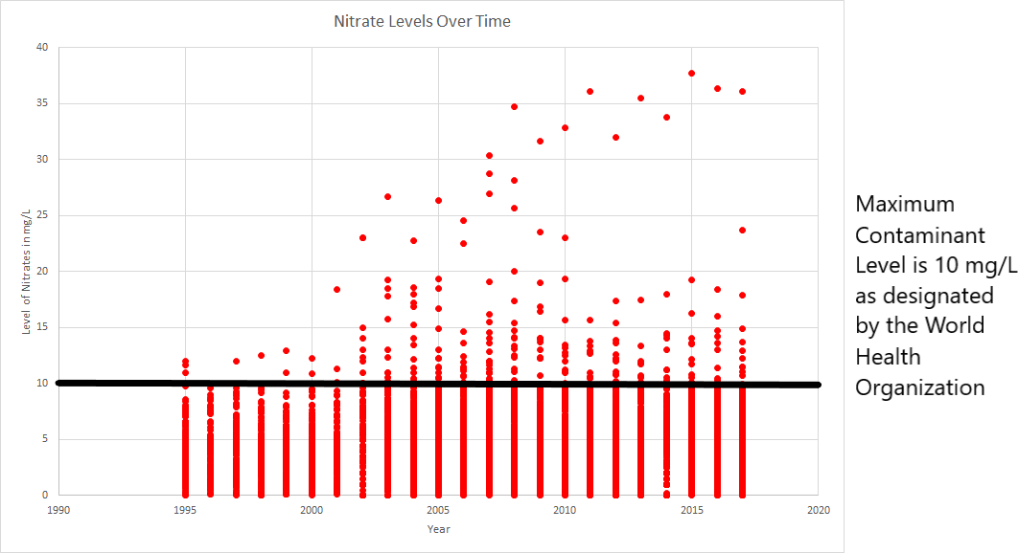

Figure 1. This graph is a compilation of all the nitrate data in Stanislaus County from GAMA starting in 1995 and ending in 2017.

To get a sense of demographic characteristics within areas with low and high nitrate levels, I chose twelve tracts that had incidences of high nitrate levels and twelve tracts that had low nitrate levels for each of the three years with demographic data. Of the twelve high and twelve low, four were further selected from each to create a small representative sample. Because of the large amount of data acquired on nitrates and the time constraint for this thesis, a small subsample was chosen. Four tracts that were chosen that had multiple nitrate samples tested that exceeded the MCL were census tracts 33, 36.03, 31, and 23.01. I wanted to compare these four tracts to census tracts that had incidences of low nitrate levels consistently over the three years observed. The four census tracts chosen with low levels of nitrates are 9.07, 5.04, 2.01, and 29.01. These four tracts had samples with nitrate levels that were generally within the 1-2 mg/L range, with a few exceptions. Although this is not completely representative of all the census tracts in Stanislaus County, it is a sample of those that typically fall in the high range of nitrate levels and those that fall in the low range of nitrates.

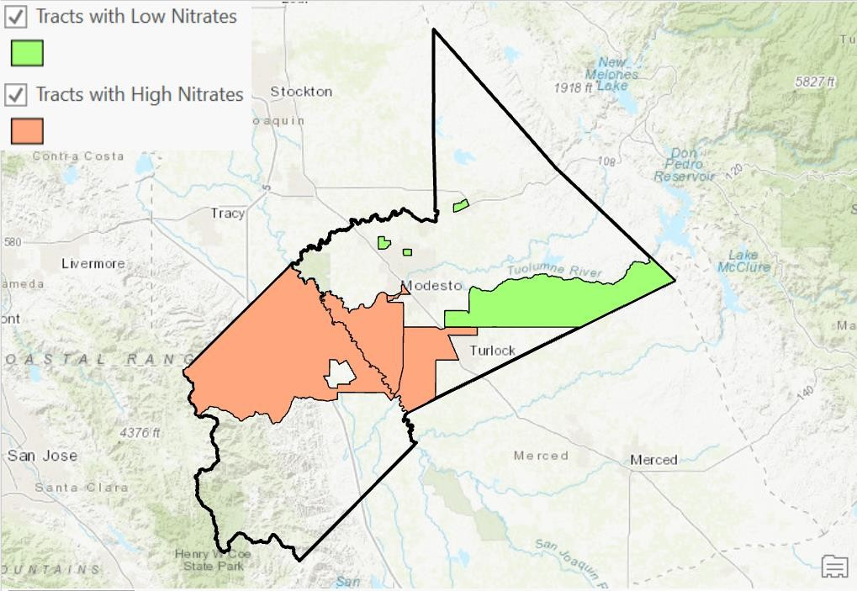

Figure 2. This map highlights the eight census tracts chosen as an area of focus. The tracts colored in red are those that have regularly high levels of nitrates and the tracts in green are those that have low levels of nitrates. The tracts with higher levels of nitrates were generally to the western and southern ends of the county, with one falling within Modesto city limits. The tracts with lower levels of nitrates were located more to the northern and eastern ends of the county, with two falling in Modesto city limits.

*Race Demographics*

Percent of minorities was the first variable observed for the eight census tracts. Federal government agencies, such as the EPA, have recognized that there are higher burdens of environmental exposure to ethnic minorities (Nweke et al., 2011).

Environmental exposure to pollutants for minorities in the United States have received minimal attention which is part of the reason why little actions have been taken. A large portion of the population in the county are Latinos and around 9.8 million Latino households in the United States that believe they have unsafe drinking water (Anque & Doval, 2014).

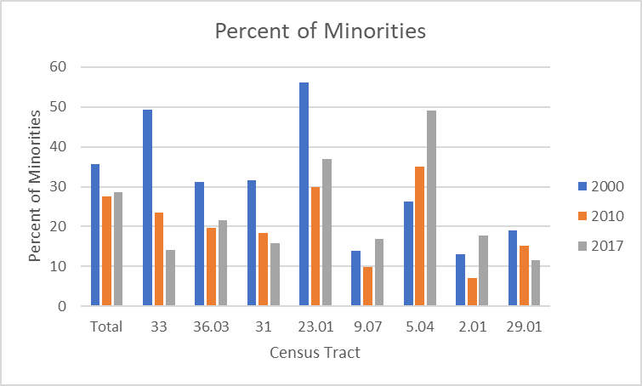

Figure 3. The percent of minorities were graphed. To the far left is the total for the county. The tracts with high nitrates are underlined in red to the left side of the graph and the tracts with low nitrates are underlined in green to the right side of the graph. The three years observed, 2000, 2010, and 2017 and shown in consecutive order above the corresponding census tract.

In 2000 and 2010, there are generally a larger percentage of minorities in the census tracts that have higher nitrates, except for census tract 5.04. There is a shift of a decrease in the percent of minorities in the higher nitrate census tracts. There is also a decrease over time in the percent of minorities for the total county which is due to either gentrification or minorities moving to more accessible and cheaper counties. There is an increase in the percent of minorities in the lower nitrate level census tracts, apart from

* 1. Overall, the populations most affected by high nitrate levels are ones that have a large percent of minorities, although that is decreasing in recent years.

*Income*

Rural areas with low-income communities also struggle with water issues (Pannu, 2012a), which is another main variable focused on. Along with ethnic minorities, low- income communities have also been recognized by federal government agencies to have higher burdens of environmental exposure, including poor water quality. (Nweke et al., 2011).

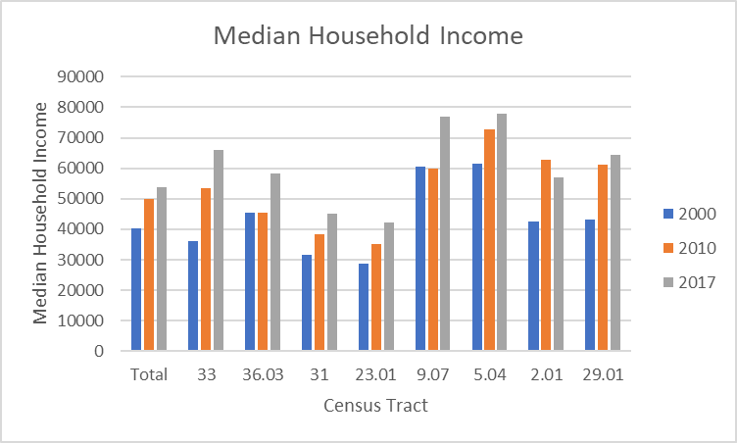

Figure 4. The median household income was graphed. To the far left is the total for the county. The tracts with high nitrates are underlined in red to the left side of the graph and the tracts with low nitrates are underlined in green to the right side of the graph. The three years observed, 2000, 2010, and 2017 and shown in consecutive order above the corresponding census tract.

The median household income for all census tracts and the total county have increased over the years. The low-income populations in Stanislaus County are affected by high nitrates more than populations that live in high-income areas.

Some individuals interviewed mentioned low-income populations having more inequities. This could be in the form of lack of access to care, or access to healthy food and water. The water provided to lower income communities is higher in nitrates than those living in higher income communities. These are just a few examples of the inequities faced by minorities in Stanislaus County.

*Education*

Education was another variable mapped, however data was only available for the years 2010 and 2017. Education and income are often linked, so I wanted to see if there was a correlation between populations with lower levels of education and high levels of nitrates. Education was also mentioned in the interview data. Some interviewees spoke about a lack of education for certain populations and those populations may be more at risk for environmental exposures.

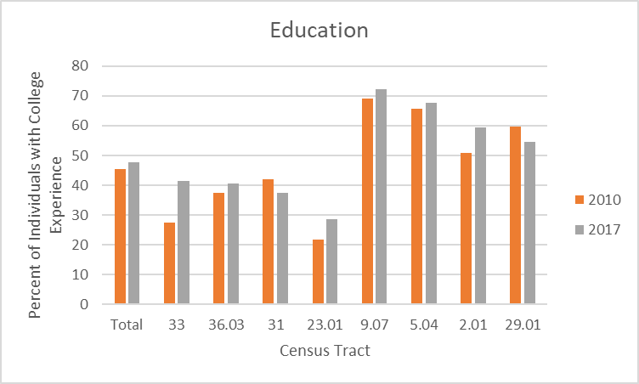

Figure 5. The percent of individuals with college experience were graphed. To the far left is the total for the county. The tracts with high nitrates are underlined in red to the left side of the graph and the tracts with low nitrates are underlined in green to the right side of the graph. Only data for 2010 and 2017 was available for this variable and the two years are listed in consecutive order above the corresponding tract.

The total for the county of those who have college experience is less than half the population. The tracts with higher levels of nitrates have less individuals who have attended or graduated college. It is less than the total for the county as well. On the other hand, the census tracts with low levels of nitrates have populations that contain more individuals that have college experience. This coincides with the income data. Those living in tracts with a low median income, also have more individuals that have had no college experience.

*Language*

Language is a barrier that was mentioned while doing interviews. Some individuals interviewed spoke about how access to care is limited for certain populations

in Stanislaus County, and one of the barriers may be language. There are populations of immigrants and/or non-English speakers in Stanislaus County, and I wanted to look for any trends that may occur with language and nitrate levels. Again, data was only available for the years 2010 and 2017.

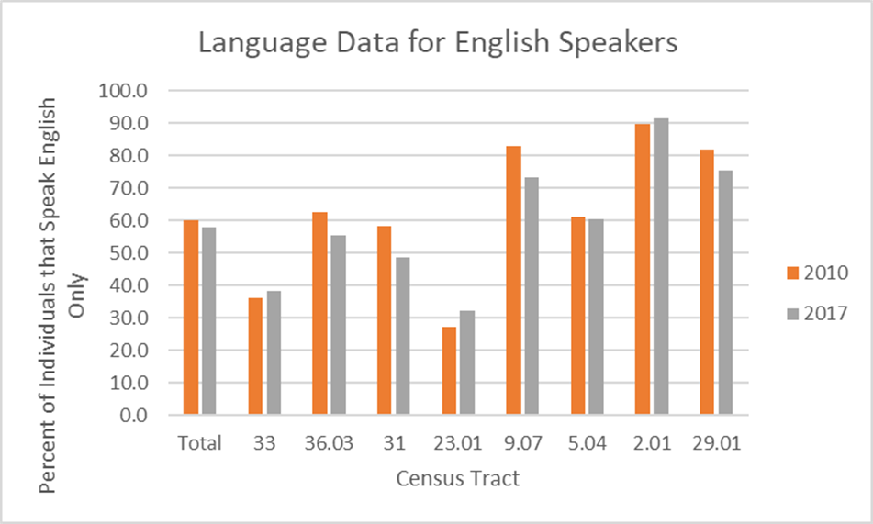

Figure 6. The percent of individuals that speak English only were graphed. To the far left is the total for the county. The tracts with high nitrates are underlined in red to the left side of the graph and the tracts with low nitrates are underlined in green to the right side of the graph. Only data for 2010 and 2017 was available for this variable and the two years are listed in consecutive order above the corresponding tract.

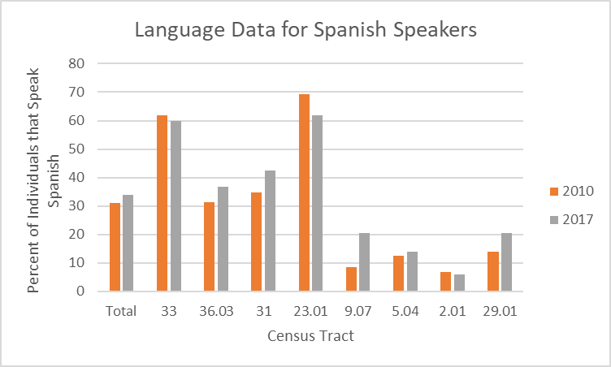

Figure 7. The percent of individuals that speak Spanish were graphed. To the far left is the total for the county. The tracts with high nitrates are underlined in red to the left side of the graph and the tracts with low nitrates are underlined in green to the right side of the graph. Only data for 2010 and 2017 was available for this variable and the two years are listed in consecutive order above the corresponding tract.

The census tracts with high levels of nitrates had lower levels of English speakers than the total for the county and for the tracts with low levels of nitrates. These tracts also had a higher percentage of Spanish speakers. The number of Spanish speakers in the tracts with low levels of nitrates is remarkably low. It is often below 20% while the number of English speakers is high, ranging from 60% to 90%. This may support the data from the interviews that language may be a barrier in advocating for safe drinking water. The areas with worse water may have populations who cannot communicate their needs or are even educated about dangers because of the language barrier that could exist.

*Land Use*

Stanislaus County is known for its rural land and agriculture and it is unclear how much agriculture affects the drinking water. When looking at the eight census tracts chosen, for all levels of nitrates measured, there was a split between where high nitrate levels occur.

Of the 16 samples with nitrate levels above the MCL from the eight census tracts within the three years studied, about 40% of the samples fall in an urban setting, 5% in barren lands, and 55% in agricultural areas. Of the 135 samples with nitrate levels below the MCL from the eight census tracts within the three years studied, 45% fall in an urban setting, 45% in agricultural areas, 5% in barren lands, and 5% in a forested area.

For areas where high nitrates arise, just over half of the incidences occur in an agricultural area. Almost half of them are in urban areas. Nitrate samples that are below the MCL were also observed and there is an almost even split between being primarily in urban and agriculture areas. There is no clear distinction if agriculture areas have worse water than urban areas.

*Dairy Farms*

Of the 16 samples with nitrate levels above the MCL for the eight census tracts within the three years studied, 50% of them fall within a mile of a dairy. Of the 135 samples with nitrate levels below the MCL for the eight census tracts within the three years studied, 22% of them fall within a mile of a dairy.

Dairies and agriculture are often to blame for water pollution. For the samples that were above the MCL, half of them did not fall within a mile of a dairy farm. For samples

below the MCL, most of them did not fall within a mile of a dairy. Based on this small sample, there is no clear distinction whether dairy farms influence high nitrates for the water data compiled over the three years. More extensive research should be done because as stated earlier, the water data does not include private water sources. Many dairy farms and agricultural areas are in rural areas that do not receive water from the cities or public sources. The data for water located near dairy farms may be skewed because water data may be missing for unincorporated areas which are generally in rural areas, possibly near dairy farms.

## Quantitative Analysis: Discussion

The occurrence of high nitrates in Stanislaus County occurs at 3.5% of tested sites, according to publicly sourced data from the U.S. Geological Survey. The percentage may be higher though with the addition of water sourced from private wells, however they are not under the same regulations.

From the data provided based on the comparative analysis of these eight census tracts chosen, areas with high nitrates generally have populations with more ethnic minorities, low-income, less education, and a greater chance of a language barrier due to the lower numbers of English speakers. It is unclear from the data whether land use or dairies have an influence on the high nitrates in the drinking water.

# CHAPTER 5: CONCLUSION

In this thesis, I conducted interviews with eleven people in three categories. I took a small sample of government officials, technical experts, and residents to view their opinions on important topics in Stanislaus County including health and access to water.

The biggest divergence across the groups was their sources of information, with government officials relying on their professional connections and stakeholders, technical experts relying on open sourced data, and residents receiving their sources of information from TV news channels. Another divergence that occurred was the breadth and depth of response to the questions from each group. The government officials focused mostly on air and water issues, funding, and education, having extensive answers to questions, but the responses were superficial and not in-depth. Technical experts covered a broader and more in-depth range of topics that went beyond broad statements such as there is water contamination. Some even discussed things such as water availability, history of toxins in the water table, and population data. The residents on the other hand, had extremely brief answers and did not seem knowledgeable about the topics discussed.

One general pattern that arose in response to questions was convergence about lack of representation or access to health care in rural areas. The lack of access to healthcare was brought up several times by multiple participants in the form of lack of physicians, or finances to pay for treatments. Another area of convergence between all three groups is that rural areas do not get as much representation. The poor water quality in Stanislaus County and the inability to consume the water was discussed among the three different groups as well.

Although many participants could name issues with the healthcare system, the poor water quality in rural areas, and underrepresentation of disadvantaged communities within the government, no solutions were explained by participants. The few solutions that were given focused on reactive measures that should be taken after negative health or poor water effects occur. The answers participants gave were focused on gaps in the healthcare system instead of preventative measures that could be taken to avert any inequities. In further studies, more participants from each of the three groups should be interviewed to not only understand their perspectives and opinions, but to collectively work towards a viable solution to improve water quality in Stanislaus County.

Safe drinking water and political representation are both lacking in rural areas which is what I expected. The population centers of the county are in the urban areas which is why there are more regulations and funding to provide clean water and better living conditions. Many interviewees mentioned that more should be done for these communities but very few people said how that could be done.

While the federal government, especially the EPA, plays an important role in ensuring the safety of drinking water, it is unfair to solely blame federal government agencies. State and local government agencies need to represent these disadvantaged communities from risks, including environmental pollution and unsafe drinking water. State and local agencies have the jurisdiction to enforce regulations. With that said, environmental risks are due to many private sector agencies and corporations which need to take responsibility for the negative actions they are executing (Konisky, 2016). State and local agencies often do not have the funds or means to provide jurisdiction for every

community. Many local government officials knew that inequities existed and there are disparities, however they do not have the tools or sources to inhibit a change.

It is often difficult for disadvantaged communities to work collectively and with government officials on environmental justice issues because of their lack of resources. Developing solutions within these communities requires understanding the problem and having access to grants and individuals that are capable of making change (Balazs & Lubell, 2014). This is an issue because most communities of color experience lower levels of education and wealth. This puts them into a position of less power compared to those living in wealthier areas (Cushing et al., 2015).

Analysis of distinct and unsettling patterns between water quality and demographics were conducted in this study for Stanislaus County, and a sample size of eight census tracts was used as a representative sample. Two treatment groups were used: four census tracts with regularly occurring high levels of nitrates over the years studied were compared to four census tracts that regularly had low levels of nitrates over the years studied. Based on the comparison of the two treatment groups, areas with high levels of nitrates generally had a higher percentage of minorities, lower median income, a lower percentage of English speakers, and a lower percentage of individuals that have college experience. Compared to urban areas, the incidences of high nitrates occurring in rural areas was found in this study to be about equal to the occurrence of nitrates near dairy farms.

Poor water quality occurring in areas with certain demographics should further be studied. As Figure 1 suggests, nitrates over the MCL are increasing over time and with an absence of solutions from government officials and experts, they can be expected to

continue to increase. This will further intensify the issue and likely harm those in disadvantaged communities even more. Analysis of the entire county, or for other years not looked at, would allow for a more comprehensive study.

There are various inequities that occur in Stanislaus County as recognized by different individuals studying this area and those living there, and as can be seen in my spatial analysis of the county using GIS. Government officials working to protect residents in Stanislaus County and technical experts studying the health of disadvantaged communities and water quality in this county have acknowledged inequities in water quality, access to care, education, and food security. Both groups have also acknowledged less political representation compared to larger urban areas. There is also a general trend as can be seen in a spatial analysis that populations with lower incomes, a smaller number of English speakers, and less education are exposed to higher nitrates in their water. Although many inequities are faced by these communities, an often overlooked one is high nitrates in drinking water. Nitrates are a large issue in Stanislaus County because of the large amount of agricultural practices that spread nitrates into waterways. These dangerous levels of nitrates can cause an array of health disorders in populations exposed to them.

Reducing the nitrates in water for disadvantaged communities would just be one step towards closing the inequity gap in Stanislaus County. This reduction would also potentially reduce the health-related illnesses that can occur with toxins in the water to improve the health of populations living in disadvantaged communities. However, a solution is far from within reach. Most experts and government officials interviewed had no response when it came to forming a solution to this problem and other environmental

health related issues. Often a solution is out of reach for local communities and greater federal or state funding and assistance is needed to find a long-term solution to these large issues.

With the lack of data that exists, the number of individuals harmed by environmental inequities is underrepresented. Unincorporated communities are ones not recognized by the government and are often not included within many state policies and actions. Not only do these populations need assistance, but they need representation from larger entities. With just nitrate data alone, the high levels are vastly underestimated because rural areas with private wells are not under the same regulations. As of now, it is unknown how many persons are affected by environmental hazards and that number may continue to grow as these populations continue to get overlooked.

There appears to be a link between poor health trends and environmental pollution. There have been studies done that state populations that experience health inequities are also ones that live in areas overburdened with environmental pollution (Nweke & Lee, 2011). These communities can have health issues like asthma, preterm births, and morbidity and mortality from cardiovascular disease (Nweke et al., 2011). These health problems are prevalent in Stanislaus County as stated by some interviewed individuals. On top of poor health trends found in these areas, it is common to have, “poor housing conditions, high crime rates, lack of access to medical care, failing education systems, lack of access to health foods, and higher rates for debilitating chronic conditions such as cardiovascular disease” (Nweke & Lee, 2011).

To save the health of individuals living in Stanislaus County, and other areas suffering from poor water quality, steps need to be taken to protect these

underrepresented communities. There does appear to be a strong correlation between high nitrate levels within Stanislaus County’s communities of color, low education and income, and non-English speaking residents. According to previous studies and interviews conducted, these areas are also less represented and have other struggles such as access to healthcare and education compared to other communities. These disparities need to be resolved and addressed and many governmental entities appear to not want the responsibility. Awareness needs to be brought to everyone to ensure this environmental injustice is answered. Citizen engagement should be encouraged and available to empower residents in pushing government leaders to make larger changes (McDonald & Jones, 2018). Without action taken, this problem of poor water quality will continue to persist and affect marginalized communities.

# Bibliography

Ahern, K. (2012). Informed consent: Are researchers accurately representing risks and benefits? *Scandinavian Journal of Caring Sciences*, *26*(4), 671–678. https://doi.org/10.1111/j.1471-6712.2012.00978.x

Alkon, A. H., Cortez, M., & Sze, J. (2013). What is in a name? Language, framing and environmental justice activism in California’s Central Valley. *Local Environment*, *18*(10), 1167–1183. https://doi.org/10.1080/13549839.2013.788483

Anque, D. A., & Doval, C. N. (2014). Latinos Seek Environmental Justice and Public Discourse for Underserved Communities in the United States. *Harvard Journal of Hispanic Policy*, *26*, 13.

Balazs, Carolina L., & Lubell, M. (2014). Social learning in an environmental justice context: A case study of integrated regional water management. *Water Policy*, *16*, 97–120. https://doi.org/10.2166/wp.2014.101

Balazs, Carolina Laurie. (2011). Just Water? Social Disparities and Drinking Water Quality in California’s San Joaquin Valley. *ProQuest Dissertations and Theses*, 142. Retrieved from <http://sfx.scholarsportal.info/guelph/docview/1526000633?accountid=11233%5Cnht> tp://sfx.scholarsportal.info/guelph?url_ver=Z39.88- 2004&rft_val_fmt=info:ofi/fmt:kev:mtx:dissertation&genre=dissertations+%26+the ses&sid=ProQ:ProQuest+Dissertations+%26+Theses+A

Bhowmik, A. K., Alamdar, A., Katsoyiannis, I., Shen, H., Ali, N., Ali, S. M., … Eqani, S.

A. M. A. S. (2015). Mapping human health risks from exposure to trace metal

contamination of drinking water sources in Pakistan. *Science of the Total Environment*, *538*, 306–316. https://doi.org/10.1016/j.scitotenv.2015.08.069

Brouwer Burg, M. (2017). It must be right, GIS told me so! Questioning the infallibility of GIS as a methodological tool. *Journal of Archaeological Science*, *84*, 115–120. https://doi.org/10.1016/j.jas.2017.05.010

Burkart, M. R., & Stoner, J. D. (2007). Nitrate in aquifers beneath agricultural systems.

*Water Science and Technology*, *56*(1), 59–69. https://doi.org/10.2166/wst.2007.436

Chakraborty, J., Maantay, J. A., & Brender, J. D. (2011). Disproportionate proximity to environmental health hazards: Methods, models, and measurement. *American Journal of Public Health*, *101*(SUPPL. 1), 27–37. https://doi.org/10.2105/AJPH.2010.300109

Chartres, N., Bero, L. A., & Norris, S. L. (2019). A review of methods used for hazard identification and risk assessment of environmental hazards. *Environment International*, *123*(October 2018), 231–239. https://doi.org/10.1016/j.envint.2018.11.060

Cushing, L., Faust, J., August, L. M., Cendak, R., Wieland, W., & Alexeeff, G. (2015). Racial/ethnic disparities in cumulative environmental health impacts in California: Evidence from a statewide environmental justice screening tool (CalEnviroScreen 1.1). *American Journal of Public Health*, *105*(11), 2341–2348. https://doi.org/10.2105/AJPH.2015.302643

Environmental Protection Agency. (2006). *EPA Needs to Perform Environmental Justice Reviews* (Vol. 24).

Fisher, J. B., Kelly, M., & Romm, J. (2006). Scales of environmental justice: Combining GIS and spatial analysis for air toxics in West Oakland, California. *Health and Place*, *12*(4), 701–714. https://doi.org/10.1016/j.healthplace.2005.09.005

Flegal, C., Rice, S., Mann, J., & Tran, J. (2013). *California Unincorporated: Mapping Disadvantaged Communities in the San Joaquin Valley*. 48. Retrieved from [www.policylink.org.](http://www.policylink.org/)

Gifford, M., Chester, M., Hristovski, K., & Westerhoff, P. (2018). Human health tradeoffs in wellhead drinking water treatment: Comparing exposure reduction to embedded life cycle risks. *Water Research*, *128*, 246–254. https://doi.org/10.1016/j.watres.2017.10.014

Higgs, G., & Gould, M. (2001). Is there a role for GIS in the “new NHS”? *Health and Place*, *7*(3), 247–259. https://doi.org/10.1016/S1353-8292(01)00014-4

Huang, G., & London, J. K. (2012). *Cumulative Environmental Vulnerability and Environmental Justice in California ’ s San Joaquin Valley*. 1593–1608. https://doi.org/10.3390/ijerph9051593

Hunter, P. R., Macdonald, A. M., & Carter, R. C. (2010). Policy Forum Water Supply and Health. *PLoS Medicine*, *7*(11). https://doi.org/10.1371/journal.pmed.1000361

Konisky, D. M. (2016). Environmental Justice Delayed: Failed Promises, Hope for the Future. *Environment*, *58*(2), 4–15.

Langholz, J., & DePaolis, F. (2018). Stanislaus County Agriculture d. *Economic Contributions of Stanislaus County Agriculture*, 1–18.

Lewis, B. (2012). *Human Rights and Environmental Wrongs : Achieving Environmental Justice through Human Rights Law*. *1*(1), 65–73.

London, J. K., Zagofsky, T. M., Huang, G., & Saklar, J. (2011). Collaboration, Participation and Technology. *Gateways: International Journal of Community Research & Engagement*, *4*(1), 12–30. Retrieved from https://search.ebscohost.com/login.aspx?direct=true&db=aph&AN=70138700&site

=ehost-live&scope=site

Maantay, J. (2016). Mapping Environmental Injustices: Pitfalls and Potential of Geographic Information Systems in Assessing Environmental Health and Equity. *Environmental Health Perspectives*, *110*, 161–171.

Matthews, G. A. (1998). Water quality in the San Joaquin-Tulare Basins, California, 1992–95. In *Crop Protection* (Vol. 17). https://doi.org/10.1016/s0261- 2194(98)00039-8

McDonald, Y. J., & Jones, N. E. (2018). Drinking water violations and environmental justice in the United States, 2011-2015. *American Journal of Public Health*, *108*(10), 1401–1407. https://doi.org/10.2105/AJPH.2018.304621

Nelson, K. S., Abkowitz, M. D., & Camp, J. V. (2015). A method for creating high resolution maps of social vulnerability in the context of environmental hazards. *Applied Geography*, *63*, 89–100. https://doi.org/10.1016/j.apgeog.2015.06.011

Nweke, O. C., & Lee, C. (2011). Achieving environmental justice: Perspectives on the path forward through collective action to eliminate health disparities. *American Journal of Public Health*, *101*(SUPPL. 1), 6–9.

https://doi.org/10.2105/AJPH.2011.300377

Nweke, O. C., Payne-Sturges, D., Garcia, L., Lee, C., Zenick, H., Grevatt, P., … Dankwa-Mullan, I. (2011). Symposium on integrating the science of environmental justice into decision-making at the Environmental Protection Agency: An overview. *American Journal of Public Health*, *101*(SUPPL. 1), 19–27. https://doi.org/10.2105/AJPH.2011.300368

Pannu, C. (2012a). Drinking water and exclusion: A case study from California’s Central Valley. *California Law Review*, *100*(1), 223–268.

Pannu, C. (2012b). Drinking water and exclusion: A case study from California’s Central Valley. *California Law Review*, *100*(1), 223–268. https://doi.org/10.15779/Z38B133

Pawar, M. (2013). Water Insecurity: A Case for Social Policy Action by Social Workers.

*Australian Social Work*, *66*(2), 248–260. https://doi.org/10.1080/0312407X.2013.777969

Pellow, D. N. (2000a). Environmental Inequality Formation: Toward a Theory of Environmental Injustice. *American Behavioral Scientist*, *43*(4), 581–601. https://doi.org/10.1177/0002764200043004004

Pellow, D. N. (2000b). Environmental Inequality Formation: Toward a Theory of Environmental Injustice. *American Behavioral Scientist*, *43*(4), 581–601. https://doi.org/10.1177/0002764200043004004

Schultze, U., & Avital, M. (2011). Designing interviews to generate rich data for information systems research. *Information and Organization*, *21*(1), 1–16.

https://doi.org/10.1016/j.infoandorg.2010.11.001

Shepherd, A., Jepson, R., Watterson, A., & Evans, J. M. M. (2012). Risk Perceptions of Environmental Hazards and Human Reproduction: A Community-Based Survey. *ISRN Public Health*, *2012*, 1–9. https://doi.org/10.5402/2012/748080

Strelau, L., & Köckler, H. (2016). “It’s optional, not mandatory”: Environmental justice in local environmental agencies in Germany. *Local Environment*, *21*(10), 1215– 1229. https://doi.org/10.1080/13549839.2015.1084278

Suthar, S. (2011). Contaminated drinking water and rural health perspectives in Rajasthan, India: An overview of recent case studies. *Environmental Monitoring and Assessment*, *173*(1–4), 837–849. https://doi.org/10.1007/s10661-010-1427-2

van der Schans, M. L., Harter, T., Leijnse, A., Mathews, M. C., & Meyer, R. D. (2009). Characterizing sources of nitrate leaching from an irrigated dairy farm in Merced County, California. *Journal of Contaminant Hydrology*, *110*(1–2), 9–21. https://doi.org/10.1016/j.jconhyd.2009.06.002

Ward, M. H., deKok, T. M., Levallois, P., Brender, J., Gulis, G., Nolan, B. T., & VanDerslice, J. (2005a). Workgroup report: Drinking-water nitrate and health - Recent findings and research needs. *Environmental Health Perspectives*, *113*(11), 1607–1614. https://doi.org/10.1289/ehp.8043

Ward, M. H., deKok, T. M., Levallois, P., Brender, J., Gulis, G., Nolan, B. T., & VanDerslice, J. (2005b). Workgroup report: Drinking-water nitrate and health - Recent findings and research needs. *Environmental Health Perspectives*, *113*(11), 1607–1614. https://doi.org/10.1289/ehp.8043

Ward, M. H., Jones, R. R., Brender, J. D., de Kok, T. M., Weyer, P. J., Nolan, B. T., … van Breda, S. G. (2018). Drinking water nitrate and human health: An updated review. *International Journal of Environmental Research and Public Health*, *15*(7), 1–31. https://doi.org/10.3390/ijerph15071557

World Health Organization. (2008). *Guidelines for Drinking-water Quality* (Vol. 1).

Wu, I. S., & Savi, B. (2010). How to persuade government officials to grant interviews and share information for your research. *PS - Political Science and Politics*, *43*(4), 721–723. https://doi.org/10.1017/S104909651000137X

# Appendix A

