Request to Present Thesis Research

Graduate Program on the Environment The Evergreen State College

Student Name: Jesse Dotson

Reader Name: Kathleen Saul

Thesis Title: Remember Remember; Hero’s Journey Through The Decomposing Fields of Human Ecology.

Students enrolled in the thesis workshop or with approved research extension to complete their thesis work must receive approval from their thesis reader to make a public presentation of their work.

To present research, the reader must have made comments and requests for change on a complete first draft.

Student Approval:

*I have submitted a complete first draft of my thesis. I am ready to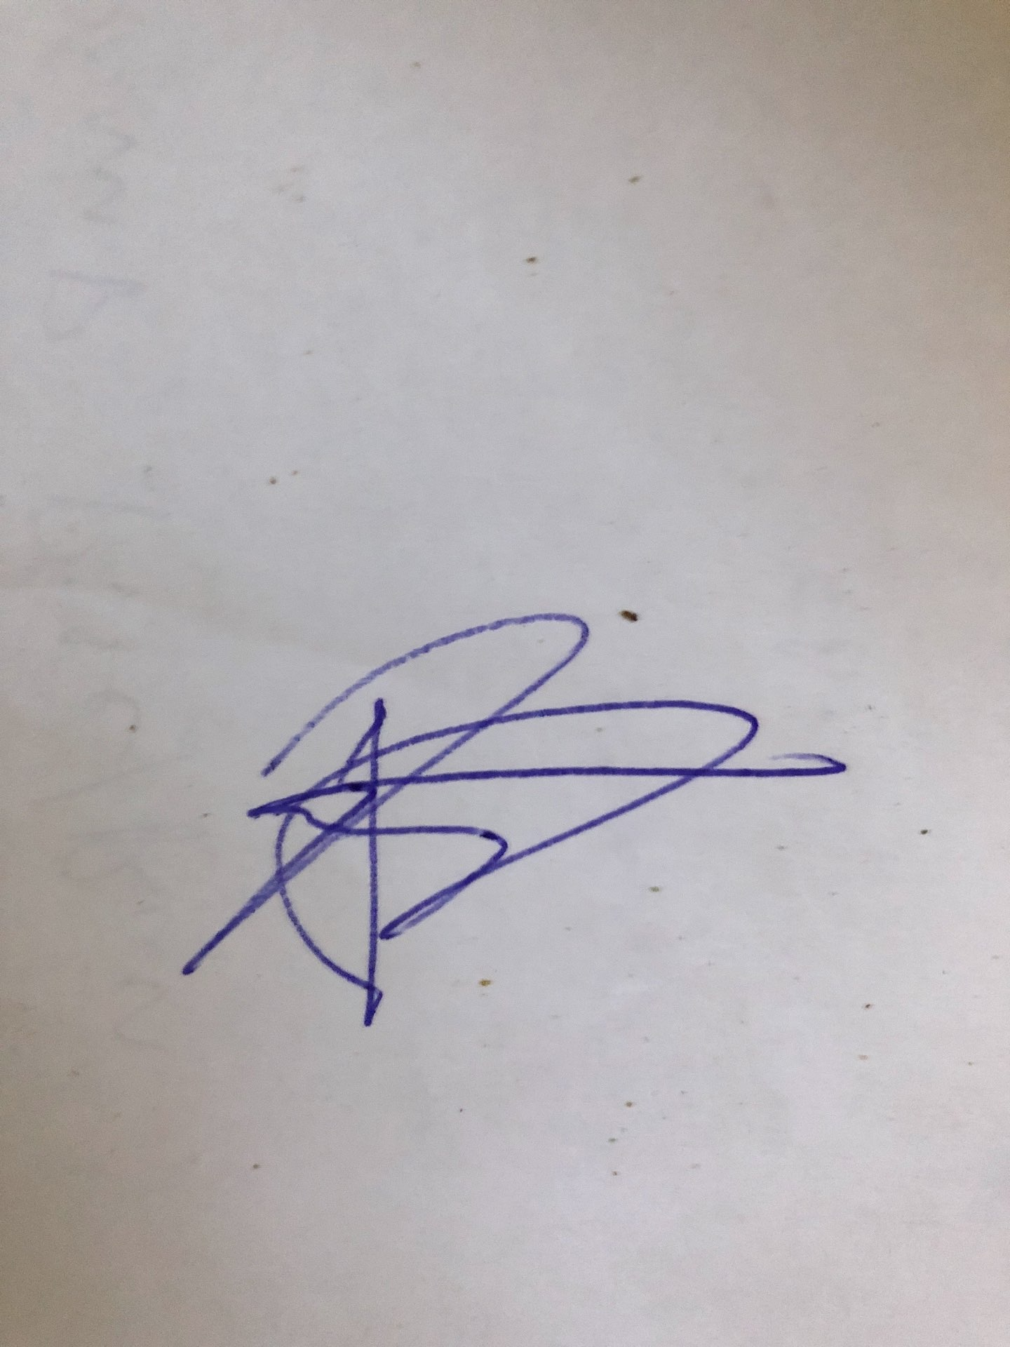 present my thesis work.*

*Student Signature: Jesse Dotson*

*Date: 11.1.20*

Reader Approval:

*The above named student has received comments based on my review of a complete first draft. I approve the student’s work and support a public presentation of the research.*

*Reader Signature:*

*Date:*