Measuring Interactions in Nature Play Activities at the Hands On Children’s Museum

By
Anastatia Zita

A Thesis
Submitted in partial fulfillment
Of the requirements for the degree
Master of Environmental Studies
The Evergreen State College
June 2022

©2022 by Anastatia Zita. All rights reserved.

This Thesis for the Master of Environmental Studies Degree
By
Anastatia Zita
Has been approved for
The Evergreen State College
By

___________________________
Kathleen Saul
Member of Faculty

June 10, 2022
_____________________
Date

ABSTRACT
Measuring Interactions in Nature Play Activities at the Hands On Children’s Museum
Anastatia Zita
The purpose of a children’s museum is to engage and excite children into learning and exploring. Many museums bring knowledge and experiences to children who would not have these opportunities otherwise. At the Hands On Children’s Museum they strive to bring exciting science, technology, engineering, art, and mathematics (STEAM) learning to children through their Nature Play activities. Through experiential play there is hope to instill environmental awareness and environmental stewardship in the next generation. This thesis shows evidence that the Hands On Children’s Museum’s Nature Play activities have the potential to create a positive, lasting effect on children later in life that could lead to environmental citizenship.

Table of Contents
Introduction 1
The Purpose of Children’s Museums 3
Impacts of Experiential Environmental Learning 4
Developing Environmental Stewardship 6
Methodology 9
Engagement Behaviors 10
Intention and Initiative Behaviors 10
Development of Understanding Behaviors 10
Social Scaffolding Behaviors 11
Results & Discussion 14
Engagement Behavior Results 17
Intention & Initiative Behaviors Results 18
Social Scaffolding Behaviors Results 19
Development of Understanding Behaviors Results 20
Conclusion 22
Future Research 23
Bibliography 24

List of Figures
Figure 1 Observational Form used in data collection 13
Figure 2 Visual percentage break down of Engagement Behaviors observed 17
Figure 3 Visual percentage break down of Intention & Initiative Behaviors observed 18
Figure 4 Visual percentage break down of Social Scaffolding Behaviors observed 19
Figure 5 Visual percentage break down of Development of Understanding Behaviors observed 20

List of Tables
Table 1 Final results from observation in the museum 14
Table 2 Nature of Caregiver Involvement 15
Table 3 Who initiates child's involvement? 15
Table 4 Age of Children Engaging in Activity 15

Acknowledgements
First, I would like to thank my thesis reader, Kathleen Saul, for her support and guidance through the thesis process as well as throughout the two years in the MES program. Your kindness and positive attitude made the entire process significantly less stressful.

I would also like to thank the Hands On Children’s Museum for allowing me to conduct my observations and research at the museum. Thank you to my supervisor, coworkers, and friends for allowing me time to collect my data as well as being understanding, flexible and most of all supportive while getting this degree.

I’d like to thank all of the teachers and educators throughout my life Mrs. Robin Gorenc, Mr. Brian Ducey, Professor David Gordon, and Chris Lanza. You have all inspired me and made me want to give the wonderful gift of knowledge to the next generation. Mine is only one of the many lives that you have touched and inspired.

Eliah – thank you for always believing in me, supporting me through every new adventure I embark on and for reminding me to take a break from work and my thesis to play with Koga and to just breathe once in a while. I appreciate everything you do for me on a daily basis.

A huge thank you to my family for all the love and support that they give me every day. Auntie Goldie – my fellow hobbit, thank you for always making me laugh, taking me on adventures and allowing me to play with your hounds to de-stress and unplug. Grandma Zenaida and Grumpy – thank you for all your endless love and prayers and for always making sure my heart and stomach are full.

To my younger brother, Tommy, you have always been my guiding light and my motivation to be better, to be smarter, to be stronger and to be an older sister that you can look up to and be proud of.

And last, but certainly not least, I’d like to thank my parents. My Mom, for instilling this love of nature in me and making me appreciate all the Earth has to offer. Thank you for always leading by example and giving me the confidence in myself to accomplish anything I put my mind to. And my Dad, for always making me laugh and believing in me. You have always made me think of the positives and have given me my sense of humor when times get rough. I love and appreciate you both so much!

I certainly would not be the person I am without you all.

Introduction
As a young child, I remember visiting different science and children’s museums for school field trips or even just fun family trips. Many of those exhibits exposed me to new and exciting science and technology that I would not have been exposed to on my own. From getting my first glimpse of space at the Liberty Science Center’s planetarium in New Jersey, to being able to touch and learn about horseshoe crabs at the Port Discovery Children’s Museum in Maryland, two decades later I still have vivid, positive memories of the different museums I have visited. At the time, I did not realize I was learning, I was simply exploring and playing within the museum. After visiting, I would come away with new interests and more questions about what I had seen and experienced at the museums. I would take out library books on the marine animals I saw, or magazines on new stars that were being discovered in our galaxy. Much of what I experienced and saw in those museums growing up has shaped what I am interested to this day.
The purpose of this thesis is to explore how children interact with hands on exploratory and experiential learning in science, technology, engineering, arts, and mathematics (STEAM) activities in the Hands On Children’s Museum. These activities have been classified as “Nature Play” activities by the museum. First, I will explain the differences between a children’s museum and a traditional museum. Second, we will investigate the value of experiential and hands on learning in children. Then finally we will look at how experiential and hands on learning can affect future scientific literacy and create lasting relationships with the natural world.
In this thesis I will address the questions, ‘How are the children coming into the Hands On Children’s Museum interacting and learning from the different Nature Play activities’? and ‘Will these experiences have the potential to have a positive, lasting effect on the children later in life’?

The Purpose of Children’s Museums
Although there are many different definitions of what a ‘children’s museum’ is, most experts agree that it is not a “traditional ‘hands-off, don’t touch’ museum” (Mayfield, 2005, p. 181). Mayfield defines children’s museums as “user friendly, interactive, hands-on, attractive, non-threatening and stimulating places designed and developed for children” (Mayfield, 2005, p.181). The types of hands-on learning that is offered at children’s museums makes this type of learning unique and special. Rix and McSorley (1999) state, “researchers and educationists have reported a strong correlation between not only hands-on activities but also science-based presentations or museum exhibits and positive attitudes in students”. In a more traditional museum, like the Museum of Natural History or the Louvre, it is common to find the paintings and exhibits far from arms reach surrounded by plexiglass or roped off to detour visitors from touching the collections. The atmosphere in these traditional museums is usually that of a library. In contrast, a children’s museum decorates its exhibits in fun, enticing colors and textures that excite and invite the visitors to touch and explore with excited squeals and giggles heard all throughout.

Impacts of Experiential Environmental Learning

Dunkley (2016) explored how eco-attractions can help teach environmental education. Dunkley (2016) examined three study cohorts where each cohort attended a two-day environmental education program within a different eco-attraction. The first cohort attended a program at a botanical garden. The second cohort attended a program at a country estate and the third attended a program at a nature reserve. After the two-day program, the students were interviewed about what they thought about the program as a whole and what they had learned from the program. Dunkley noted that many students found that they had a new appreciation for nature and its significance. Her study “support[ed] arguments that suggest gardens and nature reserves offer intrinsically valuable opportunities to reconnect with the natural world” (p. 219). In addition, Dunkley stated,
For some students who participated in the program, a novel appreciation of plant roles was coupled with a sense of awe inspired by nature and greater respect for the non- human. For example, 14-year-old John from Sussex felt the course had “opened his eyes” to the role of plants in sustaining human life: “I didn't realize that everything came from plants that was really quite an amazing thing” (Dunkley, 2016, p. 217).

Dunkley explained that John was motivated to learn more about plants and even wanted to share his newfound knowledge with his peers who were not in the program. She also quoted a student, Helen, stating that she thought “her whole [school] year [group] should take part... [in the program because] … when you get there [the nature reserve], you just get a complete change of mind” (Dunkley, 2016). The program had a great impact on Helen’s daily life; she was noted as having engaged her friends and family in conversations about the themes discussed during her visit to the eco-attraction (Dunkley, 2016). Dunkley concluded that her findings provided an in-depth insight into how young people from different backgrounds responded to various eco-attractions and environmental education programs. They enabled students to see and sense ecological issues through experiences. She also argued that the study demonstrated how eco-attractions can cultivate ecological citizenship.
Liddicoat and Krasny (2014) collected data from the North Cascades Institute’s Mountain School and the Teton Science Schools. The North Cascades School went on a three-day camping experience within the North Cascades National Park with a goal to “foster an appreciation and knowledge of the local flora and fauna... as well as to inspire stewardship of the rivers and forests of the Pacific Northwest and a commitment to environmentally friendly behaviors” (Liddicoat & Krasny, 2014, p. 183). The Teton Science School was two, three-day experiences where the students visited the Grand Teton National Park and performed inquiry-based scientific investigations while practicing environmentally friendly behaviors. These students also learned field experiences and gained skills in low-impact outdoor recreation such as cross-country skiing and snowshoeing (Liddicoat & Krasny, 2014). After these experiences concluded, the students were interviewed about the time they spent on these excursions five years later in order to study the impact these experiences had on the students. After the five-year period, the students had retained positive memories about the excursion that had the students fondly looking back on the experience, and some stated that they believe that they had a stronger connection to nature because of it.
While these two studies are excellent representations of the correlation between experiential environmental learning and ecological citizenship, they involve students who already have a higher interest in biology and the sciences. In my thesis, I will be observing children who have come to the Hands On Children’s Museum to play, therefore, observing a wider range of children who might not have an prior interest in nature and/or the environment.

Developing Environmental Stewardship
While children need to be learning about the environment and nature through the types of programs outlined above, it is just as beneficial for the children to be playing and experiencing nature without being in a formal learning setting. Learning through play and exploration in an outdoor nature setting has been documented as helping to develop a child’s relationship to the natural world. In their study of eleven preschool students, McCain and Vandermaas-Peeler (2016) have said their findings “indicated that while outdoors, children showed self-awareness with regard to environmental features, generated complex scientific theories around discoveries, and engaged in environmental stewardship” (p. 37). Since the children coming to the Hands On Children’s Museum are typically younger than 13, it is more beneficial to observe their levels of play as it relates to environmental stewardship as opposed to the more complex theory generation.
It is through play that children begin to understand the world around them. Sobel (1995) theorized that it is important for children to create lasting relationships with the natural world before they begin to formally understand it and before they can take on stewardship roles themselves. Play as a form of bonding with nature can then be the steppingstone by which a child is able to form a more scientific foundation and even a certain level of care and empathy for the environment around them.
In their research, McCain and Vandermaas-Peeler (2016) documented 131 acts of stewardship during a 16-day stay at a river. These acts of stewardship were placed under six different categories: Picking up trash, Leaving plants/animals alone, Verbally valuing nature, Photo documentation, Mindful looking/listening, and Other. In their concluding thoughts they stated,
The results of the present study indicated that children articulated a developing awareness of their selves in relation to the natural world and exhibited stewardship verbally and through actions. In addition, these complex interactions with nature occurred in a context of consistent teacher guidance, interaction with mixed-age peers, and an appreciation for the environment as third teacher (McCain & Vandermaas-Peeler, 2016, p. 51).

While it is evident that a child’s relationship to the natural world is greatly affected by their earlier experiences in nature, it is difficult to determine precisely which particular interactions will create a more mindful and environmentally conscious individual. With that being said, there are forms of play and verbal acts that can be observed that have the potential to create environmental stewardship within a child. For example, during my observations at the museum, I had often heard children describing natural materials like flowers and leaves to be “beautiful” or “pretty”. These thoughts and verbal announcements show a child’s appreciation for the qualities of nature and natural materials.
When looking at how children learn through play, a common theory is through tinkering and making. Tinkering encompasses a child’s act of playful and experimental engagement while interacting with their surroundings. The maker aspect is focused on experimental learning, creating goals, and exploring new ideas. I chose to use this theory as a way to assess how the children are learning.
There are four types of learning indicators that showcase children developing relationships with and understating the natural world:
1. Engagement behaviors - positive experiences in outdoor setting or with natural materials,
2. Intention and Initiative Behaviors – expressing interest and finding inspiration from nature,
3. Development of Understanding Behaviors - appreciation for the qualities of nature and natural objects, and
4. Social Scaffolding Behaviors - being exposed to adults and peers reenforcing exploration and play in nature (Bevan et al., 2017)(Loebach & Cox, 2020)(Roskos & Christie, 2002).
In the next section, I will describe the four types of indicators that I used when observing children developing relationships with and understanding the natural world.

Methodology
As indicated above, this thesis research relies on observation to collect data at the Hands On Children’s Museum. In Observing Children: Ideas for Teachers, Phinney (1982) provided a list of useful guidelines when using the observational technique. Phinney outlined the following:
- Describe the setting, the behavior of the child (including how she or he does something), and the behavior of others who interact with the child.
- Report each event in a separate sentence and report all events in chronological order.
- Describe what the child does, rather than what the child does not do.
- Separate all interpretative comments or inferences from the recoded observations, for example, by parenthesis or the use of a separate column.
(Phinney, 1982, p. 17-18)
I used Phinney’s list of guidelines when collecting my data. I made sure that the form I used for recording the data had a section that allowed me to describe where in the museum the Nature Play activity was being held, and other sections for describing what the child did instead of what he/she did not do. I also included a section for general comments. I used a separate sheet for set of observations.
Much of the framework used in this research to categorize the child’s behaviors stemmed from the research created by educators from the Exploratorium Tinkering Studio and the Lighthouse Community Carter School. These educators have been creating and studying Maker and Tinkering programs that are being used and adapted by many after-school programs as well as children’s museums. This framework is also used in creating many of the Hands On Children’s Museum’s activities, as well as the Nature Play activities. Within their research, Bevan et al. (2017) identified four learning dimensions which are included in the data collection form. The four learning dimensions are as follows: Engagement, Initiative and Intentionality, Conceptual Understanding, and Social Scaffolding (Bevan et al., 2017, p. 3). The actions/behaviors observed during my research were categorized under these four learning dimensions in order to identify how the observed child was interacting with the Nature Play activity.

Engagement Behaviors

Under Engagement, Bevan et al. (2017) listed indicators for the ways students exhibit this behavior: exploring materials, repetition and “re-mixing” of ideas/projects, concentration on activity, and a show of emotion towards the activity (Bevan et al., 2017). Children would exhibit these behaviors when exploring their natural surroundings as well as playing with the natural materials provided at the Nature Play activity.

Intention and Initiative Behaviors
Bevan et al. (2017) stated,
[Initiative and Intentionality] refers to the ways in which [children] engage with the activity, develop their own ideas or goals, and pursue them. As such, [children] demonstrate self-directed learning, purpose, and persistence (p. 5).

This type of behavior would be expressing one’s goals, making predictions, seeking inspiration, and taking intellectual risks. The child expressing intention and initiative would show an interest in the Nature Play activity as well as curiosity throughout the activity.

Development of Understanding Behaviors
Bevan et al. (2017) defined this section as developing “conceptual understanding by working with phenomena, concepts, and tools to achieve [the child’s] ideas and goals” (p. 6). In the context of this research, these behaviors would include a child’s demonstrating appreciation for the qualities of nature and natural objects. For example, utilizing natural materials as tools for decorating or to further their activity goals. These behaviors also include using proper vocabulary, connecting to prior knowledge, and expressing realization and understanding of the activity.

Social Scaffolding Behaviors
Bevan et al. (2017) described social scaffolding as “[children] developing a sense of belonging and building their identities as creative thinkers through active participation” (p. 7). These behaviors include noticing others’ work, requesting help from adults/peers, and interactive play with adults and/or peers.

Methods
I conducted observational research for this thesis. I observed four different Nature Play activities over the course of five days, yielding a sample of 100 children observed, with 20 children observed for each day.
The first Nature Play activity was called Kitchen Tool Exploration. During this activity, children used various kitchen tools to play and interact with different herbs, berries, and vegetables that could be found in the museum’s garden. This activity had children recognizing the foods they eat among the ones found in the garden, making the connection between themselves and plants.
The second activity observed was called Flower and Fruit Dissections. Children used scalpels and tweezers to look inside flowers and different fruits to identify seeds and different parts of a plant.
The third activity was called Fern Crowns. Here, the children would use ferns and other flowers to create wearable art and jewelry. The fourth activity, called “Plantable Paper”, involved children using recycled, shredded paper to create new sheets of paper containing wildflower seeds that could be subsequently planted in the ground.
During my observations, I documented insights on observational forms. Each observation was done on a separate sheet in order to reduce confusion. I documented the actions of each child under the four learning dimensions described above as well as noting the child’s approximate age, estimated length of the activity, the location of the activity, who initiated the child’s involvement in the activity, who the child interacted with during the activity, the caregiver’s involvement with the child, and comments on the child and caregiver. Figure 1 below contains the observation form that I used for data collection.
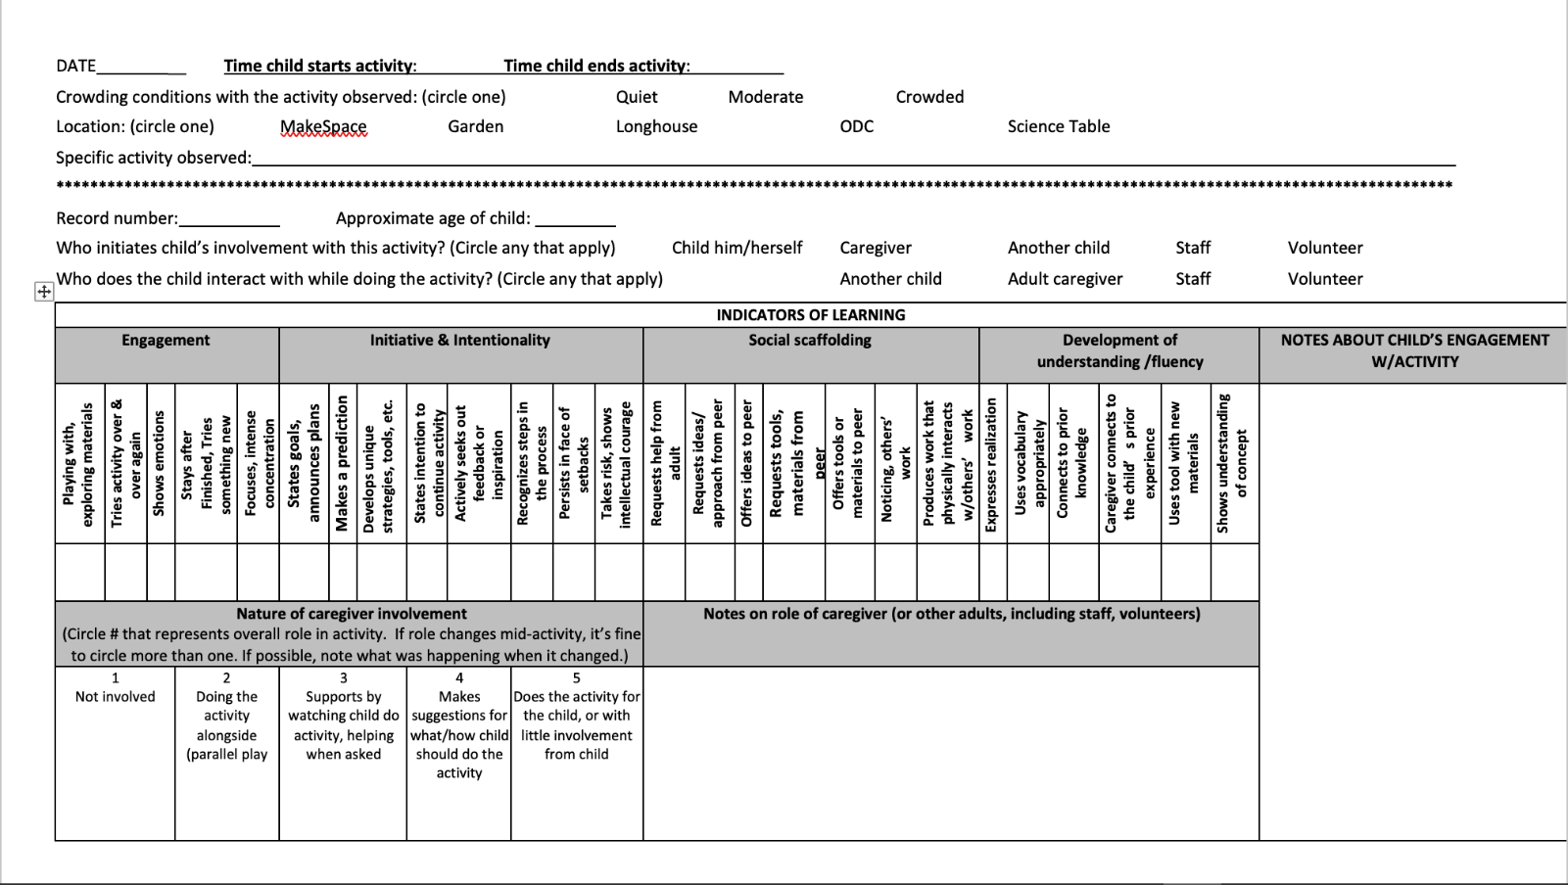
Figure 1 Observational Form used in data collection

Results & Discussion
The overall results of the data are shown in the table below.
Table 1 Final results from observation in the museum
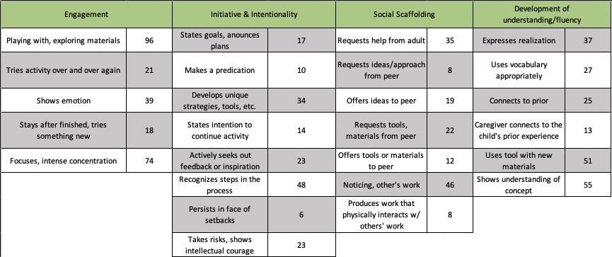

Table 2 Nature of Caregiver Involvement
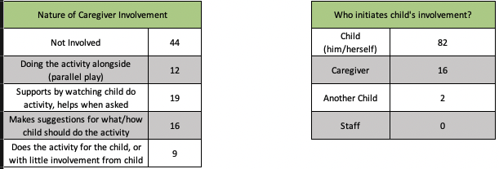
Table 3 Who initiates child's involvement?
Table 4 Age of Children Engaging in Activity
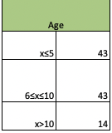
This table shows the number of children (out of 100) of each Nature Play activity exhibiting those specific playing styles under each of the learning indicators. The children’s ages ranged from three to thirteen with the majority of the children being below the age of ten as shown in Table 4. Table 3 shows who initiates the child’s involvement with the activity. I chose to document this behavior because it gave me an idea of how interested and curious the child was. In my observations, I also recorded the nature of the caregiver’s involvement. This gave me an idea of the caregiver’s relationship with the child as well as the child’s confidence and independence levels.
The engagement behaviors section had the highest numbers with 96% of children observed playing with and exploring the natural materials. In addition, 82% of the children initiated those interactions. Seventy-four percent showed intense concentration on the activity.
The majority of the children observed were younger children who were still focused on and engaged in exploring the natural materials. I also observed that the children themselves were the first ones to engage and interact with the activity. When looking at caregiver’s involvement in the activity, 44% of caregivers were not involved in the activity with their child at all. Nineteen percent of the caregivers were supportive and stood close by watching and helped when the child asked. This would suggest that the children engaging in these activities were actively and independently participating on their own without the involvement of their caretaker.
This showcases the children participating in Engagement behaviors, Initiative & Intentionality behaviors, and in behaviors showing development of understanding which have been proven to be indicators of possible environmental stewardship. In the following sections I will be breaking down the results for the individual learning behavior sections.

Engagement Behavior Results
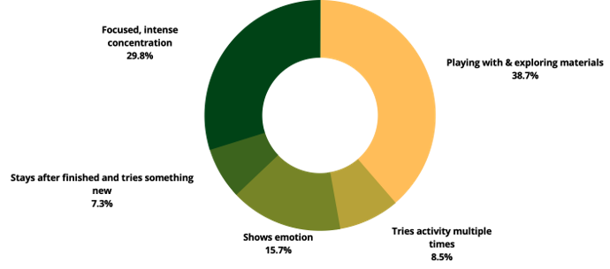
Figure 2 Visual percentage break down of Engagement Behaviors observed

Figure 2 shows the percentage breakdown for the Engagement Behavior results.
At 38.7% and 29.8%, the highest percentages in this section occurred in the categories covering children playing with and exploring the nature materials, focused, and concentrating intensely on the activity. The lower percentages for this section arose in observing the child staying after they finished the activity to try it again or to try another part of the activity. This could be due to different variables, such as the parents wanting to leave the museum/activity, or simply because the child was no longer interested and wanted to see other parts of the museum. This section also includes observing the child showing emotion, which makes up 15.7% of this section. This could include emotions such as frustration, happiness and/or excitement. The purpose of this was to show that the child is invested enough in the activity to invoke emotions. These numbers suggest that the children engaging in these activities are exhibiting high numbers in engagement behaviors. With 96 out of 100 children observed playing with and exploring the natural materials, based on the learning indicators above, this would suggest that there is a high probability that these activities had a positive, lasting effect on these children that can lead to environmental stewardship.

Intention & Initiative Behaviors Results
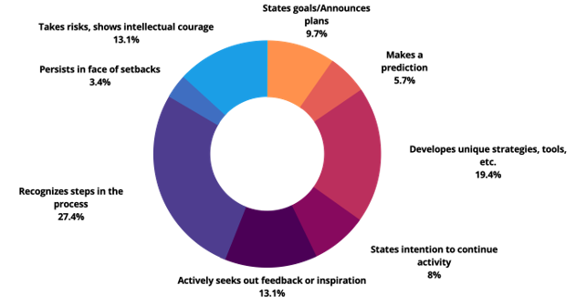
Figure 3 Visual percentage break down of Intention & Initiative Behaviors observed

In the Intention & Initiative Behavior results the highest percentage occurred in recognizing the steps to the activity. Children showed confidence in completing and performing the activity with minimal help from peers and/or adults. For example, the child might have been shown what to do once and was then able to recreate what they had seen with relative ease. Next, at 19.4%, was developing unique strategies and tools in the activity. This was observed most often in the Kitchen Tool activity where the children might try to grate a rosemary branch or squish a grape with the garlic press. These actions showed a level of understanding of not only the tools used but also of the specific organic materials being used. This would also fall under an appreciation for the qualities of a natural object. Based on these results, the children are showing a level of understanding, independence, and creativity through their play. This, coupled with the fact that, 82 of the 100 children observed were the ones that initiated this engagement show that there is a high probability that these activities had a positive, lasting effect on these children that can lead to environmental knowledge and environmental citizenship.

Social Scaffolding Behaviors Results
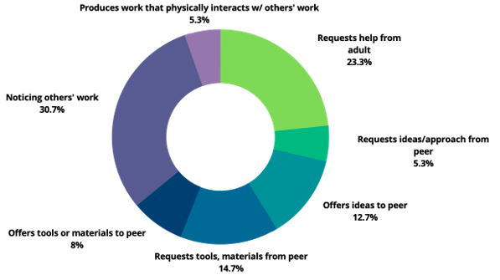
Figure 4 Visual percentage break down of Social Scaffolding Behaviors observed

The section related to Social Scaffolding Behaviors did not yield very high numbers overall. While 30.7% of children were observed noticing other people’s work, they did not engage or interact with them. Even requesting help from other adults reached only 23.3% in this section. I would like to note that this might be a side effect of the Covid-19 pandemic and quarantining. Since the majority of the children observed were under the age of 10, they would most likely not have had much social interaction with other people outside of the household because of Covid-19 and Covid-19 restrictions and two years of staying at home.

Development of Understanding Behaviors Results
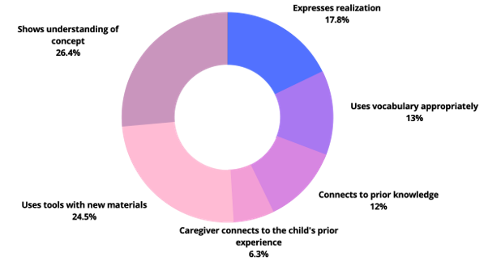
Figure 5 Visual percentage break down of Development of Understanding Behaviors observed

Higher percentages were seen in Development of Understanding Behaviors presented in the activities as well as having the children using familiar tool with new materials. Examples of this included having a child express that they have used tweezers before but never having used them on a flower. This was important to note since the child is linking something with which they are familiar to something new, something found in nature. A child expressing realization was at 17.8% in this section, an indicator of understanding and comprehension, but also a way of expressing emotion, such as excitement, regarding the activity. An example of this would be a child verbally saying, “ah hah!” or “Oh that’s how that works!” In this section, a high number of children are exhibiting behaviors that would suggest that they are linking their current lives with new things in nature, understanding natural concepts, and are even using appropriate vocabulary when talking about nature. All of these behaviors point to these children being able to comprehend environmental processes as well as gaining positive experience with the natural world.
The Hands On Children’s Museums’ mission statement expresses that it “stimulates curiosity, creativity and learning through fun, interactive exhibits and programs for children, families and school groups” (About Us, 2021). Based on the results from this research, these Nature Play activities are fulfilling the museums mission statement. With high percentages in both the Development of Understanding and Engagement sections, this shows that the Nature Play activities are stimulating curiosity through engagement as well as learning and understanding new concepts through play. However, where there were lower percentages in the Initiative & Intentionality and Social Scaffolding sections, I would suggest that the museum looks to engage the children to work with others as well as have the children express themselves and their intentions. This might look like having the children work on a collaborative terrarium in order to build those social scaffolding skills as well as working together to complete a common goal that allows them to explore and utilize natural materials. While it might be difficult to observe Initiative & Intentionality behaviors in children, the museum might benefit from seeking feedback from the caregivers and children on new exhibits and activities through a survey in order to collect a more accurate representation of the child’s goals and/or intentions.

Conclusion

The enriched nature of high-quality outdoor play environments can afford a greater diversity of opportunities for play than indoor settings. To more effectively design outdoor play settings, we must better understand how the physical environment supports, or hinders, the different types of play which suit children’s needs and interests (Loebach & Cox, 2020, p.1).

Looking back on the literature, the indicators of children developing relationships with and understanding the natural world includes positive experiences in outdoor setting or with natural materials, expressing interest and finding inspiration from nature, learning and being supported by adults/peers reenforcing exploration and play in nature, and appreciation for the qualities of nature and natural objects. The most prominent finding would be the 96% of children actively engaging with the natural materials, followed by 82% of children initiating that engagement, during which 74% showed intense concentration and focus. Since only 13% of caregivers connected to the child’s prior knowledge and experiences, it begs the question as to whether or not these children are able to have these kinds of similar experiences at home and if their caregivers support them in exploring nature. As mentioned above, the social scaffolding section was relatively low, and it is possible that it is due to the children lacking social interactions within the past two years due to the Covid-19 pandemic. I would like to recognize that my research was simply through observation and that I chose to not interview the children or the parents for this research.
In all, based on the data that I was able to collect and based on the literatures indicators of children developing relationships with nature, it can be said that these Nature Play activities do have the potential to have a positive, lasting effect on the children later in life that could lead to environmental citizenship.

Future Research
Mayfield (2004) states, “another challenge for children’s museums is the need to document what it is they do and the effects. There is relatively little research on children’s museums and much of what is available is market research and user demographics” (p. 169). It is my hope that future research is done in children’s museums in the hopes of filling in gaps that the formal school system cannot. In furthering the research in cultivating environmental citizenship in children, I would like to see a study that would be able to do a five to ten year follow up for children who have experienced the museum and the Nature Play activities and their views about the environment then verse now. In my research I chose to only observe the children’s actions while they engage with the environment, future research might benefit from interviewing the children and/or caregivers about their experiences with the Nature Play activities to get a better understanding of what the children are retaining during their play. Other future research could be addressing how the Covid-19 pandemic has either stunted or improved a child’s connection to nature or how it has affected a child’s ability to socialize and learn with others.

Bibliography
About Us. Hands on Children's Museum. (2021, June 24). Retrieved December 23, 2021, from
https://www.hocm.org/about-us/
Andre, L., Durksen, T., & Volman, M. L. (2017). Museums as avenues of learning for children:
A decade of research. Learning Environments Research, 20(1), 47–76.
https://doi.org/10.1007/s10984-016-9222-9
Bevan, B., Ryoo, J. J., Vanderwerff, A., Wilkinson, K., & Petrich, M. (2017, July). Making Deeper Learners: A Tinkering Learning Dimensions Framework v 2.0. Learning Dimensions of Making and Tinkering: A professional development tool for educators. from https://www.exploratorium.edu/tinkering/our-work/learning-dimensions-making-and-tinkering
Çil, E., Maccario, N., & Yanmaz, D. (2016). Design, implementation and evaluation of
innovative science teaching strategies for non-formal learning in a natural history
museum. Research in Science & Technological Education, 34(3), 325–341. https://doi-org.evergreen.idm.oclc.org/10.1080/02635143.2016.1222360
Dale Tunnicliffe, S., & Gkouskou, E. (2020). Science in action in spontaneous preschool play –
an essential foundation for future understanding. Early Child Development and Care, 190(1), 54–63. https://doi.org/10.1080/03004430.2019.1653552
Dunkley, R. A. (2016) Learning at eco-attractions: Exploring the bifurcation of nature and
culture through experiential environmental education, The Journal of Environmental Education, 47:3, 213-221, DOI: 10.1080/00958964.2016.1164113
Gutwill, J. P., Hido, N., & Sindorf, L. (2015). Research to Practice: Observing Learning in
Tinkering Activities. Curator: The Museum Journal, 58(2), 151–168. https://doi.org/10.1111/cura.12105
Henderson, T. Z., & Atencio, D. J. (2007). Integration of Play, Learning, and Experience: What
Museums Afford Young Visitors. Early Childhood Education Journal, 35(3), 245–251. https://doi.org/10.1007/s10643-007-0208-1
Loebach, J., & Cox, A. (2020). Tool for Observing Play Outdoors (TOPO): A New Typology for
Capturing Children’s Play Behaviors in Outdoor Environments. International Journal of Environmental Research and Public Health, 17(15), 5611. https://doi.org/10.3390/ijerph17155611
Mayfield *, M. I. (2005). Children’s museums: Purposes, practices and play? Early Child
Development and Care, 175(2), 179–192. https://doi.org/10.1080/0300443042000230348
McClain, C., & Vandermaas-Peeler, M. (2016). Outdoor explorations with preschoolers: An
observational study of young children’s developing relationship with the natural world. 17.
Paris, S. G. (Ed.). (2002). Objects of Learning, Objects of Talk: Changing Minds in Museums. In
Perspectives on Object-Centered Learning in Museums (0 ed., pp. 38–53). Routledge. https://doi.org/10.4324/9781410604132-10
Sobel, D. (1995). Beyond ecophobia: Reclaiming the heart in nature education. Great
Barrrington, Massachusetts: Orion.
Van Schijndel, T. J. P., Franse, R. K., & Raijmakers, M. E. J. (2010). The Exploratory Behavior
Scale: Assessing young visitors’ hands-on behavior in science museums: Exploratory Behavior Scale. Science Education, 94(5), 794–809. https://doi.org/10.1002/sce.20394

