**The Evergreen State College**

**Graduate Program on the Environment**

### Thesis Prospectus

|  |  |  |  |  |  |
| --- | --- | --- | --- | --- | --- |
| **Name** | **Melissa Sanchez** | | | **ID Number** | **A00420633** |
| **Mailing Address** | | | **1512 8th Ave SE** | | |
|  | | | **Olympia, WA 98501** | | |
| **Telephone** | | **( 951 ) 205 - 2272** | |
| **E-mail** | | **sanmel08@evergreen.edu** | |

**STUDENT AGREEMENT:**

**SIGNATURE: __**Melissa Sanchez___________ ___ **DATE_**12/10/2021**______**

**FACULTY READER APPROVAL:**

**SIGNATURE: __________________________________ DATE________________**

**MES DIRECTOR APPROVAL:**

**SIGNATURE: __________________________________ DATE________________**

1. **Provide the working title of your thesis[1].**

Before and After Sea Star Wasting Disease: Sea Star Populations in the Nearshore Central U.S. Strait of Juan de Fuca

1. **In 250 words or less, summarize the key background information needed to understand your research problem and question**.

Sea stars are marine invertebrates that often play an important role in the ecosystems they inhabit. Starting in 2013, a wasting epidemic hit sea stars from Alaska to Mexico at an alarming rate, affecting over 20 different sea star species (Hewson et al. 2018, Harvell et al. 2019). It only took a few days after the initial signs of wasting for the disease to completely take over and kill any affected individuals (Miner et al. 2018). The epidemic persisted in the Northeast Pacific region from 2013 to 2015 (Harvell et al 2019), however in most areas, low levels of wasting continue to exist in the post-epidemic years (2016 – present) (MARINe 2021). The geographical extent of the epidemic was large and affected many species; however most studies show the impacts of wasting on the keystone species *Pisaster ochraceous,* an intertidal star (Eisenlord et al. 2016, Menge et al. 2016, and Miner et al. 2018). Far fewer data exist for subtidal species (Harvell et al. 2019) but the studies that do exist focus primarily on *Pycnopodia helianthoides,* the sunflower star. Even fewer studies address changes in sea star assemblages, such as diversity and evenness for species over a large subtidal area. Only with continuous data before and after the sea star wasting disease can we begin to research changes in subtidal sea star populations.

1. **State your research question(s).**

How have the populations of different sea star species in the nearshore central U.S. Strait of Juan de Fuca changed between 2010 and 2020 with the onset of wasting disease? Further, how has community diversity and species density been affected?

1. **Situate your research problem within the relevant literature. What is the theoretical and/or practical framework of your research problem?**

The theoretical framework for my research is based on population ecology and marine epidemiology. In population ecology, research is done to assess the dynamics of populations of species based on ecological factors. This research is also based around a disease that affected different marine species populations and trying to capture the patterns in timing and distribution of wasting disease in sea stars.

The practical framework of this study is survey-based assessment using annual transect videography as a time series. Efforts by many organizations and citizen scientists were started to track sighting of wasting in sea stars, but most of these efforts were limited to intertidal surveys on foot and dive surveys done at individual sites. Only a few of the published studies contain baseline data to compare with post-epidemic observations, and fewer with subtidal analyses. I will assess changes in population using data gathered from repeated long-term video surveys that happened to capture pre and post sea star wasting years in the subtidal habitat where sea stars can be found. The same transects were sampled, year after year, and captured how the sea star populations changed.

1. **Explain the significance of this research problem. Why is this research important? What are the potential contributions of your work? How might your work advance scholarship?**

The data from this study could provide a clearer picture on the effects of sea star wasting disease (SSWD) on different sea star populations and their dynamics on a larger scale than previously known. Almost all of the studies that have analyzed changes in populations of sea stars in Washington State before and after the 2013-2015 SSWD epidemic address one of two species: *Pycnopodia helianthodes* or *Pisaster ochraceous.* All of those studies have documented the dramatic declines in these species since SSWD. It is not surprising that studies focused on those two species, as they are important keystone predators in their own habitats and their absence can severely disrupt important ecosystems. Furthermore, *P. helianthoides* was recently listed as a critically endangered species. I have not found any studies from areas in Washington that address changes in the dynamics among multiple species of sea stars. Results from this study have the potential to show new information such as relief in predation pressure for stars with the absence of *P. helianthoides* or a fast recovery of another affected species. Knowing where populations stood before the onset of wasting disease, how they were affected after the outbreak and any signs of recovery or continued distress would be immensely useful. By helping to describe the status of these populations, we can advocate for further funding of recovery efforts like the one at Friday Harbor Labs, where they are currently raising sunflower stars to help the population recover. In addition, the absence of sunflower stars can mean an increase in urchin populations, a favorite prey of the keystone species. Having the information from this research question could also help inform choosing to open or expand the urchin fisheries to control any rampant urchin populations that have thrived in the absence of these predators.

1. **Summarize your study design[2]. If applicable, identify the key variables in your study. What is their relationship to each other? For example, which variables are you considering as independent (explanatory) and dependent (response)?**

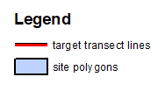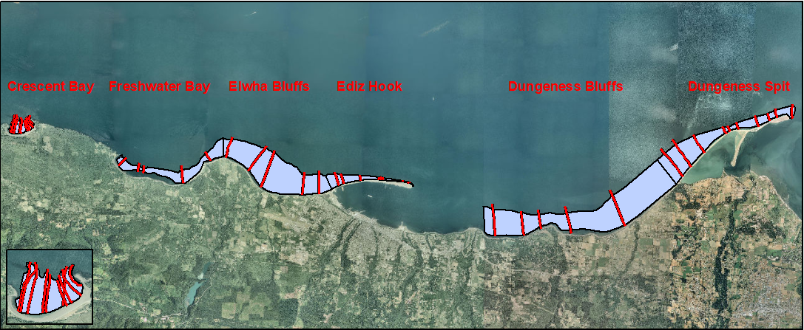

Figure : Map of the study area, including six sites from Crescent Bay to Dungeness Spit, and target transect lines.

The original study design created to collect videography near the Elwha River mouth includes six sites with transects extending from shallow subtidal to -15 m (Mean Lower Low Water) (figure 1). At each site, underwater videography was collected at either 5 or 10 transects across several years between 2010 and 2020. In this study, several variables will be part of answering my research question. Each variable and the questions they will address are summarized in figure 2.

Table Types of variables in this study

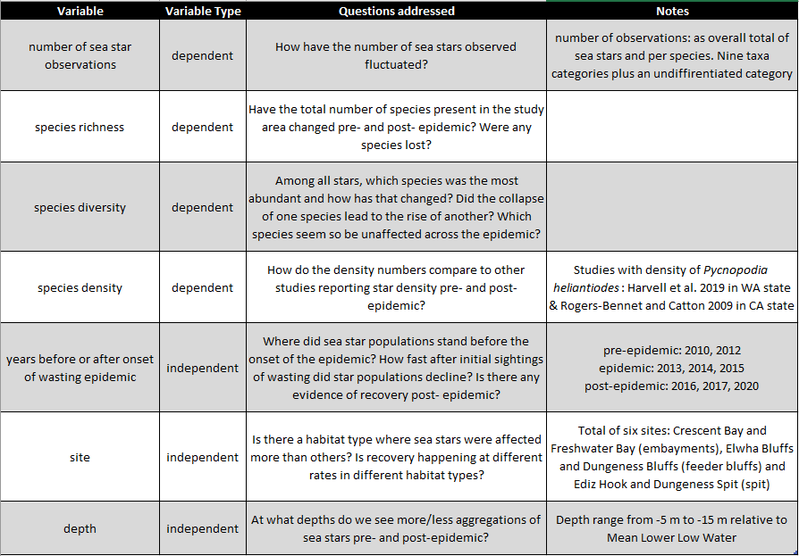

Depending on which year the sea stars were observed, sea star numbers, richness, diversity and density have the potential to be affected differently because of the onset of wasting disease that began in 2013. Furthermore, the same changes can differ among site and depth.

1. **Describe the data that will be the foundation of your thesis. Will you use existing data, or gather new data (or both)? Describe the process of acquiring or collecting data[3].** 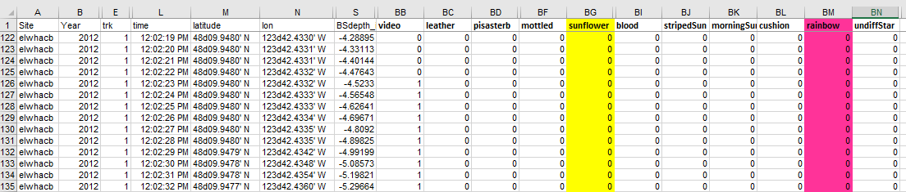

Figure 2: Partial screenshot of data spreadsheet generated at time of video surveys. The last 10 colomns on the right show the categories of each sea star taxa plus the undifferentiated star category.

I am repurposing a set of underwater transect videography that was originally collected by DNR in response to the Elwha River dam removal. I have Hi8 videotapes for the surveys completed between 2010 and 2015, and digital files for 2016 through 2020. In addition to video, a spreadsheet (figure 2) with the corresponding time, position and depth was generated at the time of the video survey for each site. The process of collecting the data is to watch all the footage and mark the presence of each sea star individual to its corresponding species category and video timestamp.

1. **Summarize your methods of data analysis. If applicable, discuss specific techniques that you will use to understand the relationships between variables (e.g., interview coding, cost-benefit analysis, specific statistical analyses, spatial analysis) and the steps and tools (e.g., lab equipment, software) that you will take to complete your analyses.**

Table Summary of method of data analysis

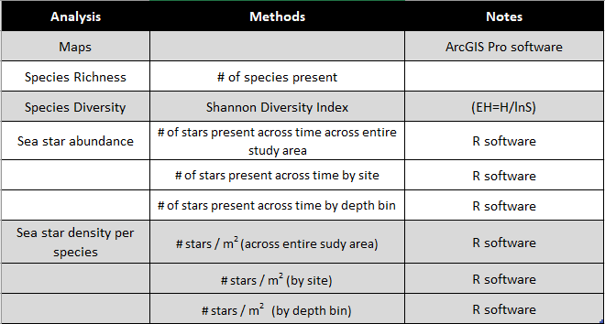

First, I will spatially visualize the sea star observations across study area, year by year. In order to do this, I will need the ArcGIS Pro software to create maps of the transects and observations for each species. Second, I want to do calculations of species richness and species diversity for the sea stars observed in the video using Shannon diversity index formulas. Using a one-way ANOVA, I will test if diversity changes significantly between pre-epidemic, epidemic and post-epidemic years. Third, I want to see how sea star abundance in each species changes across time and across the study area as a whole, as well as by site and depth bin. I will use R software to visualize those differences. Finally, I want to use GIS to obtain an approximate length per transect and calculate a star density for each species across the entire study area, by site and by depth bin. I will use a two-way ANOVA to test significant changes in sea star density (dependent) across year (independent) and depth (independent). Additionally, I will have densities to compare with a handful of studies that also calculated density for *P. helianthoides,* and I will be able to see how star density differs with other areas along the Northeast Pacific coast.

1. **Address the ethical issues[4] raised by your thesis work. Include issues such as risks to anyone involved in the research, as well as specific people or groups that might benefit from or be harmed by your thesis work, perhaps depending on your results. List any specific reviews you must complete first (e.g., Human Subjects Review or Animal Use Protocol Form).**

Groups like DNR and Washington Department of Fish and Wildlife (WDFW) who dedicate their time and money to study marine habitats and the organisms they support can benefit from this thesis work. Depending on the results, the changes and current status of sea star populations can motivate these agencies to focus their efforts in helping restore the sea star communities by monitoring kelp and urchins for example.

1. **List specific research permits[5] or permissions you need to obtain before you begin collecting data (e.g. landowner permissions, agency permits).**

I will be collecting data from an existing set of videography gathered by DNR. I have access and permission from Helen Berry to use the entire video collection for this project. Helen led the data collection from the video and analyses from the original project.

1. **Reflect on how your positionality as a researcher could affect your results and how you will account for this in the research process[6].**

I will complete this research project as an employee of the Washington Department of Natural Resources, an environmentalist and a data gatherer. The topic of sea star wasting has been prevalent in the organizations I work with and my job centers around monitoring, conserving and restoring marine nearshore habitats. With these positionalities I acknowledge that I have expectations to see the data show certain results. For example, I expect to see a decline in sea star sightings after wasting has occurred. On the other hand, I hope to see some sort of recovery following that decline. In order to account for these this, I will stay true to the sea star observations I see in the video. I will count all sea stars that I see, including the ones I cannot identify and put those in a separate ‘undifferentiated’ category.

1. **Provide at least a rough estimate of the costs associated with conducting your research.  Provide details about each budget item so that the breakdown of the final cost is clear.**

There are no financial costs associated with completing this research.

1. **Provide a detailed working outline of your thesis.**

**Introduction**

**Literature Review**

*Sea Stars in PNW*

*Sea Star Wasting Disease*

*Population estimates*

*U.S. Central Strait of Juan de Fuca and Elwha Study*

**Methods**

*Study area, sites, transects*

*Video collection (equipment, boat, original Elwha study)*

*Data collection (star ID methods and parameters)*

*Analysis*

1. *Maps*
2. *Species richness and diversity*
3. *Calculations and extrapolations of sea star density*
4. *Significance tests for sea star numbers between years*

**Results**

*Maps*

*Species richness and diversity*

*Calculations and extrapolations of sea star density*

*Significance tests for sea star numbers between years*

**Discussion**

**Conclusion**

**Bibliography**

**Appendices**

*Maps*

*Photographs/screenshots*

1. **Provide a specific work plan and a timeline for each of the major tasks in the work plan. Be as realistic as you can, even though you will probably need to alter this schedule as you complete the tasks. Remember that faculty readers take time to return your drafts and that the final polishing and formatting of your thesis for binding will take longer than you ever imagined.**

|  |  |  |
| --- | --- | --- |
| Activity | Start Date | Due Date |
| Video review/ data collection | 12/13/2021 | 01/03/2022 |
| Introduction | 12/03/2021 | 01/10/2022 |
| Data: first round of maps | 01/03/2022 | 01/17/2022 |
| Data: first round of figures and analyses | 01/03/2022 | 01/24/2022 |
| Data: complete maps | 01/31/2022 | 2/14/2021 |
| Data: complete figures and analyses | 02/07/2022 | 2/21/2021 |
| Methods draft | 01/24/2022 | 02/07/2022 |
| Methods revisions | 2/21/2022 | 03/07/2022 |
| Results draft | 02/07/2022 | 02/21/2022 |
| Results revisions | 03/07/2022 | 03/21/2022 |
| Discussion draft | 02/21/2022 | 03/14/2022 |
| Discussion revisions | 03/28/2022 | 04/11/2022 |
| Conclusion | 03/21/2022 | 04/08/2022 |
| Bibliography | 04/11/2022 | 04/18/2022 |
| **Complete draft to reader |  | 04/08/2022 |
| Salish Sea Poster presentation |  | 04/22/2022 |
| Thesis presentation slides |  | 05/09/2022 |
| Formatting | 04/25/2022 | 05/27/2022 |
| **Request to present |  | 04/29/2022 |
| **Thesis Presentations |  | 05/16-27/2022 |
| **Final Thesis to Reader |  | 05/27/2022 |
| **Final thesis to MES Director |  | 06/10/2022 |
| ** MES deadlines |  |  |

1. **Who, beyond your MES faculty reader, will support your thesis? Indicate support both within and outside of Evergreen. Be specific about who they are and in what capacity they will support your thesis. If you are working with an outside agency or expert, be specific about their expectations for your data analysis or publication of results.**

Besides my reader, I will be consulting with my work colleagues at DNR for support and guidance. Specifically, Helen Berry, who led the initial study for which the videography was collected. Up to this point she has been there to help me think about what questions to consider and answering questions I have about the study site. Her expectations are that I present this work as a poster (submitted an abstract to the 2022 Salish Sea Ecological Conference) or talk at upcoming conferences once the analyses are complete.

1. **List the 3-5 most important references you have used to identify the specific questions and context of your topic, help with issues of research design and analysis, and/or provide a basis for interpretation. For each annotated reference, explain how your project specifically connects to the source by extending, challenging, or responding to the conclusions, methods, or implications. For any other sources cited in this document provide a complete bibliographic citation.**

Harvell, C., Caldwell, J., Burt, J., Bosley, K., Keller, A., Heron, S., Salomon, A., Lee, L., Pontier, O., Pattengill-Semmens, C., & Gaydos, J. (2019). Disease epidemic and a marine heat wave are associated with the continental-scale collapse of a pivotal predator ( Pycnopodia helianthoides ). *Science Advances*, *5*, eaau7042. <https://doi.org/10.1126/sciadv.aau7042>

This study investigates the population status of the sunflower star, *Pycnopodia helianthoides,* pre and post wasting in the outer coasts from Alaska to California. After analyzing existing data from shallow nearshore diver surveys and deep offshore trawl surveys, the authors were able to show a collapse in the sunflower star populations. In the discussion of my results, I want to have other studies to compare data with, especially with the sunflower star populations. The surveys that were used in this study cover a similar time frame of the data I will have so this will be a great reference to see if the sea star declines in the Strait of Juan de Fuca had a similar timing and magnitude as the outer coasts.

Miner, C. M., Burnaford, J. L., Ambrose, R. F., Antrim, L., Bohlmann, H., Blanchette, C. A., Engle, J. M., Fradkin, S. C., Gaddam, R., Harley, C. D. G., Miner, B. G., Murray, S. N., Smith, J. R., Whitaker, S. G., & Raimondi, P. T. (2018). Large-scale impacts of sea star wasting disease (SSWD) on intertidal sea stars and implications for recovery. *PLOS ONE*, *13*(3), e0192870. <https://doi.org/10.1371/journal.pone.0192870>

The data used for this study is part of a large network of 18 groups ranging from government to private organizations that come together to survey intertidal habitats over the years. It was through these surveys that the first case of wasting was noted in Washington. The effects of wasting in sea stars found in the intertidal are well-documented using data from over 80 sites between British Columbia to San Diego, California.The surveys I am using to gather data from are by boat, so a lot of the upper intertidal is not captured. This source will be great to point out the gap on subtidal sea star population status. In addition, the descriptions of the symptoms and progression of the disease are also very detailed and will be great to include in the background information for this epidemic.

Rogers-Bennett, L., & Catton, C. A. (2019). Marine heat wave and multiple stressors tip bull kelp forest to sea urchin barrens. *Scientific Reports*, *9*(1), 15050. <https://doi.org/10.1038/s41598-019-51114-y>

This publication has helped me think about the big picture and why the project I’m doing is important. The focus of this report is the rapid climate related changes that are occurring in marine ecosystems. Specifically, bull kelp forests in northern California that have transformed into large urchin barrens. One of the key factors that may have contributed to this massive shift is the decline and probable local extinction of the sunflower star, a key urchin predator, following sea star wasting disease. The disappearance of sunflower stars in this habitat has contributed to an urchin rampage through the once healthy and productive bull kelp in Northern California. By referencing the abrupt change in a nearby pristine habitat, the importance of this research will be highlighted and understood.

**Bibliography**

Eisenlord, M. E., Groner, M. L., Yoshioka, R. M., Elliott, J., Maynard, J., Fradkin, S., Turner, M., Pyne, K., Rivlin, N., van Hooidonk, R., & Harvell, C. D. (2016). Ochre star mortality during the 2014 wasting disease epizootic: Role of population size structure and temperature. Philosophical Transactions of the Royal Society B: Biological Sciences, 371(1689), 20150212. <https://doi.org/10.1098/rstb.2015.0212>

Harvell, C., Caldwell, J., Burt, J., Bosley, K., Keller, A., Heron, S., Salomon, A., Lee, L., Pontier, O., Pattengill-Semmens, C., & Gaydos, J. (2019). Disease epidemic and a marine heat wave are associated with the continental-scale collapse of a pivotal predator ( Pycnopodia helianthoides ). *Science Advances*, *5*, eaau7042. <https://doi.org/10.1126/sciadv.aau7042>

Hewson, I., Button, J. B., Gudenkauf, B. M., Miner, B., Newton, A. L., Gaydos, J. K., Wynne, J., Groves, C. L., Hendler, G., Murray, M., Fradkin, S., Breitbart, M., Fahsbender, E., Lafferty, K. D., Kilpatrick, A. M., Miner, C. M., Raimondi, P., Lahner, L., Friedman, C. S., … Harvell, C. D. (2014). Densovirus associated with sea-star wasting disease and mass mortality. *Proceedings of the National Academy of Sciences*, *111*(48), 17278–17283. <https://doi.org/10.1073/pnas.1416625111>

MARINe (2021) *https://marine.ucsc.edu/data-products/sea-star-wasting/*

Miner, C. M., Burnaford, J. L., Ambrose, R. F., Antrim, L., Bohlmann, H., Blanchette, C. A., Engle, J. M., Fradkin, S. C., Gaddam, R., Harley, C. D. G., Miner, B. G., Murray, S. N., Smith, J. R., Whitaker, S. G., & Raimondi, P. T. (2018). Large-scale impacts of sea star wasting disease (SSWD) on intertidal sea stars and implications for recovery. *PLOS ONE*, *13*(3), e0192870. <https://doi.org/10.1371/journal.pone.0192870>

Rogers-Bennett, L., & Catton, C. A. (2019). Marine heat wave and multiple stressors tip bull kelp forest to sea urchin barrens. *Scientific Reports*, *9*(1), 15050. <https://doi.org/10.1038/s41598-019-51114-y>

1. You are not locked into this title; its purpose is to help you identify the main point or topic of your thesis at an early stage.
2. You might discuss selection of case studies, sampling methods, experimental design, and/or specific hypotheses you will test. You should also address any specialized knowledge or skills that are necessary to complete the research.
3. If you are planning to use existing data, explain the specific source, contact information, arrangement with collaborating agencies, and expectations about use of data and final products of your research. If you are planning to gather new data, describe specific methods, time, place, and equipment that will be required.
4. If you’re not sure where to start, consult a ‘Code of Ethics’ or other similar document from an academic society in an applicable field of study.
5. If you are collecting ANY samples or data, even observational data, on public lands (city, county, state and/or federal) it is your responsibility to find out the permit requirements BEFORE you collect data. Conducting research with tribal members/on tribal lands will have different and additional requirements.
6. Your *positionality as a researcher* refers to the fact that one’s “…beliefs, values systems, and moral stances are as fundamentally present and inseparable from the research process as [one]’s physical, virtual, or metaphorical presence when facilitating, participating and/or leading the research project…” (The Weingarten Blog 2017).