The Evergreen State College
Graduate Program on the Environment

Thesis Prospectus

Name | Dana Kiehl |  |  | ID Number | (pending)
Mailing Address |  |  | 3111 71st Drive SE
 |  |  | Olympia, WA
Telephone |  | (360) 789-0454
E-mail |  | danamichele@gmail.com

STUDENT AGREEMENT:

SIGNATURE: ___Dana M. Kiehl_____________________ DATE_12/17/2021_____

FACULTY READER APPROVAL:

SIGNATURE: __________________________________ DATE________________

MES DIRECTOR APPROVAL:

SIGNATURE:__________________________________ DATE________________

- Provide the working title of your thesis.

Evaluating Madagascar’s vanilla farmer-buyer partnerships using a social justice framework

- In 250 words or less, summarize the key background information needed to understand your research problem and question.

Vanilla is one of the world’s most popular and most expensive flavorings. A majority of this vanilla is grown by smallholder farmers in the northeastern corner of Madagascar, one of the least developed nations in the world (United Nations Development Program, 2020). These farmers live in unpredictable conditions, where poverty and food insecurity are common (Andriamparany et al, 2021; Herrera, 2014). Their dependence on vanilla for income is a challenge because of drastic price fluctuations, resulting in a lack of food to eat in poor years and suitcases full of money in good years, yet their proximity to banks and ideas about saving preclude investments for the future (Zhu, 2018). When prices spike, theft and violence abound in the region, leading to a race to the harvest and an unripe, poor-quality product (Osterhoudt, 2020; Reel, 2019).
Partnerships have been created between buyers and farmers in an attempt to solve some of these problems. Buyers are assured a quality crop, and farmers are assured a good price. Many other factors may be involved, from educational opportunities for farmers, banking and microloans to encourage economic diversification, and certification standards, such as Organic, Fair Trade, or Rainforest Alliance, met for buyers. Yet, it is unknown to what extent these partnerships effect positive change for the farmers. (Hänke, 2019). (Question for me to ponder: How to include farmers left out of partnerships? ACCESS principle of Social Justice.)

- State your research question(s).

Do partnerships created to improve the vanilla crop and the vanilla farmers’ livelihoods in NE Madagascar bring about meaningful change?

- Situate your research problem within the relevant literature. What is the theoretical and/or practical framework of your research problem?

Research on contract farming among Madagascar’s vanilla farmers is dominated by Hendrik Hänke (2018; 2019; Andriamparany et al, 2021). His original surveys looked at correlations between contracted farmers versus noncontracted farmers and other indicators, such as household size, hectares owned, and education levels. While contracted farmers seemed to fare somewhat better, it is unclear whether these farmers got the contracts due to their privilege or if the contracts spurred improvements in their lives.

I will be using a social justice framework (see below) to evaluate contract farming models in Madagascar’s vanilla bean industry in order to identify factors that create meaningful change for the farmers.

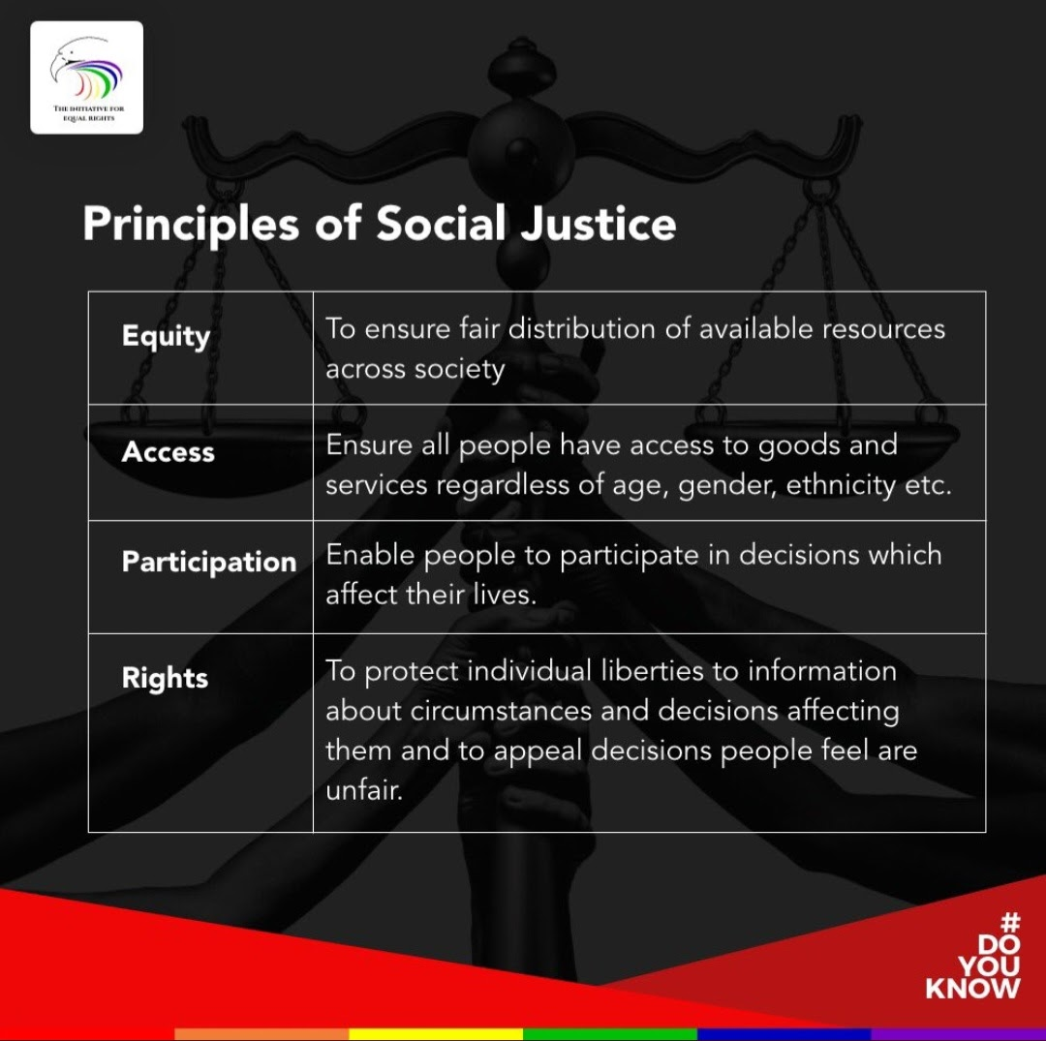
(Source: The Initiative for Equal Rights)

- Explain the significance of this research problem. Why is this research important? What are the potential contributions of your work? How might your work advance scholarship?

Madagascar is among the poorest countries in the world, yet they produce 80% of the world’s vanilla, an expensive luxury flavoring. The time and labor investments required to grow vanilla are extreme, and the farmers’ lack of stability and basic resources is a glaring example of injustice: the people putting in the most work are bearing the burden of the costs and are largely excluded from the reaping the benefits (Miller, 1999).

Interestingly, one solution to the injustices in the vanilla industry is partnerships between the farmers and the buyers. While these partnerships can benefit buyers in the form of an established vanilla source and a better-quality product, I am interested to see how or if these programs benefit the farmers. Many aspects of these programs sound meaningful: set up a banking system, provide microloans for economic diversification, get children out of the fields and into schools, and provide access to healthcare. Is there a redistribution of benefits here, or have the programs increased benefits across the board? Or is injustice perpetuated in a way that only appears more just?

Currently, it is unknown whether these programs increase farmers’ livelihoods, or whether the apparent benefits of these programs to the farmers only appear so because already-wealthier farmers are getting the contracts, which could ultimately increase current injustices (Hänke, 2019).

My research aims to identify specific factors that directly benefit farmers and serve to increase social justice across the region while also retaining benefits to buyers. If effective partnership parameters can be identified, a model for these partnerships can be created and expanded, increasing justice in the global vanilla economy.

- Summarize your study design. If applicable, identify the key variables in your study. What is their relationship to each other? For example, which variables are you considering as independent (explanatory) and dependent (response)?

My thesis is a case study that will describe vanilla grower/buyer partnerships and identify factors that are improving the livelihoods of the farmers using a social justice framework. This will involve interviewing key players in the vanilla bean industry, including employees of flavorings corporations, small businesses, nonprofit organizations, and government agencies—hopefully also vanilla players in Madagascar, possibly including exporters, traders, farmers, and nonprofit workers—to learn how these partnerships work and identify the perceived benefits. I will code the interviews and identify factors that are likely to increase farmers’ livelihoods. I will identify themes in the interviews relating to aspects of the partnership contracts (such as education, microloans, etc.) and the perceived benefits to farmers (such as economic security from diversification). If I can contact players in Madagascar, I will also have a measure of their perceived benefits. The result could inform a model of an effective grower/buyer partnership that brings about meaningful change for a vulnerable community.

- Describe the data that will be the foundation of your thesis. Will you use existing data, or gather new data (or both)? Describe the process of acquiring or collecting data.
Data will be collected in the form of interviews. I will use phone or Zoom calls to talk to key informants in the vanilla purchasing industry, particularly those who claim to improve the lives of the farmers. This may include people in corporations, small business owners, nonprofit employees, and government employees. I will also strive to connect with people in Madagascar, including exporters, buyers, farmers, and nonprofit workers. These interviews will be transcribed and coded to result in qualitative data on the partnerships and their aims, as well as narrative data from Madagascar.

- Summarize your methods of data analysis. If applicable, discuss specific techniques that you will use to understand the relationships between variables (e.g., interview coding, cost-benefit analysis, specific statistical analyses, spatial analysis) and the steps and tools (e.g., lab equipment, software) that you will take to complete your analyses.

My analysis will utilize interview coding to identify factors in the vanilla grower/buyer partnerships and the perceived benefits to those involved. I will analyze this data against the principles of social justice to determine which factors could lead to increased or decreased justice for Madagascar’s vanilla farmers.

- Address the ethical issues raised by your thesis work. Include issues such as risks to anyone involved in the research, as well as specific people or groups that might benefit from or be harmed by your thesis work, perhaps depending on your results. List any specific reviews you must complete first (e.g., Human Subjects Review or Animal Use Protocol Form).

Ethical issues in my research arise due to privilege and power dynamics between a white researcher in North America and farmers of color, often with minimal education, in a developing country in the global South. Malagasy vanilla farmers live in particularly vulnerable conditions. Hence, the most sensitive aspect I anticipate are possible interviews with vanilla bean farmers and traders in Madagascar. I will approach the interviews with reciprocity, so that we can learn from and help each other. I will give space in the interviews for unexpected topics, and I will strive to correctly represent the interviewees’ perspectives. I will respect privacy of the farmers, and I will keep confidential any identifying information or data interviewees ask me not to share. Even so, there can be a power dynamic at play, and these conversations will have potential to cause emotional upset to interviewees.

Ethical issues may also arise in the partnerships between businesses and the farmers, as the businesses hold a power position over the farmers and are also in it for reasons that benefit themselves. I am hoping that some connections to buyers could lead to connections in Madagascar, and issues could arise if farmers feel like they have to please the company rather than speaking their truths. I will counter this with confidentiality, by protecting the identity and privacy of interviewees.

Vanilla is rife with trade secrets, which requires confidentiality with buyers as well. I will keep confidential any information I’m asked not to share.

My research aims to bring the voices of the vanilla bean farmers into the academic literature and provide a perspective that can contribute to meaningful solutions for farmers. This work could benefit players throughout the vanilla industry—not only vanilla farmers, but also the buyers and consumers who care about the vanilla industry and justice issues.

I will undergo training and apply for a Human Subjects Review prior to conducting this research so I can be thoughtful, inclusive, and do my best to make this a positive experience for all involved.

- List specific research permits or permissions you need to obtain before you begin collecting data (e.g. landowner permissions, agency permits).

I will obtain verbal permission from anyone I interview. I will be transparent about my research question and ensure their participation is voluntary. I will not need any permits for my research.

- Reflect on how your positionality as a researcher could affect your results and how you will account for this in the research process.

My positionality is very relevant for my topic. I am a white, privileged, educated researcher from the USA, a leading world power and the consumer of over half the world’s vanilla (Ecott, 2005). I also speak English and will be using Western methods of science and analysis as a framework for answering my research question. My sources are also (almost exclusively) in English and use a Western academic framework. This places me as an outsider among the vanilla bean farmers, who livelihoods are the focus of my research.

The farmers are people of color living in one of the least developed nations on earth. They live in an isolated area in Madagascar and are mostly minimally-educated smallholder farmers, having inherited their land from previous generations and with cultural ideas about the relationship between humans and nature (Golden, 2014). Many experience poverty and food insecurity. This could all affect my research greatly. First, I will be thoughtful about interviewing people in a way that makes them feel safe and comfortable so they can share openly and honestly, or else my research could be missing pieces, possibly some of the most insightful pieces. I will ask open-ended questions to allow for topics that I may not have predicted. This will prevent me from fitting responses into any preconceived notions I may have, consciously or not, of their experiences.

My positionality could also come into play as I work with buyers in the vanilla industry. My research focus is on the wellbeing of the farmers and social justice. These partnerships arise with mutually beneficial goals, but I admit that I suspect the buyers usually benefit more. I need to keep this bias in check and recognize that these are the people who are potentially making the differences needed in the farmers’ lives.

Awareness of these roles can help me set myself aside so I can accurately represent the interviewees and share their voices.

- Provide at least a rough estimate of the costs associated with conducting your research. Provide details about each budget item so that the breakdown of the final cost is clear.

I expect my research to incur minimal costs, possibly for general supplies and access to information. So far I have rented a book on Amazon and purchased Microsoft Office.

I have developed a way to approach my thesis that does not require travel, but visiting would enrich my thesis in ways I know I couldn’t even predict. I was looking into a trip to Madagascar when the Omicron COVID variant was detected in South Africa. I will keep my eye on the situation, but at this point I think a trip is unlikely.

- Provide a detailed working outline of your thesis.

Introduction
- Start wide and lead to narrow
- Introduce brief relevant background information and
  - Research Question
  - Study Design
- Tell you what I am going to tell you
  - Transition to Lit Review
Literature Review (see draft for more detail)
- Introduction
- Vanilla the Flavor
- Vanilla in the Global Economy
- Vanilla the Crop
  - Emphasizing the time and labor investments required
- Vanilla Farmers of NE Madagascar
- Efforts to Improve the Vanilla Crop and Farmer Livelihoods
  - Absence of common fair trade vanilla
  - Hänke research
    - Question so far: benefits due to contracts or contracts due to privilege?
  - Contract Farming, Big Corporations, Small Businesses, NGOs
- Social Justice
- Conclusion
  - Relate to Introduction
  - Gap in research
  - Brief methods to address the Research Question
Methods
- Case Study
- Interviews
- Interview Coding
- Principles of Social Justice as a Framework
Results
- How many people from what positions were interviewed
- Results of interview coding (Include Tables and possibly Appendix?)
  - Factors identified/frequency
  - Perceived benefits to farmers
  - Data from Madagascar (include narrative data and/or Discussion)
- Link to Social Justice (or does this all go in Discussion?)
Discussion
- Link back to Literature Review
- Link Results to (broader discussion on) Social Justice
- Bring forward voices of farmers, if possible
- Suggest factors to include in a successful model for grower/buyer partnerships
Conclusion
- Tell you what I told you
- Link back to Introduction
  - Narrow to Broad

- Provide a specific work plan and a timeline for each of the major tasks in the work plan. Be as realistic as you can, even though you will probably need to alter this schedule as you complete the tasks. Remember that faculty readers take time to return your drafts and that the final polishing and formatting of your thesis for binding will take longer than you ever imagined.

Winter Quarter:
Immediate: Continue background research on partnerships and social justice
Immediate: Major revisions on Literature Review (see outlines)
ASAP: Create interview questions for different players
ASAP next: Find interviewees
ASAP next: Conduct interviews
ASAP next: Analyze interviews
Week 1: Learning about using interviews in research, including coding and analysis
Week 2: Turn in Human Subjects Review application
Week 3: Turn in Introduction
Week 4: Conduct interviews*; Transcribe and begin analysis
Week 6: Turn in Methods section
Week 8: Continue analyzing interviews and presenting results
Week 10: Turn in Results section

Spring Quarter:
Week 1: Turn in Discussion
Week 2: Submit complete draft of thesis
Weeks 3-4: Work on revisions
Week 5: Request to present
Week 6-7: Thesis revisions, finalizing (including formatting)
Week 7-8: Work on and practice presentation; revisions and finalizing
Week 8-9: Presentation; revisions and finalizing
Week 9: Submit final draft
June 10, 2022: Final, signed, formatted draft due

*upon acceptance of Human Subjects Review

- Who, beyond your MES faculty reader, will support your thesis? Indicate support both within and outside of Evergreen. Be specific about who they are and in what capacity they will support your thesis. If you are working with an outside agency or expert, be specific about their expectations for your data analysis or publication of results.

At this time, I don’t anticipate specific support for my thesis outside of my thesis reader.

- List the 3-5 most important references you have used to identify the specific questions and context of your topic, help with issues of research design and analysis, and/or provide a basis for interpretation. For each annotated reference, explain how your project specifically connects to the source by extending, challenging, or responding to the conclusions, methods, or implications. For any other sources cited in this document provide a complete bibliographic citation.

I’m beginning some new avenues of research that relate to my updated research question, but here are some influential sources so far:

Ecott, T. (2005). Vanilla: Travels in Search of the Ice Cream Orchid (1st edition). Grove Press.
This book is referenced is numerous works and is praised for its high standard of journalism. Ecott blends history and facts about vanilla with his own travels, experiences, and conversations. It is a treasure trove of information, and at the very least a starting place for getting a full big picture of vanilla.

Hänke, H., Barkmann, J., Blum, L., Franke, Y., Martin, D. A., Niens, J., Osen, K., Uruena, V., Witherspoon, S. A., & Wurz, A. (2018). Socio-economic, land use and value chain perspectives on vanilla farming in the SAVA Region (north-eastern Madagascar): The Diversity Turn Baseline Study (DTBS) (Working Paper No. 1806). Diskussionsbeitrag. https://www.econstor.eu/handle/10419/183584
This document provides detailed descriptions of vanilla farms based on survey results from farmers themselves. Variables include demographic and socioeconomic backgrounds of household members, information about the land and its uses, success of vanilla crops and vanilla sales, vanilla theft, and partnerships with vanilla buyers. This provides a thorough look at the lives of the farmers and the challenges they face, which are especially felt by women heads of household. Included in these results are differences between contracted and non-contracted farmers. Hänke seems to be the major player in looking at contracted vanilla farmers.

Hänke, H. (2019). Living Income Reference Price for Vanilla from Uganda and Madagascar. Fair Trade International. https://files.fairtrade.net/publications/Fairtrade_Vanilla_LivingIncomeRefPrice_fullreport.pdf
Hänke continues working with vanilla farmers to develop baseline living wages for farmers in Madagascar in partnership with Fair Trade International. This report also includes information on contracted versus noncontracted farmers. He asks the question: Do differences he finds based on contract status stem from the contracts themselves, or are wealthier farmers hired for the contracts due to their privilege (in this case, more land and bigger families, resulting in more labor). Higher education among contracted farmers indicated the latter, because contracts were not in place long enough for farmers to have obtained education as a result of the contracts. These pieces of information have led me to want to dig deeper. He is still working on this, too, but my approach will be different from what I would suspect he is doing.

Neimark, B., Osterhoudt, S., Blum, L., & Healy, T. (2021). Mob justice and ‘The civilized commodity.’ The Journal of Peasant Studies, 48(4), 734–753. https://doi.org/10.1080/03066150.2019.1680543
Osterhoudt, S. R. (2020). “Nobody wants to kill.” American Ethnologist, 47(3), 249–263. https://doi.org/10.1111/amet.12911
Zhu, A. (2018). Hot money, cold beer: Navigating the vanilla and rosewood export economies in northeastern Madagascar. American Ethnologist, 45(2), 253–267. https://doi.org/10.1111/amet.12636
These three resources have played a pivotal role in helping me understand the situations the farmers face. In times of high prices, when life should be good, theft and corruption run rampant. In the absence of functioning state law enforcement, farmers are left to defend their crops and seek justice on their own. These times increase anxiety and tensions in the lives of the farmers. Their lives are unstable on many fronts.

References

Andriamparany, J. N., Hänke, H., & Schlecht, E. (2021). Food security and food quality among vanilla farmers in Madagascar: The role of contract farming and livestock keeping. Food Security, 13(4), 981–1012. https://doi.org/10.1007/s12571-021-01153-z
Golden, C. (2014). Spiritual Roots of the Land. Worldviews, 18(3), 255–268. https://doi.org/10.1163/15685357-01802010
Herrera, J. P., Rabezara, J. Y., Ravelomanantsoa, N. A. F., Metz, M., France, C., Owens, A., Pender, M., Nunn, C. L., & Kramer, R. A. (2021). Food insecurity related to agricultural practices and household characteristics in rural communities of northeast Madagascar. Food Security. https://doi.org/10.1007/s12571-021-01179-3
Miller, D. (1999) Principles of Social Justice. Harvard University Press.
Reel, M. (2019) Watching global market forces at work in the far reaches of Madagascar. Bloomberg.com. Retrieved November 30, 2021, from https://www.bloomberg.com/features/2019-economics-of-vanilla-markets-madagascar/
United Nations Development Program. (2020) Latest Human Development Index Ranking | Human Development Reports. Human Development Reports. Retrieved November 19, 2021, from http://hdr.undp.org/en/content/latest-human-development-index-ranking

You are not locked into this title; its purpose is to help you identify the main point or topic of your thesis at an early stage.
You might discuss selection of case studies, sampling methods, experimental design, and/or specific hypotheses you will test. You should also address any specialized knowledge or skills that are necessary to complete the research.
If you are planning to use existing data, explain the specific source, contact information, arrangement with collaborating agencies, and expectations about use of data and final products of your research. If you are planning to gather new data, describe specific methods, time, place, and equipment that will be required.
If you’re not sure where to start, consult a ‘Code of Ethics’ or other similar document from an academic society in an applicable field of study.
If you are collecting ANY samples or data, even observational data, on public lands (city, county, state and/or federal) it is your responsibility to find out the permit requirements BEFORE you collect data. Conducting research with tribal members/on tribal lands will have different and additional requirements.
Your positionality as a researcher refers to the fact that one’s “…beliefs, values systems, and moral stances are as fundamentally present and inseparable from the research process as [one]’s physical, virtual, or metaphorical presence when facilitating, participating and/or leading the research project…” (The Weingarten Blog 2017).

