**Joint Base Lewis-McChord Fish & Wildlife**

TESC Graduate Research Idea Fair

November 3, 2016

The goal of JBLM Fish and Wildlife program is to maintain, and enhance the various ecosystems on the installation to promote native biodiversity and support the military mission. The installation covers over 90,000 acres in Pierce and Thurston counties, including approximately 14,000 acres of prairie/grassland, 4,300 acres of oak/pine savanna, 52,000 acres of forest and 4,500 acres of wetlands.

The following research project ideas have been generated by our current work and research needs. We strive to balance restoration with research, therefore most of our projects are focused on adaptive management strategies. Your thesis project has the potential to enhance the way that JBLM and other land managers in the South Puget Sound conserve and restore unique ecosystems and species.

If you are interested in any of the following projects, please discuss with your academic advisor, and afterwards feel free to contact us to further discuss your project ideas.

**Taylor’s Checkerspot Butterfly Larval Response to Fire**

* 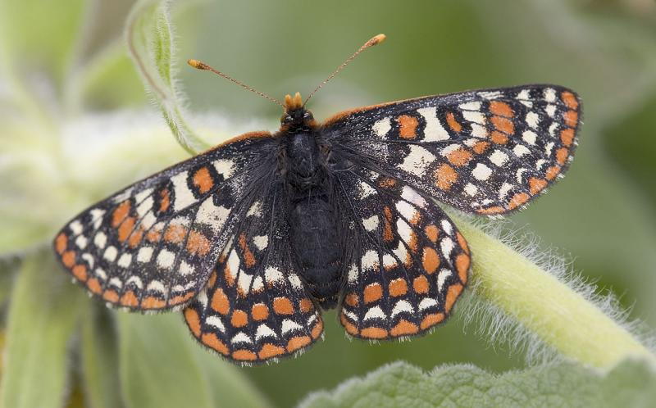*Why:* Taylor’s checkerspot butterflies are a Federally Endangered species, yet some of their life history and sources of mortality are not well understood. Fire, both wildfire and prescribed, is a historic part of the prairie ecosystem and a present management tool for the habitats in which these populations persist. Fire has large implications for Taylor’s checkerspot butterfly demographics, but we have virtually no information regarding the response of this species.

Photo credit: Rod Gilbert

* *When:* Late January- Late March during a few long days of field work, dependent on access to certain locations.
* *Where:* Extant Taylor’s checkerspot butterfly populations locations on JBLM.
* *How:* Randomized plot sampling within burned and unburned areas to look for caterpillars. Additionally, you may use already collected habitat, fire, and adult butterfly data to develop a more comprehensive analysis of larval responses.

Contact: Dan Grosboll [daniel.n.grosboll.civ@mail.mil](mailto:daniel.n.grosboll.civ@mail.mil) or 360-213-7847

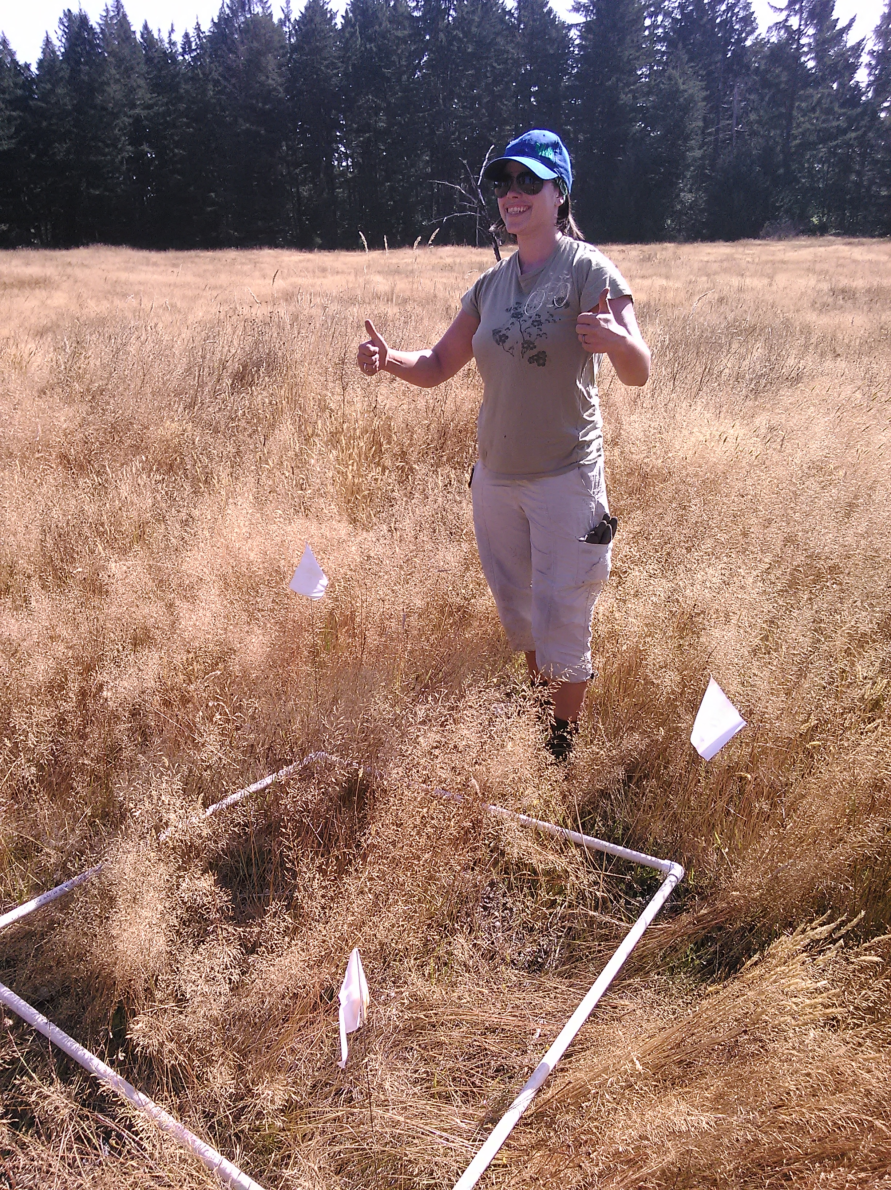**Prescribed Fire Fuels Monitoring**

* *Why:* Monitoring pre-burn fuel loading in prairies is a useful tool for land managers that are constantly striving to improve burn prescriptions to meet ecological goals. Fuel loadings can tell us many things including amount of CO2 released by burning, and can be useful for predicting the below ground soil temperatures, which are important for below-ground dwelling animals.
  + *When:* Field work in July-September 2016 after most prairie vegetation has senesced for the year.
  + *Where:* One or more prairies located on JBLM, in coordination with other prairie habitat monitoring projects
  + *How:* Collect fuel loading samples, dry, and weigh biomass. Use these data and previously collected data to correlate the effects of burn history on current fuel loading conditions. Compare these results to current fuel load modeling software such as “CONSUME” to develop South Puget Sound specific fuel models.

Contact: Sarah Krock [sarah.l.krock2.ctr@mail.mil](mailto:sarah.l.krock2.ctr@mail.mil)

**Prairie Reptile Monitoring**

* 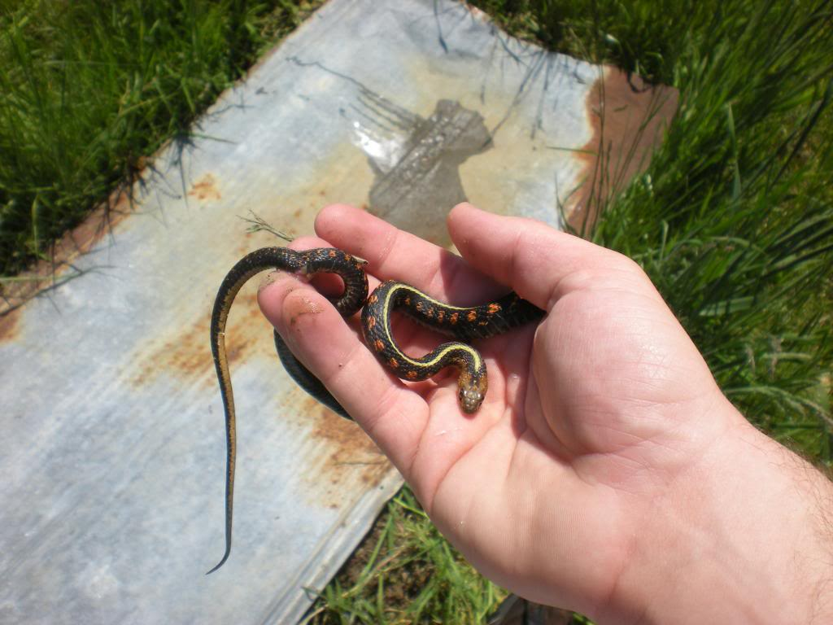*Why:* We are interesting in gaining a better understanding of how reptiles utilize burned and un-burned prairies by repeatedly checking cover boards- a common reptile monitoring technique. To date, reptiles in Western Washington prairies have not been well studied, so we want to understand their current distribution and habitat requirements.
* *When:* Identify study sites and place cover boards by March 2016 for proper acclimation. Monitor cover boards at least once a week April-September 2016

Photo credit: Joshua Wallace

* Where: Two or more prairies in Thurston County
* *How:* Using 2ftx2ft corrugated tin and plywood cover boards* you will identify reptiles that utilize these refugia. Additionally, use of thermal data loggers to determine critical thermal mass of different species. *\*May require additional funding for materials via student grants.*

Contact: Amber Martens [amber.f.martens.ctr@mail.mil](mailto:amber.f.martens.ctr@mail.mil)

**Invertebrate Community Response to Fire**

* **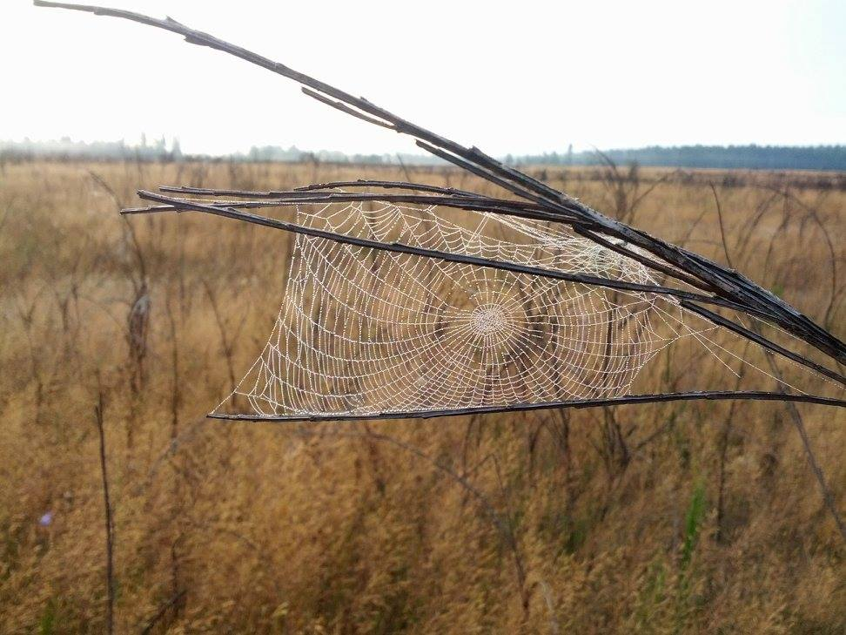***Why:* Understanding invertebrate community response to fire will give us a better understanding of Taylor’s checkerspot butterfly predators, as well as general fire ecology implications.
* *Where:* Potential Taylor’s checkerspot butterfly reintroduction sites across South Puget Sound prairies. There is the potential to investigate invertebrate communities in Clallam county (unburned only), and/or long-term unburned research plots on JBLM.

Photo credit Jerrmaine Treadwell

* *When:* Mid-April through early July, 2016 in order to capture invertebrates present during Taylor’s checkerspot egg and pre-diapause life stages.
* *How:* Extensive literature review to determine what is known about invertebrate predators of caterpillars. Field work includes setting up and monitoring invertebrate traps in paired burned and unburned prairie habitats. Identification of specimens will likely involve using available resources to identify at least into morpho-species groups.

Contact: Dan Grosboll [daniel.n.grosboll.civ@mail.mil](mailto:daniel.n.grosboll.civ@mail.mil) or 360-213-7847

**Kinnikinnick and Hoary Elfin response to fire**

* *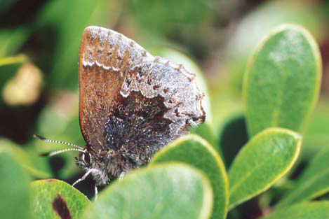Why:* Hoary elfin butterflies are a state monitored species that rely on kinnikinnick as their host and nectar plant. Hoary elfins are closely associated with patches of kinnikinnick in prairie ecosystems. Monitoring the response of kinnikinnick patches to fire and the subsequent response of hoary elfin will help guide prescribed fire management strategies in south sound prairies.
* *When:* Field work in May-June 2017.

Photo credit Dana Ross

* *Where:* One or more prairies located on JBLM, in coordination with other prairie habitat monitoring projects
* *How:* Monitor patches of kinnikinick with varying burn histories for presence of hoary elfin as well as classify kinnikinick patch characteristics.

Contact: john.f.richardson1.civ@mail.mil

**Natural Cavity Availability and Purple Martin Use on JBLM**

* *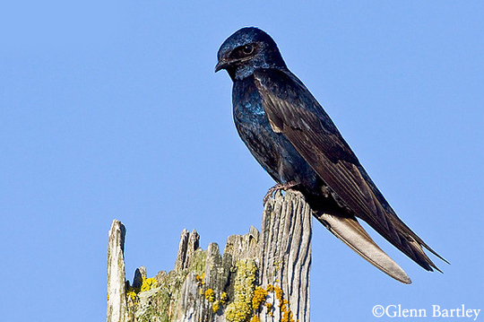Why:* The Western purple martin (*Progne subis*) is a species of conservation concern for the Department of Defense and for avian conservation organizations in the Western U.S. Purple martins, as well as numerous other avian and wildlife species, use snags for nesting in natural cavities carved out by woodpeckers. Incidences of natural cavities have declined significantly range-wide. Understanding more about available natural cavities on JBLM and how purple martins use them will aid in effective management of snags and natural cavity hosts as well as inform conservation efforts for the future.

Photo credit JBLM Fish

* *When*: Field monitoring will begin in April and end in July 2017. Snags and other natural cavity locations will be mapped in April, then surveyed a minimum of three times throughout the bird monitoring season (May-July) for purple martin use and nesting behavior. After mid-July, analyses of data collected will be conducted.
* *Where:* Multiple prairies and wetlands on JBLM, extending throughout the extent of the base.
* *How:* Use GPS software to collect snag and natural cavity data for later visualization and analysis in ArcGIS. Implement a monitoring protocol at snag and natural cavity locations to record the types of birds using the cavities, with particular focus on the purple martin. In addition, by performing behavioral observations on birds, information on cavity use for reproduction will be collected. These data will be presented to the Western Purple Martin Working Group and will be utilized in planning and management of prairie habitats. Knowledge of GPS data collection, ArcGIS, and bird identification by sight and sound is highly encouraged.

Contact: christa.l.legrande.ctr@mail.mil