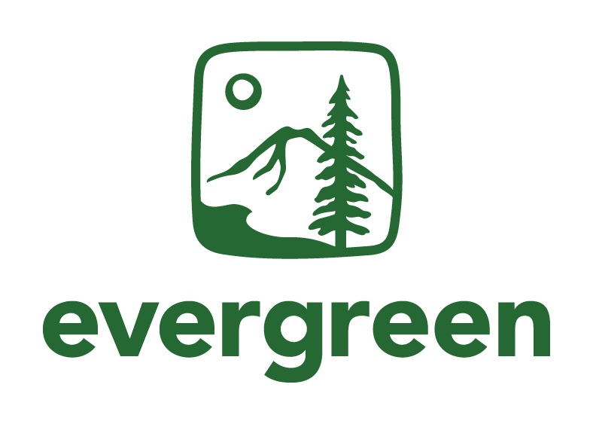
Outreach & Communications Assistant Position Description
Master of Environmental Studies

Reports To: MES Assistant Director

Hours: 15-19 hours per week. This position lasts for as long as the student is enrolled at Evergreen.

Compensation: $15.00/hour; paid in part or fully through work-study funds depending on student eligibility.

Start Date: Negotiable. Ideal start is September 1st, 2022.

Qualifications:
- Must be a current or admitted Evergreen student who is enrolled for at least 2 credits in fall, winter and spring 2022-2023.
- Excellent writing skills
- Excellent communication skills – phone, email and in-person
- Organized and detail-oriented
- Flexible and able to work with minimal direction, yet able to ask questions to clarify the task at hand
- Quick learner, able to take initiative
Preferred Qualifications
- Web design experience
- Social media experience (Facebook, Twitter, Instagram, LinkedIn)
- Interest or experience in developing outreach materials for the web such as promotional videos, interviews, blog posts, etc.

Job Duties:
- Responsible for maintaining MES Blog using Drupal, which requires writing weekly posts, interviewing people, asking students for contributions
- Work with MES Assistant Director to update Facebook, Twitter, Instagram and LinkedIn accounts with relevant MES content, and content from community partners
- Maintain and update social media and communications plan for MES with Assistant Director and MES Program Assistant
- Create videos or other interactive media for MES website to increase student recruitment
- Communicate with prospective students through phone, zoom, and email
- Attend outreach and recruitment events with Assistant Director and Program Assistant: Graduate Fairs, Conferences, etc. when needed.
  - Note: Outreach events will occur through virtual and in-person platforms but no large, in-person fairs or events will be attended if it is unsafe to do so during the pandemic.
- Other web-related outreach duties as assigned

How to apply:
- Submit a resume and cover letter with your interest to Averi Azar, MES Assistant Director by August 1, 2022, 11:59pm Pacific Time. Please email application materials to averi.a.azar@evergreen.edu. Interviews will be held the week of August 15th, 2022.

