**Adding Notes and Touches to a Contact Record in Radius**

1. Find the correct contact. I like searching by email in the Global Search Field whenever possible to make sure I’m getting the correct person.

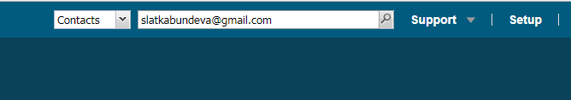

Select the correct student from the list of results:



1. Add the Notes and Touches Tab to your view of contact records. This take a few steps:
   1. Click on the Related Button button

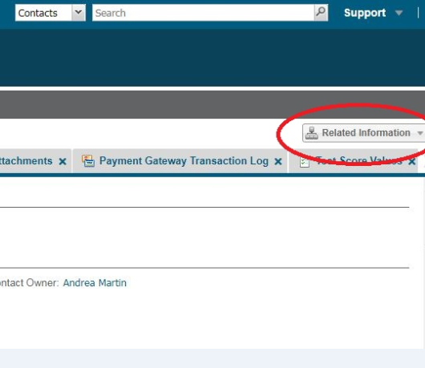

* 1. Select Notes and Touches from the list to add that tab

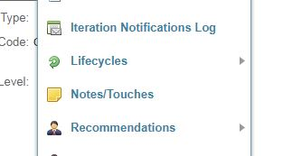

1. Click on the Notes and Touches tab, and then click the “New Notes/Touches” button

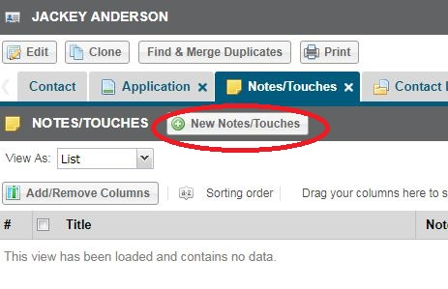

1. Once you’re in the form to create a new Note or Touch, please follow these instructions.
   1. Funnel Status: Use EITHER **Inquiry** or **Application Incomplete**. If you haven’t been told explicitly that you’re contacting prospective students with incomplete applications, please use Inquiry
   2. Note/Type Method: leave blank
   3. Note – Venue: Choose what’s accurate: Email, Mail, In Person
   4. Notes/Touch Content: Keep it brief but informative, and “sign” your initials and date
   5. Title: use the same title each time from this list:
      1. MES Ambassador Email
      2. MES Ambassador Phone Call
      3. MES Ambassador Student Meeting
   6. Notes/Touches Owner: This should default to you
   7. Related to: This should default to the Contact you selected

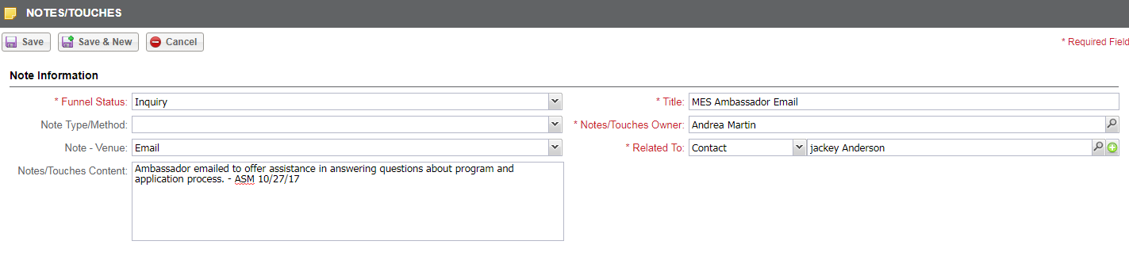

1. Make sure to save when you’re done. Congratulations! You know how to add Notes/Touches to a contact record!