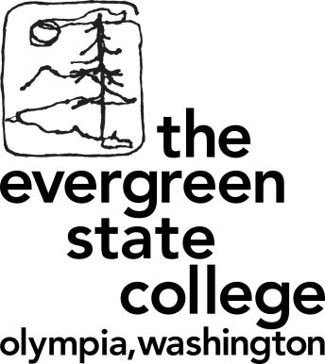**MES Ambassadors – 9/25/2017 Training Agenda**

**Goals:**

* **Go over Ambassador Job Duties**
* **Plan Fall Quarter outreach events and activities**
* **Logistics (training, getting paid, future meetings, etc.)**
* **(if time) Idea generation for future outreach**

1. **Job Duties**
   1. Meeting with prospective students
   2. Tabling at recruitment events
   3. Calling prospective students
   4. Supporting Admitted Student Afternoon
   5. Hanging posters; writing postcards
   6. Advising on recruitment strategies
   7. Helping with information sessions (as needed)
   8. Writing/editing blogs and/or posts for social media channels
2. **Attitudes**
   1. Sharing not selling
   2. Honest but not overly negative
   3. Enthusiastic but not desperate
3. **Expectations**
   1. If you sign up for an event or meeting, you will be there on time or will find another ambassador to fill your place
   2. You will share duties equally among each other. One ambassador should not be doing more than the others.
   3. You will check your email regularly for emails from Andrea and Averi about Ambassador needs, as well as the Google Doc schedule
   4. You will represent MES positively and will not give false information (if you don’t know, say so!)
4. **Training**
   1. FERPA
   2. Brochures
   3. FAQs
   4. Fall 2018 application dates- Oct 2 opens, January 15 priority deadline
      1. Updated requirements – no longer require the GRE. Additional essay (“Analytical Essay”) requirement
   5. Meeting with students
      1. Could be any time – only expected to meet for one hour, but can also add a tour if you want (official tours also given at 11am & 2:30pm from admissions). If later in the day, we usually take (or show) them to the first year core class at 6 so they can sit in on the first half of class. *Should we have set times that prospective students can meet with you?* 
         1. Items to include:
            1. Library services (library, finaid, reg/records, cashier, computer lab)
            2. Sem II
            3. CAB & Einstein Bros.
            4. CRC
            5. LH
            6. Health Center/Police
            7. Whatever else you want
      2. Food – will receive a coupon for Market or Einstein Bros. for you and guest - Andrea/Averi will provide
5. **Events**
   1. See Google Doc for list of current events
   2. Grad school fairs at Evergreen or Saint Martin’s
   3. Academic Fairs – every quarter
   4. Off-campus events
   5. See upcoming fall quarter events
6. **Communication**
   1. Google docs –Please sign up on google doc so I know if you can make it
   2. I will email you all if I don’t see that someone has signed up or if there is a short turnaround meeting
   3. You may decide to talk amongst yourselves to split up duties, as well
   4. Averi or Andrea will forward all 4 of you email messages from prospective students that come to [mescommunications@evergreen.edu](mailto:mescommunications@evergreen.edu). Please “reply-all” to let everyone know you’ll be reaching out to the email sender
7. **Calendar**
   1. Future meetings – Once a month for 1-2 hours
   2. Tabling and student meetings – see google doc
   3. Ambassador “events” (e.g. writing postcards to prospective students) – what’s the best method for everyone?
8. **Reaching out to prospective students**
   1. Use Radius database to access prospective student contact information – future training
   2. Call interested students/applicants to see if they have any questions, remind of application and other app requirements
   3. Send postcards to prospective students – remind about application opening and/or priority deadline
   4. To decide - tracking progress; follow-up emails
9. **Admitted Student Day – late March 2018**
   1. Ambassadors will help with panels, finding off-campus housing, tours, and social events
   2. Call admits to invite
10. **Getting paid**
    1. Average of 5 hours/week at $11/hour, $550/qtr
    2. Current student employees should track their hours personally for submission during break/eval weeks
    3. Tina Pearson, 3rd floor library
11. **Next steps**
    1. Plan postcard writing
    2. Set next Ambassador meeting
    3. Evergreen Grad Fair
    4. Write one blog each about research interests/summer internships/experience in MES by November 1
    5. Bio to Josh by Tue, Oct 4