**Annual Report (2014-2015)**

**Graduate Program on the Environment / Masters of Environmental Studies**

**Kevin Francis (Director), Gail Wootan (Assistant Director)**

Written by Kevin Francis

The Graduate Program on the Environment (“MES”) is successfully recruiting and educating students for a diversity of environmental careers. This document provides an overview of faculty and curriculum, student and alumni engagement, budget and fundraising, and student recruitment and retention. For the most part, we think the MES program is an effective model of educating environmental professionals at the graduate level, but we also want to take this opportunity to focus on particular challenges and areas of innovation and movement.

**Faculty and Curriculum**

Six core faculty (5.5 lines) provided instruction in core courses, thesis advising, internship sponsorship, and six electives: Peter Dorman, Erin Martin, Dina Roberts, Kathleen Saul, Shangrila Wynn, and Kevin Francis (director with split appointment between administration and teaching). Last year one faculty had a split appointment between the undergraduate and MES curriculum; a key improvement this year is that all core faculty had full-time positions dedicated to the program.

This number of faculty lines is the minimum staffing required to provide a strong educational experience for incoming cohorts of 45-48 students, as we had this year and plan to have in future years. Under this model, each core faculty typically teaches two 8-credit core programs and one 4-credit elective in addition to advising thesis students. (As director, my teaching included one 8-credit core program, one 4-credit elective, and the thesis workshop during winter and spring quarter.)

The successful hire of a dedicated faculty, Erin Martin, was an important step toward stabilizing the core faculty. This year we plan to search for a second dedicated faculty who will compliment Erin’s expertise within the natural sciences. Next year we plan to search for an environmental social scientist. A team of dedicated MES core faculty is important for both long-term stewardship of the program and recruitment of new students.

Seven adjunct faculty provided instruction in seven electives: Richard Bigley (Sustainable Forestry), Sarah Hamman (Restoration Ecology), Paul Pickett (Water Management), Mike Ruth (Introduction to GIS, Advanced GIS), Timothy Quinn (Conserving and Restoring Biodiversity), Scott Morgan and Lola Flores (The Value of Natural Capital)[1].

In addition, teaching assistants provided valuable academic support in argumentation and writing (fall, winter, spring), statistics (spring), and GIS (spring).

**First-Year Core Sequence**

The fall 2014 cohort had 45 students enrolled in gCORE (fall), 42 enrolled in ESS (winter), and 40 enrolled in RDQM (spring). At this point, 35 students have successfully completed the requirements for the first-year core sequence and can enroll in the second-year core sequence.

The first-year sequence, as a whole, provides a solid foundation in many disciplines within environmental studies, as well as sustained emphasis on academic skills such as argumentation and writing, collection and synthesis of scholarship, experimental design and statistical analysis, collaborative problem-solving, and public speaking. My sense from student feedback is that most students found these courses challenging and rigorous, but ultimately manageable.

Two requirements were especially difficult for a substantial handful of students: the candidacy paper in ESS and the course material and some assignments in RDQM. One reason is that the faculty worked hard, individually and as a team, to hold all students to consistent and high academic standards. Among other things, this goal involved ongoing discussions about standards for student work and review of borderline student work by multiple faculty. All students eventually submitted adequate candidacy papers, but the core faculty should continue to explore ways to improve student preparation in gCORE, communicate the expectations for the candidacy paper, and provide supportive mentorship throughout this process. Five students did not successfully passed RDQM (one has a pending incomplete) and will need to retake the course in order to continue in the program. Although each student’s situation is unique, the increased number over previous years warrants some exploration as the faculty team develops the next iteration of RDQM.

I will take two concrete steps in the next month that will help faculty build on the strengths and address some of the weaknesses of the first-year sequence. First, I plan to distribute a survey to this cohort about their experience. We received course evaluations from almost every student in gCORE that provided specific feedback that we are incorporating into our course planning for the coming year. However, we did not receive systematic end-of-course program evaluations for ESS and RDQM. Such feedback from the cohort who recently completed the first-year sequence will be valuable as the faculty modify ESS and RDQM for the upcoming year. This year I would like to work with the faculty to incorporate the collection of such feedback a continuing element of administrative and faculty practice in MES. Second, I plan to organize a workshop on graduate-level writing instruction and evaluation with Michael Radelich of Evergreen’s Writing Center. We have discussed the value of this workshop as a faculty and we are hoping it will enable all of us to provide better feedback throughout the candidacy paper and thesis process.

**Second-Year Core Sequence**

Case Studies had 34 enrolled students embarking on their thesis. In Spring Quarter 27 students successfully gave their thesis presentations and almost all officially graduated. Those that did not present or finish in the Spring are expected to finish in Summer or Fall 2015. This record of completion is a testament to the diligence, mutual support, and sense of community among students, as well as strong advising and hard work by the Case Studies faculty team and the faculty readers.[2]

After the submission deadline, I invited students to provide feedback on the process through survey monkey and received responses from 22 students. (Summary of results in separate document.) Here are, to my mind, the most important results:

* Many students said the thesis opportunity attracted them to the MES program: 50% agreed or strongly agreed that the thesis was a major reason for enrolling in MES; 45% were neutral.
* All students view the thesis as an important contribution to their intellectual development and professional development: 100% agreed or strongly agreed with statements along these lines.
* The biggest source of dissatisfaction and frustration with the thesis process was connected to the focus / organization of Case Studies and the compressed timeline for research and writing.
* Research costs were variable ($0 to $3500). Research grants (external and internal) covered many, but not all, of these expenses.

The faculty anticipated the sources of dissatisfaction and frustration since they reflect longstanding points of tension. We began a proactive approach to these issues through a collaborative redesign of Case Studies and Research Design, which has received a fair amount of student criticism over the past several years. Basically, by this point in the program most students want to launch into their thesis research and are frustrated and restless with too much emphasis on what they see as tangential topics. The Case Studies revision aims to create more time for students to work on developing and starting their thesis research within the broader framework of introducing students to research methods and skills that are employed across a wide range of environmental problems. An important component is to move the deadline for the thesis prospectus closer to the beginning of the quarter and have students work with their assigned faculty readers earlier in the quarter to finalize their prospectus and begin their data collection.

Finally, we are taking steps in the first-year sequence to initiate students to begin serious thinking about thesis topics during their first quarter. For each of the past three years we have held a Thesis Idea Fair, where local agencies and NGOs visit with our students and share potential research topics. The first year we held this event in April and the second year we held this event in January. Now we are planning to hold it in November in order to provide students time to consider thesis topics prior to their candidacy paper, so that they are in a better position to focus on potential thesis topics. In addition, we are incorporating the development and submission of a preliminary prospectus as a formal requirement for students who want to begin collecting data during the summer between their first and second years in order to make sure that there is sufficient faculty oversight of this process prior to extensive data collection. As part of this effort, we hope to increase the emphasis on this option within RDQM to help students think through potential research projects and experimental designs and to relieve pressure on faculty, especially those who teach in the natural sciences, who are working with increasing numbers of students who want to start their thesis research over the summer.

I will survey students next year to see how they respond to these changes.

**Electives**

Most adjunct faculty have primary work responsibilities outside academia and bring connections and experiences that are vital for student professional development. Most core faculty use electives as a way to teach key areas of expertise in greater depth than allowed in the core sequence. Both are valuable contributions to our students.

Mean enrollment for all electives this year was slightly above 14.[3] Enrollment figures below show high demand for most electives, and many were overenrolled with faculty permission. Core and adjunct faculty in the program have discussed the administration’s proposal of increasing standard enrollment to 20 students. The consensus among our faculty is that the increase from 15 to 20 students would degrade the seminars, field trips, and project advising that are key elements of many electives. At the same time, individual faculty have been very cooperative in providing additional seats for students when there is high demand for their courses. In some cases, such as Introduction to GIS, high enrollment was anticipated and we provided additional support through a paid student teaching assistant and volunteer GIS professionals recruited by the primary instructor.

|  |  |  |
| --- | --- | --- |
| **Enrollment in MES Electives (14-15)** | | |
| QUARTER | COURSE | ENROLLMENT  (MES,MPA) |
| Fall | Advanced GIS | 15 |
| Fall | Conserving and Restoring Biodiversity | 18 |
| Fall | Cost-Benefit Analysis | 11 (10,1) |
| Fall | Sustainable Forestry | 17 |
| Winter | Environmental Communication and Rhetoric | 15 |
| Winter | From Electrons to Renewable Energy Credits | 3 |
| Winter | Restoration Ecology | 17 |
| Winter | Water Management | 13 |
| Winter | Wildlife Conservation and Policy | 8 (6,2) |
| Spring | Aquatic Ecology | 15 |
| Spring | Climate Justice | 15 |
| Spring | Introduction to GIS | 22 (20,2) |
| Spring | The Value of Natural Capital | 14 (7,7) |
| Summer | Research Design and Qualitative Methods | 7 |

The two most popular courses this year in terms of early registration were Advanced GIS (Fall) and Restoration Ecology (Winter), with full waitlists in both classes. I addressed the GIS demand by working with Mike Ruth to develop a two-quarter GIS sequence with Introductory GIS in the spring and Advanced GIS in the fall. With this new curriculum, I persuaded many first-year students to wait until spring to begin taking GIS coursework in order to create space for second-year students who required this course for their thesis research or professional aspirations. Based on enrollment in Introduction to GIS (Spring 2015) and upcoming enrollment in Advanced GIS (Fall 2015), this two-course sequence appears to be a appropriate solution to address student demand. I addressed the Restoration Ecology demand by revising our tentative elective offerings for the upcoming year in order to offer this course again in Fall 2015. We have managed enrollment in both Advanced GIS and Restoration Ecology for this fall through signature requirements to make sure that sufficient space exists for second-year students.

As these examples illustrate, one challenge with electives is finding the ideal combination of electives for each quarter. Winter quarter was the best example of how we did not anticipate student demand. In addition to having at least 30 students who wanted to enroll in Restoration Ecology, I offered an “additional” elective to provide support in argumentation and writing for students who were struggling with these academic skills. During the previous two years, the core faculty identified argumentation and writing as the primary hurdle for a handful of students who arrive in the program without adequate academic preparation in these areas. One consequence of offering this fifth elective is the mean enrollment for winter quarter electives was lower than other quarters.

**Internships**

Faculty sponsored 49 internships and 11 independent learning contracts. Internships are a key educational component of our program, but we currently do not have an ongoing system for compiling and tracking internship contacts and patterns over time. Gail has developed a preliminary database. As the person who approves internships, one of my unmet goals as director last year—and thus a goal for the coming year—is to develop and track internships in a more systematic way.

**Student Engagement**

MESA continues to be an active organization that builds community through service events, social events, field trips, special events like the Rachel Carson Forum, and support for student participation in academic conferences. MES students attended CONFOR West in Friday Harbor, where many students presented their work and MES adjunct faculty Richard Bigley was a keynote speaker. MESA received funding for these events through Student Activities, as well as extensive fundraising efforts like selling chocolate and sweatshirts. MESA has also contributed to the student experience by conducting mid-quarter evaluations of each core program and coordinating with the faculty team to identify and discuss concerns.

Field trips are another way to build community among students. We are currently planning a joint three-day field trip to the Olympic Peninsula for both cohorts. We are hoping to introduce students to important sites in this area and provide the opportunity for building stronger connections between the two cohorts.

**Alumni Engagement**

We celebrated the 30th class of MES graduates with two major events in April. We had an on-campus brunch with a formal program and an off-campus evening event. Both were well attended, with a combined attendance of around 180 people that included 6 directors, 20 faculty, 80 alumni, and 40 current or prospective students. This event required an extensive commitment of resources and time beginning the previous summer, but served an important purpose of reconnecting alumni, faculty, and current students with the MES program. We plan to continue to engage alumni through events like the Rachel Carson Forum as well as one or two social events each year. Our first event is a September event at Fertile Grounds for incoming students, second-year students, and alumni.

Another goal for the coming year is to survey the last two graduating classes about their employment status, so that we have more comprehensive information about how our students fare after they graduate.

**Budget and Fundraising**

Our current budget covers the basic requirements of the program. However, we could improve the MES program with additional resources to devote to key areas. The 30th anniversary celebration sparked conversations with MES alumni and former directors and faculty about ways that they could support the program. Two former directors suggested that the MES faculty develop a list of fundraising goals to share with potential donors. Our current list, which I will flesh out following a training on fundraising by Evergreen’s development office, includes 1) scholarships, 2) support for student thesis research, 3) support for faculty research, especially where this research aligns with potential thesis projects, 4) funding to support enrichment activities (e.g. long-range monitoring protocols or data analysis techniques) outside the expertise of current faculty, 5) support for faculty expenses to visit students at the field sites of their thesis research. In addition to fundraising among MES alumni and former directors/faculty, I am also collaborating with the MPA program to create a GIS course that will provide funds for some of these program objectives.

We also envision some expansion in laboratories and field excursions as part of the evening curriculum (both in the core sequence and electives), which would require increased SIT capacity and a likely increase in program expenditures.

**Written by Gail Wootan**

For 2014-2015, our recruitment dollars were spent on a combination of various events and web marketing. We continued to pay for a profile on gradschools.com, which is one of our primary feeders for inquiries. In conjunction with the other graduate programs, we also advertised with AmeriCorps Alums through one of their monthly newsletters (in Fall 2014, 14% of our total student body were AmeriCorps alumni, 16% of the Fall 14 cohort were AmeriCorps alumni, and so far 22% of the Fall 2015 cohort are AmeriCorps alumni). In addition to monthly info sessions (including one in Tacoma), which have been very successful in recruiting students, we also attended the following events:

* National Conference on Undergraduate Research (NCUR)
* Northern and Southern California Diversity Forums (including visit to San Diego State University, San Diego University, and Soka University)
* Tacoma Sustainability Summit
* University of Santa Cruz grad fair (including visit to Santa Clara University)
* South Sound Science Symposium
* AASHE (Association for the Advancement of Sustainability in Higher Education)
* St. Martin’s/Evergreen Career and Grad Fairs
* Storming the Sound

Most of these events yield a large number of inquiries, but so far we have not seen many applicants from these fairs. As such, our focus for 15-16 will be on more Washington recruitment, but we will continue to attend AASHE, NCUR, and local fairs because we also get a large number of applicants through word of mouth.

In addition to recruitment events, the program continued to hire 3 ambassadors. These students helped plan our third annual admitted student day (28 attendees), which this year was planned in conjunction with the MES 30th Anniversary. Ambassadors also meet in person and over the phone with prospective and admitted students. The MES Ambassador program is a key component to our recruitment and yield strategy, and also gives paid leadership positions to current MES students.

Due to all of these recruitment efforts, MES received around 700 inquiries for Fall 2015, and currently have 95 applicants, 10 more than Fall 2014. We also had the largest number of nonresidents (41). Despite the larger number of applicants, we expect to see about 45-47 students start in the Fall 2015 cohort. It is evident that a larger percentage of nonresidents in our applicant/admit pool means that our total yield will go down, since the 5-year average yield for nonresidents is 44.2% (compared with 68.7% for residents). In addition, surveys of admits who decide not to come to Evergreen indicate that the top reasons are that Evergreen was not their first choice and that other institutions offered more financial aid.

As for financial aid, Fall 2014 nonresidents who applied for aid received an average of $5,800 and residents received an average of $3,180. For Fall 2015, these numbers went down to $4,759 and $2,232, respectively. The average resident award went down primarily because the Evergreen Need Grant was reduced to $2,100 instead of the usual $2,700. The eligibility criteria also became stricter, thus reducing the number of students who received it. Because Fall 2015 saw such a large number of nonresident applicants (and because of the reduced Evergreen Need Grant), we successfully lobbied for $29,500 more in tuition waivers (over our usual $75,000). However, by the time the waivers had been approved, the students we had hoped to convince to come had already made a decision not to attend. Some of the waiver funds were approved to use for second year students. It remains to be seen if they will all be used for 15/16. At this time, about $8,000 of the $29,500 has been awarded.

In the 2013-14 report, I had indicated that MES would implement a new customer relationship management system called Salesforce. This ended up not happening with the primary reason being that Evergreen decided to purchase CRM software through Hobson’s (called Radius) that will be implemented for 15-16.

As for retention, out of the 40 students who started in Fall 2013, 34 returned for Fall 2014 (not counting students on leave of absence). In Fall 2014, a total of 45 new students enrolled and 41 enrolled for Spring 2015 (one of these students did not enroll in RDQM because he is part-time). We do not have final numbers for students returning for Fall 2015. In addition, the total headcount of MES students in Fall 2014 was 101. The average FTE for 2014-15 (Fall, Winter, Spring) was 91.

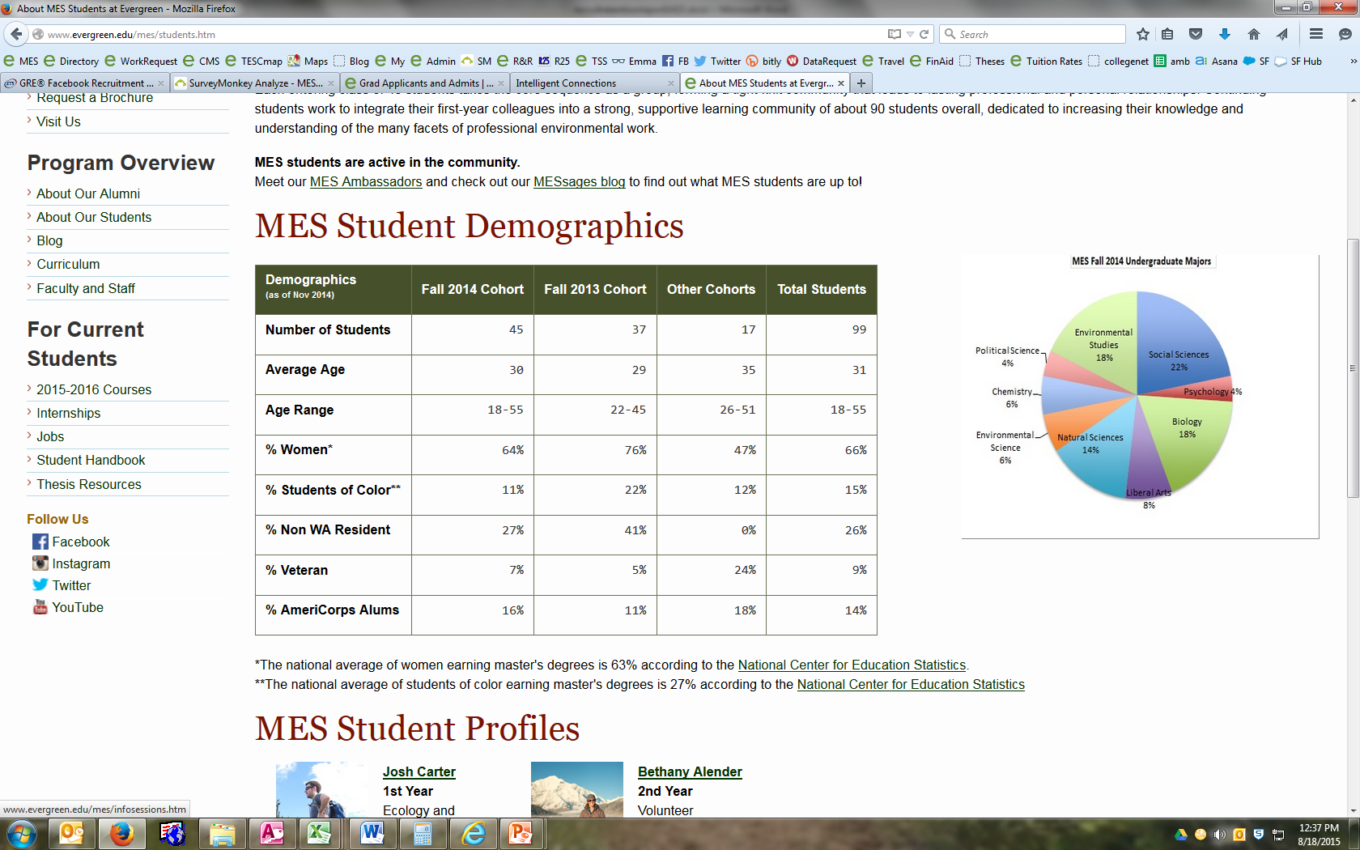

1. Elective was joint offering between MES and MPA.
2. Note that students on the three-year plan take Case Studies their second year and complete their thesis the following year, so Case Studies enrollment and completed thesis numbers do not map precisely on each other. That said, we anticipate timely thesis completion rates between 90% and 100% for the year.
3. This number does not include the summer elective.