**The Graduate Program on the Environment in Indian Country**

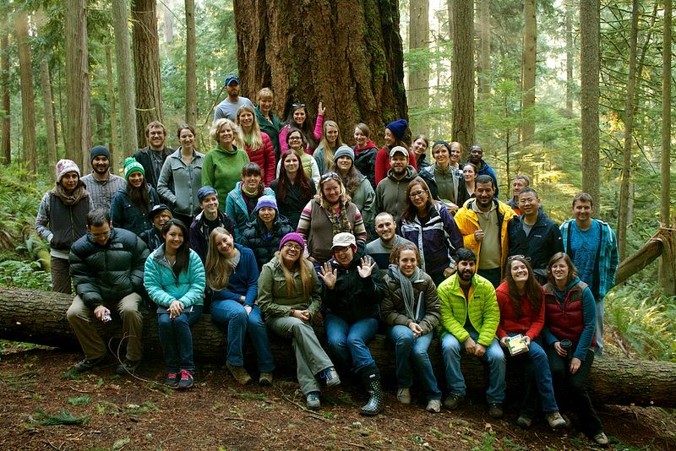

Evergreen’s Graduate Program on the Environment, offering the Master of Environmental Studies (MES) degree, has a long history of supporting Native students, communities, and natural resource issues directly related to Puget Sound tribes. The unique relationship between tribes and Washington State, as well as federal agencies, defines the natural resources and habitats of western Washington. The most significant message MES faculty convey is that all natural resources and habitats must include the goal of harvestable resources at the time of treaty making.

MES students on a field trip to Pack Forest in Fall 2013.

Over the years, MES has had faculty with advanced training in Indian-federal relations, western Washington habitats, and methods of management including Geographic Information Systems. These faculty members have included information about Indian Country in their lectures, on field trips, and in supporting student research. Students in the program are required to finish a thesis project as part of their degree, and several of these have been directly related to tribal environmental issues.

A number of the program’s graduates currently work as biologists or administrators for tribal governments in Washington and other states, including the Muckleshoot Indian Tribe, Squaxin Island Tribe, Nisqually Indian Tribe, and Louden Tribal Council in Alaska. We also currently have an alum who serves as a tribal liaison to the Oregon Department of Environmental Quality and a handful of students have interned or worked at the Northwest Indian Fisheries Commission. The graduate program is also proud to have Billy Frank, Jr. as an honorary degree holder.

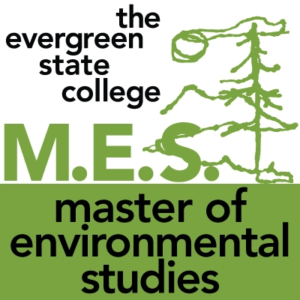Since our start in 1984, we have graduated nine Native students. By Fall 2014, we expect to have five Native students enrolled out of approximately 100 students. One of our current Native students received the Sara Ann Bilezikian Fellowship, our most prestigious scholarship equal to two years of study. In the future, we look forward to continuing to serve tribal members as students in the program and collaborating with tribes on resource management projects through internships or thesis projects

.