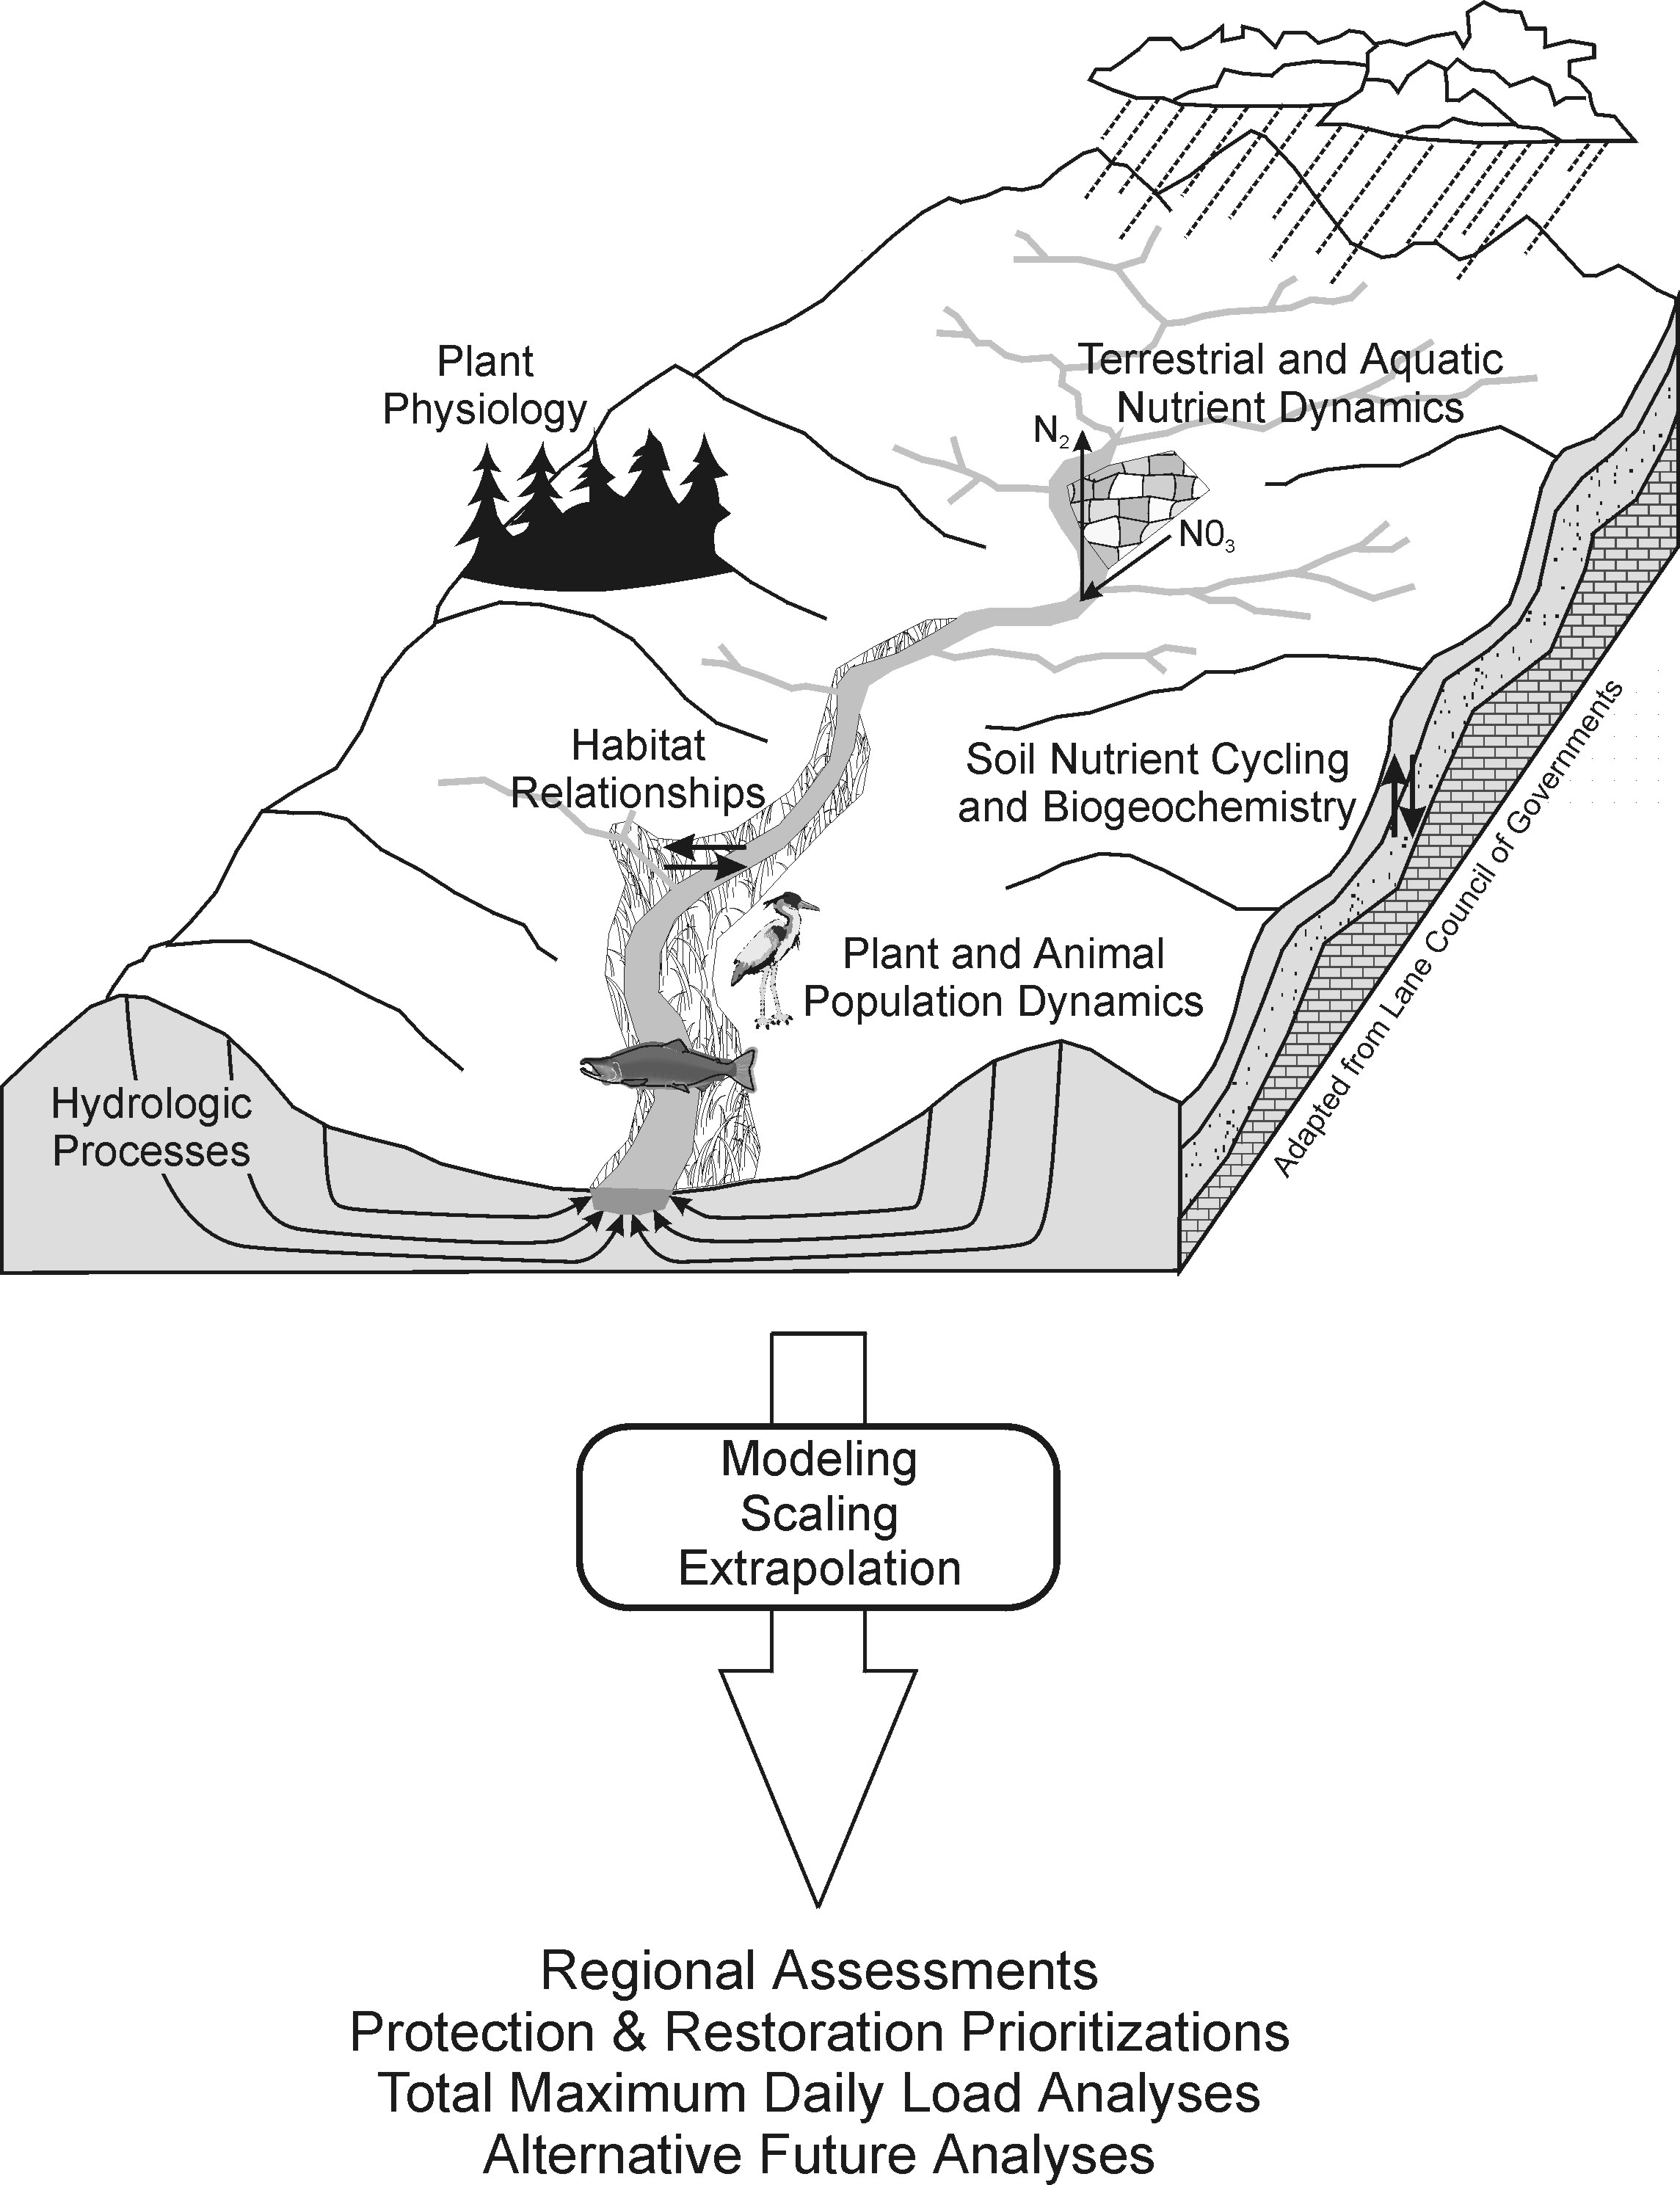

***Basin, Region***

***Plots, Stands***

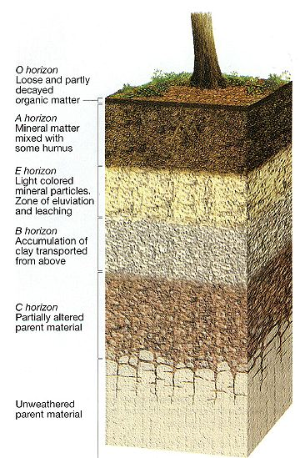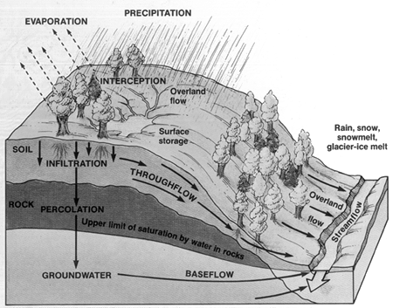

***Hillslopes, Catchments***

snobear.colorado.edu/IntroHydro/hydro.gif

Fig. 1: Eco-hydrologic modeling: Integrate & Scale Up Data from Plots to Region, from Days to Centuries

|  |  |  |
| --- | --- | --- |
| Visualization of N Uptake Data_view1 | 3D Water Visualization - Frame 21 | ws01 2006 run_10Oct08 |
| a. Effect of tree size & competitors on N uptake in a 400-yr forest. Visualized patterns not evident in raw data provide new insight into forest habitat structure. | b. Soil moisture patterns for a headwater catchment visualized on 3D topographic data help scientists calibrate simulation models used for scaling up experimental data in space and time. | c. Visualizations at basin scale help users understand & communicate climate change & forest harvest: stream network, soil moisture, stream water quality & quantity. |
| Fig 2: The VISTAS prototype helps scientists display & interpret data. From left to right, visualizations a) 0.1 km² forest stand, b) 1 km² catchment, c) 64 km² basin. (b) & (c) can be animated showing change over time. | | |