**Volume 5, Issue 2**

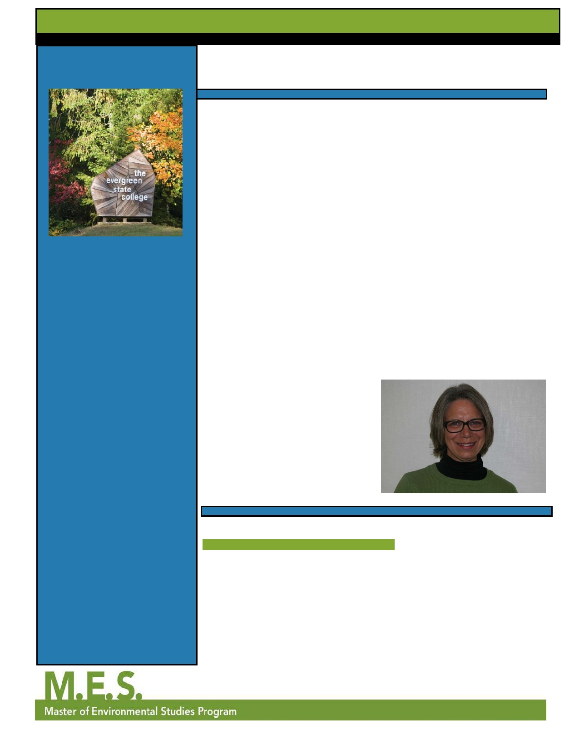

**Master of Environmental**

**Studies Program**

**MESsages**

**Letter from the Director**

**Winter 2012**

I recently had the opportunity to attend

three conferences on the East Coast. One

of the joys of academic work is getting away from your home institution and

ways of seeing the world. Traveling from our beloved Evergreen State College on

the edge of the Olympic Peninsula to

Washington, DC to attend the National

Council for Science and Environment

meetings, to Yale University in

what we assumed would be just food

systems and equal access to clean water.

We were hoping to bring home ideas

for curriculum and internships for the

MES program and its students. We were,

to use a word that hardly characterizes our thoughts, surprised to find plenary

sessions and working sessions focused on

the military security of industrial food producers, neo-Malthusian population

**Director:** Martha Henderson

Connecticut to attend an environmental

predictions, and research funded by

**Assistant Director:** Gail Wootan history meeting, and to Manhattan

**Contact MES:** (360)867-6225 or for the Association of American

known arms and weaponry companies.

The misuse of old data, avoidance of

mes@evergreen.edu

Geographers annual meeting is a

reality check. Not only are the physical

contemporary scientific thinking that

focuses on protecting users of ecosystems

**Editors: Robyn Andrusyszyn &** diertcepcesnrofat, theingsttaonmabetweeenorld

s an g e di ce my and species, and assumptions about how

p tio work ke th w

**Aaron Zimmer**

"The human race is challenged

more than ever before to

demonstrate our mastery - not

over nature but of ourselves"

- Rachel Carson

Inside This Issue :

more environmentally just is remote

compared to what many environmental professionals are working towards.

Attending these meetings has forced me to reconsider what our MES program is about and how we are aligned with other academic and professional organizations that identify as 'green' or 'environmental.'

The NCSE meeting was subtitled

"Environment and Security." MES

Assistant Director Gail Wootan also

to control specific human populations

who are defined as a liability in the

coming world resources food and energy fight was a traumatic experience.

***continued on page 3***

Letter from the Director 1 attended this meeting and we were

looking forward to hearing more about

Antarctic Adventures 1 ***Martha Henderson***

Sustainable Prisons Project

VISTAS

Alumni Corner

Rachel Carson Forum

Financial Aid Changes

Recent MES Grads

2

4

5

6

6

8

**Martha and Gail's Excellent Adventure**

By Gail Wootan, MES Assistant Director

I'm sitting on an undulating magic carpet of ice chunks, which extends into

oblivion, silence piercing the air. Ignoring my frozen fingers, I slowly lift up

my paddle and slice through the white fabric, leaving a ribbon of midnight blue

water in my wake and filling the silence with the satisfying crunch of plastic

on sea ice. As I near the shoreline, I see penguins jumping like dolphins a few

meters ahead of me, so I draw closer and watch them gracefully swim under my kayak through the clear, almost tropical-looking, water. The squawk of penguins

***continued on page 7***

page 1

**Volume 5, Issue 2**  **Winter 2012**

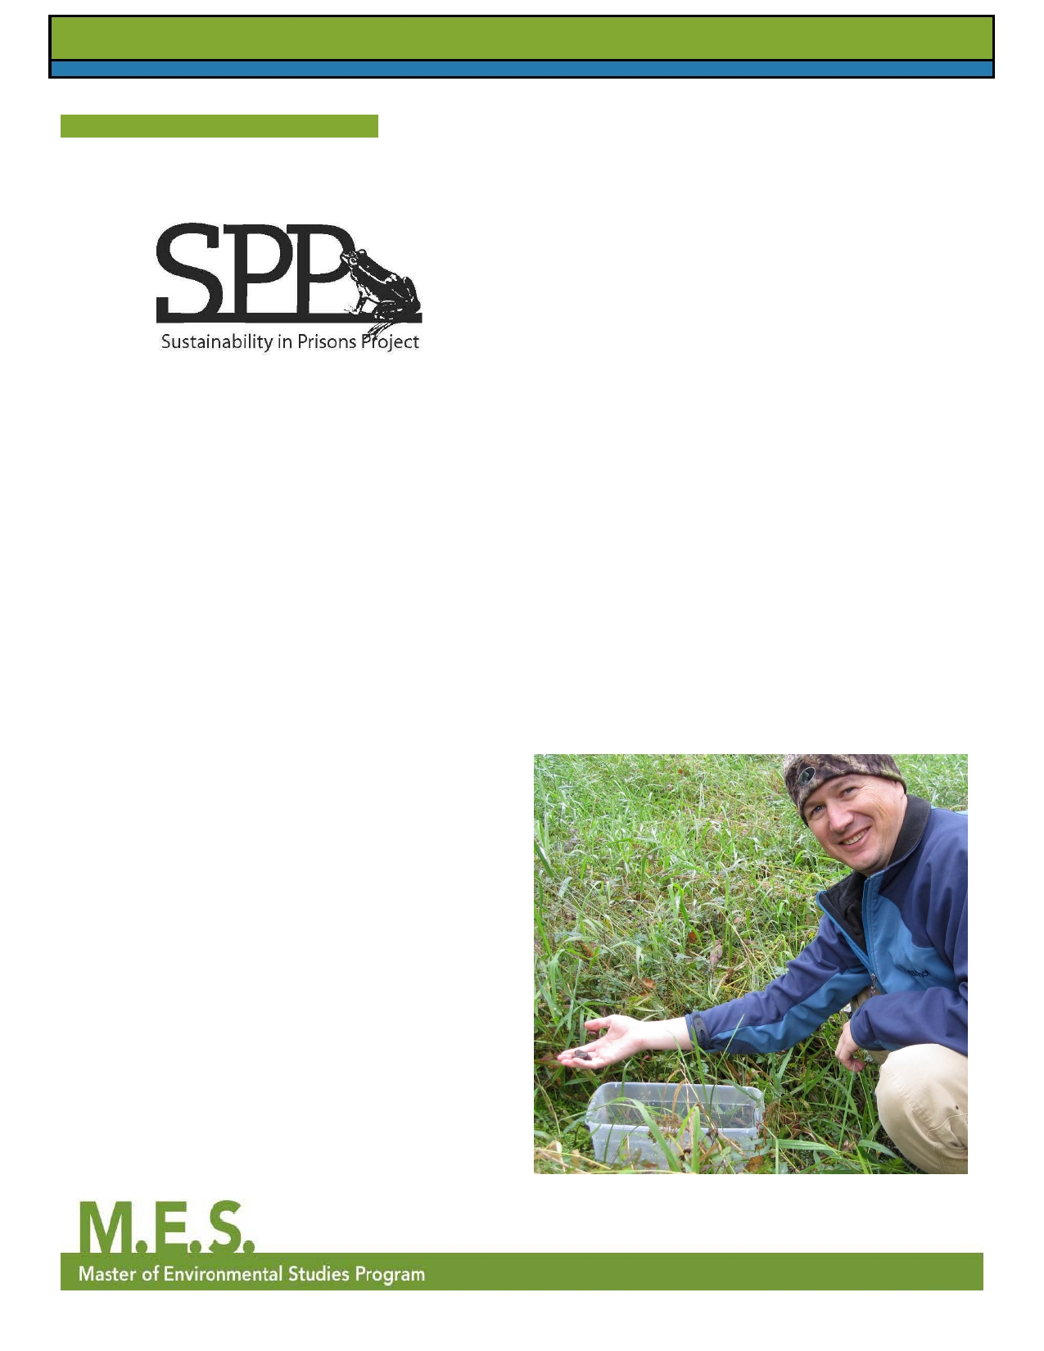

By Brittany G lagher, MES 1st Year **Student**a**Involvement in the Sustainable Prisons Project**

**The Sustainable Prisons Project (SPP) Interview with**

**Brittany Gallagher**

**What is the primary objective of the Sustainable Prisons**

**Project?**

SPP "brings science into prisons." We aim to reduce the economic, environmental, and social costs of prisons by inspiring and educating prison inmates and staff about conservation and sustainability.

**As a graduate student, what is your role in achieving the**

**objectives of SPP?**

SPP employs graduate research associates to work on various projects in partnership with the prison(s) and

community partners. Each one of us is "in charge" of a conservation or education project.

**What projects are MESers currently working on?**

I coordinate a sustainability lecture series at two prisons,

which involves recruiting scientists and others who

work on all matter of environmental topics to share their knowledge and experience with prison inmates. Dennis

Aubrey is working at Mission Creek Corrections Center for

Women on the captive rearing of the endangered Taylor's checkerspot butterfly. Andrea Martin works with inmates

at Cedar Creek Corrections Center raising endangered

Oregon spotted frogs. Evan Hayduk and Carl Elliot, also MESers, work with inmates at Stafford Creek Corrections

Center, where they are growing six types of endangered prairie plants.

**What excites or inspires you most about working with**

**SPP?**

I'm happy to be a part of an organization that serves and

empowers people who have been largely forgotten or given up on by the rest of society.

page 2

**How does your work relate to MES? Or, how has MES**

**helped you with your work?**

SPP was one of the things that drew me to Evergreen,

because it combined environmental education and social

justice. It lets us apply what we're learning in MES courses to the real world.

**What are the hopeful impacts of SPP?**

We hope to show that working with SPP helps inmates find something positive to do with their time, both while they're

in prison and after their release. We will be doing a study

this year on recidivism rates to see if people who participate

in our programs are less likely to re-offend after they are released from prison. Through publicity of our projects,

we'd like the general public to see that conservation leadership can arise from unlikely places.

SPP also wants to inspire positive change toward

sustainability in the way prisons operate (by reducing

energy use and waste, for example). Finally, our

conservation programs are making a big impact on the restoration of their target endangered species.

*For more information about SSP, please visit*

*http://blogs.evergreen.edu/sustainableprisons/*

***Dennis Aubrey, an MES Student,***

***releasing Oregon Spotted Frogs***

**Volume 5, Issue 2**  **Winter 2012**



**Letter from the Director (continued from page 1)**

Two weeks later I found myself in an academic meeting with

the best environmental history and historical economists

on the East Coast. Proudly, the invited speaker was Richard

White from Stanford University, a great supporter of

Evergreen and the MES program for years. Professor White

talked about the American West and the role of the 1860s railroad building process that was instrumental in making

western resources accessible to eastern businessmen. In fact,

the railroad companies operated in a deficit and were able to survive because of American bankruptcy processes that

protect corporations rather than labor or resources. The rest of the talks were about essentially the same level of coercion, collaboration and collusion in Roman and Chinese dynasties.

I once again heard a belief in Malthusian population

dynamics, the need to protect resources for exploitation by

specific class, race and gender groups, and predictions of what could happen given the historic models of political

control that mediates humans and the environment. I began

to wonder how our MES program fits into this dismal arrangement.

My last stop on the conference tour was the Association

of American Geographers meeting. I have been a member of the AAG since 1974; have served as a chair on one of its

committees; and have given papers at its meetings since my grad school days. The AAG, like many social science

organizations, has had to face some difficulties with regard to

human rights and research agendas that have not protected

human subjects, cultural identities or access to resources.

As a member of the AAG Focus Group on human rights, I

attended a working session led by the American Association

for the Advancement of Science with Jessica Wyndham,

Associate Director of the Scientific Responsibility, Human Rights, and Law Program. The AAAS has long worked to

support the United Nations Universal Declaration of Human

Rights. On April 16, 2010, the AAAS Board of Directors

adopted the following statement: "On the human right to the

benefits of scientific progress."

I found the AAG focus group members to share my concern

for the misuse of science. Our expressed concerns addressed

the rights of all humans to have access to the best scientific

data and means of analysis. We underscored the need for vigilance in using the Human Subjects Review process.

Finally, we asked that environmental justice be placed in

funding reviews by the National Science Foundation. I

requested that human rights be extended to all species and

that NSF and other government agencies promote the usage

of "Earth" rather than the common practice of "the earth."

The last plenary session at the AAG included talks by the

*New York Times* editorial writer Nicholas Kristof, Secretary

General Salil Shetty of Amnesty International, and Ivan

Simonovic, Assistant Secretary-General for Human

Rights, Office of the UN High Commissioner for Human Rights. These talks were sobering yet encouraging. Kristof

encouraged us to see the world through the eyes and

experiences of individuals if we expect to make change.

Shetty applauded the capacity of geographic technology like GIS and GPS to help expose forced migrations, identify mass

graves, and calculate the loss of agricultural capacity due to scorch and burn practices. While these technologies help to bring about the recognition of unjust conditions, Simonovic

warned that the increasing capacity for surveillance and monitoring of specific populations reduces human rights

and freedoms. All three of the speakers voiced a concern for social and environmental justice.

So what does this all mean for MES way back on the Olympic

Peninsula in our own bubble of food systems studies,

species and habitat protection, and discovering sustainable energy and resource use? Does the program do enough to

distinguish the contingent relationships between natural

and social sciences in the pursuit of environmental justice? Are students able to experience learning that leads them to do excellent science, examine political contexts and create

new knowledge? First, MES is offering an alternative to

what the majority of environmental studies programs and employers are doing. Second, our strong research program

for class papers and thesis projects holds true to the absolute need to use the Human Subjects Review process. Third, our

capacity to integrate internships and work with local non-

governmental organizations is creating a pathway for social and environmental justice. Even our ecosystem internships with agencies such as US Fish and Wildlife or Washington

Department of Transportation are ultimately about

environmental justice for all species and groups of humans.

I am proud to say that MES offers an alternative to historic

and contemporary conditions that bring about injustices.

While I do not advocate a nominal change of our program as

we are well known as the Master of Environmental Studies, I do subscribe to the unwritten subtext that our curriculum

and student work supports the struggle for peace and justice.

This entire experience makes me even more dedicated

to our curriculum and opportunity to transform human relationships with Earth.

page 3

**Volume 5, Issue 2**

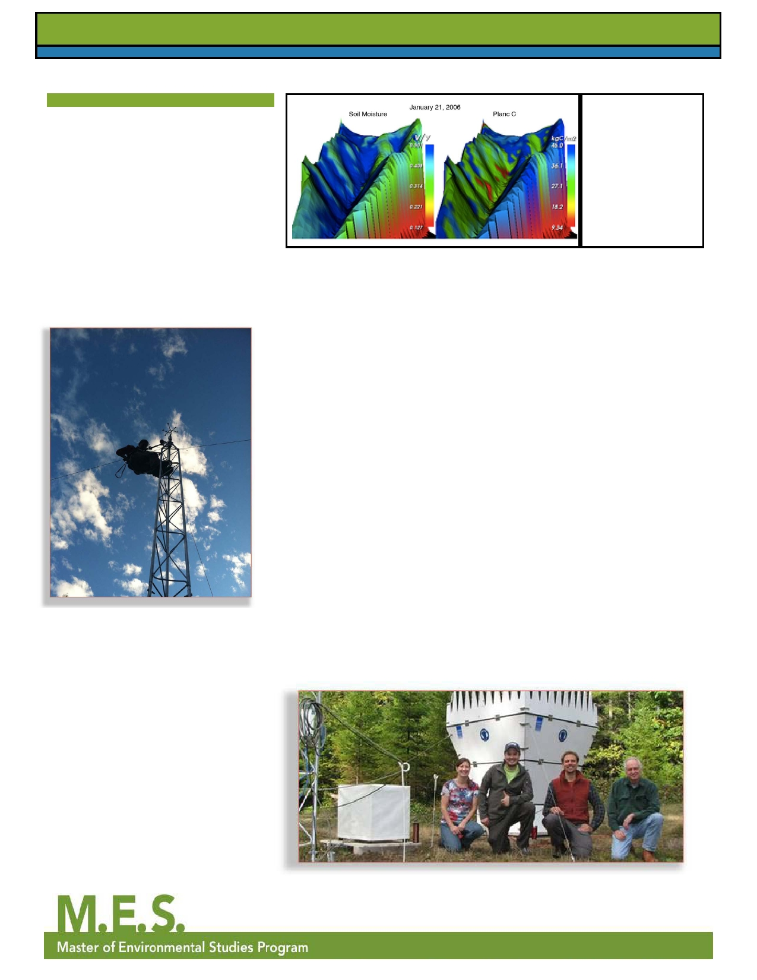

**Modeling Ecological Processes with VISTAS**

By: Evan Hayduk, MES 2nd Year

The VISualizing Terrestrial Aquatics

Systems (VISTAS) project is an

NSF funded collaboration among

faculty and graduate students at The

Evergreen State College, Oregon State University (OSU), and the

H.J. Andrews Experimental Forest

(HJA). The goal of VISTAS is to develop visual analytics to help

**Winter 2012**

*VISTAS Model -*

*Soil Moisture Map*

*January 21,*

*2006*

scientists understand relationships

among ecological processes at the same and different scales, develop

new testable hypotheses, and

2nd Year MES Student

Jerilyn Walley

explain research results. VISTAS'

scope is interdisciplinary in nature,

combining computer science research

and development, a broad range of

ecological research domains, and

social science inquiry to develop and evaluate software and visualizations for ecologists to utilize in their work.

The VISTAS project currently

supports three graduate students,

two here at Evergreen and one at OSU. Kirsten Winters, a PhD

student at OSU, works with Denise

Lach, heading up the social science

component of the VISTAS' project.

Kirsten is currently interviewing

our domain scientists, programmers

and computer scientists in order to

provide input to the development

of the VISTAS software. Jerilyn

Walley, a second year MES student, is completing her thesis work with Christoph Thomas, a professor in biomicrometerology at OSU. Their

project, VALCEX (VALley Circulation

EXperiment), involves developing a wind profile for a valley in the HJA

using two sophisticated SODAR (Sonic Detection and Ranging)

systems. I am also a second year MES

student, and I work with Barbara Bond, former Lead PI of the HJA, and Scott Allen, a master's student

in ecohydrology at OSU, developing

visualizations of ecologic and

hydrologic phenomena in Watershed

1 and creating an accurate measure

of canopy cover by comparing

Leaf Area Index (LAI) with LiDAR

(Light Detection and Ranging)

measurements. The new measure

of canopy cover would be used for

modeling precipitation interception.

Along with our thesis work, Jerilyn,

Kirsten and I are currently surveying

six months of articles from leading

research journals to assess what

visualizations are currently being used

by ecologists. This involves creating

a visualization database, where we

store our survey of the nine journals, roughly 1,300 articles and over 32,000

visualizations!

Working with the VISTAS project

has provided Jerilyn and me with an amazing opportunity to perform and

be a part of cutting edge research.

The collaboration with OSU and the HJA has provided us resources and

expertise that have enriched our MES

theses. Currently in its first year, the VISTAS project is moving forward,

and the next two years are sure to

bring more excitement and further results.

VALCEX Team - Jerilyn Walley and Evan Hayduk on left

page 4

**Volume 5, Issue 2**

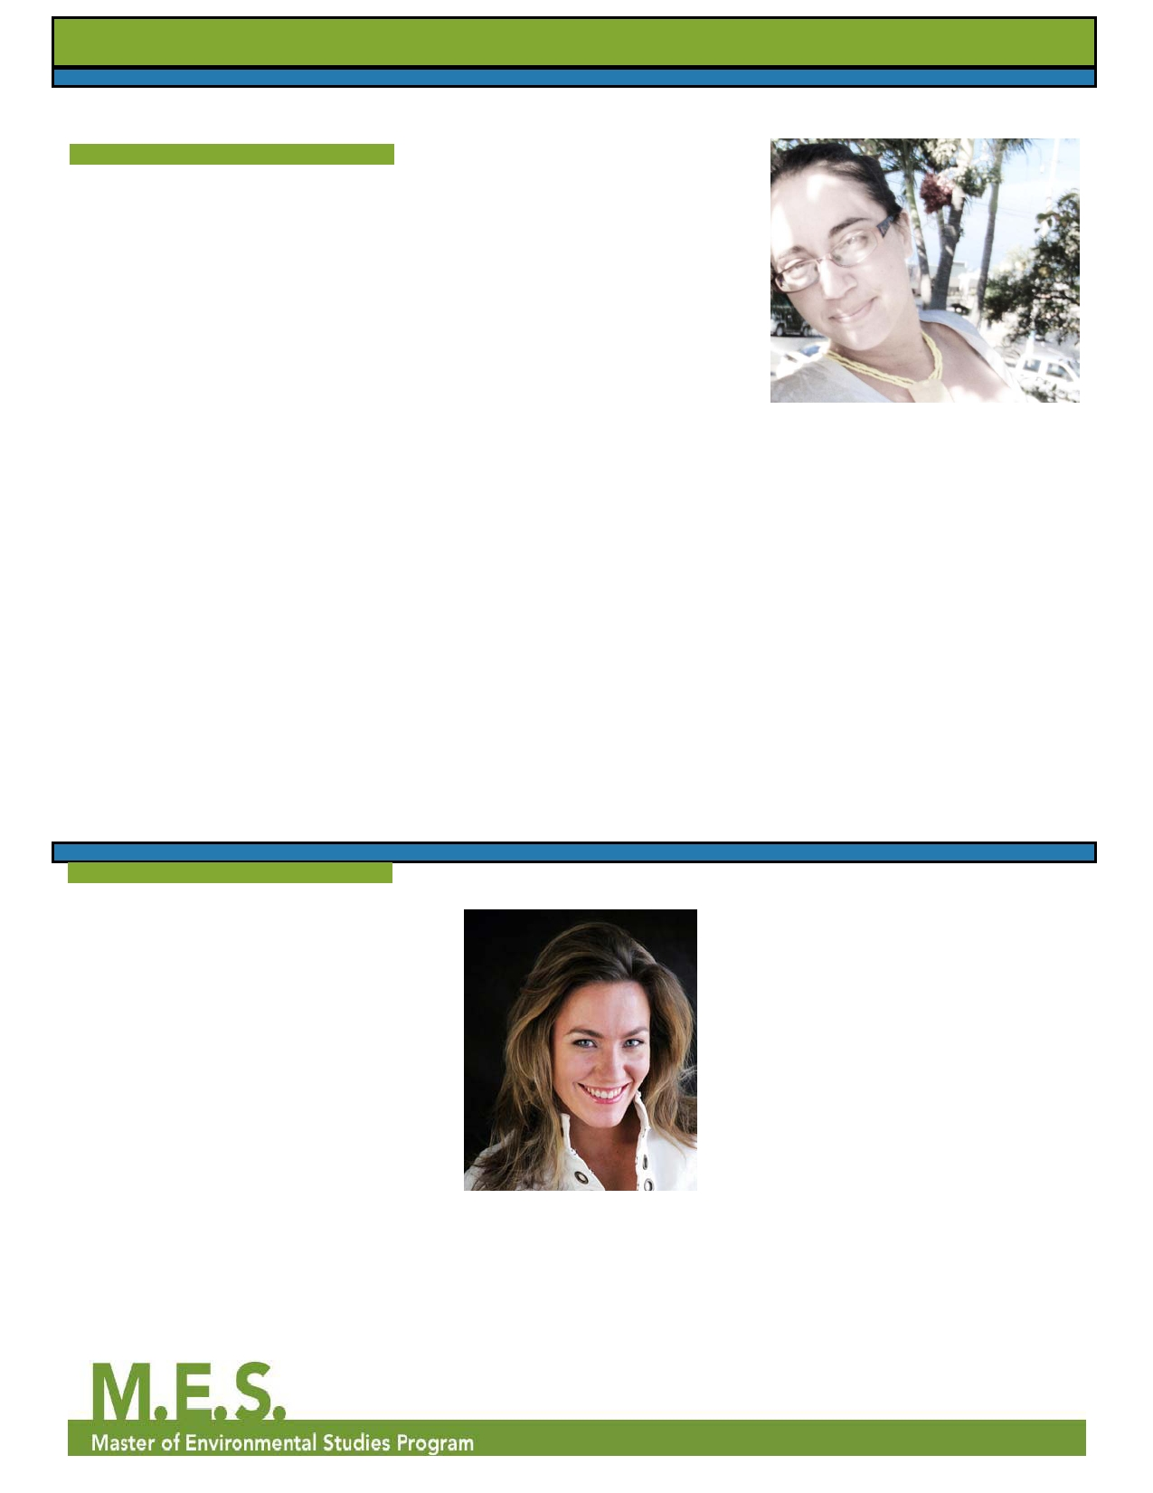

**Alumni Corner**

Natalie Pyrooz MES 2009

After graduating from the MES

program in 2009, focusing on

sustainability, conservation, and

botany/ethnobotany, Natalie Pyrooz

took an eight-month journey through much of South America, volunteering

with several NGOs and private

reserves. Afterwards, she wanted

to lend her expertise in a more

substantial manner to these countries

that host fascinating biodiversity

but lack many financial or academic

resources. She volunteered for the

Reserva Biologica Cerro Seco (RBCS),

in the coastal dry tropical forest of

Ecuador, near Bahía de Caráquez. This area has had very little ecological study

but boasts a 25% endemism rate, and Natalie was inspired to return to do a

botanical inventory and develop a field

guide to the plant species of the area.

Self-funded by a combination of

extreme frugality and seasonal field

jobs, in May 2010 Pyrooz returned to

the reserve and embarked upon the

study. The project involved collecting

Eva Otto, MES 2003

Eva Otto is a graduate of the MES

program where she focused her

study on International Trade and the Environment. Eva's research

explored the historical connection

between our political economy and the

degradation of the Earth's biosphere. Eva's thesis made recommendations

for reforming the global economy towards sustainable development,

and ultimately restructuring the

political economy towards restorative development.

After completing her MES coursework

in 2003, Eva moved to Seattle and co-founded Infiniti Real Estate &

Development where she is a LEED

page 5

samples of fertile and infertile plant

specimens, and working either alone or leading groups of volunteers and

tourists to do this. Because there is no

taxonomic key to the area, and there

are over 18,000 documented plant

species in Ecuador she volunteered in the National Herbarium in the capitol

city of Quito to ID the plants to species

when possible, as well as educate

herself on herbarium management in a developing country. During her time at RBCS, Natalie also educated school groups and locals about plant and forest ecology, and helped with restoration efforts.

Pyrooz was fortunate to have a few

exciting discoveries: she found a plant

species new to science, which she

hopes to describe and publish; there are also at least two species collected which are Critically Endangered.

Pyrooz says the MES program

cemented her abilities to coordinate

groups, manage large amounts of data,

and plan an intensive study of this

Eva Otto, MES 2003

Accredited Professional and an

Ecobroker specializing in marketing,

selling, and educating the public about green homes, Eva is an industry expert

**Winter 2012**

Natalie Pyrooz, MES 2009

magnitude. It also helped in enhancing

her perspective on how policy

influences environmental management and she provided valuable input to the

decision-making process at RBCS as

they develop sustainable eco-tourism.

Natalie hopes to return next year to

continue the study. She believes her current findings will help to solicit

future funding and partnership

opportunities. If anyone is interested in

learning more about her work, please

contact her at

natalie.pyrooz@gmail.com.

in green building, real estate and

also works internationally in Costa

Rica where she is developing an eco- community in Playa Esteriollos.

Eva is grateful to Evergreen and the

MES program because during her

graduate study she was able to intern

for the Washington State Office of Trade and Economic Development

for a full year in 2001, and afterwards

intern with the United Nations for

6 months preparing a policy agenda

for the World Summit on Sustainable Development. Later in 2002 Eva spent

6 months in Brazil researching and

participating in the World Social

Forum. "MES gave me the framework

*continued on page 6*

**Volume 5, Issue 2**  **Winter 2012**

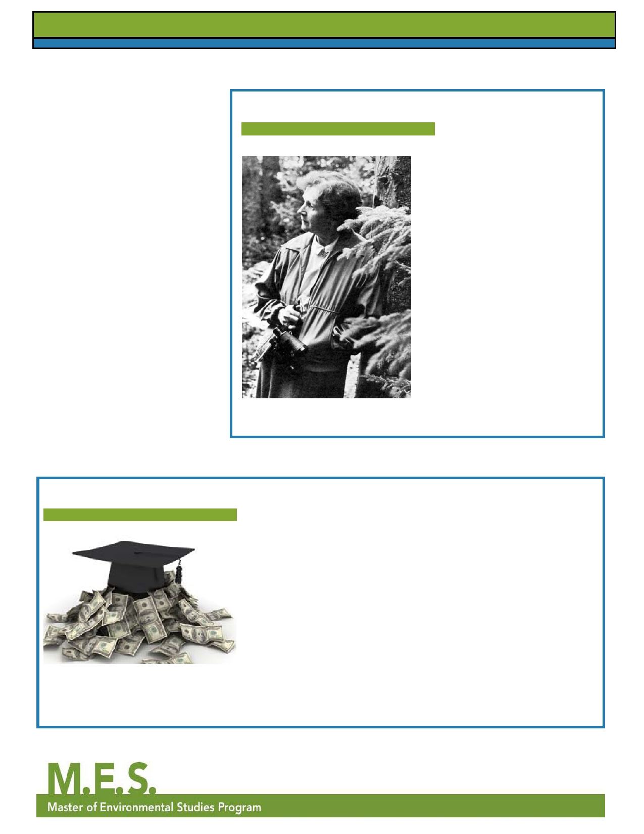

**Alumni Corner (continued from page 5)**

to carry out some of my life's most

important research, and allowed me

freedom to create my educational

experience. These accomplishments through the MES program gave me

the confidence to forge my own path

as an eco-entrepreneur and go out and

create the change I wanted to see in

the marketplace."

Currently, Eva is selling Washington

State's first Zero Net Energy

multifamily development in Issaquah

(www.z-home.org). Eva also finds time to give back to her community, and is on the board of directors for EcoAudit USA, the Seattle Institute for Oriental

Medicine, and the Sustainability

Committee for the Seattle Chamber

of Commerce. She is a member of

the Global Interdependence Center

where she travels internationally

to participate in discussions on

economic interdependence between

nation states. You can visit Eva's

website at

www.infinitiRED.com

**Rachel Carson Forum, 2012**

By: Aaron Zimmer, MES 1st Year

In recognition of the 50th anniversary

of Carson's first publication of Silent

Spring and in coordination with

the Willie Unsoeld Seminar (which

this year on May 3 is presenting Kaiulani Lee in her play *A Sense*

*Of Wonder*, about key moments in

Caron's life), the student-run Master

of Environmental Studies Association

(MESA) is presenting the Rachel

Carson Forum. This year, a panel of

policy makers, activists, biological

scientists, and research scientists will be speaking on "The Social,

Ecological, Economical, and Political Implications of 'Correct' Pesticide Use in Our Society Today" in our gorgeous

400-capacity Salish Longhouse, Tuesday, May 1 at 6:00pm.

**Big Changes to MES Financial Aid Awards**

By: Gail Wootan, MES Asst. Director

MES students can now apply for scholarships, fellowships, and

tuition waivers for 2012-2013. Students should pay close attention to award descriptions, as several have changed since the 2011-2012

award application. New this year are awards specifically for incoming

students, based on their admissions applications, so they will receive an award at the same time they are admitted. For all students, we've changed the ever-popular AmeriCorps Service Award to be available for ALL AmeriCorps alumni no matter the length of service - all that

is required is proof of service. In addition, awards are broken up for

new students and continuing students. All students will continue to be

eligible for need-based waivers, as long as they filled out a FAFSA by

March 1. Applications are due Wednesday, April 11 at 5pm PST. Apply online at http://www.evergreen.edu/mes/awards.htm.

page 6

**Volume 5, Issue 2**  **Winter 2012**

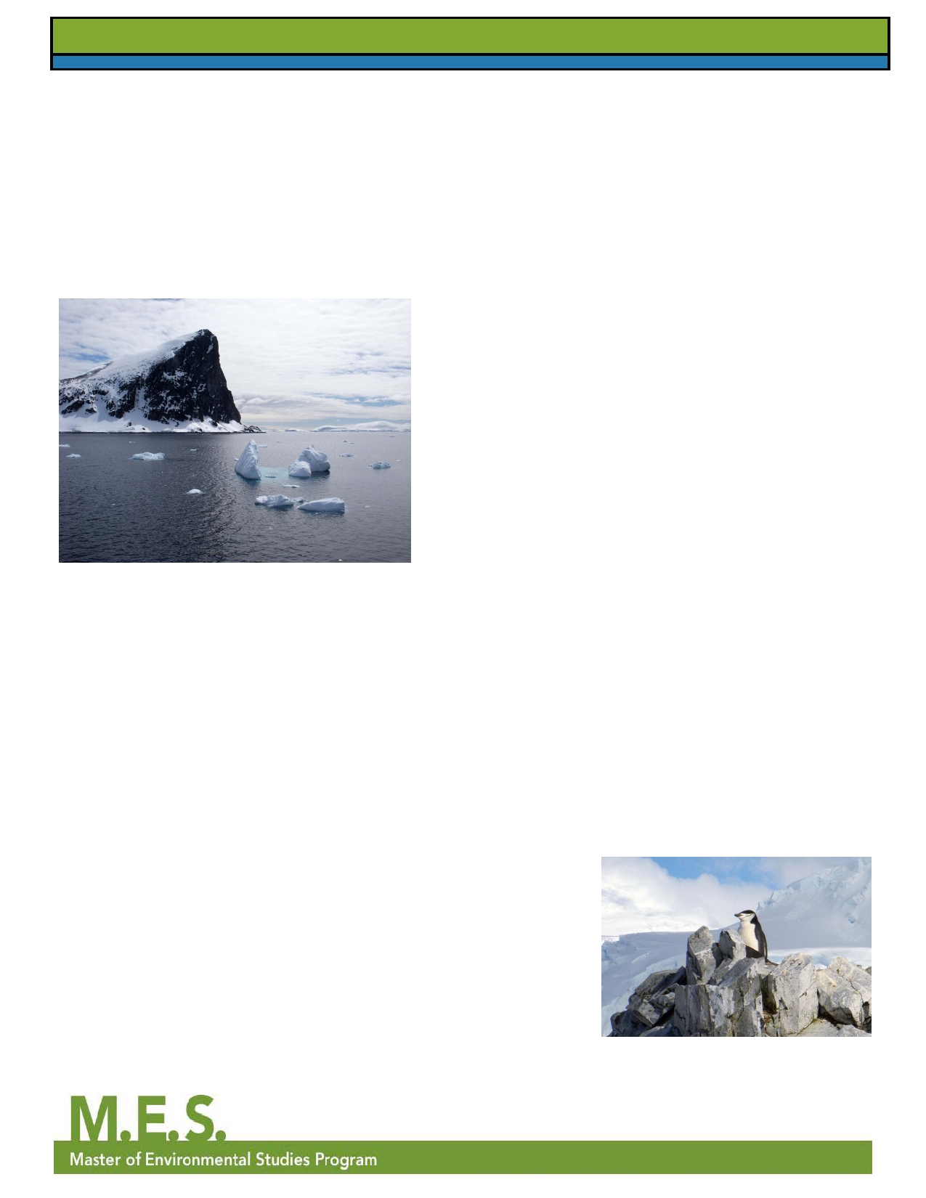

**Antarctica (continued from page 1)**

from the shore, a sound that reminds

me of the harshness of a crow's call,

but belongs to feces-stained birds that stumble on land like human toddlers

yet swim like underwater missiles, breaks my reverie. I think, for the five-billionth time that day, "Holy crap, I'm kayaking in Antarctica!"

its crisp, spring air and stunning

views, but it was time to hit the road on the Academik Sergey Vavilov, our shipboard home for the next 10 days.

One of the things about an oceangoing

trip to Antarctica is that you spend much more time onboard the ship than you do off the ship, so a good

crew of people and

an uneventful Drake Passage crossing are

crucial. Luckily, we hit

the jackpot with our ship

considering that two of the staff on board,

our kayak guides, were

Greeners!! We knew

(like the South Shetlands). For a

bit more (okay, a lot more) money,

passengers could also sign up to

kayak, cross-country ski, climb, or

camp. Martha and I chose to kayak, and I also chose to ski. Every stop we made had its own special memory.

My first climb up a glacier, roped up

on skis with complete strangers on Livingston Island, was exhilarating, but not as exhilarating as the "polar plunge" into the gunmetal waters of

the old whaling station on Deception Island.

The second day was our first step

on the actual continent (although

the islands off the mainland are also

we'd chosen the right trip considered to be Antarctica). Kate

from that point forward. and I stepped off the Zodiac together

The actual passage itself to share the experience of "bagging" was literally smooth our seventh continent. That day was

sailing - no seasickness crystal clear - the blues of the sky and for us, although the side water were incredible, and the white

effects of our seasickness of the snow was dotted with black

*Orne Harbor, Antarctica. Photo by Gail Wootan*

In November 2011, the MES Director,

patches were another

story.

chinstrap penguins waddling around

with rocks in their beaks for their nests.

Martha Henderson and I jumped on But you really want to know about

a plane to experience summer on the Antarctica, right? Antarctica is one The rest of the trip was a whirlwind

other side of the world and to snag my of those places and experiences that of long days of daylight; laughing

sixth and seventh continents. The idea are hard to explain using just our with new friends from around

of going to Antarctica was sparked by common vernacular. Instead, one the world; waiting for the dinner

a college friend of mine. It had been a must hear the sounds, drink in the announcement; walking through the

lifelong dream of Kate's to hit all seven impossible blues, and view the never- halls in just our robes to get to the

continents and it took me putting the ending glaciers, icebergs, mountains, shower; waking up at Oh-dark-thirty down payment on a trip to get her to and penguins to understand that it is to wiggle into a drysuit for a morning

go. I told Martha about the upcoming best just to experience it yourself. It paddle; encountering giant sapphire-

trip and the rest was history. is difficult to portray just how exciting blue icebergs; penguins, penguins,

The trip actually started in Buenos

Aires, which is an entirely different

story unto itself filled with samba parades, Italian street festivals, late

night feasts, an 18-meter high Jesus,

a death-defying bike ride through

potholed streets, and newfound friendships. To get to Antarctica

from Buenos Aires, we had to fly to

the small mountain town of Ushuaia,

which considers itself "El Fin del

it is to see that first iceberg and that

first penguin, and then to have each day provide a new experience until

the end of the trip when the icebergs,

penguins, and colors become an

expected everyday spectacle outside your room's porthole.

However, I will try to share some of

our experiences with you here. For

the actual Antarctic part of the trip, we

had five days in the region to explore

and more penguins; dealing with

Mundo," or "The End of the World." with twice-daily trips by Zodiac to the *Chinstrap penguin. Photo by Gail Wootan*

The town was exciting enough with

mainland or islands off the peninsula

*continued on page 8*

page 7

**Volume 5, Issue 2**

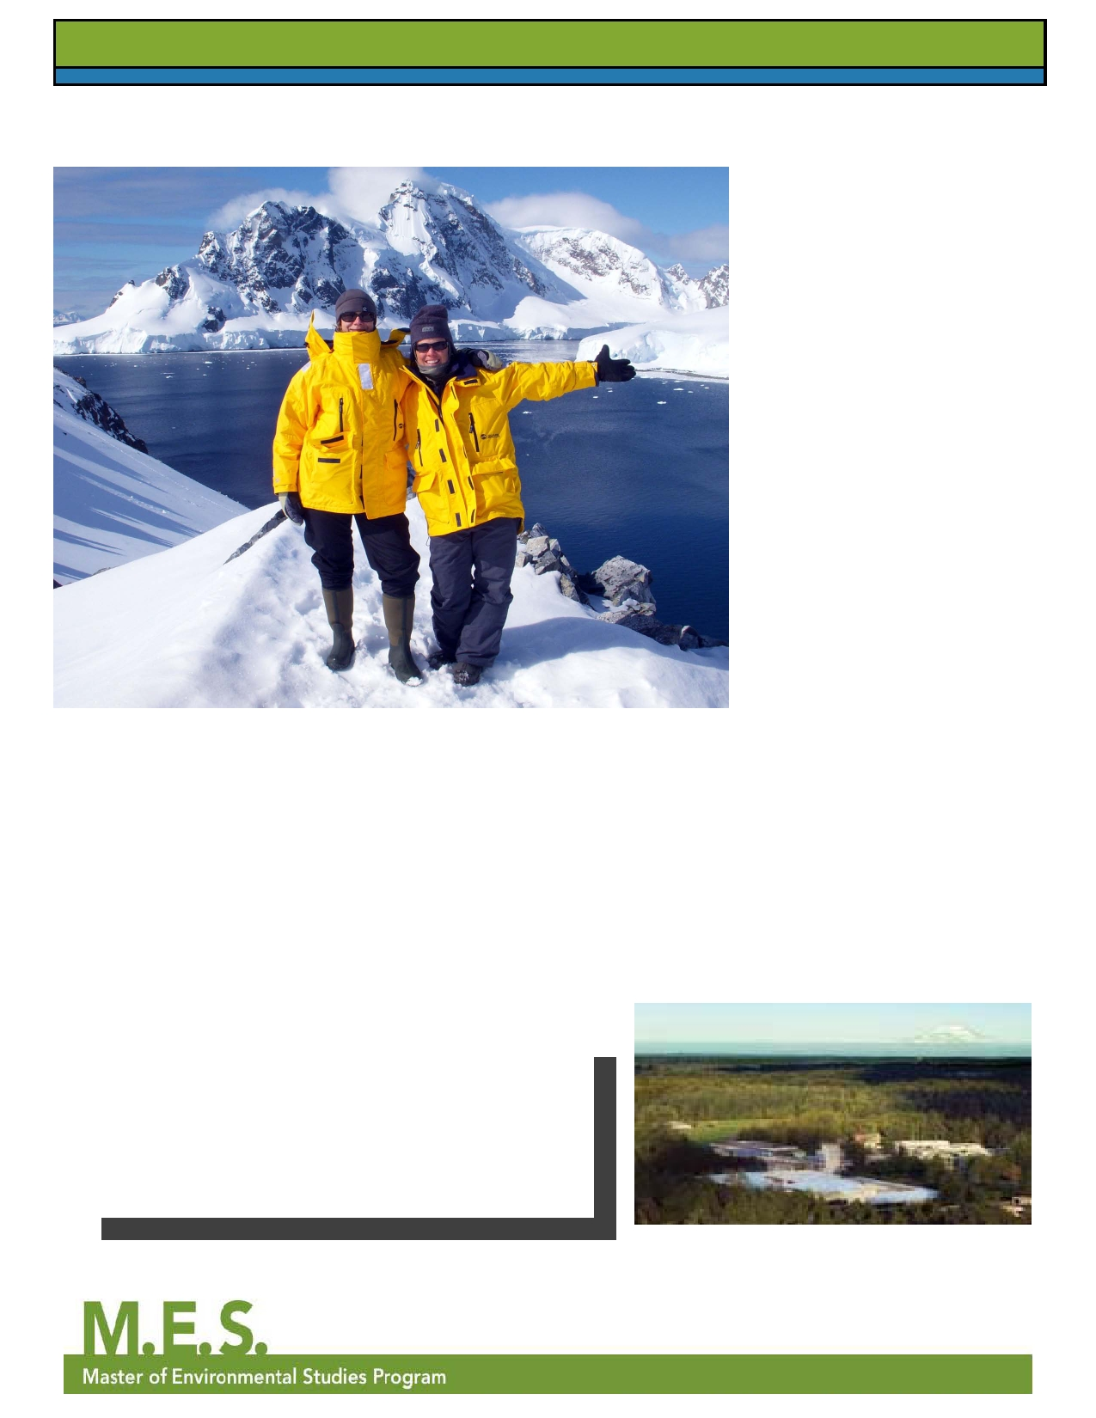

**Antarctica (continued from page 7)**

Martha Henderson and Gail Wootan in Antarctica

**Winter 2012**

windburned skin; and the delicious

taste of a cup of warm hot chocolate at our favorite spot: the top deck bar.

My magic carpet kayak trip was

my most memorable experience,

not only for the beauty and the

otherworldly experience of floating in an infinite ice patch, but because

it reminded me of my love for the water and mountains, for fresh air,

for challenging my body, and for the epiphanies that adventure and travel

bring for me. When Martha and I, regretfully, landed at SEA-TAC and

jumped into her car, I felt a slight

sadness, as I realized it was back to the daily grind of the "real-world." But that feeling was soon replaced with the possibilities for my life: I

could work in Antarctica if I wanted

to! I can play in the snow here in Washington - there's plenty of it! I can meet new people, join new

groups, learn new things. Now that I think about it, my life has changed

quite a bit since getting back to the US. Since then, I've become more active in local environmental issues, I've met new friends

through various hiking and volunteer groups, and I'm excited for my adventures yet to come (Habitat for Humanity in Sri

Lanka is the next one for me)! I know it sounds cheesy, but anything truly is possible - even going to Antarctica. Essentially, it

can all be summed up by my new credo: "Try it! It's not as hard as it seems."

**MES 2011 Graduates**

**Summer**

***Nahal Ghoghaie***

***Aaron Litwak***

***Ashley Lyon***

***John Richardson***

**Fall**

***David Falzetti***

***Mercy Kariuki-McGee***

***Melanie Kincaid***

***Daniel Wolff***

page 8